Supplementary materials
Social behavior in action video game players: the contribution of competitive personality

Swann Pichon^{1,2,3}, Lia Antico^{1,2} Julien Chanal^{1,4}, Tania Singer⁵, Daphne Bavelier^{1,6}

¹Faculty of Psychology and Educational Sciences, University of Geneva, Geneva, Switzerland
²Swiss Center for Affective Sciences, University of Geneva, Geneva, Switzerland
³Geneva School of Health Science, Geneva, Switzerland
⁴Faculty of Psychology, UniDistance Suisse, Brig, Switzerland
⁵Social Neuroscience Lab, Max Planck Society, Berlin, Germany
⁶Campus Biotech, Geneva, Switzerland

Supplementary Methods S1. Competitive Reaction Time Task (CRTT)
The Competitive Reaction Time Task (CRTT) was administered using the computerized version of the paradigm (version 3.4.2; https://uk.groups.yahoo.com/neo/groups/CRTRP/info). Participants were told that they would compete online against a same-sex participant from another European research institute. In reality, the opponent was computer-controlled.
The CRTT consisted of 25 competitive reaction-time trials. On each trial, participants were instructed to respond as quickly as possible to a visual cue. Before each trial, participants selected the intensity and duration of the noise blast that their opponent would receive if the opponent lost, using two scales ranging from 0 to 10. Noise intensity ranged from 60 dBA at Level 1 to 105 dBA at Level 10, increasing in 5-dBA increments. Noise-blast duration ranged from 0 to 5 s in 0.5-s increments. Participants then completed the reaction-time trial and received feedback indicating whether they had won or lost. Following each trial, they were shown the intensity and duration supposedly selected by their opponent. On loss trials, participants subsequently received the corresponding noise blast.
Unknown to participants, trial outcomes and the opponent's punishment selections were predetermined and identical across participants. All participants experienced the same sequence of 12 wins and 13 losses. The opponent's programmed selections provided repeated provocation by varying the intensity and duration of the noise blasts ostensibly selected for the participant while keeping exposure identical across participants. To establish a strong initial provocation, the first trial always resulted in a loss, with the participant receiving the maximum intensity and duration selected by the computer-controlled opponent. The complete sequence was: [L-10-10, L-9-10, W-8-7, W-7-8, L-6-6, W-5-4, L-4-2, L-3-3, W-2-5, W-2-5, W-4-3, L-3-2, W-5-4, L-6-6, L-8-8, W-9-9, L-7-7, W-7-9, L-9-8, W-8-6, W-6-7, L-5-5, L-3-4, W-4-3, L-2-2], where W and L denote trials won and lost by the participant, respectively, and the two numbers indicate the opponent's programmed noise-blast intensity and duration levels, respectively.
Noise-blast intensity was calibrated using a sound level meter (NTI XL2; impulse measure LAImax, temporal integration window = 35 ms) to ensure accurate delivery through the headphone system.

Supplementary Methods S2. Auditory discomfort threshold
Individual thresholds of auditory discomfort were estimated using a double random interleaved adaptive staircase procedure. The auditory stimulus corresponded to the same white-noise burst used in the Competitive Reaction Time Task (CRTT) and could vary between 50 and 105 dB.
On each trial, participants heard a 0.5-s noise burst and rated its loudness using the seven-category loudness perception scale proposed by Cox et al. (1997):
- Very soft
- Soft
- Comfortable, but slightly soft
- Comfortable
- Comfortable, but slightly loud
- Loud, but acceptable
- Uncomfortably loud

Responses from categories 1–6 were considered acceptable loudness, whereas category 7 indicated an aversive level.
Two independent staircases started at 50 dB and 75 dB, respectively. The next trial was randomly selected from one of the two staircases. A 1-up/2-down adaptive rule was used, such that stimulus intensity increased after each acceptable response but decreased only after two consecutive aversive responses.
Stimulus intensity initially changed in 5-dB steps until the second reversal, after which the step size was reduced to 2 dB. The procedure ended after 12 reversals, and the discomfort threshold was calculated as the average of the final four reversals from each staircase. An additional stopping rule terminated the procedure if the maximum stimulus intensity (105 dB) was presented four consecutive times.

Supplementary Methods S3. Zurich Prosocial Game (ZPG)
Helping behavior was assessed using the Zurich Prosocial Game (ZPG), following the paradigm developed by Leiberg et al. (2011). Participants were instructed that they would be connected online with a different participant from a partner European research institute on each trial, although all co-players were computer-controlled. The goal of the game was to navigate a virtual character through a maze and reach a treasure within 1 min. Successfully reaching the treasure awarded 50 points, which participants were told would be converted into money at the end of the experiment. For ethical reasons, all participants ultimately received the same fixed bonus (5 CHF), irrespective of their performance.
At the beginning of each trial, participants selected one of two possible paths through the maze. Each player possessed a limited set of red and blue keys that could be used either to open gates blocking their own path or to assist the co-player by opening gates on the co-player's path. Throughout the game, participants could monitor the remaining gates as well as the keys available to both players. Helping behavior was operationalized as the voluntary use of one's own keys to assist the co-player. Participants could continue using their remaining keys until they reached the treasure, even if their own avatar had already been blocked.
To encourage participants to monitor the entire game environment, red stars appeared in five of the 11 experimental trials, awarding 20 additional points if collected within 3 s. Participants competed with the other player to collect these stars. In addition to helping behavior, the task provided several secondary performance measures, including helping reaction time, time to reach the treasure, star collection reaction time, and star collection rate (proportion of stars collected among the five presented).
Participants first completed four training trials before completing 11 experimental trials. The experimental trials manipulated four determinants of helping behavior:
- Reciprocity (reciprocity vs. no reciprocity): in reciprocity trials, the co-player had previously helped the participant during the same trial before the participant had an opportunity to reciprocate. In no-reciprocity trials, participants knew that the co-player would not subsequently have an opportunity to help them.
- Helping cost (high vs. low): in high-cost trials, donating a key carried a 25% probability that the participant would subsequently require that same key to reach the treasure. In low-cost trials, participants knew that the donated key would not be required.
- Distress cues (present vs. absent): in distress trials, the blocked co-player emitted audible distress vocalizations, whereas no vocalizations were presented in the no-distress condition.
- Fairness (fair vs. unfair): additional experimental trials manipulated whether the co-player behaved fairly or unfairly toward the participant.
The primary outcome measure was the number of helping behaviors performed across the experimental trials.
Before beginning the task, participants received standardized written and verbal instructions and completed five comprehension questions to ensure that they understood the game mechanics. Participants then entered a self-selected nickname and were ostensibly connected to the online game network. At the end of the task, participants completed a debriefing describing their subjective impressions of the co-player. This procedure served to identify participants who had become aware of the experimental deception.

Supplementary results

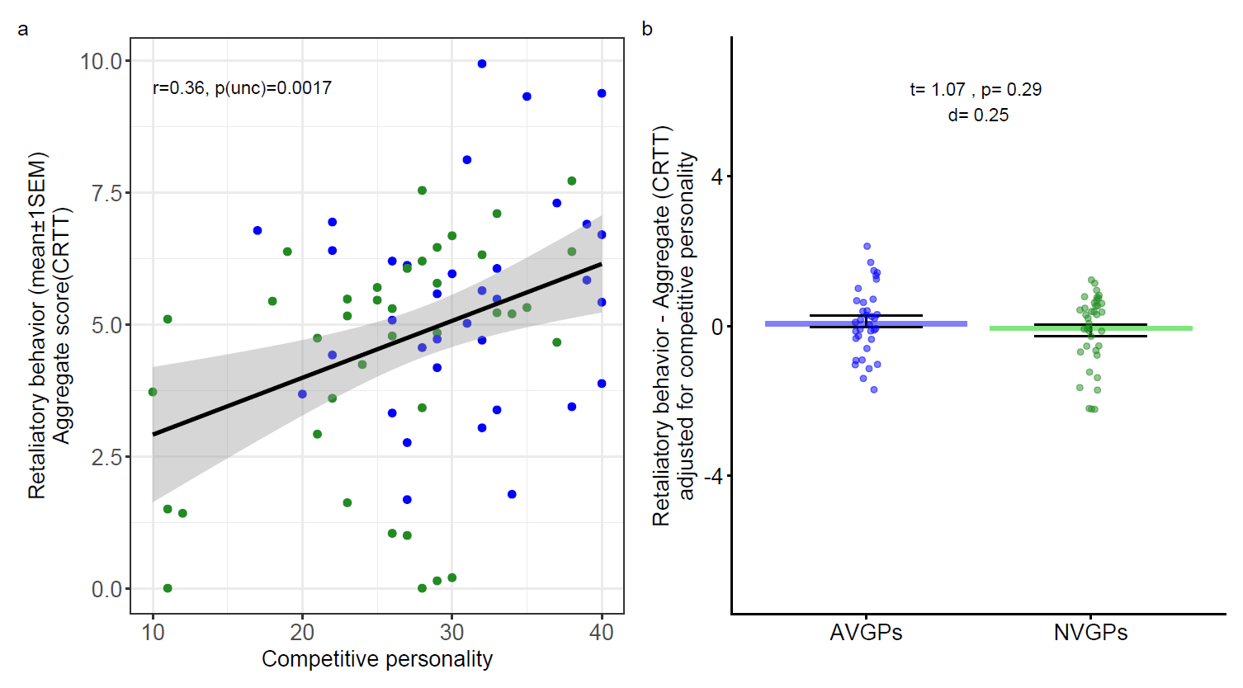

Figure S1. Competitive personality and retaliatory behavior in the CRTT. Competitive personality was positively associated with aggregate retaliatory behavior in the CRTT (a). After adjustment for individual differences in competitive personality, the AVGP–NVGP difference in aggregate retaliatory behavior was substantially attenuated (b). The shaded area represents the 95% confidence interval around the regression line. Bars represent means, error bars indicate ±1 standard error of the mean (SEM), and dots represent individual participants.

