Supplementary Information
A General Approach for All-visible-light Switching of Diarylethenes through Triplet Sensitization using Semiconducting Nanocrystals
Lili Hou^{1,2,3}*, Wera Larsson¹, Stefan Hecht^{4,5}, Joakim Andréasson¹, Bo Albinsson¹*
¹Department of Chemistry and Chemical Engineering, Chalmers University of Technology, Gothenburg 412 96, Sweden.
² Present Address: School of Precision Instruments and Optoelectronics Engineering, Tianjin University, Tianjin 300072, China.
³ Present Address: Key Laboratory of Optoelectronics Information Technology, Ministry of Education, Tianjin 300072, China.
⁴ Department of Chemistry & IRIS Adlershof, Humboldt‐Universität zu Berlin, Brook‐Taylor‐Str. 2, 12489 Berlin, Germany.
⁵DWI—Leibniz Institute for Interactive Materials & Institute of Technical and Macromolecular Chemistry at RWTH Aachen University, 52074 Aachen, Germany.
*Corresponding author e-mails: lilihou@tju.edu.cn; balb@chalmers.se

Contents
1. TEM images, absorption and PL spectra of CdS NCs S2
2. Light response of DAE1 S3
3. PL quenching of CdS NCs by 3-PCA S3
4. DAE1 mixtures under visible light irradiation. S4
5. PL quenching of CdS 405 by PyCOOH S4
6. DAE3 and DAE4 under visible light irradiation S5
7. DAE1 mixture under visible irradiation in an air-equilibrated solution S5
8. DFT calculations of the first excited triplet states of DAEs S5

TEM images, absorption and PL spectra of CdS NCs
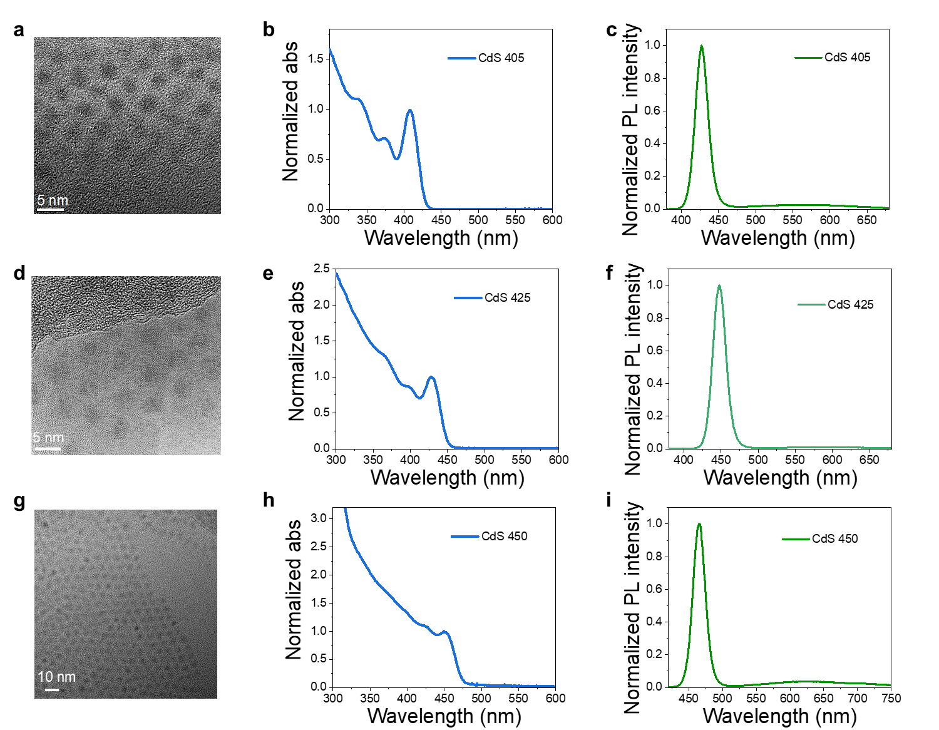
Supplementary Figure 1. Spectroscopy of CdS NCs. a. TEM image of CdS 405, b. Normalized UV-visible absorption of CdS 405 in toluene, c. PL spectrum of CdS 405 in toluene; d. TEM image of CdS 425, e. Normalized UV-visible absorption of CdS 425 in toluene, f. PL spectrum of CdS 425 in toluene, g. TEM image of CdS 450, h. Normalized UV-visible absorption of CdS 450 in toluene, and i. PL spectrum of CdS 450 in toluene.

Light response of DAE1
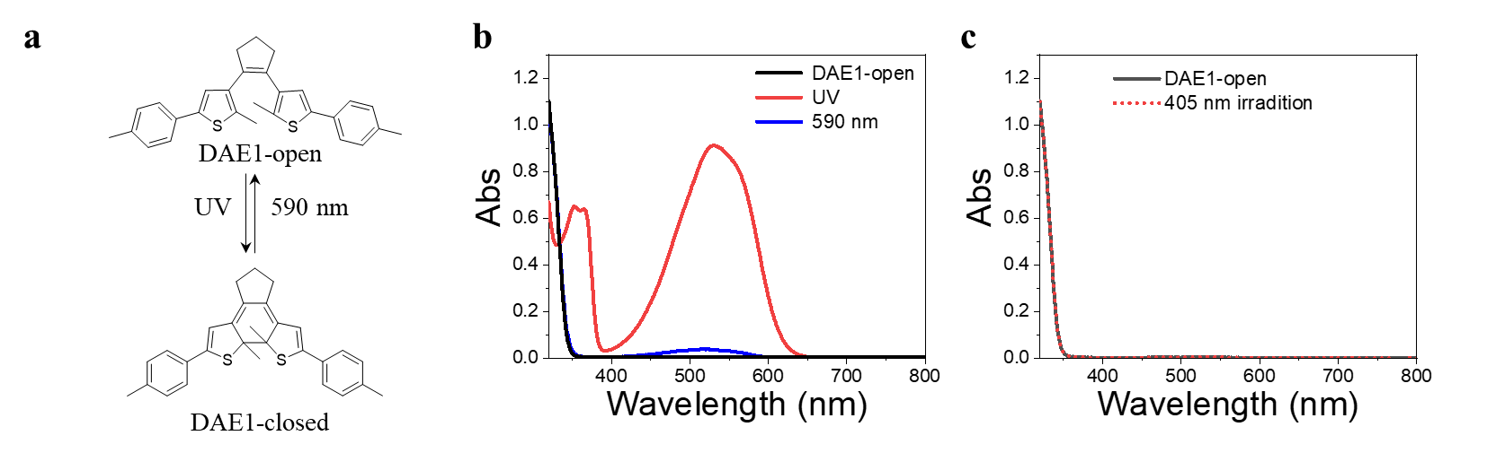
Supplementary Figure 2. Light response of DAE1. a. Photoisomerization of DAE1 under UV and 590 nm light irradiation. b. UV-visible absorption spectra of DAE1-open (50 μM) in toluene before and after 302 nm (30 s), and after 590 nm light irradiation (90 s). c. UV-visible absorption spectra of DAE1-open (50 μM) in toluene before and after 405 nm light irradiation (120 s).

PL quenching of CdS NCs by 3-PCA
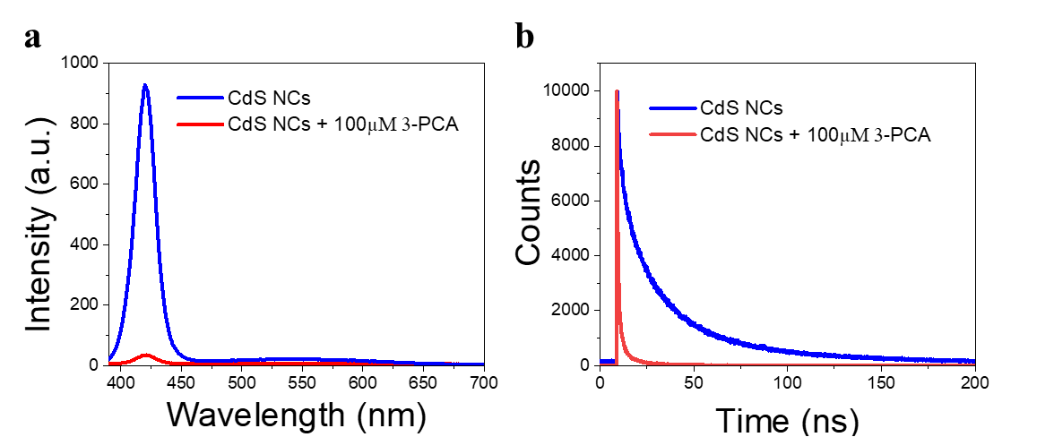
Supplementary Figure 3. PL quenching of CdS 405 by 3-PCA. a. PL spectra and b. time-resolved PL decay of CdS NCs (CdS 405) with and without the mediator 3-PCA (100 μM).
PL decay of CdS NCs exhibits complicated multiple exponential components. Herein three exponentials decay was used to achieve a satisfactory fit:
$I= I_{0}\sum_{i=1}^{3}{A_{i}e^{-t/τ_{i}}}$ (1)
where $A_{i}$ and $τ_{i}$ are the amplitude and lifetime of the $i$:th exponential component, respectively. The decays were deconvoluted using the instrument response function (IRF). The amplitude-weighted average lifetimes were calculated using equation 2
Amplitude-weighted: $<τ> =\frac{ \sum_{i=1}^{3}{A_{i}τ_{i}}}{ \sum_{i=1}^{3}{A_{i}}}$ (2)
The efficiency of the first triplet energy transfer (TET₁), $Ф_{TET1}$, was estimated from PL lifetime quenching using equation 3
$Ф_{TET1}=1-<τ>/{<τ>}_{0}$ (3)
where $<τ>$ and ${<τ>}_{0}$ are the amplitude-weighted average PL lifetimes of CdS NCs with and without the mediator, respectively.
The amplitude-weighted PL liftetime of CdS 405 is reduced from 16.0 ns to 1.5 ns after adding 3-PCA, and the TET₁ efficiency was calculated to be 91%, which was also consistent with the efficiency estimated from PL intensity quenching.

DAE1 mixtures under visible light irradiation.
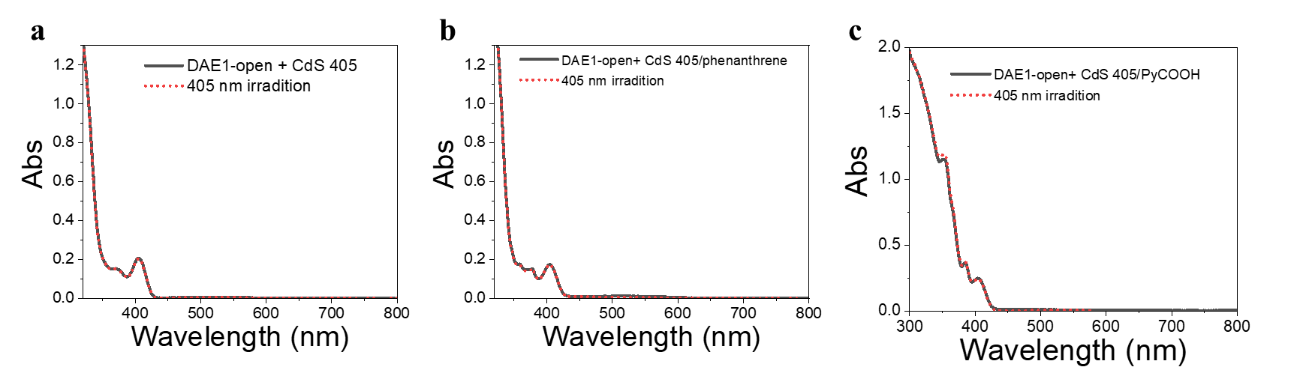
Supplementary Figure 4. Visible light response of DAE1 mixtures. a. UV-visible absorption spectra of DAE1 (50 μM) mixed with CdS 405 (0.5 μM) in deaerated toluene before (black-line) and after 405 nm visible light irradiation (120s, red-dot). b. UV-visible absorption spectra of DAE1 (50 μM) mixed with CdS 405 (0.5 μM) and phenanthrene (100 μM) in deaerated toluene before (black-line) and after 405 nm visible light irradiation (120 s, red-dot). c. UV-visible absorption spectra of DAE1 (50 μM) mixed with CdS 405 (0.5 μM) and PyCOOH (100 μM) in deaerated toluene before (black-line) and after 405 nm visible light irradiation (120 s, red-dot). In all the three cases, 405 nm light irradiation did not result in any obvious photoisomerization of DAE1.

PL quenching of CdS 405 by PyCOOH
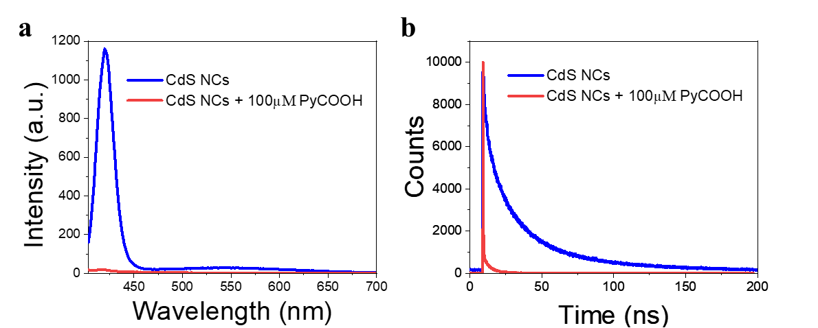
Supplementary Figure 5. PL quenching of CdS 405 by PyCOOH. a. PL spectra and b. time-resolved PL decay of CdS NCs (CdS 405, 0.5 μM) with and without the mediator PyCOOH (100 μM) in toluene.
The amplitude-weighted PL liftetime of CdS 405 is reduced from 16.0 ns to 1.9 ns after adding PyCOOH (100 μM), and the TET₁ efficiency was calculated to be 88% using equation 3, which was very similar to the efficiency estimated from PL intensity quenching.

DAE3 and DAE4 under visible light irradiation

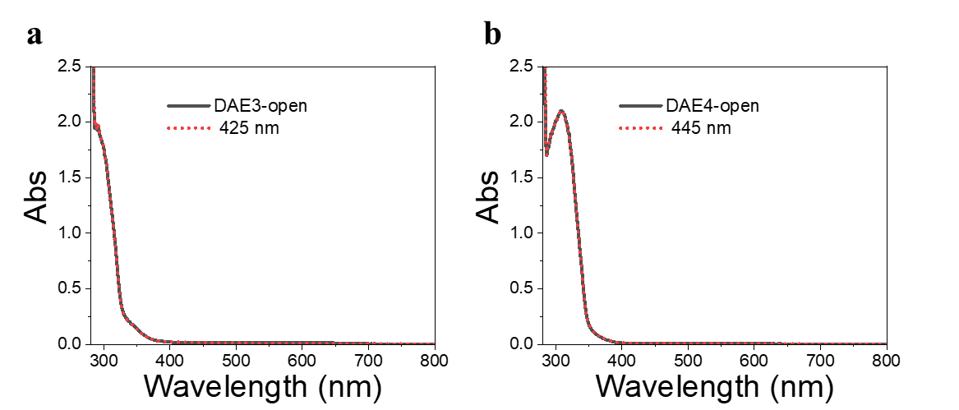
Supplementary Figure 6. Visible light response of DAE3 and DAE4. a. UV-visible absorption spectra of DAE3 (50 μM) in toluene before (black-line) and after 425 nm visible light irradiation (10 min, red-dot). b. UV-visible absorption spectra of DAE4 (50 μM) in toluene before (black-line) and after 445 nm visible light irradiation (9 min, red-dot). In these two cases, visible light irradiation did not result in any obvious photoisomerization of DAEs.

DAE1 mixture under visible light irradiation in an air-equilibrated solution
Supplementary Figure 7. Visible light response of DAE1 mixed with CdS 405 and 3-PCA in an air-equilibrated solution. UV-visible absorption spectra of DAE1-open (50 μM) mixed with CdS 405 and 3-PCA prepared in aerated toluene before (black) and after 405 nm light irradiation (120 s, red-line).

DFT calculations of the first excited triplet states of DAEs
Supplementary Table 1. Energy of the first excited triplet states (T₁) of investigated DAEs from TDDFT calculations on optimized ground state geometries.
Structure | 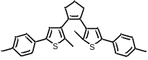  DAE1-open | 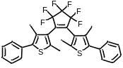  DAE2-open | 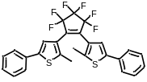  DAE3-open | 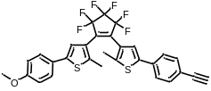  DAE4-open
T₁ (eV) | 2.5 eV | 2.8 eV | 2.6 eV | 2.5 eV

