Supplementary Information
Biosynthesis-Integrated Editing of Bacterial Cellulose Enables Sequence-Programmable Biointerfaces
Guoliang Tang^{1,2},|| Qi He³,|| Shidong Zou¹, Hao Wang¹, Guobin Huang², Wenqi Yin¹, Zhijun Shi¹, Zhishui Chen²,* Lin Yin³,* Guosong Chen³, Guang Yang¹*
¹Department of Biomedical Engineering, College of Life Science and Technology, Huazhong University of Science and Technology, Wuhan 430074, China
²Institute of Organ Transplantation, Tongji Hospital, Tongji Medical College, Huazhong University of Science and Technology, Wuhan 430030, China
³State Key Laboratory of Molecular Engineering of Polymers and Department of Macromolecular Science, Fudan University, Shanghai 200433, China
E-mail: zschen@tjh.tjmu.edu.cn
E-mail: lin_yin@fudan.edu.cn
E-mail: gyang-hust@hust.edu.cn

Experimental Section
Materials and Reagents
Yeast extract was purchased from Oxoid. Phi29 DNA polymerase (D7053), T4 DNA ligase (D7006), dNTP (D7573), DNase I (D7073), Gel-Green (D0143), and Calcein/PI (Live/Dead Viability) Assay Kit (C2015L) were purchased from Beyotime Biotechnology. EPCAM/CD326 antibody (CL555-21050) was purchased from Proteintech. CM-DiI (40792ES50), CM-DiO (40725ES10), and FITC Phalloidin (40735ES75), and Cell Counting Kit (CCK-8) were purchased from Yeasen Biotechnology. HGF protein (HY-P7121) was purchased from MedChemExpress. Geltrex (A1413202) was purchased from Thermo Fisher Scientific. All DNA oligonucleotides used in this study were synthesized by Auker Biotech. All the other chemicals were of analytical grade and were used without further purification.
Microorganism and Culture
The bacterial cellulose (BC)-producing strain, Komagataeibacter sucrofermentans (K. sucrofermentans, DSM 15973), was obtained from Leibniz Institute DSMZ-German Collection of Microorganisms and Cell Cultures GmbH. The medium contained 100 g L⁻¹ glucose, 10 g L⁻¹ yeast extract, and 20 g L⁻¹ CaCO₃; the initial pH was adjusted to 6.8.
Synthesis of DBCO-Modified Primer-Template Complex
DBCO-circular DNA complexes were prepared using a previously reported splint-assisted ligation procedure with modifications¹. Briefly, a 5′-phosphorylated linear single-stranded DNA (ssDNA) template and a 5′-DBCO-modified primer (Table S1) were mixed at a 1:1 molar ratio (10 μM). The mixture was heated to 95 °C for 5 min, cooled to room temperature, and incubated for 1 h to allow the primer to hybridize with complementary sequences at both termini of the linear template, thereby bringing its 5′-phosphate and 3′-hydroxyl termini into proximity. T4 DNA ligase (2 U) was then added in 1× ligation buffer containing 40 mM Tris-HCl (pH 7.8), 10 mM MgCl₂, 10 mM dithiothreitol (DTT), and 1 mM ATP. The ligation reaction was carried out at 16 °C for 8 h, followed by enzyme inactivation at 65 °C for 10 min. The resulting circularized DBCO-modified primer-template complex was used for subsequent surface conjugation.
Preparation of N₃-BC and Apt-N₃-BC
Komagataeibacter sucrofermentans was cultured in either normal medium or medium supplemented with the C2, C3, or C6-azido-glucose analogue (N₃-Glc) at 30 °C for 5 d. The resulting native BC or N₃-BC pellicles were collected and boiled in 0.1 M NaOH for 30 min to remove residual bacterial cells and proteins. The samples were then thoroughly washed with deionized water until the wash solution reached pH 7.0. The purified N₃-BC samples were immersed in a solution of the DBCO-modified primer-template complex (50 nM) and a solution volume of 50 μL cm⁻². The SPAAC reaction was allowed to proceed at room temperature for 10 min, resulting in the covalent immobilization of the DBCO-modified primer-template complex on N₃-BC. Bovine serum albumin (0.2 mg mL⁻¹), dNTPs (1 mM), NaCl (80 mM), 1× phi29 DNA polymerase buffer, and phi29 DNA polymerase (0.2 U μL⁻¹) were subsequently added to initiate rolling circle amplification (RCA). The samples were incubated in a thermoshaker at 37 °C and 400 rpm for 8 h. The reaction was terminated by heating at 65 °C for 10 min and washing to remove unbound DNA and other reagents, yielding Apt-N₃-BC.
Structural characterization
The chemical structures of the freeze-dried samples were characterized by attenuated total reflectance Fourier-transform infrared spectroscopy (ATR-FTIR; VERTEX 70, Bruker) over the wavenumber range of 4000-400 cm⁻¹ at a spectral resolution of 5 cm⁻¹. Raman spectra were acquired using a confocal Raman imaging microscope (DXR3xi, Thermo Fisher Scientific) equipped with a 532 nm excitation laser and a 40× objective. Spectra were collected at a laser power of 15 mW with an integration time of 0.1 s and 50 accumulations. Raman mapping was performed with a spatial step size of 5 μm, and the characteristic azide band at approximately 2140 cm⁻¹ was used to assess the spatial distribution of azide functionalities. Surface elemental composition and N 1s spectra were analyzed by X-ray photoelectron spectroscopy (XPS; AXIS SUPRA+, Kratos Analytical). The crystalline structures of the samples were characterized by powder X-ray diffraction (XRD; Empyrean, Malvern Panalytical) using Cu Kα radiation (λ = 1.5406 Å) at an operating voltage of 40 kV and a current of 40 mA. Diffraction patterns were collected over a 2θ range of 5-40° with a step size of 0.02°. Solid-state ¹³C nuclear magnetic resonance (ssNMR) spectra were acquired using an AVANCE NEO 400 WB spectrometer (Bruker) operating at a ¹³C resonance frequency of approximately 100.6 MHz. The surface and cross-sectional morphologies of the freeze-dried samples were examined by field-emission scanning electron microscopy (FE-SEM; SU8010, Hitachi) at an accelerating voltage of 10.0 kV. For tensile testing, the samples were cut into dumbbell-shaped specimens with a gauge section measuring 2 mm × 12 mm. The specimens were mounted between the grips of a universal testing machine (UTM6503, SUNS Industrial Testing System) and subjected to uniaxial tension at a constant crosshead speed of 5 mm min⁻¹. Tensile stress and strain were calculated from the recorded force-displacement curves using the initial cross-sectional area and gauge length, respectively.
Fluorescence Labeling and Confocal Imaging of N₃-BC and Apt-N₃-BC
The fluorescence labeling of N₃-BC and Apt-N₃-BC was performed to visualize the incorporated azide groups and immobilized DNA networks, respectively. Briefly, N₃-BC samples were incubated with DBCO-Cy3 (20 μM) at room temperature for 30 min to fluorescently label the accessible azide groups through strain-promoted azide-alkyne cycloaddition (SPAAC). The samples were subsequently washed thoroughly with Dulbecco's phosphate-buffered saline (DPBS) to remove unreacted fluorescent probes. For visualization of the immobilized DNA networks, Apt-N₃-BC samples were incubated with 1× Gel-Green nucleic acid stain for 30 min at room temperature, followed by thorough washing with DPBS to remove unbound dye. The stained samples were transferred to glass-bottom confocal dishes and imaged by confocal laser scanning microscopy (CLSM) using excitation wavelengths of 561 and 488 nm for DBCO-Cy3 and Gel-Green, respectively.
Time-Resolved Raman Analysis of SPAAC Conjugation
The kinetics of SPAAC between N₃-BC and the DBCO-circular DNA complex were investigated by time-resolved Raman spectroscopy. Briefly, N₃-BC samples were exposed to the DBCO-circular DNA complex (50 nM; 50 µL cm⁻²) at room temperature. Raman spectra were acquired at predetermined reaction times over 0-10 min using a Raman imaging microscope. The characteristic azide-stretching band at approximately 2140 cm⁻¹ was monitored, and its integrated intensity was determined after baseline correction and normalized to the initial value to evaluate the time-dependent consumption of azide functionalities.
Cell and Culture
Murine mammary carcinoma 4T1 cells and human umbilical vein endothelial cells (HUVECs) were obtained from the Institute of Biochemistry and Cell Biology, Chinese Academy of Sciences (Shanghai, China). 4T1 cells and HUVECs were cultured in RPMI 1640 medium or Dulbecco’s modified Eagle’s medium (DMEM), respectively, both supplemented with 10% (v/v) fetal bovine serum (FBS) and gentamicin (10 μg mL⁻¹). The culture media, FBS, and gentamicin were purchased from Thermo Fisher Scientific. Cells were maintained in T25 culture flasks at 37 °C in a humidified atmosphere containing 5% CO₂.
Biocompatibility Assays for N₃-BC Variants
The cytocompatibility of BC and N₃-BC variants was evaluated using a CCK-8 assay. Briefly, sterilized BC, 2-N₃-BC, 3-N₃-BC, and 6-N₃-BC samples were immersed in complete culture medium at a material-to-medium ratio of 6 cm² mL⁻¹ and incubated at 37 °C for 24 h to obtain the corresponding material extracts. HUVECs were seeded into 96-well plates at a density of 1 × 10³ cells per well and cultured for 24 h to allow cell attachment. The culture medium was subsequently replaced with the respective material extracts, while cells maintained in fresh culture medium served as controls. After 1, 3, and 5 days of culture, cellular metabolic activity was evaluated using CCK-8 reagent according to the manufacturer's instructions. Following incubation at 37 °C for 1 h, the absorbance at 450 nm was measured using a microplate reader. After background correction, relative cell viability was calculated by normalizing the absorbance of each treatment group to that of the corresponding control group.
The cytocompatibility of BC and N₃-BC variants was further evaluated by Calcein/PI (Live/Dead Viability) Assay Kit. Briefly, HUVECs were seeded in culture plates at a density of 1 × 10³ per well and incubated for 24 h to allow cell attachment. The culture medium was subsequently replaced with extracts of BC, 2-N₃-BC, 3-N₃-BC, or 6-N₃-BC prepared as described above. Cells cultured in fresh medium served as controls. After 1 day of incubation, the cells were washed with DPBS and stained with Calcein-AM and PI according to the manufacturer's instructions. Fluorescence images were acquired by CLSM, with viable and membrane-compromised cells identified by green and red fluorescence, respectively.
The hemocompatibility of BC and N₃-BC variants was evaluated by an extract-based hemolysis assay using rabbit erythrocytes. Briefly, sterilized BC, 2-N₃-BC, 3-N₃-BC, and 6-N₃-BC samples were separately immersed in phosphate-buffered saline (PBS, pH 7.4) at a surface-area-to-volume ratio of 6 cm² mL⁻¹ and incubated at 37 °C for 24 h to obtain the corresponding material extracts. Fresh anticoagulated rabbit blood was centrifuged at 1500 × g for 10 min to collect erythrocytes, which were subsequently washed three times with PBS and resuspended in PBS to obtain a 2% (v/v) erythrocyte suspension. The erythrocyte suspension (500 µL) was mixed with an equal volume of each material extract and incubated at 37 °C for 1 h. Erythrocytes incubated with PBS or 2% (v/v) Triton X-100 solution served as the negative and positive controls, respectively. Following incubation, the suspensions were centrifuged at 1000 × g for 10 min, and the absorbance of the collected supernatants was measured at 540 nm using a microplate reader to quantify released hemoglobin. The hemolysis rate was calculated as follows:
Hemolysis (%) = [(A_{sample} − A_{negative})/(A_{positive} − A_{negative})] × 100%
where A_{sample}, A_{negative}, and A_{positive} represent the absorbance values of the sample, negative control, and positive control, respectively.
Immunofluorescence Colocalization of EpCAM Aptamer and EpCAM Protein
4T1 cells were seeded in glass-bottom confocal dishes and cultured for 24 h to allow cell attachment. The cells were subsequently incubated with FAM-labeled EpCAM aptamer (200 nM) in aptamer-binding buffer at 4 °C for 40 min. After washing with DPBS to remove unbound aptamers, the cells were fixed with 4% (w/v) paraformaldehyde for 15 min at room temperature. The fixed cells were blocked with 10% (w/v) donkey serum for 30 min and incubated with CoraLite 555-conjugated anti-EpCAM antibody (1:200 dilution) for overnight at 4 °C. Following washing with DPBS, cell nuclei were counterstained with Hoechst 33342. Fluorescence images were acquired by structured illumination microscopy (SIM) to visualize the FAM-labeled aptamer (green), EpCAM immunostaining (red), and cell nuclei (blue). The spatial distribution and colocalization of the aptamer and EpCAM fluorescence signals were assessed from the merged images.
Flow Cytometric Analysis of Aptamer Binding and Determination of the Apparent Dissociation Constant
The binding specificity and affinity of the EpCAM aptamer were evaluated by flow cytometry following a previously reported procedure with modifications². Briefly, 4T1 cells and HUVECs were collected, washed with binding buffer, and resuspended at a density of 1 × 10⁵ cells per sample. The cells were incubated with FAM-labeled EpCAM aptamer or its FAM-labeled reverse-sequence control at a concentration of 100 nM in binding buffer for 30 min at 4 °C. Untreated cells served as fluorescence background controls. After incubation, the cells were washed three times with binding buffer to remove unbound DNA and resuspended for flow cytometric analysis. Fluorescence signals were collected using the FITC channel, and the mean fluorescence intensity (MFI) was determined.
To determine the apparent dissociation constant (K_{d}) of the EpCAM aptamer-cell interaction, 4T1 cells were incubated with increasing concentrations of FAM-labeled EpCAM aptamer (10-480 nM) under the same conditions. Following removal of unbound aptamers, cell-associated fluorescence was quantified by flow cytometry. The specific binding fluorescence intensity was obtained by subtracting the fluorescence background from the measured MFI. The apparent K_{d} was determined by nonlinear regression of the specific fluorescence intensity against the aptamer concentration using the one-site saturation binding equation,
$$Y=\frac{B_{max}X}{K_{d}+X}$$
where Y represents the specific fluorescence intensity, B_{max} is the maximum binding fluorescence intensity, and X is the aptamer concentration. Curve fitting was performed using SigmaPlot software.
Selective Cell Capture with Apt-N₃-BC
The selective cell capture performance of Apt-N₃-BC was first evaluated using a mixed-cell system consisting of EpCAM-positive 4T1 cells and EpCAM-negative HUVECs. Briefly, 4T1 cells and HUVECs were separately labeled with CM-DiI (red) and CM-DiO (green), respectively, according to the manufacturer's instructions. The labeled cells were mixed at a 1:1 ratio and incubated with native BC, Apt-N₃-BC, or Rev-N₃-BC films (15 mm in diameter) in glass-bottom confocal dishes at a total density of 1 × 10⁶ cells per dish. After incubation at 37 °C for 30 min, the cell suspensions were removed, and the samples were washed with Dulbecco's phosphate-buffered saline (DPBS) under gentle shaking at 90 rpm for 10 min to remove unbound cells. The retained cells were visualized by CLSM, and the numbers of captured 4T1 cells and HUVECs were quantified using ImageJ software. The proportion of 4T1 cells was calculated as the number of captured 4T1 cells divided by the total number of retained cells.
Cell capture assays were further performed separately using 4T1 cells or HUVECs to evaluate the capture capacity and specificity of the materials. Each cell type was independently labeled with CM-DiI and incubated with the indicated BC-based samples at a density of 1 × 10⁶ cells per dish under the same incubation and washing conditions. For visualization of the immobilized DNA network, the samples were stained with 1× Gel-Green for 30 min and thoroughly washed with DPBS before cell incubation. Fluorescence images were acquired by CLSM using excitation wavelengths of 488 and 561 nm for Gel-Green and CM-DiI, respectively. The numbers of retained cells were quantified from the fluorescence images using ImageJ software and normalized to the analyzed surface area.

Release of 4T1s from Apt-N₃-BC
To release the captured 4T1 cells, Apt-N₃-BC samples were treated with DNase I (0.1 U) to enzymatically degrade the immobilized DNA network. The samples were incubated for 30 min, after which the released cells were collected and cultured in glass-bottom confocal dishes for an additional 24 h. Cell viability after release was evaluated using a Calcein/PI (Live/Dead Viability) Assay Kit according to the manufacturer’s instructions. Live and dead cells were visualized by fluorescence microscopy based on Calcein-AM (green) and propidium iodide (red) fluorescence, respectively.
HUVEC proliferation assay
HUVECs were seeded into 96-well plates at a density of 1 × 10³ cells per well and cultured in standard growth medium for 12 h to allow cell attachment. The medium was then replaced with DMEM supplemented with 2% (v/v) FBS and the corresponding material extract. Cells were maintained at 37 °C in a humidified atmosphere containing 5% CO₂, and the culture medium was replaced every 2 d. After 6 d of culture, cellular metabolic activity was evaluated using a Cell Counting Kit-8 according to the manufacturer’s instructions. The absorbance at 450 nm was measured using a microplate reader. After background correction, the relative proliferative activity of each treatment group was calculated by normalizing its absorbance value to the mean value of the control group.
HUVEC growth on Apt-N₃-BC
Sterilized BC-based samples were placed individually in glass-bottom confocal dishes. HUVECs were seeded onto each sample at a density of 1 × 10⁵ cells per sample and cultured under standard conditions. After 1 and 5 d of culture, cell viability was evaluated using a Calcein/PI (Live/Dead Viability) Assay Kit according to the manufacturer’s instructions. Fluorescence images were acquired by CLSM, and the percentages of viable and dead cells were determined from the Calcein-AM-positive and PI-positive cell populations, respectively. On Day 5, cell morphology and spreading were further examined by fluorescence staining. The cells were fixed, permeabilized, and stained with FITC-conjugated phalloidin to visualize filamentous actin, while cell nuclei were counterstained with DAPI. The stained samples were subsequently imaged by CLSM.
HUVEC migration assay
HUVEC migration was evaluated using two-well culture inserts. The inserts were placed in 12-well plates, and HUVECs were seeded at a density of 1 × 10⁵ cells per well in standard growth medium. After 24 h, the inserts were carefully removed to generate a defined cell-free gap, and the cells were washed twice with DPBS to remove non-adherent cells. The culture medium was then replaced with DMEM containing 0.5% (v/v) FBS and supplemented with HGF (1 nM) or the corresponding material extract. Phase-contrast images of the same regions were acquired at 0 and 24 h using an inverted microscope. The wound area was quantified using ImageJ software, and the relative wound-closure rate was calculated as follows,
Relative wound closure (%) = [(A₀ – A₂₄)/A₀] × 100
where A₀ and A₂₄ represent the cell-free areas measured at 0 and 24 h, respectively.
HUVEC tube formation assay
Geltrex was thawed on ice and added to pre-cooled six-well plates at a volume of 500 μL per well. The coated plates were incubated at 37 °C for 30 min to allow complete gelation. Before the assay, HUVECs were serum-starved in serum-free DMEM for 4 h. The cells were then seeded onto the polymerized Geltrex at a density of 2 × 10⁵ cells per well and cultured in the presence of HGF (1 nM) or the corresponding material extract. After 12 h, the formation of capillary-like networks was examined using an inverted microscope. The total tube length and number of branch points were quantified from the acquired images using ImageJ software.

Table S1. Oligonucleotide sequences used in this work (all sequences 5′→3′; P- = 5′ phosphate, DBCO- = 5′ DBCO).
Name | Sequences | Description/comment
Apt-EpCAM | CACTACAGAGGTTGCGTCTGTCCCACGTTGTCATGGGGGGTTGGCCTG | DNA aptamer used for binding EpCAM³
Template-EpCAM | P-AAACCTTCCTCCGCAATACTCCCCCAGGAAACAGGCCAACCCCCCATGACAACGTGGGACAGACGCAACCTCTGTAGTGACATGACAGATCAAT | RCA template for binding EpCAM, the 5′ end was modified with a phosphate group to enable T4 DNA ligase-mediated circularization
DBCO-Primer- EpCAM | DBCO- TGCGGAGGAAGGTTTATTGATCTGTCATGT | RCA primer for binding EpCAM, the 5′ end was modified with a DBCO group to enable SPAAC conjugation to N₃-BC
Rev-Template-EpCAM | P-ATTGATCTGTCATGTCACTACAGAGGTTGCGTCTGTCCCACGTTGTCATGGGGGGTTGGCCTGTTTCCTGGGGGAGTATTGCGGAGGAAGGTTT | Reverse sequence (complement) of RCA template for binding EpCAM, the 5′ end was modified with a phosphate group to enable T4 DNA ligase-mediated circularization
DBCO-Rev- Primer- EpCAM | DBCO-ACATGACAGATCAATAAACCTTCCTCCGCA | RCA primer of reverse sequence (complement) of RCA template for binding EpCAM, the 5′ end was modified with a DBCO group to enable SPAAC conjugation to N₃-BC
Apt-Met | ATCAGGCTGGATGGTAGCTCGGTCGGGGTGGGTGGGTTGGCAAGTCTGATCGTGTCACGGATGGTAGCTCGGTCGGGGTGGGTGGGTTGGCAGTGACACG | DNA aptamer used for binding Met⁴
Rev-Met | CGTGTCACTGCCAACCCACCCACCCCGACCGAGCTACCATCCGTGACACGATCAGACTTGCCAACCCACCCACCCCGACCGAGCTACCATCCAGCCTGAT | Reverse sequence (complement) of Apt-Met
Template-Met | P-CGTGTCACTGCCAACCCACCCACCCCGACCGAGCTACCATCCGTGACACGATCAGACTTGCCAACCCACCCACCCCGACCGAGCTACCATCCAGCCTGAT | RCA template for binding Met, the 5′ end was modified with a phosphate group to enable T4 DNA ligase-mediated circularization
DBCO-Primer-Met | DBCO-GGTTGGCAGTGACACGATCAGGCTGGATGGTA | RCA primer for binding Met, the 5′ end was modified with a DBCO group to enable SPAAC conjugation to N₃-BC

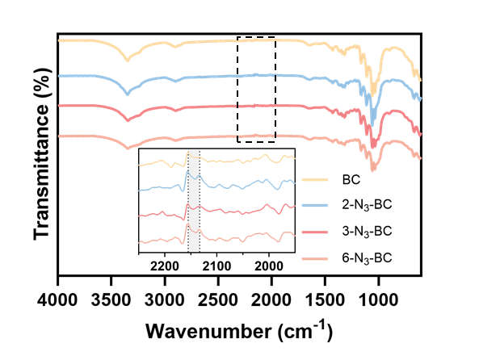
Supplementary Figure 1. ATR-FTIR spectra of native BC and N₃-BC variants. Inset: enlarged spectral region containing the characteristic azide-stretching absorption.
Supplementary Figure 2. ¹³C-ssNMR spectrum of native BC.
Supplementary Figure 3. ¹³C-ssNMR spectrum of 2-N₃-BC.

Supplementary Figure 4. ¹³C-ssNMR spectrum of 3-N₃-BC.

Supplementary Figure 5. ¹³C-ssNMR spectrum of 6-N₃-BC.

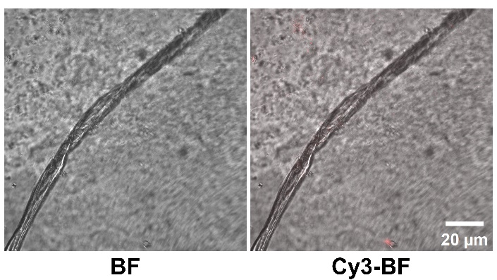
Supplementary Figure 6. Representative bright-field (BF) and fluorescence micrographs of native BC after treating with DBCO–Cy3 (red) and washing. Scale bar: 20 μm.

Supplementary Figure 7. Relative metabolic activity of HUVECs cultured for 1, 3, and 5 days in medium containing extracts of native BC and N₃-BC variants, as determined by the CCK-8 assay. Values are normalized to cells cultured in control medium at each time point. ns, not significant (one-way ANOVA).

Supplementary Figure 8. Representative Calcein-AM (green) and PI (red) fluorescence images of HUVECs after 24 h of exposure to extracts of native BC and the N₃-BC variants. Cells cultured in fresh medium served as controls. Scale bar: 200 μm.

Supplementary Figure 9. Hemolysis percentages for rabbit erythrocytes exposed to PBS extracts of native BC and the indicated N₃-BC variants. PBS and Triton X-100 served as the negative and positive controls, respectively. Inset: representative photographs of erythrocyte suspensions following the hemolysis assay.

Supplementary Figure 10. DNA concentrations measured at the indicated time points during RCA (0-8 h) using a NanoPhotometer (Implen).

Supplementary Figure 11. Representative flow cytometry histograms showing cell-associated FAM fluorescence in 4T1 cells (left) and HUVECs (right) incubated with FAM-labeled EpCAM aptamer. Buffer-only controls are included for both cell types, and a FAM-labeled reverse-sequence aptamer control is shown for 4T1 cells.

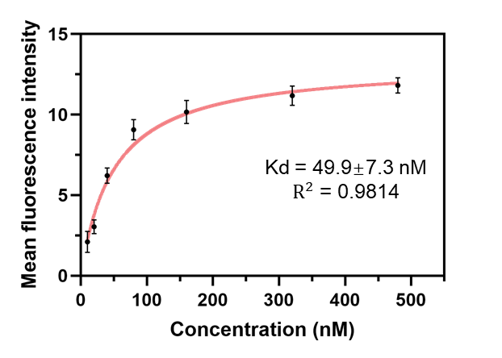
Supplementary Figure 12. Concentration-dependent binding of FAM-labeled EpCAM aptamer to 4T1 cells determined by flow cytometry. The curve represents a one-site saturation fit to the fluorescence data, yielding an apparent dissociation constant of 49.9 ± 7.3 nM (R² = 0.9814).

Supplementary Figure 13. Density of 4T1 cells retained on Apt-N₃-BC as a function of cell incubation time (5–30 min).

Supplementary Figure 14. Density of 4T1 cells captured on N₃-BC functionalized with EpCAM aptamer-containing DNA networks produced using different RCA durations (1–8 h).

Supplementary Figure 15. Time-dependent release of captured 4T1 cells from Apt-N₃-BC following DNase I treatment (0-60 min).

Supplementary Figure 16. Representative Calcein-AM (green)/PI (red) live/dead fluorescence images of HUVECs cultured on native BC, Apt-N₃-BC, RCA-N₃-BC, and Rev-N₃-BC for 1 and 5 days. Scale bar: 200 μm.

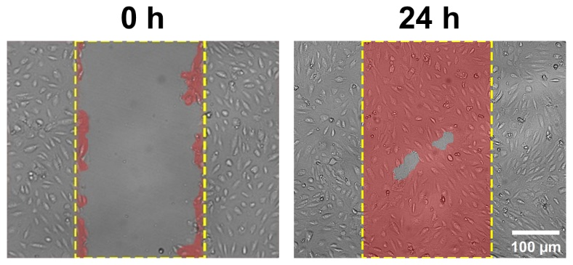
Supplementary Figure 17. Scratch-wound migration assay of HUVECs supplemented with HGF (1 nM), with representative images acquired at 0 and 24 h. Scale bar, 100 μm.

Supplementary Figure 18. Quantification of (left) relative branch-point number and (right) relative total tube length in the HUVEC tube-formation assay after 12 h on basement membrane matrix, under HGF (1 nM) and BC-derived treatment conditions. Values are expressed relative to the untreated control. Statistical significance was assessed by one-way ANOVA; ***p < 0.001, ****p < 0.0001; ns, not significant.

Reference
(1) Yao, C.; Zhang, R.; Tang, J.; Yang, D. Rolling circle amplification (RCA)-based DNA hydrogel. Nature Protocols 2021, 16 (12), 5460–5483.
(2) Sefah, K.; Shangguan, D.; Xiong, X.; O'Donoghue, M. B.; Tan, W. Development of DNA aptamers using cell-SELEX. Nature Protocols 2010, 5 (6), 1169–1185.
(3) Song, Y.; Zhu, Z.; An, Y.; Zhang, W.; Zhang, H.; Liu, D.; Yu, C.; Duan, W.; Yang, C. J. Selection of DNA aptamers against epithelial cell adhesion molecule for cancer cell imaging and circulating tumor cell capture. Anal. Chem. 2013, 85 (8), 4141–4149.
(4) Ueki, R.; Ueki, A.; Kanda, N.; Sando, S. Oligonucleotide-based mimetics of hepatocyte growth factor. Angew. Chem. Int. Ed. 2016, 55 (2), 579–582.

