Supporting Information

4081 Times Increase in Atmospheric Humidity Capture Capacity via Confinement of 2D Nanosheets in 3D Matrix

Yang-Hui Luo,* Lan Zhang, Shu-Hua Ma, Hui Dong, Feng-Lian Zeng, Ya-Chen Zou, Ke-Xin Xu,

School of Chemistry and Chemical Engineering, Southeast University, Nanjing, 211189, P.R. China. E-mail: luoyh2016@seu.edu.cn

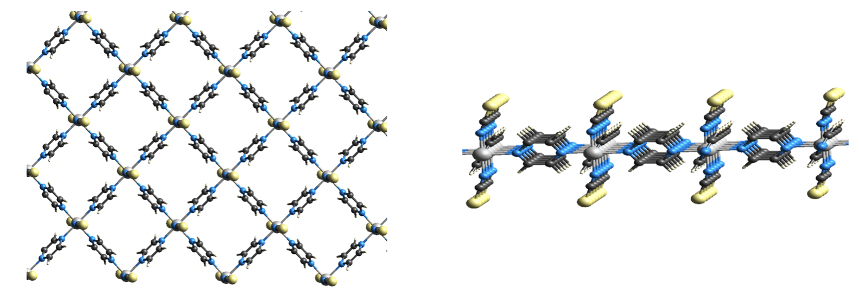
Figure S1. Single layer structure of 2D-Co (left) and side view of a single layer (right).

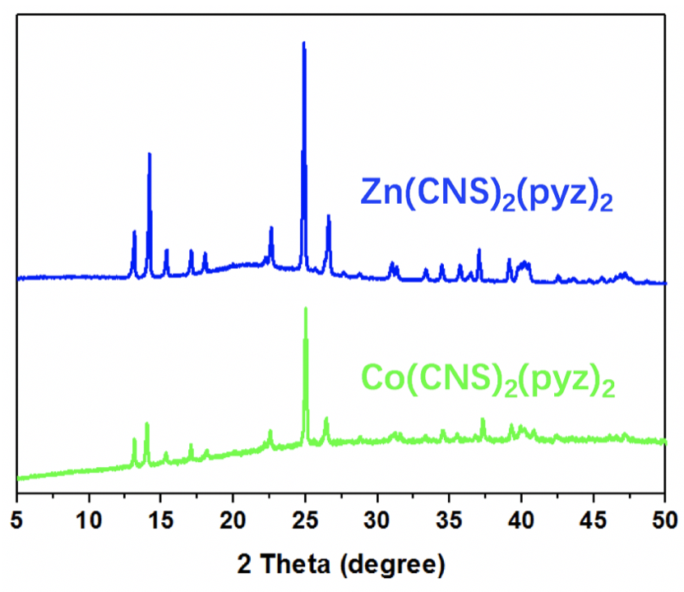
Figure S2. PXRD patterns of the bulk precursors of 2D-Zn and 2D-Co, which have suggested the identical crystal lattice.

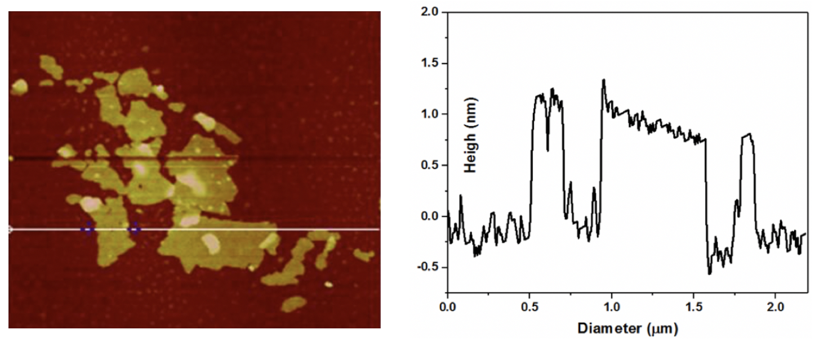
Figure S3. AFM topological image (left) and height profile of 2D-Co along the white line (right).

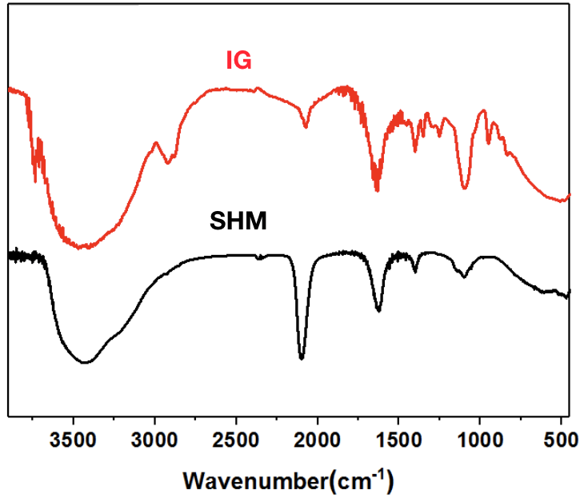
Figure S4. Comparison between the IR spectra of SHM and IG, suggesting the well dispersion of 2D SHM in 3D matrix.
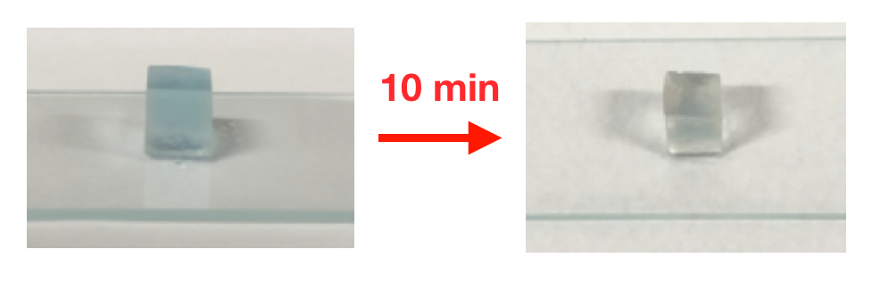
Figure S5. Variation of IG with weight ratio of SHM:PVDF = 3% upon exposure to ambient air for 10 min.

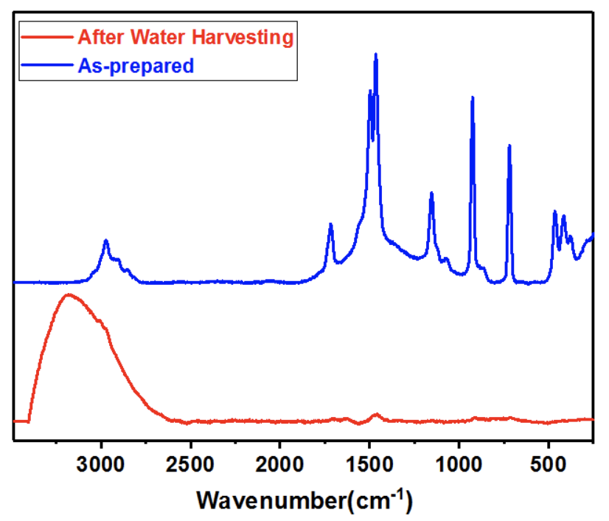
Figure S6. Comparison between the Raman spectra of IG before and after water harvesting, suggesting that the water molecules were adsorbed on the 2D surfaces of SHM.

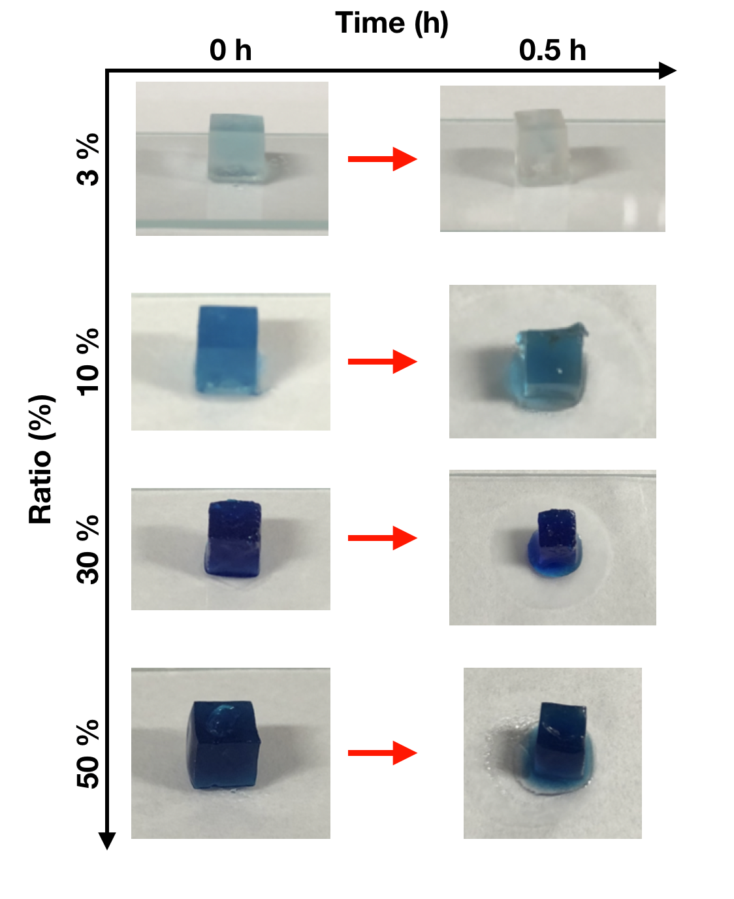
Figure S7. Variation of IG with weight ratio of SHM:PVDF = 3, 10, 30, and 50 % upon exposure to ambient air for 0.5h.

