Supplementary Materials

Supplementary Methods

Supplementary Figures:
Supplementary Fig. 1 OPLS-DA model performance for IGR subjects and matched healthy controls.
Supplementary Fig. 2 OPLS-DA model performance for IGR subgroups and matched healthy controls.
Supplementary Fig. 3 OPLS-DA model performance for IGR remission, IGR progression, and healthy controls at baseline and follow-up.
Supplementary Fig. 4 Trends of key biomarkers across different disease stages.
Supplementary Fig. 5 RSD distribution of targeted biomarkers in MRM method.
Supplementary Fig. 6 Targeted profiling of related tetradecanedioic acid metabolites across different T2DM stages.
Supplementary Fig. 7 Data quality assessment of untargeted metabolomics.

Supplementary Tables 1-10 given in another Excel file
Supplementary Methods
Patients in the cohort
Participants were drawn from the Shanghai Nicheng longitudinal cohort. The baseline survey was conducted between April 2013 and August 2014 in a community-based population of 23,375 residents. Among these individuals, 21,408 provided informed consent and 17,212 completed the baseline investigation. Participants were excluded if they had missing or substandard measurements for body mass index (BMI), waist circumference, body fat percentage, fasting plasma glucose, 2-h post-load glucose or history of diabetes. After these exclusions, 12,137 participants were retained for longitudinal outcome screening. A nested longitudinal metabolomics sub-cohort was established from the eligible Nicheng cohort participants. This sub-cohort included 1,103 individuals, comprising 128 healthy controls (HC) and 975 participants with impaired glucose regulation (IGR) at baseline. Participants were followed for 2.5 years. During follow-up, baseline IGR participants were classified according to their subsequent glycaemic status into three trajectory groups: reversion to normal glucose regulation (NGR; n = 202), persistent IGR (n = 554) and progression to type 2 diabetes mellitus (T2DM; n = 219).
For trajectory-based metabolomics analyses, samples were labelled according to sampling year and follow-up outcome. Baseline IGR samples were annotated as IGR-2013(NGR), IGR-2013(IGR) and IGR-2013(DM), corresponding to participants who subsequently reverted to NGR, remained in IGR or progressed to T2DM, respectively. Follow-up samples from the same participants were annotated as NGR-2016, IGR-2016 and DM-2016. Healthy control samples were annotated as HC-2013 at baseline and HC-2016 at follow-up. Follow-up samples were available for 121 of the 128 baseline healthy controls.
This study was designed to support three complementary metabolomics analyses. First, baseline and follow-up HC and IGR samples were used as discovery and validation sets to identify reproducible metabolic alterations associated with IGR. Second, baseline IGR samples were compared according to their subsequent glycaemic outcomes to evaluate whether future remission, persistence or progression was associated with distinct pre-existing metabolic profiles. Third, paired baseline and follow-up samples were analysed to identify longitudinal metabolic changes associated with IGR remission or progression. Healthy controls with paired samples were used as a time-matched reference to distinguish outcome-associated metabolic alterations from follow-up-related metabolic variation. The overall cohort stratification and analytical workflow are summarized in Fig. 1.

Data quality assessment
A total of 627 metabolites were identified in this study, including 350 detected in the positive ion mode and 277 in the negative ion mode. After isotope-labeled internal standard correction, 91.39% of the metabolites exhibited relative standard deviations (RSDs) below 30% in the QC samples (Supplementary Fig. 7a-b), indicating good repeatability and analytical stability of the present platform. Following structural deduplication of the metabolite annotations, 542 unique compounds were retained for subsequent analyses. These metabolites covered a broad range of chemical classes, including 55 amino acids and their derivatives, 27 bile acids and related compounds, 4 carbohydrates, 27 carnitines and related metabolites, 103 fatty acids and derivatives, 20 hormones and steroid-related compounds, 18 lipid-related metabolites, 7 lysophosphatidic acids, 30 lysophosphatidylcholines, 16 lysophosphatidylethanolamines, 8 nucleosides and nucleic acid-related compounds, 44 organic acids, 51 phosphatidylcholines, 9 phosphatidylethanolamines, 25 sphingolipids, and 98 compounds from other categories (Supplementary Fig. 7c). Overall, the metabolite panel provided broad coverage of key biological pathways, including amino acid metabolism, lipid metabolism, bile acid metabolism, and energy metabolism, demonstrating strong representativeness of the metabolome. In addition, all QC samples were distributed within the ±2 SD range, further confirming the stability and reproducibility of the analytical workflow throughout the experiment (Supplementary Fig. 7d). Collectively, these results indicate that the untargeted metabolomics data generated in this study were of high quality, with low variability and high stability, and were therefore suitable for subsequent statistical analyses.

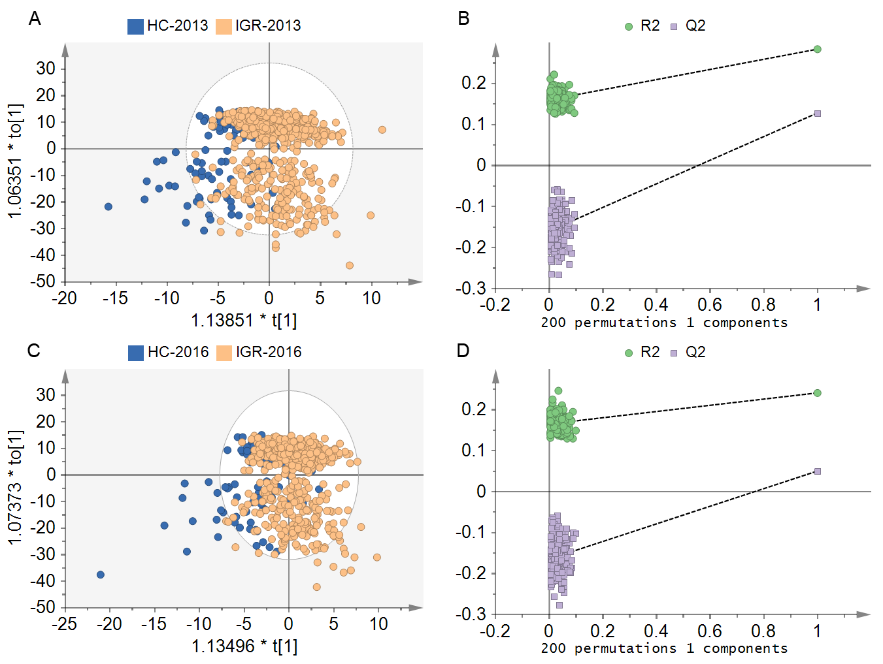
Supplementary Fig. 1 OPLS-DA model performance for IGR subjects and matched healthy controls. a-b, OPLS-DA score plot and 200-time permutation test based on UV scaling comparing IGR subjects and matched healthy controls in the discovery set. The model showed R²Y = 0.284 and Q² = 0.128, with permutation validation results of R² = 0.160 and Q² = −0.159; c-d, OPLS-DA score plot and permutation test based on UV scaling for IGR subjects and matched healthy controls in the validation set. The model yielded R²Y = 0.241 and Q² = 0.051, with permutation validation results of R² = 0.166 and Q² = −0.164. Cohort information: Healthy controls enrolled in 2013 (HC-2013, n = 121) and individuals with IGR at baseline in 2013 who remained IGR at follow-up (IGR-2013, n = 554) constituted the discovery set. Healthy controls enrolled in 2016 (HC-2016, n = 121) and individuals with IGR in 2016 (IGR-2016, n = 554) constituted the validation set.
Supplementary Fig. 2 OPLS-DA model performance for IGR subgroups and matched healthy controls. a-c, OPLS-DA score plots and 200-time permutation tests based on UV scaling comparing IGR subgroups with matched healthy controls. The models yielded R²Y values of 0.369, 0.284, and 0.437, and Q² values of 0.126, 0.125, and 0.236, respectively. D-f, Corresponding 200-time permutation test results, demonstrating model reliability and the absence of overfitting, with validation R² values of 0.278, 0.160, and 0.254 and validation Q² values of -0.249, -0.158, and -0.238, respectively. Based on follow-up outcomes, blood samples collected at baseline in 2013 were classified into three groups: individuals who progressed to normal glucose regulation (IGR-2013_{(NGR)}, n = 202), those who remained IGR at follow-up (IGR-2013_{(IGR)}, n = 554), and those who progressed to diabetes mellitus (IGR-2013_{(DM)}, n = 219). Metabolic differences between each IGR subgroup and healthy controls were assessed.
Supplementary Fig. 3 OPLS-DA model performance for IGR remission, IGR progression, and healthy controls at baseline and follow-up. a–c, OPLS-DA score plot and 200-permutation validation based on UV scaling for the comparison between IGR-2013(DM) and DM-2016, IGR-2013(NGR) and NGR-2016, HC-2013 and HC-2016, respectively. The models yielded R²Y values of 0.707, 0.729, and 0.498, and Q² values of 0.560, 0.568, and 0.321, respectively. d–f, Corresponding 200-time permutation test results, demonstrating model reliability and the absence of overfitting, with validation R² intercepts of 0.285, 0.319, and 0.312, and the Q² intercepts of −0.343, −0.368, and −0.261, respectively.
Supplementary Fig. 4 Trends of key biomarkers across different disease stages. Statistical significance was assessed using nonparametric tests: * indicates p < 0.05, ** indicates p < 0.01, *** indicates p < 0.001, and ns denotes no statistical significance
Supplementary Fig. 5 RSD distribution of targeted biomarkers in MRM method in IGR progression (a) and remission (b) models

Supplementary Fig. 6 Targeted profiling of related tetradecanedioic acid metabolites across different T2DM stages. Standardized abundances represent z-scores of log₁₀-transformed metabolite abundances. Statistical significance was assessed using nonparametric tests. *p < 0.05, **p < 0.01, ***p < 0.001; ****p < 0.0001, ns, not significant.

Supplementary Fig. 7 Data quality assessment of untargeted metabolomics. a–b, Distributions of metabolite RSDs in quality control (QC) samples in positive and negative ion modes, respectively, with 91.39% of metabolites showing RSDs below 30% after isotope-labeled internal standard correction and including 545 unique metabolites after deduplication. c, Chemical classification of the 545 unique metabolites retained after structural deduplication. d, QC monitoring plot showing all QC samples within ±2 standard deviations, supporting analytical stability throughout the experiment.

