Supplementary Information

Dynamic Network Context Predicts Mutation-Induced Reshaping of Protein Conformational Free-Energy Landscapes

Byung Ho Lee¹, Domenico Scaramozzino¹, Serena Piticchio¹, Laura Orellana^{1,*}

¹ Department of Oncology-Pathology, Karolinska Institutet, Stockholm 171 77, Sweden.

* Corresponding author. Email: laura.orellana@ki.se

This Supplementary Information file includes:
Supplementary Figs. 1 to 4.
Supplementary Tables 1 to 6.

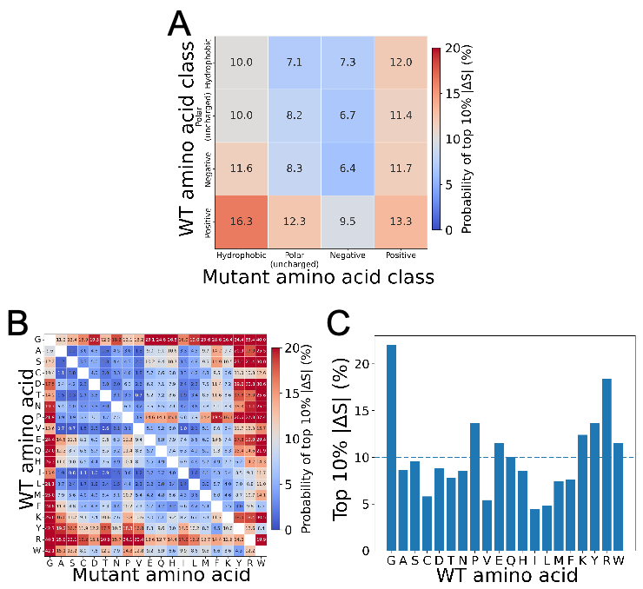

Supplementary Fig. 1. Amino-acid-type-dependent patterns of high-|ΔS| mutations. (A) Probability of belonging to the top 10% |ΔS| group as a function of the physicochemical classes of the WT and mutant amino acids: hydrophobic, polar uncharged, negatively charged, and positively charged. (B) Probability of belonging to the top 10% |ΔS| group across all 20 $×$ 20 amino-acid pairs. For both heatmaps, the color scale is centered at 10%, corresponding to the background expectation. (C) Probability of belonging to the top 10% |ΔS| group by WT amino-acid type. Bars represent the probability that mutations originating from each WT residue belong to the top 10% |ΔS| group. The dashed line marks the 10% background level.

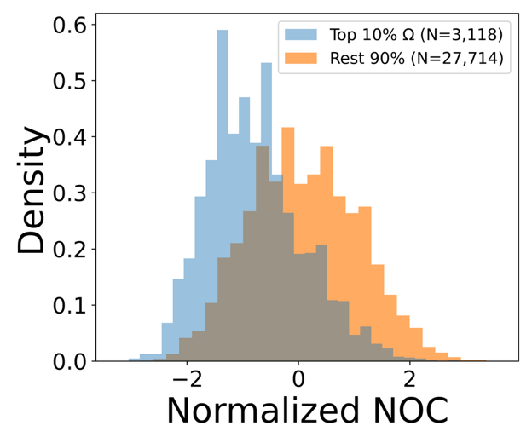

Supplementary Fig. 2. The distribution of residue-level number of contacts (NOC) values for residues ranked within the top 10% of Ω versus the remaining 90%. NOC was defined as the number of neighboring Cα atoms within 8 Å of the target Cα atom and was Z-score-normalized per structure. The legend indicates the total number of residues in each Ω group.

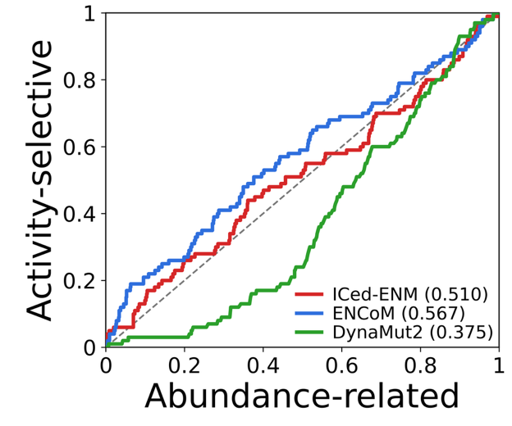

Supplementary Fig. 3. ROC curves for distinguishing PTEN loss phenotypes at the substitution level. Receiver operating characteristic (ROC) curves distinguish activity-selective loss substitutions (positive class; n = 100) from abundance-related loss substitutions (negative class; n = 856). Activity-selective loss denotes reduced phosphatase activity with WT-like abundance, whereas abundance-related loss denotes reduced abundance regardless of activity. The ICed-ENM curve uses |ΔS| obtained from ICed-ENM-based mutation-impact analysis, and the ENCoM curve uses the corresponding ENCoM |ΔS| scores. The DynaMut2 curve uses predicted stability changes (ΔΔG), with more negative values ranked higher to prioritize predicted destabilization. The y-axis indicates the proportion of activity-selective substitutions recovered, whereas the x-axis indicates the proportion of abundance-related substitutions selected as substitutions are progressively included in ranking order. The dashed diagonal line represents random classification. The area under the ROC curve (AUROC) is 0.510 for ICed-ENM, 0.567 for ENCoM, and 0.375 for DynaMut2.

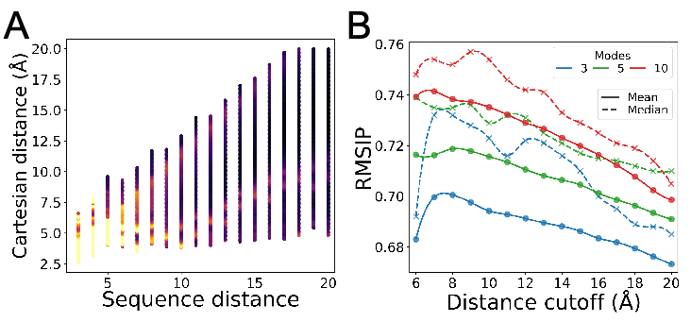

Supplementary Fig. 4. Parameter optimization of ICed-ENM. (A) Optimization of nonlinear spring model parameters from apparent force constant ($K_{app}$) profiles. Reference $K_{app}$ profiles were derived from the local dataset as functions of sequence distance ($d_{seq}$) and Cartesian distance ($d_{cart}$). The color scale represents the magnitude of $K_{app}$, reflecting effective inter-node stiffness inferred from time-ensemble fluctuations. These reference profiles served as training data for calibrating the nonlinear spring function in ICed-ENM. (B) Optimization of cutoff distance ($d_{cutoff}$) based on subspace similarity between ICed-ENM normal modes and MD-derived essential dynamics (ED). For the combined MD dataset (local and MDverse datasets), the overlap between subspaces spanned by the lowest 3, 5, and 10 modes was quantified through the root-mean-square inner product (RMSIP), shown in blue, green, and red, respectively. Mean and median RMSIP values are shown as solid lines with circle markers and dashed lines with cross markers, respectively, as functions of $d_{cutoff}$.

Supplementary Table 1. Residue-level Ω scores and structural contexts of matched hot- and cold-spot pairs selected for mutant MD validation.
Protein | Hot spot | Hot Ω percentile / score* | Cold spot | Cold Ω percentile / score* | SASA (%)  hot / cold† | Structural context  hot / cold‡
RBP | Q235 | 90.4 / 0.202 | Q184 | 4.4 / 0.117 | 33.7 / 44.3 | canonical hinge-region solvent-exposed loop / C-domain comparable solvent-exposed loop
RBP | E255 | 98.5 / 0.285 | E122 | 17.0 / 0.120 | 54.9 / 66.1 | N-domain-side hinge-proximal solvent-exposed loop / C-domain comparable solvent-exposed loop
5′NTase | E182 | 96.4 / 0.244 | K134 | 7.2 / 0.037 | 84.9 / 85.7 | N-domain interdomain-facing solvent-exposed surface site / N-domain comparable solvent-exposed surface site
5′NTase | R396 | 95.8 / 0.214 | R102 | 3.4 / 0.034 | 28.7 / 33.1 | C-domain interdomain-facing α-helical segment / N-domain comparable α-helical segment
SERCA | K47 | 98.9 / 0.290 | K169 | 10.5 / 0.045 | 60.7 / 63.4 | TM–A linker solvent-exposed loop / A-domain comparable solvent-exposed loop
SERCA | N428 | 93.5 / 0.192 | N453 | 45.6 / 0.064 | 22.1 / 16.9 | N-domain A-facing surface segment / N-domain comparable surface segment
* Values are reported as Ω percentile rank / Ω score. Percentile ranks were calculated separately within each protein-specific residue-level Ω distribution.
† SASA values are relative solvent-accessible surface areas (%) calculated from the corresponding WT reference structures.
‡ Structural contexts are reported in hot/cold order. Comparable indicates the matched cold-spot local environment rather than an identical structural position.

Supplementary Table 2. Direct comparisons of PTEN loss-phenotype associations between ICed-ENM and benchmark methods at substitution and position levels.
Level | Comparison | Ratio of ORs (95% CI)* | $P$ for ratio of ORs† | ΔAUROC (95% CI)‡ | $P$ for ΔAUROC§
Substitution | ICed-ENM vs.  ENCoM | 0.825  (0.213–3.201) | 0.781 | -0.056  (-0.176–0.075) | 0.371
Position | ICed-ENM vs.  ENCoM | 9.34  (1.34–65.17) | 0.0484 | 0.214  (0.012–0.412) | 0.0478
Position | ICed-ENM vs.  Rhapsody-2(dyn) | 3.15  (0.46–21.47) | 0.241 | 0.254  (0.035–0.462) | 0.0478
* The ratio of odds ratios (ORs) is the ICed-ENM OR divided by the comparator OR. Each OR compares inclusion in the top 10% score group for activity-selective loss versus abundance-related loss (565 of 5,643 substitutions or 30 of 297 positions; score definitions and ranking directions as in Table 2). Ratios and nominal 95% confidence intervals (CIs) were estimated using generalized estimating equations (GEE), with observations clustered by PTEN position in both substitution- and position-level comparisons.
† Two-sided Wald P values from the GEE models test ratio of ORs = 1. The two position-level P values were Holm-adjusted as one comparison family; the sole substitution-level P value was unadjusted.
‡ The difference in area under the receiver operating characteristic curve (ΔAUROC) is the ICed-ENM AUROC minus the comparator AUROC. AUROCs used the full score rankings of 956 phenotype-annotated substitutions or 193 phenotype-annotated positions, with activity-selective loss as the positive class and abundance-related loss as the negative class. Nominal 95% CIs were estimated by paired bootstrap resampling of PTEN positions, stratified by phenotype at the position level.
§ Two-sided bootstrap P values test ΔAUROC = 0. The two position-level P values were Holm-adjusted as a separate comparison family; the sole substitution-level P value was unadjusted.

Supplementary Table 3. Fundamental information about 5 proteins used in this study for unbiased MD simulations with different force-field models.
Protein | PDB ID*, chain, status | Length† | Force-field model | Simulation time (ns)‡
Escherichia coli Ribose-binding protein (RBP) | 1ba2, A, Open | 271 | AMBER99SB-ILDN¹, CHARMM36m²,  OPLS-AA/L³ | 2 $×$ 200
Escherichia coli Ribose-binding protein (RBP) | 2dri, A, Closed | 271 | AMBER99SB-ILDN, CHARMM36m, OPLS-AA/L | 2 $×$ 200
Escherichia coli 5′-nucleotidase (5′NTase) | 1hpu, A, Bound | 525 | AMBER99SB-ILDN, CHARMM36m, OPLS-AA/L | 2 $×$ 200
Escherichia coli 5′-nucleotidase (5′NTase) | 1oid, A, Unbound | 525 | AMBER99SB-ILDN, CHARMM36m, OPLS-AA/L | 2 $×$ 200
Aquifex aeolicus RNA endonuclease III (RNaseIII) | 1yyw, AB, Open | 438 | AMBER99SB-ILDN, CHARMM36m, OPLS-AA/L | 2 $×$ 200
Aquifex aeolicus RNA endonuclease III (RNaseIII) | 1yyo, AB, Closed | 438 | AMBER99SB-ILDN, CHARMM36m, OPLS-AA/L | 2 $×$ 200
Oryctolagus cuniculus sarco/endoplasmic reticulum Ca²⁺-ATPase 1 (SERCA) | 2c9m, A, Open | 994 | AMBER99SB-ILDN, CHARMM36m, OPLS-AA/L | 2 $×$ 200
 | 1t5s, A, Closed | 994 | AMBER99SB-ILDN, CHARMM36m, OPLS-AA/L | 2 $×$ 200
Homo sapiens ATP-citrate lyase (ACLY) | 6pof*, ABCD, Open | 4384 | CHARMM36m | 3 $×$ 200
Homo sapiens ATP-citrate lyase (ACLY) | 6hxh*, ABCD, Closed | 4384 | CHARMM36m | 3 $×$ 200
* The asterisk indicates that the PDB model was re-modeled to add missing residues using SWISS-MODEL⁴.
† Length indicates the number of residues of the PDB models.
‡ x × y indicates that simulation was performed for y ns with x replicas for each force-field model.

Supplementary Table 4. Dataset of unbiased MD simulations used in this study.
Zenodo ID* | Protein | Length | Force-field model | Simulation time (ns)
3991429⁵ | T4 lysozyme | 162 | AMBER ff15ipq with modified methyl rotation barriers⁶ | 3 $×$ 1 µs
3989057⁷ | T4 lysozyme | 162 | AMBER ff99SB-ILDN with modified methyl rotation barriers⁸ | 5 $×$ 1 µs
3754109⁹ | Helicobacter pylori TonB (30-285) | 256 | AMBER ff99SB-ILDN | 1 $×$ 387 ns
3778216¹⁰ | EN2 (143-259) | 117 | AMBER ff03ws¹¹ | 1 $×$ 1 µs
1010406¹² | Pseudomonas aeruginosa TonB-CTD (244-342) | 99 | AMBER ff99SB-ILDN | 1 $×$ 400 ns
3743358¹³ | Helicobacter pylori HpTonB (30-285) | 256 | CHARMM36m | 1 $×$ 400 ns
6592231¹⁴ | GSH bound to Rat Multidrug resistance protein 1 (Mrp1) | 1339 | CHARMM36m | 1 $×$ 1 µs
6592231¹⁴ | GSSG bound to rat Mrp1 | 1339 | CHARMM36m | 1 $×$ 1 µs
6592231¹⁴ | Ritonavir bound to rat Mrp1 | 1339 | CHARMM36m | 1 $×$ 1 µs
6592231¹⁴ | GSH + Ritonavir bound to rat Mrp1 | 1339 | CHARMM36m | 1 $×$ 1 µs
6592231¹⁴ | GSSG + Ritonavir bound to rat Mrp1 | 1339 | CHARMM36m | 1 $×$ 1 µs
5226209¹⁵ | Glucagon-like peptide receptor (GLP-1R) + GLP-1 | 1163 | CHARMM36m | 4 $×$ 500 ns
5226209¹⁵ | GLP-1R + exendin-4 | 1164 | CHARMM36m | 4 $×$ 500 ns
5226209¹⁵ | GLP-1R + exendin-P5 | 1165 | CHARMM36m | 4 $×$ 500 ns
5226209¹⁵ | GLP-1R + oxyntomodulin | 1164 | CHARMM36m | 4 $×$ 500 ns
5811977¹⁶ | Meiosis 1-associated protein (M1AP) | 530 | CHARMM36m | 2 $×$ 500 ns
6558396¹⁷ | SARS-CoV-2 Spike RBD alpha variant (alpha-RBD) | 195 | CHARMM36m | 1 $×$ 300 ns
6558396¹⁷ | Alpha-RBD + BD23 | 423 | CHARMM36m | 1 $×$ 300 ns
6558396¹⁷ | Alpha-RBD + B38 | 629 | CHARMM36m | 1 $×$ 300 ns
6755131¹⁸ | Phenylalanine-4-hydroxylase (PAH) tetramer wild type | 1808 | CHARMM36m | 1 $×$ 100 ns
6755131¹⁸ | PAH tetramer with mutations | 1808 | CHARMM36m | 1 $×$ 100 ns
These were retrieved from MDverse data explorer¹⁹.
* Each ID identifies the Zenodo record containing the corresponding trajectory data.

Supplementary Table 5. Dataset of the transition PDB pairs.
Open  PDB ID*, chain, RG (Å) | Closed  PDB ID, chain, RG (Å) | Length | RMSD† (Å) | Collectivity‡ | Protein
1ba2, A, 20.77 | 2dri, A, 19.08 | 271 | 6.28 | 0.77 | Ribose-binding protein (RBP)
1hpu, A, 24.32 | 1oid, A, 24.21 | 525 | 9.18 | 0.43 | 5′-nucleotidase (5′NTase)
1yyw, AB, 26.27 | 1yyo, AB, 23.81 | 438 | 17.46 | 0.32 | RNA endonuclease III (RNaseIII)
2c9m, A, 38.53 | 1t5s, A, 37.57 | 994 | 14.37 | 0.71 | Sarco(endo)plasmic calcium ATPase 1a pump (SERCA)
6pof*, ABCD, 62.98 | 6hxh*, ABCD, 59.75 | 4068* | 12.56 | 0.60 | ATP-citrate lyase (ACLY)
2eia, B, 23.26 | 1eia, A, 22.88 | 204 | 8.07 | 0.67 | p26 capsid protein
4ake, A, 19.46 | 1ake, A, 16.37 | 214 | 7.18 | 0.48 | E. coli Adenylate Kinase (ADK)
1m8p, A, 30.15 | 1i2d, B, 28.13 | 572 | 4.74 | 0.63 | ATP Sulfurylase (ATPS)
1dap, A, 22.00 | 3dap, B, 20.53 | 320 | 4.31 | 0.46 | Meso-diaminopimelic acid dehydrogenase (DAPDH)
1dpe, A, 24.67 | 1dpp, A, 22.77 | 507 | 6.55 | 0.69 | Dipeptide binding protein (DppA)
1ggg, A, 19.03 | 1wdn, A, 17.48 | 220 | 5.45 | 0.71 | Glutamine binding protein (GlnBP)
2lao, A, 19.06 | 1lst, A, 17.70 | 238 | 4.74 | 0.69 | Lysine, arginine, ornithine (LAO) binding protein
1lfg, A, 29.41 | 1lfh, A, 28.33 | 691 | 6.56 | 0.59 | Lactoferrin
1rkm, A, 23.81 | 1jet, A, 22.90 | 517 | 3.16 | 0.64 | Oligo-peptide binding protein (OPPA)
1tde, A, 21.34 | 1f6m, A, 21.24 | 315 | 7.35 | 0.67 | Thioredoxin reductase (TrxR)
1fgu, A, 21.11 | 1jmc, A, 18.85 | 238 | 8.33 | 0.57 | ssDNA-binding domain of human replication protein A (RPA)
1bp5, A, 21.26 | 1a8e, A, 19.28 | 328 | 6.75 | 0.77 | N-terminal lobe of transferrin
1ram, B, 24.56 | 1lei, A, 23.11 | 273 | 3.11 | 0.65 | NF-kappa B p65
1ckm, A, 20.90 | 1ckm, B, 19.63 | 317 | 3.52 | 0.44 | mRNA capping enzyme
1omp, A, 21.63 | 1anf, A, 20.72 | 369 | 3.78 | 0.73 | Maltodextrin-binding protein (mBP)
1sx4, A, 29.23 | 1oel, A, 25.36 | 524 | 12.33 | 0.58 | Chaperonin GroEL
1oao, D, 28.45 | 1oao, C, 27.03 | 728 | 7.07 | 0.66 | Acetyl-CoA synthase/carbon monoxide dehydrogenase
6y2p, A, 27.32 | 7aex, A, 18.57 | 267 | 21.44 | 0.73 | mRNA endoribonuclease toxin LS
7k6f, A, 25.65 | 7l6x, A, 20.33 | 250 | 14.48 | 0.70 | Transcription initiation factor TFIID subunit 1
6eze, B, 23.43 | 1ob2, A, 21.52 | 386 | 12.24 | 0.65 | E. coli Elongation factor Tu  (EF-Tu)
1tui, C, 23.54 | 1ob5, A, 21.60 | 397 | 11.67 | 0.65 | T. aquaticus Elongation factor Tu  (EF-Tu)
1kzq, A, 23.13 | 1ynt, F, 22.40 | 252 | 10.70 | 0.77 | Major surface antigen P30
7oh6, A, 38.58 | 7oh5, A, 37.68 | 1064 | 10.26 | 0.66 | Probable phospholipid-transporting ATPase DRS2
3njp, A, 34.86 | 1nql, A, 32.96 | 610 | 27.08 | 0.74 | Epidermal Growth Factor Receptor (EGFR)
2rh5, A, 18.70 | 3sr0, B, 16.23 | 202 | 5.69 | 0.43 | A. aeolicus Adenylate Kinase (ADK)
3k1p, A, 32.95 | 3k1p, B, 26.88 | 303 | 19.96 | 0.64 | ADP1 HTH-type transcriptional regulator benM E266K mutant
3tch, A, 24.33 | 3tcf, A, 23.14 | 517 | 5.16 | 0.67 | Periplasmic oligopeptide-binding protein (OppA)
3b1o, B, 20.11 | 3b1o, A, 18.50 | 303 | 5.45 | 0.27 | Nucleoside kinase (NK)
1jvk, A, 24.71 | 1jvk, B, 21.38 | 214 | 9.94 | 0.74 | Immunoglobulin lambda light chain
4if4, A, 22.33 | 4gvp, C, 18.03 | 208 | 8.11 | 0.57 | Response regulator protein VraR
4f48, A, 18.46 | 4f3h, A, 17.68 | 241 | 4.86 | 0.07 | FimX protein
1iqp, C, 24.58 | 1iqp, A, 24.04 | 319 | 8.21 | 0.24 | Replication factor-C small subunit (RFCS)
2xro, B, 22.10 | 2xrn, A, 19.57 | 239 | 12.33 | 0.64 | Multidrug-binding protein TtgV
3fds, A, 25.80 | 1n48, A, 22.38 | 341 | 15.38 | 0.40 | DNA polymerase IV
2h6c, B, 27.25 | 2h6c, A, 24.15 | 208 | 9.68 | 0.59 | Oxidized chlorophenol reduction gene K (CprK)
1iz1, B, 32.28 | 1iz1, A, 23.53 | 292 | 18.11 | 0.72 | CbnR
* The asterisk indicates that the PDB model has missing residues.
† RMSD quantifies the spatial difference between two given PDB structures.
‡ The value of collectivity quantifies how globally the structural changes occur.

Supplementary Table 6. Dataset of the protein ensembles.
Protein | Length | PDB structures used for PCA
Escherichia coli Ribose-binding protein (RBP) | 271 | 1URP:A, 1URP:B, 1URP:C, 1URP:D, 1BA2:A, 1BA2:B, 2DRI:A, 2GX6:A, 1DRK:A, 1DBP:A, 1DRJ:A
Escherichia coli 5′-nucleotidase (5′NTase) | 525 | 1OID:A, 1HPU:A, 1HPU:B, 1HPU:C, 1HPU:D, 4WWL:A, 1OI8:A, 1OI8:B, 1HO5:A, 1HO5:B, 1USH:A, 1HP1:A, 1OIE:A
Oryctolagus cuniculus sarco/endoplasmic reticulum Ca²⁺-ATPase 1 (SERCA) | 994 | 2C9M:A, 2C9M:B, 5XAB:A, 5XA7:A, 5XA8:A, 3AR7:A, 3N5K:A, 3N5K:B, 5ZMW:A, 5XA9:A, 6RB2:A, 2ZBD:A, 3AR5:A, 3W5D:A, 3AR4:A, 4UU0:A, 5XAA:A, 4YCL:A, 5ZMV:A, 3AR6:A, 5A3S:A, 5A3S:B, 4XOU:A, 1WPG:A, 1WPG:B, 1WPG:C, 1WPG:D, 3AR3:A, 6HEF:A, 2ZBF:A, 4BEW:A, 4BEW:B, 1SU4:A, 2AGV:A, 2AGV:B, 3FGO:A, 3FGO:B, 3AR2:A, 3W5C:A, 3AR9:A, 4UU1:A, 2ZBG:A, 2DQS:A, 3AR8:A, 3N8G:A, 1T5S:A, 3B9B:A, 6YAA:A, 3W5A:A, 3W5A:B, 1T5T:A, 2C8K:A, 2EAU:A, 2EAT:A, 2C8L:A, 3B9R:A, 3B9R:B, 1VFP:A, 1VFP:B, 1XP5:A, 2YFY:A, 3FPS:A, 3J7T:A, 4J2T:A, 3W5B:A, 2C88:A, 2EAR:A, 2BY4:A, 1IWO:A, 1IWO:B, 2ZBE:A, 2ZBE:B, 1KJU:A, 5A3R:A, 4YCM:A, 4YCN:A, 3BA6:A

References
1. Lindorff‐Larsen, K. et al. Improved side‐chain torsion potentials for the Amber ff99SB protein force field. Proteins 78, 1950–1958 (2010).
2. Huang, J. et al. CHARMM36m: an improved force field for folded and intrinsically disordered proteins. Nat Methods 14, 71–73 (2017).
3. Kaminski, G. A., Friesner, R. A., Tirado-Rives, J. & Jorgensen, W. L. Evaluation and Reparametrization of the OPLS-AA Force Field for Proteins via Comparison with Accurate Quantum Chemical Calculations on Peptides. J. Phys. Chem. B 105, 6474–6487 (2001).
4. Waterhouse, A. et al. SWISS-MODEL: homology modelling of protein structures and complexes. Nucleic Acids Research 46, W296–W303 (2018).
5. Kümmerer, F. et al. 3x 1 µs all-atom MD trajectories; AMBER ff15ipq & SPC/Eb; T4 Lysozyme; ‘Fitting side-chain NMR relaxation data using molecular simulations’. Zenodo https://doi.org/10.5281/ZENODO.3991429 (2020).
6. Hoffmann, F., Mulder, F. A. A. & Schäfer, L. V. Predicting NMR relaxation of proteins from molecular dynamics simulations with accurate methyl rotation barriers. The Journal of Chemical Physics 152, 084102 (2020).
7. Kümmerer, F. et al. 5x 1 µs all-atom MD trajectories; AMBER ff99SB*-ILDN & TIP4P/2005; T4 Lysozyme; ‘Fitting side-chain NMR relaxation data using molecular simulations’. Zenodo https://doi.org/10.5281/ZENODO.3989057 (2020).
8. Hoffmann, F., Mulder, F. A. A. & Schäfer, L. V. Accurate Methyl Group Dynamics in Protein Simulations with AMBER Force Fields. J. Phys. Chem. B 122, 5038–5048 (2018).
9. Ollila, O. H. S. HpTonB(30-285) simulation Amber ff99SB-ILDN. Zenodo https://doi.org/10.5281/ZENODO.3754109 (2020).
10. Kiirikki, M. Anne; Ollila, O. H. Samuli. EN2(143-259) simulation with Amber ff03ws. Zenodo https://doi.org/10.5281/ZENODO.3778216 (2020).
11. Best, R. B., Zheng, W. & Mittal, J. Balanced Protein–Water Interactions Improve Properties of Disordered Proteins and Non-Specific Protein Association. J. Chem. Theory Comput. 10, 5113–5124 (2014).
12. Ollila, O. H. S. Md Simulation Data For Pseudomonas Aeruginosa Tonb-Ctd, Amber Ff99Sb-Ildn, Tip4P, 310K, Gromacs. Zenodo https://doi.org/10.5281/ZENODO.1010406 (2017).
13. Ollila, O. H. S. HpTonB(30-285) simulation CHARMM36m. Zenodo https://doi.org/10.5281/ZENODO.3743358 (2020).
14. Grothaus, I. L. Modulation of Multidrug Resistance Protein 1-mediated transport processes by the antiretroviral drug ritonavir. Zenodo https://doi.org/10.5281/ZENODO.6592231 (2022).
15. Deganutti, G. Molecular Dynamics Dataset - Dynamics of GLP-1R peptide agonist engagement are correlated with kinetics of G protein activation. Zenodo https://doi.org/10.5281/ZENODO.5226209 (2021).
16. Gerlevik, U., Ergoren, M. C., Sezerman, O. U. & Temel, S. G. All-atom Molecular Dynamics Simulations of Meiosis 1-associated protein (M1AP) to Investagate the Impact of Known Missense Mutations Associated with Male Infertility through Non-obstructive Azoospermia. Zenodo https://doi.org/10.5281/ZENODO.5811977 (2021).
17. Ray, D., Quijano, R. N. & Andricioaei, I. Simulation of Receptor Binding Domain of SARS-CoV-2 spike protein (WT and variants) in complex with neutralizing antibodies. Zenodo https://doi.org/10.5281/ZENODO.6558396 (2022).
18. Aslan, T. et al. All-atom molecular dynamics simulations of phenylalanine-4-hydroxylase (PAH) tetramer to investigate the impact of two novel heterozygous mutations, p.Y198N and p.Y204F, observed in a classical phenylketonuria patient. Zenodo https://doi.org/10.5281/ZENODO.6755131 (2022).
19. Tiemann, J. K. et al. MDverse, shedding light on the dark matter of molecular dynamics simulations. eLife 12, RP90061 (2024).

