Supplementary Information for
Reduced endothelial activation upon human blood perfusion of pig kidney xenografts lacking MHC class I and three xenoantigens
Lin Lin 1,2#, Franca M.R. Witjas 3#, Konrad Fischer 4#, Marten A. Engelse 3#, Annemarie M.A. de Graaf 3, Beate Rieblinger 4, Andrea Fischer 4, Ying Wang 4, Monica Ronderos Herrera 7, Anastasia Milusev 8, Fei Wang1, Xue Liang 6, Xi Xiang1, Lin Xie 5, Ping Liu 5, Fang Chen 5, Hui Jiang 5, Huanming Yang 6, 9, Lars Bolund 1,6, Alain Despont ⁸, Robert Rieben 8, Katja Steiger 7, Cees van Kooten 3, Angelika Schnieke 4*, Ton J Rabelink 3*, Yonglun Luo 1,2,6*

1 Department of Biomedicine, Aarhus University, Aarhus, Denmark
2 Steno Diabetes Center Aarhus, Aarhus University Hospital, Aarhus, Denmark
3 Department of Nephrology, Leiden University Medical Centre, Leiden, The Netherlands
4. Chair of Livestock Biotechnology, Technische Universität München, Freising, Germany.
5. MGI, BGI-Shenzhen, Shenzhen, China
6. Lars Bolund Institute of Regenerative Medicine, Qingdao-Europe Advanced Institute for Life Sciences, BGI-Qingdao, BGI-Shenzhen, Qingdao, China
7. Institute of Pathology, Technische Universität München, Munich, Germany
8. Department for BioMedical Research, University of Bern, Switzerland
9. IBMC-BGI Center, the Cancer Hospital of the University of Chinese Academy of Sciences (Zhejiang Cancer Hospital), Institute of Basic Medicine and Cancer (IBMC), Chinese Academy of Sciences, Hangzhou, Zhejiang 310022, China.
#. These authors contribute equally and should be regarded as co-first authors.

*Corresponding authors: Angelika Schnieke, Ton J Rabelink, Yonglun Luo.
Email: angelika.schnieke@wzw.tum.de; a.j.rabelink@lumc.nl; alun@biomed.au.dk

This PDF file includes:

Figures S1 to S2
Tables S1-S6

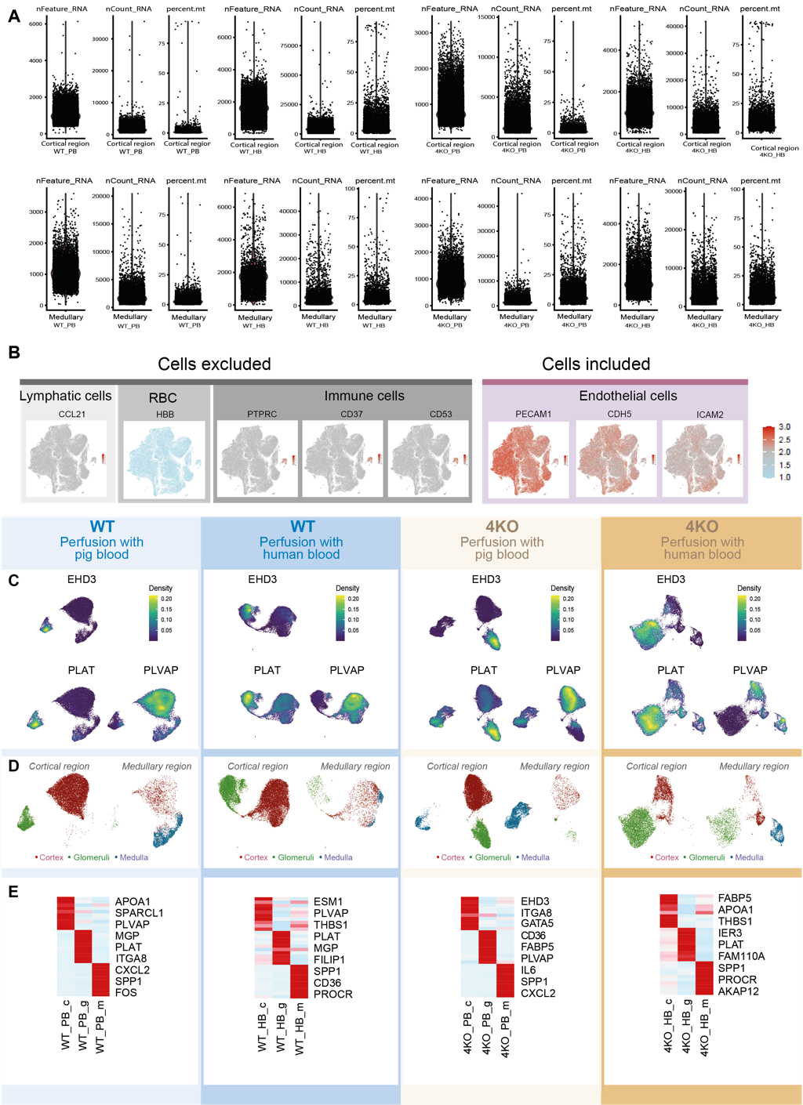
Supplemental figure S1. Single cell RNA sequencing of kidney endothelial cells
A, QC and data filtering numbers for each condition and compartment. B, Ex-and included cells based on the RNA expression levels of the shown markers. C, UMAP of canonical marker expression (EHD3, PLAT and PLVAP) which were used for clustering. D, UMAP for both cortical (left) and medullary (right) region showing the distribution of cortical, glomerular and medullary cells. E, Heatmap showing the top marker expression for each compartment.

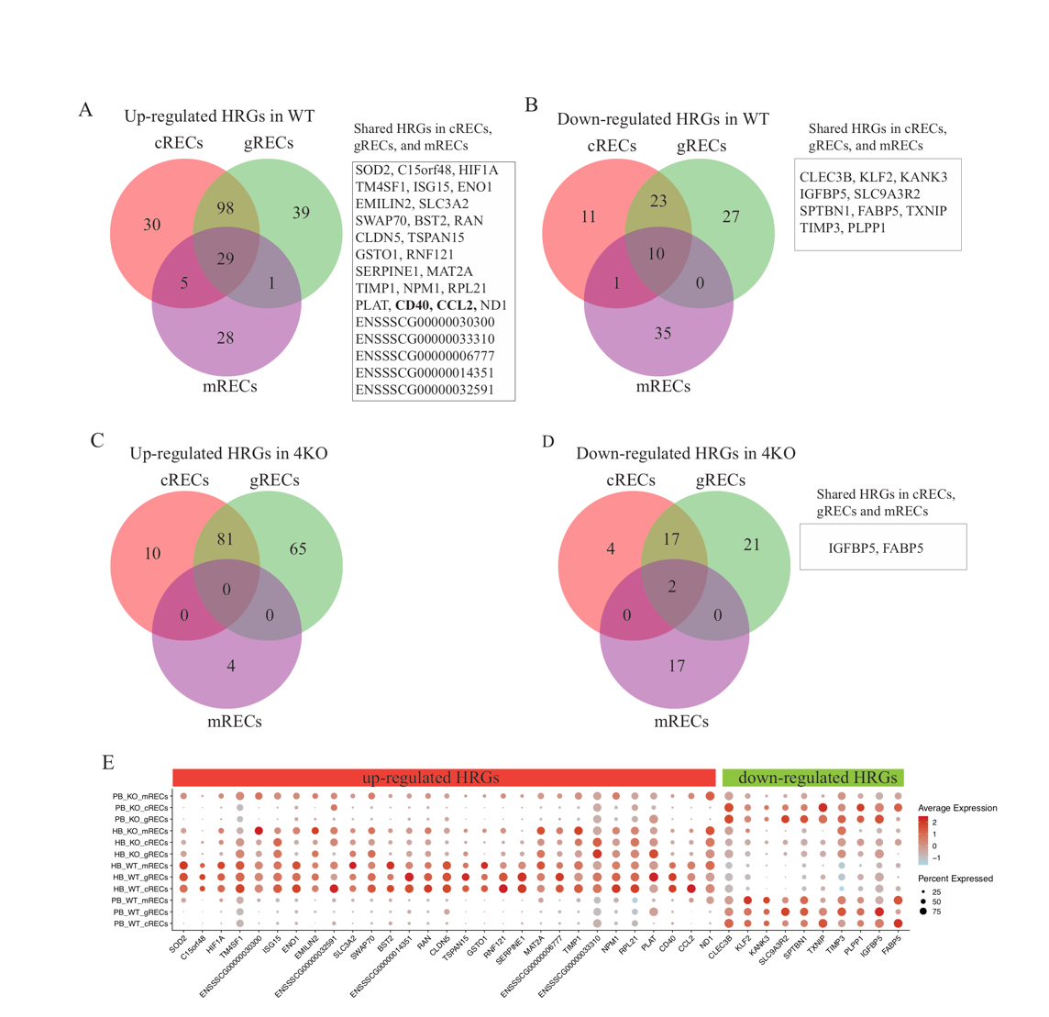
Supplementary Figure S2. Comparison and expression of high response genes in WT and 4KO RECs.
A-D, Venn diagram of high response genes (HRGs) (fold changes >= 2, adj. p value < 0.05) in the cRECs, gRECs, and mRECs, which are up-regulated (A) or down-regulated (B) in HP-perfused WT kidney compared to PB-perfused WT kidney, up-regulated (C) or down-regulated (D) in HP-perfused 4KO kidney compared to PB-perfused 4KO kidney. Commonly up-regulated genes in cRECs, gRECs, and mRECs are showed in the box to the right. E, Dot plot of average gene expression and fraction of cells expressed for the common HRGs highlighted in the boxes of A-D.

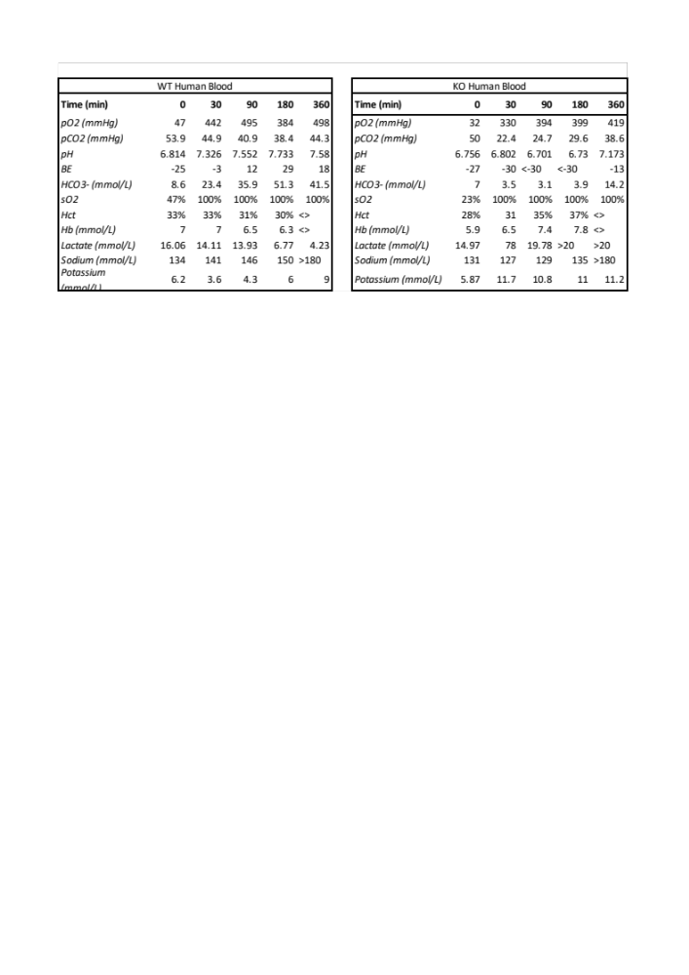

Table S1. Levels of electrolytes and gas analysis during the perfusion measured with iSTAT. Hct, Hematocrit;

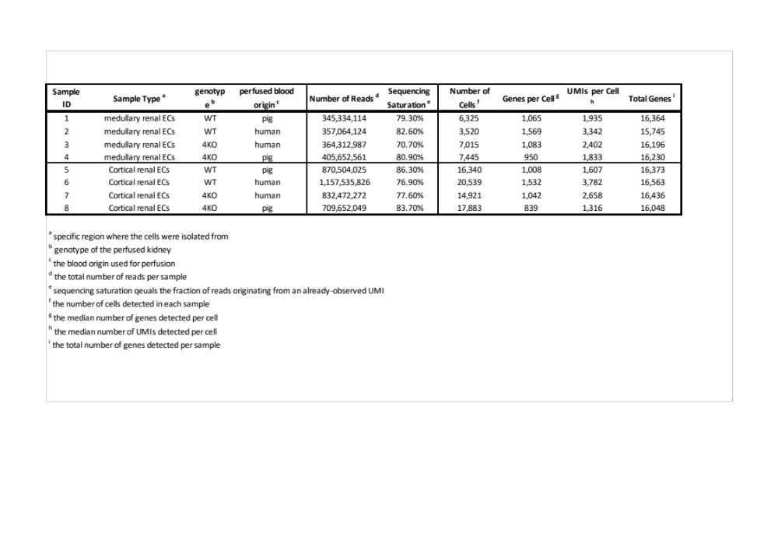
Table S2. Quality controls of single cell RNA sequencing data.

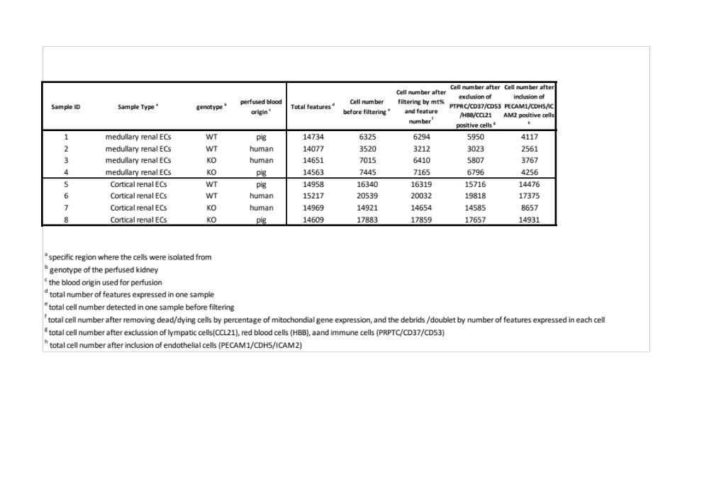
Table S3. List of total genes detected (features), number of cells before filtering and after each step of marker-based in silico selection.

Table S4-S6 are provided in separate excel sheets.

Table S4: Top 50 markers for each renal endothelial cell (REC) cluster.

Table S5: Differentially expressed genes (DEGs) between human blood-perfused and pig blood-perfused kidneys in each cluster of renal endothelial cells (RECs) of WT and 4KO pigs

Table S6: Differentially expressed immune genes between human blood-perfused and pig blood-perfused kidneys in each cluster of renal endothelial cells (RECs) of WT and 4KO pigs

