Restoration Starts in the Soil

Authors: Riley J. Hodgson¹*, Sacha Jellinek², Amy Annells¹, Andrew D. Barnes³, Brianna Le Busque⁴, Sofie M. Costin¹, Craig Liddicoat¹, Steven-Khoa Nguyen⁵, Shawn D. Peddle¹, Jake M. Robinson^{1,6}, Heidi Rogers¹, Alex-Flynn Taylor¹, Nick S. Whiterod^{5,7}, Jamie R. Wood^{5,8}, Martin F. Breed^{1,6}*
Corresponding authors: riley.hodgson@flinders.edu.au; martin.breed@flinders.edu.au

Affiliations:
¹ College of Science and Engineering, Flinders University; Bedford Park, SA 5042, Australia.
² Waterway Ecosystem Research Group, School of Agriculture, Food and Ecosystem Sciences, The University of Melbourne; Melbourne, Vic 3001, Australia.
³ Te Aka Mātuatua – School of Science, The University of Waikato; Hamilton, New Zealand.
⁴ School of Physics, Chemistry and Earth Sciences, Adelaide University; Adelaide, SA 5000, Australia.
⁵ School of Biological Sciences, Adelaide University; Adelaide, SA 5005, Australia.
⁶ The Aerobiome Innovation & Research Hub, Flinders University; Bedford Park, SA 5042, Australia.
⁷ CLLMM Research Centre, Goyder Institute for Water Research; Goolwa, SA 5214, Australia.
⁸ Environment Institute, Adelaide University; Adelaide, 5000, Australia.
* Corresponding authors. Email: riley.hodgson@flinders.edu.au; martin.breed@flinders.edu.au

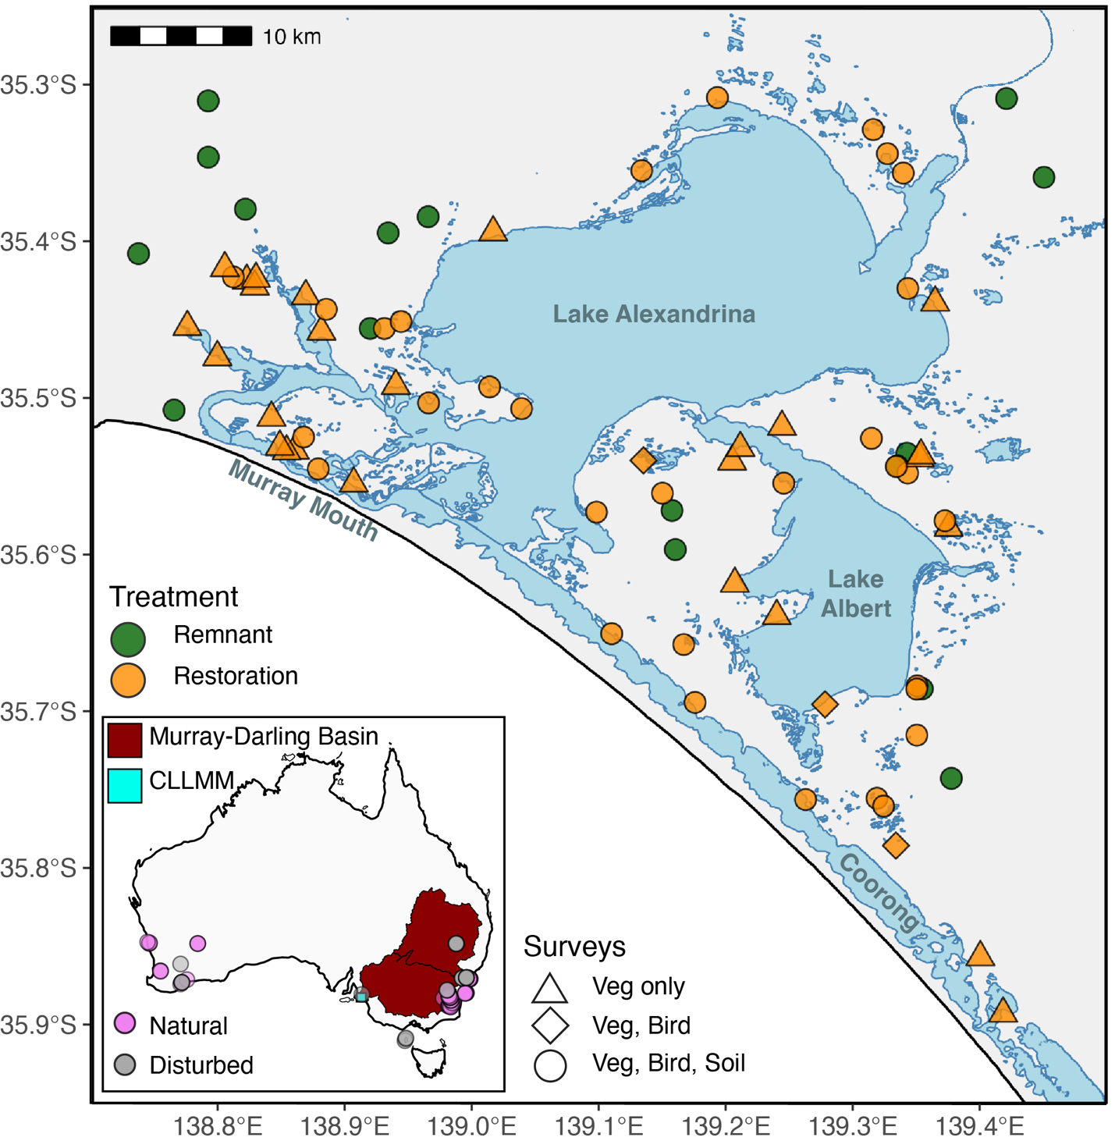

Fig. S1.
Study region and restoration and intact reference sites across the Coorong, Lower Lakes and Murray Mouth (CLLMM) region. The CLLMM region supports a Ramsar-listed wetland system at the mouth of the Murray–Darling Basin. Locations of restoration sites (orange) and intact reference native vegetation reference sites (green) across the CLLMM region sampled in both 2015 and 2025. Inset map shows natural (pink) and disturbed (grey) sites across Australia obtained from the Australian Microbiome database.
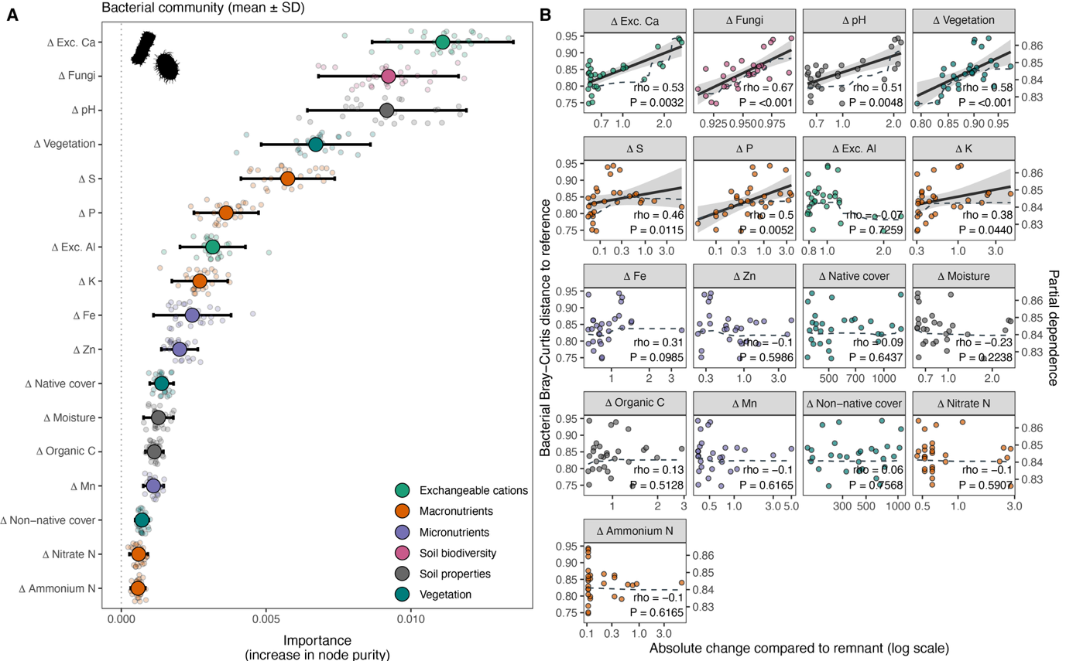

Fig. S2.
Environmental predictors of bacterial community dissimilarity to intact reference sites. (A) Predictor importance scores derived from a leave-one-out cross-validation (LOOCV) random forest model. (B) Relationships between predictor variables (ordered from highest to lowest importance) and bacterial community divergence from intact reference-like (remnant) conditions. Points show observed data, solid lines represent fitted linear regressions, and dashed lines show partial dependence curves illustrating the marginal effect of each predictor after accounting for all other predictors in the model. Partial dependence values are plotted against the secondary y-axis for visual clarity. Spearman's rank correlation coefficient (ρ) is shown for each predictor.
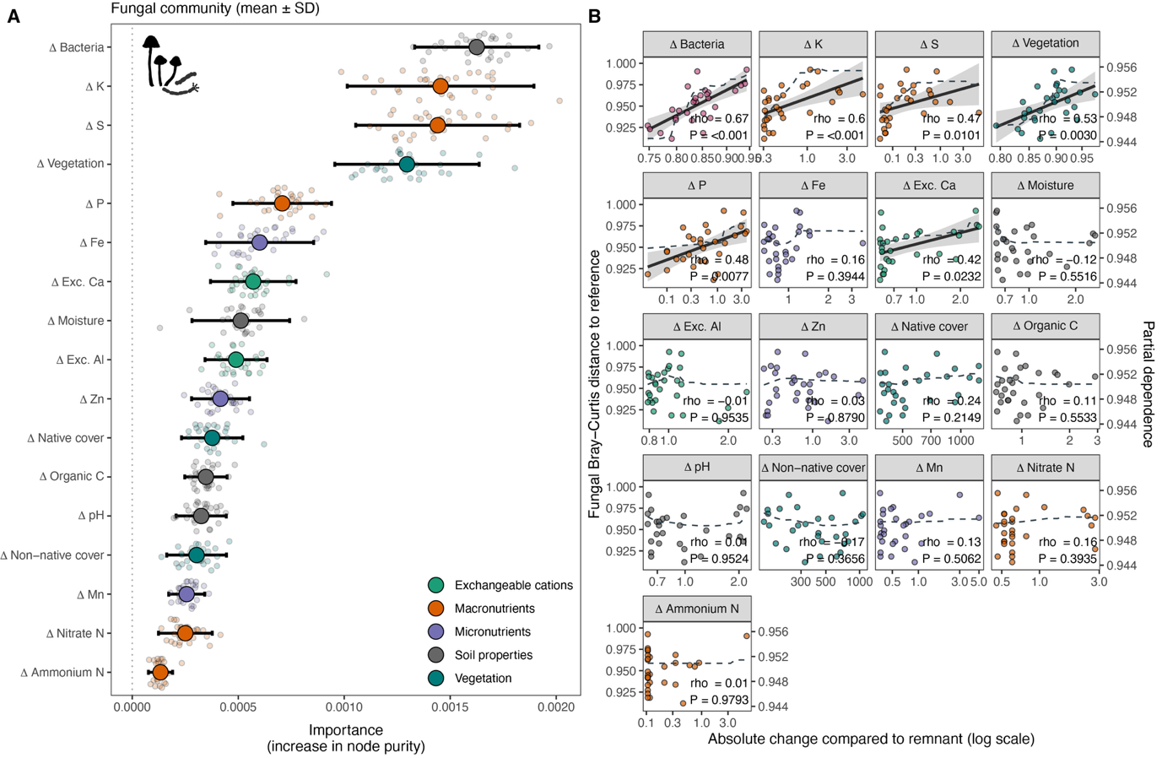

Fig. S3.
Environmental predictors of fungal community dissimilarity to intact reference sites. (A) Predictor importance scores derived from a leave-one-out cross-validation (LOOCV) random forest model. (B) Relationships between predictor variables (ordered from highest to lowest importance) and fungal community divergence from intact reference-like (remnant) conditions. Points show observed data, solid lines represent fitted linear regressions, and dashed lines show partial dependence curves illustrating the marginal effect of each predictor after accounting for all other predictors in the model. Partial dependence values are plotted against the secondary y-axis for visual clarity. Spearman's rank correlation coefficient (ρ) is shown for each predictor.

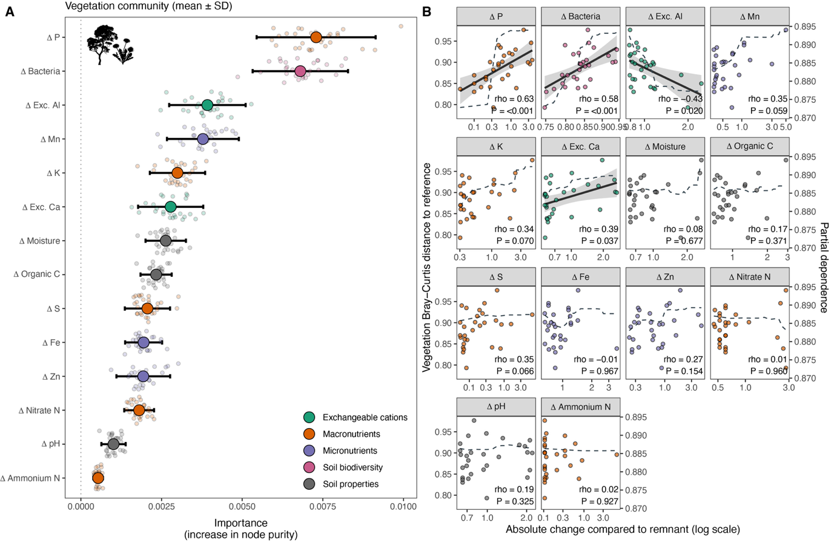

Fig. S4.
Environmental predictors of vegetation community dissimilarity to intact reference sites. (A) Predictor importance scores derived from a leave-one-out cross-validation (LOOCV) random forest model. (B) Relationships between predictor variables (ordered from highest to lowest importance) and vegetation community dissimilarity to intact reference-like (remnant) conditions. Points show observed data, solid lines represent fitted linear regressions, and dashed lines show partial dependence curves illustrating the marginal effect of each predictor after accounting for all other predictors in the model. Partial dependence values are plotted against the secondary y-axis for visual clarity. Spearman's rank correlation coefficient (ρ) is shown for each predictor.

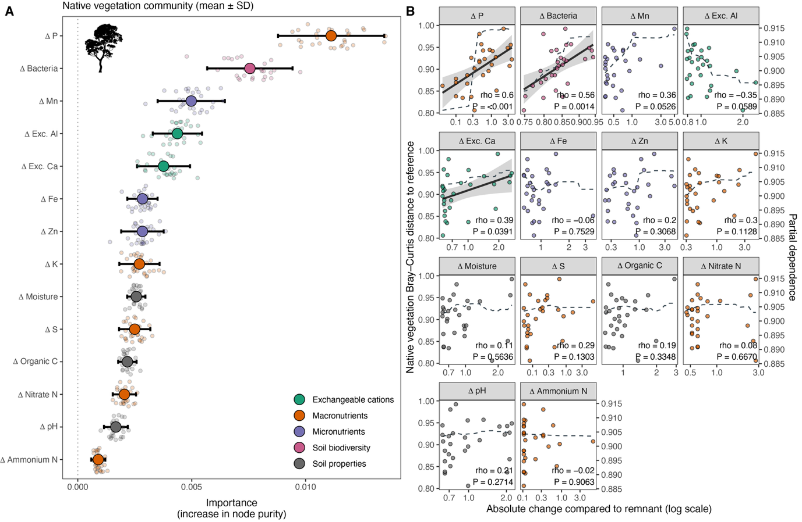

Fig. S5.
Environmental predictors of native vegetation community dissimilarity to intact reference sites. (A) Predictor importance scores derived from a leave-one-out cross-validation (LOOCV) random forest model. (B) Relationships between predictor variables (ordered from highest to lowest importance) and native vegetation community dissimilarity to intact reference-like (remnant) conditions. Points show observed data, solid lines represent fitted linear regressions, and dashed lines show partial dependence curves illustrating the marginal effect of each predictor after accounting for all other predictors in the model. Partial dependence values are plotted against the secondary y-axis for visual clarity. Spearman's rank correlation coefficient (ρ) is shown for each predictor.

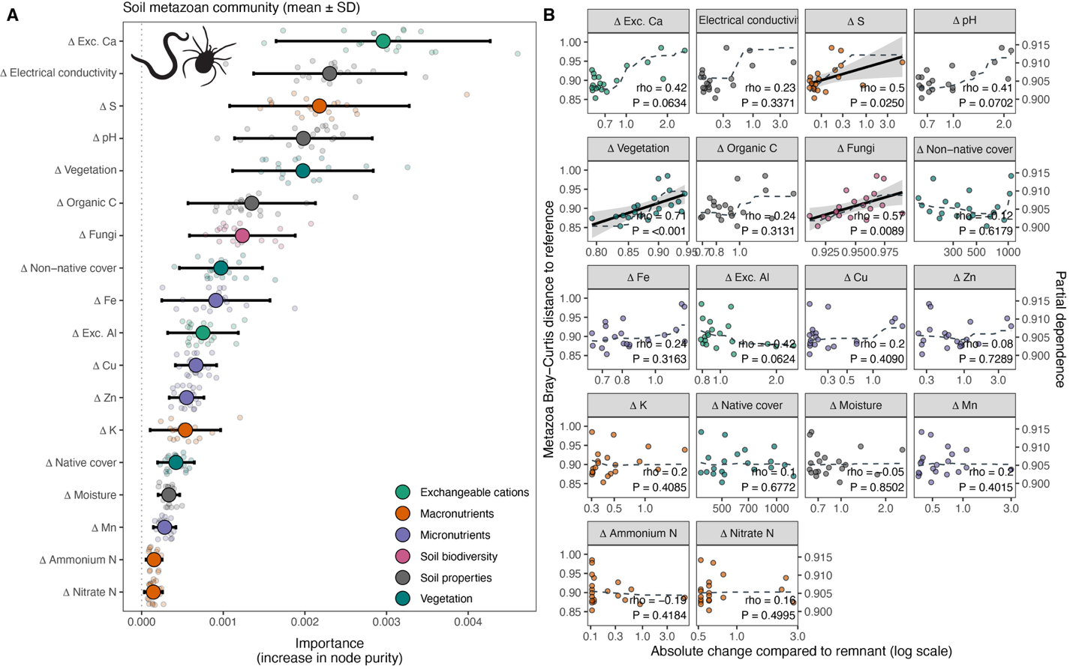Fig. S6.
Environmental predictors of soil metazoan community dissimilarity to intact reference sites. (A) Predictor importance scores derived from a leave-one-out cross-validation (LOOCV) random forest model. (B) Relationships between predictor variables (ordered from highest to lowest importance) and soil metazoan community divergence from intact reference-like (remnant) conditions. Points show observed data, solid lines represent fitted linear regressions, and dashed lines show partial dependence curves illustrating the marginal effect of each predictor after accounting for all other predictors in the model. Partial dependence values are plotted against the secondary y-axis for visual clarity. Spearman's rank correlation coefficient (ρ) is shown for each predictor.
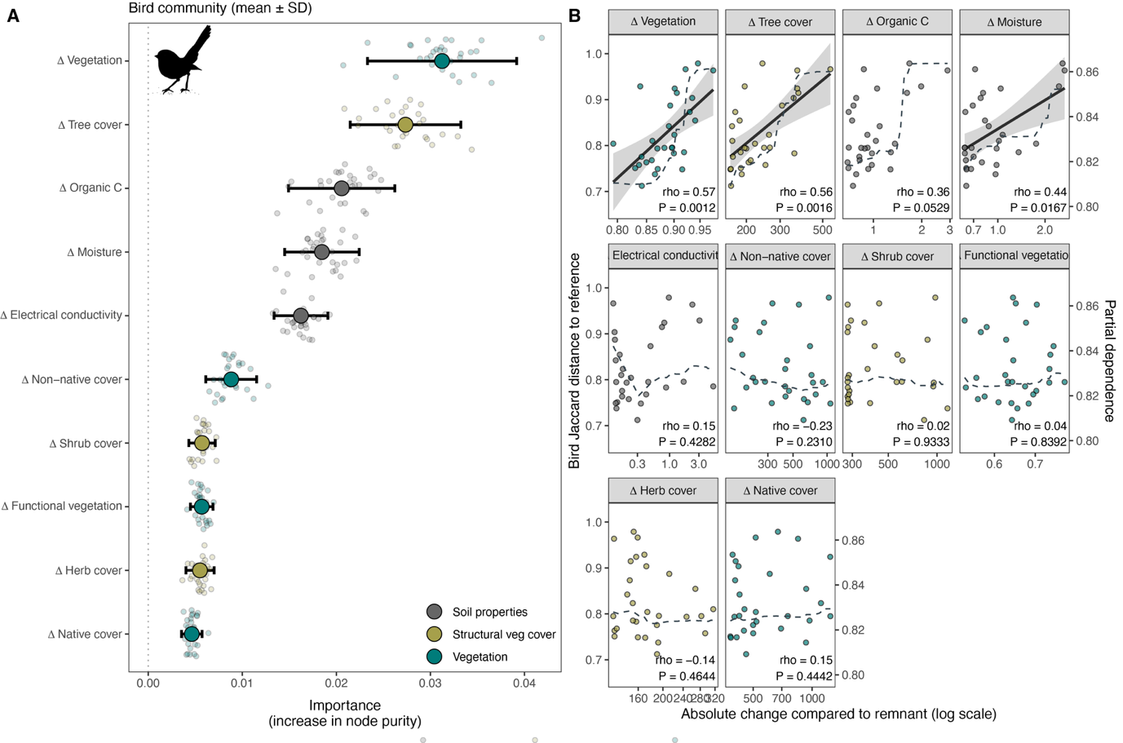

Fig. S7.
Environmental predictors of bird community dissimilarity to intact reference sites. (A) Predictor importance scores derived from a leave-one-out cross-validation (LOOCV) random forest model. (B) Relationships between predictor variables (ordered from highest to lowest importance) and bird community divergence from intact reference-like (remnant) conditions. Points show observed data, solid lines represent fitted linear regressions, and dashed lines show partial dependence curves illustrating the marginal effect of each predictor after accounting for all other predictors in the model. Partial dependence values are plotted against the secondary y-axis for visual clarity. Spearman's rank correlation coefficient (ρ) is shown for each predictor.

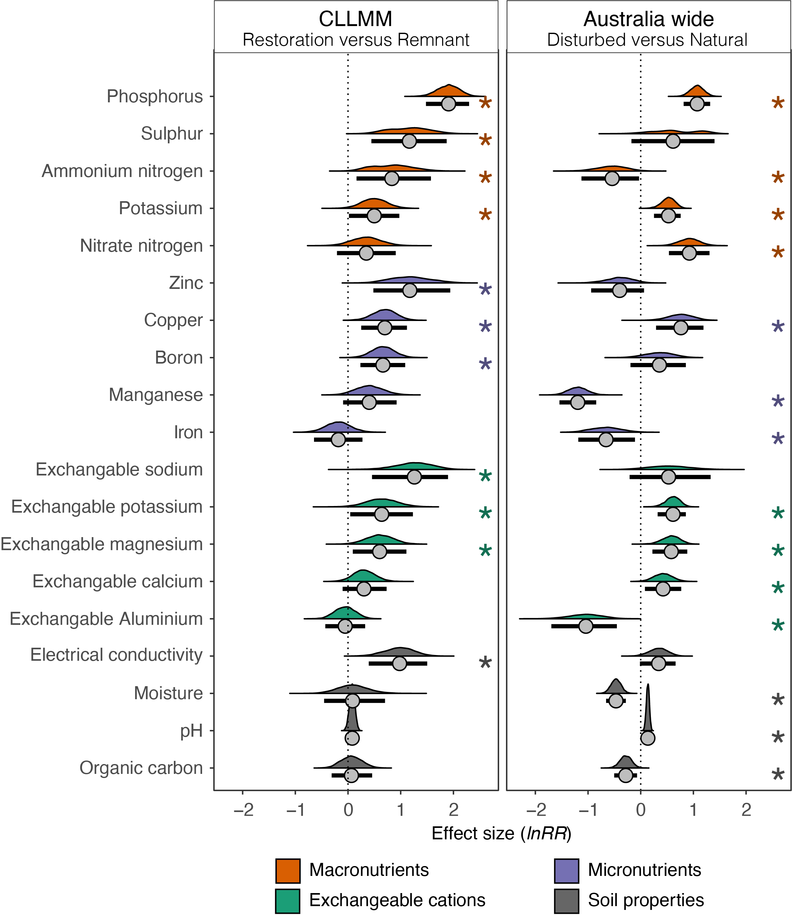

Fig. S8.
Differences in soil physicochemical properties between restoration and reference conditions at regional and continental scales. Effect sizes (lnRR) compare restoration and intact reference sites in the CLLMM region (2025 surveys only), and disturbed and natural sites across Australia. Negative effect sizes (< 0) indicate lower values in restoration than intact reference sites, or disturbed than natural sites, whereas positive effect sizes (> 0) indicate higher values. Effect sizes were calculated using univariate response ratios (RR_{univariate}). Error bars show 95% bootstrapped confidence intervals; intervals overlapping zero indicate no detectable difference between restoration and intact reference conditions, or between disturbed and natural conditions. Asterisks (*) denote confidence intervals that do not overlap zero. Density distributions show the distribution of bootstrapped estimates, with points indicating median values.
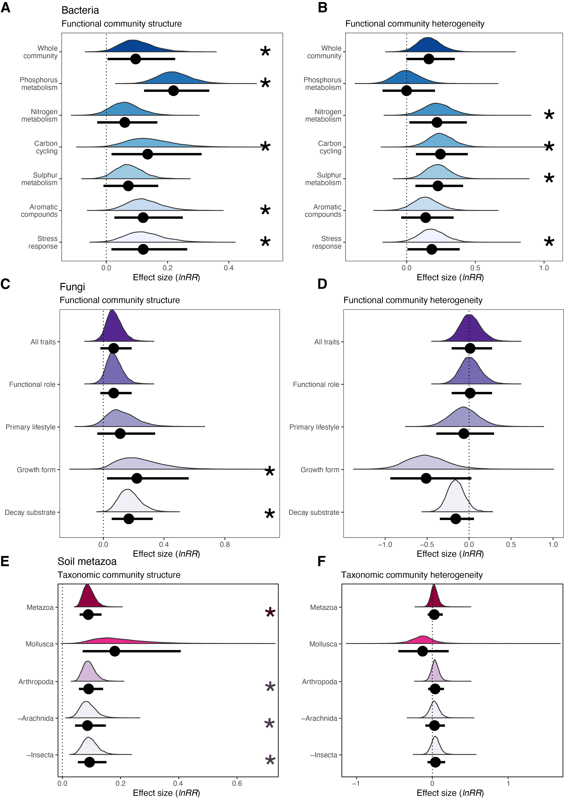

Fig. S9.
Recovery of belowground functional communities. Soil biodiversity was surveyed in 2025 only. Panels show (A) bacterial functional gene composition and (B) community heterogeneity; (C) fungal functional community composition and (D) community heterogeneity; and (E) soil metazoan community composition across taxonomic groups and (F) community heterogeneity. Fungal functional groups were inferred taxonomically using the FungalTraits database, whereas bacterial functional communities were characterized from shotgun metagenomic sequences using SEED subsystem level 1 annotations. For community composition, positive effect sizes (lnRR > 0) indicate greater compositional dissimilarity between restoration and intact reference sites, calculated using community compositional response ratios (RR_{composition}). For community heterogeneity, positive effect sizes (> 0) indicate greater heterogeneity among restoration sites than among intact reference sites, calculated using community heterogeneity response ratios (RR_{beta}). Error bars show 95% bootstrapped confidence intervals; intervals overlapping zero indicate no detectable difference between restoration and intact reference conditions. Asterisks (*) denote confidence intervals that do not overlap zero. Density distributions show the distribution of bootstrapped estimates, with points indicating median values.
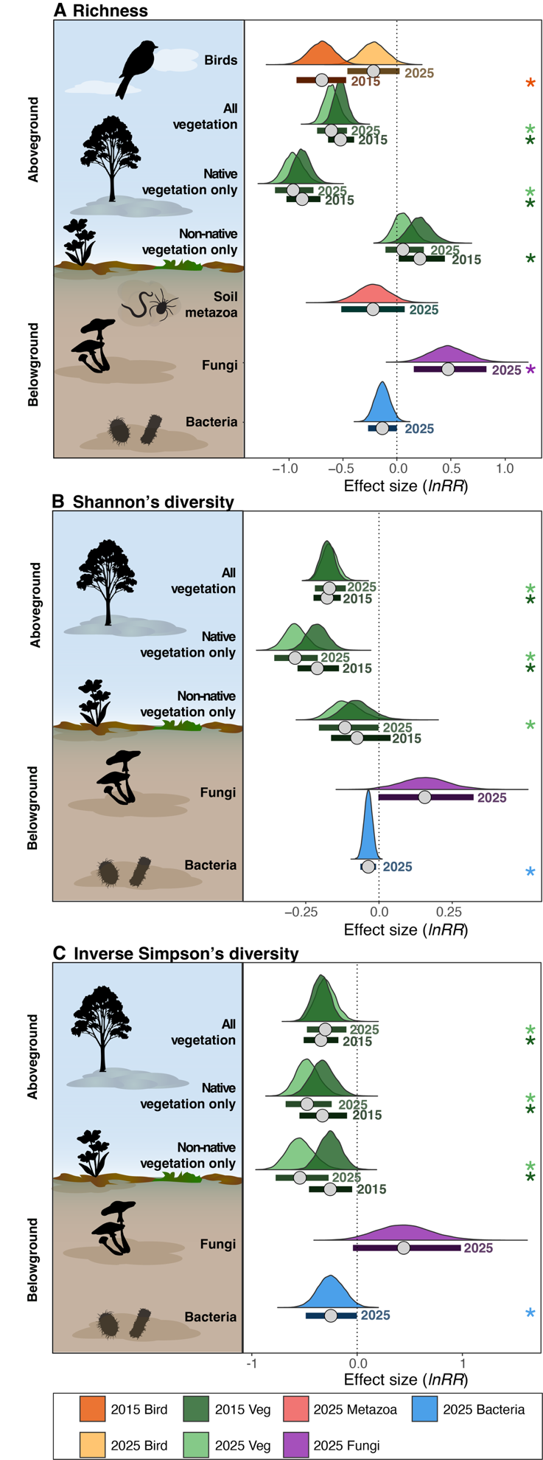

Fig. S10.
Univariate differences between restoration and intact reference sites across ecosystem components. Effect sizes (lnRR) compare restoration and intact reference sites for (A) taxonomic richness, (B) Shannon diversity, and (C) inverse Simpson diversity. Soil biodiversity was surveyed in 2025 only. Negative effect sizes (< 0) indicate lower values in restoration than intact reference sites, whereas positive effect sizes (> 0) indicate higher values. Effect sizes were calculated using univariate response ratios (RR_{univariate}). Error bars show 95% bootstrapped confidence intervals; intervals overlapping zero indicate no detectable difference between restoration and intact reference conditions. Asterisks (*) denote confidence intervals that do not overlap zero. Density distributions show the distribution of bootstrapped estimates, with points indicating median values.
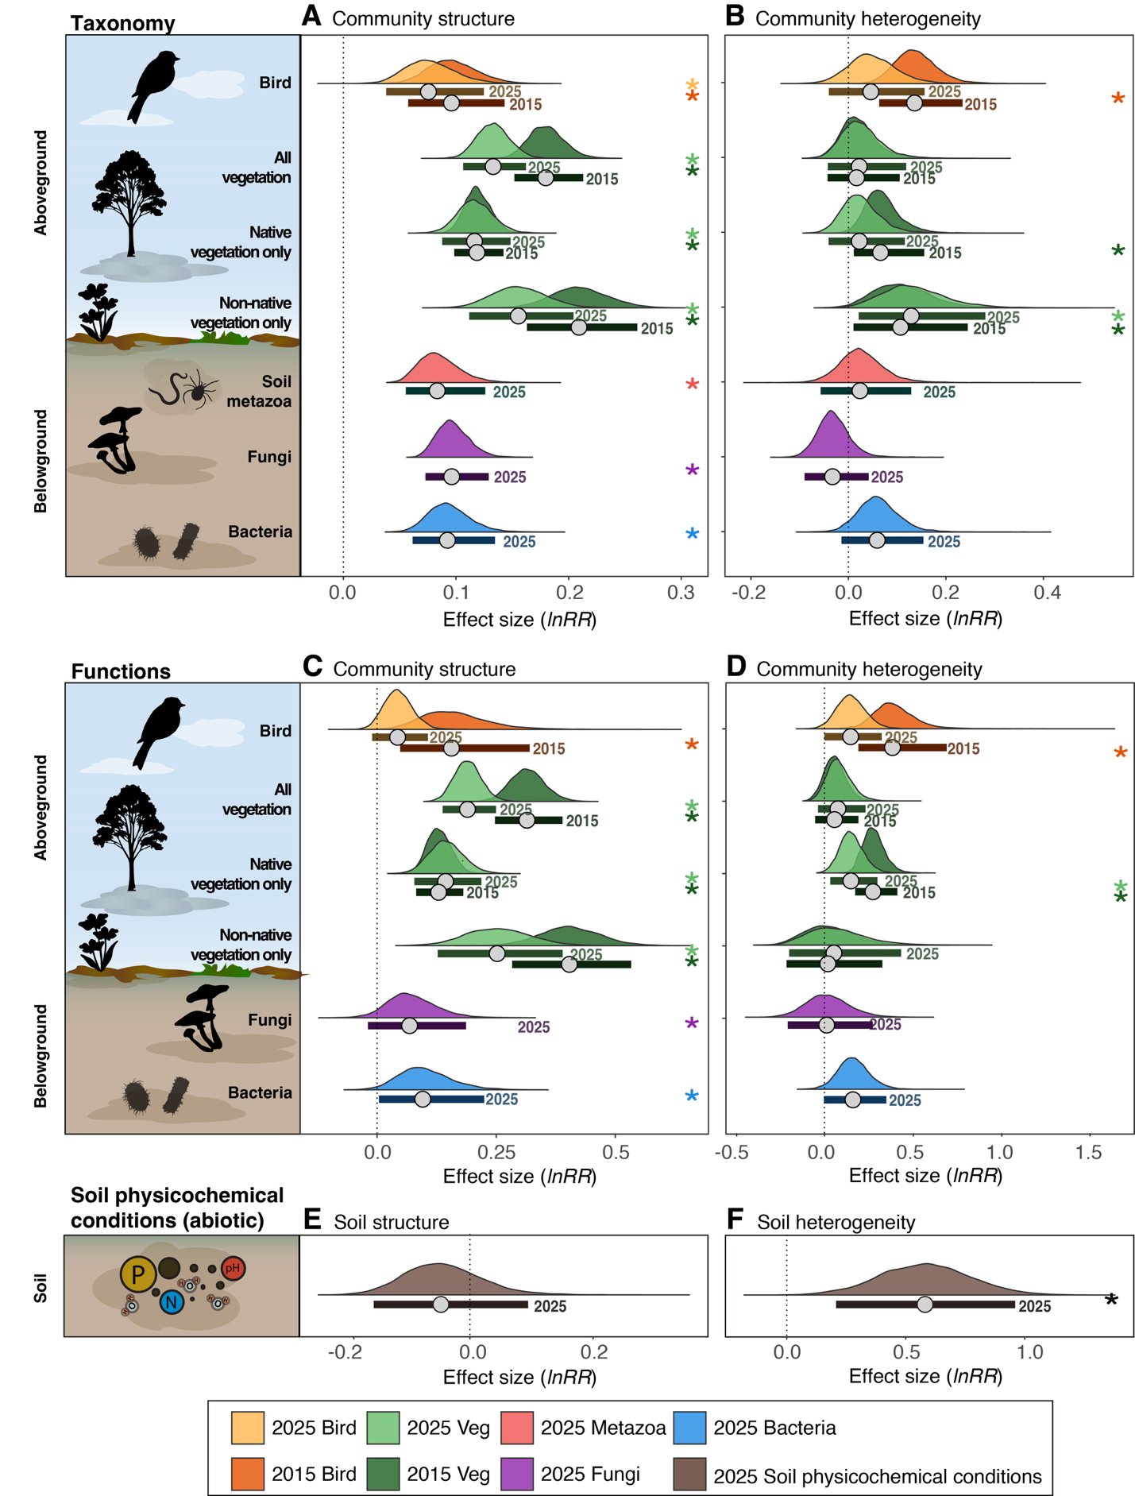

Fig. S11.
Recovery baselines, progress, and remaining gaps across ecosystem components. Effect sizes (lnRR) quantify recovery towards intact reference-like conditions for (A) taxonomic community composition, (B) taxonomic community heterogeneity, (C) functional community composition, and (D) functional community heterogeneity. Recovery baselines represent the initial divergence between restoration and intact reference sites in 2015, recovery progress represents movement towards intact reference-like conditions between 2015 and 2025, and recovery gaps represent the remaining divergence from intact reference conditions in 2025. Soil biodiversity was surveyed in 2025 only and therefore has no recovery baseline or progress estimate. For community composition, positive effect sizes (> 0) indicate greater compositional dissimilarity between restoration and intact reference sites, calculated using community compositional response ratios (RR_{composition}). For community heterogeneity, positive effect sizes (> 0) indicate greater heterogeneity among restoration sites than among intact reference sites, calculated using community heterogeneity response ratios (RR_{beta}). Error bars show 95% bootstrapped confidence intervals; intervals overlapping zero indicate no detectable difference from intact reference-like conditions. Asterisks (*) denote confidence intervals that do not overlap zero. Density distributions show the distribution of bootstrapped estimates, with points indicating median values.

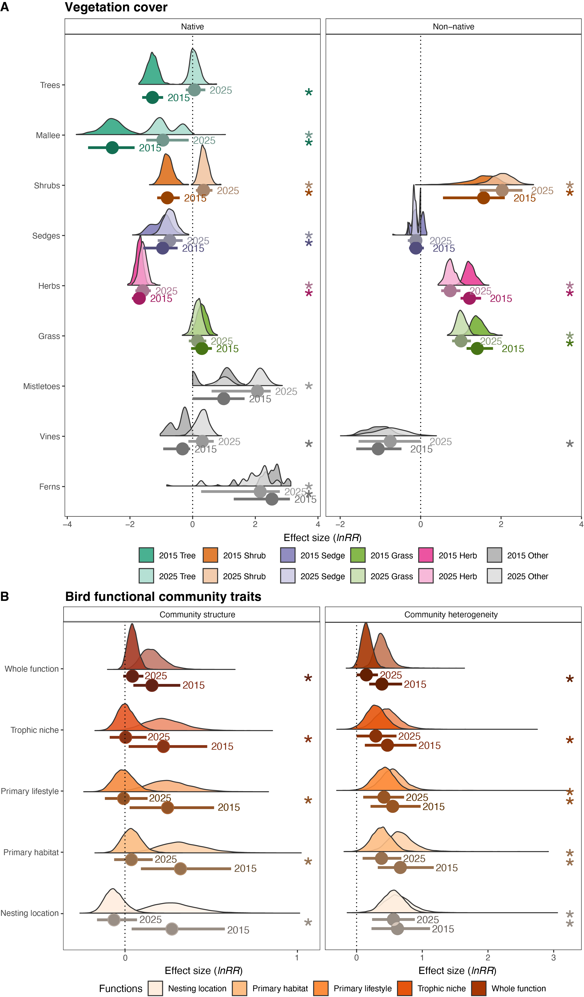

Fig. S12.
Recovery of vegetation and bird functional groups. Panels show effect size (lnRR) differences for (A) cover of native and non-native plant functional groups and (B) community composition and heterogeneity of bird functional groups across survey years. Vegetation cover effect sizes were calculated using univariate response ratios (RR_{univariate}). Bird functional community composition was assessed using compositional response ratios (RR_{composition}), where positive values (> 0) indicate greater compositional dissimilarity between restoration and intact reference sites. Bird functional community heterogeneity was assessed using community heterogeneity response ratios (RR_{beta}), where positive values (> 0) indicate greater heterogeneity among restoration sites than among intact reference sites. Error bars show 95% bootstrapped confidence intervals; intervals overlapping zero indicate no detectable difference between restoration and intact reference conditions. Asterisks (*) denote confidence intervals that do not overlap zero. Density distributions show the distribution of bootstrapped estimates, with points indicating median values.
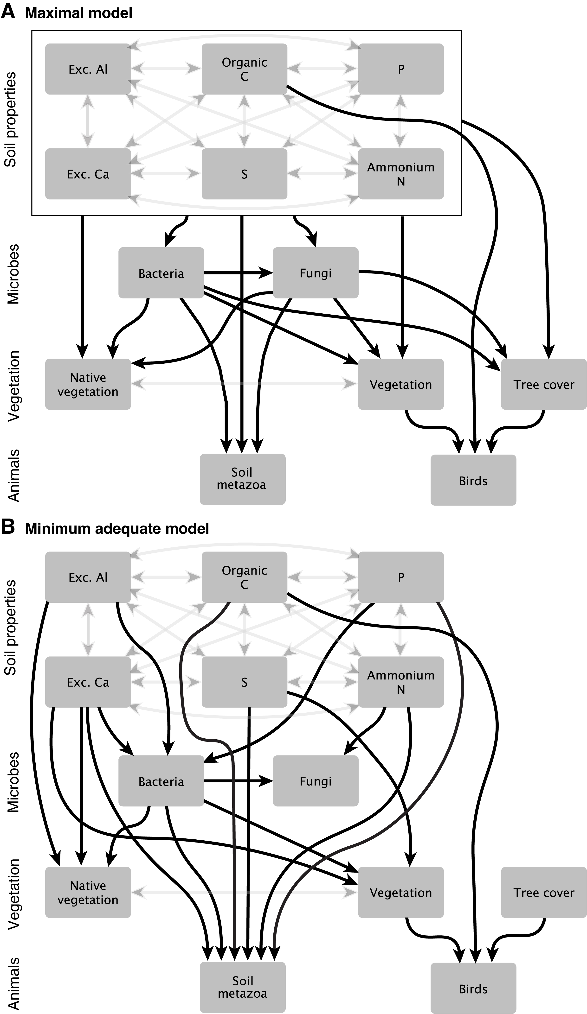

Fig. S13.
Conceptual pathways linking dissimilarity from intact reference conditions across soil physicochemical properties, microbial communities, vegetation and higher trophic groups, evaluated using piecewise structural equation modelling (SEM). The path diagram represents (A) the maximal SEM containing the retained soil physicochemical variables and hypothesized ecological pathways following covariate removal. Arrows originating from the box surrounding the soil physicochemical variables indicate that each soil variable was included a predictor of the connected response. (B) Minimum adequate model showing all hypothesized paths following reduced predictor set identified following a maximum-likelihood multi-model inferencing. Single-headed black arrows represent hypothesized directional relationships among variables, while grey double-headed black arrows represent correlated errors included to account for residual covariance.

Table S1.
Direct pathways in the minimum adequate structural equation model (SEM). Estimates, standard errors (SE), degrees of freedom, test statistics and P-values are reported for each predictor–response relationship retained following multi-model inference. Positive estimates indicate that dissimilarity in the response increased with the predictor, whereas negative estimates indicate decreasing dissimilarity with increasing predictor values. Significant pathways are indicated by P < 0.05, P < 0.01 and P < 0.001. Gamma-distributed SEM components were range-standardized using the observed ranges of the predictor and response variables.
Response | Predictor | Estimate | Standard error | Degrees of freedom | Crit. value | P value | Standardized estimate
Bacteria ~ | Phosphorus | 0.0129 | 0.0096 | 16 | 1.3456 | 0.1972 | 0.2448
 | Exc. Aluminum | -0.0353 | 0.0213 | 16 | -1.6568 | 0.117 | -0.3250
 | Exc. Calcium | 0.0537 | 0.018 | 16 | 2.991 | 0.0086** | 0.6211
Fungi ~ | Bacteria | 0.2998 | 0.0641 | 17 | 4.6801 | 0.0002*** | 0.6986
 | Ammonium Nitrogen | 0.0067 | 0.0022 | 17 | 3.0506 | 0.0072** | 0.5483
Vegetation ~ | Bacteria | 0.9816 | 0.2132 | 16 | 4.6038 | 0.0003*** | 1.1765
 | Exc. Calcium | -0.0445 | 0.0185 | 16 | -2.4081 | 0.0285* | -0.6159
 | Sulfur | 0.0123 | 0.0055 | 16 | 2.2305 | 0.0404* | 0.5112
Native vegetation ~ | Bacteria | 0.9353 | 0.2878 | 15 | 3.2494 | 0.0054** | 0.9831
 | Exc. Aluminum | -0.0124 | 0.0223 | 15 | -0.5541 | 0.5877 | -0.1198
 | Exc. Calcium | -0.0384 | 0.0232 | 15 | -1.6553 | 0.1186 | -0.4665
 | Sulfur | 0.0113 | 0.007 | 15 | 1.6202 | 0.126 | 0.4133
Tree cover ~ | Bacteria | 3.3089 | 3.3933 | 15 | 0.9751 | 0.345 | 0.0016
 | Fungi | 0.7356 | 6.7395 | 15 | 0.1092 | 0.9145 | 0.0002
 | Phosphorus | 0.0441 | 0.102 | 15 | 0.4322 | 0.6717 | 0.0004
 | Exc. Calcium | -0.1878 | 0.2241 | 15 | -0.8379 | 0.4152 | -0.0010
Birds ~ | Vegetation | 0.8913 | 0.3452 | 17 | 2.5821 | 0.0194* | 0.3623
 | Tree cover | 0.0004 | 0.0002 | 17 | 2.9147 | 0.0097** | 0.5157
 | Organic Carbon | 0.0791 | 0.0502 | 16 | 1.5734 | 0.1352 | 0.2316
Metazoa ~ | Ammonium Nitrogen | -0.007 | 0.0043 | 13 | -1.6066 | 0.1321 | -0.3414
 | Bacteria | 0.5378 | 0.1296 | 13 | 4.1483 | 0.0011** | 0.7504
 | Exc. Calcium | 0.0055 | 0.0113 | 13 | 0.4859 | 0.6352 | 0.0887
 | Organic. Carbon | 0.0127 | 0.0227 | 13 | 0.5597 | 0.5852 | 0.0955
 | Phosphorus | 0.0058 | 0.0071 | 13 | 0.8127 | 0.431 | 0.1527
 | Sulfur | 0.0069 | 0.0033 | 13 | 2.0895 | 0.0569 | 0.3340

Table S2.
Correlated errors specified in the minimum adequate structural equation model (SEM). Correlated errors were included among soil physicochemical variables and among vegetation responses to account for shared covariance not represented by directional pathways in the SEM. Estimates, degrees of freedom, test statistics, P-values and standardized estimates are reported. Significant correlations are indicated by P < 0.05, P < 0.01 and P < 0.001.
Variable 1 | Variable 2 | Estimate | Degrees of freedom | Crit value | P value | Std estimate
Ammonium Nitrogen ~ | ~Phosphorus | 0.5164 | 18 | 2.5587 | 0.0197* | 0.5164
Ammonium Nitrogen ~ | ~Sulfur | 0.0427 | 18 | 0.1813 | 0.8581 | 0.0427
Ammonium Nitrogen ~ | ~Organic Carbon | -0.0716 | 18 | -0.3047 | 0.7641 | -0.0716
Ammonium Nitrogen ~ | ~Exc. Aluminum | 0.0253 | 18 | 0.1072 | 0.9158 | 0.0253
Ammonium Nitrogen ~ | ~Exc. Calcium | -0.1686 | 18 | -0.7257 | 0.4773 | -0.1686
Phosphorus ~ | ~Sulfur | 0.1479 | 18 | 0.6346 | 0.5337 | 0.1479
Phosphorus ~ | ~Organic Carbon | 0.5061 | 18 | 2.4896 | 0.0228* | 0.5061
Phosphorus ~ | ~Exc. Aluminum | -0.0887 | 18 | -0.378 | 0.7099 | -0.0887
Phosphorus ~ | ~Exc. Calcium | 0.3558 | 18 | 1.6151 | 0.1237 | 0.3558
Sulfur ~ | ~Organic Carbon | 0.3178 | 18 | 1.4222 | 0.1721 | 0.3178
Sulfur ~ | ~Exc. Aluminum | -0.1574 | 18 | -0.676 | 0.5076 | -0.1574
Sulfur ~ | ~Exc. Calcium | 0.2214 | 18 | 0.9634 | 0.3481 | 0.2214
Organic Carbon ~ | ~Exc. Aluminum | -0.0393 | 18 | -0.1671 | 0.8692 | -0.0393
Organic Carbon ~ | ~Exc. Calcium | 0.2759 | 18 | 1.2177 | 0.2391 | 0.2759
Exc. Aluminum ~ | ~Exc. Calcium | -0.2025 | 18 | -0.8772 | 0.3919 | -0.2025
Vegetation ~ | ~Native vegetation | 0.9109 | 20 | 9.1011 | <0.001*** | 0.9109
Vegetation ~ | ~Tree cover | 0.1658 | 20 | 0.6931 | 0.2488 | 0.1658
Native vegetation ~ | ~Tree cover | 0.2397 | 20 | 1.0179 | 0.1615 | 0.2397

Table S3.
Random forest model specifications and performance. Model specifications include the number of trees (ntree) and the number of predictor variables considered at each split (mtry). Model performance is reported using out-of-bag (OOB) and leave-one-out cross-validation (LOOCV) metrics, including mean squared error (MSE), percentage variance explained (R²), root mean squared error (RMSE), Pearson's correlation coefficient (r), and mean absolute error (MAE).
Community response | Distance metric | ntree | mtry | OOB MSE | OOB R² | OOB RMSE | LOOCV R² | LOOCV Pearson’s r | LOOCV MAE | LOOCV RMSE
Bird | Jaccard | 500 | 3 | 0.003 | 0.41 | 0.06 | 0.38 | 0.64 | 0.05 | 0.06
Vegetation | Bray-Curtis | 500 | 4 | 0.001 | 0.18 | 0.04 | 0.19 | 0.44 | 0.03 | 0.04
Vegetation (native) | Bray-Curtis | 500 | 4 | 0.002 | 0.16 | 0.04 | 0.20 | 0.44 | 0.03 | 0.04
Metazoa | Jaccard | 500 | 6 | 0.001 | 0.27 | 0.03 | 0.31 | 0.58 | 0.02 | 0.03
Fungi | Bray-Curtis | 500 | 5 | 0.0003 | 0.33 | 0.02 | 0.32 | 0.58 | 0.01 | 0.02
Bacteria | Bray-Curtis | 500 | 5 | 0.001 | 0.57 | 0.03 | 0.55 | 0.78 | 0.03 | 0.03

Table S4.
Log response ratios (lnRR) for soil physicochemical variables relative to intact reference sites. Median, lower and upper confidence limits represent bootstrapped 95% percentile confidence intervals (CIs) of the response ratios (RR_{univariate}). Confidence intervals that do not overlap zero indicate evidence of a directional difference from intact reference conditions.
Region | Soil variable | Metric | Median | CI lower | CI upper | Trend
CLLMM ~ | Ammonium nitrogen | RR_{univariate} | 0.83 | 0.16 | 1.57 | Higher than intact reference
CLLMM ~ | Boron | RR_{univariate} | 0.66 | 0.23 | 1.08 | Higher than intact reference
CLLMM ~ | Electrical conductivity | RR_{univariate} | 0.98 | 0.39 | 1.50 | Higher than intact reference
CLLMM ~ | Copper | RR_{univariate} | 0.70 | 0.25 | 1.12 | Higher than intact reference
CLLMM ~ | Iron | RR_{univariate} | -0.18 | -0.64 | 0.27 | –
CLLMM ~ | Manganese | RR_{univariate} | 0.40 | -0.09 | 0.92 | –
CLLMM ~ | Zinc | RR_{univariate} | 1.17 | 0.48 | 1.94 | Higher than intact reference
CLLMM ~ | Exchangeable aluminum | RR_{univariate} | -0.05 | -0.43 | 0.32 | –
CLLMM ~ | Exchangeable calcium | RR_{univariate} | 0.30 | -0.10 | 0.73 | –
CLLMM ~ | Exchangeable magnesium | RR_{univariate} | 0.60 | 0.09 | 1.11 | Higher than intact reference
CLLMM ~ | Exchangeable potassium | RR_{univariate} | 0.64 | 0.04 | 1.23 | Higher than intact reference
CLLMM ~ | Exchangeable sodium | RR_{univariate} | 1.26 | 0.46 | 1.90 | Higher than intact reference
CLLMM ~ | Nitrate nitrogen | RR_{univariate} | 0.35 | -0.21 | 0.90 | –
CLLMM ~ | Organic carbon | RR_{univariate} | 0.06 | -0.31 | 0.46 | –
CLLMM ~ | Phosphorus | RR_{univariate} | 1.91 | 1.48 | 2.30 | Higher than intact reference
CLLMM ~ | Potassium | RR_{univariate} | 0.50 | 0.02 | 0.97 | Higher than intact reference
CLLMM ~ | Sulfur | RR_{univariate} | 1.16 | 0.44 | 1.87 | Higher than intact reference
CLLMM ~ | Moisture | RR_{univariate} | 0.09 | -0.45 | 0.70 | –
CLLMM ~ | pH | RR_{univariate} | 0.08 | -0.02 | 0.18 | –
Australia-wide ~ | Ammonium nitrogen | RR_{univariate} | -0.54 | -1.12 | -0.03 | Lower than natural
Australia-wide ~ | Boron | RR_{univariate} | 0.36 | -0.19 | 0.86 | –
Australia-wide ~ | Electrical conductivity | RR_{univariate} | 0.34 | -0.01 | 0.66 | –
Australia-wide ~ | Copper | RR_{univariate} | 0.76 | 0.29 | 1.19 | Higher than natural
Australia-wide ~ | Iron | RR_{univariate} | -0.66 | -1.18 | -0.11 | Lower than natural
Australia-wide ~ | Manganese | RR_{univariate} | -1.19 | -1.54 | -0.85 | Lower than natural
Australia-wide ~ | Zinc | RR_{univariate} | -0.40 | -0.94 | 0.06 | –
Australia-wide ~ | Exchangeable aluminum | RR_{univariate} | -1.04 | -1.70 | -0.45 | Lower than natural
Australia-wide ~ | Exchangeable calcium | RR_{univariate} | 0.42 | 0.08 | 0.77 | Higher than natural
Australia-wide ~ | Exchangeable magnesium | RR_{univariate} | 0.58 | 0.22 | 0.88 | Higher than natural
Australia-wide ~ | Exchangeable potassium | RR_{univariate} | 0.61 | 0.32 | 0.86 | Higher than natural
Australia-wide ~ | Exchangeable sodium | RR_{univariate} | 0.53 | -0.21 | 1.33 | –
Australia-wide ~ | Nitrate nitrogen | RR_{univariate} | 0.92 | 0.54 | 1.31 | Higher than natural
Australia-wide ~ | Organic carbon | RR_{univariate} | -0.28 | -0.50 | -0.07 | Lower than natural
Australia-wide ~ | pH | RR_{univariate} | 0.14 | 0.08 | 0.19 | Higher than natural
Australia-wide ~ | Phosphorus | RR_{univariate} | 1.07 | 0.81 | 1.32 | Higher than natural
Australia-wide ~ | Potassium | RR_{univariate} | 0.53 | 0.25 | 0.76 | Higher than natural
Australia-wide ~ | Sulfur | RR_{univariate} | 0.61 | -0.18 | 1.40 | –
Australia-wide ~ | Moisture | RR_{univariate} | -0.47 | -0.66 | -0.28 | Lower than natural

Table S5.
Log response ratios (lnRR) for functional attributes relative to intact reference-like conditions across the CLLMM region. Functional attributes include individual gene categories, ecological guilds and functional groups. Median, lower and upper confidence limits represent bootstrapped 95% percentile confidence intervals (CIs) of the log response ratios. Trends indicate the direction of response, with confidence intervals that do not overlap zero interpreted as evidence of a directional difference from intact reference-like conditions.
Organism | Functions | Year | Metric | Median | CI lower | CI upper | Trends
Bacteria ~ | Aromatic compounds | 2025 | Community (RR_{composition}) | 0.12 | 0.03 | 0.25 | Higher than intact reference
Bacteria ~ | Aromatic compounds | 2025 | Heterogeneity (RR_{beta}) | 0.14 | -0.04 | 0.34 | –
Bacteria ~ | Carbon cycling | 2025 | Community (RR_{composition}) | 0.13 | 0.02 | 0.31 | Higher than intact reference
Bacteria ~ | Carbon cycling | 2025 | Heterogeneity (RR_{beta}) | 0.25 | 0.07 | 0.44 | Higher than intact reference
Bacteria ~ | Nitrogen metabolism | 2025 | Community (RR_{composition}) | 0.06 | -0.03 | 0.17 | –
Bacteria ~ | Nitrogen metabolism | 2025 | Heterogeneity (RR_{beta}) | 0.22 | 0.02 | 0.44 | Higher than intact reference
Bacteria ~ | Phosphorus metabolism | 2025 | Community (RR_{composition}) | 0.22 | 0.12 | 0.34 | Higher than intact reference
Bacteria ~ | Phosphorus metabolism | 2025 | Heterogeneity (RR_{beta}) | 0.00 | -0.18 | 0.21 | –
Bacteria ~ | Stress response | 2025 | Community (RR_{composition}) | 0.12 | 0.02 | 0.26 | Higher than intact reference
Bacteria ~ | Stress response | 2025 | Heterogeneity (RR_{beta}) | 0.18 | 0.01 | 0.39 | Higher than intact reference
Bacteria ~ | Sulfur metabolism | 2025 | Community (RR_{composition}) | 0.07 | -0.01 | 0.17 | –
Bacteria ~ | Sulfur metabolism | 2025 | Heterogeneity (RR_{beta}) | 0.23 | 0.06 | 0.41 | Higher than intact reference
Fungi ~ | Decay substrate | 2025 | Community (RR_{composition}) | 0.17 | 0.06 | 0.33 | Higher than intact reference
Fungi ~ | Decay substrate | 2025 | Heterogeneity (RR_{beta}) | -0.16 | -0.35 | 0.06 | –
Fungi ~ | Functional role | 2025 | Community (RR_{composition}) | 0.07 | -0.02 | 0.19 | –
Fungi ~ | Functional role | 2025 | Heterogeneity (RR_{beta}) | 0.01 | -0.21 | 0.27 | –
Fungi ~ | Growth form | 2025 | Community (RR_{composition}) | 0.22 | 0.02 | 0.56 | Higher than intact reference
Fungi ~ | Growth form | 2025 | Heterogeneity (RR_{beta}) | -0.51 | -0.94 | 0.03 | –
Fungi ~ | Primary lifestyle | 2025 | Community (RR_{composition}) | 0.11 | -0.04 | 0.34 | –
Fungi ~ | Primary lifestyle | 2025 | Heterogeneity (RR_{beta}) | -0.06 | -0.39 | 0.30 | –
Birds ~ | Nesting location | 2025 | Community (RR_{composition}) | -0.06 | -0.16 | 0.07 | –
Birds ~ | Nesting location | 2025 | Heterogeneity (RR_{beta}) | 0.56 | 0.24 | 0.89 | Higher than intact reference
Birds ~ | Nesting location | 2015 | Community (RR_{composition}) | 0.27 | 0.04 | 0.58 | Higher than intact reference
Birds ~ | Nesting location | 2015 | Heterogeneity (RR_{beta}) | 0.62 | 0.23 | 1.12 | Higher than intact reference
Birds ~ | Primary habitat | 2025 | Community (RR_{composition}) | 0.04 | -0.06 | 0.16 | –
Birds ~ | Primary habitat | 2025 | Heterogeneity (RR_{beta}) | 0.38 | 0.09 | 0.68 | Higher than intact reference
Birds ~ | Primary habitat | 2015 | Community (RR_{composition}) | 0.32 | 0.09 | 0.61 | Higher than intact reference
Birds ~ | Primary habitat | 2015 | Heterogeneity (RR_{beta}) | 0.67 | 0.32 | 1.17 | Higher than intact reference
Birds ~ | Primary lifestyle | 2025 | Community (RR_{composition}) | -0.01 | -0.12 | 0.13 | –
Birds ~ | Primary lifestyle | 2025 | Heterogeneity (RR_{beta}) | 0.42 | 0.10 | 0.72 | Higher than intact reference
Birds ~ | Primary lifestyle | 2015 | Community (RR_{composition}) | 0.25 | 0.03 | 0.52 | Higher than intact reference
Birds ~ | Primary lifestyle | 2015 | Heterogeneity (RR_{beta}) | 0.55 | 0.21 | 0.97 | Higher than intact reference
Birds ~ | Trophic niche | 2025 | Community (RR_{composition}) | 0.00 | -0.09 | 0.12 | –
Birds ~ | Trophic niche | 2025 | Heterogeneity (RR_{beta}) | 0.29 | 0.00 | 0.61 | –
Birds ~ | Trophic niche | 2015 | Community (RR_{composition}) | 0.22 | 0.02 | 0.48 | Higher than intact reference
Birds ~ | Trophic niche | 2015 | Heterogeneity (RR_{beta}) | 0.47 | 0.13 | 0.91 | Higher than intact reference

Table S6.
Log response ratios (lnRR) for taxonomic community composition, heterogeneity and alpha diversity across the CLLMM region. Median, lower and upper confidence limits represent bootstrapped 95% percentile confidence intervals (CIs) of the log response ratios. Trends indicate the direction of response, with confidence intervals that do not overlap zero interpreted as evidence of a directional difference from intact reference-like conditions.
Organism | Year | Metric | Median | CI lower | CI upper | Significance
Bacteria ~ | 2025 | Shannon (RR_{univariate}) | -0.04 | -0.06 | -0.01 | Lower than intact reference
Bacteria ~ | 2025 | Richness (RR_{univariate}) | -0.13 | -0.27 | 0.00 | –
Bacteria ~ | 2025 | Inverse Simpson (RR_{univariate}) | -0.25 | -0.49 | 0.00 | Lower than intact reference
Bacteria ~ | 2025 | Community (RR_{composition}) | 0.09 | 0.06 | 0.13 | Higher than intact reference
Bacteria ~ | 2025 | Heterogeneity (RR_{beta}) | 0.05 | -0.03 | 0.14 | –
Vegetation ~ | 2025 | Shannon (RR_{univariate}) | -0.17 | -0.22 | -0.11 | Lower than intact reference
Vegetation ~ | 2015 | Shannon (RR_{univariate}) | -0.18 | -0.22 | -0.13 | Lower than intact reference
Vegetation ~ | 2025 | Richness (RR_{univariate}) | -0.61 | -0.74 | -0.46 | Lower than intact reference
Vegetation ~ | 2015 | Richness (RR_{univariate}) | -0.52 | -0.64 | -0.40 | Lower than intact reference
Vegetation ~ | 2025 | Inverse Simpson (RR_{univariate}) | -0.30 | -0.48 | -0.10 | Lower than intact reference
Vegetation ~ | 2015 | Inverse Simpson (RR_{univariate}) | -0.34 | -0.51 | -0.18 | Lower than intact reference
Vegetation ~ | 2025 | Community (RR_{composition}) | 0.13 | 0.11 | 0.16 | Higher than intact reference
Vegetation ~ | 2015 | Community (RR_{composition}) | 0.18 | 0.15 | 0.21 | Higher than intact reference
Vegetation ~ | 2025 | Heterogeneity (RR_{beta}) | 0.02 | -0.04 | 0.12 | –
Vegetation ~ | 2015 | Heterogeneity (RR_{beta}) | 0.02 | -0.04 | 0.11 | –
Veg (native) ~ | 2025 | Shannon (RR_{univariate}) | -0.29 | -0.36 | -0.21 | Lower than intact reference
Veg (native) ~ | 2015 | Shannon (RR_{univariate}) | -0.21 | -0.28 | -0.14 | Lower than intact reference
Veg (native) ~ | 2025 | Richness (RR_{univariate}) | -0.96 | -1.13 | -0.77 | Lower than intact reference
Veg (native) ~ | 2015 | Richness (RR_{univariate}) | -0.88 | -1.02 | -0.71 | Lower than intact reference
Veg (native) ~ | 2025 | Inverse Simpson (RR_{univariate}) | -0.48 | -0.68 | -0.24 | Lower than intact reference
Veg (native) ~ | 2015 | Inverse Simpson (RR_{univariate}) | -0.33 | -0.55 | -0.10 | Lower than intact reference
Veg (native) ~ | 2025 | Community (RR_{composition}) | 0.12 | 0.09 | 0.15 | Higher than intact reference
Veg (native) ~ | 2015 | Community (RR_{composition}) | 0.12 | 0.10 | 0.14 | Higher than intact reference
Veg (native) ~ | 2025 | Heterogeneity (RR_{beta}) | 0.02 | -0.04 | 0.12 | –
Veg (native) ~ | 2015 | Heterogeneity (RR_{beta}) | 0.07 | 0.01 | 0.16 | Higher than intact reference
Veg (non-native) ~ | 2025 | Shannon (RR_{univariate}) | -0.12 | -0.21 | 0.00 | Lower than intact reference
Veg (non-native) ~ | 2015 | Shannon (RR_{univariate}) | -0.07 | -0.16 | 0.04 | –
Veg (non-native) ~ | 2025 | Richness (RR_{univariate}) | 0.06 | -0.11 | 0.25 | –
Veg (non-native) ~ | 2015 | Richness (RR_{univariate}) | 0.21 | 0.02 | 0.45 | Higher than intact reference
Veg (non-native) ~ | 2025 | Inverse Simpson (RR_{univariate}) | -0.54 | -0.77 | -0.27 | Lower than intact reference
Veg (non-native) ~ | 2015 | Inverse Simpson (RR_{univariate}) | -0.26 | -0.46 | -0.05 | Lower than intact reference
Veg (non-native) ~ | 2025 | Community (RR_{composition}) | 0.16 | 0.11 | 0.20 | Higher than intact reference
Veg (non-native) ~ | 2015 | Community (RR_{composition}) | 0.21 | 0.16 | 0.26 | Higher than intact reference
Veg (non-native) ~ | 2025 | Heterogeneity (RR_{beta}) | 0.13 | 0.02 | 0.28 | Higher than intact reference
Veg (non-native) ~ | 2015 | Heterogeneity (RR_{beta}) | 0.11 | 0.01 | 0.24 | Higher than intact reference
Fungi ~ | 2025 | Shannon (RR_{univariate}) | 0.16 | 0.00 | 0.32 | –
Fungi ~ | 2025 | Richness (RR_{univariate}) | 0.48 | 0.16 | 0.83 | Higher than intact reference
Fungi ~ | 2025 | Inverse Simpson (RR_{univariate}) | 0.44 | -0.04 | 0.99 | –
Fungi ~ | 2025 | Community (RR_{composition}) | 0.10 | 0.07 | 0.13 | Higher than intact reference
Fungi ~ | 2025 | Heterogeneity (RR_{beta}) | -0.03 | -0.09 | 0.04 | –
Metazoa ~ | 2025 | Richness (RR_{univariate}) | -0.22 | -0.52 | 0.07 | –
Metazoa ~ | 2025 | Community (RR_{composition}) | 0.08 | 0.06 | 0.13 | Higher than intact reference
Metazoa ~ | 2025 | Heterogeneity (RR_{beta}) | 0.02 | -0.06 | 0.13 | –
Arthropoda (Metazoa) | 2025 | Community (RR_{composition}) | 0.08 | 0.05 | 0.13 | Higher than intact reference
Arthropoda (Metazoa) | 2025 | Heterogeneity (RR_{beta}) | 0.03 | -0.05 | 0.14 | –
Mollusca (Metazoa) | 2025 | Community (RR_{composition}) | 0.17 | 0.07 | 0.38 | Higher than intact reference
Mollusca (Metazoa) | 2025 | Heterogeneity (RR_{beta}) | -0.12 | -0.42 | 0.20 | –
~Arachnida (Metazoa: Arthropoda) | 2025 | Community (RR_{composition}) | 0.08 | 0.04 | 0.14 | Higher than intact reference
~Arachnida (Metazoa: Arthropoda) | 2025 | Heterogeneity (RR_{beta}) | 0.03 | -0.09 | 0.16 | –
~Insecta (Metazoa: Arthropoda) | 2025 | Community (RR_{composition}) | 0.09 | 0.05 | 0.14 | Higher than intact reference
~Insecta (Metazoa: Arthropoda) | 2025 | Heterogeneity (RR_{beta}) | 0.04 | -0.06 | 0.16 | –
Birds ~ | 2025 | Richness (RR_{univariate}) | -0.22 | -0.46 | 0.02 | –
Birds ~ | 2015 | Richness (RR_{univariate}) | -0.70 | -0.93 | -0.47 | Lower than intact reference
Birds ~ | 2025 | Community (RR_{composition}) | 0.08 | 0.04 | 0.12 | Higher than intact reference
Birds ~ | 2015 | Community (RR_{composition}) | 0.10 | 0.06 | 0.14 | Higher than intact reference
Birds ~ | 2025 | Heterogeneity (RR_{beta}) | 0.05 | -0.04 | 0.16 | –
Birds ~ | 2015 | Heterogeneity (RR_{beta}) | 0.14 | 0.06 | 0.23 | Higher than intact reference
Soil conditions ~ | 2025 | Community (RR_{composition}) | -0.05 | -0.16 | 0.09 | –
Soil conditions ~ | 2025 | Heterogeneity (RR_{beta}) | 0.58 | 0.21 | 0.96 | Higher than intact reference

Table S7.
Log response ratios (lnRR) for vegetation cover across functional plant groups relative to intact reference-like conditions. Median, lower and upper confidence limits represent bootstrapped 95% percentile confidence intervals (CIs) of the log response ratios (RR_{univariate}). Trends indicate the direction of response, with confidence intervals that do not overlap zero interpreted as evidence of a directional difference from intact reference-like conditions.
Structure | Functional group | Origin | Year | Metric | Median | CI lower | CI upper | Trends
Tree ~ | Trees | Native | 2015 | Cover (RR_{univariate}) | -1.28 | -1.61 | -0.94 | Lower than intact reference
Tree ~ | Trees | Native | 2025 | Cover (RR_{univariate}) | 0.06 | -0.22 | 0.40 | –
Tree ~ | Mallee | Native | 2015 | Cover (RR_{univariate}) | -2.56 | -3.34 | -1.85 | Lower than intact reference
Tree ~ | Mallee | Native | 2025 | Cover (RR_{univariate}) | -0.95 | -1.48 | -0.13 | Lower than intact reference
Shrub ~ | Shrubs | Native | 2015 | Cover (RR_{univariate}) | -0.81 | -1.13 | -0.41 | Lower than intact reference
Shrub ~ | Shrubs | Non-native | 2015 | Cover (RR_{univariate}) | 1.57 | 0.56 | 2.09 | Higher than intact reference
Shrub ~ | Shrubs | Native | 2025 | Cover (RR_{univariate}) | 0.35 | 0.11 | 0.63 | Higher than intact reference
Shrub ~ | Shrubs | Non-native | 2025 | Cover (RR_{univariate}) | 2.03 | 1.47 | 2.53 | Higher than intact reference
Sedge ~ | Sedges | Native | 2015 | Cover (RR_{univariate}) | -0.96 | -1.58 | -0.48 | Lower than intact reference
Sedge ~ | Sedges | Non-native | 2015 | Cover (RR_{univariate}) | -0.12 | -0.29 | 0.08 | –
Sedge ~ | Sedges | Native | 2025 | Cover (RR_{univariate}) | -0.73 | -1.11 | -0.32 | Lower than intact reference
Sedge ~ | Sedges | Non-native | 2025 | Cover (RR_{univariate}) | -0.12 | -0.32 | 0.00 | –
Herb ~ | Herbs | Native | 2015 | Cover (RR_{univariate}) | -1.70 | -1.94 | -1.50 | Lower than intact reference
Herb ~ | Herbs | Non-native | 2015 | Cover (RR_{univariate}) | 1.22 | 0.99 | 1.50 | Higher than intact reference
Herb ~ | Herbs | Native | 2025 | Cover (RR_{univariate}) | -1.59 | -1.83 | -1.33 | Lower than intact reference
Herb ~ | Herbs | Non-native | 2025 | Cover (RR_{univariate}) | 0.73 | 0.51 | 0.99 | Higher than intact reference
Grass ~ | Grass | Native | 2015 | Cover (RR_{univariate}) | 0.29 | -0.05 | 0.61 | –
Grass ~ | Grass | Non-native | 2015 | Cover (RR_{univariate}) | 1.41 | 1.14 | 1.80 | Higher than intact reference
Grass ~ | Grass | Native | 2025 | Cover (RR_{univariate}) | 0.16 | -0.12 | 0.43 | –
Grass ~ | Grass | Non-native | 2025 | Cover (RR_{univariate}) | 1.00 | 0.78 | 1.25 | Higher than intact reference
Other ~ | Mistletoes | Native | 2015 | Cover (RR_{univariate}) | 0.99 | 0.00 | 1.66 | –
Other ~ | Mistletoes | Native | 2025 | Cover (RR_{univariate}) | 2.07 | 0.61 | 2.49 | Higher than intact reference
Other ~ | Vines | Native | 2015 | Cover (RR_{univariate}) | -0.32 | -0.94 | -0.08 | Lower than intact reference
Other ~ | Vines | Non-native | 2015 | Cover (RR_{univariate}) | -1.06 | -1.60 | -0.48 | Lower than intact reference
Other ~ | Vines | Native | 2025 | Cover (RR_{univariate}) | 0.31 | -0.14 | 0.67 | –
Other ~ | Vines | Non-native | 2025 | Cover (RR_{univariate}) | -0.76 | -1.54 | 0.00 | –
Other ~ | Ferns | Native | 2015 | Cover (RR_{univariate}) | 2.53 | 1.31 | 3.10 | Higher than intact reference
Other ~ | Ferns | Native | 2025 | Cover (RR_{univariate}) | 2.16 | 0.27 | 2.78 | Higher than intact reference

Table S8.
Log response ratios (lnRR) for functional community composition and heterogeneity across the CLLMM region. Functional communities include gene profiles, ecological guilds and functional groups. Median, lower and upper confidence limits represent bootstrapped 95% percentile confidence intervals (CIs) of the log response ratios. Trends indicate the direction of response, with confidence intervals that do not overlap zero interpreted as evidence of a directional difference from intact reference-like conditions.
Organism | Year | Metric | Median | CI lower | CI upper | Trends
Bacterial functional genes ~ | 2025 | Community (RR_{composition}) | 0.10 | 0.00 | 0.22 | Higher than intact reference
Bacterial functional genes ~ | 2025 | Heterogeneity (RR_{beta}) | 0.16 | 0.00 | 0.35 | –
Functional vegetation (Native) ~ | 2025 | Community (RR_{composition}) | 0.14 | 0.08 | 0.22 | Higher than intact reference
Functional vegetation (Native) ~ | 2025 | Heterogeneity (RR_{beta}) | 0.15 | 0.03 | 0.30 | Higher than intact reference
Functional vegetation (Native) ~ | 2015 | Community (RR_{composition}) | 0.13 | 0.08 | 0.18 | Higher than intact reference
Functional vegetation (Native) ~ | 2015 | Heterogeneity (RR_{beta}) | 0.27 | 0.17 | 0.41 | Higher than intact reference
Functional vegetation (Non-native) ~ | 2025 | Community (RR_{composition}) | 0.25 | 0.13 | 0.39 | Higher than intact reference
Functional vegetation (Non-native) ~ | 2025 | Heterogeneity (RR_{beta}) | 0.05 | -0.20 | 0.43 | –
Functional vegetation (Non-native) ~ | 2015 | Community (RR_{composition}) | 0.40 | 0.28 | 0.53 | Higher than intact reference
Functional vegetation (Non-native) ~ | 2015 | Heterogeneity (RR_{beta}) | 0.02 | -0.21 | 0.33 | –
Functional vegetation ~ | 2025 | Community (RR_{composition}) | 0.19 | 0.14 | 0.25 | Higher than intact reference
Functional vegetation ~ | 2025 | Heterogeneity (RR_{beta}) | 0.08 | -0.04 | 0.23 | –
Functional vegetation ~ | 2015 | Community (RR_{composition}) | 0.31 | 0.25 | 0.39 | Higher than intact reference
Functional vegetation ~ | 2015 | Heterogeneity (RR_{beta}) | 0.06 | -0.05 | 0.19 | –
Fungal functional traits ~ | 2025 | Community (RR_{composition}) | 0.07 | -0.02 | 0.19 | –
Fungal functional traits ~ | 2025 | Heterogeneity (RR_{beta}) | 0.01 | -0.21 | 0.27 | –
Bird functional guilds ~ | 2025 | Community (RR_{composition}) | 0.04 | -0.01 | 0.11 | –
Bird functional guilds ~ | 2025 | Heterogeneity (RR_{beta}) | 0.15 | 0.00 | 0.32 | –
Bird functional guilds ~ | 2015 | Community (RR_{composition}) | 0.16 | 0.05 | 0.32 | Higher than intact reference
Bird functional guilds ~ | 2015 | Heterogeneity (RR_{beta}) | 0.38 | 0.19 | 0.69 | Higher than intact reference

Table S9.
Summary of Australia wide soil site inclusion and exclusion criteria. Site inclusion category indicates whether sites were classified as natural, disturbed, or excluded from analysis. Land-use criteria indicate the Australian Microbiome (AM) land-use classifications used to assign sites to each category; numerical codes denote the hierarchical land-use classification associated with each land-use class.
Site inclusion category | Land-use criteria
Natural | 1.1 Nature conservation; 1.1.1 Strict nature reserve; 1.1.2 Wilderness area; 1.1.3 National park; 1.1.5 Habitat/species management area; 1.1.7 Other conserved area; 1.3.3 Residual native cover; 2.1 Grazing native vegetation
Disturbed | 3.2.1 Native/exotic pasture mosaic; 3.3.1 Cereals; 3.3.6 Cotton; 3.4.1 Tree fruits; 3.4.4 Vine fruits; 4.2.3 Irrigated legume/grass mixtures; 4.5 Irrigated seasonal horticulture
Excluded – ambiguous and/or not comparable | 1.2.2 Surface water supply; 1.3 Other minimal use; 1.3.2 Stock route; 1.1.6 Protected landscape; 1.3.4 Rehabilitation; 5.4.1 Urban residential; 5.5.3 Recreation and culture; 5.6.4 Electricity substations and transmission; 6.5.1 Marsh/wetland–conservation

Table S10.
Summary of ecological response variables and dissimilarity metrics used to quantify ecosystem recovery. Ecological response variables differed among ecosystem components because of differences in data types (e.g., count, continuous and compositional data) and survey methodologies. Relative divergence from intact reference-like conditions was therefore quantified using the most appropriate dissimilarity metric for each dataset, as summarized below.
Ecosystem response | Data type | Distance matrix
Bird community | Presence-absence (species) | Jaccard dissimilarity
Vegetation community | Cover-abundance via Braun-Blanquet surveys (species) | Bray-Curtis dissimilarity
Metazoan community | Amplicon sequencing presence-absence (COI, 97OTUs) | Jaccard dissimilarity
Fungal community | Amplicon sequencing relative abundance (ITS, Zero-radius operational taxonomic units) | Bray-Curtis dissimilarity
Bacterial community (taxonomy) | Amplicon sequencing relative abundance (16S, Zero-radius operational taxonomic units) | Bray-Curtis dissimilarity
Bacterial community (functions) | Shotgun metagenomic sequencing, normalized abundances (species/functional process) | Bray-Curtis dissimilarity
Soil chemistry | Quantifications | Standardized Euclidian distances

Table S11.
Structure of the maximal structural equation model (SEM). Component models are shown for each endogenous response, together with the error distribution and link function used for each generalized linear model.
Response | Predictors | Distribution | Link function
Bacteria dissimilarity ~ | Phosphorus + Exc. Aluminum + Exc. Calcium + Sulfur + Ammonium Nitrogen + Organic Carbon | Gamma | Log
Fungi dissimilarity ~ | Bacteria + Phosphorus + Phosphorus + Exc. Aluminum + Exc. Calcium + Sulfur + Ammonium Nitrogen + Organic Carbon | Gamma | Log
Vegetation dissimilarity ~ | Bacteria + Fungi + Phosphorus + Exc. Aluminum + Exc. Calcium + Sulfur + Ammonium Nitrogen + Organic Carbon | Gamma | Log
Native vegetation dissimilarity ~ | Bacteria + Fungi + Phosphorus + Exc. Aluminum + Exc. Calcium + Sulfur + Ammonium Nitrogen + Organic Carbon | Gamma | Log
Tree cover dissimilarity ~ | Bacteria + Fungi + Phosphorus + Exc. Aluminum + Exc. Calcium + Sulfur + Ammonium Nitrogen + Organic Carbon | Gamma | Log
Birds dissimilarity ~ | Vegetation + Tree cover + Organic Carbon | Gamma | Log
Metazoa dissimilarity ~ | Bacteria + Fungi + Phosphorus + Exc. Aluminum + Exc. Calcium + Sulfur + Ammonium Nitrogen + Organic Carbon | Gamma | Log

Table S12.
Maximum-likelihood multi-model inference results for the component models used to construct the minimum adequate structural equation model. Response indicates the response variable for each component model, while Model terms lists the predictor variables included in each candidate model. Model degrees of freedom (df), log-likelihood (logLik), corrected Akaike Information Criterion (AICc), ΔAICc and Akaike weight (AICw) are reported for each model. Only models with ΔAICc < 4 are shown, except where candidate models ranked below the null (intercept-only) model. Models within ΔAICc < 2 have variable names in bold text to indicate variable inclusion in the minimum adequate structural equation model.
Response | Model terms | df | logLik | AICc | ΔAICc | AICw
Bacteria ~ | Exc. Calcium | 3 | 38.5976 | -69.6953 | 0.0000 | 0.1730
 | Exc. Aluminum + Exc. Calcium | 4 | 40.0589 | -69.4512 | 0.2441 | 0.1532
 | Phosphorus + Exc. Calcium | 4 | 39.5641 | -68.4615 | 1.2338 | 0.0934
 | Phosphorus + Exc. Aluminum + Exc. Calcium | 5 | 41.1346 | -67.9835 | 1.7118 | 0.0735
 | Ammonium Nitrogen + Exc. Calcium | 4 | 39.1286 | -67.5906 | 2.1046 | 0.0604
 | Sulfur + Exc. Calcium | 4 | 39.0445 | -67.4224 | 2.2729 | 0.0555
 | Sulfur + Exc. Aluminum + Exc. Calcium | 5 | 40.8300 | -67.3742 | 2.3211 | 0.0542
 | Ammonium Nitrogen + Exc. Aluminum + Exc. Calcium | 5 | 40.6629 | -67.0401 | 2.6551 | 0.0459
 | Organic Carbon + Exc. Calcium | 4 | 38.6135 | -66.5602 | 3.1350 | 0.0361
 | Phosphorus + Sulfur + Exc. Calcium | 5 | 40.1832 | -66.0808 | 3.6145 | 0.0284
 | Phosphorus + Sulfur + Exc. Aluminum + Exc. Calcium | 6 | 42.1723 | -65.8830 | 3.8122 | 0.0257
 | Organic Carbon + Exc. Aluminum + Exc. Calcium | 5 | 40.0761 | -65.8664 | 3.8288 | 0.0255
 | Phosphorus + Organic Carbon + Exc. Calcium | 5 | 40.0243 | -65.7629 | 3.9323 | 0.0242
Fungi ~ | Ammonium Nitrogen + Bacteria | 4 | 60.1855 | -109.7043 | 0.0000 | 0.3699
 | Ammonium Nitrogen + Exc. Calcium + Bacteria | 5 | 60.7105 | -107.1352 | 2.5690 | 0.1024
 | Ammonium Nitrogen + Phosphorus + Bacteria | 5 | 60.2951 | -106.3045 | 3.3998 | 0.0676
 | Ammonium Nitrogen + Organic Carbon + Bacteria | 5 | 60.2155 | -106.1453 | 3.5590 | 0.0624
 | Ammonium Nitrogen + Exc. Aluminum + Bacteria | 5 | 60.1908 | -106.0959 | 3.6084 | 0.0609
 | Ammonium Nitrogen + Sulfur + Bacteria | 5 | 60.1855 | -106.0852 | 3.6190 | 0.0606
Vegetation ~ | Sulfur + Exc. Calcium + Bacteria | 5 | 45.3801 | -76.4745 | 0.0000 | 0.1479
 | Bacteria | 3 | 41.1525 | -74.8049 | 1.6696 | 0.0642
 | Exc. Calcium + Bacteria | 4 | 42.5618 | -74.4569 | 2.0176 | 0.0539
 | Exc. Aluminum + Bacteria | 4 | 42.3829 | -74.0992 | 2.3754 | 0.0451
 | Sulfur + Bacteria | 4 | 42.2376 | -73.8085 | 2.6661 | 0.0390
 | Phosphorus + Sulfur + Exc. Calcium + Bacteria | 6 | 46.1264 | -73.7912 | 2.6833 | 0.0387
 | Sulfur + Exc. Aluminum + Exc. Calcium + Bacteria | 6 | 46.0739 | -73.6863 | 2.7883 | 0.0367
 | Exc. Aluminum + Exc. Calcium + Bacteria | 5 | 43.7079 | -73.1301 | 3.3444 | 0.0278
 | Phosphorus + Bacteria | 4 | 41.8599 | -73.0531 | 3.4214 | 0.0267
 | Phosphorus + Exc. Calcium + Bacteria | 5 | 43.5534 | -72.8210 | 3.6535 | 0.0238
 | Phosphorus + Exc. Aluminum + Bacteria | 5 | 43.4422 | -72.5987 | 3.8758 | 0.0213
Native vegetation ~ | Bacteria | 3 | 38.2755 | -69.0510 | 0.0000 | 0.1289
 | Sulfur + Exc. Calcium + Bacteria | 5 | 41.0797 | -67.8737 | 1.1774 | 0.0715
 | Sulfur + Bacteria | 4 | 39.1715 | -67.6763 | 1.3747 | 0.0648
 | Exc. Calcium + Bacteria | 4 | 39.1115 | -67.5563 | 1.4947 | 0.0610
 | Exc. Aluminum + Bacteria | 4 | 38.8653 | -67.0639 | 1.9871 | 0.0477
 | Phosphorus + Bacteria | 4 | 38.8462 | -67.0257 | 2.0254 | 0.0468
 | Bacteria + Fungi | 4 | 38.3116 | -65.9564 | 3.0946 | 0.0274
 | Ammonium Nitrogen + Bacteria | 4 | 38.2867 | -65.9068 | 3.1442 | 0.0268
 | Organic Carbon + Bacteria | 4 | 38.2757 | -65.8848 | 3.1662 | 0.0265
 | Phosphorus + Exc. Calcium + Bacteria | 5 | 39.8586 | -65.4315 | 3.6195 | 0.0211
Tree cover ~ | Fungi | 3 | -113.2624 | 234.0247 | 0.0000 | 0.1568
 | Bacteria | 3 | -113.3038 | 234.1077 | 0.0830 | 0.1505
 | Intercept only | 2 | -114.7400 | 234.1859 | 0.1612 | 0.1447
Birds ~ | Vegetation + Tree cover | 4 | 34.7001 | -58.7336 | 0.0000 | 0.4508
 | Organic Carbon + Vegetation + Tree cover | 5 | 36.1859 | -58.0861 | 0.6474 | 0.3261
 | Organic Carbon + Tree cover | 4 | 33.2842 | -55.9018 | 2.8318 | 0.1094
 | Tree cover | 3 | 31.2303 | -54.9607 | 3.7729 | 0.0683
Metazoa ~ | Ammonium Nitrogen + Sulfur + Bacteria | 5 | 55.8013 | -97.3169 | 0.0000 | 0.0865
 | Sulfur + Bacteria | 4 | 53.8280 | -96.9894 | 0.3276 | 0.0735
 | Ammonium Nitrogen + Phosphorus + Sulfur + Bacteria | 6 | 57.6388 | -96.8160 | 0.5010 | 0.0674
 | Sulfur + Organic Carbon + Bacteria | 5 | 55.2982 | -96.3107 | 1.0063 | 0.0523
 | Ammonium Nitrogen + Sulfur + Organic Carbon + Bacteria | 6 | 57.2162 | -95.9708 | 1.3461 | 0.0441
 | Sulfur + Exc. Calcium + Bacteria | 5 | 54.8385 | -95.3912 | 1.9257 | 0.0330
 | Exc. Calcium + Vegetation | 4 | 52.9310 | -95.1954 | 2.1215 | 0.0300
 | Organic Carbon + Bacteria | 4 | 52.8099 | -94.9531 | 2.3638 | 0.0265
 | Ammonium Nitrogen + Sulfur + Bacteria + Fungi | 6 | 56.3921 | -94.3226 | 2.9943 | 0.0194
 | Organic Carbon + Exc. Calcium + Bacteria | 5 | 54.2029 | -94.1202 | 3.1968 | 0.0175
 | Ammonium Nitrogen + Sulfur + Exc. Calcium + Bacteria | 6 | 56.2489 | -94.0363 | 3.2807 | 0.0168
 | Exc. Calcium + Vegetation + Bacteria | 5 | 54.1072 | -93.9286 | 3.3883 | 0.0159
 | Exc. Calcium + Bacteria | 4 | 52.2390 | -93.8114 | 3.5056 | 0.0150
 | Sulfur + Organic Carbon + Exc. Calcium + Bacteria | 6 | 56.1096 | -93.7578 | 3.5592 | 0.0146
 | Ammonium Nitrogen + Organic Carbon + Bacteria | 5 | 53.9956 | -93.7054 | 3.6115 | 0.0142
 | Sulfur + Bacteria + Fungi | 5 | 53.8931 | -93.5004 | 3.8165 | 0.0128
 | Phosphorus + Sulfur + Bacteria | 5 | 53.8858 | -93.4860 | 3.8310 | 0.0127
 | Organic Carbon + Exc. Calcium + Vegetation | 5 | 53.8527 | -93.4196 | 3.8973 | 0.0123
 | Sulfur + Exc. Aluminum + Bacteria | 5 | 53.8508 | -93.4159 | 3.9010 | 0.0123
 | Sulfur + Vegetation + Bacteria | 5 | 53.8363 | -93.3869 | 3.9301 | 0.0121

Table S13.
Structure of the minimum adequate structural equation model (SEM). Component models are shown for each endogenous response, with predictors retained following AICc-based model selection, together with the error distribution and link function used for each generalized linear model.
Response | Predictors | Distribution | Link function
Bacteria dissimilarity ~ | Phosphorus + Exc. Aluminum + Exc. Calcium | Gamma | Log
Fungi dissimilarity ~ | Bacteria + Ammonium Nitrogen | Gamma | Log
Vegetation dissimilarity ~ | Bacteria + Exc. Calcium + Sulfur | Gamma | Log
Native vegetation dissimilarity ~ | Bacteria + Exc. Aluminum + Exc. Calcium + Sulfur | Gamma | Log
Birds dissimilarity ~ | Vegetation + Tree cover | Gamma | Log
Metazoa dissimilarity ~ | Ammonium Nitrogen + Bacteria + Exc. Calcium + Organic Carbon + Phosphorus + Sulfur | Gamma | Log

