Supplemental Materials

Table of Contents
Supplementary Figures 1
Figure S1. Missing Data 2
Figure S2. Missing Data by Treatment Week 3
Figure S3. Individual Trajectories of Suicidal Ideation Responses by Treatment and Follow-up Week 4
Supplementary Tables 5
Table S1. MLM Model and Fit Statistics 5

Supplementary Figures

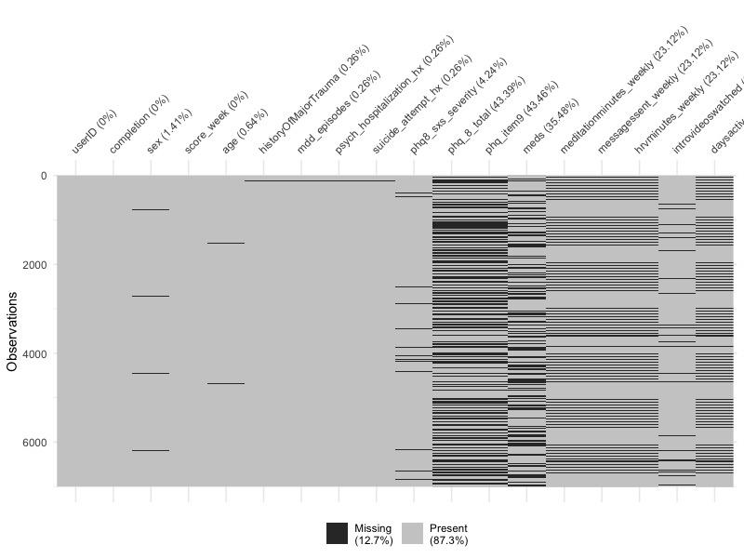

Figure S1. Missing Data

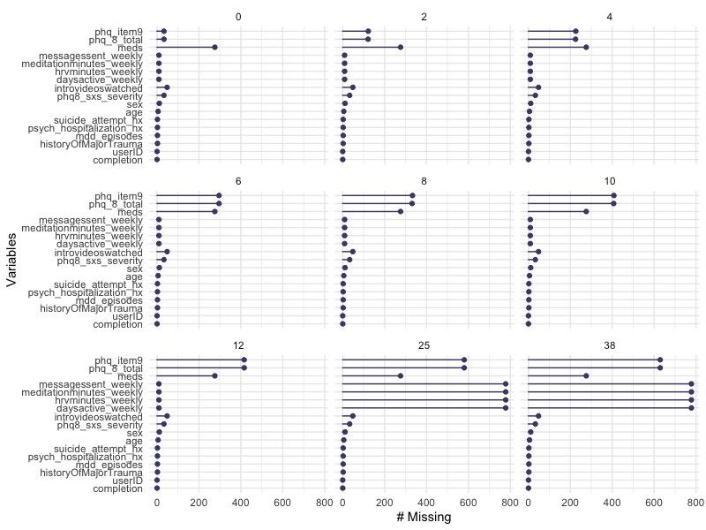

Figure S2. Missing Data by Treatment Week

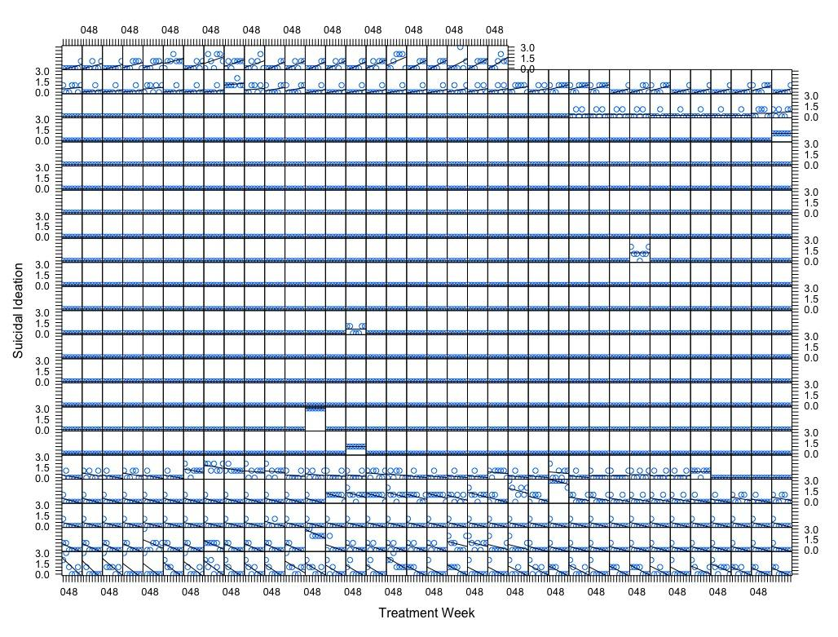

Figure S3. Individual Trajectories of Suicidal Ideation Responses by Treatment and Follow-up Week

Supplementary Tables

Table S1. MLM Model and Fit Statistics
 | Linear Model |  |  |  | Poisson Model |  |  |  | Negative Binomial Model
Predictors | Standardized Beta | Standardized SE | Standardized  95% CI | P-Value | Log-Mean | SE | 95% CI | P-Value | Log-Mean | SE | 95% CI | P-Value
(Intercept) | -0.321 | 0.062 | -0.442 – -0.201 | <0.001 | -4.197 | 0.481 | -5.140 – -3.255 | <0.001 | -4.197 | 0.560 | -5.296 – -3.099 | <0.001
Treatment Week | -0.110 | 0.013 | -0.137 – -0.084 | <0.001 | -0.158 | 0.022 | -0.201 – -0.114 | <0.001 | -0.158 | 0.013 | -0.183 – -0.132 | <0.001
Sex- Male | 0.087 | 0.055 | -0.020 – 0.194 | 0.111 | 0.259 | 0.171 | -0.076 – 0.594 | 0.130 | 0.259 | 0.177 | -0.089 – 0.606 | 0.144
Sex- Other | -0.620 | 0.631 | -1.857 – 0.617 | 0.326 | -15.901 | 2063.644 | -4060.570 –  4028.767 | 0.994 | -22.229 | 65819.200 | -129025.490 –  128981.032 | 1.000
Age | -0.045 | 0.023 | -0.090 – 0.001 | 0.054 | -0.016 | 0.006 | -0.028 – -0.003 | 0.014 | -0.016 | 0.007 | -0.028 – -0.003 | 0.017
Average Days Active Weekly | -0.098 | 0.012 | -0.122 – -0.075 | <0.001 | -0.047 | 0.010 | -0.066 – -0.028 | <0.001 | -0.047 | 0.010 | -0.067 – -0.028 | <0.001
Single MDE | 0.121 | 0.069 | -0.014 – 0.256 | 0.078 | 0.472 | 0.233 | 0.014 – 0.929 | 0.043 | 0.472 | 0.249 | -0.016 – 0.959 | 0.058
Recurrent MDE | 0.205 | 0.055 | 0.097 – 0.312 | <0.001 | 0.871 | 0.176 | 0.527 – 1.216 | <0.001 | 0.871 | 0.185 | 0.508 – 1.234 | <0.001
Lifetime Psychiatric Hospitalization-Yes | 0.433 | 0.116 | 0.206 – 0.660 | <0.001 | 0.563 | 0.290 | -0.006 – 1.132 | 0.053 | 0.563 | 0.290 | -0.006 – 1.132 | 0.052
Lifetime Suicide Attempt-Yes | -0.005 | 0.123 | -0.245 – 0.235 | 0.967 | -0.090 | 0.314 | -0.706 – 0.526 | 0.774 | -0.090 | 0.316 | -0.709 – 0.529 | 0.775
Lifetime Major Traumatic Event Exposure- Unknown | -0.018 | 0.162 | -0.337 – 0.300 | 0.910 | 0.151 | 0.427 | -0.687 – 0.988 | 0.724 | 0.151 | 0.434 | -0.700 – 1.002 | 0.728
Lifetime Major Traumatic Event Exposure-Yes | -0.015 | 0.048 | -0.110 – 0.080 | 0.753 | 0.152 | 0.154 | -0.149 – 0.453 | 0.322 | 0.152 | 0.160 | -0.162 – 0.466 | 0.342
Baseline PHQ-8 Symptom Severity- Mild | 0.012 | 0.068 | -0.121 – 0.145 | 0.864 | 1.049 | 0.437 | 0.193 – 1.905 | 0.016 | 1.049 | 0.533 | 0.004 – 2.094 | 0.049
Baseline PHQ-8 Symptom Severity- Moderate | 0.131 | 0.072 | -0.010 – 0.272 | 0.068 | 2.010 | 0.424 | 1.178 – 2.841 | <0.001 | 2.010 | 0.515 | 1.001 – 3.018 | <0.001
Baseline PHQ-8 Symptom Severity- Moderately Severe | 0.420 | 0.075 | 0.272 – 0.567 | <0.001 | 2.797 | 0.420 | 1.975 – 3.620 | <0.001 | 2.797 | 0.509 | 1.800 – 3.795 | <0.001
Baseline PHQ-8 Symptom Severity- Severe | 0.579 | 0.099 | 0.386 – 0.773 | <0.001 | 3.210 | 0.441 | 2.344 – 4.075 | <0.001 | 3.210 | 0.526 | 2.180 – 4.240 | <0.001
Taking Psychotropic Medication | 0.022 | 0.034 | -0.045 – 0.089 | 0.519 | 0.005 | 0.114 | -0.219 – 0.229 | 0.967 | 0.005 | 0.118 | -0.227 – 0.237 | 0.968
Random Effects
σ² | 0.08 |  |  |  | 3.78 |  |  |  | 3.78
τ₀₀ | 0.11 _{userID} |  |  |  | 1.12 _{userID} |  |  |  | 1.12 _{userID}
τ₁₁ | 0.00 _{userID.score_week} |  |  |  | 0.01 _{userID.score_week} |  |  |  | 0.01 _{userID.score_week}
ρ₀₁ | -0.75 _{userID} |  |  |  | 0.14 _{userID} |  |  |  | 0.14 _{userID}
ICC | 0.48 |  |  |  | 0.35 |  |  |  | 0.35
AIC | 3557.244 |  |  |  | 3285.766 |  |  |  | 3287.782
BIC | 3695.900 |  |  |  | 3417.819 |  |  |  | 3426.437
N | 778 _{userID} |  |  |  | 778 _{userID} |  |  |  | 778 _{userID}
Observations | 5446 |  |  |  | 5446 |  |  |  | 5446
Marginal R² / Conditional R² | 0.108 / 0.536 |  |  |  | 0.289 / 0.540 |  |  |  | 0.313 / 0.556
Notes: CI=confidence interval, MDE = Major Depressive Episode, PHQ = Patient Health Questionnaire, SE=standard error. Symptom severity is measured by baseline PHQ-8 score as follows: less than mild=0-4, mild=5-9, moderate=10-14, moderately severe=15-19, severe=20+.

