Supplemental methods for
Toward marker-assisted breeding for bioaccessible provitamin A in sorghum: genetic and environmental basis of carotenoid bioaccessibility

Rae McDowell¹, Álvaro Cruz-Carrión², Chelsey Fiecke², Michael P. Dzakovich³, Richard E. Boyles⁴, Hugo Cuevas⁵, Terry Felderhoff ⁶, Chad Hayes⁷, Elizabeth A. Cooper⁸, John K. McKay⁹, Jacqueline M Chaparro¹, Jessica E. Prenni¹, Geoffrey P. Morris⁹, Mario Ferruzzi^{2,10}, and Davina H. Rhodes¹*²

¹Cell and Molecular Biology Program, Department of Horticulture & Landscape Architecture, Colorado State University, Fort Collins, CO 80523, USA
²University of Arkansas for Medical Sciences, Department of Pediatrics; Arkansas Children’s Nutrition Center, United States, USA
³Department of Pediatrics, Baylor College of Medicine, USDA-ARS Children’s Nutrition Research Center, Houston, TX, United States, USA
⁴Department of Plant and Environmental Sciences, Clemson University, Clemson, South Carolina, USA
⁵USDA-ARS, Tropical Agriculture Research Station, 2200 Pedro Albizu Campos Avenue, Mayaguez, Puerto Rico 00680, USA
⁶Department of Agronomy, Kansas State University, Manhattan, KS, 66506, USA
⁷USDA-ARS, Plant Stress & Germplasm Development Research Unit, Cropping Systems Research Laboratory, Lubbock, TX, 79415, USA
⁸Department of Bioinformatics and Genomics, UNC Charlotte, Kannapolis, NC 28081
⁹Department of Soil & Crop Science, Colorado State University, Fort Collins, CO 80523, USA
¹⁰College of Agriculture and Life Sciences, Virginia Tech, Blacksburg, Virginia 24061, USA

*Corresponding author (davina.rhodes@colostate.edu)

Checking data and quality control
Proportion of heterozygosity was calculated for 223 F6 lines using TASSEL (Figure S1). At the F6 generation, RILs are expected to retain more than expected heterozygosity were removed, where these ranged from 6-40% heterozygosity.

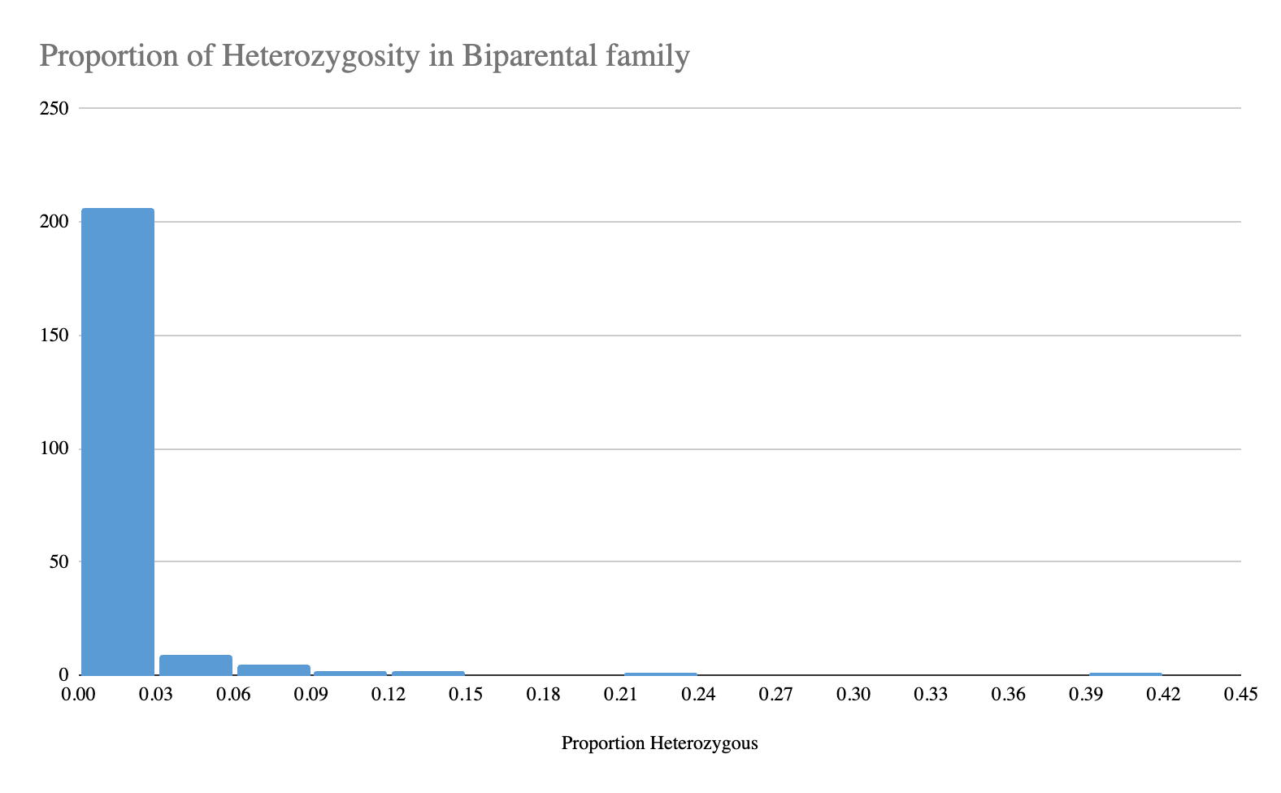
Figure SM1. Proportion of heterozygosity from individual lines at F6 genotyping

Checking for errors in R/QTL revealed more inconsistencies in the data and that there were unusually high amounts of recombination for a large number of individuals. Individuals that had high predicted error from using the “calc.errorlod” function with an error rate of 0.01 and had unusually high rates of recombination across several chromosomes were removed. Pre-filtering, the genetic composition of the progeny of parental markers was 53.3% AA, 43.3% BB, and 3.46% AB. Removal of suspected contaminated lines left the mapping population with the allele frequencies: 52.1% AA, 2.5% AB, and 47.9% BB, with parent A being RTx430 and parent B being the carotenoid donor PI585348.

Six lines were initially removed for failing genotyping, and then 11 lines were removed due to high (>6%) heterozygosity. Kinship patterns of the progeny also showed two distinct clusters of genetic structure as seen in Figure 2 of a kinship matrix derived from R/GAPIT. Then, 69 lines were removed as being identified as outliers from PCA1 (Figure 7 C) and from the kinship matrix (Figure 2 A). The remaining lines were removed for unusual identical blocks of recombination (Figure 4), leading to the total removal of 83 lines.

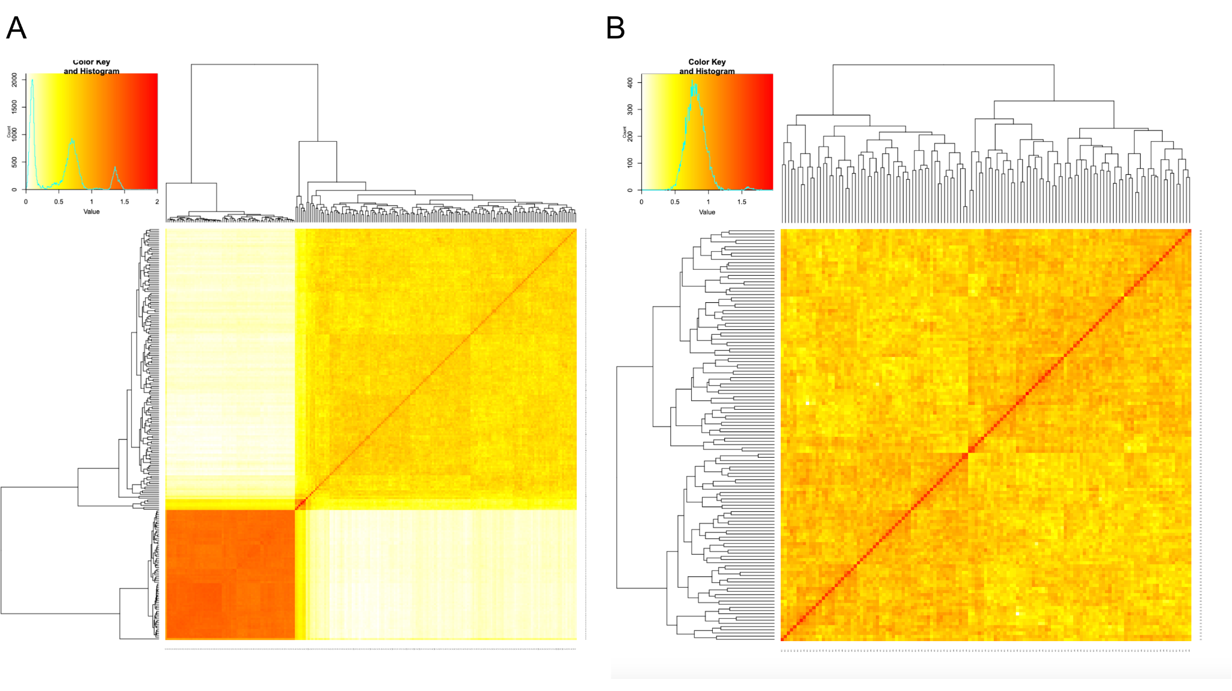
Figure SM2. Kinship matrix of A) unfiltered biparental mapping family with clear subgrouping of genotypes that violates expectation of an inbred family (n= 223 with 2 parents) and B) filtered biparental (n= 140 with 2 parental lines) where lines were removed for 1) being an outlier on PCA and kinship matrix, >6% heterozygosity, and 2) unusual predicted recombinations. Lines classified in the lower left hand matrix A were classified as a divergent genomic cluster.

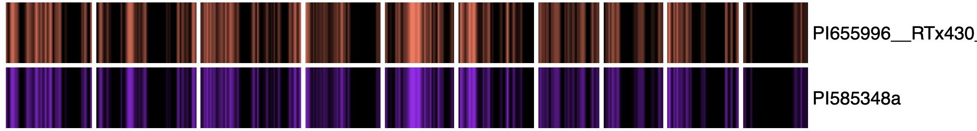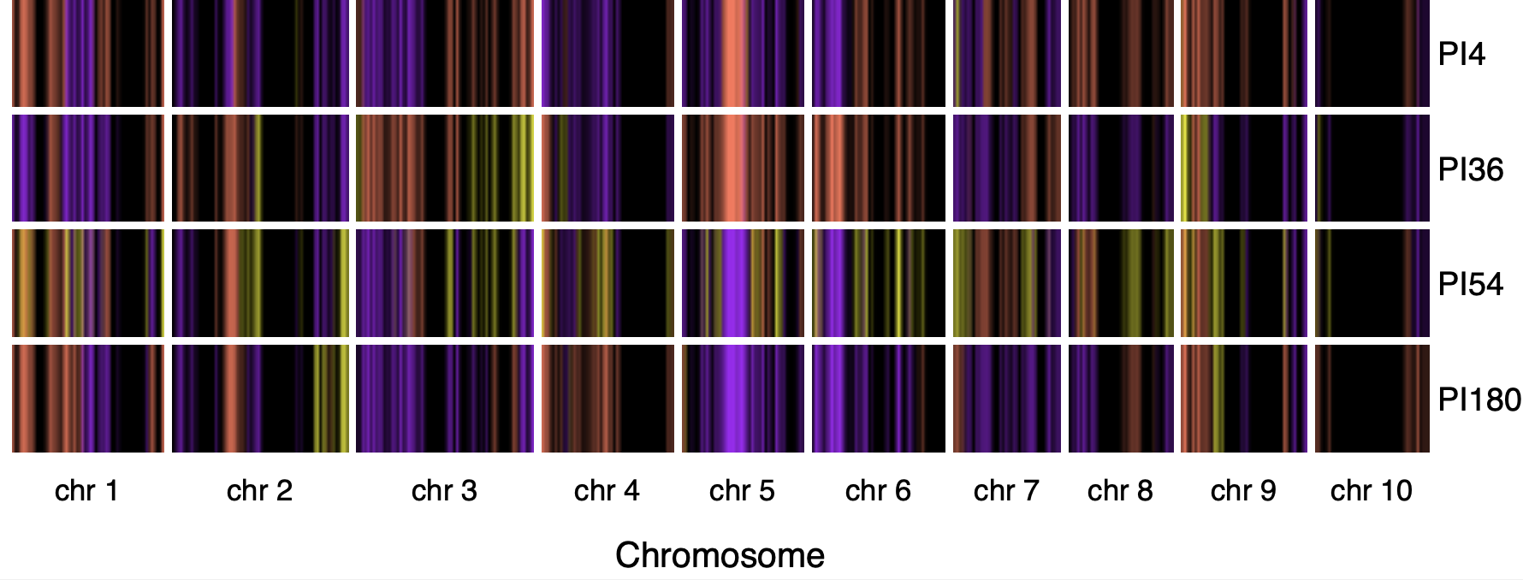Figure SM3. Example visualization of high heterozygosity lines. Pink represents B alleles, Purple represents A alleles and yellow represents heterozygotes while black represents a lack of marker or a monomorphic marker between the parents. Each vertical line represents the allele at that marker site for the 639 markers across the 10 chromosomes. The line PI54 had about 11% heterozygous marker states whereas PI180 and PI4 had within the tolerable threshold.

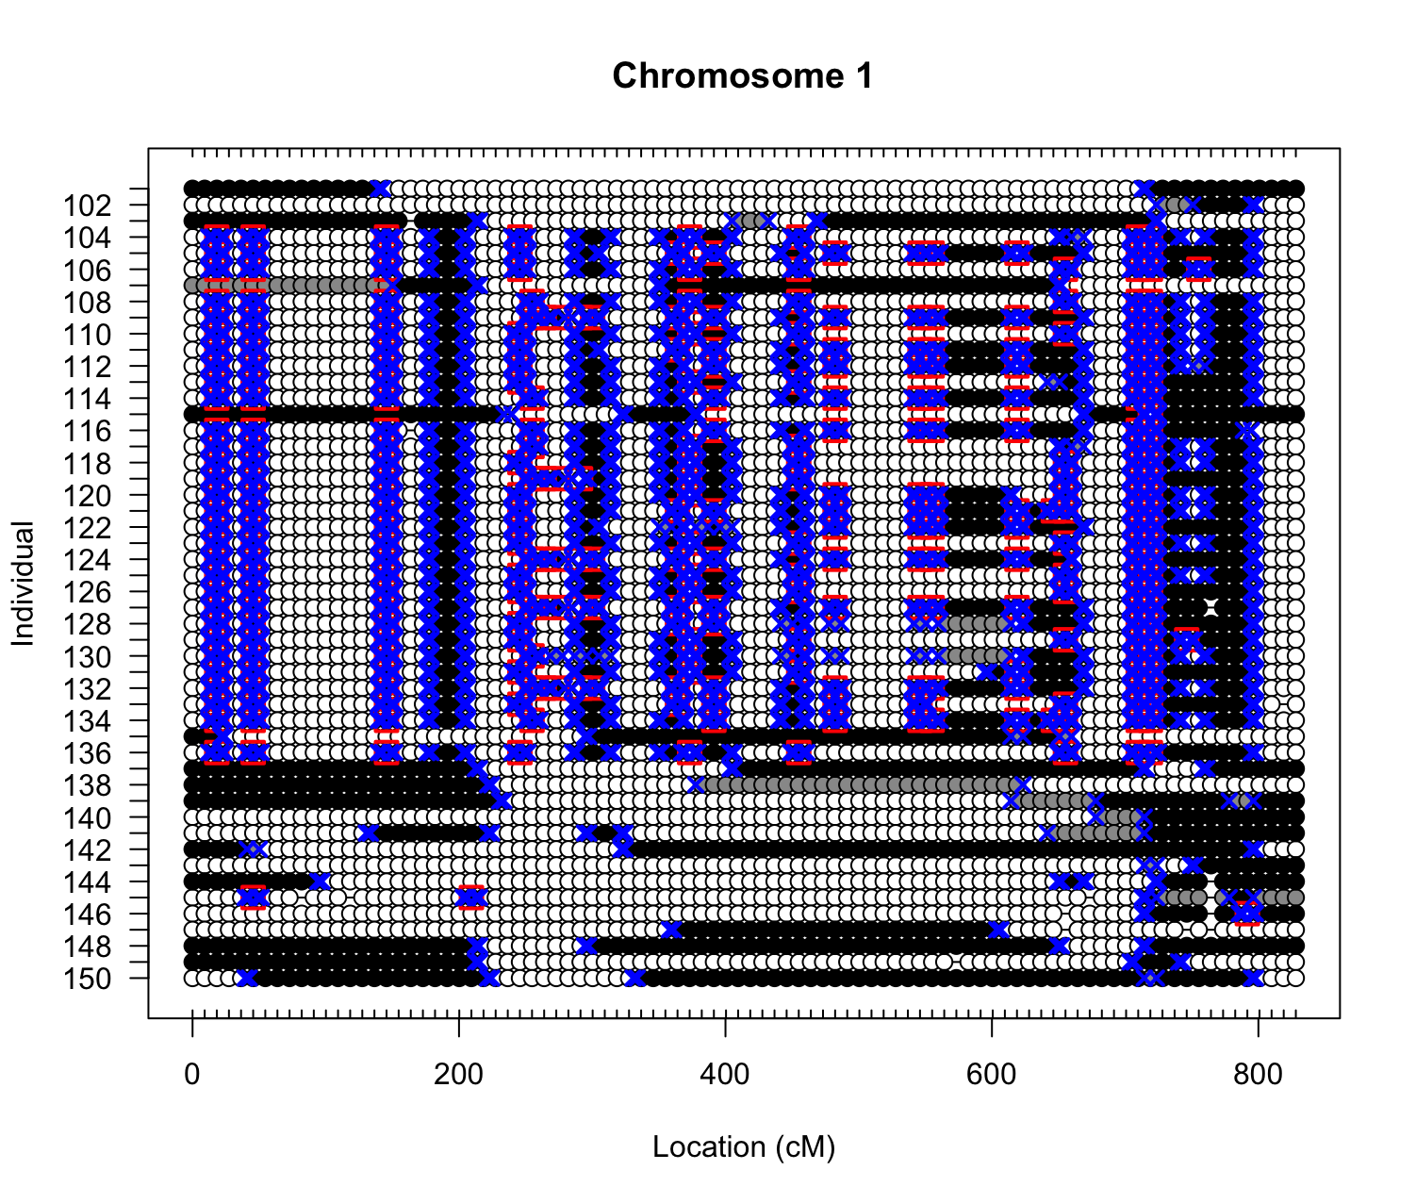
Figure SM4. Example of unusual recombination patterns in suspect progeny.
Recombination prediction plot from R/QTL where blue X’s represent predicted crossing over events through different parental allele states in the progeny. White and black circles represent parental alleles in the homozygous state, whereas grey circles represent heterozygous alleles. Red boxes denote predicted errors. Examples of individuals that had higher proportions of recombinations and double crossovers than expected. These recombinations happened at the same loci, which violates assumptions of random assortment of gametes and generally random crossing over.

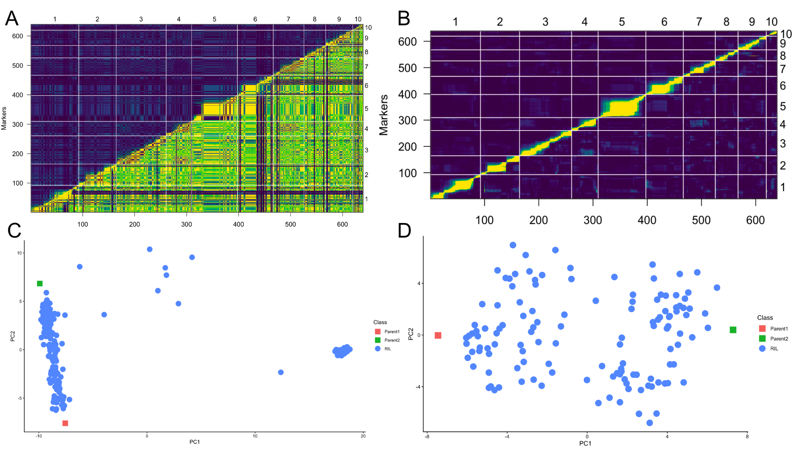
Figure SM5. Pairwise recombination fractions and PCA scores for individuals A) after filtering out high heterozygosity lines B) after additionally filtering out identified divergent genotypes. The ~600 SNP markers are on both the x and y axis across 10 chromosomes, where in the right corner below the diagonal are the estimated recombination fraction for all pairs of markers. As seen through the lack of hotspots in B compared to A, there are less expected errors in the data that are from higher than expected recombination events. The PCAs below the pairwise recombination plots also depict the improvement of family structure, where the C) PCA before filtering lines shows an abnormal structure and clustering that is not to be expected. However after filtering, D) the PCA shows the expected structure of genotypes, where the RILs that share genetic material from both parents cluster in the center between both parents on the extreme ends. Lines with PC1 > - 5 were classified as members of the divergent genomic cluster.

Filtering was made conservative due to the fact that inclusion of genetically divergent individuals could lead to spurious identification of false positive QTL during mapping, therefore the ambiguous individuals were excluded from analysis due to multiple genomic QC metrics that indicated inconsistencies in the expected structure of the biparental family.

