Supporting information for
Toward marker-assisted breeding for bioaccessible provitamin A in sorghum: genetic and environmental basis of carotenoid bioaccessibility

Rae McDowell¹, Álvaro Cruz-Carrión², Chelsey Fiecke², Michael P. Dzakovich³, Richard E. Boyles⁴, Hugo Cuevas⁵, Terry Felderhoff ⁶, Chad Hayes⁷, Elizabeth A. Cooper⁸, John K. McKay⁹, Jacqueline M Chaparro¹, Jessica E. Prenni¹, Geoffrey P. Morris⁹, Mario Ferruzzi^{2,10}, and Davina H. Rhodes¹*²

¹Cell and Molecular Biology Program, Department of Horticulture & Landscape Architecture, Colorado State University, Fort Collins, CO 80523, USA
²University of Arkansas for Medical Sciences, Department of Pediatrics; Arkansas Children’s Nutrition Center, United States, USA
³Department of Pediatrics, Baylor College of Medicine, USDA-ARS Children’s Nutrition Research Center, Houston, TX, United States, USA
⁴Department of Plant and Environmental Sciences, Clemson University, Clemson, South Carolina, USA
⁵USDA-ARS, Tropical Agriculture Research Station, 2200 Pedro Albizu Campos Avenue, Mayaguez, Puerto Rico 00680, USA
⁶Department of Agronomy, Kansas State University, Manhattan, KS, 66506, USA
⁷USDA-ARS, Plant Stress & Germplasm Development Research Unit, Cropping Systems Research Laboratory, Lubbock, TX, 79415, USA
⁸Department of Bioinformatics and Genomics, UNC Charlotte, Kannapolis, NC 28081
⁹Department of Soil & Crop Science, Colorado State University, Fort Collins, CO 80523, USA
¹⁰College of Agriculture and Life Sciences, Virginia Tech, Blacksburg, Virginia 24061, USA

*Corresponding author (davina.rhodes@colostate.edu)

Supplementary Figures

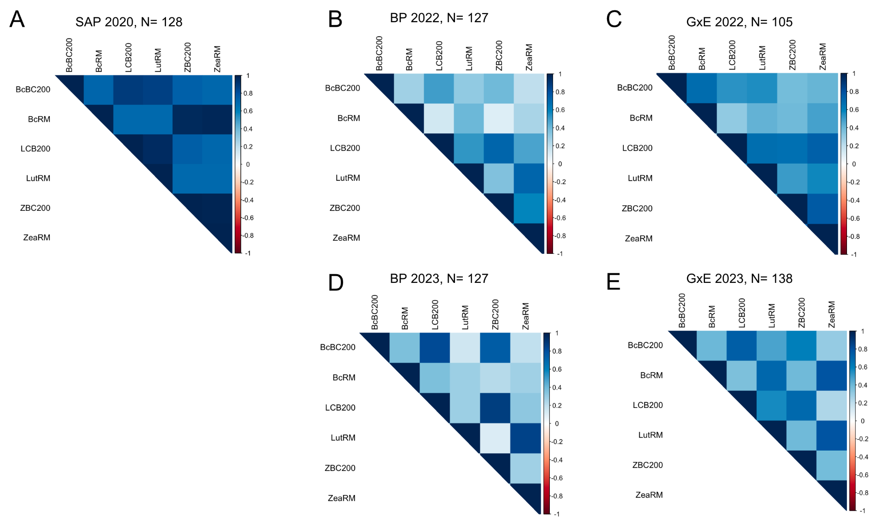Figure S1: Correlations between bioaccessible content and raw material carotenoids in A) the SAP, B) 2022 Biparental, C) 2022 GxE, D) 2023 Biparental, E) 2023 GxE. Sample sizes are denoted by N, the temperature scale on the right of each correlation matrix denotes correlation, where r = 1 is blue and r = -1 is red. The darkness of the hue denotes the strength of the correlation.

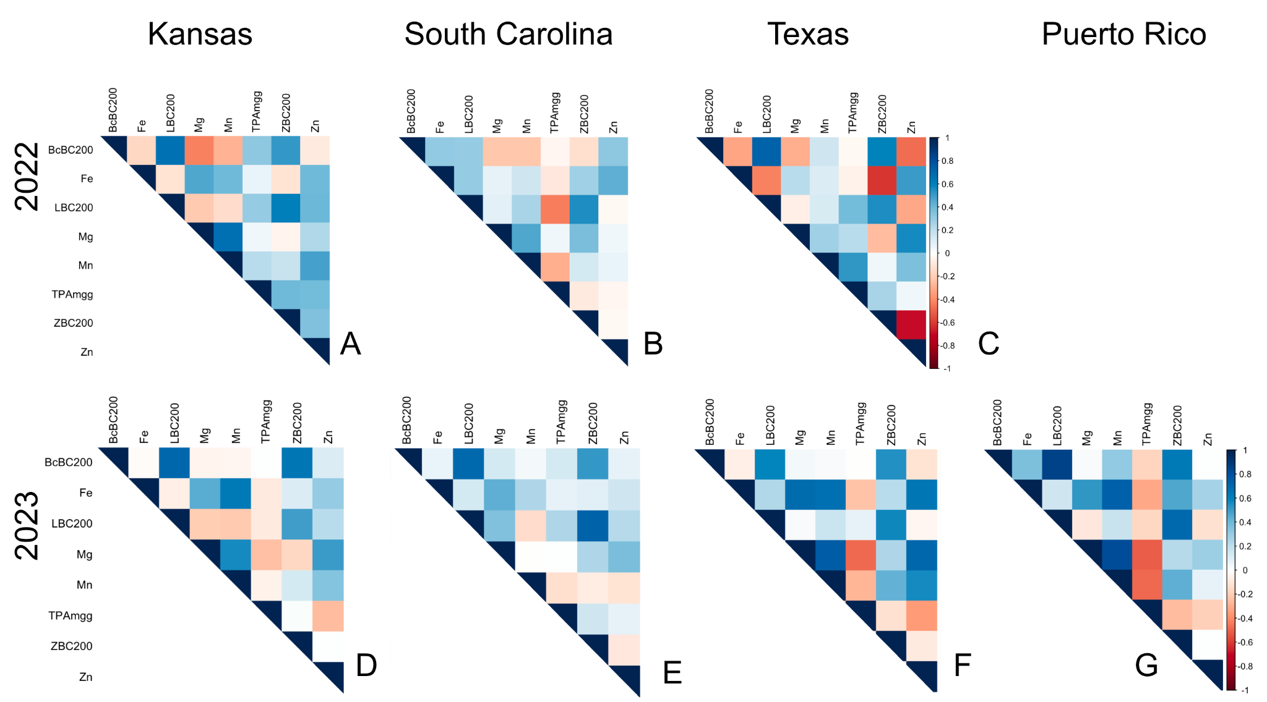

Figure S2: Correlation matrices for carotenoid bioaccessible content and inhibitors across environments and years. Top row: 2022: A) Kansas, B) South Carolina, C) Texas. Bottom row: 2023: D) Kansas, E) South Carolina, F) Texas, G) Puerto Rico

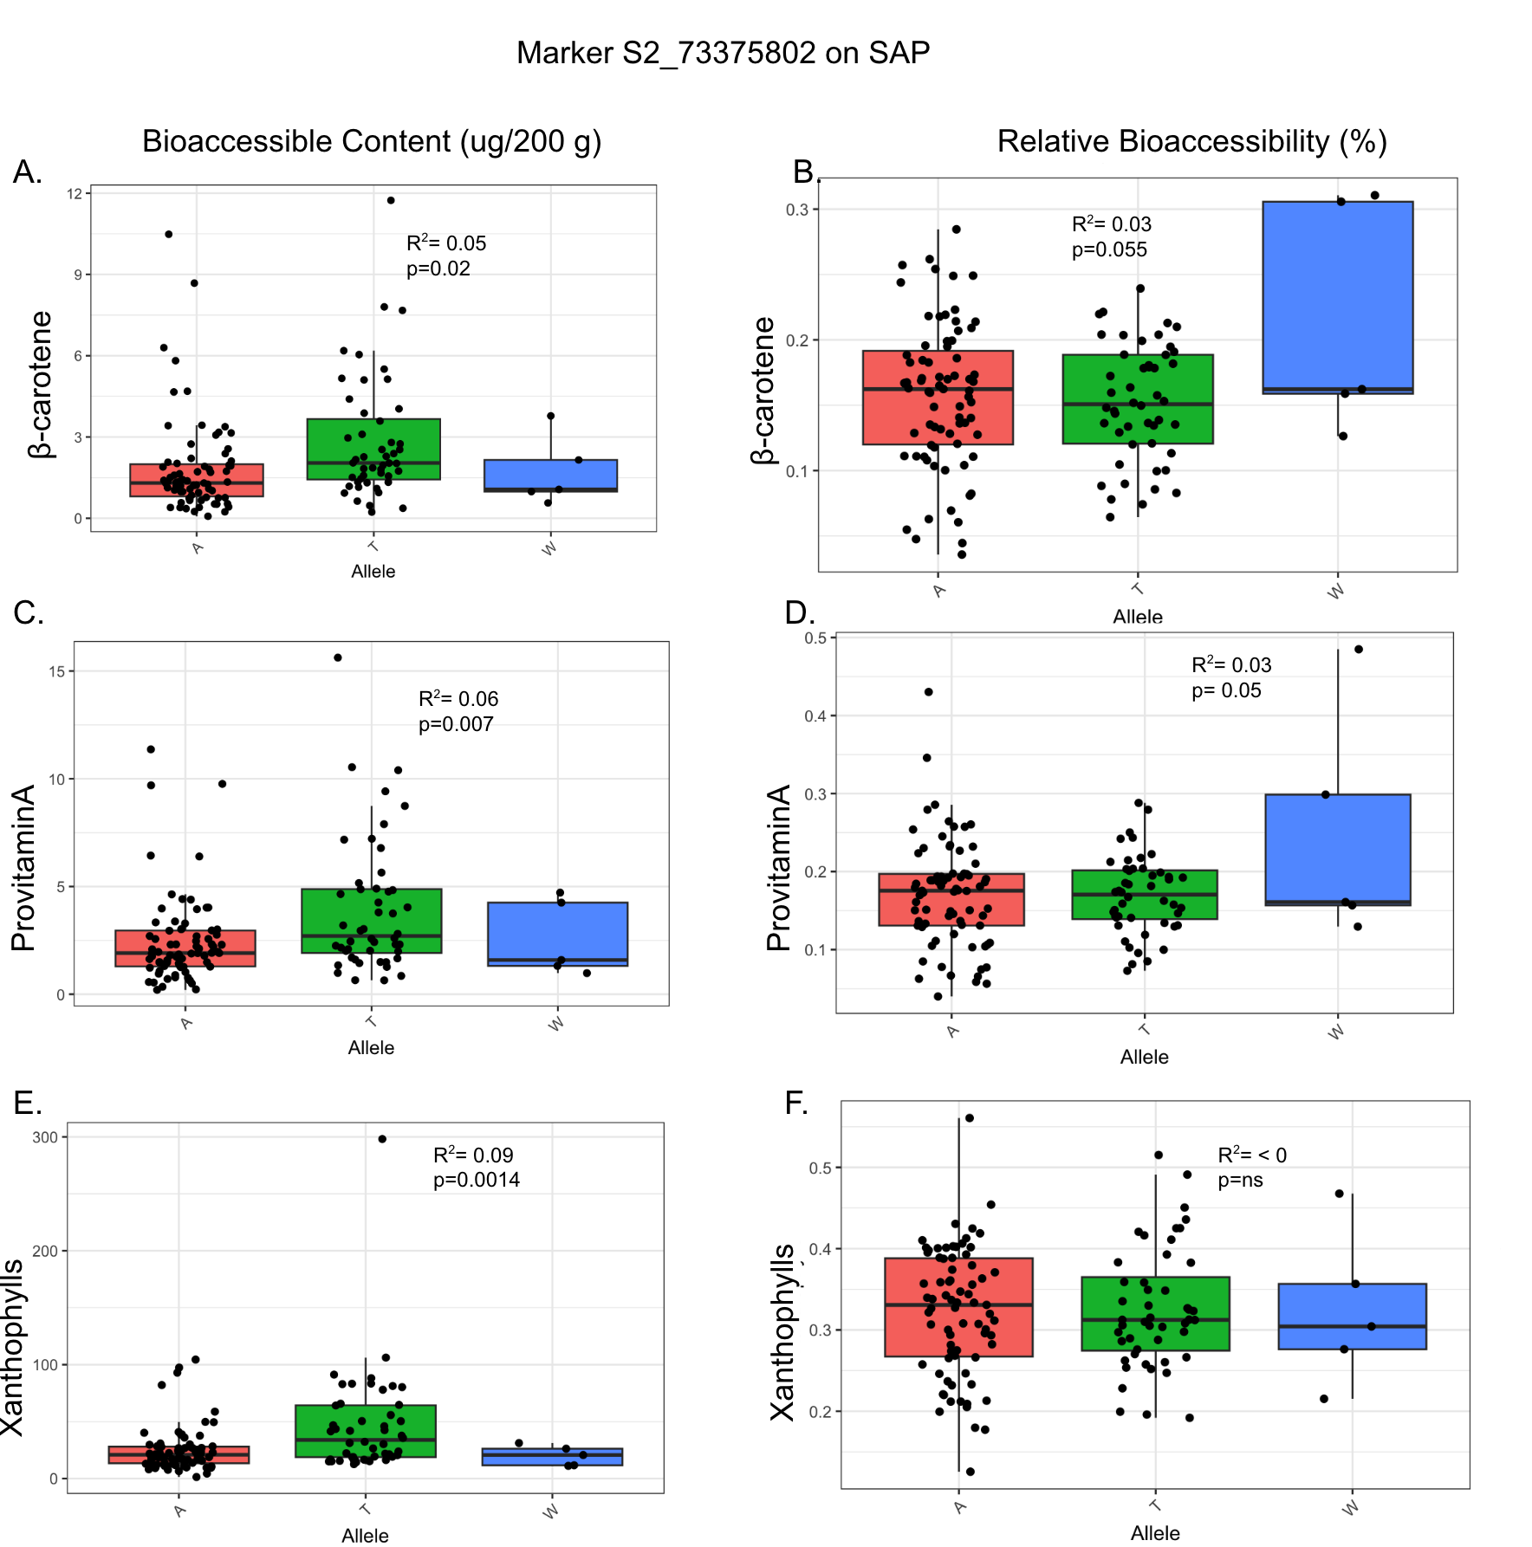

Figure S3: Boxplots of S2_73375802 QTL explains partial variance in bioaccessibility traits in the diversity panel. Left (A,C,E) Bioaccessible content of A) β-carotene, C) Provitamin A, D) Xanthophylls. Right (B,D,F). Relative bioaccessibility of B) β-carotene, D) Provitamin A, and F) Xanthophylls

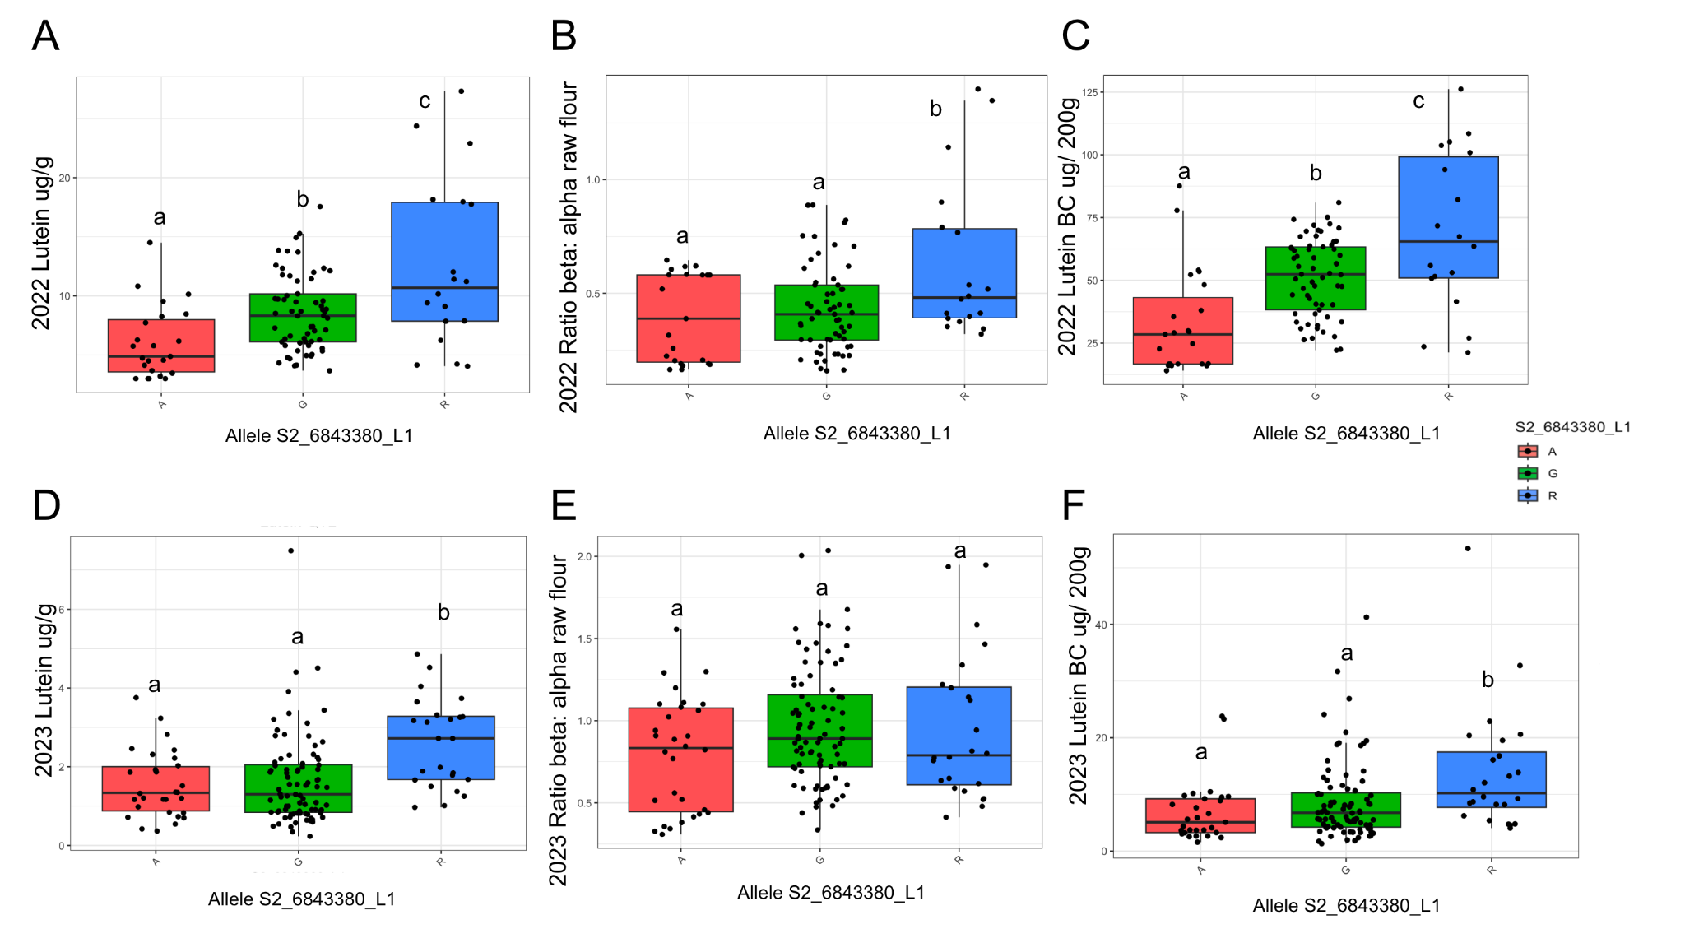

Figure S4: Boxplots comparing carotenoid traits in 2022 and 2023 GxE data by Lutein QTL S2_6843380. Top row: 2022: A) Lutein content ug/g, B) ratio of β and 𝛂 branch products in flour, C) Lutein bioaccessible content (BC) ug/200g; Bottom row: 2023: D) Lutein content ug/g, E) ratio of β and 𝛂 branch products in flour, F) Lutein bioaccessible content (BC) ug/200g

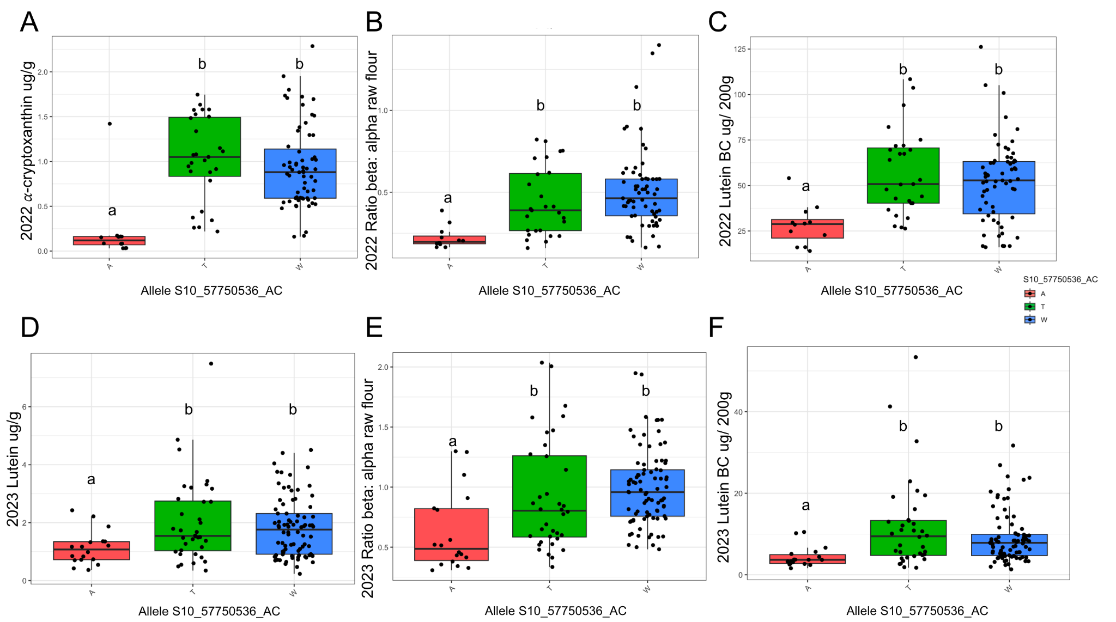

Figure S5: Boxplots comparing carotenoid traits in 2022 and 2023 GxE data by the alpha-cryptoxanthin QTL S10_57750536. Top row: 2022: A) Alpha-cryptoxanthin ug/g, B) ratio of β and 𝛂 branch products in flour, C) Lutein bioaccessible content (BC) ug/200g; Bottom row: 2023: D) Lutein content ug/g, E) ratio of β and 𝛂 branch products in flour, F) Lutein bioaccessible content (BC) ug/200g

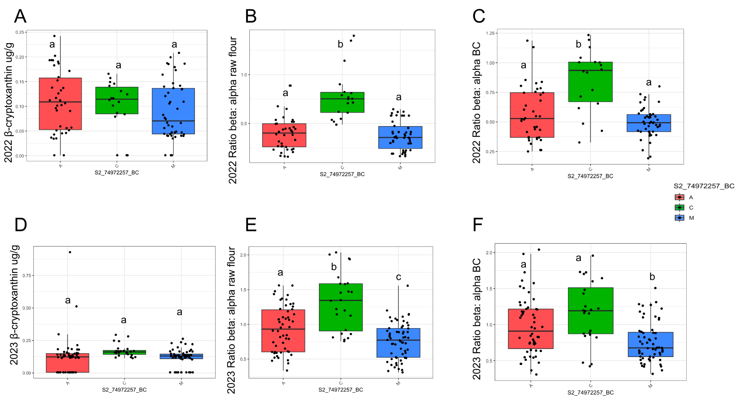

Figure S6: Boxplots comparing carotenoid traits in 2022 and 2023 GxE data by the β-cryptoxanthin QTL S2_74972257. Top row: 2022: A) β-cryptoxanthin ug/g, B) ratio of β and 𝛂 branch products in flour, C) ratio of bioaccessible β and 𝛂 branch products; Bottom row: 2023: D) β-cryptoxanthin ug/g E) ratio of β and 𝛂 branch products in flour, F) ratio of bioaccessible β and 𝛂 branch products

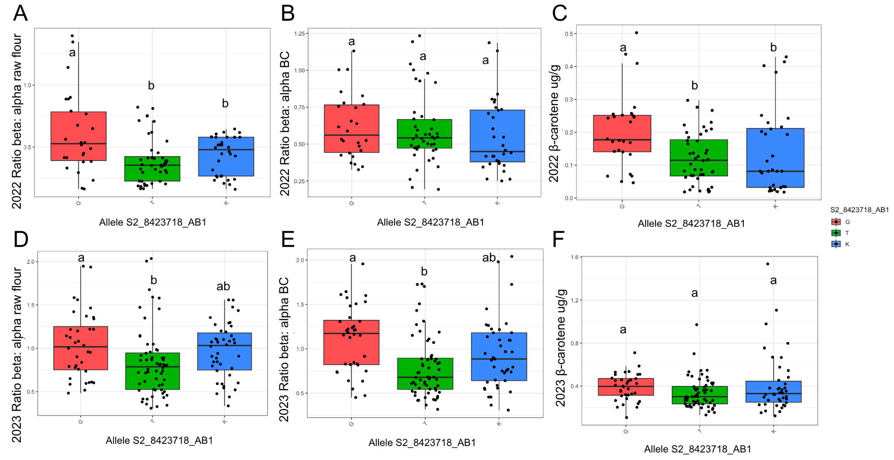

Figure S7: Boxplots comparing carotenoid traits in 2022 and 2023 GxE data by the alpha: β branch products QTL S2_8423718. Top row: 2022: A) ratio of β and 𝛂 branch products in flour, B) ratio of bioaccessible β and 𝛂 branch products, C) β-carotene ug/g; Bottom row: 2023: D) ratio of β and 𝛂 branch products in flour, E) ratio of bioaccessible β and 𝛂 branch products, F) β-carotene ug/g

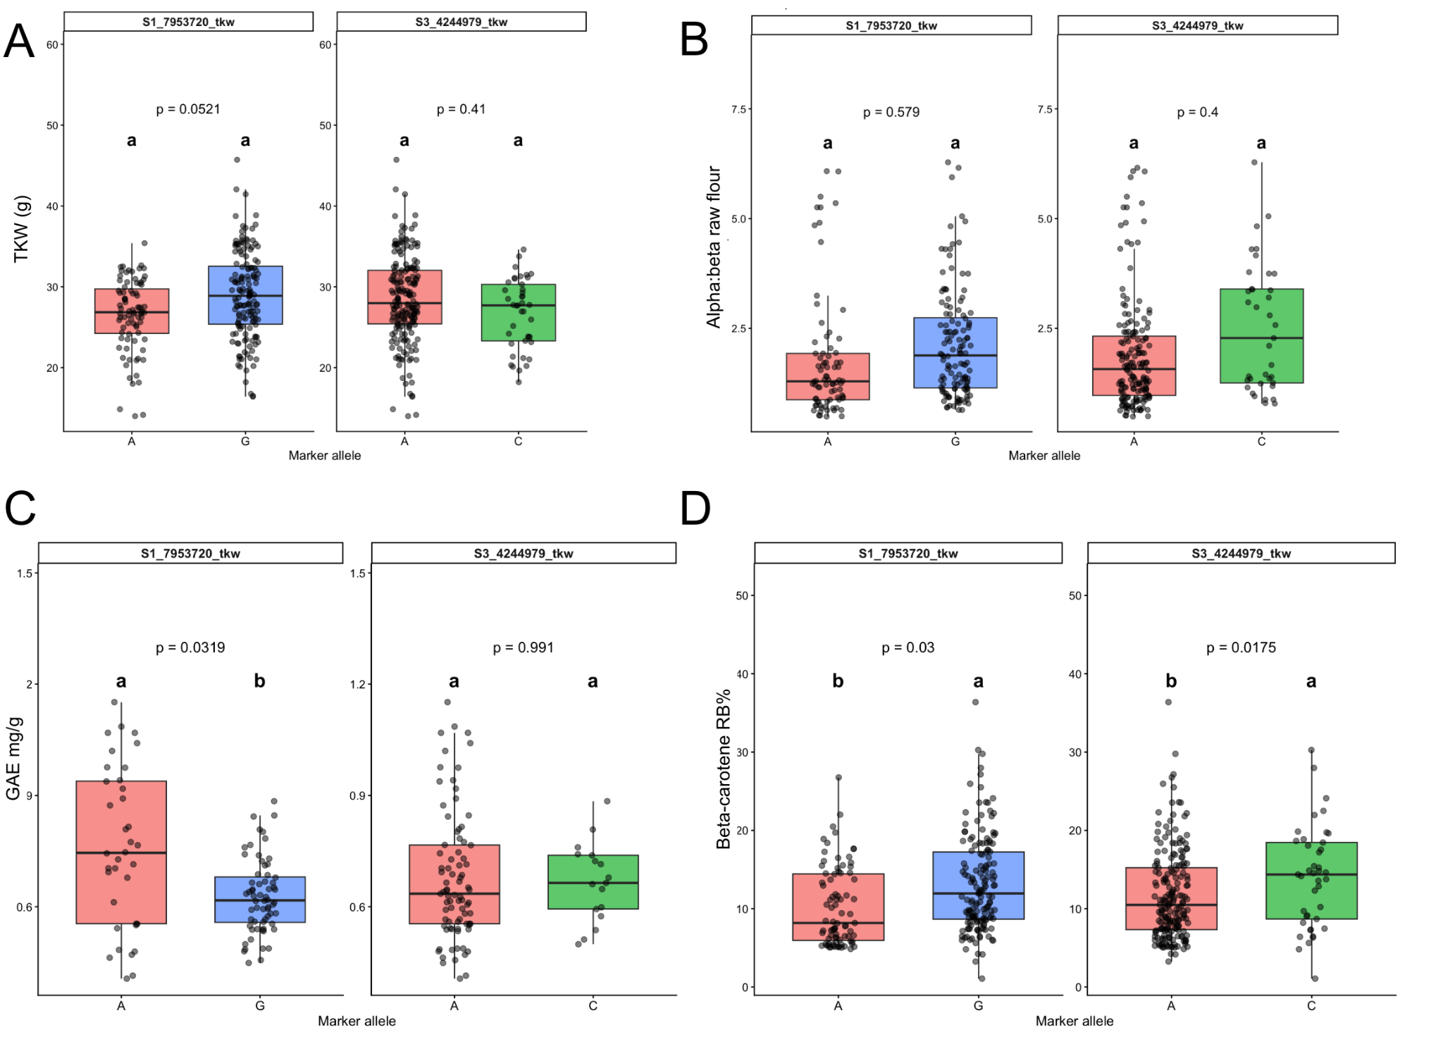

Figure S8: Boxplots comparing carotenoid traits in pooled GxE data by the TKW QTL S1_7953720 and S3_4244979. A) thousand kernel weight (g) B) ratio of 𝛂 and β branch products in raw flour C) GAE mg/g; D) β-carotene Relative Bioaccessibility %

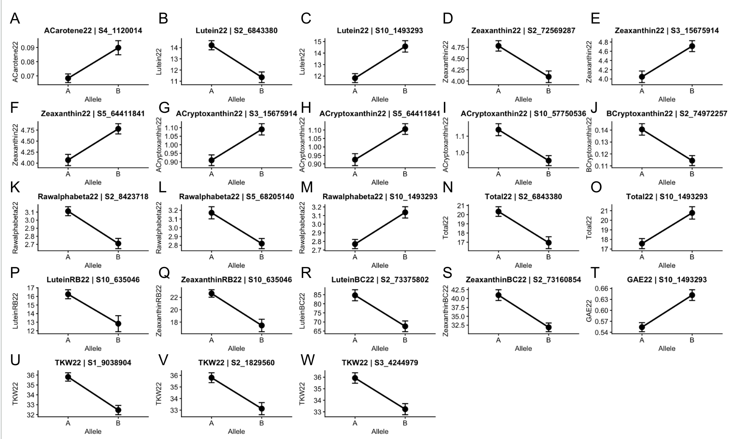

Figure S9: Allele Effects of markers in QTL data for Parental A and Parent B alleles. (A) ACarotene22 ~S4_1120014, (B) Lutein22 ~ S2_6843380, (C) Lutein22 ~ S10_1493293 (D) Zeaxanthin22 ~ S2_72569287, (E) Zeaxanthin22 ~S3_15675914, (F) Zeaxanthin22 ~ S5_64411841, (G) ACryptoxanthin22 ~ S3_15675914, (H) ACryptoxanthin22 ~ S5_64411841, (I)ACryptoxanthin22 ~ S10_57750536, (J) BCryptoxanthin22~ S2_74972257, (K) Rawalphabeta22 ~ S2_8423718, (L) Rawalphabeta22 ~S5_68205140, (M) Rawalphabeta22 ~S10_1493293, (N) Total22 ~S2_6843380, (O)Total22 ~ S10_1493293, (P) LuteinRB22 ~S10_635046, (Q) ZeaxanthinRB22 ~S10_635046, (R) LuteinBC22 ~ S2_73375802, (S) ZeaxanthinBC22 ~ S2_73160854, (T) GAE22 ~S10_1493293, (U) TKW22 ~ S1_9038904, (V) TKW22~ S2_1829560, (W) TKW22 ~S3_4244979

Supplementary Tables

Table S1. Average climatic conditions per environment for June 01 2022- October 31 2022.
 | Humid Continental | Humid Subtropical | Semi Arid
Location | Manhattan, KS | Florence, SC | Lubbock, TX
Field coordinates | nd | 34.31118530962418, -79.7445732985552 | nd
Elevation | 1,056 (322) | 126 ft. (38 m) | 3,202 (976 m)
Total Precipitation (in) | 15.9” | 14.8” | 10.1“
Temperature (℉)  Average | Max: 84.8 Min: 60.4 | Max: 84.6 Min: 64.7 | Max: 89.1 Min: 64.7
Average Soil divalent minerals (lbs/A) | Mg= 128  Ca= 4762  Zn= 2.6  Mn= nd  Fe= nd  (test from 2017) | Mg= 94  Ca= 539  Zn= 5.23  Mn= 9  Fe= nd  (test from 2022) | Mg= 1054  Ca= 3524  Zn= 5.8  Mn= 206  Fe= 78  (test from 2022)
Average soil pH | 8.3 | 7.8 | 7.8
Drying method | Not bagged, Forced air dried 35℃ | Not bagged, strung and air dried | Mesh bagged, field dried
Planting- Harvest date | 6/20 - 10/28 | 5/26- 9/12 | 9/26 | 6/15 - 10/10
Climate data source | https://mesonet.k-state.edu/weather/historical/#! | Weather station on site and https://www.visualcrossing.com/weather-history/florence,%20SC/us/2022-06-01/2022-10-31 | https://www.weather.gov/lub/events-2022-20221231-summary

Table S2. 2022 Mean carotenoid bioaccessibility traits across environments.
 | Kansas | South Carolina | Texas
β-Carotene bioaccessible content (ug/ 200g)*** | 0.09 ± 0.05ª | 0.18 ± 0.07^{b} | 0.22 ± 0.07^{c}
Lutein bioaccessible content (ug/ 200g)*** | 35.9 ± 13.7ª | 67.7 ± 23.7^{b} | 49.9 ± 16.6^{c}
Zeaxanthin bioaccessible content (ug/ 200g)*** | 18.8 ± 8.3ª | 36.8 ± 18.7^{b} | 31.7 ± 12.8^{b}
β-Carotene Relative Bioaccessibility %^{ns} | 4.5 % ± 3.3ª | 3.3 % ± 1.3ª | 4.3 % ± 3.8ª
Lutein Relative Bioaccessibility %*** | 16.5 % ± 6.6ª | 17.9% ± 6.6ª | 12.7 % ± 3.7^{b}
Zeaxanthin Relative Bioaccessibility % * | 23.7 % ± 8.4ª | 19.8 % ± 7.7^{ab} | 18.9 % ± 6.6^{b}
Bioaccessible Provitamin A: Bioaccessible Total %*** | 0.52 % ± 0.28ª | 0.44 % ± 0.21ª | 0.86% ± 0.37^{b}
Letters denote significant differences between environments within rows to a significance level of 0.05. Bioaccessible content is per 200 g serving of porridge or 40 g flour.

Table S3. 2023 Mean carotenoid bioaccessibility traits across environments.
 | Kansas | South Carolina | Texas | Puerto Rico
β-Carotene bioaccessible content (ug/ 200g)* | 1.60 ± 0.9^{ab} | 2.1 ± 1.2^{ab} | 1.5 ±0.7^{b} | 2.2 ± 1.4ª
Lutein bioaccessible content (ug/ 200g)*** | 6.6 ± 3.9ª | 10.2 ± 7.3^{ab} | 6.1 ± 3.1ª | 14.5 ± 11.6^{b}
Zeaxanthin bioaccessible content (ug/ 200g)^{ns} | 4.3 ± 2.5 | 6.4 ± 4.2 | 4.3 ± 2.8 | 6.7 ± 5.5
β-Carotene Relative Bioaccessibility %^{ns} | 13.8 ± 6.6 | 11.7 ± 5.9 | 12.9 ± 5.2 | 14.6 ± 7.1
Lutein Relative Bioaccessibility %^{ns} | 14.1 ± 6.8 | 12.2 ± 6.9 | 14.6 ± 6.7 | 13.6 ± 8.2
Zeaxanthin Relative Bioaccessibility %^{ns} | 16.3 ± 9.7 | 13.0 ± 8.4 | 14.0 ± 5.7 | 14.9 ± 9.6
Bioaccessible Provitamin A: Bioaccessible Total %^{ns} | 13.3 ± 4.1 | 11.1 ± 4.8 | 12.3 ± 4.7 | 13.8 ± 4.7
Letters denote significant differences between environments within rows to a significance level of 0.05. Bioaccessible content is per 200 g serving of porridge or 40 g flour.

Table S4. 2022 Concentration of bioaccessibility traits pooled together across environments.
 | β-Carotene bioaccessible content (ug/ 200g)** | Lutein + Zeaxanthin bioaccessible content (ug/ 200g)*** | β-Carotene Relative Bioaccessibility %*** | Lutein Relative Bioaccessibility %*** | Zeaxanthin Relative Bioaccessibility %**
PI533877 | 0.52 ± 0.26^{ab} | 119.7 ± 39.5ª | 3.8 ± 1.3^{ab} | 12.4± 3.4^{ab} | 18.0± 3.1^{ab}
PI563068 | 0.63 ± 0.52^{ab} | 77.2 ± 42.8^{ab} | 1.4 ± 0.7^{b} | 15.6 ± 3.0^{bc} | 12.6 ± 3.7^{b}
PI563409 | 0.35 ± 0.18^{ab} | 70.5 ± 17.5^{bc} | 9.0 ± 5.1^{c} | 13.2 ± 2.4^{bc} | 22.8 ± 10.1^{ab}
PI563450 | 0.57 ± 0.42^{ab} | 104.0± 51.6^{ac} | 2.5 ± 1.8^{b} | 18.6 ± 8.1^{bc} | 13.7± 4.2^{b}
PI563453 | 0.63 ± 0.20^{ab} | 71.0 ± 26.4^{bc} | 2.6 ± 0.8^{b} | 20.2 ± 5.7^{ac} | 23.6 ± 7.1^{ab}
PI563454 | 0.66 ± 0.07^{ab} | 80.5 ± 21.3^{ac} | 2.5± 0.6^{b} | 13.6 ± 4.3^{bc} | 21.6 ± 10.0^{ab}
PI563455 | 0.46 ± 0.48^{ab} | 83.7 ± 32.3^{ac} | 4.5 ± 2.2^{abd} | 13.5 ± 2.7^{bc} | 21.0± 6.3^{ab}
PI569812 | 0.33 ± 0.15^{ab} | 80.6 ± 14.5^{ac} | 7.5 ± 2.2^{cd} | 15.3 ± 4.7^{bc} | 23.0 ± 9.1^{ab}
PI576426 | 0.20 ± 0.05ª | 32.0 ± 6.9^{b} | 6.1 ± 2.8^{ac} | 10.4 ± 2.4^{b} | 21.8 ± 4.8^{ab}
PI585347 | 0.42 ± 0.04^{ab} | 86.7 ± 34.8^{ac} | 2.0 ± 1.0^{b} | 17.9 ± 6.3^{bc} | 21.2 ± 4.3^{ab}
PI585348 | 0.84 ± 0.51^{ab} | 70.3 ± 23.2^{ab} | 2.5 ± 1.2^{ab} | 16.4 ± 6.1^{bc} | 23.2 ± 11.3^{ab}
PI585369 | 0.76 ± 0.41^{b} | 91.8 ± 12.2^{ac} | 3.3± 0.7^{ab} | 21.4 ± 10.6^{c} | 27.0 ± 6.7ª
Letters denote significant differences between genotypes within columns. p<0.001***, p<0.01**, p<0.05*

Table S5. 2023 Concentration of bioaccessibility traits pooled together across environments.
 | β-Carotene bioaccessible content (ug/ 200g)*** | Lutein + Zeaxanthin bioaccessible content (ug/ 200g)*** | β-Carotene Relative Bioaccessibility % | Lutein Relative Bioaccessibility % | Zeaxanthin Relative Bioaccessibility %
PI533877 | 2.4 ± 1.8^{ab} | 24.2 ± 18.0ª | 15.6 ± 8.4 | 14.8 ± 7.5 | 13.7 ± 7.9
PI563068 | 2.7 ± 1.08^{b} | 18.0 ± 10.3^{ab} | 12.6 ± 6.8 | 12.6 ± 4.5 | 11.4 ± 4.5
PI563409 | 1.8 ± 1.03^{bc} | 16.3 ± 13.4^{ab} | 13.8 ± 8.1 | 17.9 ± 10.2 | 19.7 ± 13.6
PI563450 | 2.6 ± 1.04^{b} | 20.1 ± 11.4^{ac} | 13.0 ± 4.9 | 11.7 ± 5.0 | 12.1 ± 7.7
PI563453 | 1.5 ± 0.8^{bc} | 13.2 ± 7.5^{ab} | 12.6 ± 7.3 | 13.7 ± 8.1 | 16.0 ± 10.9
PI563454 | 1.9 ± 0.85^{bc} | 14.2 ± 10.0^{ab} | 15.2 ± 6.3 | 12.6 ± 8.5 | 14.1 ± 6.6
PI563455 | 1.2 ± 0.58^{ac} | 8.5 ± 4.0^{bc} | 10.8 ± 5.4 | 11.7 ± 4.6 | 12.7 ± 7.9
PI569812 | 2.2 ± 1.15^{bc} | 16.8 ± 10.1^{ab} | 13.4 ± 3.6 | 14.3 ± 5.9 | 13.6 ± 6.4
PI576426 | 1.03 ± 0.44^{c} | 5.4 ± 2.8^{b} | 11.6 ± 4.7 | 8.6 ± 4.6 | 14.8 ± 5.5
PI585347 | 1.05 ± 0.41^{c} | 11.2 ± 7.7^{ab} | 9.6 ± 3.5 | 14.1 ± 8.4 | 11.2 ± 6.6
PI585348 | 1.3 ± 0.60^{bc} | 8.1 ± 5.3^{ab} | 17.3 ± 8.3 | 15.9 ± 6.4 | 16.4 ± 6.7
PI585369 | 2.2 ± 0.62^{bc} | 15.8 ± 8.9^{ab} | 15.7 ± 5.6 | 17.6 ± 6.5 | 20.0 ± 10.2
Letters denote significant differences between genotypes within columns. p<0.001***, p<0.01**, p<0.05*

Table S6. H2 of inhibitor metabolites in 2022 and 2023 GXE
Trait | Breeder's H² |  | H² (Vg/Vt) |  | Ve/Vt |  | Vgxe/Vt |  | Vε/Vt
 | 2022 | 2023 | 2022 | 2023 | 2022 | 2023 | 2022 | 2023 | 2022 | 2023
GAE | 0.46 | – | 0.10 | – | 0.44 | – | 0.31 | – | 0.15 | –
Phytate | 0.21 | 0 | 0.09 | 0 | 0.04 | 0 | 0.81 | 0.30 | 0.07 | 0.70
TKW | 0.49 | 0.75 | 0.13 | 0.20 | 0.23 | 0.43 | 0.22 | 0.22 | 0.41 | 0.16
Fe | 0.28 | 0.73 | 0.04 | 0.23 | 0.24 | 0.25 | 0.08 | 0.25 | 0.11 | 0.27
Zn | 0.63 | 0.64 | 0.21 | 0.13 | 0.28 | 0.48 | 0.29 | 0.24 | 0.23 | 0.14

Table S7: QTL identified in current study that overlap with QTL identified in published literature
QTL_SNP | Trait | SNP support Interval | Previous QTL bp | Citation
S10_635046 | LutRB | S10_635046- S10_4811956 | Waxy;  1,655,644- 1,680,631  Fe grain:  1,461,578- 1,486,565 | Mace & Jordan, 2010  Shakoor et al., 2016
S10_635046 | ZeaRB | S10_635046- S10_1493293 | Waxy;  1,655,644- 1,680,631  Fe grain:  1,461,578- 1,486,565 | Mace & Jordan, 2010  Shakoor et al., 2016
S2_73375802 | LutBC | S2_66955986- S2_76427244 | Beta-Carotene  S2_71546000  S2_74186245  S2_74186252  S2_74186501 | Cruet-Burgos et al., 2020
S10_1493293 | Lutein | S10_670699- S10_4811956
S10_1493293 | Total 22 | S10_635046- S10_4811956
S10_1493293 | Phenols | S10_635046- S10_4811956
S10_1493293 | alphabeta | S10_670699- S10_4811956 | Beta-Carotene  S10_8977194 | Cruet-Burgos et al., 2020
S2_6843380 | Lutein | S2_4286577- S2_14749096
S2_8423718 | alphabeta | S2_6843380- S2_14749096 | Zeaxanthin  S2_7576842 | Cruet-Burgos et al., 2020
S10_57750536 | ACrypto | S10_56744957- S10_58070085  40 - 65 cm | Beta-Carotene  S10_56227968  S10_56227969  Zeaxanthin  S10_58602593  S10_58602721  Lutein  52.3 cm  Beta-Carotene, total carotenoids  56.3 cm | Cruet-Burgos et al., 2020  Salas Fernandez et al. 2007
S2_74972257 | BCrypto | S2_72882731- S2_76796292 | Beta-Carotene  S2_74186245  S2_74186252  S2_74186501 | Cruet-Burgos et al., 2020
S1_7953720 | TKW22 | S1_6666029- S1_13444316 | Grain volume?  6907688-7312727 | Tao et al., 2019
S3_4244979 | TKW22 | 1441117 - 7724286 | Amino Acids  3,913,742- 5,319,204 | Kimani et al., 2020
S2_1829560 | TKW22 | S2_1829560- S2_3272882 | qTGW2.1  1.88–1.87Mb  qGW2.1- grain width  1.88–1.87Mb | Cao et al., 2024
S3_15675914 | 𝛼-Cryp | S3_13359317 S3_51320664
S5_66622383 | 𝛼-Cryp | S5_63876151 S5_68205140
S5_61168342 | Ratio ɑ:β | S5_60450850 S5_63876151
S2_73160854 | Zea BC | S2_71654434 S2_74442614
S3_13716353 | Zeaxanthin | S3_12301649 S3_45554013

