Supplementary Figures
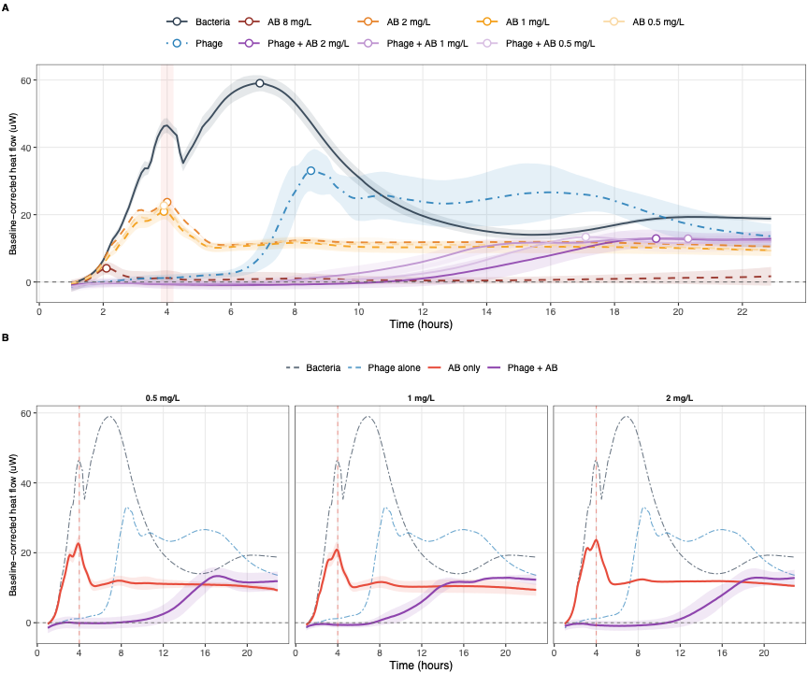
Figure S1. Isothermal microcalorimetry analysis of EC10P1-ATM-AVI interaction. Relative heat flow is plotted over time as a continuous measure of bacterial metabolic activity. (A) Heat-flow profiles for untreated bacteria, ATM-AVI alone, EC10P1 alone, and EC10P1 plus ATM-AVI. (B) Matched comparisons of ATM-AVI alone versus EC10P1 plus ATM-AVI at 0.5, 1, and 2 mg/L. Combination treatment maintained near-zero heat flow during the 4-hour harvest window, whereas antibiotic-alone cultures retained measurable metabolic activity.

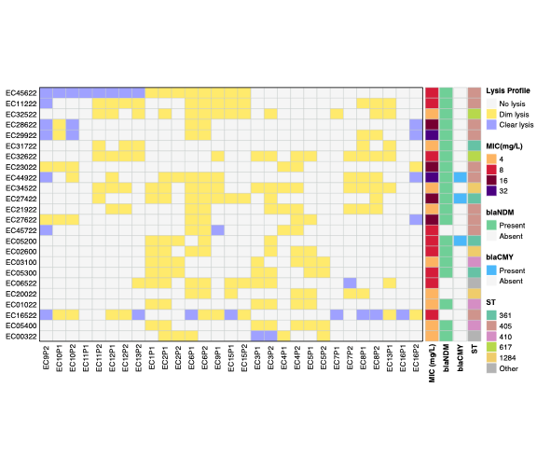
Figure S2. Screening of phage vs. E. coli isolate interactions in the ATM-AVI isolate panel. Rows indicate E. coli isolates and columns indicate phages. Lysis phenotypes are shown as no lysis, dim lysis, or clear lysis; side annotations show MIC and selected resistance/genotype features from the previous study. EC10P1-EC45622 was selected for downstream experiments because this pair showed reproducible clear lysis in an elevated-MIC background.

