Extended Data for
A mechanically strong and ductile soft magnet with ultralow coercivity
Liuliu Han¹, Fernando Maccari², Isnaldi R. Souza Filho¹, Nicolas J. Peter¹, Ye Wei¹, Baptiste Gault¹, Oliver Gutfleisch², Zhiming Li^{1, 3}, Dierk Raabe¹
¹Max-Planck-Institut für Eisenforschung, Max-Planck-Straße 1, 40237 Düsseldorf, Germany
²Department of Material Science, Technical University of Darmstadt, 64287 Darmstadt, Germany
³School of Materials Science and Engineering, Central South University, 410083 Changsha, China
*Correspondence to lizhiming@csu.edu.cn (Z.L.), d.raabe@mpie.de (D.R.)

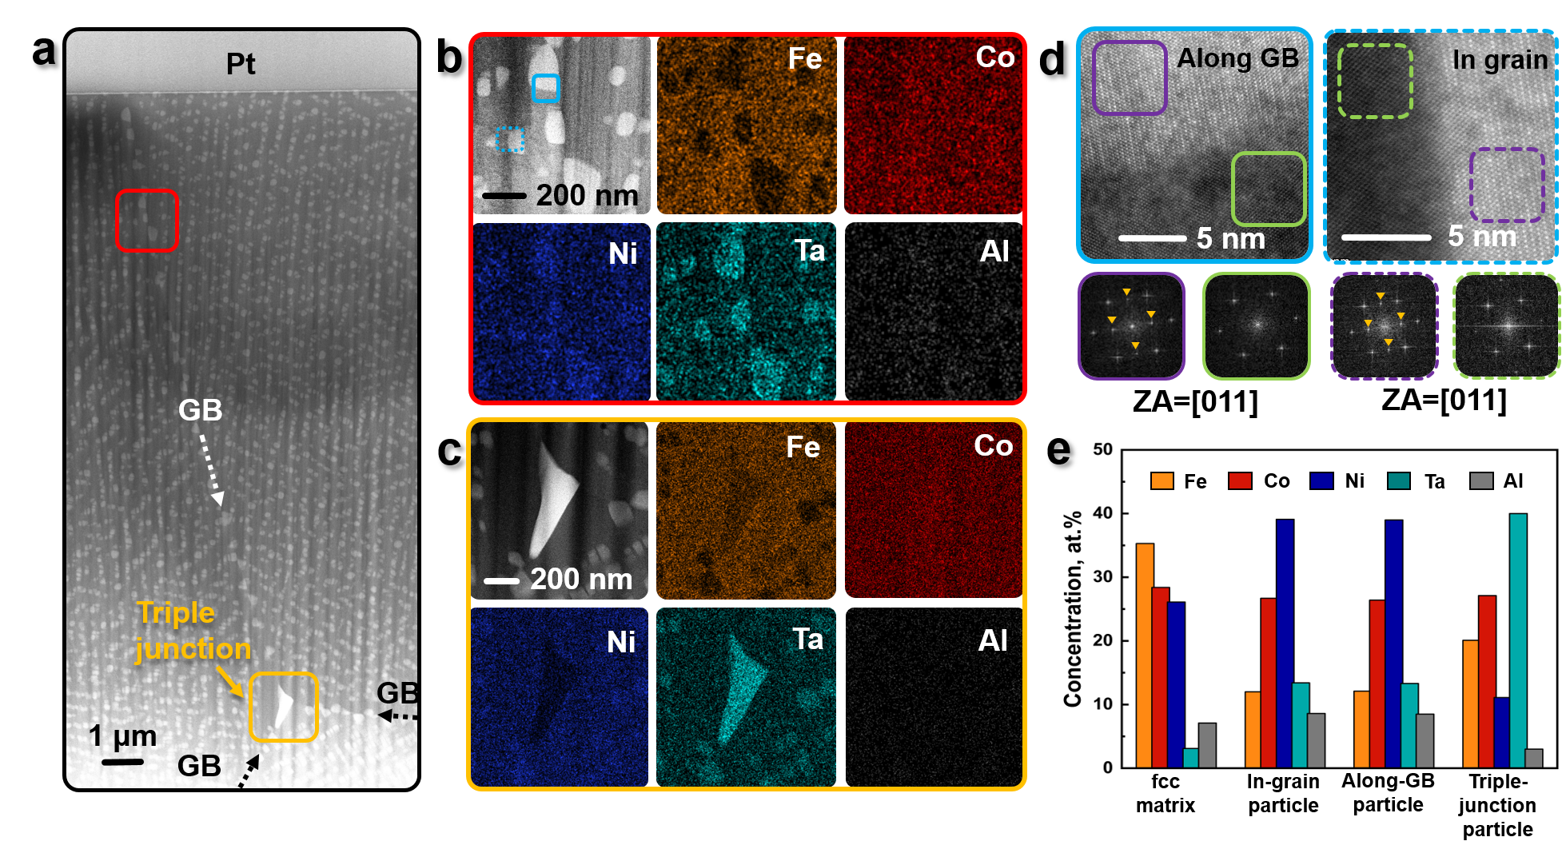
Extended Data Figure 1 | STEM-HAADF micrographs and corresponding STEM-EDS analysis showing the structure and chemical composition of the particles with different morphologies. a, Overview of a STEM lamella showing the variation in particle morphology near the grain boundary. b, Enlarged view (red frame in a) exhibiting particles inside the grains and along the GBs as well as their respective EDS elemental maps. c, Enlarged view (orange frame in a) illustrating a heterogeneous non-coherent particle at the triple-junction of GBs and its EDS elemental maps. d, Atomically resolved HAADF-STEM micrographs and Fast Fourier transforms of representative matrix and particle regions, indicating that the particles (ordered, bright) are coherent with the matrix (disordered, dark). The micrographs were obtained along [011] zone axis. e, Comparison of the average chemical composition of different particles and the matrix determined by the EDS mapping. “GB” stands for “grain boundary”.

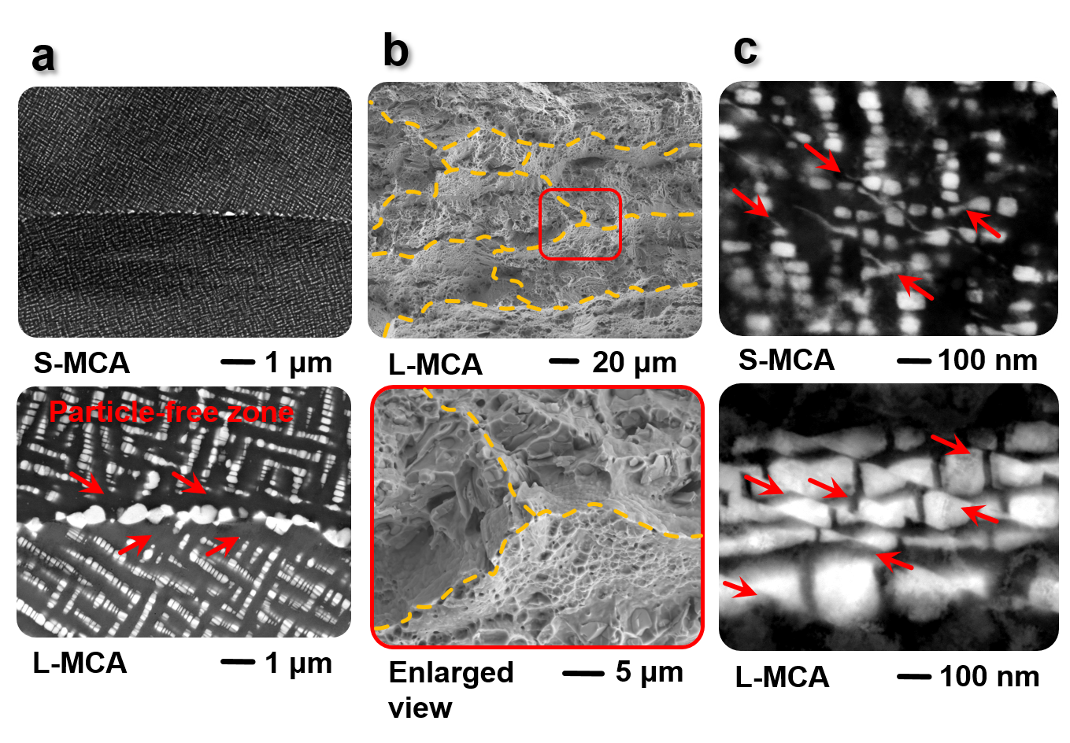
Extended Data Figure 2 | Deformation mechanisms of the investigated MCAs. a, ECC images of the S-MCA and L-MCA. The formation of the particle-free zone can be identified in the L-MCA. b, Fracture surface morphologies of the L-MCA. The enlarged view shows the presence of intergranular fracture at the triple-junction of GBs with dimpled topology at one side of the grain facets. c, ECCI analysis showing the microbands and the shearing of the particles in the S-MCA and L-MCA.

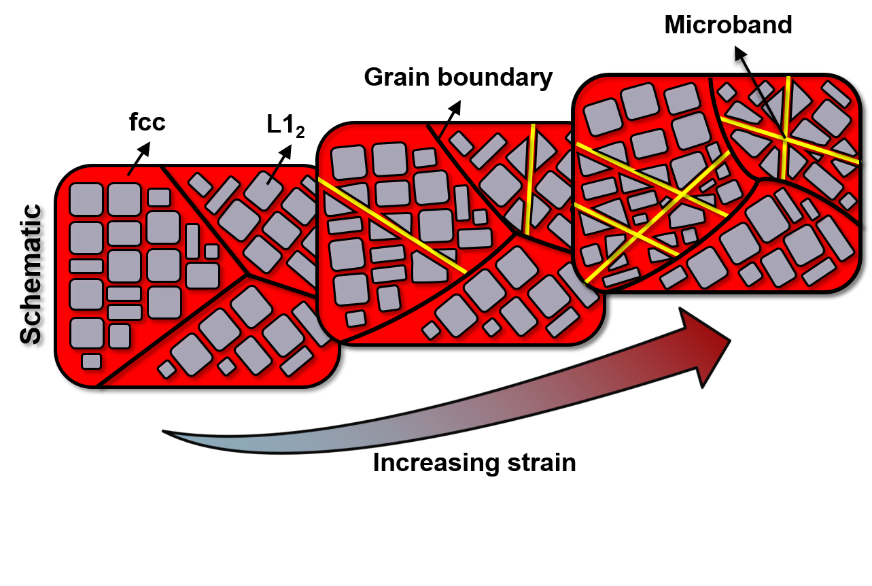
Extended Data Figure 3 | Schematic illustration of the microband refinement in the MCAs during plastic straining.

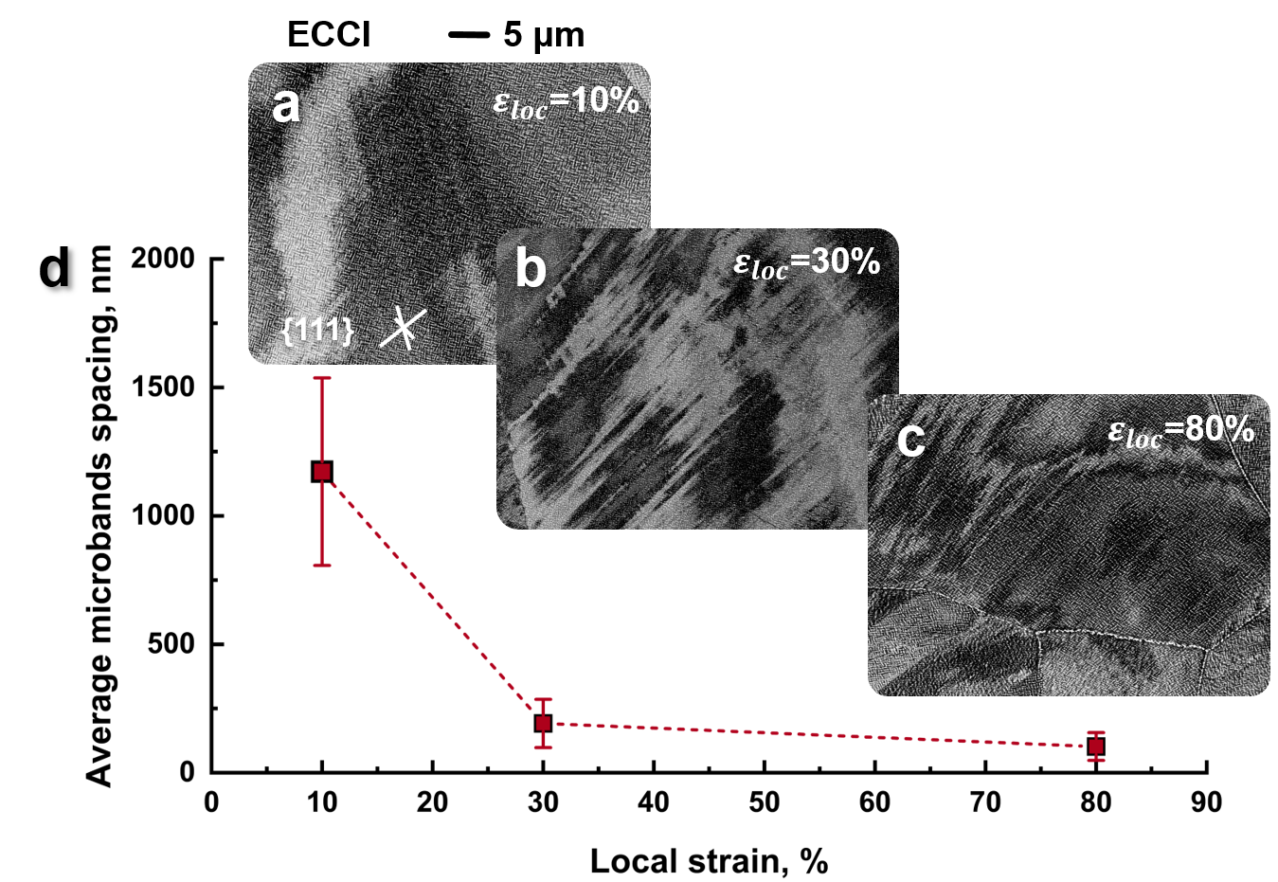
Extended Data Figure 4 | Evolution of the microband refinement. a-c, ECCI analysis revealing the evolution of microbands with increasing local strain at ε_{loc}=10%, 30% and 80%, respectively. d, Quantification of the decreases in average microband spacing with increasing local strain.

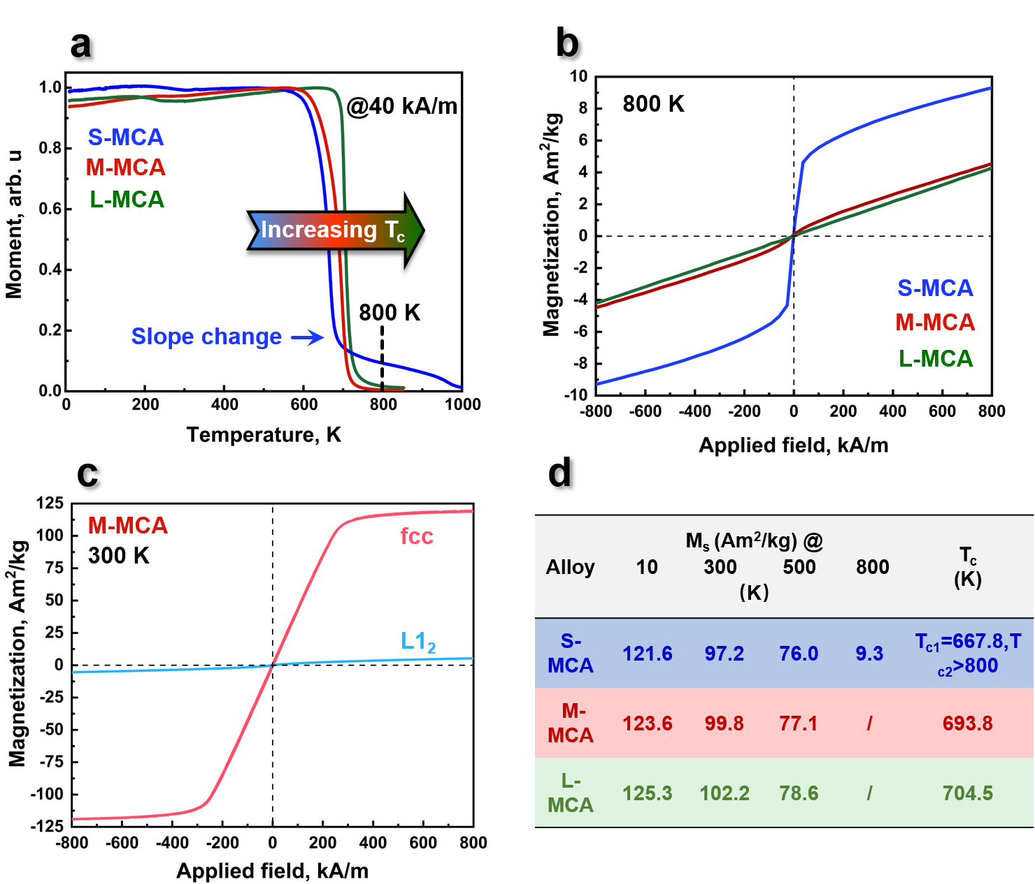
Extended Data Figure 5 | Magnetic behaviour of the MCAs in a wide temperature range. a, M(T) curves measured in the temperature range between 10 K and 1000 K under a magnetic field of 40 kA/m. b, M(H) loops of the MCAs measured at 800 K, confirming the second phase in the S-MCA is ferromagnetic with a T_{c} higher than 800 K. The measuring temperature of 800 K was selected based on the M(T) results as marked by a black dashed line in a. c, M(H) loops of the individual cast fcc and L1₂ phases in the M-MCA measured at 300 K. d, Temperature dependence of the M_{s} of the investigated MCAs.

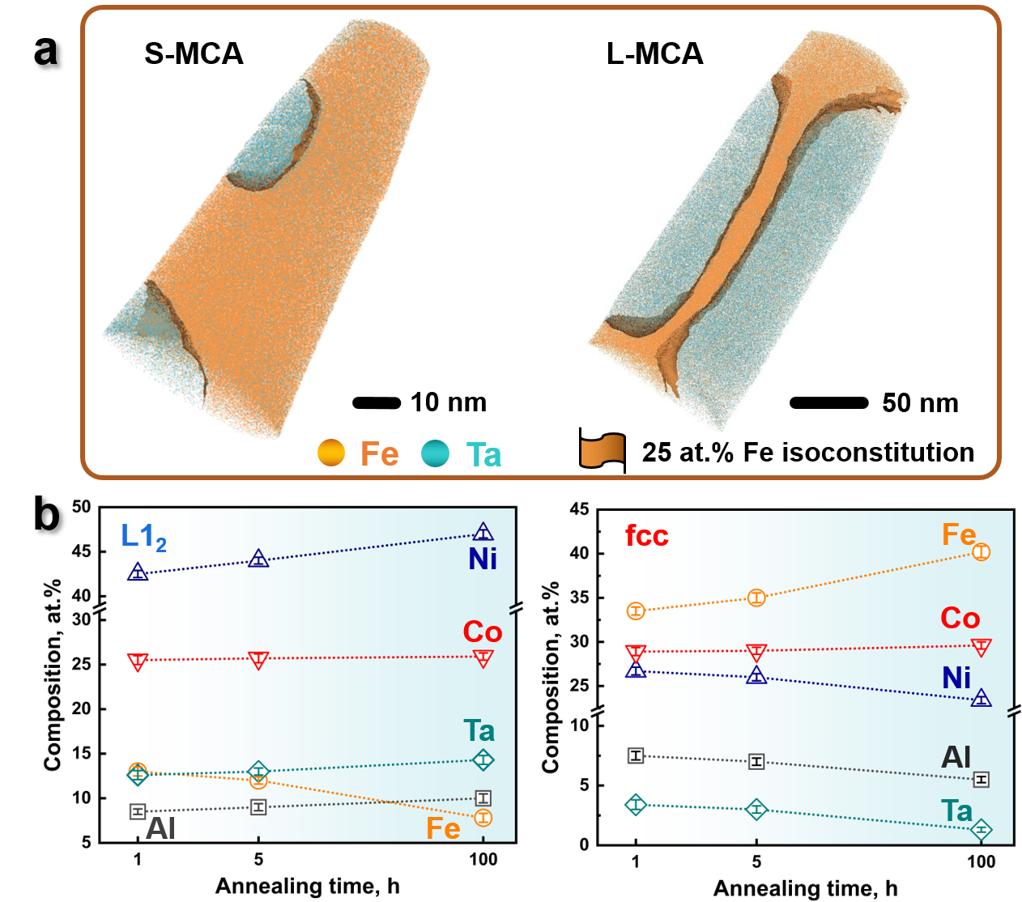
Extended Data Figure 6 | Atom probe characterization showing the tomography and composition of the L1₂ particles and fcc matrix in the MCAs. a, APT datasets showing the reconstructed S-MCA and L-MCA containing L1₂ particles. b, Average chemical compositions of the fcc and L1₂ phases acquired from the APT sub-volumes.

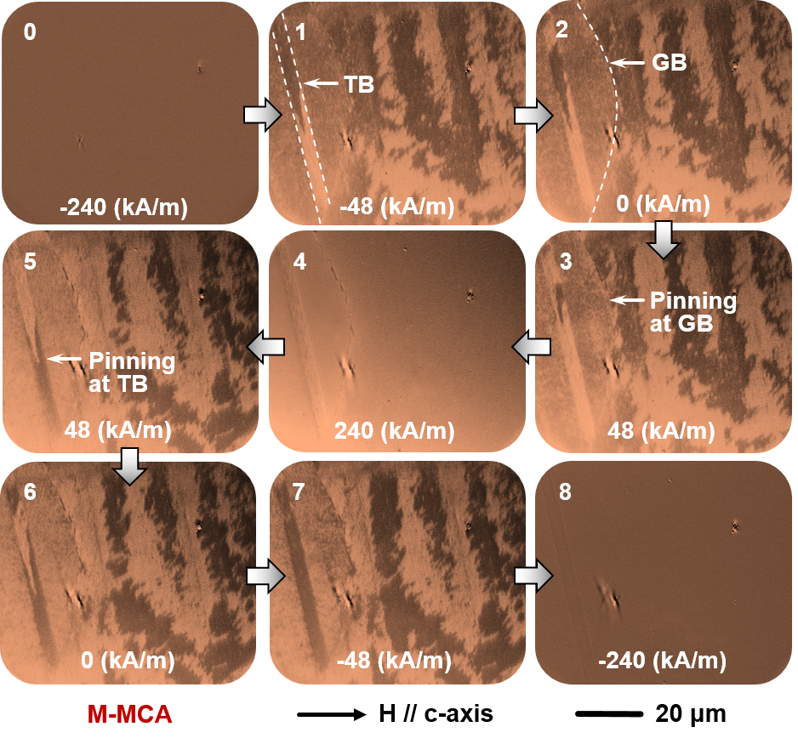

Extended Data Figure 7 | MOKE microscopy observation revealing the pinning of magnetic domain wall during magnetization process in the M-MCA. GBs and TBs act as the pinning sites for domain wall movement. The applied magnetic field is horizontal to the viewing plane. “GB” and “TB” stand for “grain boundary” and “twin boundary”, respectively.

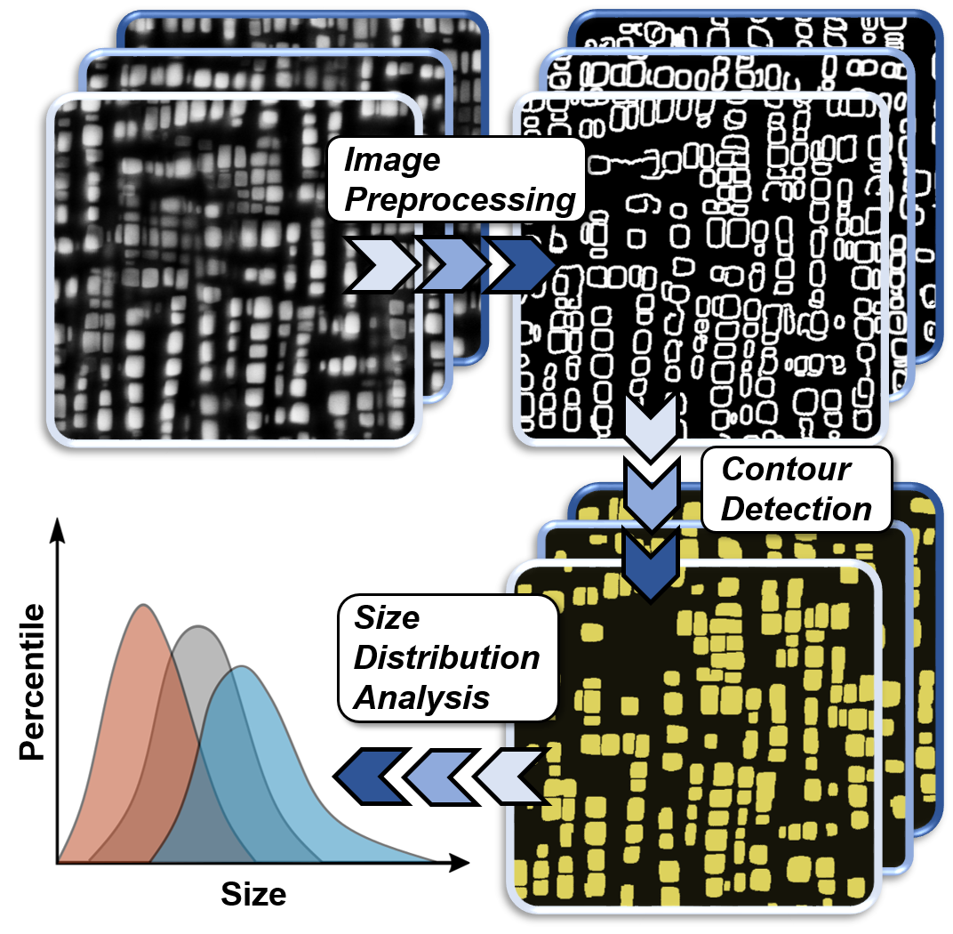

Extended Data Figure 8 | Size distribution of the L1₂ particles analyzed by batch image processing protocol. Firstly, an edge detection algorithm was applied to the raw images to isolate particles from the matrix. Secondly, a contour detection algorithm was used to search for closed contours. Finally, the size distribution of closed contours (particles) was computed. The algorithm was constructed using Python Package (G. Bradski, Dr. Dobb's j. softw. tools prof. program. 25, 120–123 (2000)). For each sample, the particle size distribution was derived from more than 20 ECC images of different sample regions.

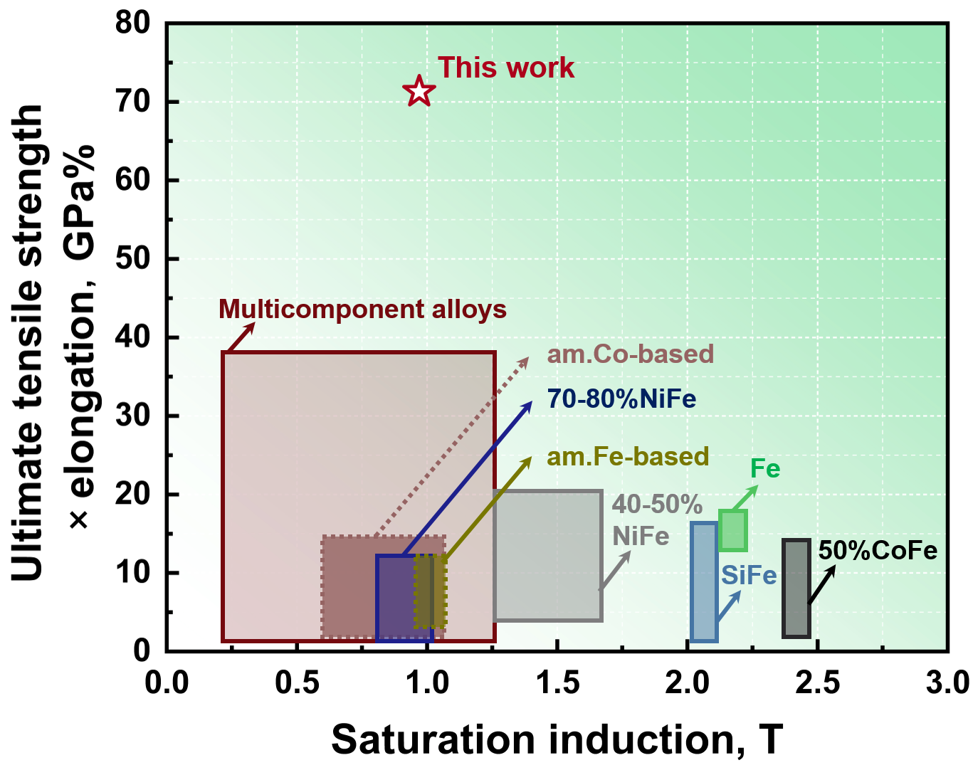
Extended Data Figure 9 | Ashby map showing $σ_{UTS}$×$T_{E}$ as a function of saturation induction (B_{s}). The investigated M-MCA is compared to a wide class of conventional soft magnetic materials including NiFe, CoFe, SiFe, Fe, amorphous alloys and other MCAs. The B_{s} is calculated using the equation B_{s}=4π$∙$M_{s}$∙$ρ_{m}/10000, where ρ_{m}=8.6 g/cm³ is the mass density of M-MCA.

Extended Data Table 1 | Structural parameters of the present MCAs.
Alloys | S-MCA | M-MCA | L-MCA
$a_{0}^{fcc}$ (Å) | 3.6062 ± 0.0001 | 3.6050 ± 0.0001 | 3.6030 ± 0.0001
$a_{0}^{L1_{2}}$ (Å) | 3.6223 ± 0.0001 | 3.6225 ± 0.0001 | 3.6228 ± 0.0001
Lattice misfit, $δ_{0}$ (%) | 0.445 | 0.484 | 0.548
Volume fraction of the particle (%) | 43.2 ± 0.5 | 55.2 ± 0.8 | 60.5 ± 1.0
Average particle size (nm) | 23.9 ± 12.3 | 90.8 ± 35.8 | 255.5 ± 50.1
Average grain size (μm) | 72.6 ± 16.9 | 85.3 ± 25.6 | 150.2 ± 50.4
Mean spacing of the particles (nm) | 192.8 ± 74 | 65.5 ± 40.6 | 30.3 ± 17.3
Specific surface area (m²/m³) | 1.08×10⁸ | 3.65×10⁷ | 1.42×10⁷
Specific surface area × integrated lattice misfit (%$∙$m²/m³) | 1.09×10⁶ | 4.08×10⁵ | 1.96×10⁵
Microstrain, $ε_{s}$ | 0.00084 ± 0.00002 | 0.00085 ± 0.00002 | 0.00087 ± 0.00002
Crystallite size, D (nm) | 76 ± 4 | 124 ± 9 | 220 ± 40
Dislocation density (m⁻²) | 1.50×10¹⁴ | 9.32×10¹³ | 5.38×10¹³

Extended Data Table 2 | Vegard coefficients in the disordered fcc phase and the ordered Ni₃Al phase taken from the Ni-base superalloys. Data is taken from reference 55.
Element (at%) | Fe | Ni | Co | Ta | Al
$Г_{i}^{γ}$ ($Г_{i}^{fcc}$) | 0.123 | 0 | 0.02 | 0.725 | 0.179
$Г_{i}^{{Ni}_{3}Al}$ ($Г_{i}^{L1_{2}}$) | 0.01 | 0 | 0 | 0.51 | 0

