Supplementary Information

Polar Vortexes and Charged Domain Walls in a Room Temperature Magnetoelectric Thin Film

Kalani Moore^{1*}, Eoghan N. O’Connell¹, Lynette Keeney², Clive Downing³, Michael Schmidt^{2,} Valeria Nicolosi,^{3,4} Ursel Bangert¹, Michele Conroy^{1*}
1. Department of Physics, Bernal Institute, School of Natural Sciences, University of Limerick, Ireland
2. Tyndall National Institute, University College Cork, Ireland
3. Advanced Microscopy Laboratory & AMBER, Trinity College Dublin, Dublin 2, Ireland
4. School of Chemistry, Trinity College Dublin, Dublin 2, Ireland

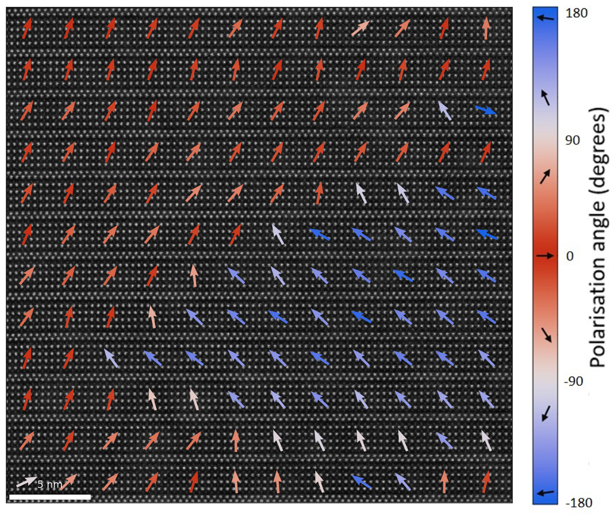
Supplementary Figure 1: The same polarisation map as Figure 1(c) in the main article, but averaged over 5 x 5 unit cells. There is a significant upwards c-axis component to the measured net polarisation, which may be due to slight off-zone axis tilt in the sample. This map compares with Figure 4 (b), which shows averaged net polarisation almost completely in-plane, although there are some smaller areas of c-axis polarisation. Indeed the ability of B6TFMO to be polarised out-of-plane is demonstrated by the head-to-tail domain wall in Figure 3. Regardless of whether sample tilt, a true upward polarisation, or some combination thereof, is causing the out-of-plane appearance, the analysis of the head-to-head nature due to the in-plane polarisation components in Figures 1 & 2 remains applicable. Scalebar = 5 nm.

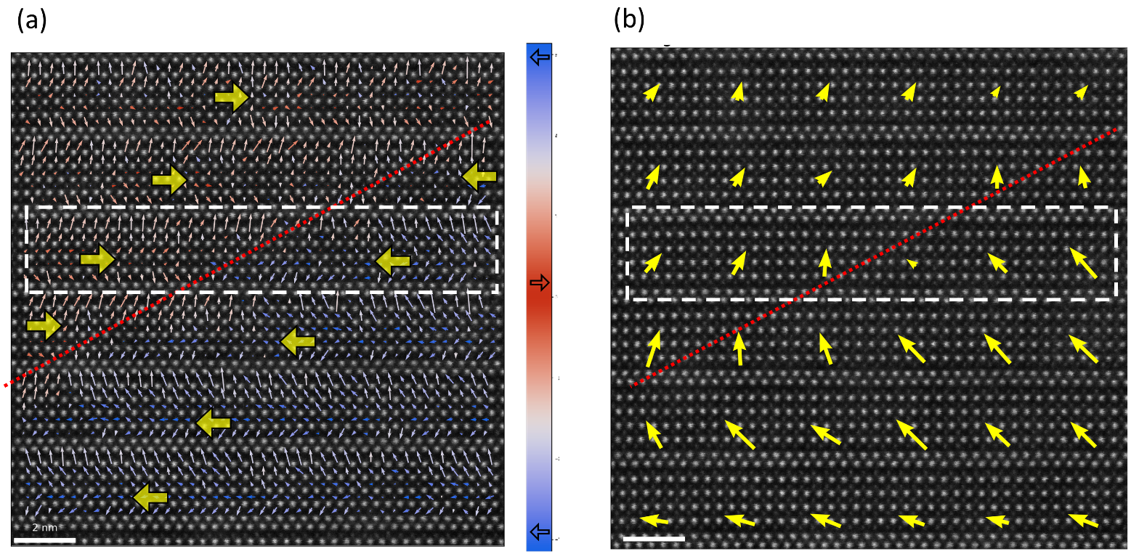
Supplementary Figure 2: (a) Polarisation map of 6 perovskite (PK) layers with interpreted net polarisation indicated by yellow arrows. The layer contained by the dashed box is analysed in Figure 2 of the main paper. A 180° head-to-head (H-H) domain wall (DW) is present, connecting through the perovskite layers, indicated by the dotted red line. (b) The same polarisation map but with the polarisation vectors averaged over 5x5 PK-cells. There is a net upward c-axis component in addition to the in-plane opposing polarisation . The out-of-plane component may appear due to sample tilt. Scalebars = 2 nm.

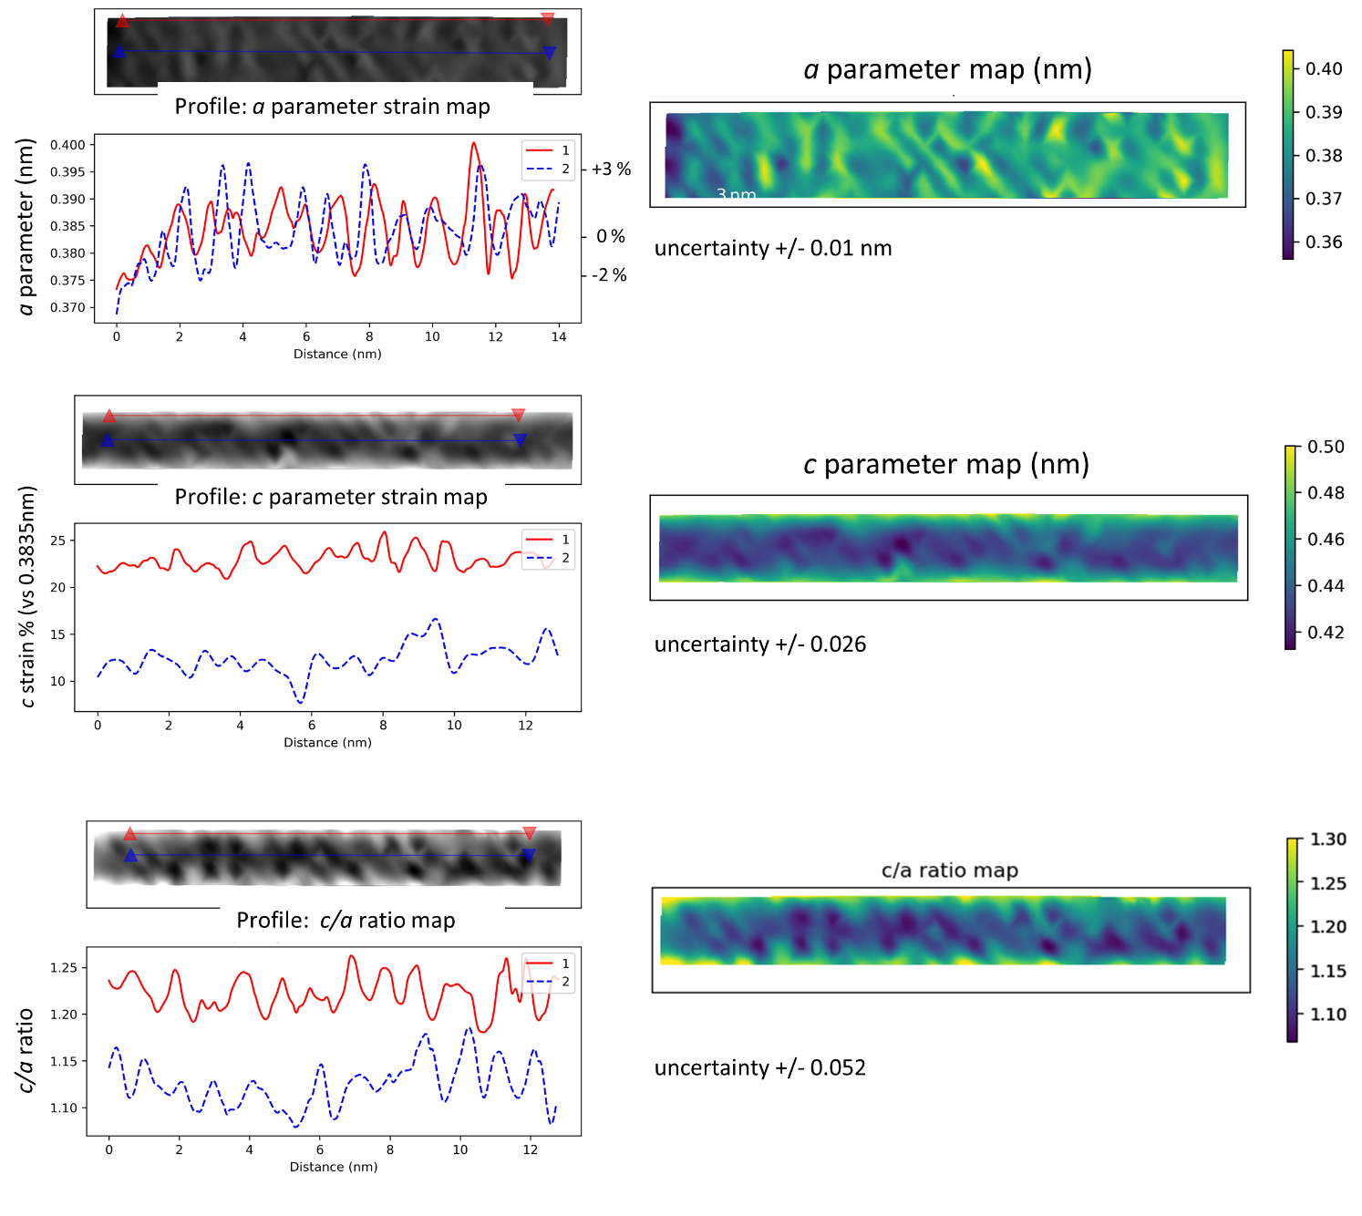

Supplementary Figure 3: Extended strain analysis of the head-to-head domain wall in Figure 2 of the main paper. The uncertainty for the double-gaussian fitting method used varies with image signal to noise ratio. We have taken a value of 1/3 of a pixel for each atom. Distance/strain measurements use two atom locations so the uncertainty is 2/3*(0.15 Å per pixel) = 0.1 Å. The c/a ratio map combines two measurements, introducing more error and thus more variance in the map and profile. The same trend is identified as for the map and profile measured relative to the average a spacing in Figures 2(c & d).

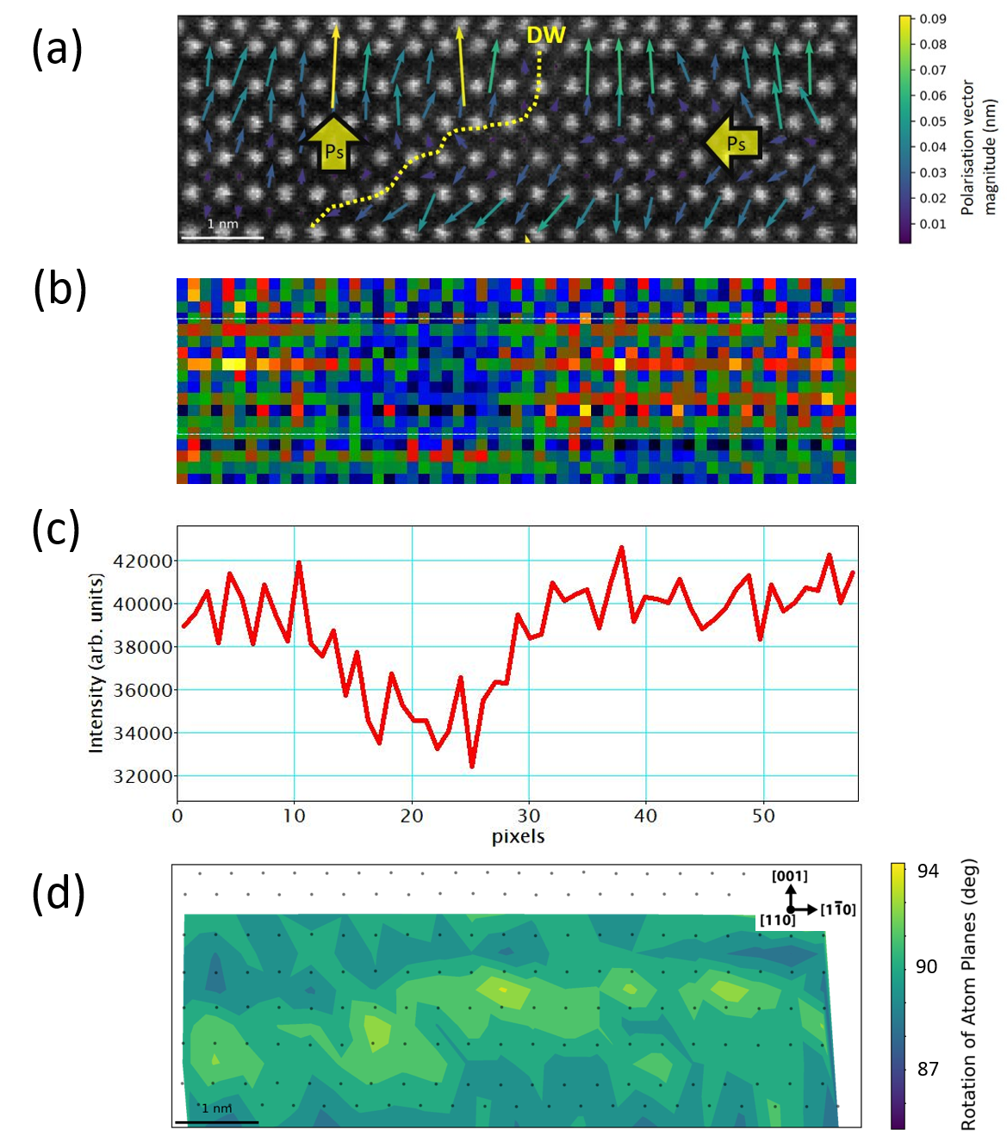
Supplementary Figure 4: (a) Head-to-tail (H-T) domain wall (DW) shown in Figure 3. (b) Oxygen EELS core loss map of the same area as (a) extracted using a power law background and a signal window from 530 - 570 ev in Digital Micrograph. Principle components analysis was applied to the spectrum image before extraction. (c) Intensity profile across the map in (b). Integration width was 10 pixels to exclude the dielectric layer. The drop in the intensity profile and lower intensity in the map correspond to oxygen vacancies at the DW. (d) Rotation map of the [001] zone of the perovskite cells at the H-T DW. There is some indication of increased shearing at the DW. In comparison to the clear correlation seen at the H-H DW in Figure 2(b) the shearing does not seem to be confined to the H-T DW. The magnitude of rotation ~6˚ is again notably large.

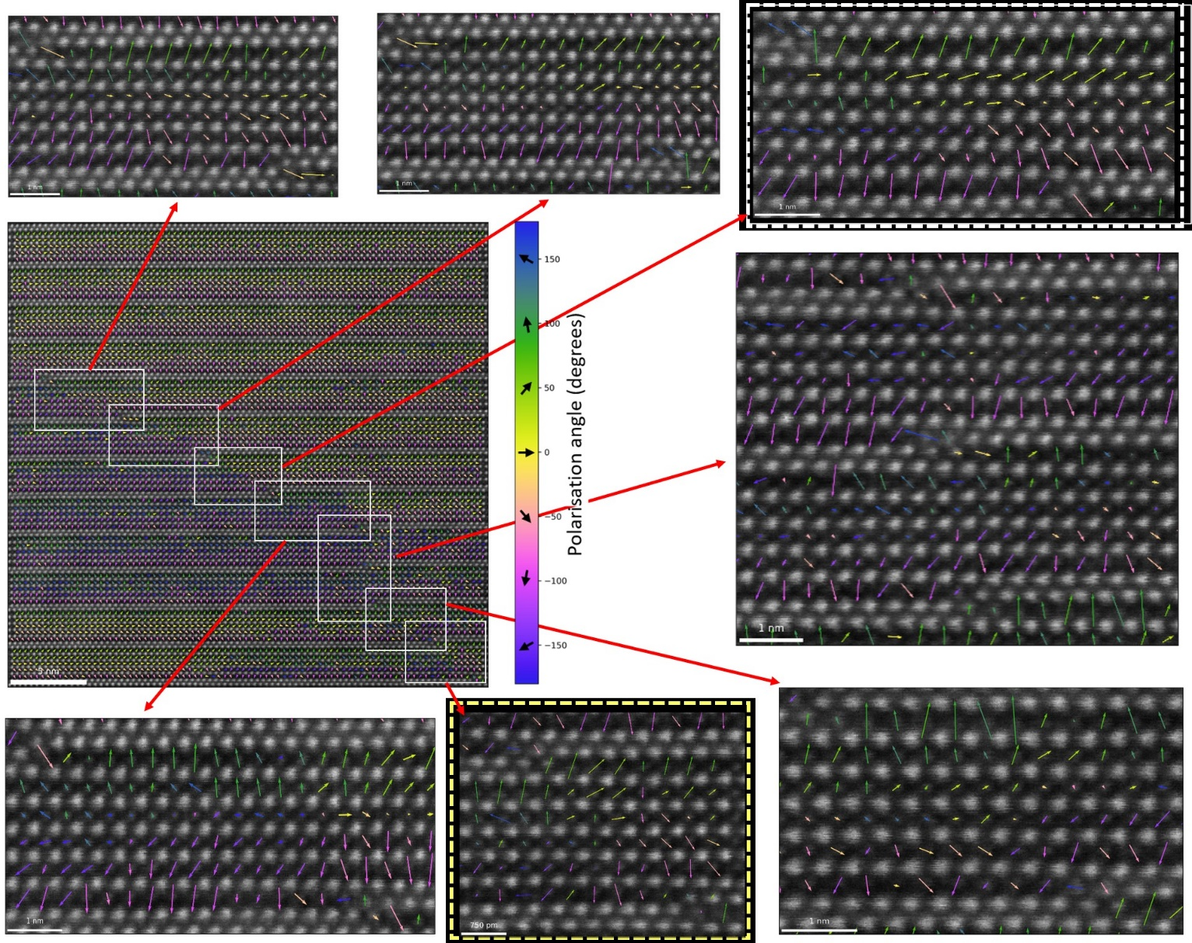
Supplementary Figure 5: The same polarisation map as displayed in Figure 4. Scalebar = 5nm. Enlarged areas are portions of the map between successive OPBs, displayed for each PK-layer. The effects of the various DWs and OPBs listed in table 1 can be seen in the differing behaviour of the polarisation in each PK-layer. White and yellow dashed boxes surround the areas included in Figure 4(c) and Figure 4(d) respectively in the main paper.

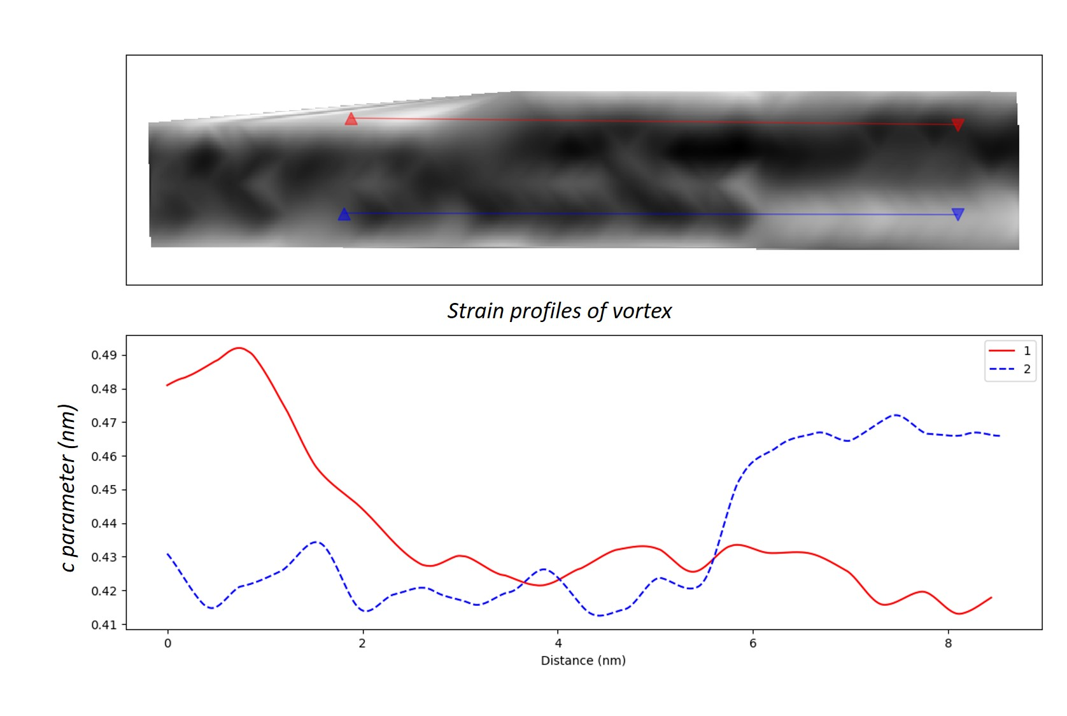
Supplementary Figure 6: Strain profiles across the vortex in the ɛ_{yy} strain map displayed in Figure 4(e).

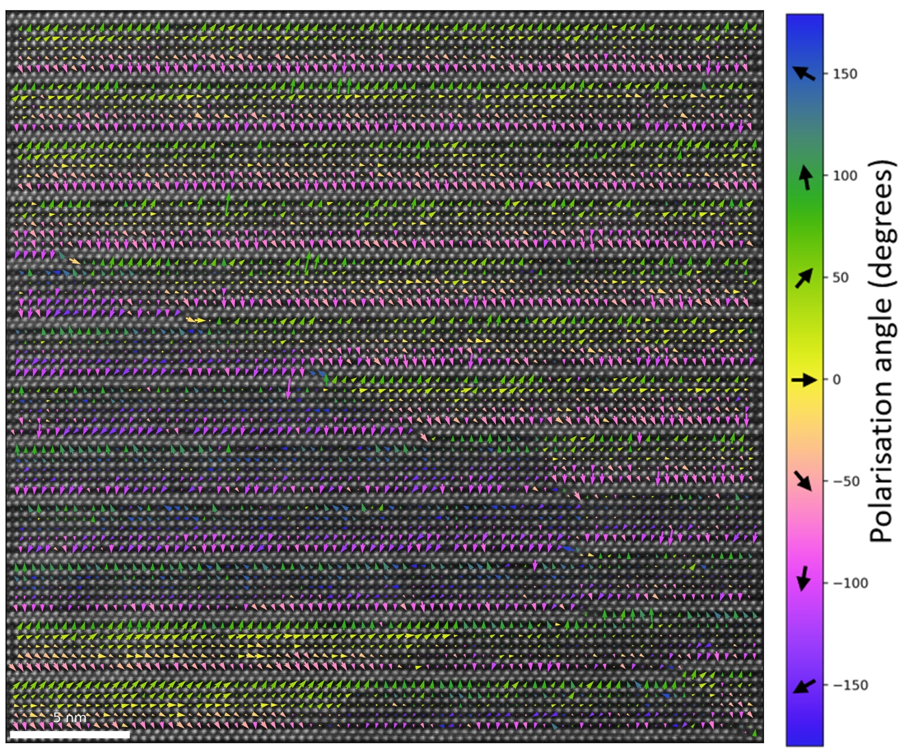Supplementary Figure 7: Enlarged view of Figure 4(a) to enable detailed inspection of each layer.
Scalebar = 5nm.

