Supplementary Information

Using ZnCo₂O₄ nanoparticles as the hole transport layer to improve long-term stability of perovskite solar cells

Bo-Rong Jheng,¹ Pei-Ting Chiu,^{1,2} Sheng-Hsiung Yang,^{1,}* and Yung-Liang Tong²
¹Institute of Lighting and Energy Photonics, College of Photonics, National Yang Ming Chiao Tung University, No.301, Section 2, Gaofa 3rd Road, Guiren District, Tainan 71150, Taiwan R.O.C.

²Green Energy and Environment Research Laboratories, Industrial Technology Research Institute, No.360, Gaofa 2nd Road, Guiren District, Tainan 71150, R.O.C.
*Correspondence: yangsh@mail.nctu.edu.tw

Table S1. Lifetime parameters of TR-PL curves of the perovskite on the FTO substrate, PEDOT:PSS film, and ZnCo₂O₄ NPs layer.
substrate | A₁ (%) | τ₁ (ns) | A₂ (%) | τ₂ (ns) | τ_{avg} (ns)
FTO | 54.61 | 13.12 | 45.39 | 119.59 | 107.17
PEDOT:PSS film | 58.51 | 11.74 | 41.49 | 101.19 | 88.61
ZnCo₂O₄ NPs layer | 54.41 | 10.15 | 45.59 | 47.58 | 39.98

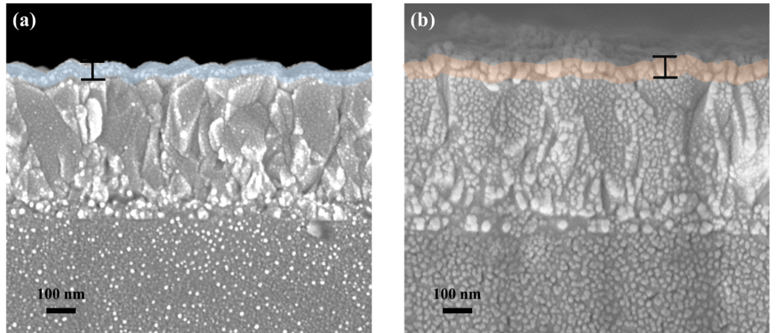
Figure S1. Cross-sectional SEM images of (a) PEDOT:PSS film and (b) ZnCo₂O₄ NPs layer deposited on FTO substrates.

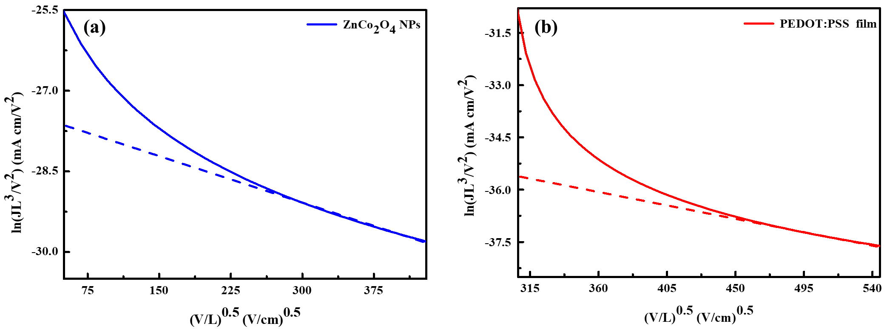
Figure S2. Hole mobility of (a) ZnCo₂O₄ NPs layer and (b) PEDOT:PSS film versus electric field (V/L)^{0.5}.

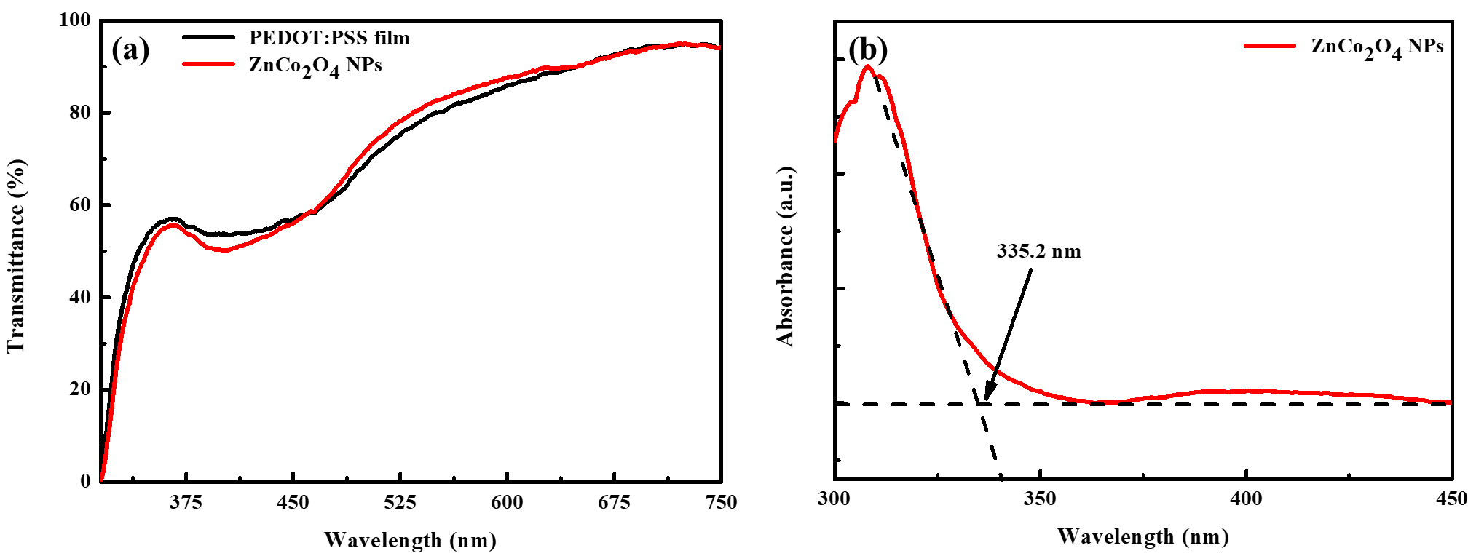
Figure S3. (a) Transmission spectra of PEDOT:PSS film and ZnCo₂O₄ NPs layer and (b) absorption spectra of ZnCo₂O₄ NPs layer.

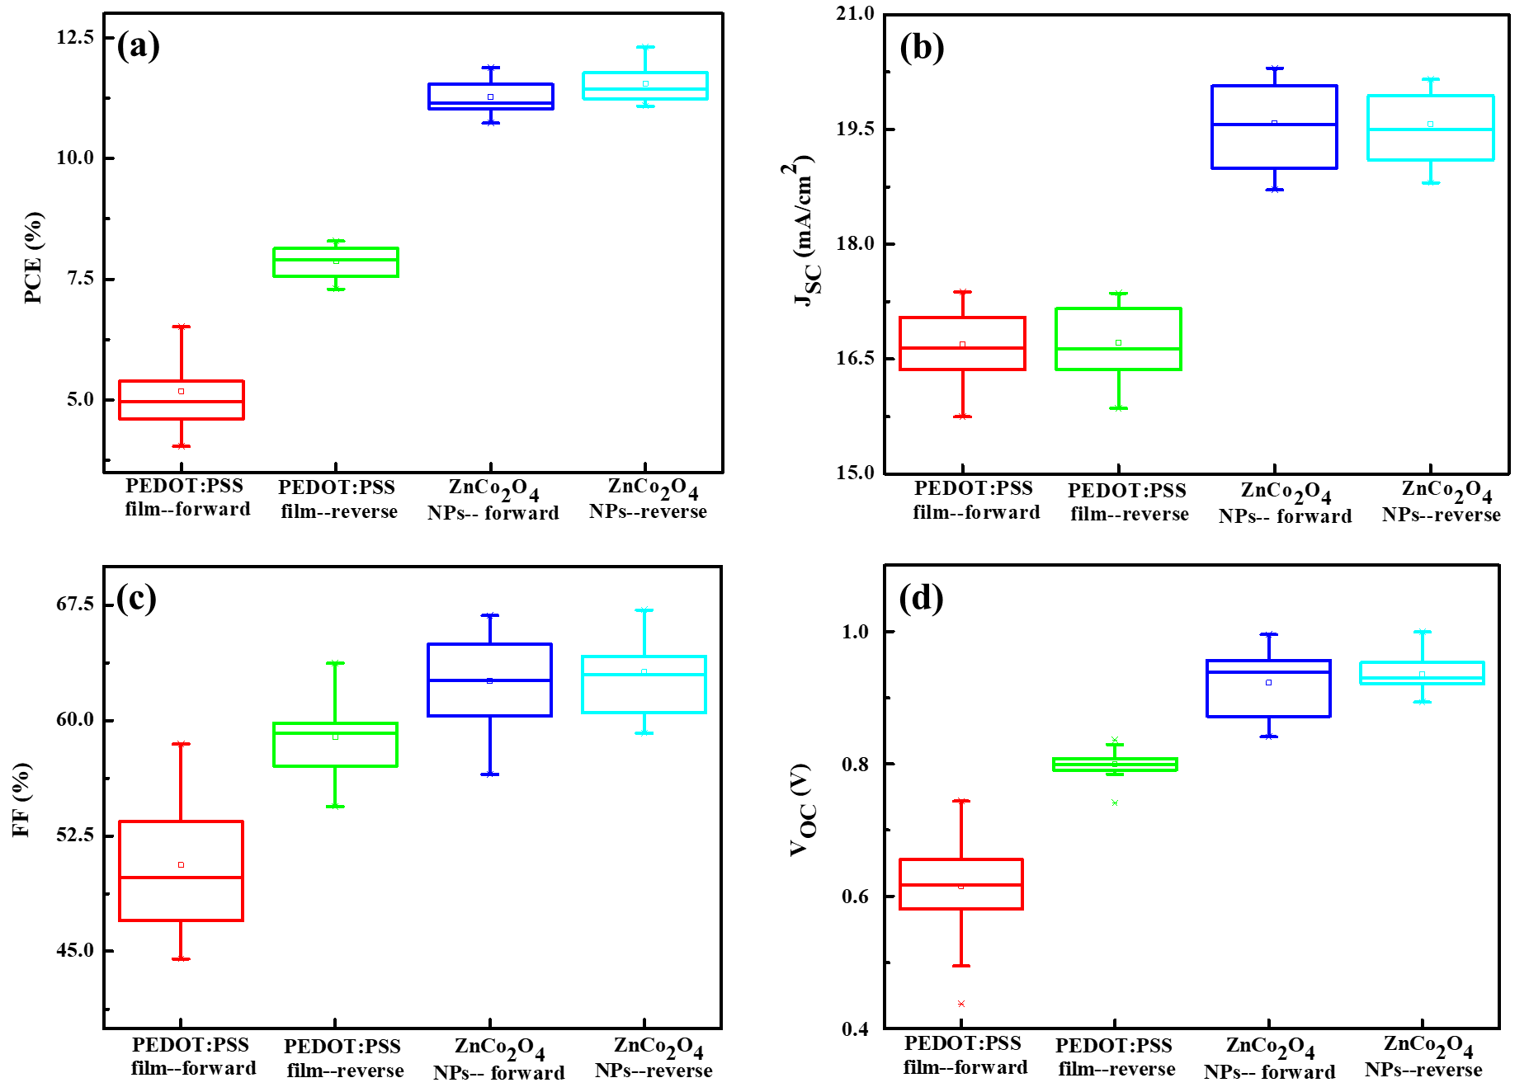
Figure S4. Performance variation represented as a standard box plot in (a) PCE, (b) J_{SC}, (c) FF, and (d) V_{OC} from 20 devices based on PEDOT:PSS film and ZnCo₂O₄ NPs layer under forward and reverse scans

