Question:  Which zone has the greatest impact on water quality and plant species composition in the waterbody?  Which use has the greatest negative and which positive impact? | 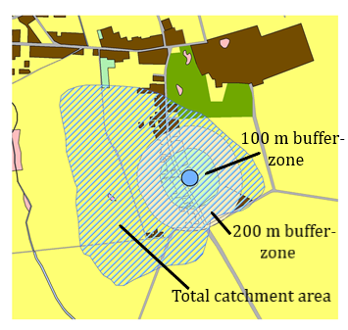 | Result:  100 m buffer-zone  The greatest negative impact: arable land and built-up areas, while the positive: bushy areas, extensively used orchards and perennial vegetation

