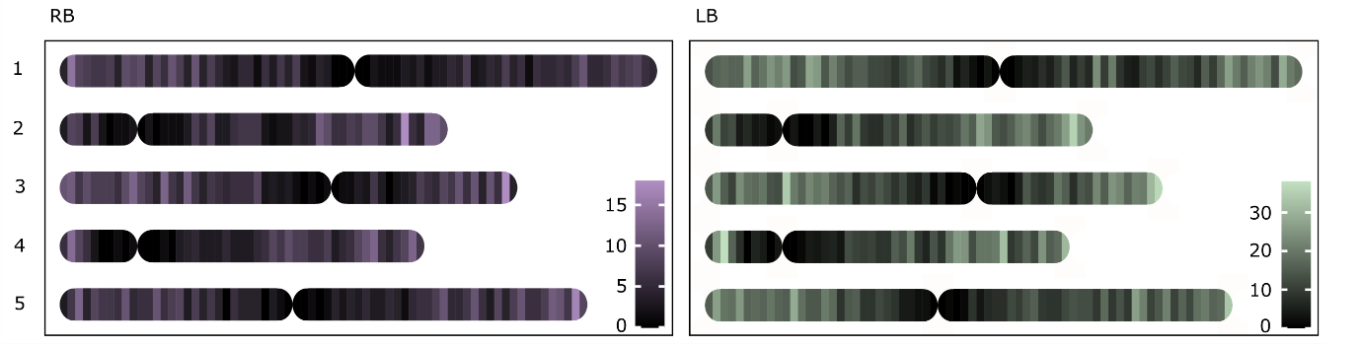
Supplementary Figure 1. Genomic position of wild type junctions obtained with TRANSGUIDE. Arabidopsis chromosomes (1-5) were divided into 0.4 mb bins, in which RB (purple) and LB (green) junctions were counted. The brightness of the color indicates the number of junctions. Centromere positions were rounded to the nearest border between bins.

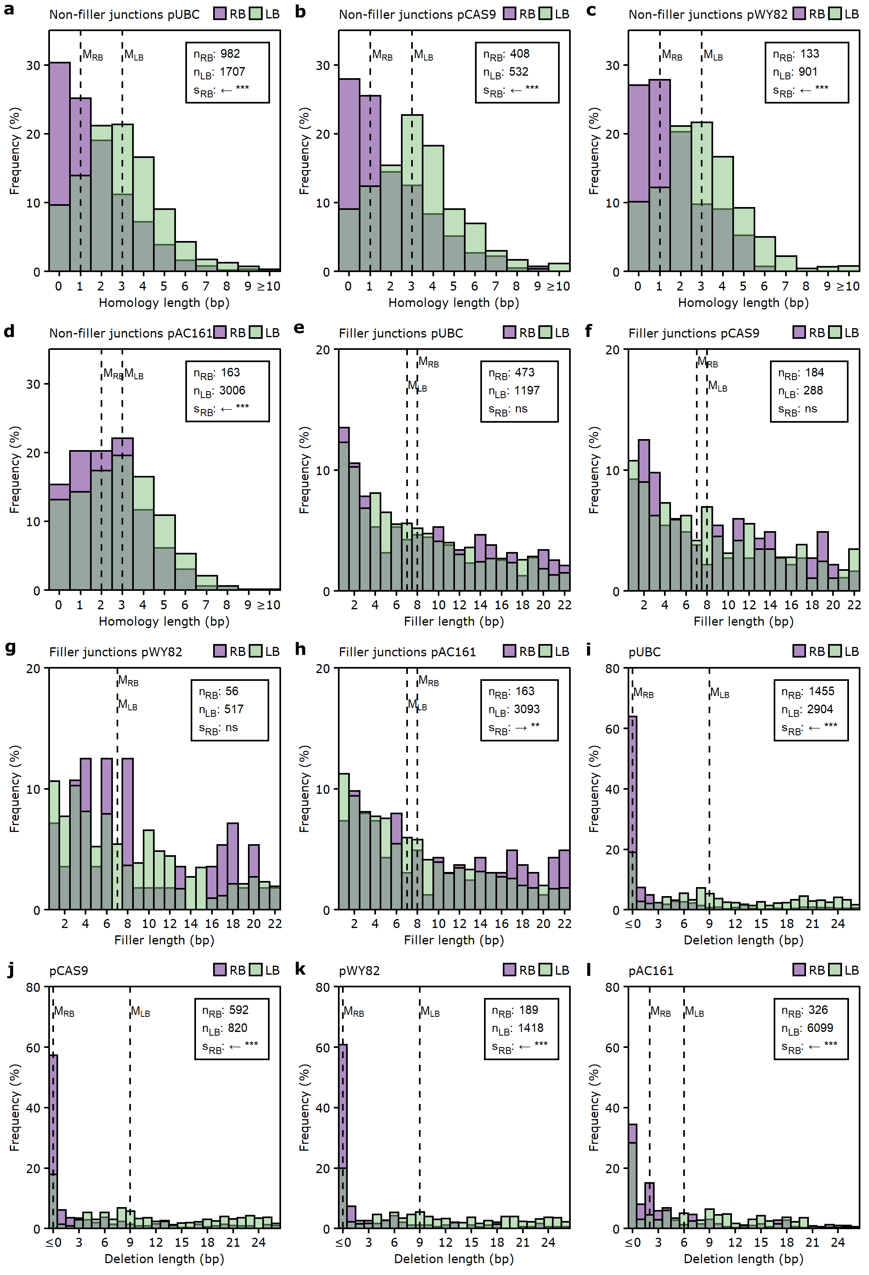
Supplementary Figure 2. Homology, filler, and T-DNA loss profiles for 4 different constructs. Overlapping histograms indicating the frequency of different lengths of micro-homology (a - d), filler (e - h), or T-DNA loss (i - l) at RB (purple) and LB (green) junctions, for 3 constructs after somatic transformation (pUBC, pCAS9, and pWY82) and for 1 construct after germ-line transformation (pAC161, (data van Kregten et al. 2016)). The medians (dashed lines), the number of observations (n), and shifts in the RB distribution relative to LB (s) are indicated. One-sided Wilcoxon rank-sum tests were performed to find the direction and the significance of the shifts; ns: p≥0.05, *: p<0.05, **: p<0.01, ***: p<0.001. The arrow indicates the direction of the shift.

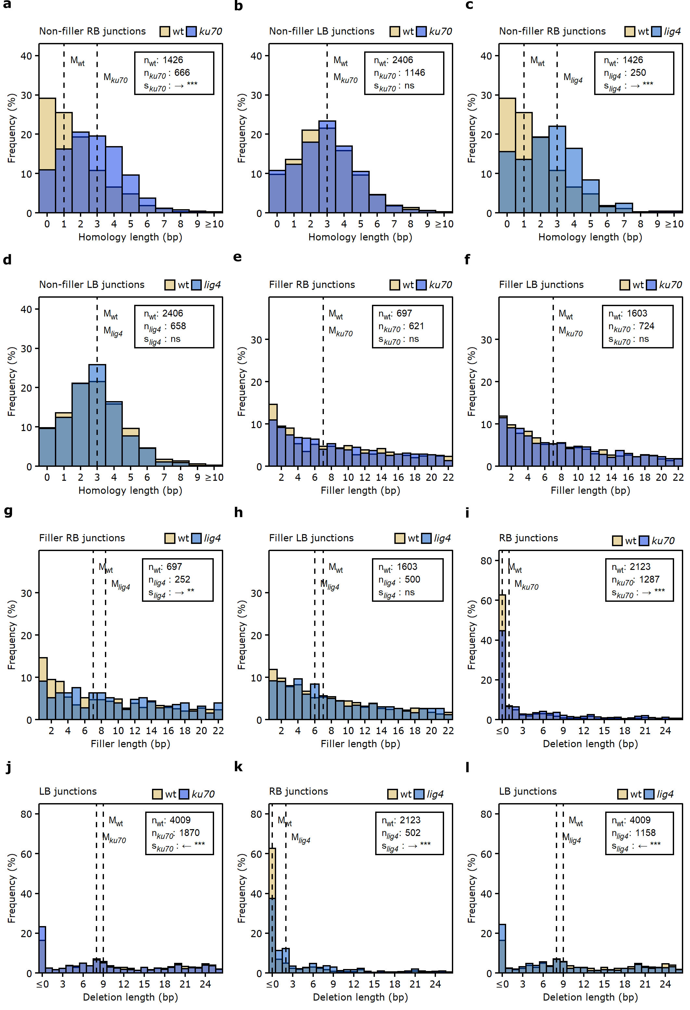
Supplementary Figure 3. Homology, filler, and T-DNA loss profiles for cNHEJ mutants. Overlapping histograms indicating the frequency of different lengths of micro-homology (a - d), filler (e - h), or T-DNA loss (i - l) at RB and LB junctions, comparing wt (yellow) with cNHEJ mutants ku70 and lig4 (blue). The medians (dashed lines), the number of observations (n), and shifts in the mutant distribution relative to wt (s) are indicated. One-sided Wilcoxon rank-sum tests were performed to find the direction and the significance of the shifts; ns: p≥0.05, *: p<0.05, **: p<0.01, ***: p<0.001. The arrow indicates the direction of the shift.

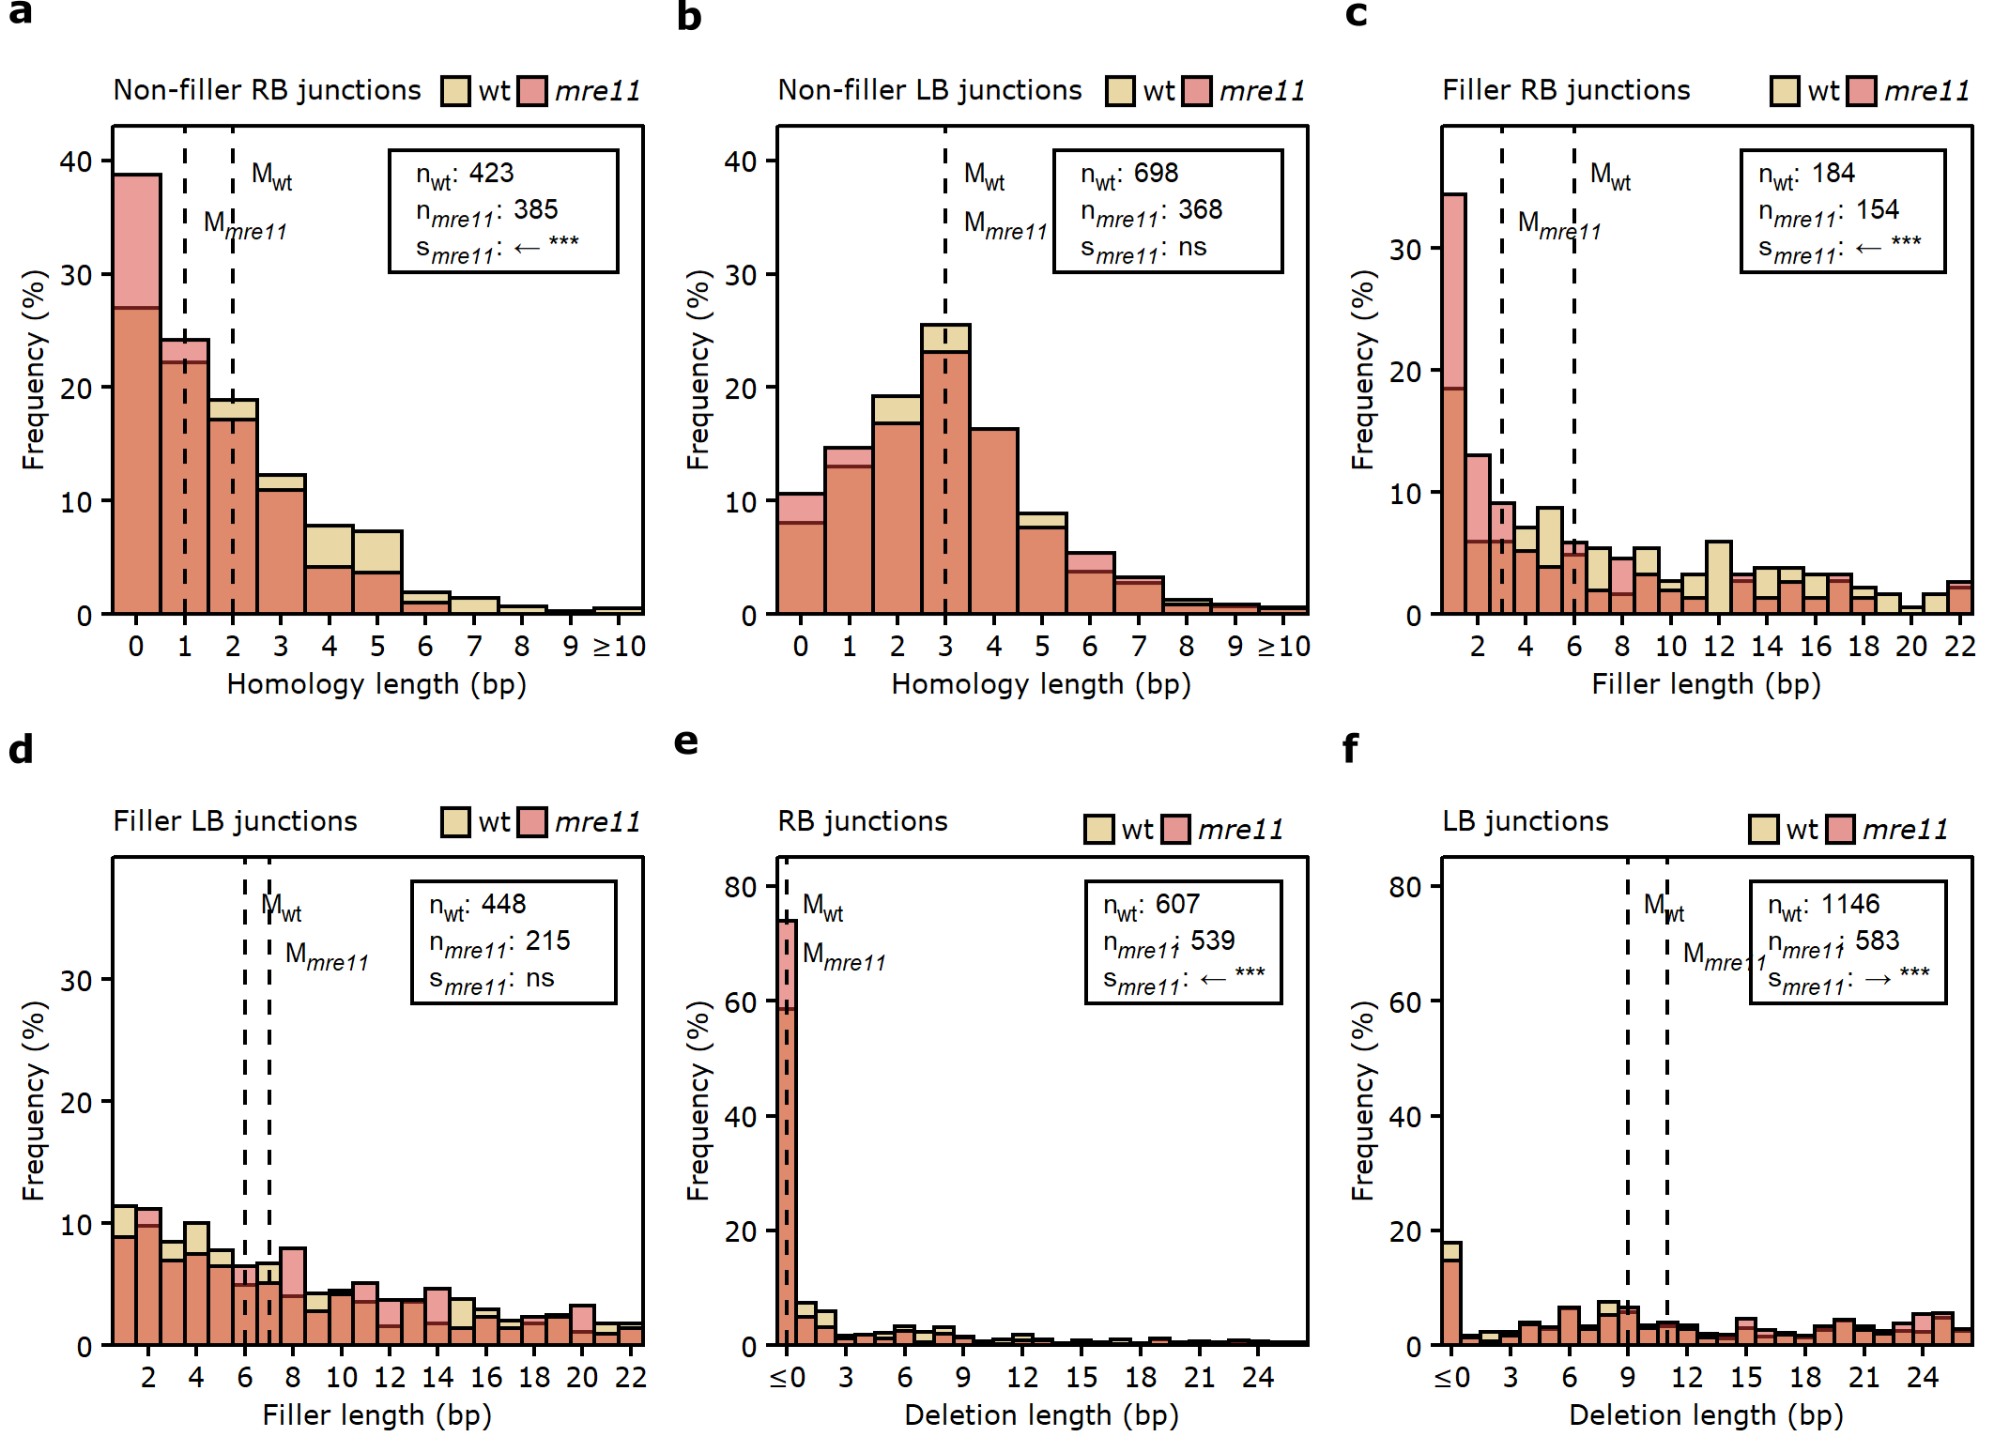
Supplementary Figure 4. Homology, filler, and T-DNA loss profiles for mre11 mutant. Overlapping histograms indicating the frequency of different lengths of micro-homology (a, b), filler (c, d), or T-DNA loss (e, f) at RB and LB junctions, comparing wt (yellow) with the mre11 mutant (light red). The medians (dashed lines), the number of observations (n), and shifts in the mutant distribution relative to wt (s) are indicated. One-sided Wilcoxon rank-sum tests were performed to find the direction and the significance of the shifts; ns: p≥0.05, *: p<0.05, **: p<0.01, ***: p<0.001. The arrow indicates the direction of the shift.

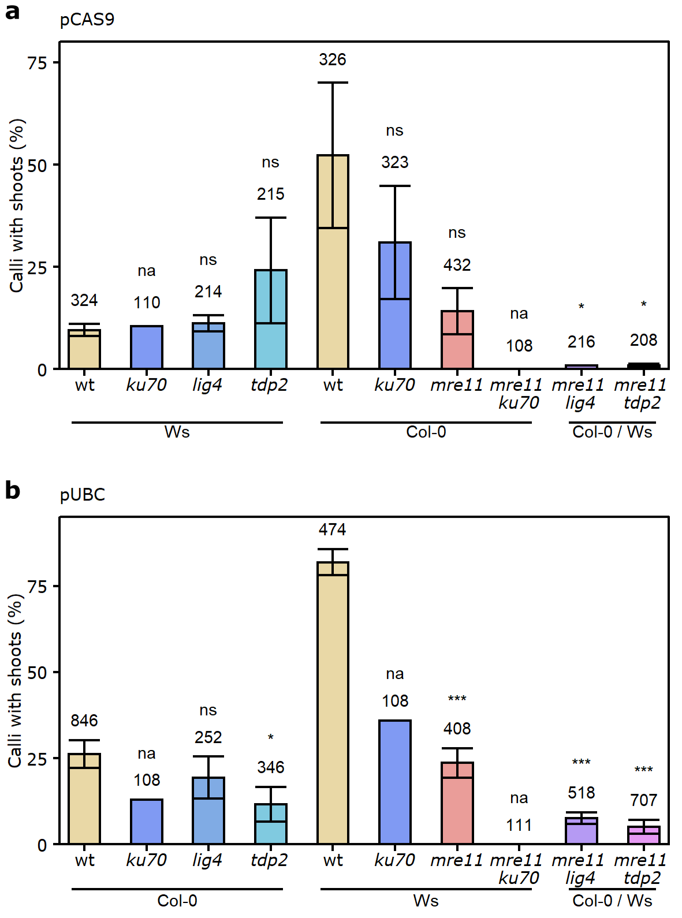
Supplementary Figure 5. Integration efficiencies. Barplots showing the average percentage of calli with shoot tissue (a measure of T-DNA integration success) after transformation with pCAS9 (a) or pUBC (b). Error bars indicate the standard error of the mean. One-sided Student's t-tests were performed to test for significant reductions in T-DNA integration efficiency; ns: p>=0.05, *: p<0.05, **: p<0.01, ***: p<0.001, na: not enough observations. Mutants were compared to the wt of the same genetic background, except for mutants with mixed background, which were compared to the Col-0 wt.

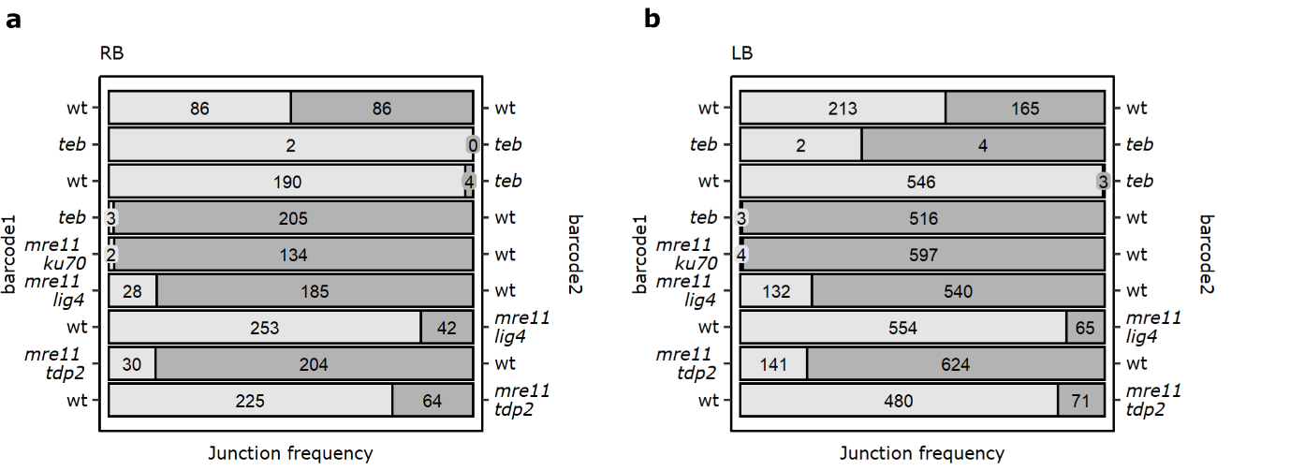
Supplementary Figure 6. Comparison of junction numbers by competitive TRANSGUIDE. Number of RB (a) and LB (b) junctions in competitive TRANSGUIDE, in which equimolar amounts of genomic DNA of two samples with differently barcoded T-DNA (barcode 1 in light grey, and barcode 2 in dark grey) were combined.

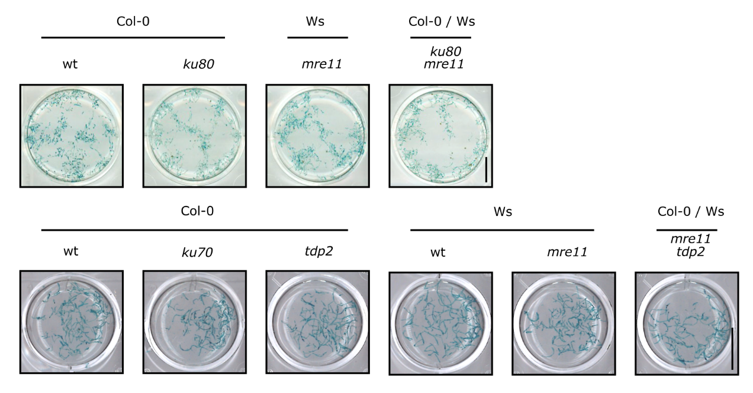
Supplementary Figure 7. All tested genotypes show (transient) T-DNA expression. Pictures show GUS-stained roots in well plates shortly after co-cultivation with Agrobacterium. The blue color indicates expression of the T-DNA (pCAMBIA3301). Scale, 1 cm.

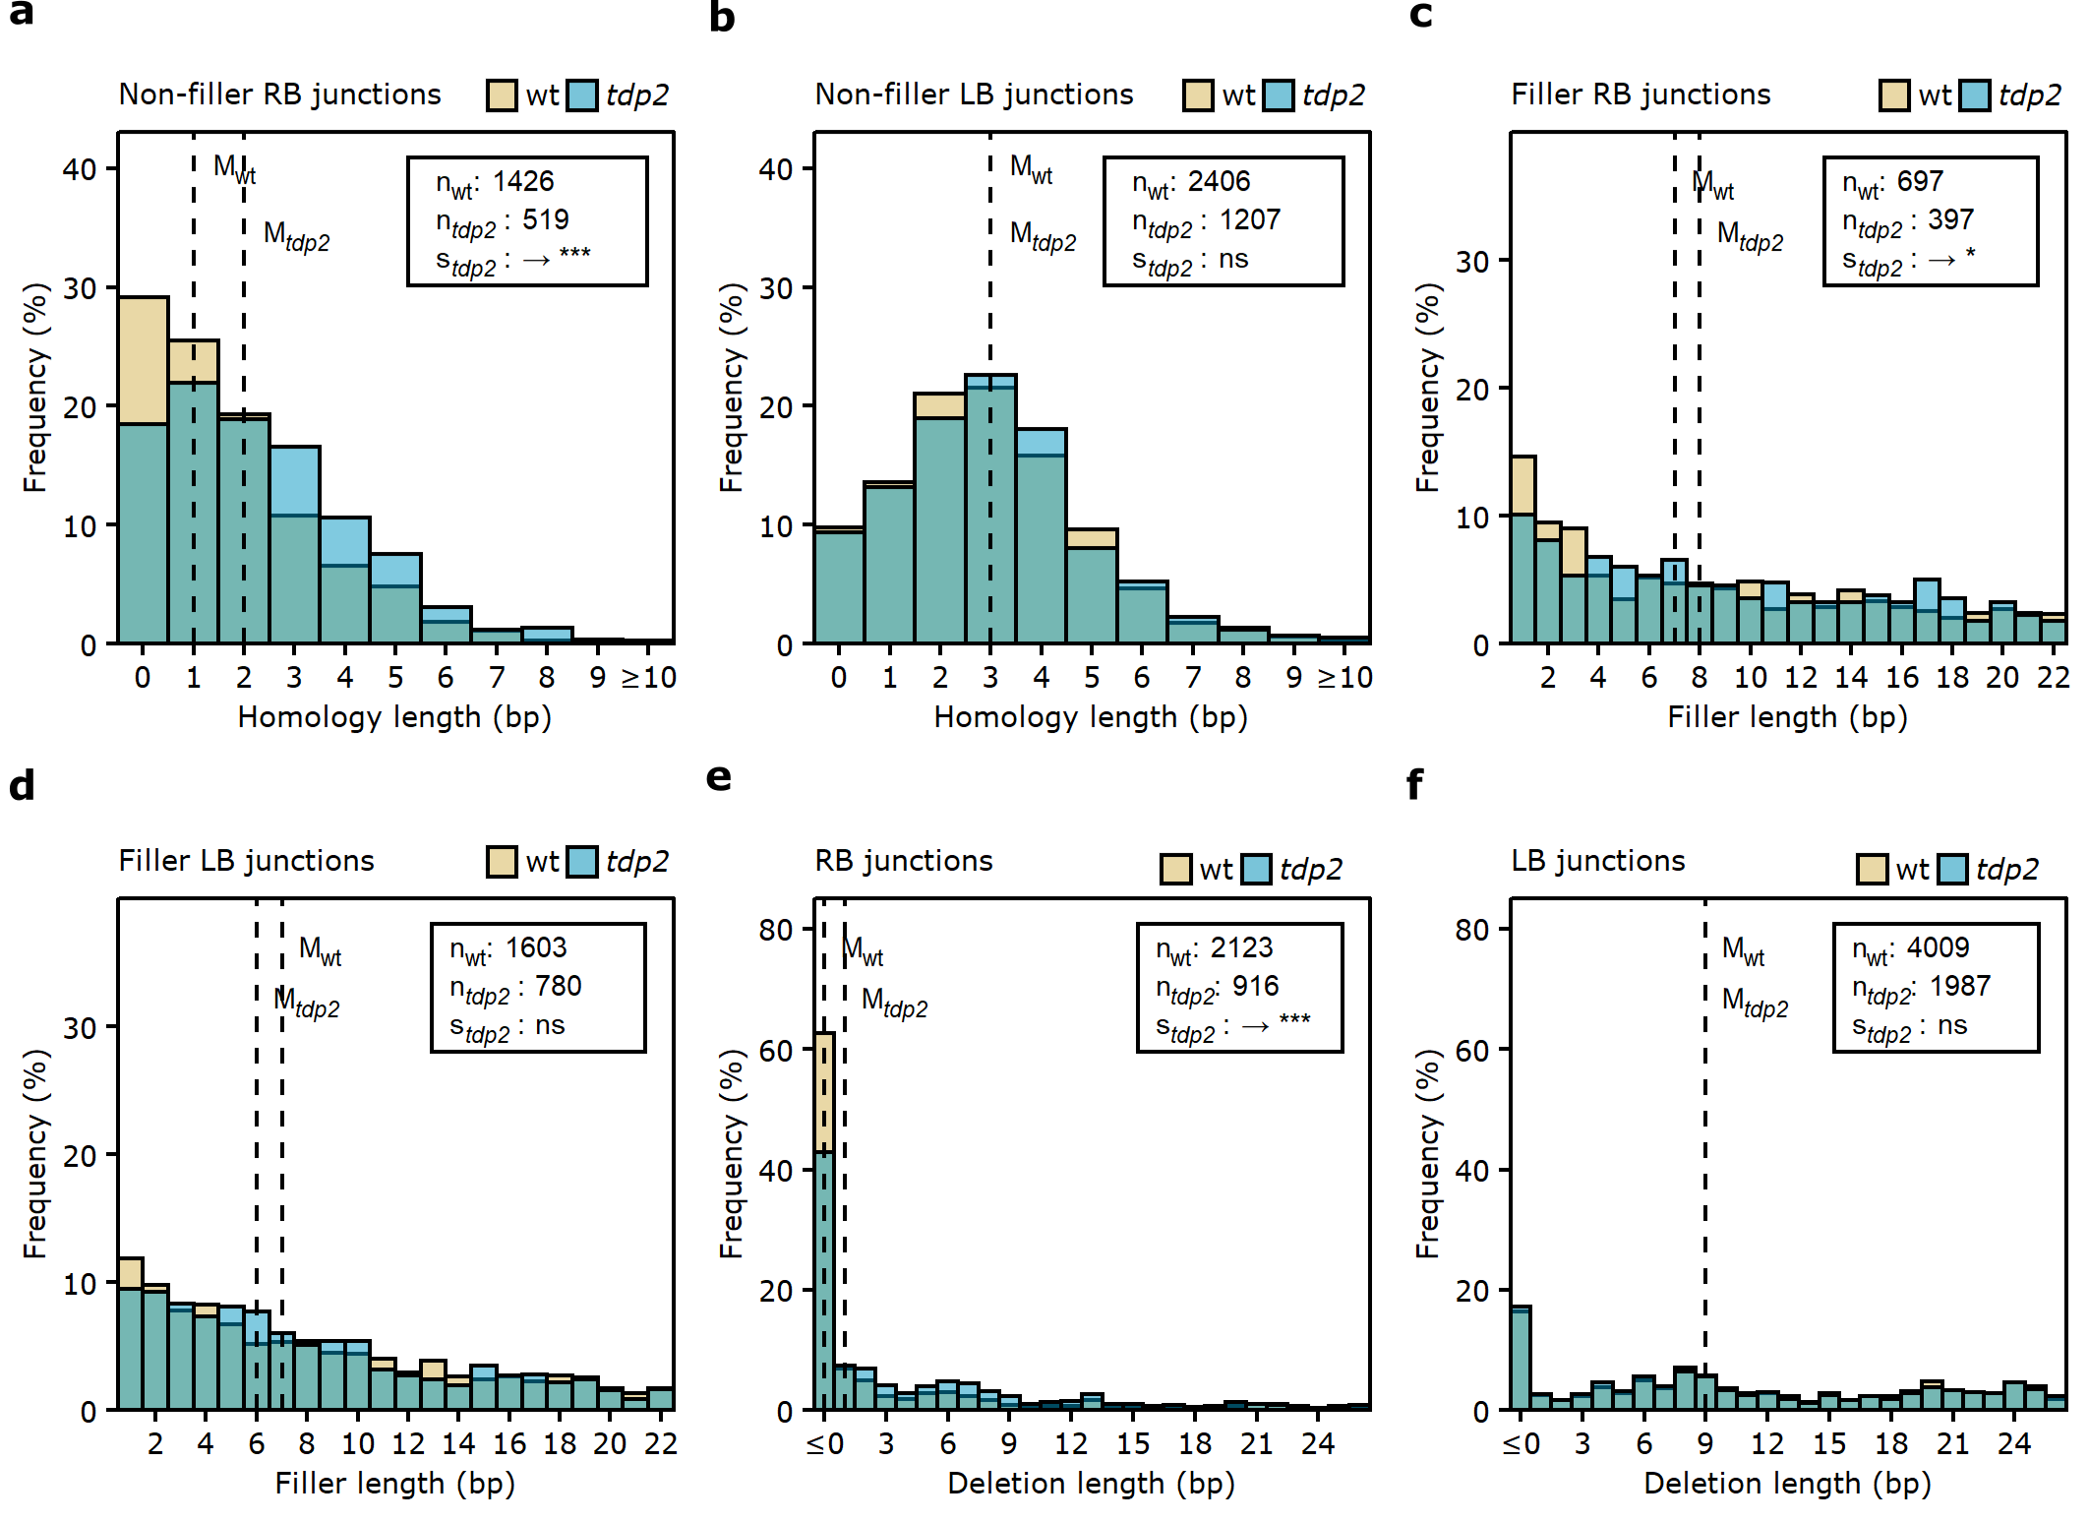
Supplementary Figure 8. Homology, filler, and T-DNA loss profiles for tdp2 mutant. Overlapping histograms indicating the frequency of different lengths of micro-homology (a, b), filler (c, d), or T-DNA loss (e, f) at RB and LB junctions, comparing wt (yellow) with the tdp2 mutant (cyan). The medians (dashed lines), the number of observations (n), and shifts in the mutant distribution relative to wt (s) are indicated. One-sided Wilcoxon rank-sum tests were performed to find the direction and the significance of the shifts; ns: p≥0.05, *: p<0.05, **: p<0.01, ***: p<0.001. The arrow indicates the direction of the shift.
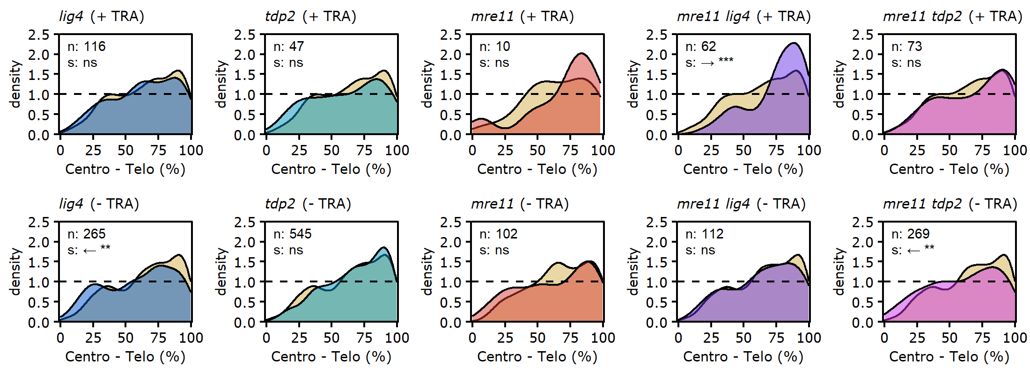
Supplementary Figure 9. Relative genomic position of junctions. Density plots showing the relative frequency of LB junctions after transformation with pWY82 (+ TRA) or pUBC (- TRA) along all chromosome arms, comparing wt (yellow) and mutants (other colors). Mutants were compared to wt of the same genetic background, with the exception of mre11 lig4 and mre11 tdp2, which were compared to the wt of the Col-0 background. 0 % indicates centromeric position and 100% telomeric; n indicates the number of mutant junctions. One-sided Wilcoxon rank-sum tests were performed to find the direction and significance level of the shifts (s) in relative position; ns: p≥0.05, *: p<0.05, **: p<0.01, ***: p<0.001. Only junctions that are represented by more than 20 different DNA molecules (thus representing events that are compatible with multiple cell divisions) were included in this analysis.

