Supplementary Material
Figure S1. Study timeline for measuring the BKPyV viral load in urine and conducting intracellular cytokine staining to assess BKPyV-specific immunity.
Figure S2. Mixed-linear regression coefficients for the percentages of NK, NKT, and VP1-specific cells among KT recipients. (A–C) Mixed linear regression coefficients for the percentages of NK (A), NKT (B), and VP1-specific NK (C) cells as vectors of dependent variables at pre-transplant and one-month post-transplant among KT recipients who were diagnosed with (red) or without (blue) BKPyVAN.
Table S1. Definitions of BKPyV infections based on the American Society of Transplantation Infectious Diseases Community of Practice guidelines published in 2019.

Figure S1. Study timeline for measuring the BKPyV viral load in urine and conducting intracellular cytokine staining to assess BKPyV-specific immunity.

Figure S2. Mixed-linear regression coefficients for the percentages of NK, NKT, and VP1-specific cells among KT recipients. (A–C) Mixed linear regression coefficients for the percentages of NK (A), NKT (B), and VP1-specific NK (C) cells as vectors of dependent variables at pre-transplant and one-month post-transplant among KT recipients who were diagnosed with (red) or without (blue) BKPyVAN.
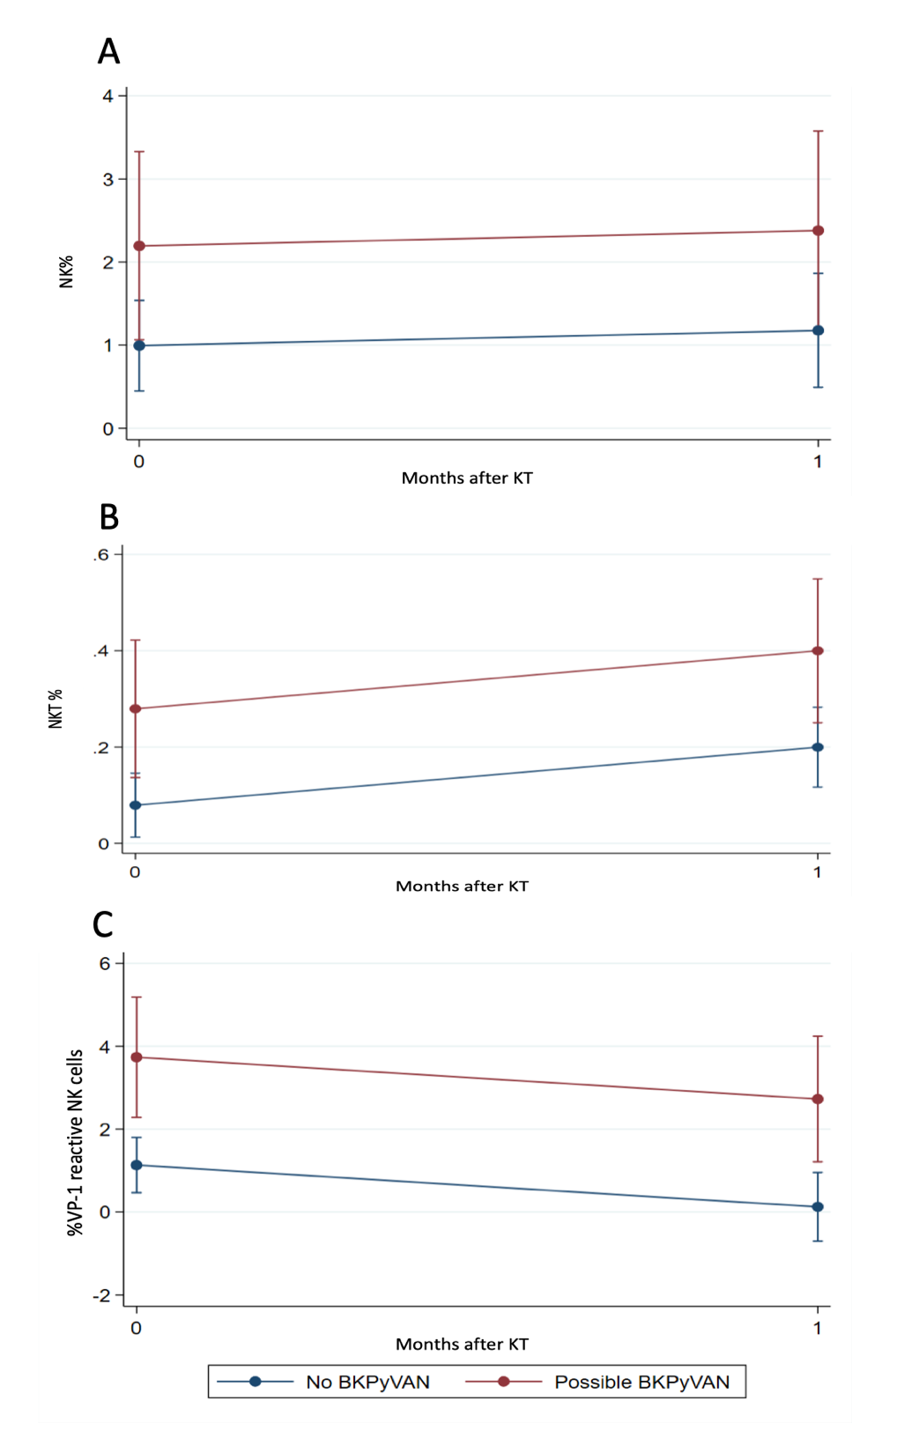
Table S1. Definitions of BK polyomavirus (BKPyV) infections based on the American Society of Transplantation Infectious Diseases Community of Practice guidelines published in 2019.
Terms | Definition
Low-level BKPyV DNAuria | Detectable urine BKPyV DNA load but < 7 log10 copies/mL
High-level BKPyV DNAuria  (possible BKPyVAN) | Detectable urine BKPyV DNA load > 7 log10 copies/mL
Presumptive BKPyVAN | Detectable plasma BKPyV DNA load > 4 log10 copies/mL
Proven BKPyVAN | Biopsy-proven polyomavirus-associated nephropathy (viral cytopathic change, inflammatory infiltrates or tubulitis or more than mild interstitial fibrosis/tubular atrophy)

Table S2. Mixed linear effect between immunological factors and time (pre-KT vs. 1-month post-KT) among all KT recipients and those with BKPyVAN
Factors | All patients (n = 40) |  |  | BKPyVAN (n = 18)
 | Coefficient | 95%CI | P-value | Coefficient | 95%CI | P-value
%CD4⁺ | 1.527 | −2.272 to 5.325 | 0.431 | −1.253 | −7.650 to 5.145 | 0.701
%LT-specific CD4⁺ | 0.007 | 0.001 to 0.013 | 0.018 | −0.001 | −0.009 to 0.006 | 0.755
%VP1-specific CD4⁺ | less than −0.001 | −0.006 to 0.005 | 0.925 | 0.003 | −0.005 to 0.012 | 0.372
%CD8⁺ | 0.855 | −0.807 to 2.518 | 0.313 | 4.277 | −0.484 to 9.039 | 0.078
%LT-specific CD8⁺ | −0.005 | −0.016 to 0.005 | 0.356 | −0.001 | −0.017 to 0.014 | 0.876
%VP1-specific CD8⁺ | −0.013 | −0.033 to 0.006 | 0.191 | 0.025 | −0.004 to 0.055 | 0.094
%NK | 0.185 | −0.658 to 1.027 | 0.668 | 1.202 | 0.033 to 2.371 | 0.044
%LT-specific NK | −0.269 | −1.030 to 0.493 | 0.489 | −0.307 | −1.503 to 0.911 | 0.621
%VP1-specific NK | −1.007 | −1.934 to −0.080 | 0.033 | 2.602 | 1.083 to 4.121 | 0.001
%NKT | 0.120 | 0.025-0.215 | 0.013 | 0.199 | 0.051-0.348 | 0.008
%LT-specific NKT | 0.294 | −1.861 to 2.449 | 0.789 | −1.671 | −5.331 to 1.990 | 0.371
%VP1-specific NKT | −0.690 | 2.651 to 1.271 | 0.490 | −0.319 | −3.041 to 2.403 | 0.819
Abbreviations: CI, confidence interval; CD4, CD4 T lymphocyte; LT, large-T antigen; VP1, viral capsid protein-1; CD8, CD8 T lymphocyte; NK, natural killer cell; NKT, natural-killer T cell

