Title: Efficacy of vafidemstat in experimental autoimmune encephalomyelitis highlights the KDM1A/RCOR1/HDAC epigenetic axis in multiple sclerosis
Authors: Fernando Cavalcanti¹, Elena Gonzalez-Rey², Mario Delgado², Leyre Mestre³, Carmen Guaza³, Michele MP Lufino¹, Jordi Xaus¹, Cristina Mascaró¹, Serena Lunardi¹, Natalia Sacilotto¹, Paola Dessanti¹, David Rotllant¹, Xavier Navarro⁴, Mireia Herrando-Grabulosa⁴, Carlos Buesa¹ and Tamara Maes¹
¹ Oryzon Genomics, S.A. Carrer Sant Ferran 74, 08940 Cornellà de Llobregat, Spain.
² Institute of Parasitology and Biomedicine Lopez-Neyra, IPBLN-CSIC, Granada, Spain.
³ Department of Functional and Systems Neurobiology, Cajal Institute (CSIC), Madrid, Spain.
⁴ Departament de Biologia Cel.lular, Fisiologia i Immunologia, Institut de Neurociències, Universitat Autònoma de Barcelona, and Centro de Investigación Biomédica en Red sobre Enfermedades Neurodegenerativas (CIBERNED), Bellaterra, Spain.

Additional File 3

Additional Figures

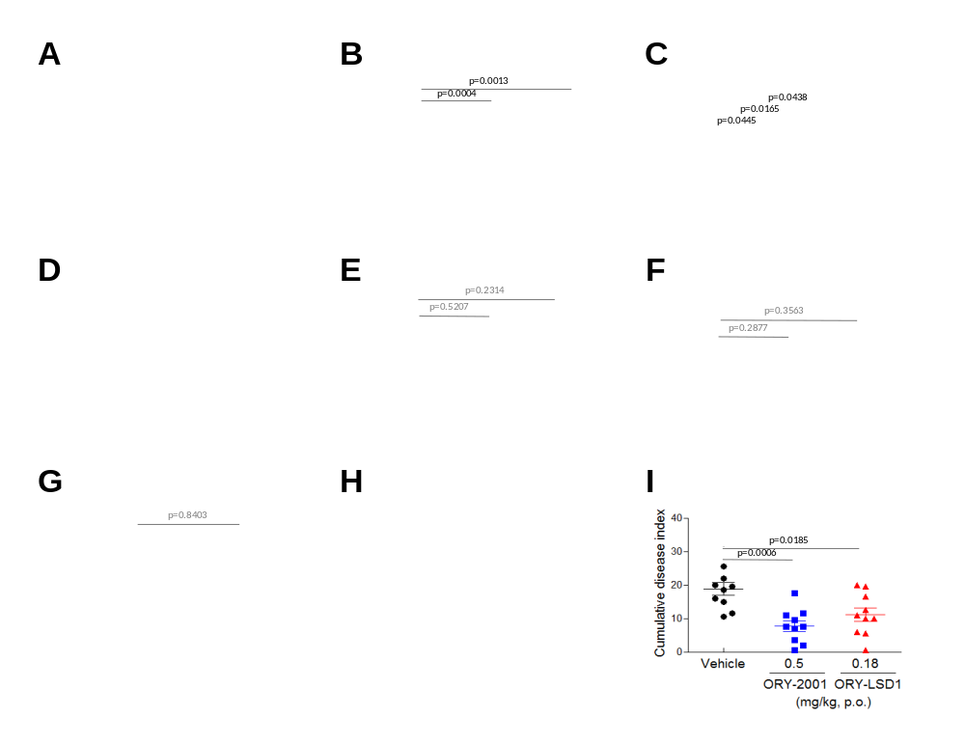
Figure A1. Therapeutic effects of ORY-2001 in EAE mice
(A)The effects of ORY-2001 on the clinical score of EAE mice during the chronic phase. The clinical score was monitored before, during, and after two weeks of treatment (five consecutive days per week) with ● (black) Vehicle (N=10 mice/group) or ORY-2001 (blue) at ■ 1.0 mg/kg (N=10 mice/group) and ▲3.0 mg/kg (N= 9 mice/group). Results are expressed as mean ± SEM. Cumulative disease index of Vehicle and ORY-2001 treatment at (B) 1 and 3 mg/kg and (C) 0.05, 0.1 and 0.5 mg/kg. Results are expressed as mean ± SEM. Dunnett's and Bonferroni's multiple comparisons test were used, respectively (D) The effects of ORY-LSD1 on the clinical score of EAE mice during the chronic phase. The clinical score was monitored before, during, and after two weeks of treatment (five consecutive days per week) with ● (black) Vehicle or ORY-LSD1 (red) at ■ 0.06 mg/kg and ▲0.18 mg/kg (N= 10 mice/in all groups). Results are expressed as mean ± SEM. Monitoring of the chronic phase was performed upto day 51 post-immunization; 28 days after last dose. Black arrows indicate the time of the beginning of the administration of the compounds. Cumulative disease index of Vehicle and ORY-LSD1 treatment at (E) 0.06 and 0.18 mg/kg and (F) 0.09 and 0.18 mg/kg. Results are expressed as mean ± SEM. Dunnett's and Bonferroni's multiple comparisons test were used, respectively. (G) Cumulative disease index of rasagiline at 3 mg/kg in the chronic phase. Results are expressed as mean ± SEM. Two-tailed paired t test was used (H) The effects of Vehicle or ORY-2001 at 0.5 mg/kg and ORY-LSD1 at 0.18 mg/kg (N=10 mice/in all groups) on the mean clinical score and (I) on the cumulative disease index in the sub-chronic phase. Results are expressed as mean ± SEM. Bonferroni's multiple comparisons test was used.
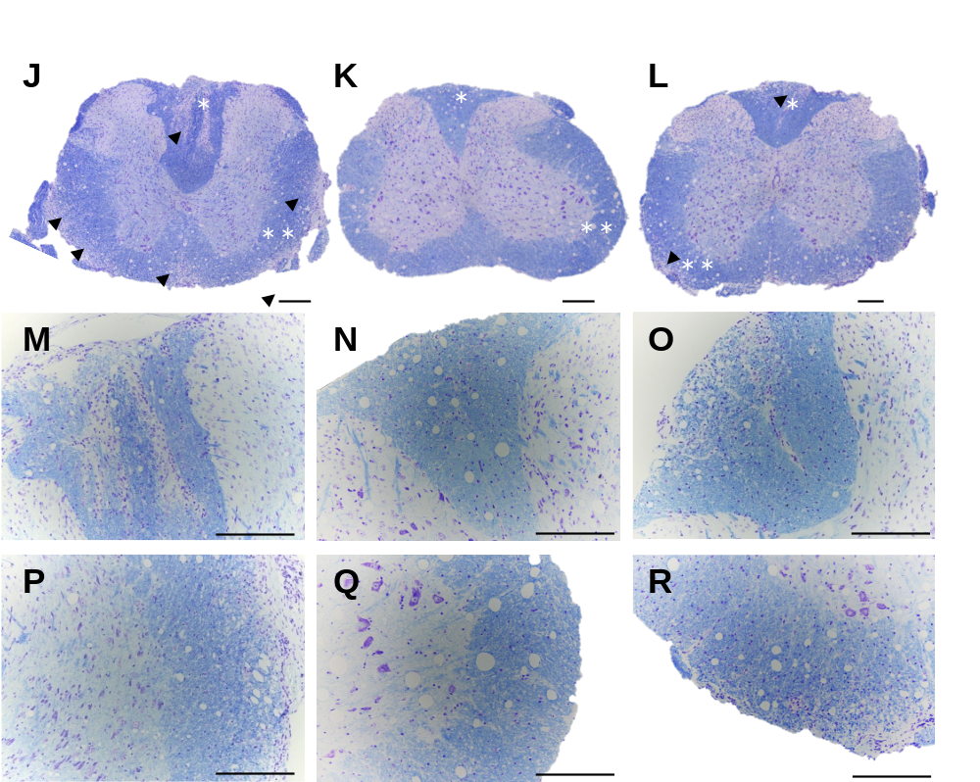
Figure A1 (continued). Therapeutic effects of ORY-2001 in EAE mice
Infiltration of inflammatory cells and demyelination as seen in Kluver-Barrera stained cervical section of spinal cords isolated from EAE mice after two weeks of treatment with (J) Vehicle (N=3 animals/group), (K) 0.5 mg/kg ORY-2001 (N=5 animals /group) or (L) 0.18 mg/kg ORY-LSD1 (N=5 animal/group); and the corresponding magnified areas (M,P), (N,Q) and (O,R) labeled with (*,**). Arrowheads point to areas of demyelination and inflammatory cell infiltration. Representative images for different areas of the spinal cord from different animals in each group are showed. Scale bar = 200 μm.

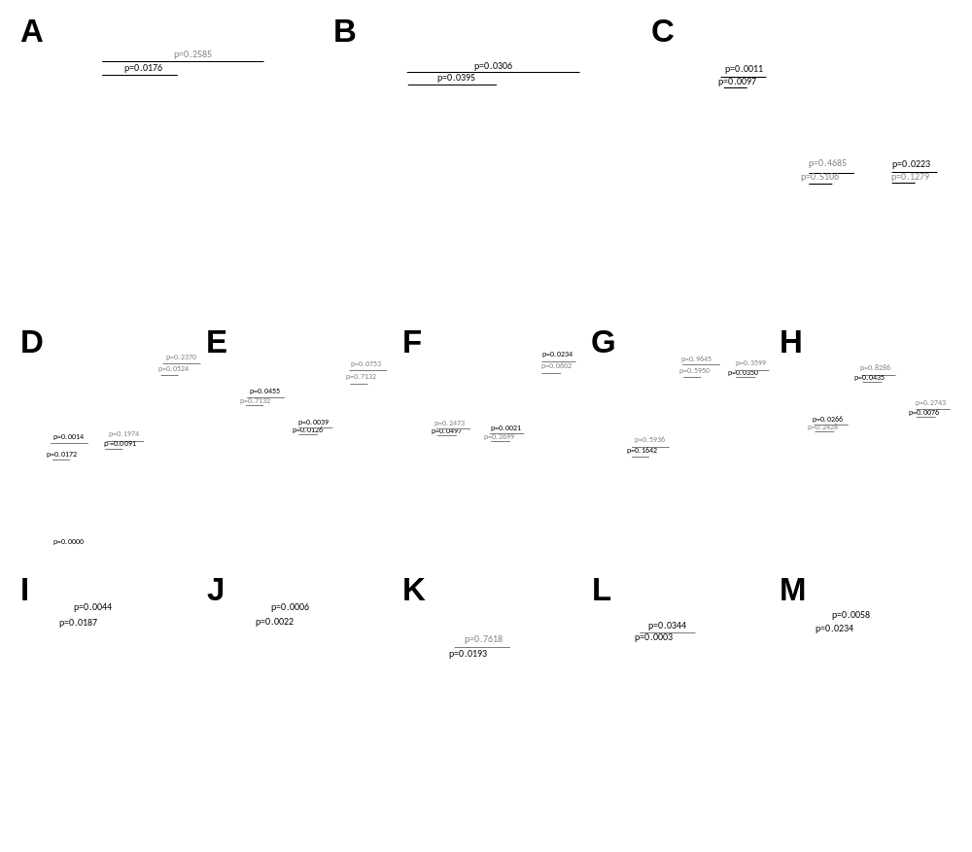
Figure A2. Effect of treatment with ORY-2001 and FTY720 on EAE mice in effector phase
(A) Cumulative disease index of EAE mice treated with Vehicle ● (black), ORY-2001 ■ (blue) at 0.5 mg/kg and FTY720 ▲(green) at 1.0 mg/kg after 5 days of treatment, in the effector phase (N=10 mice/in all groups). Results are expressed as mean ± SEM. Bonferroni's multiple comparisons test was used. (B-C) Cells isolated at EAE peak were assayed for T cell lineage expression by flow cytometry in the CD4 population (CD4CD44low/CD62Lhigh as naïve T cells CD4/CD44high/CD62Llow as memory T cells and CD4/CD44medium/CD62Llow as effector T cells). Treatment with Vehicle ● (black; N=4 mice/group), ■ (blue) ORY-2001 (0.5 mg/kg; N=5 mice/group) and ▲ (green) FTY720 (1.0 mg/kg; N=5 mice/group). Results are expressed as mean ± SEM. One-tailed unpaired t test was used. Effect of culture in medium with or without MOG or ConA on the release of (D) IL2 from spleen cells (vehicle N=10 mice/group; ORY-2001 N=10 mice/group and FTY-720, N=8 mice/group), and of (E-F) cytokines and (G-H) chemokines from lymph node cells (vehicle N=10 mice/group; ORY-2001 N=9 mice/group and FTY-720, N=8 mice/group). Results are expressed as mean ± SEM. Two-tailed Mann Whitney test test was used (I-M) Effects of treatment on the release of cytokines and chemokines in the mouse brain (N=10 mice/in all groups). Statistical differences were indicated as Vehicle vs ORY-2001 or FTY720using ANOVA followed by Tukey’s multiple comparison test or Two-tailed Mann-Whitney test.
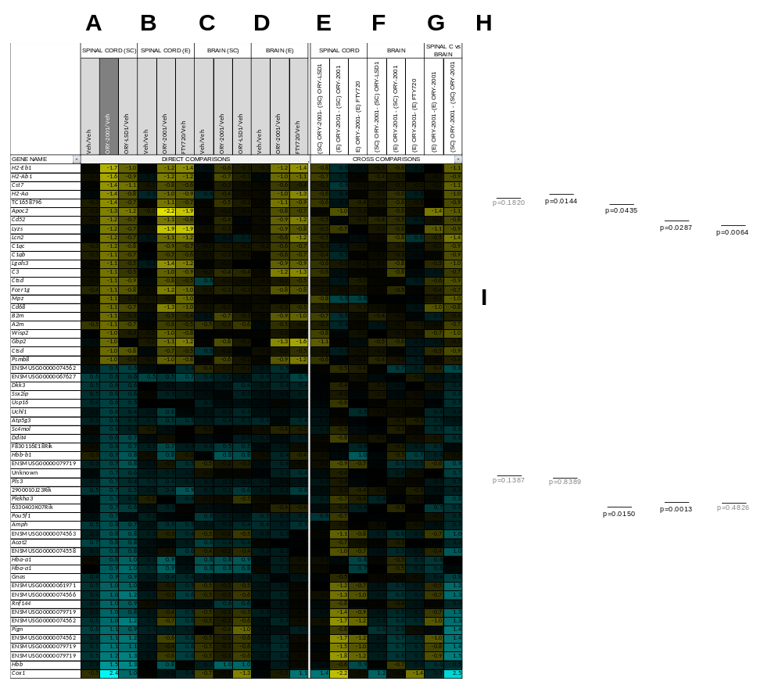Figure A3. Gene expression analysis of ORY-2001, ORY-LSD1, FTY720
Gene expression analysis in brain and spinal cord of mice treated with Vehicle, ORY-2001 at 0.5 mg/kg, ORY-LSD1 at 0.18 mg/kg and FTY720 at 1 mg/kg (A) Microarray survey of gene expression changes in the spinal cord in the sub-chronic phase; 3 days after the last dose. (B) Gene expression changes in spinal cord in the effector phase. (C) Gene expression changes in brain in the sub-chronic phase; 3 days after the last dose. (D) Gene expression changes in spinal cord in the effector phase. (E, F) Comparison of the effect of the different treatments and disease phases in spinal cord (E) and brain (F). (G) Comparison of the effects of ORY-2001 in spinal cord and brain, in both phases. Pooled RNA from N=5 spinal cords or 10 brains of Vehicle, ORY-2001 or ORY-LSD1 treated mice or from N=4 spinal cords or 6 brains of FTY720 treated mice was used to perform each survey, n=3 replicate probes within an array. Gene expression changes are expressed as Log₂(Treatment/Veh) for direct comparisons, and as the difference of the Log₂(Treatment/Veh) values for the respective conditions in the cross-comparisons. Genes up-regulated > 1.5 fold (Log₂(ORY-2001/Veh) > 0.6) or down-regulated > 2 fold (Log₂(ORY-2001/Veh) < -1) by ORY-2001 in the spinal cord in the sub-chronic phase were selected and represented for all comparisons. (H, I) qRT-PCR validations of selected individual genes modulated by ORY-2001 (blue), and ORY-LSD1 (red) in the sub-chronic phase in H) spinal cord and I) brain. Data are represented as -ΔΔCt values and mean ± SEM. (H) N=5 mice/group, three technical replicate PCRs per mouse sample. (I) N=10 mice/group, three technical replicate PCRs per mouse sample. Statistical analysis between Vehicle and ORY-2001 was calculated using two-tailed unpaired t-test. Welch’s t-test correction was applied when the populations had unequal variances.

