Supplementary Information

Green solvents improving mechanical disruption of palm kernel oil extraction

Eko K. Sitepu^{a,b*}, Andy Chandraª, Emma F. Zaidarª, Annur Vikaª, Firman Sebayang^{a,b}, Misdawati^{c}, Trung T. Nguyen^{d}, Justaman Karo-karo^{e} and Juliati Br. Tarigan^{a,b}

ª Department of Chemistry, Faculty of Mathematics and Natural Sciences, Universitas Sumatera Utara, Medan 20155, Indonesia
^{b} Carbon Research Centre, Universitas Sumatera Utara, Medan 20155, Indonesia
^{c} Department of Civil Engineering, Universitas Al Washliyah, Medan 20147, Indonesia
^{d} Department of Food Technology, An Giang University, Long Xuyen City, Vietnam
^{e} Balai Riset dan Standarisasi Industri, Kementerian Perindustrian, Medan 20214, Indonesia

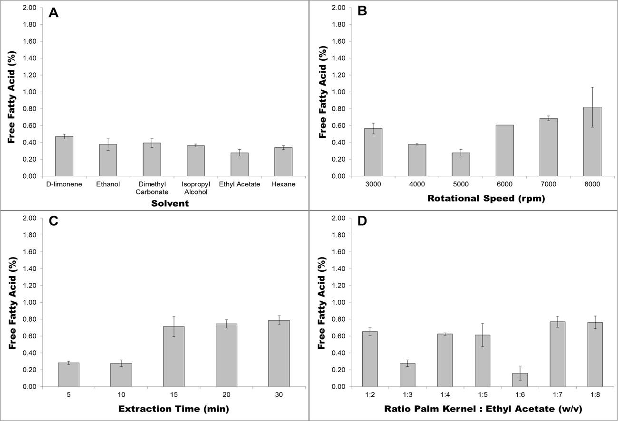
Figure 1. Effect of (A) solvent; (B) rotational speed; (C) extraction time; and (D) ratio palm kernel to ethyl acetate on free fatty acid content of CBE-intensified palm kernel oil extraction. Error bars represent SD.

Table 1. ANOVA and Hartley-Cochran homogeneity test and Tukey post hoc test for extraction efficiency of CBE-intensified green solvents palm kernel extraction. Significance values below α<0.05 are colour coded in red.

Effect of rotational speed
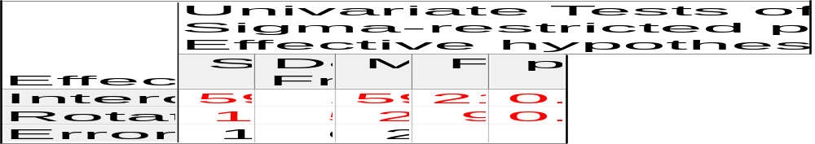
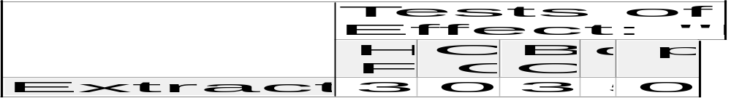
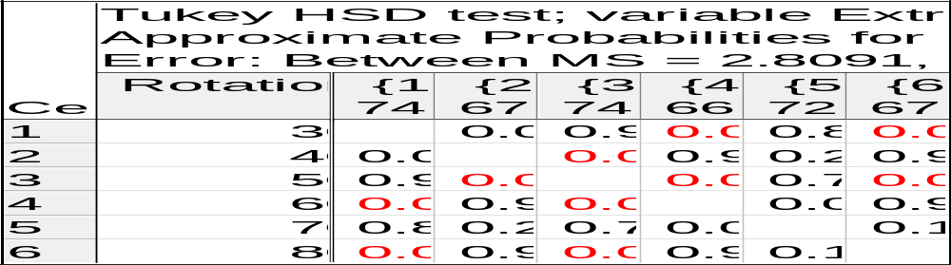

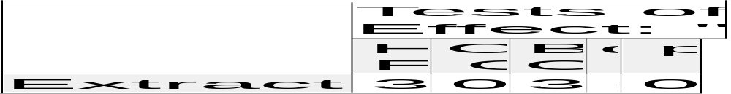

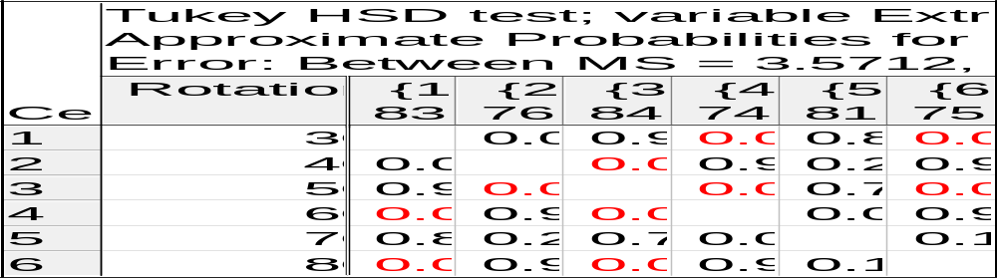

Effect of extraction time

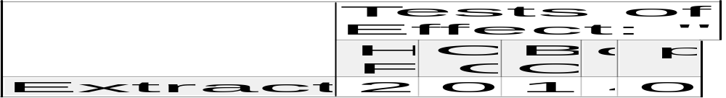
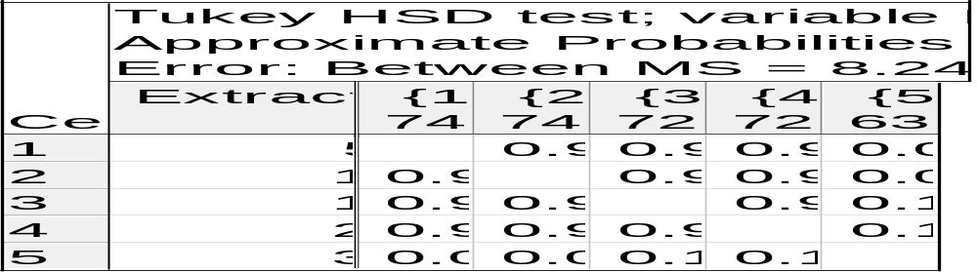


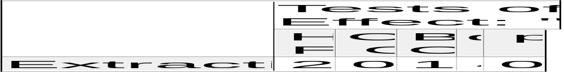
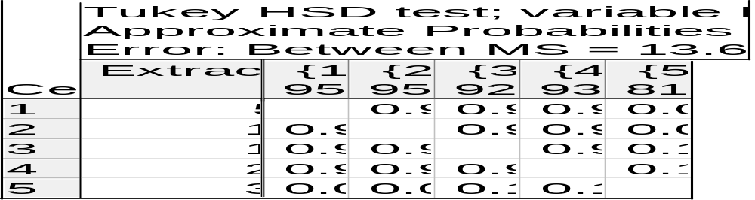

Effect of ratio palm kernel : ethyl acetate
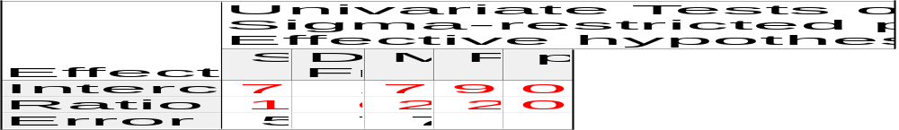
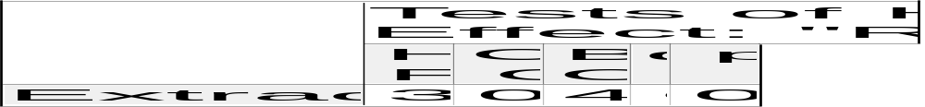
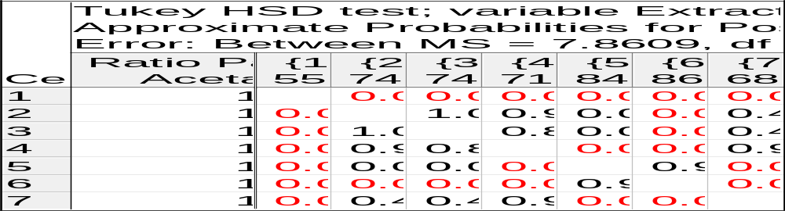

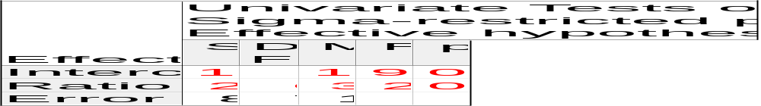
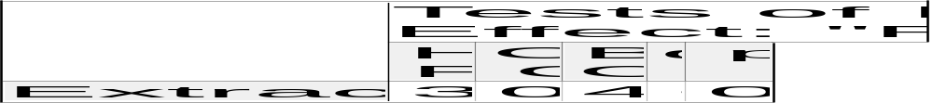
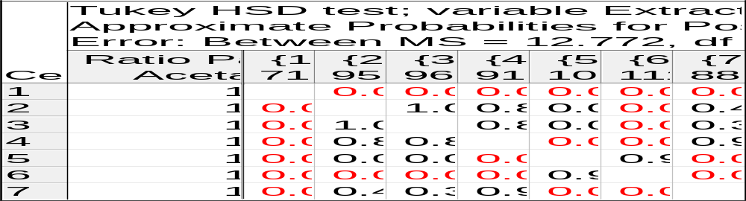

Table 2. ANOVA and Hartley-Cochran homogeneity test and Tukey post hoc test for free fatty acid value of CBE-intensified green solvents palm kernel extraction. Significance values below α<0.05 are colour coded in red.

Effect of rotational speed
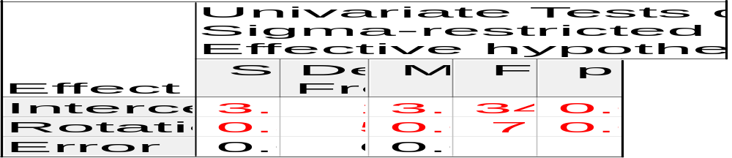
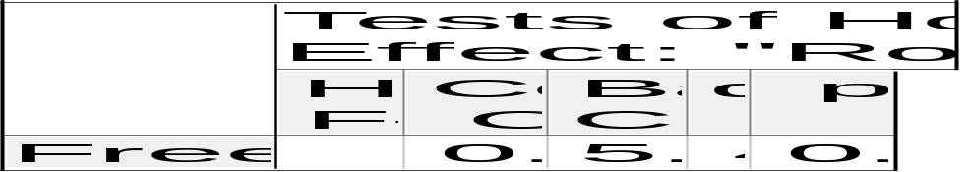
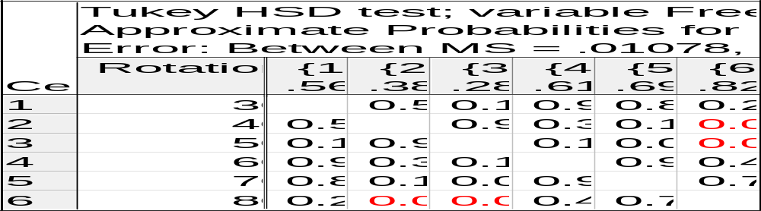

Effect of extraction time
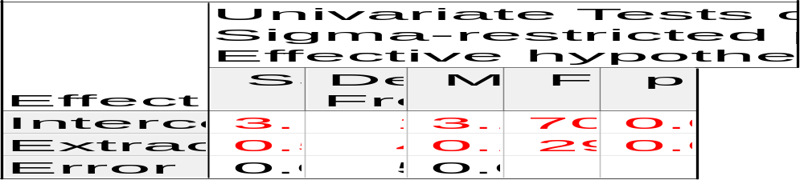
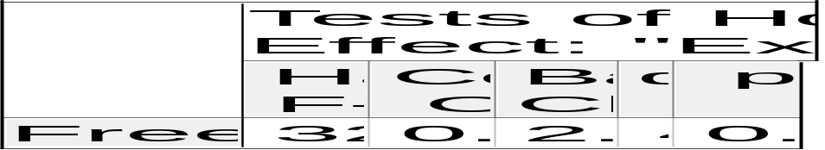
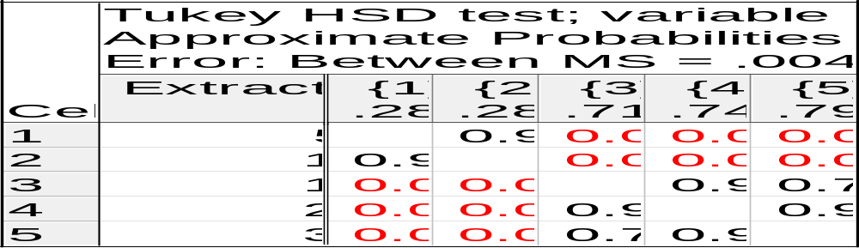

Effect of ratio palm kernel : ethyl acetate
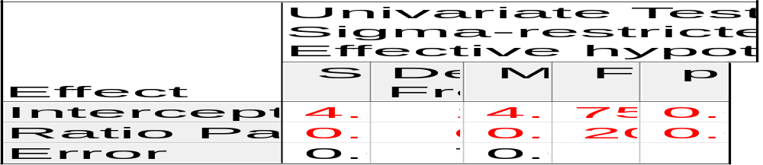
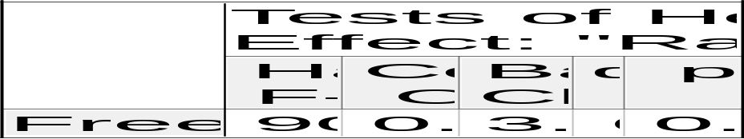
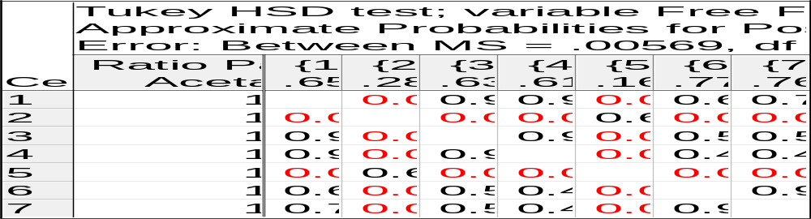

Table 3. ANOVA and Hartley-Cochran homogeneity test and Tukey post hoc test for monoglyceride concentration (mol%) of CBE-intensified green solvents palm kernel extraction. Significance values below α<0.05 are colour coded in red.

Effect of rotational speed
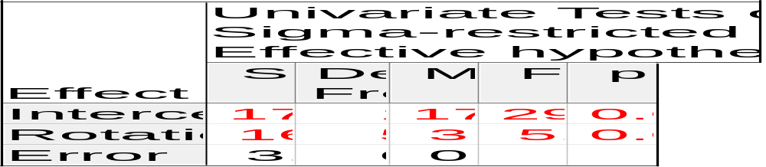
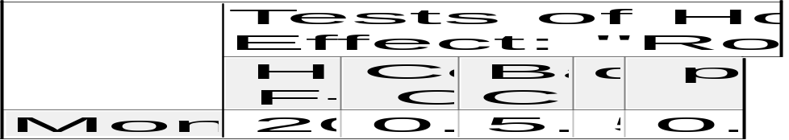
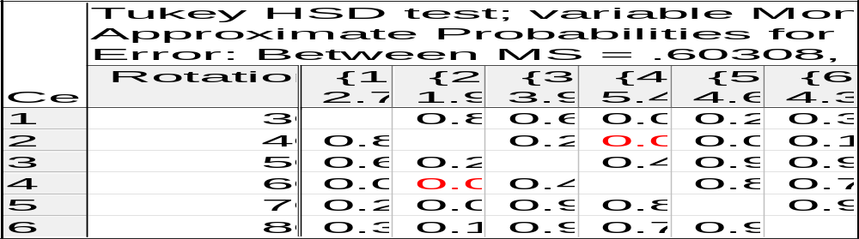

Effect of extraction time
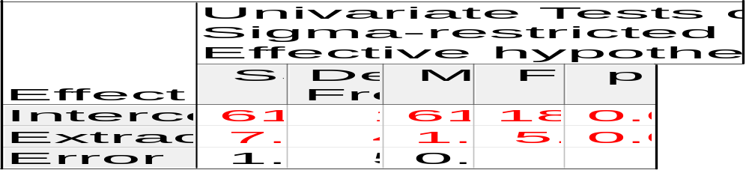
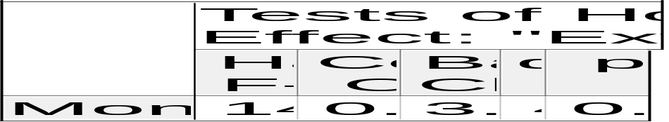
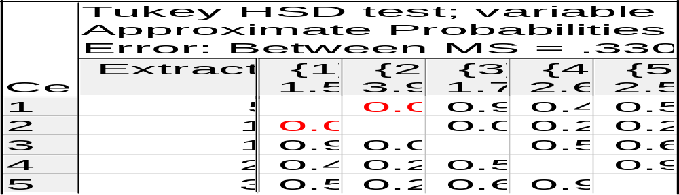

Effect of ratio palm kernel : ethyl acetate
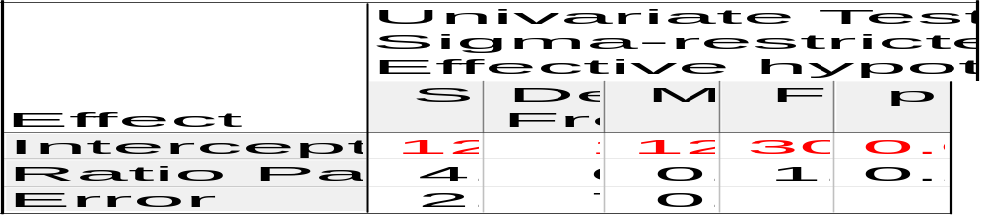
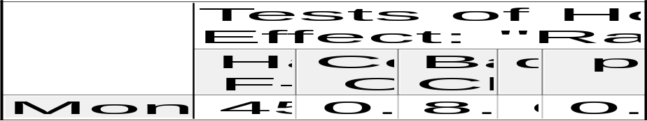
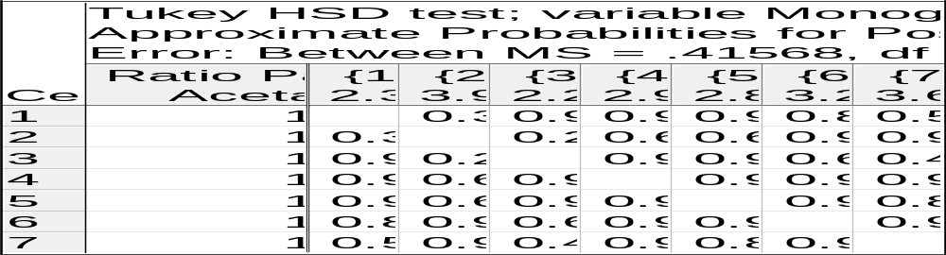

Table 4. ANOVA and Hartley-Cochran homogeneity test and Tukey post hoc test for diglyceride concentration (mol%) of CBE-intensified green solvents palm kernel extraction. Significance values below α<0.05 are colour coded in red.

Effect of rotational speed
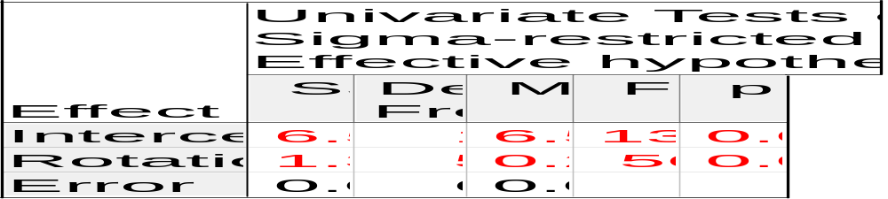
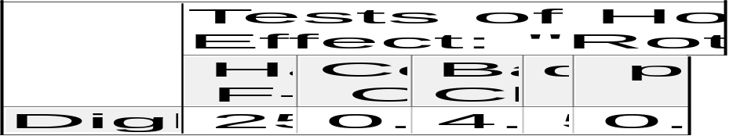
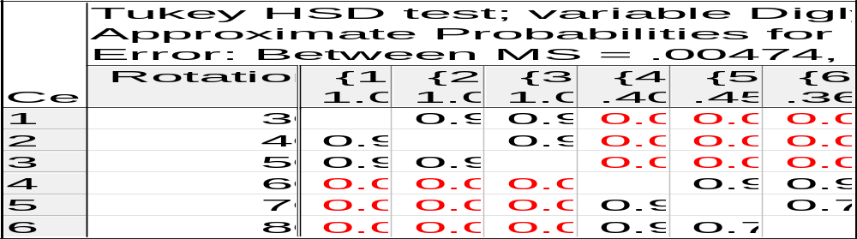

Effect of extraction time
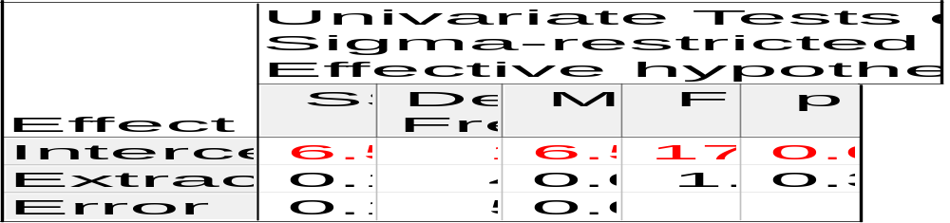
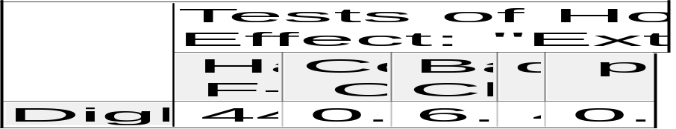
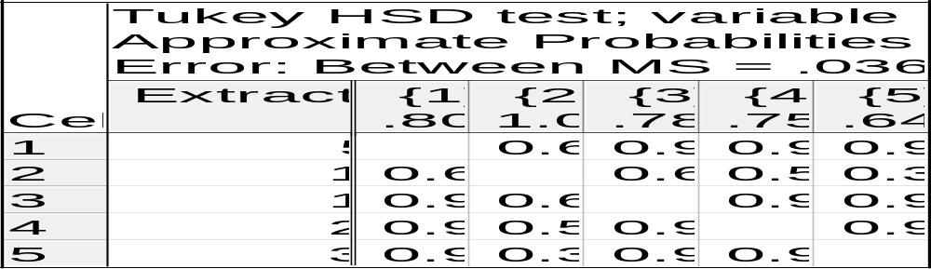

Effect of ratio palm kernel : ethyl acetate
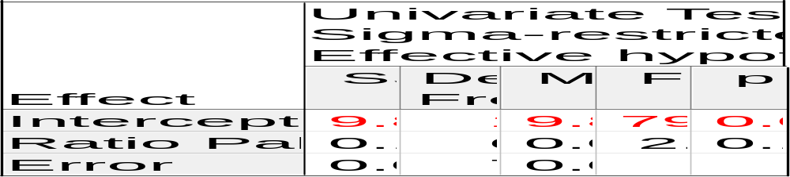
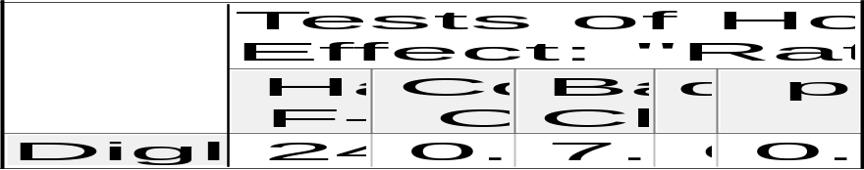
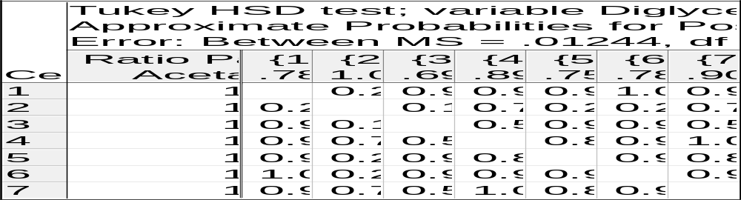

Table 5. ANOVA and Hartley-Cochran homogeneity test and Tukey post hoc test for triglyceride concentration (mol%) of CBE-intensified green solvents palm kernel extraction. Significance values below α<0.05 are colour coded in red.

Effect of rotational speed
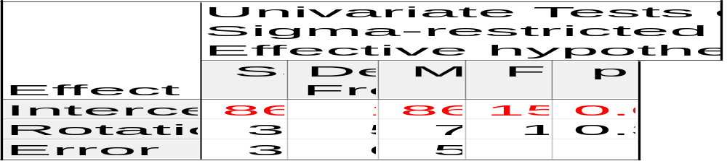
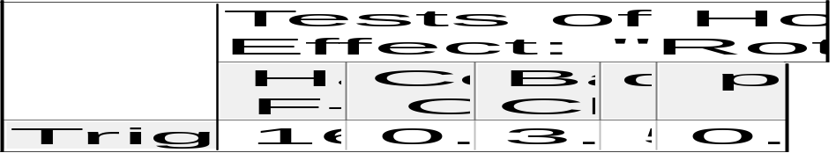
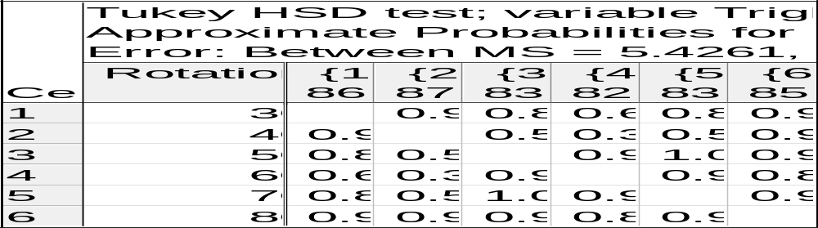

Effect of extraction time
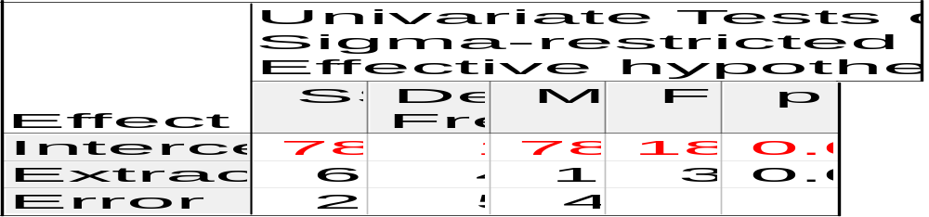
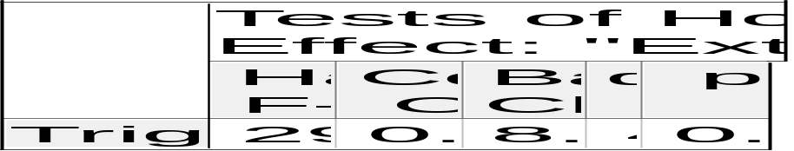
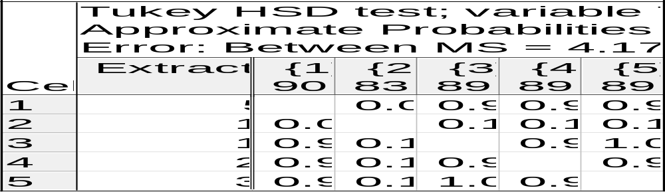

Effect of ratio palm kernel : ethyl acetate
