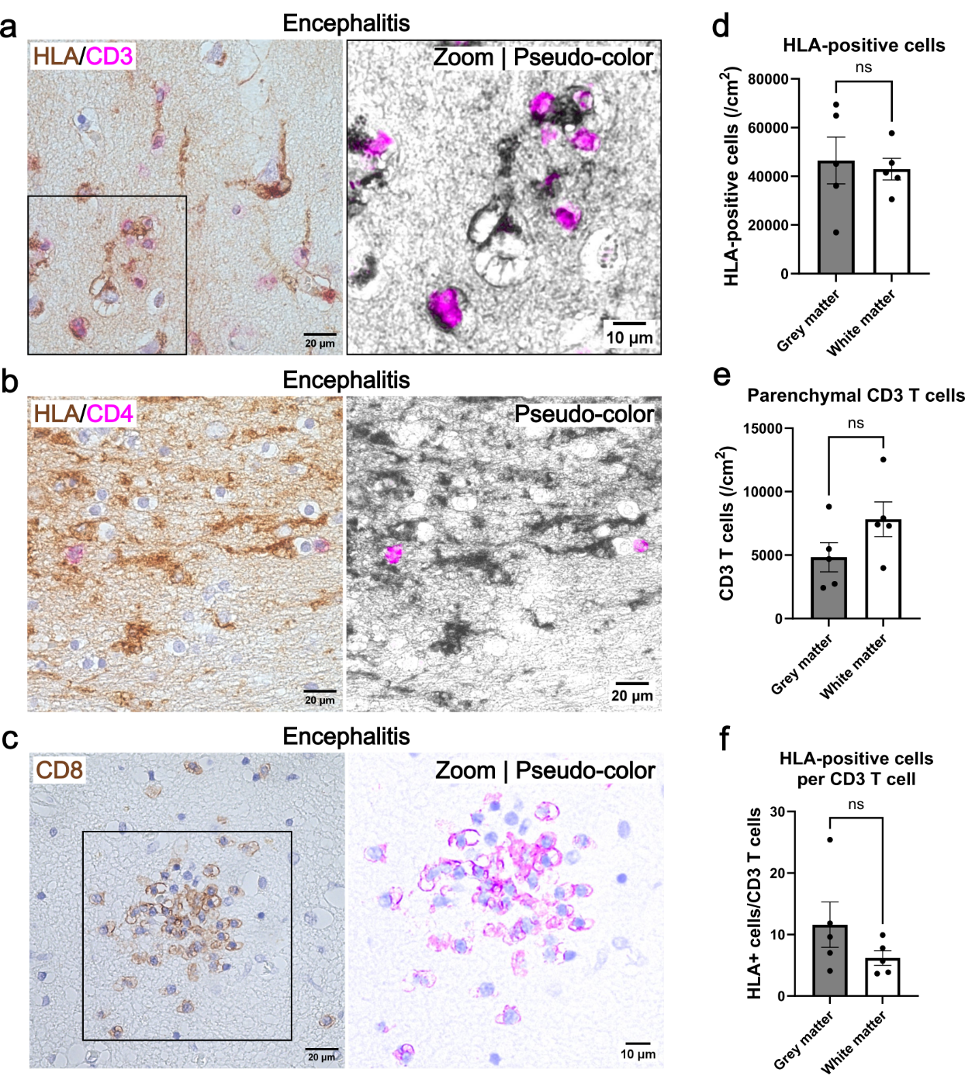
Supplementary Figure 1. Positive control for T cell infiltration in brain tissue. Representative chromogenic immunostainings for HLA-DR/DP/DQ (DAB, brown) together with CD3 (a) or CD4 (b) (FastRed, red), and single chromogenic staining for CD8 (c) (DAB, brown) in a case with acute disseminated encephalomyelitis (ADEM). Representative images of local T cell infiltrates were acquired from the temporal cortex (a and b) and hippocampus (c). Original bright field images are shown in the left panels. CD3-, CD4- and CD8-positive T cells are highlighted in the right panels using magenta pseudo-coloring, together with HLA-DR/DP/DQ shown in grey values (a and b) or haematoxylin shown in blue (c). The number of HLA-positive cells (d) and parenchymal CD3-positive T cells (e) were quantified per cm² in 5 local T cell infiltrations in grey and white matter. The number of positive cells per local infiltrate is shown, together with mean and SEM. The ratio of HLA-positive cells over parenchymal CD3 T cells represents the extend of T cell infiltration per local infiltrate (f).

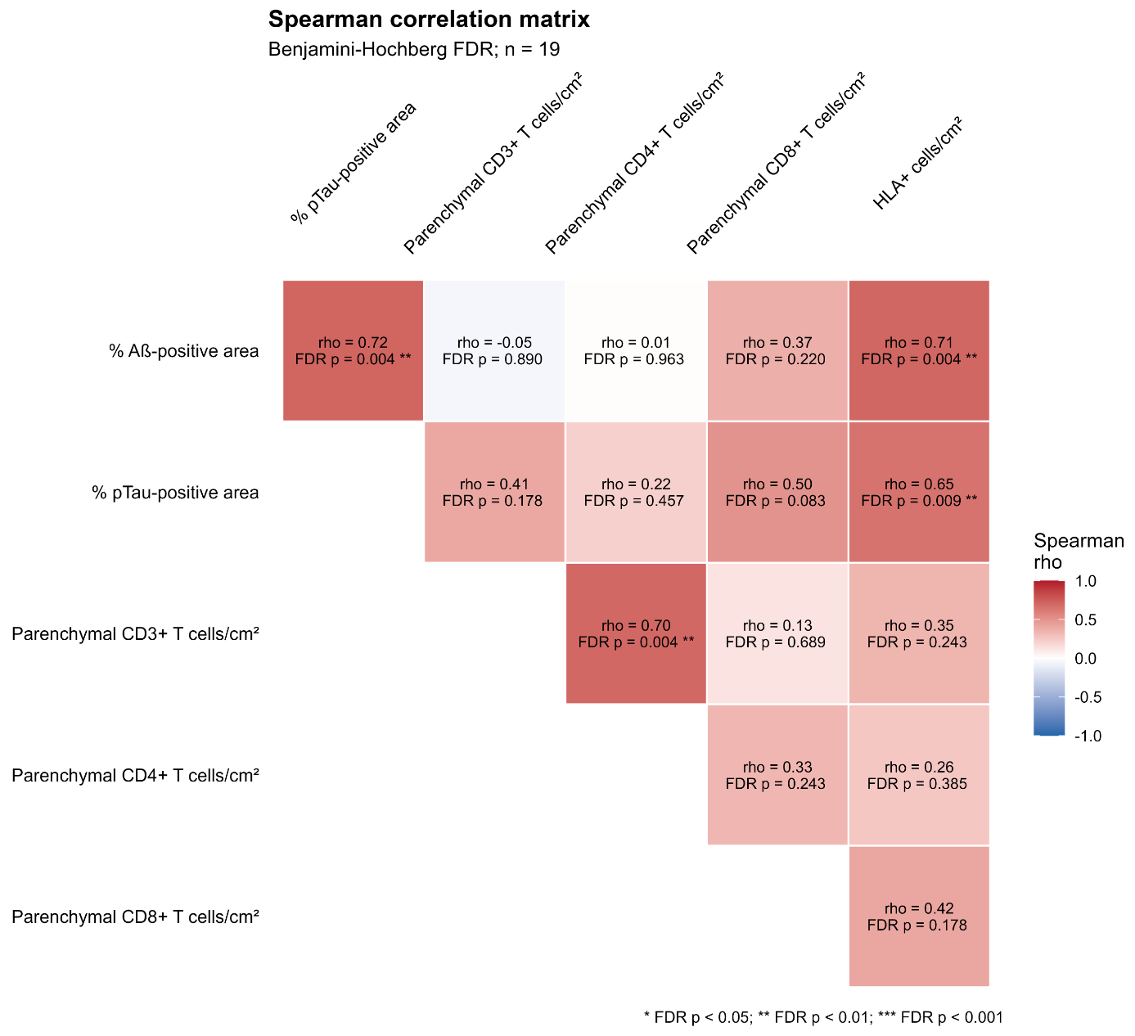
Supplementary Figure 2. Spearman correlation matrix. Spearman correlation was performed with the Benjamini-Hochberg procedure to control the false discovery rate. Correlation is showed for each combination of variables (rho) together with p-value with Benjamini-Hochberg correction (FDR p). Unadjusted p-values are shown in Supplementary Figure 3. Scatter plots are shown in Supplementary Figure 4, between the number of parenchymal CD8 T cells and the number of HLA-positive cells, and the Aβ-positive area and pTau-positive area.

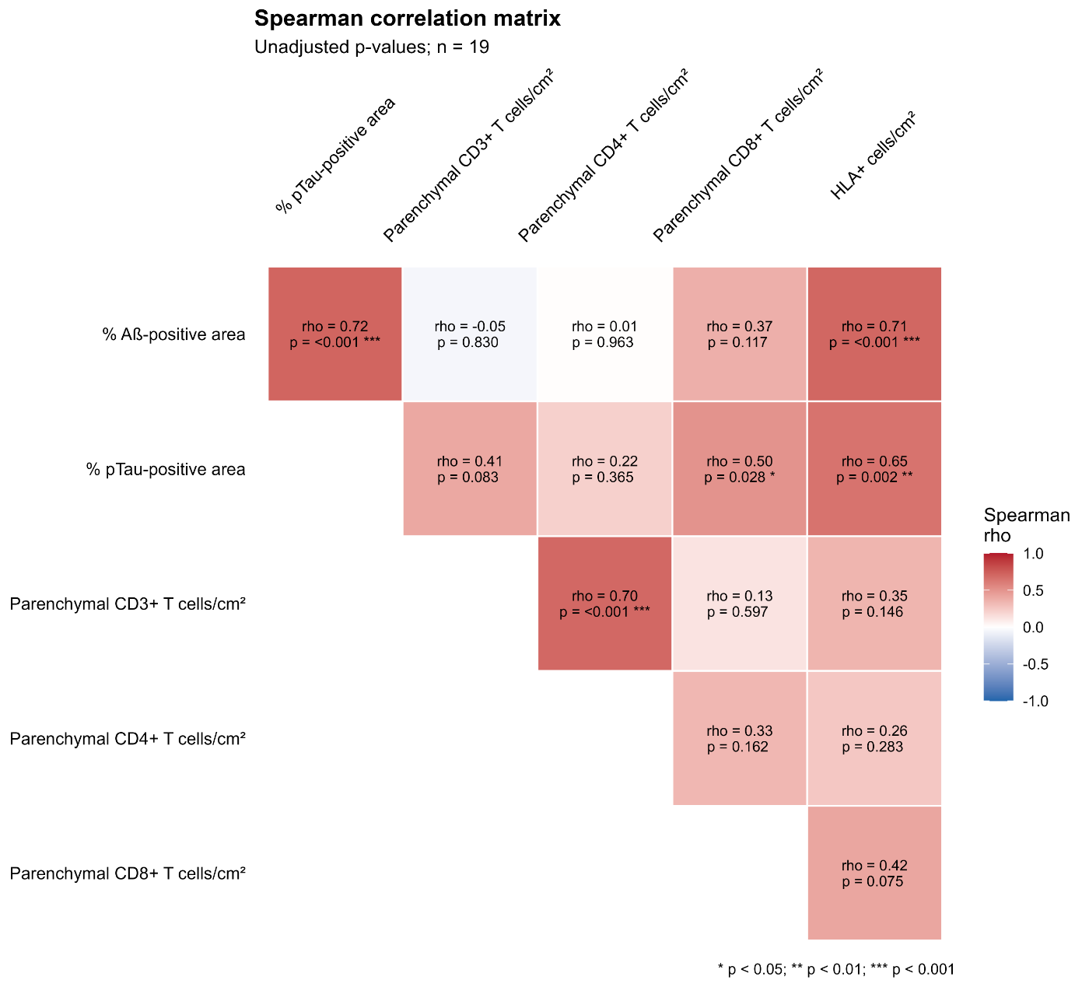
Supplementary Figure 3. Spearman correlation matrix with unadjusted p-values. Spearman correlation was performed without correction for multiple testing. Correlation is showed for each combination of variables (rho) together with unadjusted p-value. Scatter plots are shown in Supplementary Figure 4, with the number of HLA-positive cells against the Aβ-positive area and pTau-positive area, and with the number of parenchymal CD8 T cells against the Aβ-positive area and pTau-positive area.

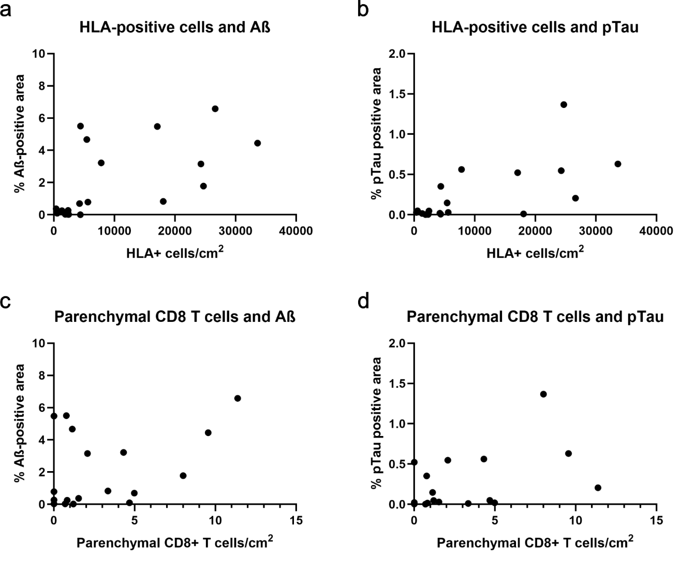
Supplementary Figure 4. Scatter plots. Scatter plots are shown with the number of HLA-positive cells against the Aβ-positive area and pTau-positive area, and with the number of parenchymal CD8 T cells against the Aβ-positive area and pTau-positive area.

