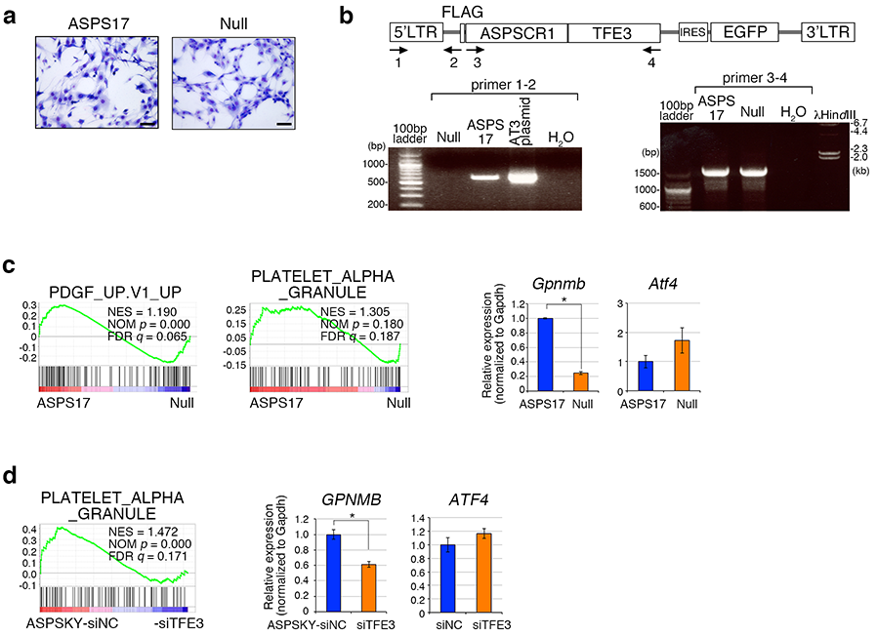
Extended Data Fig. 1. | Reduced ASPSCR1-TFE3 expression alters gene expression profiles in murine and human ASPS cells. a, Photomicrographs of ASPS17 and null cells in culture. Scale bar: 50 µm. b, Deletion of the DNA sequence including 5’-long terminal repeat (LTR) within the retroviral vector in ASPS null cells. The structure of pMY-ASPSCR1-TFE3-IRES-GFP (top), and genomic PCR results for the 5’-LTR (bottom left) and the ASPSCR1-TFE3 sequence (bottom right) are shown. c, GSEA showing enrichment of PDGF and platelet alpha granule pathways between ASPS17 and ASPS null cells (left). qRT-PCR shows downregulation of Gpnmb in ASPS null cells while Atf4 expression was increased (right). * P < 0.05. d, GSEA showing enrichment of the platelet alpha granule pathways by comparing human ASPS-KY cells with and without knockdown of ASPSCR1-TFE3 (left). GPNMB is downregulated by the knockdown of ASPSCR1-TFE3 while ATF4 expression was unchanged (right). * P < 0.05.

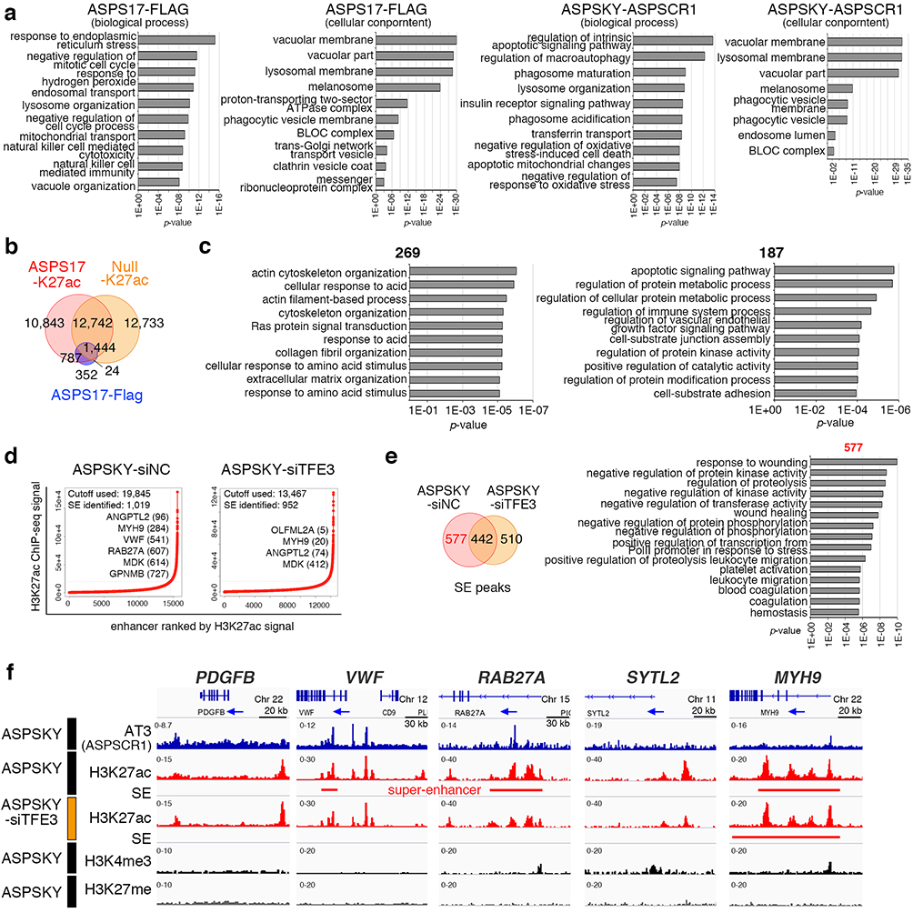
Extended Data Fig. 2. | The loss of ASPSCR1-TFE3 expression modulates distribution of super-enhancers. a, The GREAT pathway analysis for ASPSCR1-TFE3 binding peaks in ASPS17 cells (left two graphs) and ASPS-KY cells (right two graphs). b, Venn diagram showing the number and overlapping of H3K27ac in ASPS17 and null cells, and ASPSCR1-TFE3 (FLAG) in ASPS17 cells. c, The GREAT pathway analysis for 269 overlapping in both ASPS17 and null cells, and 187 null-specific super-enhancers appeared in Fig. 2f. d, Enhancers are ranked by increasing H3K27ac signals in ASPS-KY cells introduced with control siRNA and siTFE3. Using the ROSE algorithm, 1019 and 952 enhancers were defined as super-enhancers in ASPS-KY cells with control siRNA and siTFE3, respectively. e, Venn diagram showing overlapping and distinct super-enhancers (left). Enrichment of Gene Ontology biological process for 577 ASPSCR1-TFE3-positive ASPS-KY specific super-enhancers (right). f, ChIP-seq track at PDGFB, VWF, RAB27A, SYTL2, and MYH9 genomic loci, showing association between ASPSCR1-TFE3 and H3K27ac binding in ASPS-KY cells. Significant loss of H3K27ac signals and/or super-enhancer by TFE3 knockdown are exhibited. The MYH9 genomic locus is shown as an example of un-affected super-enhancers by ASPSCR1-TFE3 knockdown.

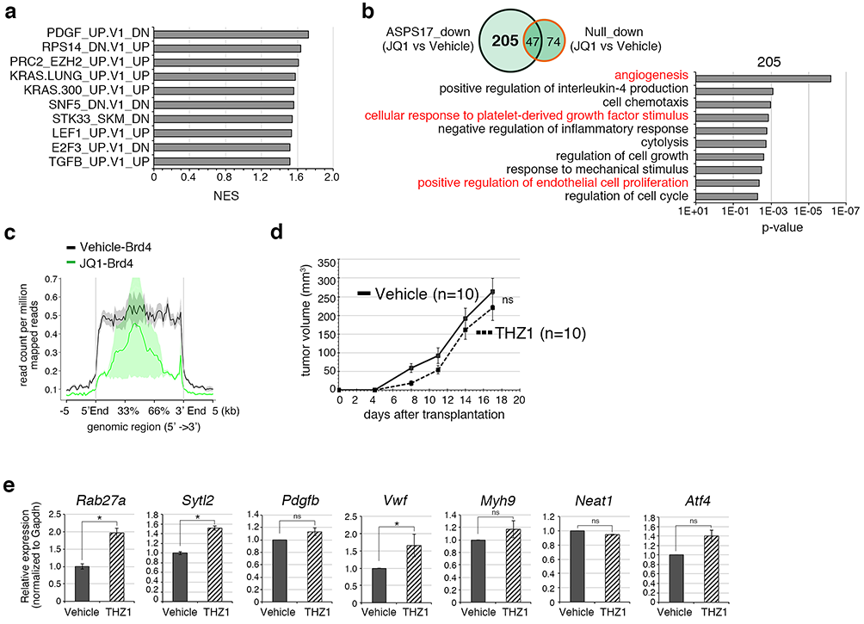
Extended Data Fig. 3. | JQ1 suppresses angiogenesis-associated gene expression via suppression of Brd4 binding whereas THZ1 does not affect angiogenesis and tumor development of ASPS. a, GSEA results on the comparison between ASPS treated with vehicle and JQ1 gene expression signatures. Top 10 pathways for normalized enrichment scores are indicated. b, Venn diagram showing overlapping and distinct down-regulated genes in ASPS17 and null cells treated with JQ1 and vehicle (top). The DAVID analysis for 205 downregulated genes unique in ASPS17 cells showing enrichment of angiogenesis-associated pathways (bottom, indicated in red). c, Composite plots showing the significant reduction of Brd4 binding signals around 527 SEs of ASPS17 cells by JQ1 treatment. d, Effects of THZ1 treatment on the in vivo growth of ASPS17 cells. No significant growth inhibition is observed. e, Expression of Rab27a, Sytl2, Pdgfb, Vwf, Myh9, Neat1, and Atf4 in ASPS17 treated with JQ1. None of genes show downregulated expression. * P < 0.05.

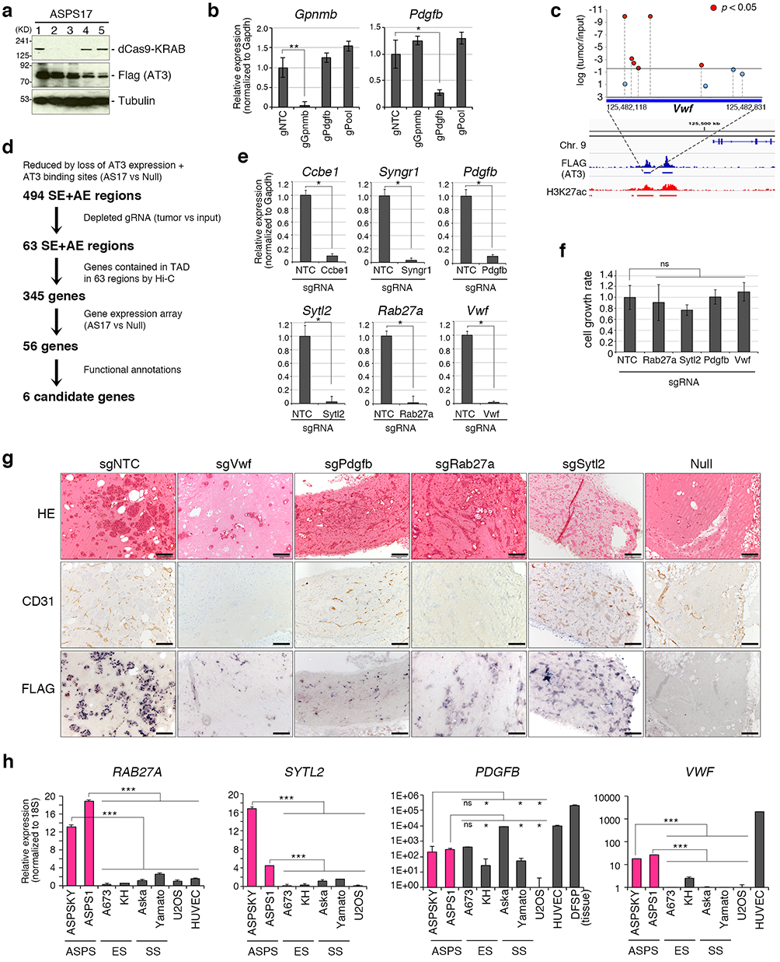
Extended Data Fig. 4. | Identification of ASPSCR1-TFE3 targets by epigenomic CRISPR/dCas9 screening. a, Exogenous expression of dCas9-KRAB protein in ASPS17 cells detected with the anti-Cas9 antibody. The clone #1 was used for the subsequent screening. b, Efficiencies of downregulated expression by introducing individual gRNA for Gpnmb and Pdgfb in dCas9-KRAB-expressing ASPS cells. * P < 0.05, ** P < 0.01. c, A detailed view of the region around Vwf for the dCas9-KRAB screen. Log₂ fold change of the gRNA abundance is shown. d, The schematic diagram of the screening procedure. A total of 494 SE and active enhancers (AE) were selected as primary targets. e, Validation of gene knockout confirmed by qRT-PCR. * P < 0.05. f, Knockout of Rab27a, Sytl2, Pdgfb, or Vwf does not suppress cell proliferation in vitro. g, Immunostaining for CD31 and FLAG (ASPSCR1-TFE3) in recipient nude mice two weeks after transplantion of ASPS cells showing significant suppression of angiogenesis and tumor growth by knockout of Vwf, Pdgfb, Rab27a and Sytl2 as well as in the ASPSCR1-TFE3 loss (null cells). Scale bar, 100 µm. h, qRT-PCR of RAB27A, SYTL2, PDGFB, and VWF in human sarcoma cell lines. *** P < 0.001.

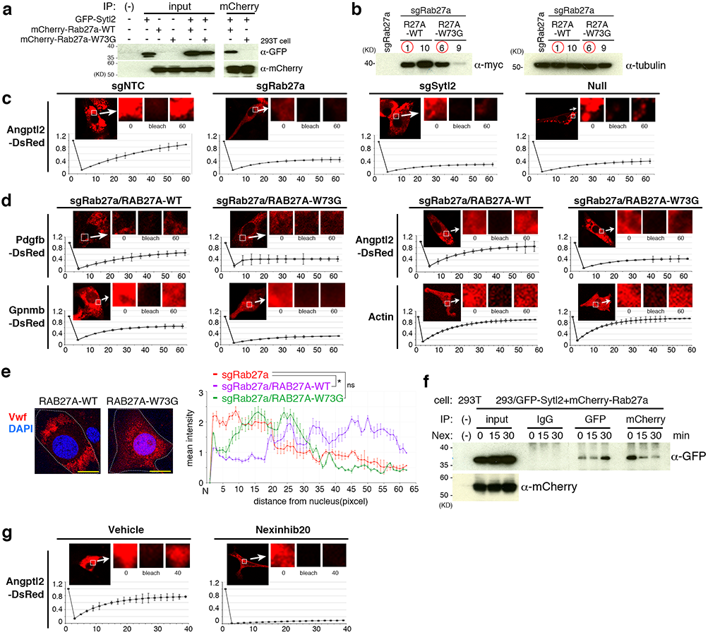
Extended Data Fig. 5. | Intracellular trafficking of angiogenic factors is promoted by the Rab27a/Sytl2 axis. a, Co-immunoprecipitation showing interaction between Sytl2 and wild type Rab27a but not the W73G mutant of Rab27a. GFP-tagged Sytl2 and mCherry-tagged Rab27a were introduced into HEK293T cells. b, Western blotting showing exogenous expression of myc-tagged wild type and W73G Rab27a in ASPS17 cells with knockout of endogenous Rab27a. Red circles indicate clones used for ELISA and the trafficking experiment shown in Fig. 5a, b, d, and e. c, FRAP showing marked delay in trafficking of DsRed-labeld Angptl2 by Rab27a knockout, Sytl2 knockout and ASPS null cells. Representative images of FRAP of ASPS17 cells are shown in upper panels and representative normalized traces of FRAP for each experiment are shown in lower panels. Each point represents one image acquired every 5 min. d, FRAP showing rescue of trafficking by wild type Rab27a but not W73G mutant in ASPS17 cells with endogenous Rab27a knockout. Time course of DsRed-labeld Pdgfb, Gpnmb, and Angptl2 distributions are shown. e, Immunofluorescence showing intracellular localization of Vwf in Rab27a knockout cells in the presence of exogenous wild type or W73G proteins. Localization in peripheral areas in ASPS17 cells with Rab27a knockout was recovered by introduction of human wild type RAB27A but not by the W73G mutant (left). Intracellular distribution of Vwf in each cell type was plotted as mean intensities of fluorescence at indicated distances from nucleus (right). Scale bar, 10 µm. * P < 0.05. f, Inhibition of Sytl2 and Rab27a interaction by Nexinhib 20 shown by co-immunoprecipitation. HEK293T cells were introduced with mCherry-tagged Rab27a and GFP-tagged Sytl2. Cells were treated with 10 µM of Nexinhib 20 and were subjected to immunoprecipitation at indicated time points. Significant immunoprecipitated signals for GFP-Sytl2 are shown at 15 and 30 min after treatment. g, FRAP showing significant delay in Angptl2 trafficking by Nexinhib 20 treatment.

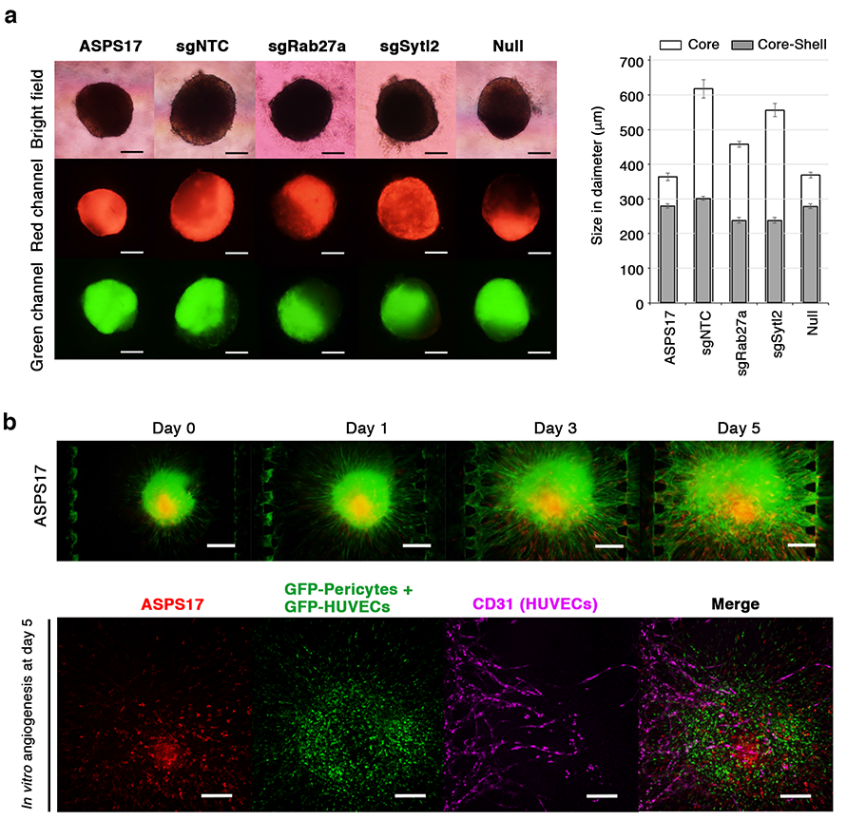
Extended Data Fig. 6. | Induction of vascular network by co-culture of tumor spheroids, pericytes and HUVEC cells in the microfluidic device. a, Core shell spheroid structure. The bright field, green fluorescence channel, and red fluorescence channel images of the co-culture core shell spheroids after three days in suspension culture (left). The size in diameter of core and core shell spheroids was measured (n = 20) (right). Scale bar, 200 µm. b, The time-course fluorescent images of the in vitro angiogenesis using the core shell ASPS17 cells and the immunofluorescence-based characterization on day 5. Scale bar, 200 µm.

