Supporting information for
A Rule-Breaking Class of Planar Central Chiral Molecules in Planar Tetracoordinate Carbon Systems
Devipriya Sivadasan ^{[1]}, Krishnan Thirumoorthy ^{[1, 2]}*
¹Department of Chemistry, School of Advanced Sciences, Vellore Institute of Technology, Vellore 632014, Tamil Nadu, India.
²School of Computer Science and Engineering, Vellore Institute of Technology, Vellore 632014, Tamil Nadu, India.
E-mail: kthirumoorthy@gmail.com & thirumoorthy.krishnan@vit.ac.in

Contents
List of Figures ………………………………………………………………………………………….... S1
List of Tables ……………………………………………………………………………………………. S2

List of Figures
S1 Optimized geometries of enantiomers of ptCC systems with their bond lengths in Å and their chemical formula, dipole moments (in Debye), and the number of imaginary frequencies (NImag) calculated at ωB97XD/aug-cc-pVTZ level of theory………………………. S3
S2 Optimized geometries of enantiomers of ptCC systems with their bond lengths in Å and their chemical formula, dipole moments (in Debye), and the number of imaginary frequencies (NImag) calculated at MP2/aug-cc-pVTZ level of theory……………………………. S4
List of Tables
S1 Absolute configuration, total energies (E), zero-point vibrational energies (ZPVE), ZPVE-corrected total energies (E+ZPVE), dipole moments (μ), and the number of imaginary frequencies (NImag) of enantiomers of ptCC systems calculated at ωB97XD /aug-cc-pVTZ level of theory………………………………………….……………………………………………………….. S5
S2 Absolute configuration, total energies (E), zero-point vibrational energies (ZPVE), ZPVE-corrected total energies (E+ZPVE), dipole moments (μ), and the number of imaginary frequencies (NImag) of enantiomers of ptCC systems calculated at MP2/aug-cc-pVTZ level of theory……………….………………………………………………………………………………………. S6
S3 Absolute configuration, total energies (E), zero-point vibrational energies (ZPVE), ZPVE-corrected total energies (E+ZPVE), dipole moments (μ), and the number of imaginary frequencies (NImag) of enantiomers of ptCC systems calculated at CCSD/aug-cc-pVTZ level of theory……………….………………………………………………………………………………………. S7
S4 Absolute configuration, total energies (E), and the dipole moments (μ) of enantiomers of ptCC systems calculated at the CCSD(T)/aug-cc-pVTZ//CCSD/aug-cc-pVTZ level of theory……………….………………………………………………………………………………………. S8
S5 The bond lengths of enantiomers of ptCC systems calculated at the ωB97XD/aug-cc-pVTZ, MP2/aug-cc-pVTZ, and CCSD/aug-cc-pVTZ levels of theory…………………………………………………………..………...…………..……………………. S9
S6 The natural atomic charges of atoms in the enantiomers of ptCC systems calculated at the MP2/aug-cc-pVTZ level of theory.……………..…………………………………………. S11
S7 Wiberg bond indices of enantiomers of ptCC systems calculated at MP2/aug-cc-pVTZ level of theory…………………………………………………………………………………………… S13
S8 Cartesian coordinates (in Å units) of the optimized geometries of the enantiomers of ptCC systems calculated at the ωB97XD/aug-cc-pVTZ level of theory………. S15
S9 Cartesian coordinates (in Å units) of the optimized geometries of the enantiomers of ptCC systems calculated at MP2/aug-cc-pVTZ level of theory……………………… S17
S10 Cartesian coordinates (in Å units) of the optimized geometries of the enantiomers of ptCC systems calculated at CCSD/aug-cc-pVTZ level of theory…………………….. S19

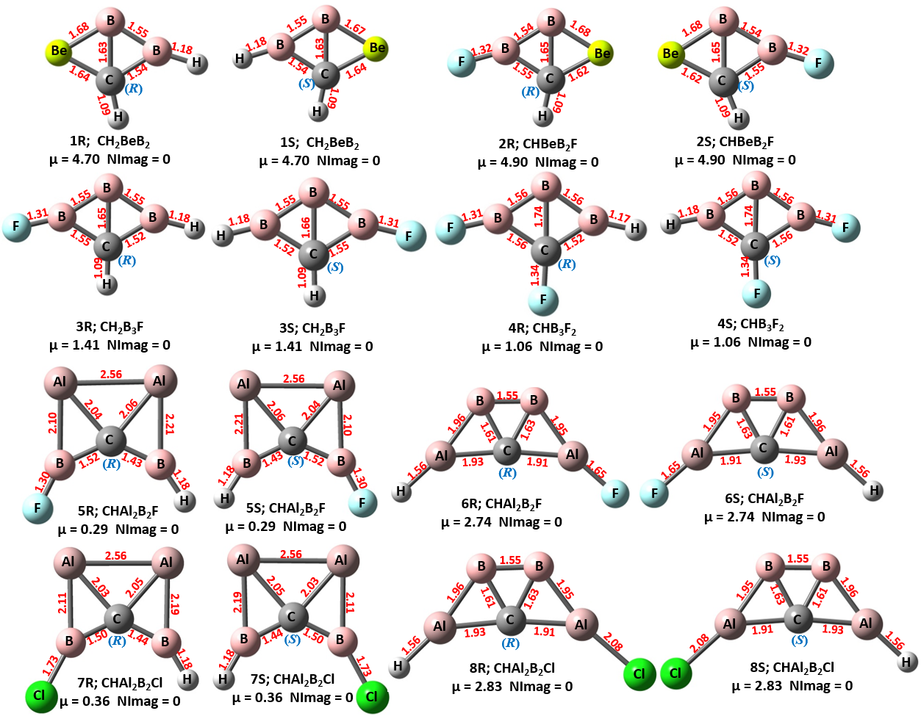
Figure S1. Optimized geometries of enantiomers of ptCC systems with their bond lengths in Å and their chemical formula, dipole moments (in Debye), and the number of imaginary frequencies (NImag) calculated at ωB97XD/aug-cc-pVTZ level of theory.

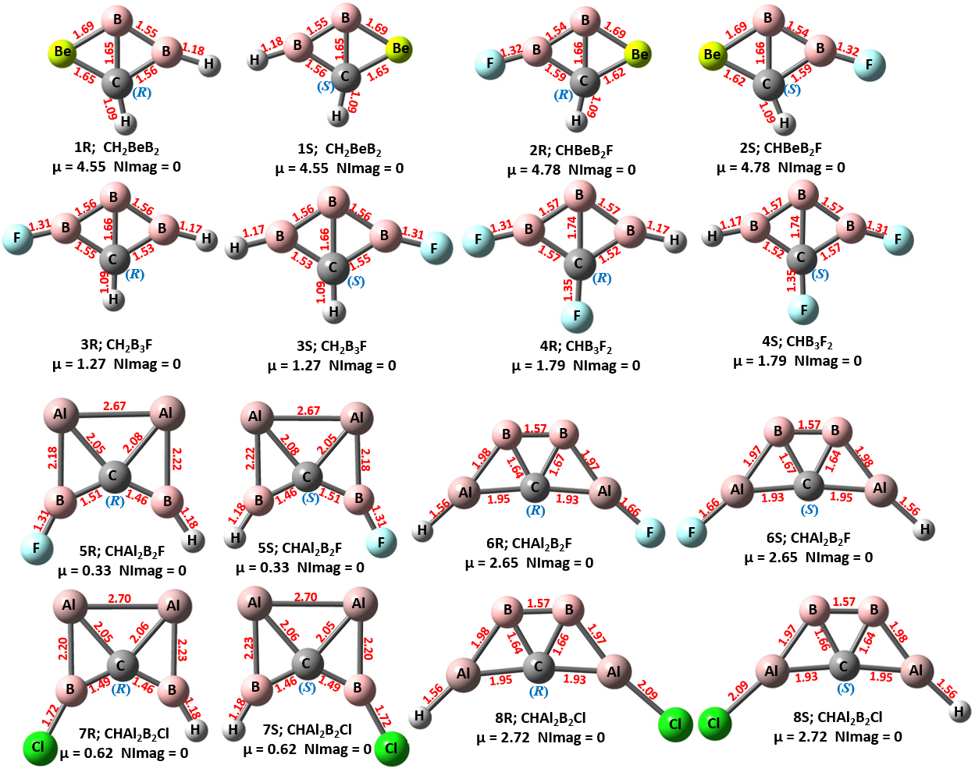
Figure S2. Optimized geometries of enantiomers of ptCC systems with their bond lengths in Å and their chemical formula, dipole moments (in Debye), and the number of imaginary frequencies (NImag) calculated at MP2/aug-cc-pVTZ level of theory.

Table S1. Absolute configuration, total energies (E), zero-point vibrational energies (ZPVE), ZPVE-corrected total energies (E+ZPVE), dipole moments (Debye), and the number of imaginary frequencies (NImag) of enantiomers of ptCC systems calculated at ωB97XD/aug-cc-pVTZ level of theory.
Chemical Formula | ptCC  Systems | Absolute Configuration | Energy  (a.u) | ZPVE (a.u) | E+ZPVE (a.u) | μ  Debye | NImag
CH₂BeB₂ | 1R | R | -103.602 | 0.031251 | -103.571 | 4.70 | 0
CH₂BeB₂ | 1S | S | -103.602 | 0.031251 | -103.571 | 4.70 | 0
CHBeB₂F | 2R | R | -202.917 | 0.025531 | -202.892 | 4.90 | 0
CHBeB₂F | 2S | S | -202.917 | 0.025537 | -202.892 | 4.90 | 0
CH₂B₃F | 3R | R | -213.677 | 0.037105 | -213.639 | 1.41 | 0
CH₂B₃F | 3S | S | -213.677 | 0.037103 | -213.639 | 1.41 | 0
CHB₃F₂ | 4R | R | -312.904 | 0.030113 | -312.874 | 1.06 | 0
CHB₃F₂ | 4S | S | -312.904 | 0.030113 | -312.874 | 1.06 | 0
CHAl₂B₂F | 5R | R | -673.086 | 0.024069 | -673.062 | 0.29 | 0
CHAl₂B₂F | 5S | S | -673.086 | 0.024069 | -673.062 | 0.29 | 0
CHAl₂B₂F | 6R | R | -673.056 | 0.022457 | -673.034 | 2.74 | 0
CHAl₂B₂F | 6S | S | -673.056 | 0.022457 | -673.034 | 2.74 | 0
CHAl₂B₂Cl | 7R | R | -1033.434 | 0.022726 | -1033.412 | 0.36 | 0
CHAl₂B₂Cl | 7S | S | -1033.434 | 0.022726 | -1033.412 | 0.36 | 0
CHAl₂B₂Cl | 8R | R | -1033.418 | 0.021551 | -1033.396 | 2.83 | 0
CHAl₂B₂Cl | 8S | S | -1033.418 | 0.021551 | -1033.396 | 2.83 | 0

Table S2. Absolute configuration, total energies (E), zero-point vibrational energies (ZPVE), ZPVE-corrected total energies (E+ZPVE), dipole moments (Debye), and the number of imaginary frequencies (NImag) of enantiomers of ptCC systems calculated at the MP2/aug-cc-pVTZ level of theory.
Chemical Formula | ptCC  Systems | Absolute Configuration | Energy  (a.u) | ZPVE (a.u) | E+ZPVE (a.u) | μ  Debye | NImag
CH₂BeB₂ | 1R | R | -103.303 | 0.030847 | -103.272 | 4.55 | 0
CH₂BeB₂ | 1S | S | -103.303 | 0.030847 | -103.272 | 4.55 | 0
CHBeB₂F | 2R | R | -202.509 | 0.025287 | -202.484 | 4.78 | 0
CHBeB₂F | 2S | S | -202.509 | 0.025287 | -202.484 | 4.77 | 0
CH₂B₃F | 3R | R | -213.257 | 0.0369 | -213.22 | 1.27 | 0
CH₂B₃F | 3S | S | -213.257 | 0.036899 | -213.22 | 1.27 | 0
CHB₃F₂ | 4R | R | -312.369 | 0.029898 | -312.339 | 1.79 | 0
CHB₃F₂ | 4S | S | -312.369 | 0.029898 | -312.339 | 1.79 | 0
CHAl₂B₂F | 5R | R | -671.88 | 0.024156 | -671.856 | 0.33 | 0
CHAl₂B₂F | 5S | S | -671.88 | 0.024156 | -671.856 | 0.33 | 0
CHAl₂B₂F | 6R | R | -671.849 | 0.021756 | -671.827 | 2.65 | 0
CHAl₂B₂F | 6S | S | -671.849 | 0.021756 | -671.827 | 2.65 | 0
CHAl₂B₂Cl | 7R | R | -1031.84 | 0.022873 | -1031.82 | 0.62 | 0
CHAl₂B₂Cl | 7S | S | -1031.84 | 0.022873 | -1031.82 | 0.62 | 0
CHAl₂B₂Cl | 8R | R | -1031.82 | 0.020921 | -1031.8 | 2.72 | 0
CHAl₂B₂Cl | 8S | S | -1031.82 | 0.020921 | -1031.8 | 2.72 | 0

Table S3. Absolute configuration, total energies (E), zero-point vibrational energies (ZPVE), ZPVE-corrected total energies (E+ZPVE), dipole moments (Debye), and the number of imaginary frequencies (NImag) of enantiomers of ptCC systems calculated at the CCSD/aug-cc-pVTZ level of theory.
Chemical Formula | ptCC  Systems | Absolute Configuration | Energy  (a.u) | ZPVE (a.u) | E+ZPVE (a.u) | μ  Debye | NImag
CH₂BeB₂ | 1R | R | -103.322 | 0.030865 | -103.292 | 4.64 | 0
CH₂BeB₂ | 1S | S | -103.322 | 0.030865 | -103.292 | 4.64 | 0
CHBeB₂F | 2R | R | -202.522 | 0.025211 | -202.496 | 5.06 | 0
CHBeB₂F | 2S | S | -202.522 | 0.025213 | -202.496 | 5.06 | 0
CH₂B₃F | 3R | R | -213.275 | 0.037072 | -213.238 | 1.26 | 0
CH₂B₃F | 3S | S | -213.275 | 0.03707 | -213.238 | 1.26 | 0
CHB₃F₂ | 4R | R | -312.383 | 0.030174 | -312.353 | 1.82 | 0
CHB₃F₂ | 4S | S | -312.383 | 0.030174 | -312.353 | 1.82 | 0
CHAl₂B₂F | 5R | R | -671.891 | 0.023537 | -671.867 | 0.81 | 0
CHAl₂B₂F | 5S | S | -671.891 | 0.023537 | -671.867 | 0.81 | 0
CHAl₂B₂F | 6R | R | -671.863 | 0.022051 | -671.841 | 2.67 | 0
CHAl₂B₂F | 6S | S | -671.863 | 0.022051 | -671.841 | 2.67 | 0
CHAl₂B₂Cl | 7R | R | -1031.866 | 0.021986 | -1031.844 | 0.84 | 0
CHAl₂B₂Cl | 7S | S | -1031.866 | 0.021986 | -1031.844 | 0.84 | 0
CHAl₂B₂Cl | 8R | R | -1031.850 | 0.021182 | -1031.829 | 2.75 | 0
CHAl₂B₂Cl | 8S | S | -1031.850 | 0.021181 | -1031.829 | 2.75 | 0

Table S4. Absolute configuration, total energies (E), and the dipole moments (μ) of enantiomers of ptCC systems calculated at the CCSD(T)/aug-cc-pVTZ//CCSD/aug-cc-pVTZ level of theory.
Chemical Formula | ptCC  Systems | Absolute Configuration | Energy  (a.u) | μ  Debye
CH₂BeB₂ | 1R | R | -103.348 | 4.64
CH₂BeB₂ | 1S | S | -103.348 | 4.64
CHBeB₂F | 2R | R | -202.555 | 5.06
CHBeB₂F | 2S | S | -202.555 | 5.06
CH₂B₃F | 3R | R | -213.309 | 1.26
CH₂B₃F | 3S | S | -213.309 | 1.26
CHB₃F₂ | 4R | R | -312.427 | 1.82
CHB₃F₂ | 4S | S | -312.427 | 1.82
CHAl₂B₂F | 5R | R | -671.937 | 0.81
CHAl₂B₂F | 5S | S | -671.937 | 0.81
CHAl₂B₂F | 6R | R | -671.904 | 2.67
CHAl₂B₂F | 6S | S | -671.904 | 2.67
CHAl₂B₂Cl | 7R | R | -1031.915 | 0.84
CHAl₂B₂Cl | 7S | S | -1031.915 | 0.84
CHAl₂B₂Cl | 8R | R | -1031.893 | 2.75
CHAl₂B₂Cl | 8S | S | -1031.893 | 2.75

Table S5: The bond lengths of enantiomers of ptCC systems calculated at the ωB97XD /aug-cc-pVTZ, MP2/aug-cc-pVTZ, and CCSD/aug-cc-pVTZ levels of theory. The atom labels are followed as given in Figure 3.
ptCC systems | Atoms | Bond length (Å)
ptCC systems | Atoms | ωB97XD/aug-cc-pVTZ | MP2/aug-cc-pVTZ | CCSD/aug-cc-pVTZ
1R | C1 - B2 | 1.54 | 1.56 | 1.54
1R | C1 - B4 | 1.63 | 1.65 | 1.66
1R | C1 - Be5 | 1.64 | 1.65 | 1.65
1R | C1 - H3 | 1.09 | 1.09 | 1.09
1S | C1 - B2 | 1.54 | 1.56 | 1.54
1S | C1 - B4 | 1.63 | 1.65 | 1.66
1S | C1 - Be5 | 1.64 | 1.65 | 1.65
1S | C1 - H3 | 1.09 | 1.09 | 1.09
2R | C1 - B2 | 1.55 | 1.59 | 1.56
2R | C1 - H3 | 1.09 | 1.09 | 1.09
2R | C1 – B5 | 1.65 | 1.66 | 1.67
2R | C1 - Be6 | 1.62 | 1.62 | 1.63
2S | C1 - B2 | 1.55 | 1.59 | 1.56
2S | C1 - H3 | 1.09 | 1.09 | 1.09
2S | C1 – B5 | 1.65 | 1.66 | 1.67
2S | C1 - Be6 | 1.62 | 1.62 | 1.63
3R | C1 - B2 | 1.52 | 1.53 | 1.53
3R | C1 - B3 | 1.55 | 1.55 | 1.55
3R | C1 - H5 | 1.08 | 1.09 | 1.09
3R | C1 - B7 | 1.65 | 1.66 | 1.67
3S | C1 – B3 | 1.55 | 1.55 | 1.55
3S | C1 – B2 | 1.52 | 1.53 | 1.53
3S | C1 – H4 | 1.08 | 1.09 | 1.09
3S | C1 – B7 | 1.64 | 1.66 | 1.67
4R | C1 - B2 | 1.56 | 1.53 | 1.56
4R | C1 - B3 | 1.52 | 1.57 | 1.53
4R | C1 - B6 | 1.74 | 1.74 | 1.76
4R | C1 - F7 | 1.34 | 1.35 | 1.35
4S | C1 - B2 | 1.52 | 1.53 | 1.53
4S | C1 - B3 | 1.56 | 1.57 | 1.56
4S | C1 - B6 | 1.74 | 1.74 | 1.76
4S | C1 - F7 | 1.34 | 1.35 | 1.35
5R | C1 - B2 | 1.52 | 1.51 | 1.55
5R | C1 - B3 | 1.43 | 1.46 | 1.40
5R | C1 - Al4 | 2.06 | 2.08 | 2.10
5R | C1 - Al5 | 2.04 | 2.05 | 2.07
5S | C1 - B2 | 1.52 | 1.51 | 1.55
5S | C1 - B3 | 1.43 | 1.46 | 1.40
5S | C1 - Al4 | 2.06 | 2.08 | 2.10
5S | C1 - Al5 | 2.04 | 2.05 | 2.07
6R | C1 - B4 | 1.61 | 1.64 | 1.63
6R | C1 - B5 | 1.63 | 1.67 | 1.65
6R | C1 - Al6 | 1.91 | 1.93 | 1.92
6R | C1 - Al7 | 1.93 | 1.95 | 1.94
6S | C1 - B4 | 1.61 | 1.64 | 1.63
6S | C1 - B5 | 1.63 | 1.67 | 1.65
6S | C1 - Al6 | 1.91 | 1.93 | 1.92
6S | C1 - Al7 | 1.93 | 1.95 | 1.94
7R | C1 - B5 | 1.44 | 1.46 | 1.41
7R | C1 - B4 | 1.50 | 1.49 | 1.52
7R | C1 - Al6 | 2.05 | 2.06 | 2.09
7R | C1 - Al7 | 2.03 | 2.05 | 2.06
7S | C1 - B5 | 1.44 | 1.46 | 1.41
7S | C1 - B4 | 1.50 | 1.49 | 1.52
7S | C1 - Al6 | 2.05 | 2.06 | 2.09
7S | C1 - Al7 | 2.03 | 2.05 | 2.06
8R | C1 - B2 | 1.61 | 1.64 | 1.63
8R | C1 - B7 | 1.63 | 1.66 | 1.64
8R | C1 - Al3 | 1.93 | 1.95 | 1.94
8R | C1 - Al6 | 1.91 | 1.93 | 1.92
8S | C1 - B2 | 1.61 | 1.64 | 1.63
8S | C1 - B7 | 1.63 | 1.66 | 1.64
8S | C1 - Al3 | 1.93 | 1.95 | 1.94
8S | C1 - Al6 | 1.91 | 1.93 | 1.92

Table S6: The natural atomic charges of atoms in the enantiomers of ptCC systems calculated at the MP2/aug-cc-pVTZ level of theory. The atom labels are followed as given in Figure 3.
ptCC systems | Atom | Natural Atomic Charge | ptCC systems | Atom | Natural Atomic Charge
1R | C1 | -1.44245 | 1S | C1 | -1.44245
1R | B2 | 0.20571 | 1S | B2 | 0.20571
1R | H3 | 0.25753 | 1S | H3 | 0.25753
1R | B4 | -0.56149 | 1S | B4 | -0.56149
1R | Be5 | 1.59745 | 1S | Be5 | 1.59745
1R | H6 | -0.05674 | 1S | H6 | -0.05674
2R | C1 | -1.49570 | 2S | C1 | -1.49573
2R | B2 | 0.81157 | 2S | B2 | 0.81155
2R | H3 | 0.26185 | 2S | H3 | 0.26186
2R | F4 | -0.50821 | 2S | F4 | -0.50821
2R | B5 | -0.68100 | 2S | B5 | -0.68095
2R | Be6 | 1.61148 | 2S | Be6 | 1.61148
3R | C1 | -0.86695 | 3S | C1 | -0.86695
3R | B2 | 0.23943 | 3S | B2 | 0.23943
3R | B3 | 0.82079 | 3S | B3 | 0.82079
3R | H4 | -0.04409 | 3S | H4 | -0.04409
3R | H5 | 0.26824 | 3S | H5 | 0.26824
3R | F6 | -0.49574 | 3S | F6 | -0.49574
3R | B7 | 0.07833 | 3S | B7 | 0.07833
4R | C1 | -0.09405 | 4S | C1 | -0.09405
4R | B2 | 0.1008 | 4S | B2 | 0.1008
4R | B3 | 0.71769 | 4S | B3 | 0.71769
4R | H4 | -0.02832 | 4S | H4 | -0.02832
4R | F5 | -0.48966 | 4S | F5 | -0.48966
4R | B6 | 0.16023 | 4S | B6 | 0.16023
4R | F7 | -0.36668 | 4S | F7 | -0.36668
5R | C1 | -1.96252 | 5S | C1 | -1.96252
5R | B2 | 0.9401 | 5S | B2 | 0.9401
5R | B3 | 0.46857 | 5S | B3 | 0.46857
5R | Al4 | 0.59674 | 5S | Al4 | 0.59674
5R | Al5 | 0.57399 | 5S | Al5 | 0.57399
5R | H6 | -0.08858 | 5S | H6 | -0.08858
5R | F7 | -0.52829 | 5S | F7 | -0.52829
6R | C1 | -1.65695 | 6S | C1 | -1.65695
6R | H2 | -0.38474 | 6S | H2 | -0.38474
6R | F3 | -0.77175 | 6S | F3 | -0.77175
6R | B4 | -0.30135 | 6S | B4 | -0.30135
6R | B5 | -0.34273 | 6S | B5 | -0.34273
6R | Al6 | 1.96025 | 6S | Al6 | 1.96025
6R | Al7 | 1.49727 | 6S | Al7 | 1.49727
7R | C1 | -1.94874 | 7S | C1 | -1.94874
7R | H2 | -0.09356 | 7S | H2 | -0.09356
7R | Cl3 | -0.15886 | 7S | Cl3 | -0.15886
7R | B4 | 0.45258 | 7S | B4 | 0.45258
7R | B5 | 0.48492 | 7S | B5 | 0.48492
7R | Al6 | 0.60733 | 7S | Al6 | 0.60733
7R | Al7 | 0.65633 | 7S | Al7 | 0.65633
8R | C1 | -1.63621 | 8S | C1 | -1.63621
8R | B2 | -0.29492 | 8S | B2 | -0.29492
8R | Al3 | 1.49697 | 8S | Al3 | 1.49697
8R | H4 | -0.38536 | 8S | H4 | -0.38536
8R | Cl5 | -0.52506 | 8S | Cl5 | -0.52506
8R | Al6 | 1.64845 | 8S | Al6 | 1.64845
8R | B7 | -0.30387 | 8S | B7 | -0.30387

Table S7: Wiberg bond indices of enantiomers of ptCC systems calculated at the MP2/aug-cc-pVTZ level of theory. The atom labels are followed as given in Figure 3.
1R |  | 1S
C1 - B2 | 1.0844 | C1 - B2 | 1.0844
C1 - B4 | 1.1734 | C1 - B4 | 1.1734
C1 - Be5 | 0.1732 | C1 - Be5 | 0.1732
C1 - H3 | 0.8570 | C1 - H3 | 0.8570
B4 - B2 | 1.2209 | B4 - B2 | 1.2209
B4 - Be5 | 0.5026 | B4 - Be5 | 0.5026
B2 - H6 | 0.9784 | B2 - H6 | 0.9784
2R |  | 2S
C1 - B2 | 0.9995 | C1 - B2 | 0.9521
C1 - H3 | 0.8559 | C1 - H3 | 0.8523
C1 – B5 | 1.2052 | C1 – B5 | 1.2177
C1 - Be6 | 0.1737 | C1 - Be6 | 0.1865
B2 - B5 | 1.1806 | B2 - B5 | 1.2028
B5 - Be6 | 0.4862 | B5 - Be6 | 0.4680
B2 - F4 | 0.7965 | B2 - F4 | 0.7949
3R |  | 3S
C1 - B2 | 1.0707 | C1 – B3 | 1.0704
C1 - B3 | 0.966 | C1 – B2 | 0.9667
C1 - H5 | 0.8587 | C1 – H4 | 0.8586
C1 - B7 | 0.8366 | C1 - B5 | 0.8360
B2 - H4 | 0.9818 | B3 – H7 | 0.9818
B2 - B7 | 1.1553 | B3 – B5 | 1.1554
B3 - B7 | 1.1191 | B2 – B5 | 1.1186
B3 – F6 | 0.8130 | B2 – F6 | 0.8129
4R |  | 4S
C1 - B2 | 1.1317 | C1 - B2 | 1.1317
C1 - B3 | 0.9861 | C1 - B3 | 0.9861
C1 - B6 | 0.7299 | C1 - B6 | 0.7299
C1 - F7 | 0.8609 | C1 - F7 | 0.8609
B2 - H4 | 0.9826 | B2 - H4 | 0.9826
B2 - B6 | 1.1772 | B2 - B6 | 1.1772
B3 - B6 | 1.1439 | B3 - B6 | 1.1439
B3 - F5 | 0.8176 | B3 - F5 | 0.8176
5R |  | 5S
C1 - B2 | 1.0406 | C1 - B2 | 1.0406
C1 - B3 | 1.2942 | C1 - B3 | 1.2942
C1 - Al4 | 0.3379 | C1 - Al4 | 0.3379
C1 - Al5 | 0.3423 | C1 - Al5 | 0.3423
B3 - Al4 | 0.5298 | B3 - Al4 | 0.5298
B2 - Al5 | 0.6437 | B2 - Al5 | 0.6437
B2 - F7 | 0.7871 | B2 - F7 | 0.7871
B3 - H6 | 0.9669 | B3 - H6 | 0.9669
Al4 - Al5 | 0.5624 | Al4 - Al5 | 0.5624
6R |  | 6S
C1 - B4 | 1.1117 | C1 - B4 | 1.1117
C1 - B5 | 1.0978 | C1 - B5 | 1.0978
C1 - Al6 | 0.4120 | C1 - Al6 | 0.4120
C1 - Al7 | 0.4554 | C1 - Al7 | 0.4554
B4 - B5 | 1.2097 | B4 - B5 | 1.2097
B4 - Al7 | 0.8240 | B4 - Al7 | 0.8240
B5 - Al6 | 0.7788 | B5 - Al6 | 0.7788
Al6 - F3 | 0.4121 | Al6 - F3 | 0.4121
Al7 - H2 | 0.8367 | Al7 - H2 | 0.8367
7R |  | 7S
C1 - B5 | 1.22 | C1 - B5 | 1.22
C1 - B4 | 1.1403 | C1 - B4 | 1.1403
C1 - Al6 | 0.3231 | C1 - Al6 | 0.3231
C1 - Al7 | 0.3216 | C1 - Al7 | 0.3216
B4 - Al7 | 0.5829 | B4 - Al7 | 0.5829
B5 - Al6 | 0.5497 | B5 - Al6 | 0.5497
B4 - Cl3 | 1.1839 | B4 - Cl3 | 1.1839
B5 - H2 | 0.9653 | B5 - H2 | 0.9653
Al6 - Al7 | 0.5221 | Al6 - Al7 | 0.5221
8R |  | 8S
C1 - B2 | 1.1044 | C1 - B2 | 1.1044
C1 - B7 | 1.0964 | C1 - B7 | 1.0964
C1 - Al3 | 0.4526 | C1 - Al3 | 0.4526
C1 - Al6 | 0.4458 | C1 - Al6 | 0.4458
B2 - B7 | 1.2068 | B2 - B7 | 1.2068
B2 - Al3 | 0.8244 | B2 - Al3 | 0.8244
B7 - Al6 | 0.8115 | B7 - Al6 | 0.8115
Al3 - H4 | 0.836 | Al3 - H4 | 0.836
Al6 - Cl5 | 0.7818 | Al6 - Cl5 | 0.7818

Table S8. Cartesian coordinates (in Å units) of the optimized geometries of the enantiomers of ptCC systems calculated at the ωB97XD/aug-cc-pVTZ level of theory.
1R | 1S
C -0.123231 0.674204 -0.000080  B 1.150187 -0.185476 0.000068  H 0.057648 1.744649 -0.000174  B -0.191829 -0.955486 0.000104  Be -1.601065 -0.047704 -0.000072  H 2.294205 0.105757 0.000077 | C -0.110941 0.678074 0.000091  B 1.155192 -0.192301 -0.000057  H 0.078948 1.746958 0.000186  B -0.193261 -0.950980 -0.000093  Be -1.594803 -0.031361 0.000083  H 2.301622 0.089288 -0.000066
2R | 2S
C 0.759916 0.679904 -0.000532  B -0.484560 -0.244826 -0.000221  H 0.461336 1.724939 0.000564  F -1.777373 0.019816 -0.000460  B 0.881332 -0.964852 0.001080  Be 2.241407 0.013869 -0.000899 | C -0.761009 0.679298 0.000478  B 0.483715 -0.244155 0.000019  H -0.464073 1.724819 0.001054  F 1.776023 0.022070 0.000199  B -0.881312 -0.965466 -0.000291  Be -2.241785 0.012328 -0.000080
3R | 3S
C -0.625631 0.660263 -0.000448  B -1.958066 -0.078642 0.000335  B 0.651048 -0.209977 0.000232  H -3.084436 0.262032 0.000658  H -0.559985 1.742531 -0.000530  F 1.934894 0.043937 0.000468  B -0.697124 -0.983677 -0.000783 | C 0.627512 -0.660388 0.000225  B 1.959630 0.078887 0.000299  B -0.650285 0.208254 -0.000179  H 3.086547 -0.259358 0.000461  H 0.562680 -1.742836 0.000410  F -1.934204 -0.045415 -0.000459  B 0.697612 0.983085 0.000327
4R | 4S
C -0.572478 0.173660 0.000194  B 0.860163 -0.442256 -0.000052  B -1.671596 -0.880280 0.000001  B -0.258207 -1.536838 -0.000094  F -0.773943 1.499609 0.000105  F 2.065762 0.065292 -0.000096  H -2.847619 -0.830327 0.000006 | C -0.572478 0.173660 -0.000194  B 0.860163 -0.442256 0.000052  B -1.671596 -0.880280 -0.000001  B -0.258207 -1.536838 0.000094  F -0.773943 1.499609 -0.000105  F 2.065762 0.065292 0.000096  H -2.847619 -0.830327 -0.000006
5R | 5S
C -0.008593 0.496551 0.000044  B -1.414336 -0.069710 -0.000042  B 0.560414 1.805237 0.000021  Al 2.025083 0.146292 -0.000024  Al 0.092633 -1.537046 0.000083  H 0.516045 2.983786 0.000110  F -2.636132 0.382120 -0.000114 | C 0.003552 0.450068 -0.000019  B -1.426234 -0.035720 -0.000036  B 0.527105 1.807815 0.000043  Al 2.064943 0.205383 -0.000034  Al 0.094432 -1.598955 0.000037  H 0.318889 2.970601 0.000194  F -2.657382 0.398328 -0.000018
6R | 6S
C 0.486337 -0.033198 -0.000065  H 3.239766 -1.839328 -0.000409  F -2.807917 -0.714449 0.000142  B 1.508072 1.214381 0.000092  B -0.015820 1.520914 0.000055  Al -1.413617 0.162543 -0.000117  Al 2.343321 -0.557760 -0.000040 | C -0.477754 -0.037697 -0.000049  H -3.219215 -1.861941 -0.000393  F 2.820920 -0.697213 0.000158  B -1.507692 1.203119 0.000108  B 0.014145 1.519693 0.000070  Al 1.420869 0.170567 -0.000101  Al -2.331239 -0.574491 -0.000024
7R | 7S
C -0.415360 0.446246 -0.000034  H -0.675192 2.974084 -0.000141  Cl 2.600998 0.164528 0.000013  B 0.919041 -0.228097 0.000014  B -0.872427 1.810430 -0.000104  Al -2.462582 0.302236 0.000030  Al -0.713009 -1.560713 0.000015 | C -0.375447 0.443077 0.000047  H -0.552247 2.978075 0.000154  Cl 2.630049 0.062597 0.000001  B 0.936123 -0.274662 -0.000001  B -0.787534 1.821515 0.000117  Al -2.426291 0.366277 -0.000016  Al -0.738749 -1.553043 -0.000001
8R | 8S
C 0.978200 0.019967 -0.000048  B 2.139569 1.138997 0.000099  Al 2.759185 -0.720696 -0.000041  H 3.500951 -2.097784 -0.000230  Cl -2.756306 -0.484372 0.000006  Al -0.890535 0.430267 -0.000075  B 0.659861 1.614704 0.000081 | C -0.964995 0.015127 -0.000031  B -2.136171 1.123888 0.000116  Al -2.739390 -0.741189 -0.000024  H -3.469001 -2.124754 -0.000213  Cl 2.773808 -0.456310 0.000023  Al 0.900055 0.441866 -0.000058  B -0.660710 1.612605 0.000098

Table S9. Cartesian coordinates (in Å units) of the optimized geometries of the enantiomers of ptCC systems calculated at the MP2/aug-cc-pVTZ level of theory
1R | 1S
C -0.130091 0.684951 0.000050  B 1.154260 -0.195453 -0.000111  H 0.125445 1.742097 0.000129  B -0.192430 -0.966050 -0.000022  Be -1.611207 -0.039472 0.000045  H 2.290780 0.113605 0.000053 | C 0.639948 -0.647059 -0.000069  B -0.657855 0.213393 0.000092  H 0.400779 -1.708027 -0.000149  B 0.676766 1.004709 0.000002  Be 2.109692 0.100166 -0.000064  H -1.789464 -0.113192 -0.000072
2R | 2S
C 0.807595 0.686379 0.000072  B -0.478049 -0.247886 0.000076  H 0.362602 1.681020 0.000157  F -1.757628 0.082797 0.000032  B 0.884330 -0.970690 0.000060  Be 2.272611 -0.001677 -0.000028 | C 0.805283 0.686921 -0.000110  B -0.478883 -0.249411 -0.000084  H 0.358575 1.680791 -0.000155  F -1.758958 0.079291 -0.000048  B 0.884662 -0.970004 -0.000055  Be 2.271379 0.001263 -0.000018
3R | 3S
C -0.175687 1.073162 0.002168  B -1.669408 0.740333 0.002175  B 0.801018 -0.135347 -0.004010  H -2.653965 1.380179 0.004861  H 0.201134 2.091683 0.004665  F 2.108576 -0.264845 -0.006550  B -0.720039 -0.499870 -0.003103 | C 0.621307 -0.674224 -0.000060  B 1.986915 0.066143 0.000072  B -0.630273 0.206687 -0.000029  H 0.576828 -1.759344 -0.000190  B 0.722445 0.987600 -0.000090  F 3.244576 -0.314467 0.000162  H -1.784876 -0.006959 -0.000022
4R | 4S
C -0.580046 0.175913 -0.000325  B -1.696983 -0.862539 -0.000201  B 0.857555 -0.460909 -0.000100  H -2.870661 -0.815567 -0.000216  F 2.067708 0.046578 -0.000041  B -0.281374 -1.542668 0.000179  F -0.739380 1.519051 0.000349 | C 0.636544 -0.710988 0.000265  B 1.946070 0.070723 0.000141  B -0.635954 0.212588 0.000039  H 3.083929 -0.220830 0.000156  F -1.925514 -0.030408 -0.000019  B 0.704141 1.032043 -0.000239  F 0.511264 -2.057729 -0.000410
5R | 5S
C 0.003552 0.450068 -0.000019  B -1.426234 -0.035720 -0.000036  B 0.527105 1.807815 0.000043  Al 2.064943 0.205383 -0.000034  Al 0.094432 -1.598955 0.000037  H 0.318889 2.970601 0.000194  F -2.657382 0.398328 -0.000018 | C 0.008501 0.727451 0.000553  B 1.384701 1.349023 0.001701  B -1.301187 1.361723 0.000574  Al -1.330220 -0.859063 -0.001453  Al 1.341443 -0.831402 -0.000146  H -1.943183 2.353321 0.001298  F 1.987618 2.506871 0.003002
6R | 6S
C -0.130026 0.630350 -0.000298  H 1.419501 3.565042 -0.002083  F -3.334997 -0.507768 0.000776  B 1.402582 0.038673 -0.000406  B 0.232020 -1.000125 0.000455  Al -1.679649 -0.526996 0.000240  Al 1.248145 2.009915 -0.000935 | C 0.483342 -0.065262 -0.000016  H 3.294765 -1.828600 -0.000460  F -2.860551 -0.686176 0.000121  B 1.513225 1.214702 -0.000099  B -0.020291 1.527182 0.000187  Al -1.437618 0.159881 -0.000157  Al 2.367269 -0.568624 0.000082
7R | 7S
C -0.072890 0.487859 -0.000253  H -2.611295 0.541318 -0.000297  Cl 0.147727 3.537749 -0.001625  B 0.507285 1.858458 -0.000897  B -1.496590 0.148189 -0.000092  Al -0.092228 -1.573331 0.000870  Al 1.951664 0.194378 -0.000215 | C -0.441597 0.383408 0.000051  H -0.393678 2.921923 0.000191  Cl 2.608768 0.169449 -0.000041  B 0.930266 -0.193774 0.000014  B -0.784374 1.806363 0.000120  Al -2.502824 0.398247 -0.000090  Al -0.730657 -1.641782 0.000054
8R | 8S
C 0.970928 -0.010564 -0.000051  B 2.144433 1.140110 0.000215  Al 2.782981 -0.732345 0.000026  H 3.556253 -2.092107 -0.000301  Cl -2.804727 -0.451763 0.000077  Al -0.913458 0.427079 -0.000154  B 0.654515 1.620674 -0.000020 | C -0.264092 0.690212 -0.000303  B 0.140588 -0.902710 0.000367  Al -1.799047 -0.513291 0.000485  H -3.363231 -0.498093 0.000937  Cl 1.252772 4.175803 -0.002685  Al 1.061610 2.099094 -0.001172  B 1.305071 0.143606 -0.000136

Table S10. Cartesian coordinates (in Å units) of the optimized geometries of the enantiomers of ptCC systems calculated at the CCSD/aug-cc-pVTZ level of theory
1R | 1S
C 0.126806 0.685097 0.000086  B -1.149520 -0.185119 0.000026  H -0.063148 1.755006 -0.000047  B 0.188664 -0.971319 -0.000521  Be 1.604670 -0.051545 0.000433  H -2.293388 0.103823 0.000101 | C -0.126806 0.685097 0.000086  B 1.149520 -0.185118 0.000026  H 0.063147 1.755007 -0.000047  B -0.188664 -0.971319 -0.000521  Be -1.604670 -0.051546 0.000433  H 2.293388 0.103823 0.000101
2R | 2S
C -0.768686 0.689930 -0.000481  B 0.479925 -0.243677 -0.000030  H -0.444546 1.728600 -0.000999  F 1.772434 0.028529 -0.000238  B -0.880098 -0.981296 0.000301  Be -2.247471 0.006808 0.000069 | C -0.768808 0.689930 -0.000060  B 0.479881 -0.244024 -0.000042  H -0.443621 1.728242 0.000231  F 1.772189 0.029031 -0.000081  B -0.880261 -0.981147 0.000282  Be -2.247508 0.006949 -0.000260
3R | 3S
C 0.623381 0.671578 0.000184  B 1.957713 -0.076857 -0.000033  B -0.650268 -0.208000 0.000034  H 3.085661 0.256150 -0.000023  H 0.561144 1.755150 0.000081  F -1.938327 0.035350 0.000141  B 0.698494 -0.995614 -0.000190 | C -0.623628 0.671493 0.000021  B -1.957919 -0.077257 -0.000037  B 0.650294 -0.207505 0.000082  H -3.086021 0.254987 -0.000054  H -0.562152 1.755182 0.000108  F 1.938456 0.035441 0.000101  B -0.698330 -0.995874 -0.000155
4R | 4S
C -0.572405 0.181520 -0.000407  B 0.858716 -0.438810 -0.000205  B -1.672475 -0.878501 -0.000150  B -0.255292 -1.551641 0.000444  F -0.774796 1.512012 0.000554  F 2.068978 0.062687 -0.000179  H -2.848498 -0.840484 -0.000084 | C 0.572405 0.181520 -0.000407  B -0.858716 -0.438810 -0.000205  B 1.672475 -0.878501 -0.000150  B 0.255292 -1.551641 0.000444  F 0.774796 1.512012 0.000554  F -2.068978 0.062687 -0.000179  H 2.848498 -0.840484 -0.000084
5R | 5S
C 0.044804 0.472508 -0.000021  B -1.401195 -0.084545 -0.000295  B 0.424334 1.822817 0.000148  Al 2.112459 0.119922 0.000637  Al 0.066311 -1.602258 -0.000227  H 0.468685 2.997265 0.000116  F -2.580283 0.481522 -0.000279 | C 0.044803 0.472508 0.000020  B -1.401195 -0.084545 0.000295  B 0.424333 1.822817 -0.000148  Al 2.112460 0.119922 -0.000636  Al 0.066310 -1.602258 0.000227  H 0.468686 2.997265 -0.000116  F -2.580283 0.481521 0.000279
6R | 6S
C -0.473771 -0.053362 0.000069  H -3.248056 -1.859123 0.000351  F 2.842801 -0.683751 -0.000143  B -1.510032 1.206043 -0.000101  B 0.015889 1.524555 -0.000097  Al 1.433638 0.168973 0.000073  Al -2.340435 -0.581297 0.000079 | C 0.473771 -0.053362 0.000069  H 3.248056 -1.859123 0.000351  F -2.842801 -0.683751 -0.000143  B 1.510032 1.206043 -0.000101  B -0.015889 1.524555 -0.000097  Al -1.433638 0.168972 0.000073  Al 2.340435 -0.581297 0.000079
7R | 7S
C 0.475314 0.415747 0.000005  H 0.604460 2.974979 0.000135  Cl -2.551351 0.288594 0.000013  B -0.899296 -0.240774 0.000002  B 0.725768 1.805390 0.000074  Al 2.559996 0.293286 0.000068  Al 0.703639 -1.628507 -0.000091 | C 0.475314 -0.415747 0.000005  H 0.604461 -2.974979 0.000135  Cl -2.551351 -0.288595 0.000013  B -0.899295 0.240775 0.000002  B 0.725767 -1.805390 0.000074  Al 2.559997 -0.293286 0.000068  Al 0.703639 1.628507 -0.000091
8R | 8S
C -0.960629 0.000832 0.000030  B -2.139783 1.127394 -0.000106  Al -2.749017 -0.748212 0.000039  H -3.498647 -2.124892 0.000202  Cl 2.800424 -0.442504 -0.000011  Al 0.911224 0.440918 0.000039  B -0.659977 1.617697 -0.000104 | C 0.960629 0.000832 0.000030  B 2.139783 1.127394 -0.000106  Al 2.749017 -0.748212 0.000039  H 3.498646 -2.124892 0.000202  Cl -2.800424 -0.442504 -0.000011  Al -0.911224 0.440918 0.000039  B 0.659977 1.617697 -0.000104

