Supplementary materials
Figure S1
Tables S1, S3, S4, and S5
Text box 1

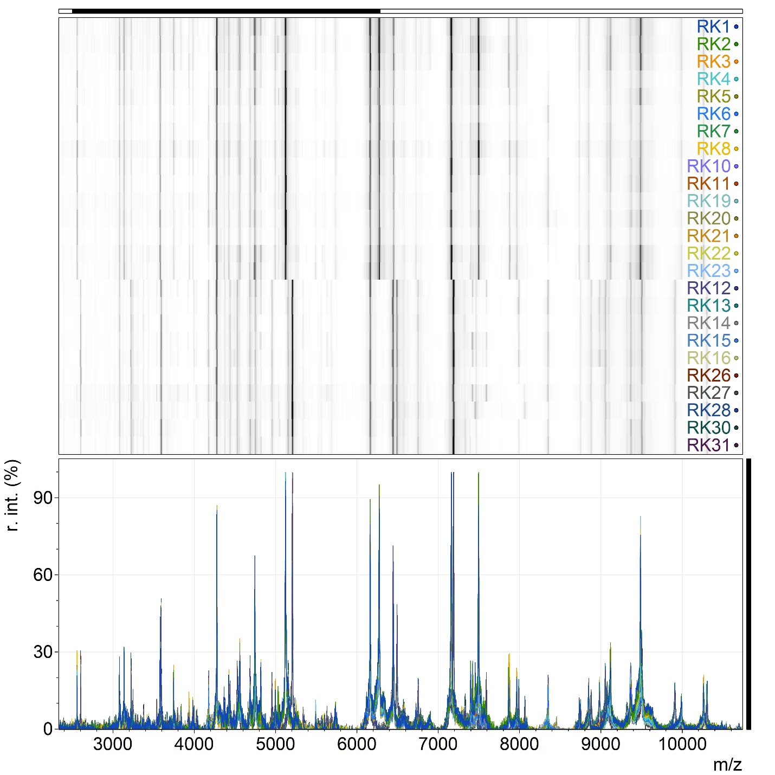
Figure S1. Mass spectra of protein extracts from all isolated luminescent strains. The top panel shows the Gel View spectra; the bottom panel shows the spectra in the standard format.

Table S1. List of sequences used for phylogenetic analysis.
Strain | NCBI Assembly ID
RK-1 | SUB16102110
RK-2 | SUB16102110
RK-3 | SUB16102110
RK-7 | SUB16102110
RK-4 | SUB16209717
RK-19 | SUB16209717
RK-24 | SUB16209717
Vibrio harveyi ATCC 33843 (outgroup) | CP009467.2
Vibrio campbellii 151112C | NZ_CP025953.1
Vibrio cholerae W7G | CP053813.1
Vibrio cholerae W6G | CP053810.1
Vibrio cholerae S17-284 | CP118727.1
Vibrio cholerae TP | MIPK00000000.1
Vibrio cholerae PNUSAV004467 | CP145609.1
Vibrio cholerae 19MO03SH03-1 | CP095331.1
Vibrio cholerae PNUSAV001140 | CP104354.1
Vibrio cholerae SA10G | CP053820.1
Vibrio cholerae SA7G | NZ_CP053816.1
Vibrio cholerae E7G | NZ_CP053822.1
Vibrio cholerae RFB16 | CP043554.1
Vibrio cholerae ATCC 14547 | GCA_000518145.1
Vibrio cholerae SA3G | CP053744.1
Vibrio cholerae M646 | CP173268.1
Vibrio cholerae E4 | CP033515.1
Vibrio cholerae C5 | CP013301.1
Vibrio cholerae classical A103 | CP196621.1
Vibrio cholerae Sudan_2019_18 | CP152071.1
Vibrio cholerae O1 | GCA_000006745
Vibrio cholerae RFB16 | CP043554.1
Vibrio cholerae ATCC 14547 | GCA_000518145.1
Vibrio cholerae O395 | CP001235.1
Vibrio cholerae M66-2 | CP001234.1
RK-27 | SUB16105328
Vibrio campbellii 151112C | NZ_CP025953.1
Vibrio vulnificus 2497-87 | CP060047.1
Vibrio vulnificus 2009V-1035 | NZ_CP035784.1
Vibrio vulnificus 06-2410 | NZ_CP046833.1
Vibrio vulnificus Per2 | CP151588.1
Vibrio vulnificus TBV029 | CP151937.1
Vibrio vulnificus FDAARGOS_119 | NZ_CP014048.2
Vibrio vulnificus FORC_036 | CP015512.1
Vibrio vulnificus ATCC 43382 | EU122289.1
Vibrio vulnificus MO6-24O | CP002469.1
Vibrio vulnificus SUKU_G3 | CP133117.1
Vibrio vulnificus 2142-87 | CP035731.1
Vibrio vulnificus CECT 4999 | CP014636.1
Vibrio vulnificus Per1 | CP150831.1
Table S3. Pathogenicity Factors.
 | Pathogenicity Factor | RK2 | RK27 | V. cholerae* | V. vulnificus*
1 | Adhesion Index/% of Epithelial Cells Involved in Adhesion | 9.1/100 | 12.5/100 | 0,5-31/100  (Sasmal et al., 1987) | 3-33 /100  (Reyes et al., 1985)
2 | Hemolytic Activity | β-hemolysis | α-hemolysis | + | +/-
3 | Urease Activity | - | - | - | -
4 | Mannitol Fermentation | + | - | + | V**
5 | Plasma Coagulase Activity | + | ±
6 | Catalase Activity |  |  | ?/+ | +/+
*Data for pathogenic strains are taken from literature (Mizuno et al., 2019; VetBact, n.d.)
** V - variable, can be used to differentiate the three biogroups of V. vulnificus

Table S4. Growth and bioluminescence of isolated strains depending on salt concentration. “Good” – individual colonies of normal size are formed / bright glow; “medium” - individual colonies of small size are formed / visually well distinguished glow; “unstable” – formation of colonies and their glow vary significantly in biological replicates; “weak” – almost no individual colonies are formed / cells emit very little light, almost not visible.
Salt concentration (g/L) | Growth |  | Visible luminescence
Salt concentration (g/L) | RK2 | RK27 | RK2 | RK27
0 | Medium | None | Weak | None
5 | Good | Weak | Medium | Unstable
10 | Good | Unstable | Medium | Unstable
20 | Good | Unstable | Weak | Unstable
30 | Good | Good | None | Medium
40 | Good | Good | None | Good
50 | Medium | Good | None | Good
60 | Weak | Medium | None | Medium
70 | None | Weak | None | Unstable
80 | None | Unstable | None | None

Table S5. Paleogeographic evolution of the Aral sea. Original data are taken from (Svitohc, 2009)
TIME |  | Event Systematics |  |  | Transgressive (T) – Regressive (R)  rhythmics |  | C¹⁴ dates (years) | Sea level (abs. elev., m) | Salinity, ‰ | Paleogeographical situation
 |  | Epoch | Stage | Phase
HOLOCENE | late | of marine Aral | marine | modern | T |  |  | 53 | 11.3 | Inland freshened closed-basin sea with sharp changes in level and salinity; during regressions, it breaks into systems of saline and freshwater lakes. Terrigenous and chemogenic sedimentation  Penetration and spread of Cerastoderma glaucum (Cardium edule)
 |  |  |  |  | R |  | MGU 734 970±140 | 43-44
 |  |  |  | late | T |  | MGU 734 970±140 | 53-53.5 | ~8-12
 |  |  |  |  | R | max | MGU 778 1590±140 | up to 30
 |  |  |  | middle | T | max | MGU 778 1590±140 | 54.5 | ~8-9
 |  |  |  |  | R |  | MGU 742 3600±140 | 35-40
 |  |  |  | early | T | max | MGU 741 4850±90 | up to 57 | ~11.3
 |  |  |  |  | R
 |  |  |  |  | T
HOLOCENE | early | of marine Aral | saline lake |  |  | max | MGU 740 4960±100 |  |  | Lake system periodically drying out. Active salt deposition
PLEISTOCENE | 900 k | prehistory | continental |  |  |  |  |  |  | Desiccation, dominance of subarid processes
PLEISTOCENE | 900 k | prehistory | marine | Apsheron |  |  |  |  |  | Freshened bay of a large intracontinental saline-brackish water body
LATE PLIOCENE | 3 M
 |  |  |  | Akchagyl |  |  |  |  |  | Freshened bay of a large marine water body connected to the ocean

Text box S1.
A modified method for assessing bacterial adhesion to buccal epithelium (Blagonravova et al., 2011) was used to assess adhesive activity. Buccal epithelial cells, obtained from healthy, nonsmoking donors aged 18-20 years in the morning on an empty stomach, were used as the adhesion substrate. The material was collected with a cytobrush after thoroughly rinsing the mouth with buffered saline (PBS). The epithelial cells were washed twice with saline (40 g for 5 min) and suspended at a concentration of 106 cells/ml.
The bacterial strains under study were grown in Mueller-Hinton medium for 24 hours and resuspended in saline. Using a Densi-La-Meter II (Erba Group, EU), the suspensions were adjusted to an optical density of 3.0 McFarland, corresponding to 107 CFU/mL (calculated using a Goryaev chamber).
Adhesion in the microorganism-buccal epithelial cells system was assessed as follows: equal volumes (50 µl each) of the epithelial cell suspension and the studied fungi at a concentration of 105 CFU/mL were incubated for 30 min at 37°C in PBS, shaking every 5 min. After incubation, the epithelial cells were washed three times with PBS (40 g, 5 min) to remove unattached bacteria. The remaining sediment was resuspended in 100 µl of PBS, and the number of adherent cells to the buccal epithelium was counted in a Goryaev chamber. The adhesion index was determined, i.e., The average number of bacteria per epithelial cell and the percentage of epithelial cells involved in adhesion (50 cells were taken into account).
To determine hemolytic activity, we used blood agar supplemented with 5% human erythrocytes of type 0 (I) Rh (+). Alpha-hemolytic activity was determined by a change in the color of the medium from red to greenish (due to the conversion of hemoglobin to methemoglobin) near the colonies of the studied microorganisms. Beta hemolysis was determined by complete hemolysis near the studied colonies.
To assess urease activity, we used a modified urease assessment method proposed by Ming-Juan Cui et al. (Cui et al., 2022). One standard loop (2 mm) of a 24-hour culture of the studied microorganisms grown on Mueller-Hinton medium was added to PB2-16x150 mm test tubes with 5 ml of liquid Christensen's medium (peptic digest of animal tissue 1 g/l, glucose 1 g/l, sodium chloride 5 g/l, sodium hydrogen phosphate 1.2 g/l, potassium dihydrogen phosphate 0.8 g/l, phenol red 0.012 g/l, urea 20 g/l. The final pH (at 25°C) was 6.8 ± 0.2). The presence of urease activity was judged by a change in the color of the medium from yellow to crimson. Proteus vulgaris ATCC13315, a microorganism with the most pronounced urease activity, was used as a positive control. Uninoculated tubes containing the medium were used as a negative control.
Mannitol fermentation was assessed using the semi-solid Giss-GRM medium with mannitol (Obolensk) based on color change after 24 hours of incubation.
Plasmacoagulase activity was assessed using vacuum-lyophilized citrated rabbit plasma obtained from rabbit blood by mixing with 5% sodium citrate solution (Mikrogen, Tomsk Branch of Virion). Sterile tubes were inoculated with 0.5 ml of plasma and one standard loop (2 mm) of the test culture grown on Mueller-Hinton medium. The inoculated tubes were then incubated at 37 ± 1°C. Results were recorded after 1, 2, 4, 18, and 24 hours of incubation. A positive plasma coagulation test result is plasma clotting (formation of a gelatinous clot of any size). A positive plasma coagulase test result is plasma clotting within the first 4 hours of incubation; a negative result is the absence of a gelatinous clot within 18 hours of incubation (according to the manufacturer's recommendations).
Literature
Blagonravova, A. S., Afonin, N. A., Vorobyova O.N., & Shirokova I.Yu. (2011). Comparative analysis of the adhesion of microorganisms isolated from patients and from environmental objects of medical institutions. Medical Almanac, 5, 215–218. https://cyberleninka.ru/article/n/sravnitelnyy-analiz-adgezivnosti-mikroorganizmov-vydelennyh-ot-bolnyh-i-s-obektov-vneshney-sredy-lechebno-profilakticheskih
Cui, M. J., Teng, A., Chu, J., & Cao, B. (2022). A quantitative, high-throughput urease activity assay for comparison and rapid screening of ureolytic bacteria. Environmental Research, 208. https://doi.org/10.1016/J.ENVRES.2022.112738
Mizuno, T., Debnath, A., Miyoshi, S., Mizuno, T., Debnath, A., & Miyoshi, S. (2019). Hemolysin of Vibrio Species. Microorganisms. https://doi.org/10.5772/INTECHOPEN.88920
Reyes, A. L., Boutin, B. K., Peeler, J. T., & Twedt, R. M. (1985). Adherence and hemagglutination of mammalian cells by epidemiologically distinct strains of Vibrio vulnificus. Journal of Food Protection, 48(9), 783–785. https://doi.org/10.4315/0362-028X-48.9.783
Sasmal, D., Guhathakurta, B., & Datta, A. (1987). Adhesion of Vibrio cholerae 01 to human buccal epithelial cells in vitro. FEMS Microbiology Letters, 48(3), 335–338. https://doi.org/10.1111/J.1574-6968.1987.TB02620.X
Svitohc, A. (2009). The History Of The Last Aral Sea. Arid Ecosystems, 5(2)38(Cyberleninka.Ru), 5–17. https://cyberleninka.ru/article/n/istoriya-poslednego-aralskogo-morya
VetBact. (n.d.). Retrieved June 5, 2024, from https://www.vetbact.org/index.php?artid=84&vbsearchstring=V.%20vulnificus

