This online supplementary file provides the CARE timeline, component-specific exposure-state annotation, MRI-state annotation and eight illustrated MRI image sets. Seven MRI time points are represented; conventional and perfusion imaging from November 2023 are presented as separate image sets. Dexamethasone remained unchanged at 2 mg/day throughout all reported intervals. Functional findings were documented contemporaneously by the treating clinician. June 2026 source images were available for descriptive manuscript review; interval measurements and clinical classifications were taken from the signed routine radiology reports. The imaging data set was locked at 8 June 2026, the latest MRI included in the report. The file does not establish therapeutic causality or component-specific efficacy.

Supplementary Table S1. CARE timeline and clinical chronology
Date/interval | Clinical or imaging event | Key observation | Interpretive boundary
December 2022 | Initial imaging | Right temporal cortical lesion interpreted as most likely low-grade primary brain tumour/ganglioma. | Pre-diagnostic baseline.
April 2023 | Pre-surgical MRI | Large right temporal mass with mass effect. | Progression to surgically managed lesion.
16 May 2023 | First surgery | Right temporal operation. | Diagnostic tissue obtained.
31 May 2023 | Histopathology | IDH-wildtype glioblastoma. | Molecularly aggressive context later supported by CDKN2A/B deletion, EGFR and MET amplification, +7/-10 and TERT promoter mutation.
22 June to 2 August 2023 | Chemoradiotherapy | Weekday radiotherapy with concomitant temozolomide 160 mg/day. | Standard postoperative phase.
September to November 2023 | Adjuvant temozolomide | Three cycles, then stopped at the patient's request. | Prolonged temozolomide-free interval followed.
November 2023 | MRI | Irregular enhancement and perfusion features favouring residual or recurrent tumour. | Not interpreted as uncomplicated radiation necrosis.
22 December 2023 | Second surgery | Repeat operation. | Post-recurrence surgical intervention.
April 2024 and January 2025 | Follow-up MRI | Further enhancing and non-enhancing progression. | January 2025 served as the immediate pre-exposure radiological baseline.
April to mid-2025 | Non-standard exposure state | Perillyl alcohol and alpha-bisabolol administered by intranasal inhalation with individualised cannabinoids in MCT oil; dexamethasone remained unchanged at 2 mg/day. | Hemiplegia/KPS 50 and subsequent hemiparesis, regained walking and KPS 80 were documented contemporaneously by the treating clinician; interval MRI improvement was also documented.
September 2025 to April 2026 | Exposure change | Terpenoid interruption; cannabinoids in MCT oil continued; DHA 2,000 mg/day was used; dexamethasone remained 2 mg/day. | Not a clean withdrawal period.
10 February 2026 | Later MRI | Unchanged approximately 4.5-cm postoperative cavity and similarly extensive leukoencephalopathy/mild oedema; pathological enhancement beneath the right lateral ventricle increased to 2.7 cm anteriorly and posteriorly from 2 cm; new predominantly meningeal infratentorial enhancement and a 1-cm right peduncular intra-axial lesion with restricted diffusion; perfusion technically unsuccessful and therefore non-interpretable. | Mixed later state. Treatment-related supratentorial change remained possible, while new infratentorial disease was reported as progression. Source images were available; no blinded central review or formal RANO 2.0 adjudication was performed.
April to June 2026 | Reintroduction phase | Perillyl alcohol reintroduced at approximately 90% purity and alpha-bisabolol at 98% purity; dexamethasone remained 2 mg/day. | Different provenance/purity state from the initial exposure.
8 June 2026 | Later MRI | Medial postoperative enhancement measured 36 mm, previously 27 mm; the right cerebellar focus measured 14 mm, previously 10 mm; a new contralateral 13-mm focus was present. The postoperative cavity and FLAIR extent showed no major change, and lesion perfusion showed low-amplitude curves without pathological hyperperfusion or new brain displacement. | Current anatomy is source-image-supported; interval measurements and classifications derive from the signed radiology report. Low perfusion supports but does not establish treatment effect or radiation necrosis; no formal RANO 2.0 classification was assigned.

Supplementary Table S2. Component-specific exposure architecture
Interval | Exposure state | Interpretive value | Boundary
April to mid-2025 | Perillyl alcohol and alpha-bisabolol, both administered by intranasal inhalation and recorded as 95%-purity preparations, with individualised cannabinoids administered rectally, sublingually and/or orally in MCT oil. Dexamethasone remained unchanged at 2 mg/day. | Documents the early multimodal exposure interval associated with contemporaneously clinician-recorded improvement from hemiplegia/KPS 50 to hemiparesis, regained walking and KPS 80, together with mid-2025 interval radiological improvement. | Does not identify the responsible component, route, vehicle, purity grade or mechanism. Component-specific cannabinoid identities and doses, formulation concentrations, administration-device details, adherence and adverse-event surveillance were not prospectively standardised for research use. Stable dexamethasone dosing weakens a dose-change explanation but does not remove chronic corticosteroid co-exposure.
September 2025 to April 2026 | Intranasal inhalation of perillyl alcohol and alpha-bisabolol was reportedly interrupted. Cannabinoids in MCT oil continued, DHA 2,000 mg/day was used as nutritional lipid support and dexamethasone remained unchanged at 2 mg/day. | Defines a changed exposure architecture rather than a complete treatment-free period. | Cannot be interpreted as clean withdrawal of the whole regimen or as evidence for continued cannabinoid, DHA, dexamethasone or terpenoid-withdrawal effects.
April to early June 2026 | Perillyl alcohol was reportedly reintroduced by intranasal inhalation at approximately 90% purity for about two months before the June 2026 MRI report, and alpha-bisabolol was reintroduced by intranasal inhalation as a 98%-purity preparation. Dexamethasone remained unchanged at 2 mg/day. | Records a formulation/provenance change during the later progression-facing interval. | Does not establish that altered purity, reintroduction or the interruption/reintroduction sequence was clinically effective or ineffective.
All reported periods | Dexamethasone 2 mg/day remained unchanged throughout all reported exposure and imaging intervals and was ongoing at manuscript preparation. | Establishes a stable corticosteroid background across the early improvement and later mixed trajectory. | A steroid dose change does not explain the temporal improvement; chronic corticosteroid exposure nevertheless remained relevant to neurological status, oedema and enhancement.

Exposure ascertainment note. No adverse event attributed to the exposure and requiring discontinuation was identified in the available clinical documentation; adverse-event surveillance was not prospectively standardised. Component-specific cannabinoid identities and doses, formulation concentrations, administration-device details and adherence measures were not consistently standardised in the material used for this report.

Supplementary Table S3. MRI-state annotation and interpretation boundary
Imaging interval | Visible radiological state | Clinical annotation | Boundary
Mid-2025 | Interval reduction of previously prominent irregular thickened enhancement around the resection cavity. | Interval radiological improvement during the early documented multimodal exposure interval on an unchanged dexamethasone dose of 2 mg/day. | Descriptive interval improvement, not a formal RANO 2.0 response or component-specific treatment effect.
10 February 2026 | Stable postoperative cavity and similarly extensive leukoencephalopathy/mild oedema; increased periventricular pathological enhancement; new predominantly meningeal infratentorial enhancement; 1-cm right peduncular intra-axial lesion with restricted diffusion; perfusion technically unsuccessful and therefore non-interpretable. | Separates a treatment-effect-compatible supratentorial component from new progression-facing infratentorial disease on available source images. | The territories should not be collapsed into one biological class or one treatment effect. The non-interpretable perfusion study prevents a February perfusion assessment; blinded central review was not performed.
8 June 2026 | Increased/progressive: medial temporal enhancement 36 mm versus 27 mm, slightly larger distal temporal focus, right cerebellar focus 14 mm versus 10 mm, and a new contralateral 13-mm focus. Stable/no major change: postoperative cavity, FLAIR extent, caudate-head enhancement, peduncular/pontine/cerebellar-folial enhancement, ventricular configuration and brain position. Perfusion: low-amplitude curves without pathological hyperperfusion. Regression: none reported. | Image-supported continuation of a compartmentally mixed trajectory: anatomical enlargement of temporal and cerebellar enhancement with substantially stable cavity/FLAIR extent and low-amplitude lesion perfusion without pathological hyperperfusion. | Interval measurements derive from the signed report. Low perfusion supports but does not establish treatment effect or radiation necrosis and does not exclude mixed viable tumour; no formal response classification was performed.

Supplementary MRI panel inventory
The main article contains two compressed chronological figures. The panels below preserve the available source-derived MRI image sets at readable scale for radiological review, including the June 2026 endpoint and source perfusion screens. The precise date of the mid-2025 examination was not available in the source material used for this report.

Section A. Initial disease and pre-exposure progression
Supplementary Figure S1. Second pre-surgical MRI, April 2023.
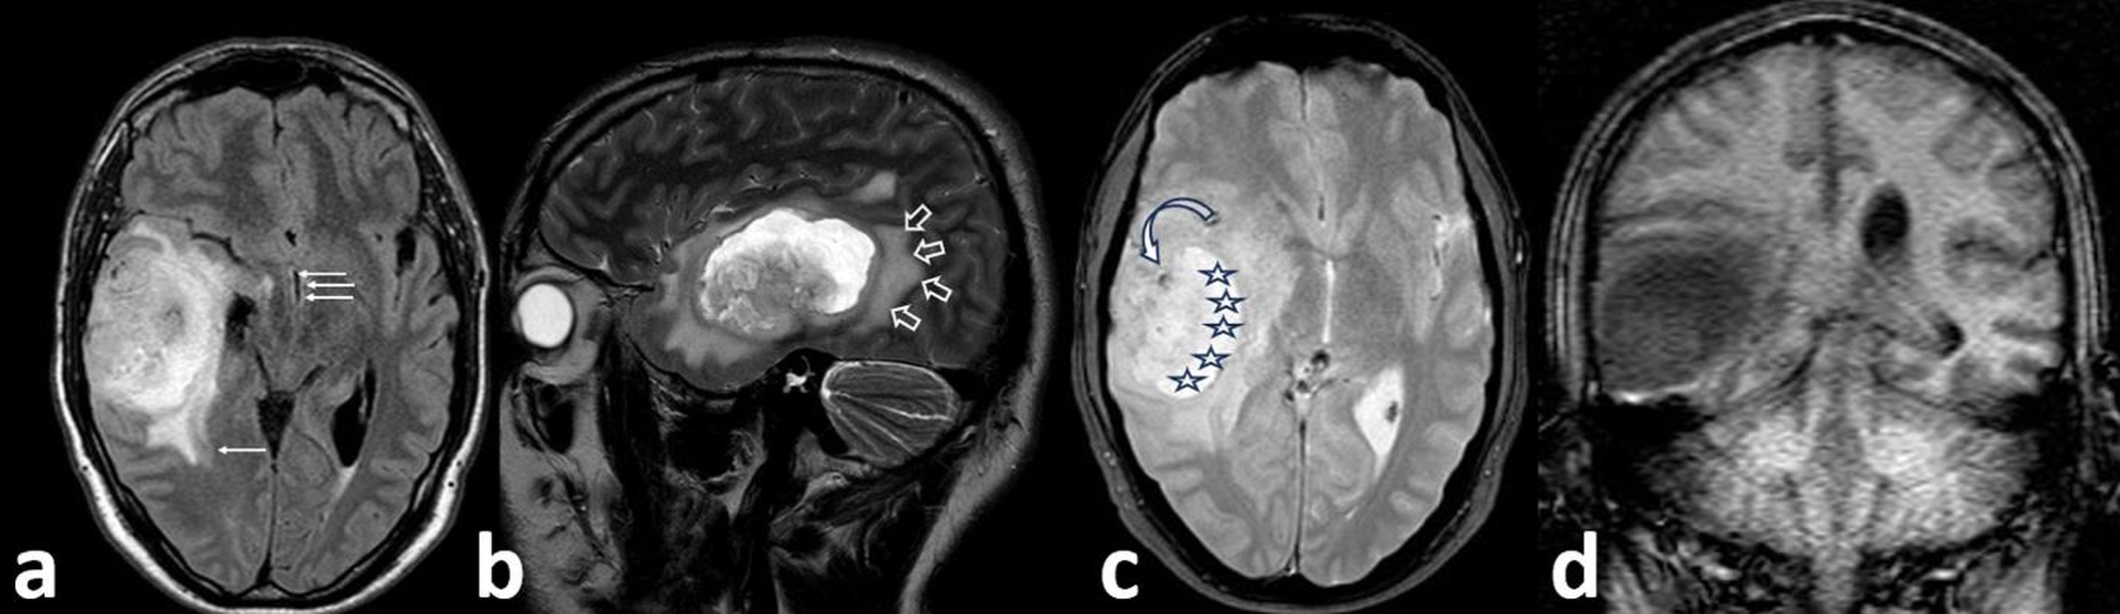
Axial FLAIR and T2-space sagittal images show a large right temporal mass with surrounding T2/FLAIR abnormality and mass effect before first surgery.
Alt text: Multi-panel pre-surgical MRI showing a large right temporal mass with surrounding FLAIR/T2 abnormality and mass effect before initial surgery.

Supplementary Figure S2. Postoperative MRI, November 2023.
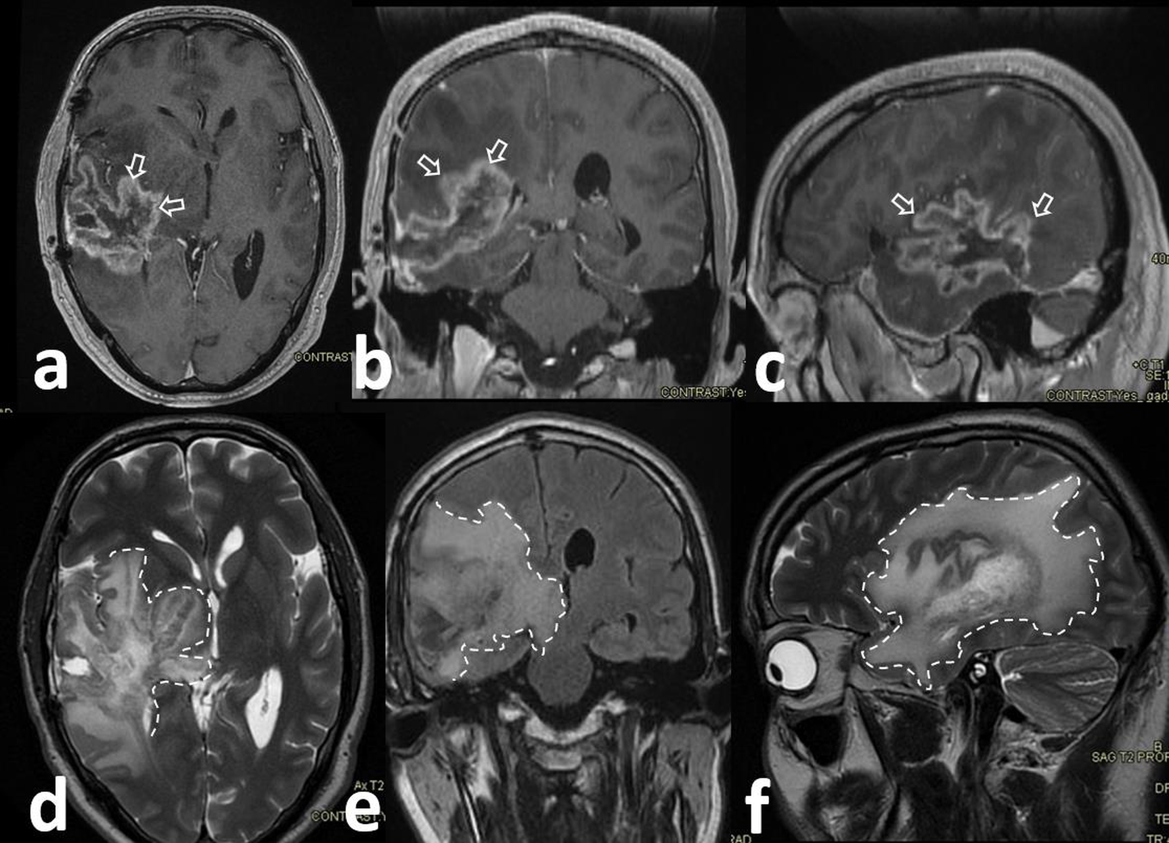
Contrast-enhanced T1-weighted, T2-weighted and FLAIR images show irregular enhancement around the right temporal resection cavity with surrounding oedema/infiltrative abnormality.
Alt text: Multi-panel postoperative MRI showing irregular enhancement around the right temporal resection cavity with surrounding oedema/infiltrative abnormality.

Supplementary Figure S3. Postoperative conventional and perfusion MRI, November 2023.
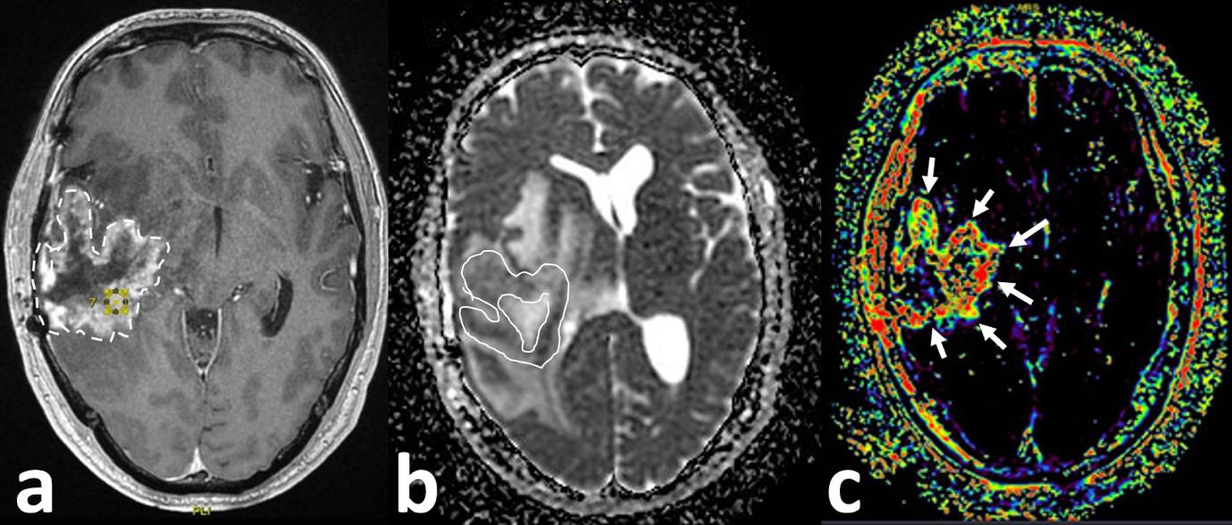
Persistent irregular enhancement, restricted diffusion and increased rCBF in an irregular rim pattern favoured residual or recurrent infiltrative tumour rather than uncomplicated radiation necrosis.
Alt text: Conventional and perfusion MRI showing persistent irregular postoperative enhancement with restricted diffusion and increased rCBF, favouring residual or recurrent tumour.

Supplementary Figure S4. Follow-up MRI showing progression, April 2024.
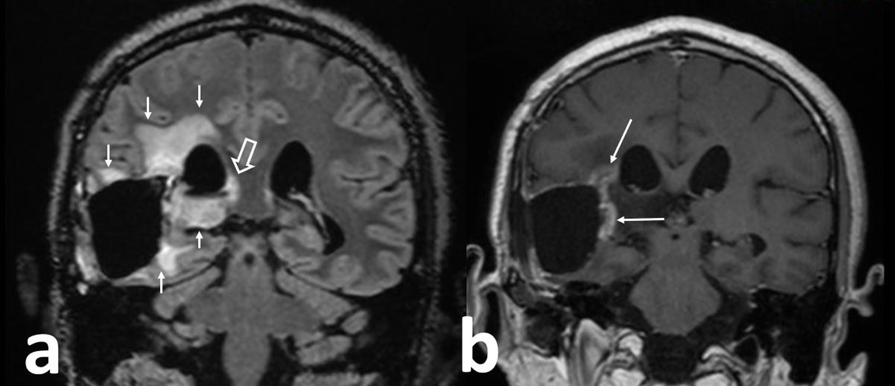
FLAIR abnormality increased around the resection cavity, medial temporal lobe and right diencephalic region, supporting ongoing infiltrative progression.
Alt text: Follow-up MRI showing increased FLAIR abnormality and persistent enhancement around the resection cavity, supporting infiltrative progression.

Supplementary Figure S5. Control MRI, January 2025.
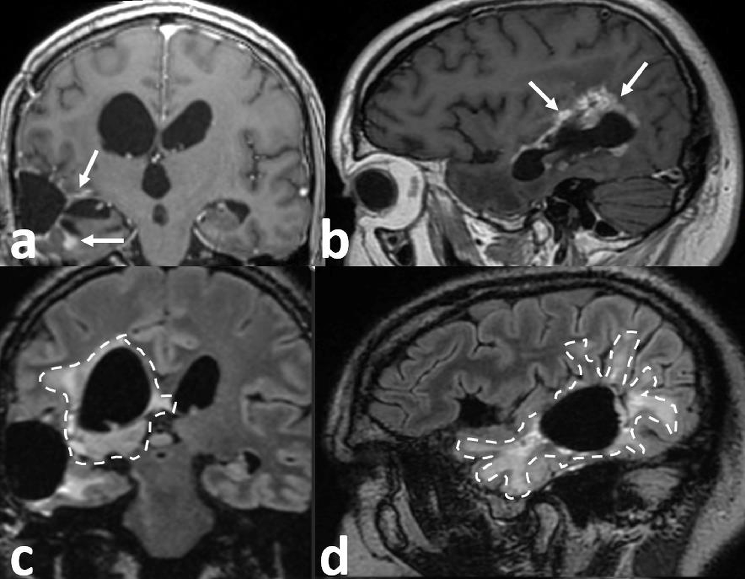
Post-contrast T1-weighted imaging shows persistent enhancing rim, while FLAIR sequences show progressive perilesional abnormality before the reported exposure interval.
Alt text: Control MRI showing persistent enhancing rim and progressive FLAIR abnormality before the reported exposure interval.

Section B. Early interval radiological improvement
Supplementary Figure S6. Mid-2025 MRI.
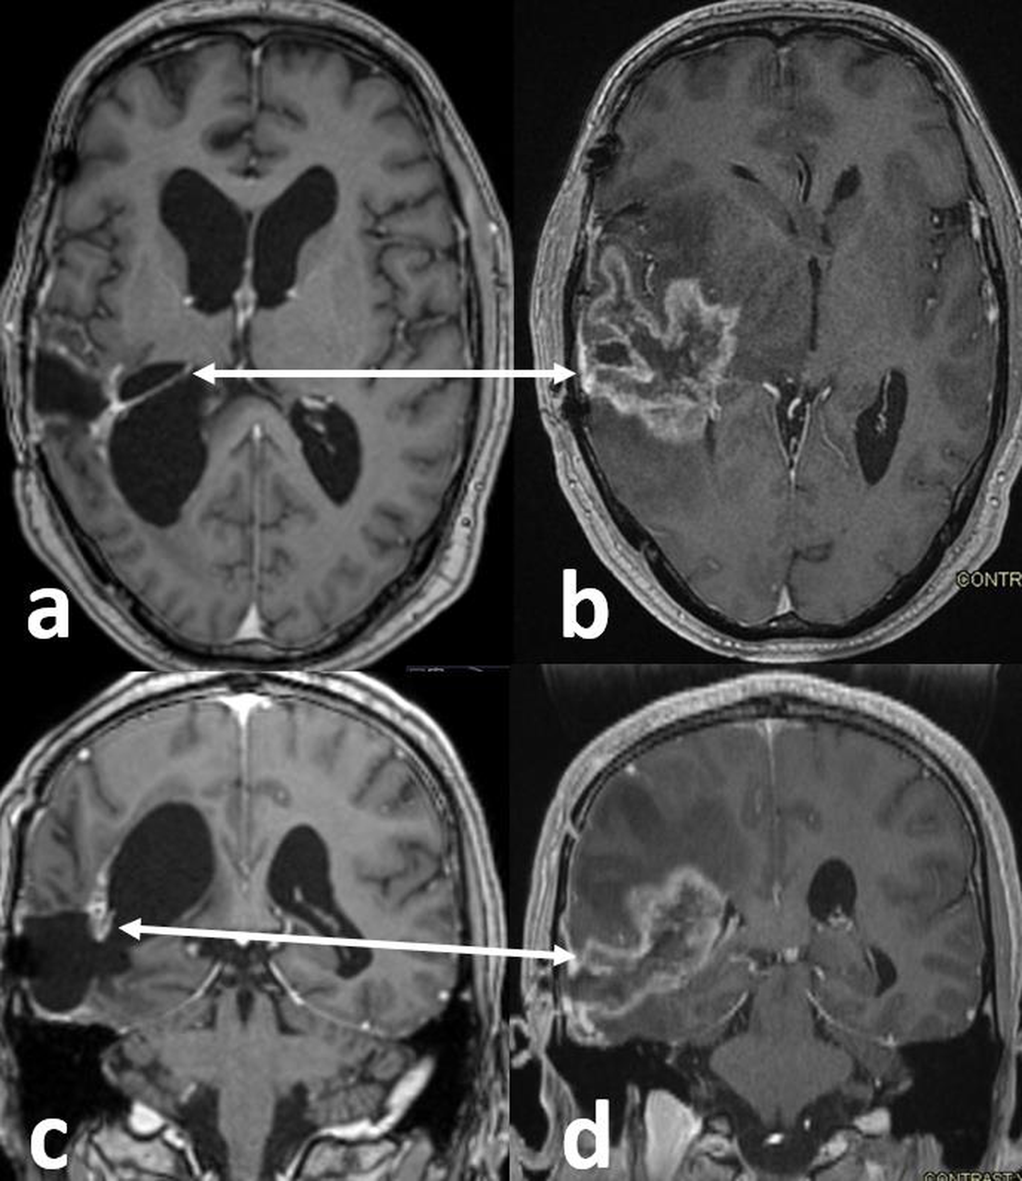
Compared with earlier progression studies, contrast-enhanced T1-weighted images show reduced irregular thickened enhancement around the resection cavity, interpreted as interval radiological improvement. The precise examination date was not available in the source material used for this report.
Alt text: Mid-2025 MRI showing interval reduction of previously prominent irregular enhancement around the resection cavity relative to earlier progression studies; the precise examination date was unavailable in the source material.

Section C. Later mixed trajectory
Supplementary Figure S7. Later MRI, 10 February 2026.
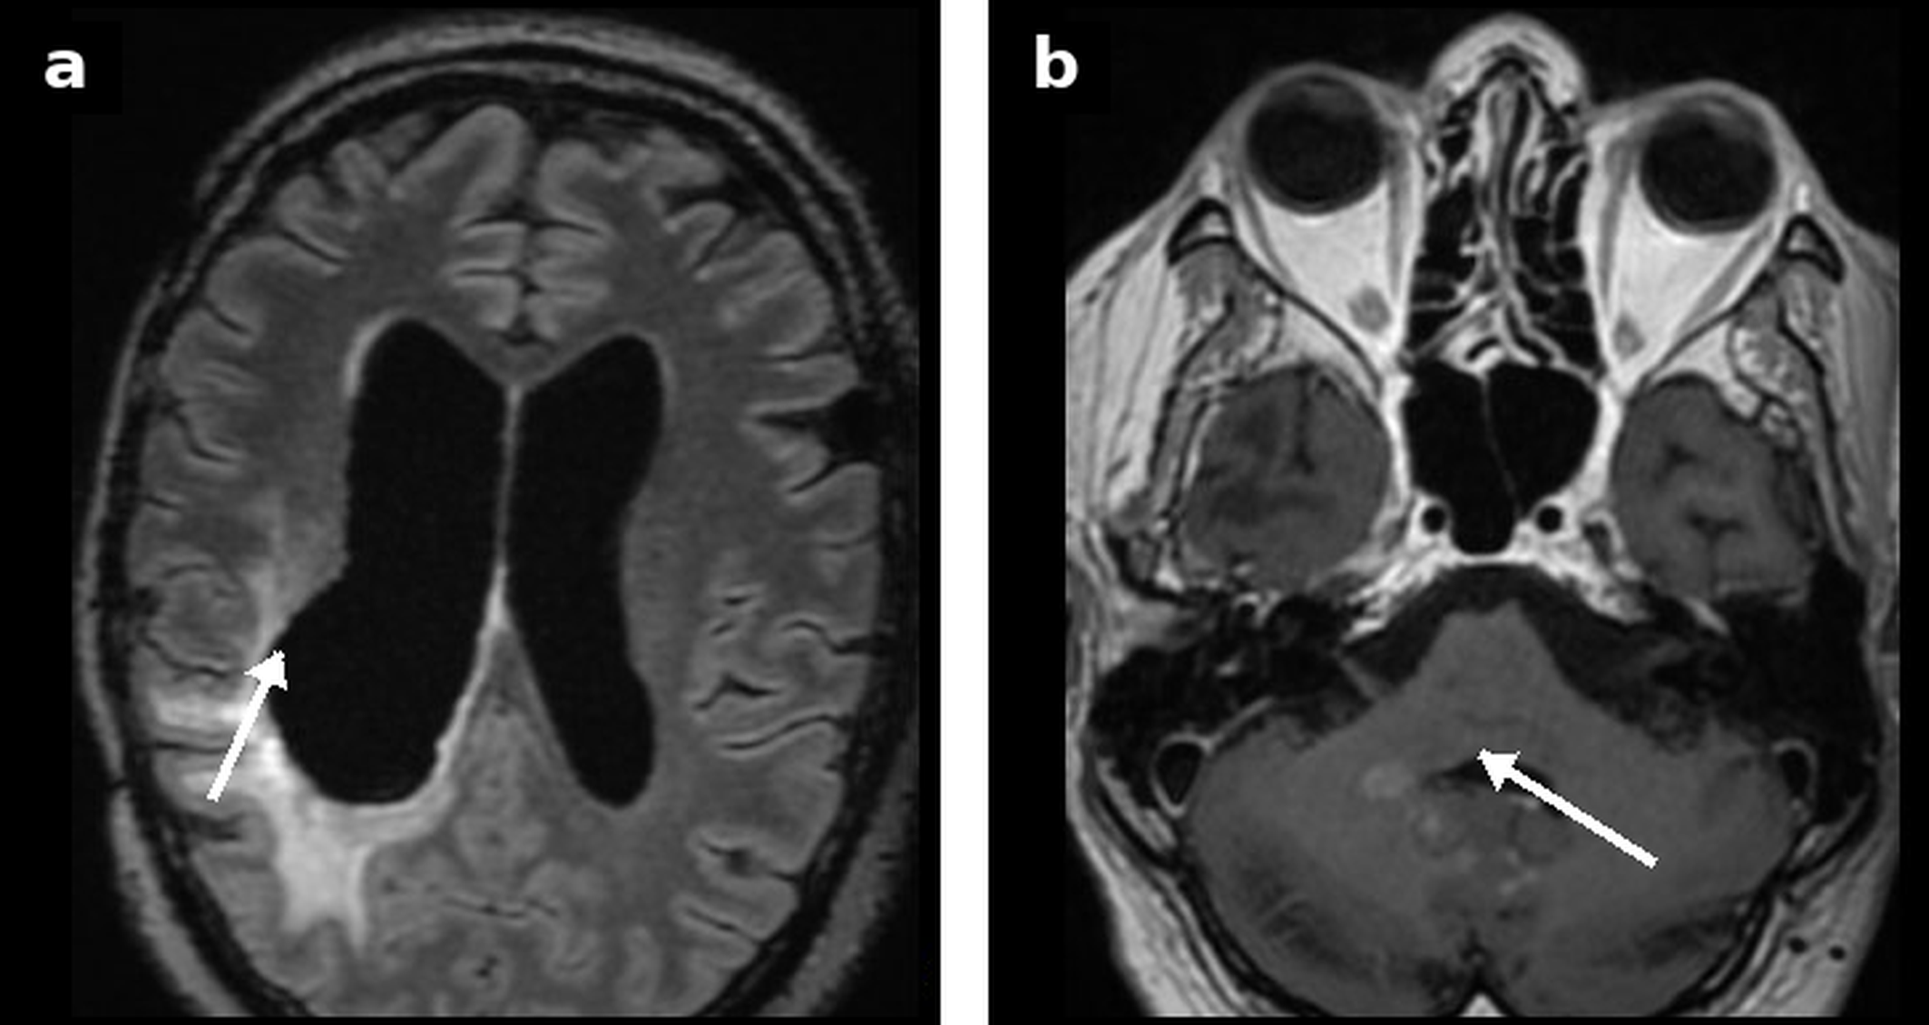
Axial FLAIR shows postoperative/periventricular hyperintensity, while post-contrast T1-weighted imaging shows an infratentorial enhancing focus. The signed report described an unchanged approximately 4.5-cm cavity and similarly extensive leukoencephalopathy/mild oedema, increased periventricular pathological enhancement, new predominantly meningeal infratentorial enhancement and a 1-cm right peduncular intra-axial lesion with restricted diffusion. Perfusion was technically unsuccessful and therefore non-interpretable.
Alt text: Two-panel February 2026 MRI showing postoperative/periventricular FLAIR abnormality and an infratentorial enhancing focus; the clinical report described new infratentorial disease and a technically unsuccessful, non-interpretable perfusion acquisition.

Supplementary Figure S8. MRI with contrast and MR perfusion, 8 June 2026.
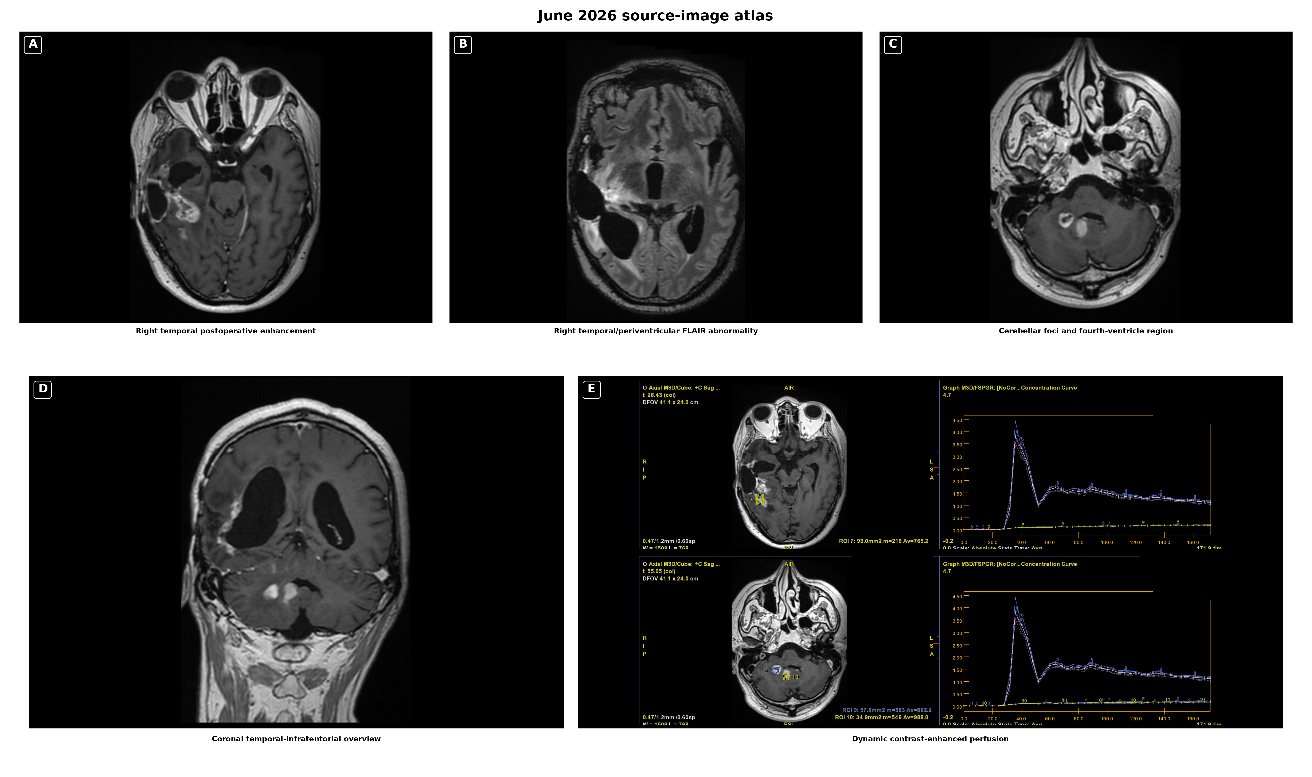
an Axial post-contrast T1-weighted imaging shows irregular enhancement along the medial/inferomedial margin of the right temporal postoperative cavity. b Axial FLAIR shows extensive right temporal and periventricular hyperintensity, without major interval change in extent according to the signed report. c Axial post-contrast T1-weighted imaging shows bilateral cerebellar enhancing foci adjacent to the fourth-ventricle region. d Coronal post-contrast T1-weighted imaging provides a temporal-infratentorial overview. e De-identified dynamic contrast-enhanced perfusion screens show low-amplitude lesion curves without pathological hyperperfusion. Interval measurements derive from the signed report; no discrete fourth-ventricular lesion was reported, and the perfusion finding supports but does not establish treatment-related change or radiation necrosis.
Alt text: Five-panel June 2026 MRI atlas showing right temporal postoperative enhancement, right temporal/periventricular FLAIR abnormality, bilateral cerebellar enhancing foci adjacent to the fourth-ventricle region, a coronal overview and low-amplitude lesion perfusion without pathological hyperperfusion.

Supplementary Box S1. Clinical attribution boundary
- Functional improvement was documented contemporaneously by the treating clinician but was not independently or blindly adjudicated. Exact dates of the Karnofsky performance status transition and standardised motor grades were not available in the material used for this report.
- Dexamethasone remained unchanged at 2 mg/day throughout the reported exposure and imaging intervals; dose change therefore does not explain the temporal improvement, although chronic corticosteroid exposure remained a co-exposure.
- Available MRI examinations and signed radiology reports were reviewed descriptively for manuscript preparation. Interval measurements and classifications derive from routine clinical reports; review was not blinded or centralised, standardised volumetry was not performed and formal RANO 2.0 adjudication was not undertaken. The February perfusion acquisition was technically unsuccessful and therefore non-interpretable.
- The exposure architecture was multi-component, changed over time and lacked a clean withdrawal period. Component-specific cannabinoid identities and doses, formulation concentrations, administration-device details, adherence, rehabilitation intensity, concomitant medication changes and adverse-event surveillance were not prospectively standardised for research assessment. The case cannot identify the responsible component or establish therapeutic causality.
The imaging data set was locked at 8 June 2026, the latest MRI included in the report; outcomes beyond that date are not evaluated here.

Clinical interpretation retained for this case report
The early functional and radiological improvement is reported as an unexpected clinical event on a stable corticosteroid background. The later course was compartmentally mixed: temporal and cerebellar enhancement increased, while cavity/FLAIR extent remained substantially stable and June lesion perfusion showed low-amplitude curves without pathological hyperperfusion. Altered terpenoid access and provenance, continued cannabinoid/MCT exposure and DHA co-exposure preclude a simple sustained-response or component-specific efficacy narrative.

Supplementary conclusion
The case is most appropriately read as an exposure-rich, radiologically dynamic recurrent-glioblastoma observation. It documents contemporaneously clinician-recorded functional improvement and interval MRI improvement followed by a compartmentally mixed later state, while preserving explicit boundaries around steroid co-exposure, formulation changes, incomplete withdrawal, incompletely standardised exposure and safety ascertainment, routine-report-derived measurements, non-interpretable February perfusion, absence of standardised volumetry, and lack of blinded RANO 2.0 adjudication.

