Fragmented care of hospital super-utilizers: a cross-sectional study.

Zach Kaltenborn MD^{1,2}
Koushik Paul BA¹
Jonathan Kirsch MD¹
Michael Aylward MD^{1,2}
Elizabeth A. Rogers MD MAS^{1,2}
Michael T. Rhodes MD^{1,2}
Michael G. Usher MD PhD¹

- Department of Medicine, Division of General Internal Medicine, University of Minnesota Medical School, Minneapolis, MN 55455
- Department of Pediatrics, University of Minnesota Medical School, Minneapolis, MN 55455

Supplemental Digital Content:
1. Supplemental Table 1: Relationship between Chronic Comorbidities and Care Fragmentation
2. Supplemental Figure 1: Distribution of number of encounters per year by fragmentation
3. Supplemental Figure 2: Distribution of fragmentation with and without inter-hospital transfers treated as a single hospital stay.
4. Supplemental Table 2a - f: Patient demographics and fragmentation by state
5. Supplemental Figure 3: Rates of chronic medical illness, substance use, and psychiatric use among super utilizers with fragmentation.
6. Supplemental Table 3: Sensitivity and specificity of measures to identify super utilizers from individual hospitals; Super-utilizers defined as 4 or more hospitals in a 1 year period.
7. Supplemental Table 4: Patient demographics and fragmentation for super-utilizers defined as the top 95th percentile of inpatient costs.
8. Supplemental Figure 4: Distribution of number of encounters per year by fragmentation of super-utilizers defined as the top 95th percentile of inpatient costs.
9. Supplemental Figure 5: Comparing 4 different single hospital methods to detect super-utilizers: 3 and 4 or more inpatient encounters, and top 5th percentile for either inpatient days or inpatient cost.
9. Supplemental Table 5: C-statistic for hospital level identification of super-utilizers, defined as the top 95th percentile of inpatient costs
10. Supplemental Table 6: Sensitivity and specificity for hospital level identification of super-utillizers, defined as the top 95th percentile of inpatient costs
11. Supplemental Figure 6: Rates of chronic medical illness, substance use, and psychiatric use, among super-utilizers defined as the top 95th percentile of inpatient costs.

Chronic Comorbidity | Beta-Coefficient | 95% CI | p
Metastatic Cancer | -0.057 | (-0.072 to -0.042) | <0.001
Lymphoma | -0.056 | (-0.078 to -0.033) | <0.001
Congestive Heart Failure | -0.031 | (-0.04 to -0.022) | <0.001
Chronic Renal Failure | -0.031 | (-0.04 to -0.023) | <0.001
Hypothyroidism | -0.019 | (-0.028 to -0.01) | <0.001
Electrolyte Abnormalities | -0.014 | (-0.022 to -0.005) | 0.001
Rheumatoid arthritis/collagen vascular disease | -0.006 | (-0.021 to 0.009) | 0.464
Acute Blood Loss Anemia | -0.006 | (-0.021 to 0.01) | 0.485
Chronic Lung Disease | -0.002 | (-0.009 to 0.006) | 0.681
Solid tumor without metastasis | -0.001 | (-0.015 to 0.012) | 0.857
Pulmonary Circulation Disorders | 0.004 | (-0.008 to 0.016) | 0.488
Diabetes with chronic complications | 0.008 | (-0.002 to 0.018) | 0.126
Hypertension with and without complications | 0.01 | (0 to 0.02) | 0.044
Coagulation Deficiency | 0.012 | (0.003 to 0.021) | 0.011
Peripheral vascular disease | 0.013 | (0.003 to 0.022) | 0.008
Liver Disease | 0.015 | (0.004 to 0.026) | 0.007
Diabetes without chronic complications | 0.018 | (0.009 to 0.026) | <0.001
Valvular disease | 0.018 | (0.008 to 0.029) | 0.001
Weight Loss | 0.03 | (0.022 to 0.039) | <0.001
HIV and AIDS | 0.034 | (0.002 to 0.067) | 0.038
Deficiency Anemias | 0.036 | (0.028 to 0.044) | <0.001
Depression | 0.04 | (0.033 to 0.048) | <0.001
Other Neurologic Disorders | 0.047 | (0.039 to 0.055) | <0.001
Paralysis | 0.051 | (0.038 to 0.064) | <0.001
Obesity | 0.055 | (0.047 to 0.064) | <0.001
Chronic Peptic Ulcer disease | 0.06 | (-0.008 to 0.128) | 0.086
Alcohol abuse | 0.142 | (0.132 to 0.152) | <0.001
Psychoses | 0.172 | (0.163 to 0.181) | <0.001
Drug Abuse | 0.214 | (0.205 to 0.224) | <0.001

Supplemental Digital Content Table 1: Independent association between chronic comorbidities and inpatient fragmentation. Association between chronic comorbidity and number of different hospitals admitted to in one year, by multivariate Poisson regression controlling for age, race, gender, insurance status, number of total inpatient encounters in 1 year.

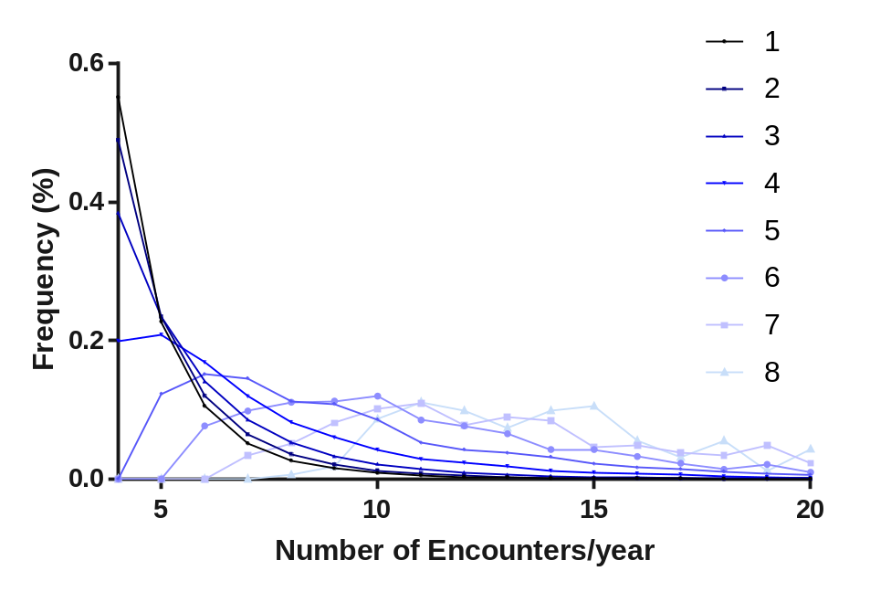
Supplemental Figure 1: Distribution of number of encounters stratified by number of hospitals visited in 1 year for super-utilizers (defined as 4 or more admissions in 1 year)
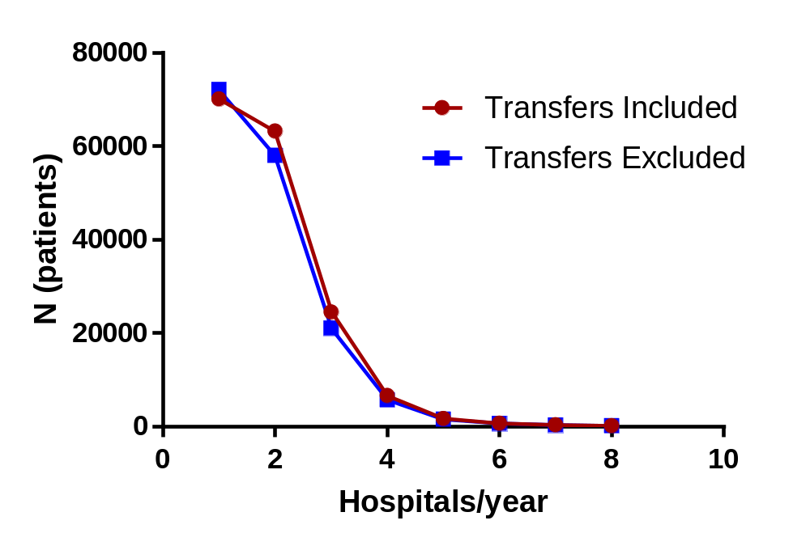
Supplemental Figure 2: Distribution of fragmentation with and without inter-hospital transfers treated as a single hospital stay.

 | 1 | 2 | 3 | 4 | 5 | 6 | 7 | 8
n | 29687 (40.58%) | 28506 (38.97%) | 10877 (14.87%) | 2874 (3.93%) | 759 (1.04%) | 281 (0.38%) | 118 (0.16%) | 53 (0.07%)
White, n(%) | 19291 (64.98%) | 17044 (59.79%) | 5994 (55.11%) | 1422 (49.48%) | 347 (45.72%) | 120 (42.7%) | 47 (39.83%) | 21 (39.62%)
Black, n (%) | 5514 (18.57%) | 5408 (18.97%) | 2093 (19.24%) | 608 (21.16%) | 167 (22%) | 64 (22.78%) | 33 (27.97%) | 16 (30.19%)
Hispanic, n (%) | 4253 (14.33%) | 5082 (17.83%) | 2329 (21.41%) | 706 (24.57%) | 199 (26.22%) | 77 (27.4%) | 32 (27.12%) | 11 (20.75%)
Other, n (%) | 629 (2.12%) | 972 (3.41%) | 461 (4.24%) | 138 (4.8%) | 46 (6.06%) | 20 (7.12%) | 6 (5.08%) | 5 (9.43%)
Medicare, (%) | 67.15% | 64.20% | 59.57% | 52.03% | 48.89% | 40.15% | 35.73% | 41.93%
Medicaid, (%) | 14.13% | 16.30% | 19.68% | 24.34% | 29.12% | 35.95% | 38.62% | 31.81%
Private (%) | 10.76% | 10.92% | 11.04% | 9.68% | 8.83% | 8.16% | 6.41% | 4.32%
Selfpay (%) | 3.65% | 4.24% | 5.63% | 8.91% | 8.92% | 9.93% | 13.15% | 12.36%
Other payer (%) | 4.30% | 4.34% | 4.07% | 5.04% | 4.23% | 5.81% | 6.08% | 9.59%
Homeless, n (%) | 244 (0.82%) | 511 (1.79%) | 420 (3.86%) | 233 (8.11%) | 128 (16.86%) | 57 (20.28%) | 31 (26.27%) | 18 (33.96%)
Churn, n (%) | 1782 (6%) | 2290 (8.03%) | 1214 (11.16%) | 488 (16.98%) | 144 (18.97%) | 59 (21%) | 32 (27.12%) | 21 (39.62%)
Large Metropolitan (>1 million), n (%) | 17931 (60.4%) | 17572 (61.64%) | 7246 (66.62%) | 2076 (72.23%) | 572 (75.36%) | 217 (77.22%) | 93 (78.81%) | 38 (71.7%)
Small Metropolitan (< 1 million), n (%) | 9772 (32.92%) | 8443 (29.62%) | 2583 (23.75%) | 532 (18.51%) | 120 (15.81%) | 50 (17.79%) | 14 (11.86%) | 11 (20.75%)
Micropolitan, n (%) | 1304 (4.39%) | 1697 (5.95%) | 696 (6.4%) | 175 (6.09%) | 44 (5.8%) | 8 (2.85%) | 10 (8.47%) | 3 (5.66%)
Rural, n (%) | 586 (1.97%) | 751 (2.63%) | 343 (3.15%) | 87 (3.03%) | 22 (2.9%) | 6 (2.14%) | 1 (0.85%) | 1 (1.89%)
Yearly Encounters, mean (SD) | 4.99 (1.69) | 5.27 (2.01) | 5.89 (2.64) | 7.36 (3.72) | 9.97 (4.83) | 12.56 (5.61) | 15.75 (5.98) | 16.85 (5.99)
Yearly Cost (k), mean (SD) | 51.84 (46.33) | 56.89 (49.5) | 62.04 (54.48) | 63.33 (52.36) | 73.4 (62.26) | 76.57 (64.43) | 89.45 (76.27) | 95.54 (52.57)
Yearly LOS (days), mean (SD) | 29.3 (21.36) | 31.32 (23.74) | 35.33 (26.66) | 42.15 (32.46) | 55.44 (39.19) | 62.32 (37.69) | 75.69 (46.68) | 83.04 (42.1)
Psychiatric Disease,n (%) | 11766 (39.63%) | 13185 (46.25%) | 5966 (54.85%) | 1880 (65.41%) | 576 (75.89%) | 226 (80.43%) | 98 (83.05%) | 44 (83.02%)
Substance Use, n (%) | 5767 (19.43%) | 7275 (25.52%) | 3905 (35.9%) | 1468 (51.08%) | 508 (66.93%) | 209 (74.38%) | 98 (83.05%) | 48 (90.57%)
Multiple Medical Comorbidities, n (%) | 26803 (90.29%) | 25633 (89.92%) | 9645 (88.67%) | 2503 (87.09%) | 649 (85.51%) | 249 (88.61%) | 105 (88.98%) | 49 (92.45%)

Table IIa: Patient demographics and yearly costs by state (Florida)

 | 1 | 2 | 3 | 4 | 5 | 6 | 7 | 8
n | 9977 (40.67%) | 9072 (36.98%) | 4071 (16.6%) | 1077 (4.39%) | 252 (1.03%) | 52 (0.21%) | 20 (0.08%) | 8 (0.03%)
White, n(%) | 5541 (55.54%) | 4776 (52.65%) | 1892 (46.48%) | 431 (40.02%) | 96 (38.1%) | 21 (40.38%) | 7 (35%) | 0 (0%)
Black, n (%) | 3708 (37.17%) | 3465 (38.19%) | 1661 (40.8%) | 472 (43.83%) | 107 (42.46%) | 21 (40.38%) | 8 (40%) | 5 (62.5%)
Hispanic, n (%) | 387 (3.88%) | 352 (3.88%) | 164 (4.03%) | 54 (5.01%) | 13 (5.16%) | 7 (13.46%) | 1 (5%) | 1 (12.5%)
Other, n (%) | 341 (3.42%) | 479 (5.28%) | 354 (8.7%) | 120 (11.14%) | 36 (14.29%) | 3 (5.77%) | 4 (20%) | 2 (25%)
Medicare, (%) | 60.26% | 59.25% | 58.46% | 52.27% | 53.26% | 37.17% | 41.70% | 41.38%
Medicaid, (%) | 13.90% | 14.99% | 15.97% | 20.19% | 23.46% | 33.26% | 25.00% | 38.04%
Private (%) | 13.61% | 15.40% | 15.15% | 15.08% | 11.25% | 11.10% | 10.97% | 4.17%
Selfpay (%) | 6.73% | 5.72% | 5.26% | 7.21% | 7.11% | 13.14% | 20.53% | 11.21%
Other payer (%) | 5.49% | 4.63% | 5.17% | 5.25% | 4.92% | 5.33% | 1.81% | 5.21%
Homeless, n (%) | 10 (0.1%) | 16 (0.18%) | 12 (0.29%) | 4 (0.37%) | 1 (0.4%) | 0 (0%) | 0 (0%) | 0 (0%)
Churn, n (%) | 963 (9.65%) | 952 (10.49%) | 487 (11.96%) | 178 (16.53%) | 51 (20.24%) | 15 (28.85%) | 7 (35%) | 5 (62.5%)
Large Metropolitan (>1 million), n (%) | 4057 (40.66%) | 4087 (45.05%) | 1917 (47.09%) | 543 (50.42%) | 134 (53.17%) | 25 (48.08%) | 11 (55%) | 6 (75%)
Small Metropolitan (< 1 million), n (%) | 3699 (37.08%) | 2450 (27.01%) | 912 (22.4%) | 216 (20.06%) | 43 (17.06%) | 10 (19.23%) | 3 (15%) | 2 (25%)
Micropolitan, n (%) | 1307 (13.1%) | 1260 (13.89%) | 550 (13.51%) | 133 (12.35%) | 31 (12.3%) | 10 (19.23%) | 1 (5%) | 0 (0%)
Rural, n (%) | 906 (9.08%) | 1275 (14.05%) | 692 (17%) | 185 (17.18%) | 44 (17.46%) | 7 (13.46%) | 5 (25%) | 0 (0%)
Yearly Encounters, mean (SD) | 4.94 (1.75) | 5.14 (1.79) | 5.51 (2.17) | 6.42 (2.93) | 8.36 (3.59) | 10.02 (4.15) | 12.4 (3.55) | 14.25 (4.17)
Yearly Cost (k), mean (SD) | 183.55 (160.24) | 223.29 (209.82) | 267.23 (262.65) | 328.74 (327.16) | 421.96 (471.34) | 397.84 (420.42) | 271.14 (164.26) | 389.98 (299.88)
Yearly LOS (days), mean (SD) | 28.98 (19.76) | 34.03 (25.07) | 41.78 (31.56) | 52.26 (38.51) | 66.69 (45.48) | 68.12 (49.42) | 63.6 (34.68) | 81.63 (48.92)
Psychiatric Disease,n (%) | 3587 (35.95%) | 3737 (41.19%) | 2043 (50.18%) | 645 (59.89%) | 168 (66.67%) | 35 (67.31%) | 16 (80%) | 4 (50%)
Substance Use, n (%) | 1702 (17.06%) | 1940 (21.38%) | 1156 (28.4%) | 448 (41.6%) | 124 (49.21%) | 32 (61.54%) | 14 (70%) | 6 (75%)
Multiple Medical Comorbidities, n (%) | 8944 (89.65%) | 8326 (91.78%) | 3711 (91.16%) | 975 (90.53%) | 236 (93.65%) | 49 (94.23%) | 17 (85%) | 7 (87.5%)

Table IIb: Patient demographics and yearly costs by state (Georgia)

 | 1 | 2 | 3 | 4 | 5 | 6
n | 3105 (0.53%) | 2217 (0.38%) | 501 (0.09%) | 57 (0.01%) | 4 (0%) | 1 (0%)
White, n(%) | 2856 (91.98%) | 2032 (91.66%) | 457 (91.22%) | 51 (89.47%) | 3 (75%) | 1 (100%)
Black, n (%) | 137 (4.41%) | 113 (5.1%) | 28 (5.59%) | 3 (5.26%) | 0 (0%) | 0 (0%)
Hispanic, n (%) | 40 (1.29%) | 40 (1.8%) | 6 (1.2%) | 3 (5.26%) | 1 (25%) | 0 (0%)
Other, n (%) | 72 (2.32%) | 32 (1.44%) | 10 (2%) | 0 (0%) | 0 (0%) | 0 (0%)
Medicare, (%) | 74.14% | 69.30% | 64.22% | 59.02% | 42.86% | 100.00%
Medicaid, (%) | 8.18% | 10.69% | 16.56% | 17.01% | 23.57% | 0.00%
Private (%) | 15.34% | 15.70% | 14.00% | 9.47% | 23.33% | 0.00%
Selfpay (%) | 1.58% | 3.17% | 3.76% | 11.11% | 5.24% | 0.00%
Other payer (%) | 0.75% | 1.14% | 1.46% | 3.39% | 5.00% | 0.00%
Homeless, n (%) | 0 (0%) | 0 (0%) | 0 (0%) | 0 (0%) | 0 (0%) | 0 (%)
Churn, n (%) | 106 (3.41%) | 159 (7.17%) | 52 (10.38%) | 16 (28.07%) | 2 (50%) | 0 (%)
Large Metropolitan (>1 million), n (%) | 0 (0%) | 0 (0%) | 0 (0%) | 0 (0%) | 0 (0%) | 0 (0%)
Small Metropolitan (< 1 million), n (%) | 1881 (60.58%) | 1050 (47.36%) | 183 (36.53%) | 22 (38.6%) | 3 (75%) | 0 (0%)
Micropolitan, n (%) | 489 (15.75%) | 446 (20.12%) | 119 (23.75%) | 9 (15.79%) | 1 (25%) | 0 (0%)
Rural, n (%) | 735 (23.67%) | 721 (32.52%) | 199 (39.72%) | 26 (45.61%) | 0 (0%) | 1 (100%)
Yearly Encounters, mean (SD) | 4.85 (1.45) | 5.04 (1.73) | 5.48 (2.1) | 6.58 (2.69) | 8.75 (4.35) | 8 (4.35)
Yearly Cost (k), mean (SD) | 53.21 (44.65) | 58.11 (43.44) | 64.43 (48.9) | 69.83 (51.26) | 70.75 (34.95) | 73.94 (34.95)
Yearly LOS (days), mean (SD) | 25.74 (17.19) | 26.39 (18.06) | 28.03 (18.22) | 34.65 (27.77) | 32.25 (18.52) | 16 (18.52)
Psychiatric Disease,n (%) | 1361 (43.83%) | 1014 (45.74%) | 254 (50.7%) | 34 (59.65%) | 3 (75%) | 1 (100%)
Substance Use, n (%) | 339 (10.92%) | 326 (14.7%) | 90 (17.96%) | 20 (35.09%) | 3 (75%) | 1 (100%)
Multiple Medical Comorbidities, n (%) | 2805 (90.34%) | 2048 (92.38%) | 458 (91.42%) | 55 (96.49%) | 4 (100%) | 1 (100%)

Table IIc: Patient demographics and yearly costs by state (Iowa)

 | 1 | 2 | 3 | 4 | 5 | 6 | 7 | 8
n | 1383 (44.84%) | 1126 (36.51%) | 421 (13.65%) | 116 (3.76%) | 30 (0.97%) | 5 (0.16%) | 2 (0.06%) | 1 (0.03%)
White, n(%) | 443 (32.03%) | 505 (44.85%) | 213 (50.59%) | 51 (43.97%) | 14 (46.67%) | 0 (0%) | 0 (0%) | 0 (0%)
Black, n (%) | 11 (0.8%) | 11 (0.98%) | 6 (1.43%) | 0 (0%) | 1 (3.33%) | 1 (20%) | 0 (0%) | 0 (0%)
Hispanic, n (%) | 75 (5.42%) | 132 (11.72%) | 76 (18.05%) | 26 (22.41%) | 9 (30%) | 2 (40%) | 0 (0%) | 0 (0%)
Other, n (%) | 854 (61.75%) | 478 (42.45%) | 126 (29.93%) | 39 (33.62%) | 6 (20%) | 2 (40%) | 2 (100%) | 1 (100%)
Medicare, (%) | 52.41% | 54.26% | 43.84% | 33.93% | 33.24% | 20.00% | 50.00% | 0.00%
Medicaid, (%) | 12.29% | 13.61% | 18.60% | 25.30% | 32.49% | 46.33% | 50.00% | 0.00%
Private (%) | 28.25% | 24.44% | 25.76% | 21.18% | 15.18% | 13.67% | 0.00% | 100.00%
Selfpay (%) | 2.93% | 3.62% | 8.04% | 10.71% | 12.58% | 17.78% | 0.00% | 0.00%
Other payer (%) | 4.12% | 4.06% | 3.75% | 8.89% | 6.50% | 2.22% | 0.00% | 0.00%
Homeless, n (%) | 0 (0%) | 0 (0%) | 0 (0%) | 1 (0.86%) | 0 (0%) | 244 (0.82%) | 0 (0%) | 0 (0%)
Churn, n (%) | 69 (4.99%) | 90 (7.99%) | 72 (17.1%) | 30 (25.86%) | 11 (36.67%) | 1782 (6%) | 0 (0%) | 0 (0%)
Large Metropolitan (>1 million), n (%) | 11 (0.8%) | 3 (0.27%) | 1 (0.24%) | 0 (0%) | 0 (0%) | 0 (0%) | 0 (0%) | 0 (0%)
Small Metropolitan (< 1 million), n (%) | 1224 (88.5%) | 940 (83.48%) | 358 (85.04%) | 103 (88.79%) | 28 (93.33%) | 5 (100%) | 2 (100%) | 1 (100%)
Micropolitan, n (%) | 87 (6.29%) | 102 (9.06%) | 20 (4.75%) | 7 (6.03%) | 0 (0%) | 0 (0%) | 0 (0%) | 0 (0%)
Rural, n (%) | 61 (4.41%) | 81 (7.19%) | 42 (9.98%) | 6 (5.17%) | 2 (6.67%) | 0 (0%) | 0 (0%) | 0 (0%)
Yearly Encounters, mean (SD) | 4.86 (1.43) | 4.98 (1.59) | 5.21 (1.88) | 6.51 (2.71) | 7.83 (1.88) | 10.6 (3.05) | 15 (2.83)
Yearly Cost (k), mean (SD) | 73.14 (78.66) | 61.98 (50.05) | 56.93 (61.38) | 53.75 (37.95) | 73.29 (44.3) | 62.86 (21.37) | 78.03 (30.08)
Yearly LOS (days), mean (SD) | 26.18 (20.66) | 23.9 (15.91) | 25.94 (17.51) | 31.06 (21.02) | 42.1 (30.02) | 43 (9.22) | 64.5 (33.23)
Psychiatric Disease,n (%) | 463 (33.48%) | 444 (39.43%) | 224 (53.21%) | 84 (72.41%) | 26 (86.67%) | 4 (80%) | 2 (100%) | 0 (0%)
Substance Use, n (%) | 207 (14.97%) | 258 (22.91%) | 180 (42.76%) | 71 (61.21%) | 21 (70%) | 3 (60%) | 2 (100%) | 1 (100%)
Multiple Medical Comorbidities, n (%) | 1075 (77.73%) | 894 (79.4%) | 290 (68.88%) | 81 (69.83%) | 23 (76.67%) | 4 (80%) | 2 (100%) | 0 (0%)

Table IId: Patient demographics and yearly costs by state (Utah)
 | 1 | 2 | 3 | 4 | 5 | 6 | 7 | 8
n | 25394 (42.29%) | 22085 (36.78%) | 8637 (14.38%) | 2489 (4.15%) | 767 (1.28%) | 363 (0.6%) | 207 (0.34%) | 100 (0.17%)
White, n(%) | 13488 (53.11%) | 10404 (47.11%) | 3208 (37.14%) | 664 (26.68%) | 143 (18.64%) | 52 (14.33%) | 22 (10.63%) | 7 (0.07%)
Black, n (%) | 4709 (18.54%) | 3924 (17.77%) | 1713 (19.83%) | 563 (22.62%) | 200 (26.08%) | 90 (24.79%) | 51 (24.64%) | 28 (0.28%)
Hispanic, n (%) | 3400 (13.39%) | 2431 (11.01%) | 990 (11.46%) | 295 (11.85%) | 89 (11.6%) | 45 (12.4%) | 27 (13.04%) | 10 (0.1%)
Other, n (%) | 3797 (14.95%) | 5326 (24.12%) | 2726 (31.56%) | 967 (38.85%) | 335 (43.68%) | 176 (48.48%) | 107 (51.69%) | 55 (0.55%)
Medicare, (%) | 62.16% | 58.79% | 51.83% | 37.33% | 29.29% | 21.16% | 20.46% | 19.69%
Medicaid, (%) | 19.96% | 23.10% | 32.15% | 48.84% | 61.02% | 68.08% | 72.19% | 73.68%
Private (%) | 14.89% | 14.73% | 12.28% | 9.08% | 5.49% | 5.08% | 3.70% | 2.12%
Selfpay (%) | 1.34% | 1.61% | 1.91% | 2.63% | 2.30% | 3.27% | 2.45% | 2.70%
Other payer (%) | 1.66% | 1.76% | 1.83% | 2.12% | 1.90% | 2.40% | 1.20% | 1.81%
Homeless, n (%) | 1057 (4.16%) | 2316 (10.49%) | 1805 (20.9%) | 972 (39.05%) | 424 (55.28%) | 240 (66.12%) | 161 (77.78%) | 84 (84%)
Churn, n (%) | 781 (3.08%) | 958 (4.34%) | 494 (5.72%) | 236 (9.48%) | 87 (11.34%) | 59 (16.25%) | 34 (16.43%) | 17 (17%)
Large Metropolitan (>1 million), n (%) | 19252 (75.81%) | 16841 (76.26%) | 6938 (80.33%) | 2084 (83.73%) | 670 (87.35%) | 317 (87.33%) | 183 (88.41%) | 86 (86%)
Small Metropolitan (< 1 million), n (%) | 4283 (16.87%) | 3428 (15.52%) | 1054 (12.2%) | 261 (10.49%) | 71 (9.26%) | 32 (8.82%) | 22 (10.63%) | 13 (13%)
Micropolitan, n (%) | 1410 (5.55%) | 1278 (5.79%) | 408 (4.72%) | 79 (3.17%) | 16 (2.09%) | 10 (2.75%) | 1 (0.48%) | 0 (0%)
Rural, n (%) | 425 (1.67%) | 535 (2.42%) | 237 (2.74%) | 65 (2.61%) | 10 (1.3%) | 4 (1.1%) | 1 (0.48%) | 1 (1%)
Yearly Encounters, mean (SD) | 4.96 (1.61) | 5.17 (1.86) | 5.69 (2.39) | 6.91 (3.19) | 9.31 (4.54) | 11.32 (4.9) | 13.87 (5.72) | 15.7 (5.5)
Yearly Cost (k), mean (SD) | 71.3 (65.36) | 76.74 (67.03) | 78.81 (70.36) | 76.32 (67.76) | 85.05 (73.17) | 90.87 (65.98) | 97.5 (65.86) | 113.39 (78.61)
Yearly LOS (days), mean (SD) | 34.67 (26.7) | 37.69 (29.77) | 42.42 (33.98) | 49.92 (38.99) | 60.64 (44.13) | 70.81 (46.53) | 78.13 (48.41) | 88.78 (55.35)
Psychiatric Disease,n (%) | 9108 (35.87%) | 9240 (41.84%) | 4322 (50.04%) | 1593 (64%) | 553 (72.1%) | 273 (75.21%) | 163 (78.74%) | 77 (77%)
Substance Use, n (%) | 4188 (16.49%) | 5216 (23.62%) | 3182 (36.84%) | 1429 (57.41%) | 566 (73.79%) | 290 (79.89%) | 170 (82.13%) | 81 (81%)
Multiple Medical Comorbidities, n (%) | 22025 (86.73%) | 18990 (85.99%) | 6947 (80.43%) | 1747 (70.19%) | 553 (72.1%) | 268 (73.83%) | 149 (71.98%) | 77 (77%)

Table IId: Patient demographics and yearly costs by state (New York)

 | 1 | 2 | 3 | 4
n | 565 (68.9%) | 233 (28.41%) | 20 (2.44%) | 2 (0.24%)
White, n(%) | 548 (96.99%) | 228 (97.85%) | 18 (90%) | 2 (100%)
Black, n (%) | 4 (0.71%) | 1 (0.43%) | 1 (5%) | 0 (0%)
Hispanic, n (%) | 0 (0%) | 0 (0%) | 0 (0%) | 0 (0%)
Other, n (%) | 13 (2.3%) | 4 (1.72%) | 1 (5%) | 0 (0%)
Medicare, (%) | 65.59% | 62.67% | 60.00% | 0.00%
Medicaid, (%) | 14.62% | 19.64% | 33.00% | 100.00%
Private (%) | 14.60% | 12.53% | 5.00% | 0.00%
Selfpay (%) | 0.27% | 1.17% | 0.00% | 0.00%
Other payer (%) | 4.92% | 3.99% | 2.00% | 0.00%
Homeless, n (%) | 0 (0%) | 0 (0%) | 0 (0%) | 0 (%)
Churn, n (%) | 6 (1.06%) | 8 (3.43%) | 0 (0%) | 0 (%)
Large Metropolitan (>1 million), n (%) | 1 (0.18%) | 0 (0%) | 0 (0%) | 0 (0%)
Small Metropolitan (< 1 million), n (%) | 211 (37.35%) | 52 (22.32%) | 1 (5%) | 0 (0%)
Micropolitan, n (%) | 273 (48.32%) | 106 (45.49%) | 10 (50%) | 0 (0%)
Rural, n (%) | 80 (14.16%) | 75 (32.19%) | 9 (45%) | 2 (100%)
Yearly Encounters, mean (SD) | 4.92 (1.55) | 5.02 (1.48) | 5.55 (1.76) | 8 (5.66)
Yearly Cost (k), mean (SD) | 67.29 (47.36) | 75.15 (49.93) | 78.31 (57.67) | 41.66 (31.11)
Yearly LOS (days), mean (SD) | 25.78 (19.68) | 26.72 (21.7) | 31.85 (26.76) | 19 (1.41)
Psychiatric Disease,n (%) | 298 (52.74%) | 114 (48.93%) | 14 (70%) | 2 (100%)
Substance Use, n (%) | 118 (20.88%) | 52 (22.32%) | 9 (45%) | 1 (50%)
Multiple Medical Comorbidities, n (%) | 502 (88.85%) | 206 (88.41%) | 15 (75%) | 2 (100%)

Table IIf: Patient demographics and yearly costs by state (Vermont)
Supplemental Digital Content Figure 3: Prevalence rate of different categories of chronic conditions stratified by the number of hospitals admitted to in a 1 year period for super utilizers defined as the top 95th percentile of inpatient costs.

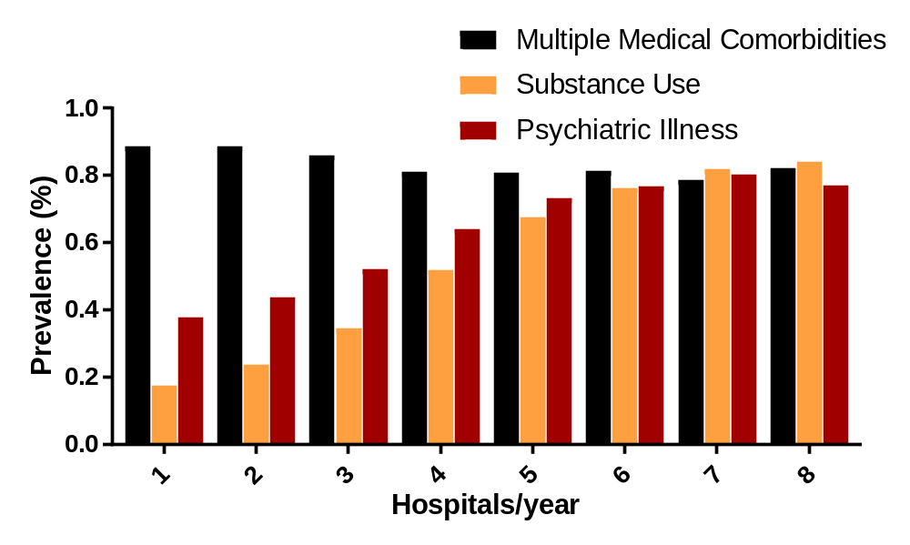

 | One Hospital |  | 2 or More Hospitals |  | Total
 | Sensitivity | Specificity | Sensitivity | Specificity | Sensitivity | Specificity
3 or more encounters | 100% | 96.81% | 51.73% | 100% | 85.23% | 98.03%
4 or more encounters | 100% | 100% | 36.10% | 100% | 62.85% | 100%
Length of Stay > 95 percentile | 81.54% | 93.51% | 64.00% | 83.34% | 71.34% | 92.81%
Yearly Cost > 95 percentile | 63.71% | 93.92% | 47.52% | 85.96% | 54.30% | 93.37%

Table III: Sensitivity and specificity of measures to identify super utilizers from individual hospitals; Super-utilizers defined as 4 or more hospitals in a 1 year period.

 | 1 | 2 | 3 | 4 | 5 | 6 | 7 | 8
n | 112528 (59.43%) | 56912 (30.05%) | 14753 (7.79%) | 3342 (1.76%) | 1047 (0.55%) | 431 (0.23%) | 225 (0.12%) | 122 (0.06%)
White, n(%) | 67786 (60.24%) | 31636 (55.59%) | 6883 (46.65%) | 1290 (38.6%) | 350 (33.43%) | 119 (27.61%) | 52 (23.11%) | 20 (16.39%)
Black, n (%) | 19978 (17.75%) | 10852 (19.07%) | 3420 (23.18%) | 885 (26.48%) | 282 (26.93%) | 110 (25.52%) | 62 (27.56%) | 41 (33.61%)
Hispanic, n (%) | 12251 (10.89%) | 6891 (12.11%) | 2137 (14.49%) | 550 (16.46%) | 176 (16.81%) | 85 (19.72%) | 40 (17.78%) | 15 (12.3%)
Other, n (%) | 12513 (11.12%) | 7533 (13.24%) | 2313 (15.68%) | 617 (18.46%) | 239 (22.83%) | 117 (27.15%) | 71 (31.56%) | 46 (37.7%)
Medicare, (%) | 56.70% | 63.16% | 62.71% | 55.06% | 47.25% | 34.04% | 30.71% | 30.60%
Medicaid, (%) | 13.87% | 14.30% | 18.39% | 26.78% | 37.73% | 49.76% | 54.73% | 56.42%
Private (%) | 22.03% | 16.59% | 13.30% | 10.62% | 7.42% | 6.15% | 4.15% | 3.34%
Selfpay (%) | 3.21% | 2.69% | 2.69% | 3.80% | 4.35% | 5.76% | 7.73% | 5.72%
Other payer (%) | 4.19% | 3.26% | 2.92% | 3.74% | 3.26% | 4.29% | 2.69% | 3.91%
Homeless, n (%) | 4645 (4.13%) | 2925 (5.14%) | 992 (6.72%) | 347 (10.38%) | 143 (13.66%) | 69 (16.01%) | 41 (18.22%) | 31 (25.41%)
Churn, n (%) | 1368 (1.22%) | 1815 (3.19%) | 937 (6.35%) | 462 (13.82%) | 248 (23.69%) | 168 (38.98%) | 110 (48.89%) | 72 (59.02%)
Large Metropolitan (>1 million), n (%) | 69788 (62.02%) | 35478 (62.34%) | 9708 (65.8%) | 2328 (69.66%) | 772 (73.73%) | 345 (80.05%) | 185 (82.22%) | 98 (80.33%)
Small Metropolitan (< 1 million), n (%) | 30063 (26.72%) | 13961 (24.53%) | 2978 (20.19%) | 580 (17.35%) | 159 (15.19%) | 60 (13.92%) | 27 (12%) | 21 (17.21%)
Micropolitan, n (%) | 7110 (6.32%) | 4287 (7.53%) | 1130 (7.66%) | 226 (6.76%) | 56 (5.35%) | 14 (3.25%) | 8 (3.56%) | 2 (1.64%)
Rural, n (%) | 5236 (4.65%) | 3156 (5.55%) | 934 (6.33%) | 208 (6.22%) | 60 (5.73%) | 12 (2.78%) | 5 (2.22%) | 1 (0.82%)
Yearly Encounters, mean (SD) | 2.68 (2.08) | 4.18 (2.4) | 5.83 (3.02) | 8.06 (4.01) | 10.62 (5.17) | 13.01 (5.79) | 16.04 (6.08) | 16.98 (5.92)
Yearly Cost (k), mean (SD) | 126.57 (126.7) | 140.65 (152.97) | 166.28 (187.88) | 179.8 (219.39) | 189.79 (273.09) | 148.13 (183.61) | 136.04 (93.64) | 142.99 (119.77)
Yearly LOS (days), mean (SD) | 34.58 (29.51) | 41.38 (30.05) | 51.87 (34.49) | 64.06 (40.53) | 76.81 (45.68) | 84.76 (44.89) | 94.79 (47.49) | 98.89 (51.37)
Psychiatric Disease,n (%) | 26445 (23.5%) | 19364 (34.02%) | 6881 (46.64%) | 2044 (61.16%) | 766 (73.16%) | 344 (79.81%) | 184 (81.78%) | 92 (75.41%)
Substance Use, n (%) | 13451 (11.95%) | 9570 (16.82%) | 3862 (26.18%) | 1475 (44.14%) | 664 (63.42%) | 329 (76.33%) | 188 (83.56%) | 107 (87.7%)
Multiple Medical Comorbidities, n (%) | 87599 (77.85%) | 52105 (91.55%) | 13983 (94.78%) | 3122 (93.42%) | 963 (91.98%) | 386 (89.56%) | 199 (88.44%) | 105 (86.07%)

Table 4: Patient demographics and yearly costs stratified by the number of hospitals admitted to in 1 year for super-utilizers; defined as top 95 percentile of yearly costs per state)

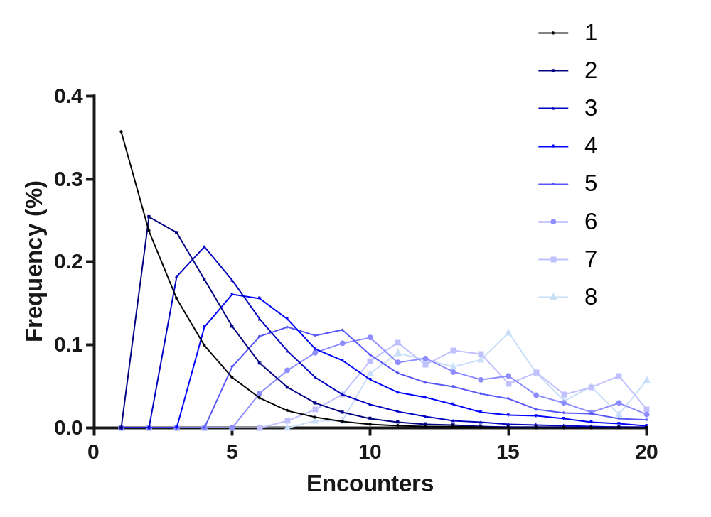
Supplemental Figure 4: Distribution of number of encounters per year by fragmentation of super-utilizers defined as the top 95th percentile of inpatient costs.
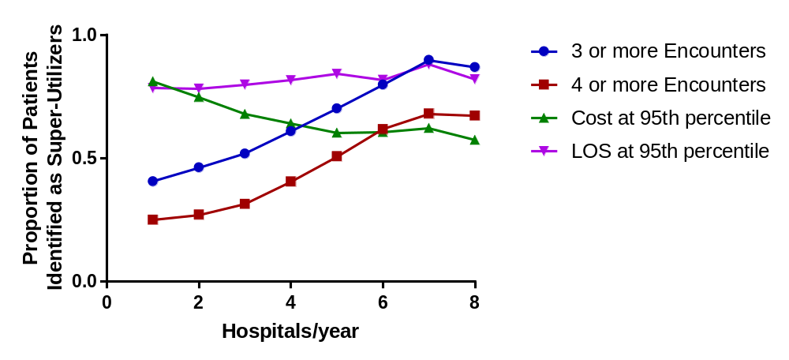

Supplemental Figure 5: Comparing 4 different single hospital methods to detect super-utilizers: 3 and 4 or more inpatient encounters, and top 5th percentile for either inpatient days or inpatient cost. We determined the likelihood that a single hospital would correctly identify a patient as a super-utilizer as defined as the top 95th percentile of yearly inpatient costs per state.

 | One Hospital | 2 or More Hospitals | Total
3 or more encounters | 0.681 (0.681 to 0.684) | 0.677 (0.675 to 0.679) | 0.696 (0.694 to 0.698)
4 or more encounters | 0.617 (0.617 yo 0.619) | 0.623 (0.620 to 0.622) | 0.625 (0.625 to 0.627)
Length of Stay > 95 percentile | 0.863 (0.862 to 0.865) | 0.813 (0.866 to 0.815) | 0.860 (0.859 to 0.861)
Yearly Cost > 95 percentile | 0.882 (0.881 to 0.883) | 0.816 (0.814 to 0.818) | 0.863 (0.862 to 0.864)

Supplemental Table 5: : Individual hospitals ability to accurately capture super-utilizers as identified as the top 95th percentile for inpatient cost C-statistic with 95% Confidence interval based on an individual patient’s maximum use at a single hospital.

Supplemental Figure 6: Prevalence rate of different categories of chronic conditions stratified by the number of hospitals admitted to in a 1 year period for super utilizers defined as the top 95th percentile of inpatient costs.

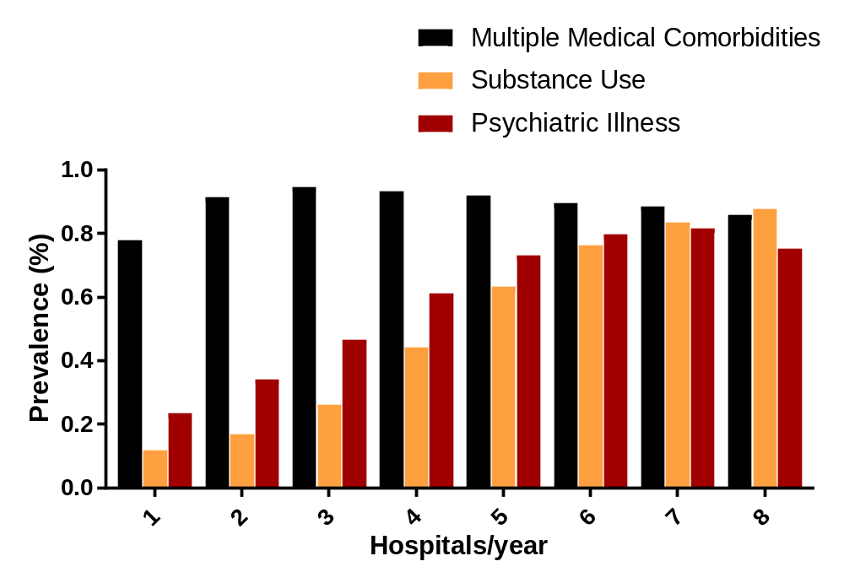

 | One Hospital |  | 2 or More Hospitals |  | Total
 | Sensitivity | Specificity | Sensitivity | Specificity | Sensitivity | Specificity
3 or more encounters | 41% | 96.03% | 48.60% | 87% | 43.82% | 95.35%
4 or more encounters | 25% | 99% | 29.17% | 95.28% | 26.66% | 98%
Length of Stay > 95 percentile | 78.35% | 94.36% | 78.75% | 84% | 78.51% | 93.58%
Yearly Cost > 95 percentile | 81.14% | 95.24% | 72.63% | 90.55% | 78.30% | 93.32%

Table 6: Sensitivity and specificity of measures to identify super utilizers from individual hospitals; Super-utilizers defined as top 95 percentile of inpatient costs.

