Supplementary Material

Bacillus cereus MHI 86 and Bacillus thuringiensis 5-29 both produce the antilisterial bacteriocin thuricin S – analysis of antimicrobial spectrum, stability, and producer strain suitability, including cytotoxicity evaluation

Saime Gülsüm Batman, Sophie Kittler, Madeleine Plötz, Gerald Dräger and Nadja Jessberger

Supplementary Tables

Supplementary Table 1: Primer sets used in this study.
Gene | Primer | Sequence (5`-3`) | Amplicon (bp) | Conditions
thuricin H  ORF | fw  rev | ATGGAAACACCAGTAGTA  ACTTGCAGTACTAGCTCC | 577  348  120 | PCR  Pre-denaturation: 60 s at 94 °C, 1 cycle  Denaturation: 30 s at 94°C  Annealing: 30 s at 42°C  Extension: 45 s at 72 °C,  35 cycles
tucA1-bmbF | fw  rev | CATAGGGAGTTATACT  CTAGCTTTTCTTTCC | 833 | Pre-denaturation: 60 s at 94 °C, 1 cycle  Denaturation: 30 s at 94°C  Annealing: 30 s at 42°C  Extension: 45 s at 72 °C,  35 cycles  RT-PCR
thuricin H  ORF | fw  rev | ATGGAAACACCAGTAGTA  ACTTGCAGTACTAGCTCC | 577  348  120 | Reverse Transcription: 1800 s at 45 °C, 1 cycle  Pre-denaturation: 300 s at 95 °C, 1 cycle  Denaturation: 30 s at 95 °C  Annealing: 30 s at 42°C  Extension: 45 s at 72 °C

Supplementary Table 2: Antibacterial activity of the CFSs of 10 B. cereus and B. thuringiensis isolates. Shown are mean values and standard deviations of the inhibition zones (in mm) as determined in agar well diffusion assays.
 |  |  |  |  | Inhibition zone (mm)
No. | Name | Species | Origin | Reference | L. monocytogenes DSM 20600 | L. monocytogenes DSM 19094 | L. innocua | E. faecalis | E. hirae | B. cereus DSM 4222
1 | MHI 86 | B. cereus | Infant food | Böhm et al., 2015; Jessberger et al., 2015 | 22.0 ± 1.0 ª | 14.3 ± 0.6 | 13.7 ± 0.6 | 12.0 ± 1.6 | 13.2 ± 0.6 | 15.7 ± 0.6
2 | MHI 3104 4.2 | B. cereus | Rice dish | Böhm et al., 2015; Jessberger et al., 2015 | 12.3 ± 1.2 ^{c} | 11.3 ± 0.6 | 10.0 ± 1.0 | 8.0 ± 1.0 | 8.0 ± 0.6 | 13.3 ± 0.6
3 | MHI 3104 8.2 | B. cereus | Rice dish | Böhm et al., 2015; Jessberger et al., 2015 | 11.7 ± 1.5 ^{c} | 11.3 ± 0.6 | 10.3 ± 0.6 | 8.2 ± 0.6 | 8.6 ± 1.0 | 12.7 ± 0.6
4 | MHI 3163 | B. thuringiensis | Salad | Schwenk et al., 2020 | 14.3 ± 0.6 ^{c} | 12.7 ± 0.6 | 11.7 ± 0.6 | 9.3 ± 0.6 | 9.0 ± 1.0 | 14.3 ± 0.6
5 | MHI 3164 | B. thuringiensis | Salad | Schwenk et al., 2020 | 14.3 ± 0.6 ^{c} | 12.3 ± 1.2 | 11.3 ± 0.6 | 9.0 ± 1.0 | 9.4 ± 0.6 | 13.3 ± 0.6
6 | MHI 271 | B. thuringiensis | Animal tissue | B. thuringiensis Berliner 1915, DSM 6029 = B. thuringiensis HD-2;  Favret & Yousten, 1989 | 13.0 ± 1.0 ^{c} | 12.7 ± 0.6 | 10.3 ± 0.6 | 8.5 ± 1.2 | 8.0 ± 0.6 | 12.7 ± 0.6
7 | BUS 1 | B. thuringiensis | Pointed pepper | unpublished | 12.0 ± 1.0 ^{c} | 11.3 ± 0.6 | 10.7 ± 0.6 | 8.3 ± 0.6 | 8.2 ± 0.6 | 11.7 ± 0.6
8 | BUS 9 | B. thuringiensis | Cheese roll | unpublished | 8.3 ± 1.2 ^{c} | 9.7 ± 0.6 | 7.3 ± 1.2 | 7.1 ± 1.2 | 7.8 ± 0.6 | 9.3 ± 0.6
9 | 5-29 | B. thuringiensis | Doughnut with custard | unpublished | 17.3 ± 0.6 ^{b} | 14.0 ± 1.0 | 13.3 ± 0.6 | 11.8 ± 0.6 | 11.0 ± 1.0 | 14.7 ± 0.6
10 | 5-336 | B. thuringiensis | Cherry tomatoes | unpublished | 12.3 ± 0.6 ^{c} | 11.7 ± 0.6 | 10.7 ± 0.6 | 8.1 ± 0.6 | 8.4 ± 0.6 | 12.3 ± 1.2

Supplementary Figures

Supplementary Figure 1

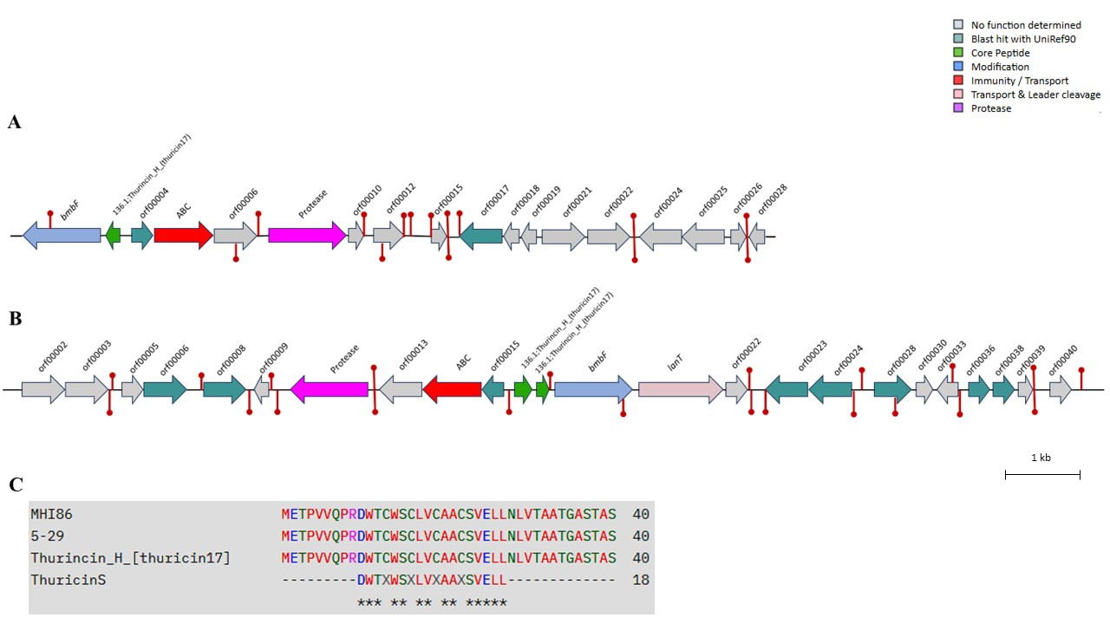

Supplementary Figure 1. Genomic organization maps of bacteriocin gene clusters and alignment of the predicted bacteriocin precursor peptide sequence with its closest match identified by BAGEL4. (A) B. cereus MHI 86; (B) B. thuringiensis 5-29; The core peptide precursor in B. cereus MHI 86 and B. thuringiensis 5-29 ABC: bacteriocin ATP-binding cassette (ABC) transporter; bmbF: post-translational modification gene; lanT: lantibiotic transporter gene, ORF: open reading frame. The scale is indicated in base pairs (bp), spanning 0 to 1000 bp. (C) Amino acid sequences of the predicted bacteriocin precursor peptides from B. cereus MHI 86 and B. thuringiensis 5-29 aligned with the reference sequences thuricin 17 (NCBI ID: WP_428884625), thurincin H (NCBI ID: FJ977580.1), and thuricin S (NCBI ID: P84763) using Clustal Omega (version 1.2.4).

Supplementary Figure 2

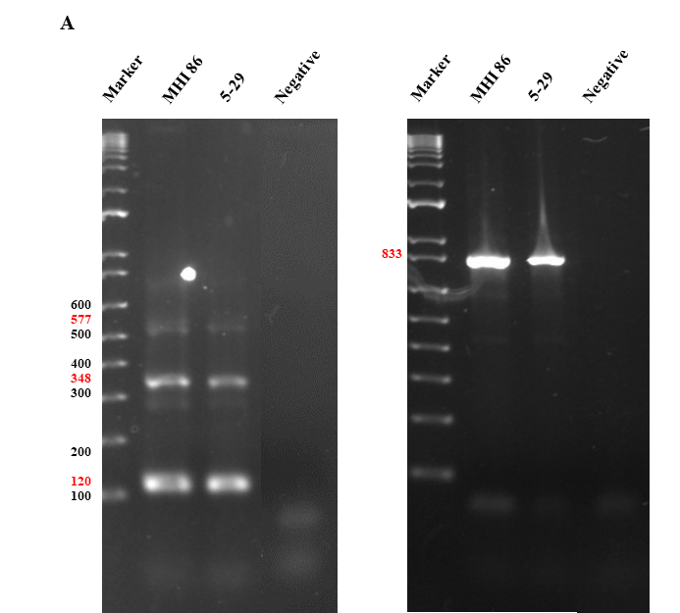

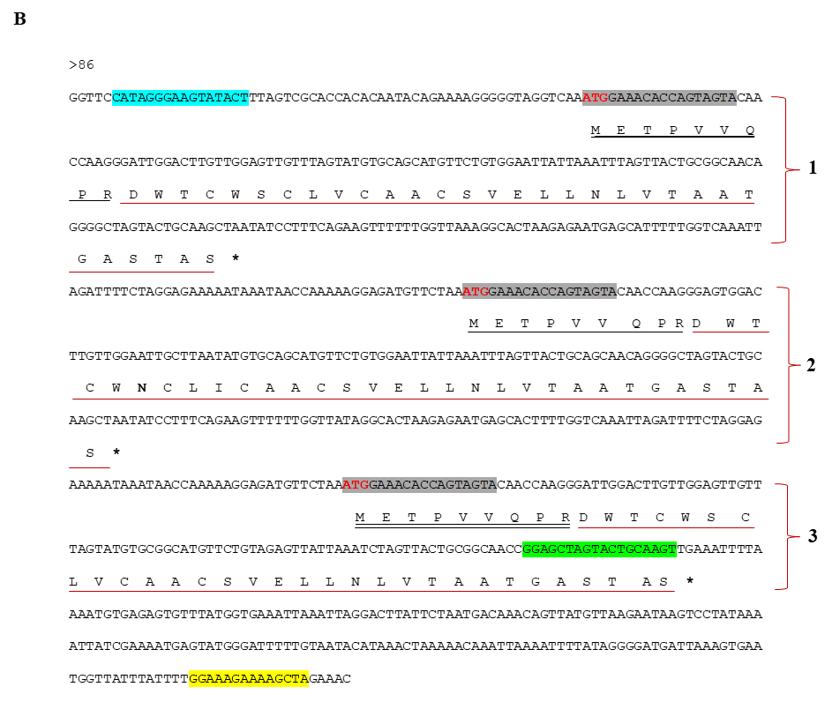

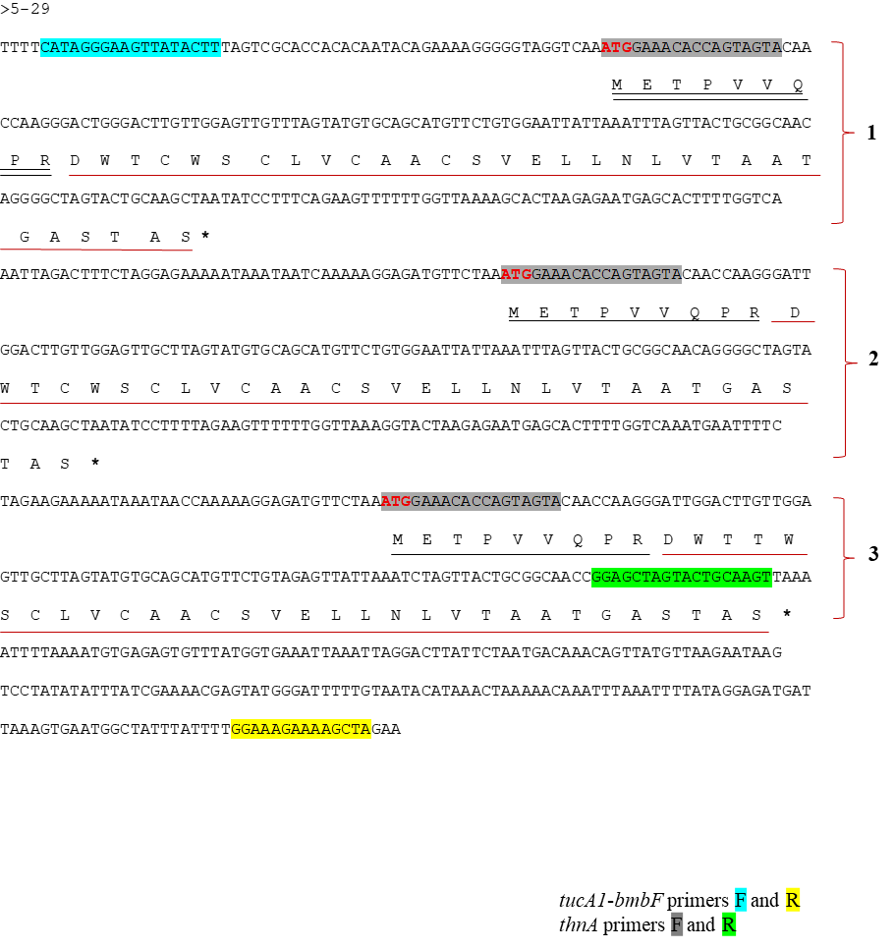

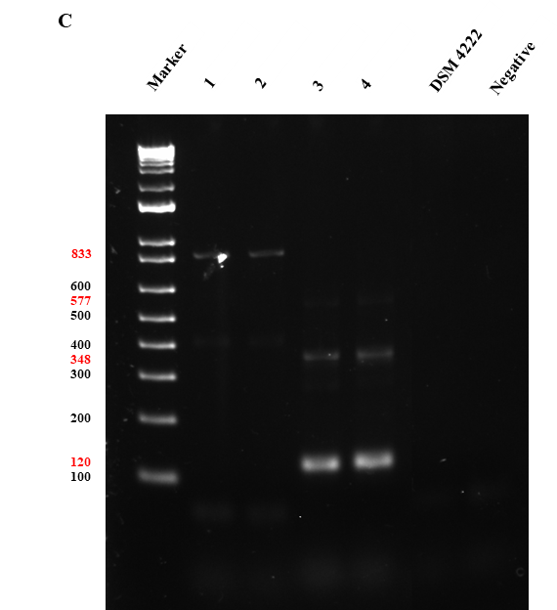

Supplementary Figure 2. Identification of the thuricin S gene region in B. cereus MHI 86 and B. thuringiensis 5-29 (A) Results of PCR using genomic DNA of strains MHI 86 and 5-29 as well as specific primers (compare Table S1) for the thuricin S encoding genes (left; 577, 348, and 120 bp amplicons) and their surrounding region (tucA1-bmbF; compare Fig. 2; right; 833 bp amplicon). Negative: non-template control. (B) Identification of nucleotide and amino acid sequences encoding tandem repeats 1, 2, and 3 of thuricin S by sequence analyses. Start codon (ATG) are showed in red. Stop codon showed with *. The leader peptide is indicated by a black line underneath, while the core peptide is drawn in red. (C) Full length control of the transcript of thuricin S in MHI 86 and 5-29 strains. 1 and 3 transcription control of the gene region in B. cereus MHI 86 with tucA1-bmbF and thnA primers, respectively. 2 and 4 transcription control of the gene region in B. thuringiensis 5-29 with tucA1-bmbF and thnA primers, respectively. DSM 4222: transcription control in B. cereus DSM 4222, Negative: non-template control.

References

Böhm, M. E., Huptas, C., Krey, V. M., & Scherer, S. (2015). Massive horizontal gene transfer, strictly vertical inheritance and ancient duplications differentially shape the evolution of Bacillus cereus enterotoxin operons hbl, cytK and nhe. BMC Evolutionary Biology, 15, 246.

Favret, M. E. & Yousten, A. A. (1989). Thuricin: The bacteriocin produced by Bacillus thuringiensis. Journal of Invertebrate Pathology, 53(2), 206-216.

Jessberger, N., Krey, V. M., Rademacher, C., Böhm, M. E., Mohr, A. K., Ehling-Schulz, M., Scherer, S. & Märtlbauer, E. (2015). From genome to toxicity: a combinatory approach highlights the complexity of enterotoxin production in Bacillus cereus. Frontiers in Microbiology, 6, 560.

Schwenk, V., Riegg, J., Lacroix, M., Märtlbauer, E., & Jessberger, N. (2020). Enteropathogenic Potential of Bacillus thuringiensis Isolates from Soil, Animals, Food and Biopesticides. Foods, 9(10), 1484.

