Supplementary File

Processing of Supplemental Technical Evidence
To capture the attached files of each submission, a secondary retrieval module was implemented to identify and aggregate those 693 supplemental documents. Utilizing an identifier mapping algorithm, a 1:1 relational link was established between each submission and its corresponding technical evidence. The system successfully retrieved 684 documents (98.7% retrieval rate); nine files were inaccessible due to server-side 404 errors at the source. Two submissions were excluded due to irrelevant content. Therefore, the final analytical census was refined to N = 682 policy-relevant submissions.
For the attached files of each submission, the PyMuPDF (Fitz) library was employed for text extraction of pdf files. For non-readable files (pdf files containing text saved as image, other text file types), the documents were manually retrieved from the specific European Commission portal, using the “Feedback ID” number to identify the specific submission link, and were transformed into readable pdfs. To prevent the data truncation common in standard database software, all extracted text underwent a process of lexical linearization. This involved the removal of non-printable control characters and the replacement of newline sequences and carriage returns with single whitespace characters. This procedure preserved the full semantic integrity of submissions while ensuring a uniform data structure for text analysis. Finally, since some submitted attachments only included a reference list, I merged the submission text (which had a 4000-character limit) with the attachment text; therefore, both texts were analyzed as one (combined) submission.

Computational Semantic Analysis
A critical architectural advantage of the LLM used (NVIDIA Nemotron-3-Ultra-550B-A55B) is its 1-million-token context window, which allows for the "lossless" processing of large documents. Unlike standard NLP models that require text truncation or extractive summarization, thereby risking the loss of significant arguments, this framework enabled the model to ingest and analyze the full semantic profile of the vast majority of submissions in a single inference pass. For the submissions exceeding 200,000 characters (n = 12), a pre-processing module utilized a sliding-window approach to analyze the documents in segments. This allowed for a lossless technical condensation (capturing the 'argumentative DNA' of the full text) to ensure total thematic representation within API constraints while preventing data loss due to context window and time-out limitations. Custom scripts compiled with Python code were prepared to interact with the LLM online.

Multilingual Semantic Integrity
Because the Nemotron-550B model is natively multilingual, the pipeline was able to process submissions containing both English and original-language text without secondary translation [15]. This approach preserved the original semantic intent and nuanced terminology of the respondents, ensuring a high degree of cross-lingual validity in the final thematic distribution.

Methodology and guidance (prompts) to determine the themes
Stage 1 involved stratified inductive thematic discovery. The 682 submissions were stratified according to the European Commission’s official stakeholder taxonomy. To maintain high-resolution attention and avoid timeout errors, the submissions were partitioned into nine batches stratified by stakeholder group (approx. 76 documents each). This was performed using Python’s random sampling and modular distribution libraries. The LLM was tasked with performing independent inductive discovery on each batch to identify 10 recurring themes within each independent segment. This minimized researcher-induced coding bias. This process yielded 90 candidate themes, ensuring that even minority stakeholder voices were represented in the initial thematic selection.
Prompt used:
“Analyze these full-text policy submissions from an EU consultation titled:
"Tobacco products and tobacco advertising – revision of EU rules".
TASK:
Identify the 10 most recurring and significant macro-themes that characterize the substantive arguments, positions, and evidence presented in this specific batch.
INSTRUCTIONS:
- Focus exclusively on the core content of the policy debate.
- Ignore administrative or procedural comments.
- Ensure themes are mutually exclusive.
- Definitions must be 2-3 sentences of professional academic description.”

Stage 2 involved hierarchical semantic synthesis. The 90 candidate themes identified in stage 1 underwent a recursive deduplication and merging process to ensure thematic parsimony while preserving technical detail. In the first step of synthesis, the 90 candidates were distilled into 19 intermediate themes. Subsequently, a "human-in-the-loop" refinement, involving researcher guidance, was utilized to merge these into 9 definitive master pillars. It should be emphasized that every pillar was defined using a neutral, dialectic framework, ensuring that the taxonomy captured the full spectrum of the consultation—encompassing both supporting and opposing arguments—without pre-judging the respondent’s stance.
Prompts used:
A. The 90 candidate themes were merged into 19 intermediate themes:
“Synthesize these 90 themes into approximately 30 high-level Master Themes for an academic paper.
Which of these Master Themes best fits the sub-theme:
Write a professional 4-sentence academic definition for: '{master_name}'.
Ensure it is neutral and dialectic.”

B. The 19 intermediate themes were merged into 9 thematic pillars:
“TASK: Synthesize these {len(data_19['taxonomy'])} high-resolution policy themes into the OPTIMAL number of Macro-Pillars (typically 7-10).
GUIDANCE PILLARS:
1. Population Health Outcomes, Cessation, Gateway Effects, and Scientific Evidence
2. Tobacco Harm Reduction vs. Total Nicotine Abstinence
3. Product Characterization, Innovation, and Consumer Appeal
4. Socio-Economic Impacts: Market Viability and Societal Costs
5. Market Dynamics: Legal Supply Chains and Illicit Trade
6. International Regulatory Frameworks and Global Policy Models
7. Regulatory Governance, Legal Process, and Proportionality
INSTRUCTIONS:
- Group the 19 themes into master pillars based on semantic and policy alignment.
- Provide a professional 4-sentence academic definition for each master pillar.
- Definitions must be neutral and dialectic (representing the tension between different policy views).
- Create a 'merging_map' showing which of the 19 theme names belong to each Master Pillar.”

Stage 3 involved thematic mapping. The full raw text (combined submission and attachment text) of all 684 documents was re-analyzed against the finalized taxonomy to generate a binary thematic matrix. The prompt directed the LLM to look for substantively relevant content through the Python script in order to classify each submission. Themes were assigned a binary value of "1" only if the respondent intentionally addressed the pillar as a functional part of their submission—defined as expressing a preference, stating a concern, or providing evidence. Passing mentions, bibliographical citations, and formal legal boilerplate were systematically assigned a "0" to preserve the integrity of the core policy findings. An additional technical audit was subsequently performed on all "zero-hit" rows, using the same LLM. This audit identified 21 institutional "false negatives", where technical jargon had been missed; these were reconciled with the final matrix. The audit and additional manual verification identified and excluded two submissions as non-substantive noise: a Greek civil service recruitment extract (Feedback ID: 33448224) and an incoherent brochure conflating tobacco policy with the film industry and unrelated leadership summits (Feedback ID: 33405655). By excluding these documents, the final analytical census was refined to N = 682 policy-relevant submissions.
Prompt used:
“INSTRUCTIONS
Analyze the DOCUMENT CONTENT below and determine if the following pillars of policy discourse are substantively relevant.
MODERATE CLASSIFICATION CRITERIA
- Assign '1' (substantively relevant): If the topic is a functional part of the submission's message. This includes expressing a preference, stating a concern, providing an opinion, or offering data. If the author is intentionally talking about this subject, mark 1.
- Assign '0' (absent/trivial): If the pillar is not mentioned, or appears only as a passing keyword (e.g., in a footer, header, or bibliography) without any accompanying thought.
PILLARS TO DETECT
{taxonomy_context}
DOCUMENT CONTENT
{text}
FINAL TASK
Review the DOCUMENT CONTENT above.
Return a JSON object where the key is the EXACT Pillar Name and the value is 1 or 0.”
Identification of Scientific and Healthcare Credentials
The following prompt was use for the LLM to determine if EU and Non-EU citizens were scientists or healthcare professionals, based on self-report in the submission.
“You are a senior credential analyst. Return ONLY valid JSON.
TASK:
Analyze the following text from a public consultation submission.
Does the author of the submission identify him/herself as a scientist, medical doctor, physician, pharmacist or other healthcare professional, or public health expert?
CRITERIA:
- 1 (Yes): Author of the submission explicitly mentions being a researcher, professor in a scientific field, MD, physician, pharmacist or other healthcare professional, or public health professional.
- 0 (No): Author of the submission is a private citizen, consumer, or does not mention these credentials, or the submission text only contains references/citations and study text without explicitly mentioning that the author of the submission has authored these studies.
FORMAT: {{"is_scientist": 1 or 0, "reasoning": "brief justification"}}
TEXT: {text}”

Determination of THR and regulatory stance
The LLM was asked to evaluate each submission for the position towards THR (anti, neutral or pro), and regulation (pro-strict, neutral or pro-flexible). The prompt was adjusted based on the main arguments relevant to each stance. The following prompt was used:
“You are a senior policy analyst. Return ONLY valid JSON.
TASK: Classify the document.
THR_STANCE (Choose one):
- PRO: Supports harm reduction, discusses benefits of switching from smoking, discusses the differences between combustible and non-combustible nicotine products, OR provides a personal story of quitting smoking via harm reduction.
- ANTI: Opposes harm reduction, discusses only about health risks of these products without discussing benefits, emphasizes nicotine addiction, or claims they are a "gateway" for youth.
- NEUTRAL: Purely descriptive, provides data without evaluation and without taking any position, or is ambiguous.
- REFERENCES_ONLY: Only if the document is strictly a list of citations/references or includes the full text of studies performed by others (not the submitter) but does not provide personal insight or opinion.

REGULATORY_STANCE (Choose one):
- pro_strict: Supports increasing restrictions, new bans, higher taxes, or stricter enforcement.
- pro_flexible: Supports "risk-proportionate" frameworks, deregulation, or lighter rules compared to combustible tobacco.
- neutral: No mention of laws or policy frameworks.
- REFERENCES_ONLY: strictly a list of citations/references.
IMPORTANT:
- If the document argues that the current rules are "too strict", it is pro_flexible.
- If it argues that current rules are "too lax" or "insufficient," it is pro_strict.

WORKFLOW:
You must think step-by-step. First, summarize the core arguments, then determine the labels.
CONFIDENCE: for the THR_STANCE, provide your confidence in the outcome, from 0% to 100%.
FORMAT:
{{
"summary": "3-5 sentence summary of the core argument",
"thr_stance": "PRO/ANTI/NEUTRAL/REFERENCES_ONLY",
"regulatory_stance": "pro_strict/pro_flexible/neutral/REFERENCES_ONLY",
"confidence": 0-100,
"short_reasoning": "Detailed justification"”

Validation
To validate the reliability of the LLM-based classification, a stratified random sample of n=68 submissions (10% of the total number, Supplementary Table 2) were manually coded by the author for THR stance, blinded to the LLM results. Precision, recall, F1-scores and Cohen’s Kappa were employed as measures of the LLM reliability. To assess the model's performance, a confusion matrix was constructed, and Precision (true positive / [true positive + false positive]), Recall (true positive / [true positive + false negative]), and F1-scores ([2 x precision x recall] / [precision + recall]) were calculated for each category (anti-THR, neutral and pro-THR) [22]. Furthermore, Cohen’s Kappa was employed to measure the inter-rater reliability between the human coder and the LLM, ensuring that the classification was not the result of random chance. Results are presented in Supplementary Table 3.
The same calculations were made for the thematic pillar validation, which was performed on the same stratified random sample by having the LLM re-run the analysis using the same prompt (mentioned above, stage 3 – thematic mapping). Results are presented in Supplementary Table 4.

Figure S1. Hierarchical structural mapping of consultation themes. The mapping illustrates the inductive-deductive pipeline where the 90 initial candidate themes were clustered into 19 technical intermediate themes, ultimately synthesized into 9 overarching Macro-Thematic Pillars for the final analysis. The number in parentheses represents that number of the 90 initial candidate themes that were integrated into each of the 19 intermediate themes.
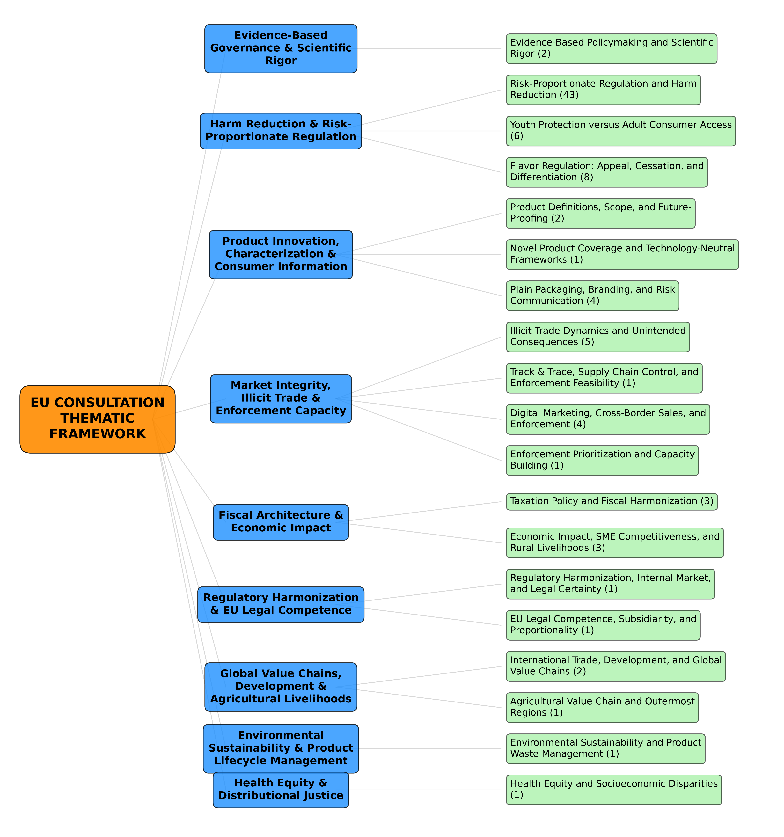
Figure S2. Thematic prevalence by stakeholder Category. This heatmap illustrates the distribution of the nine master thematic pillars across the various stakeholder groups identified in the public consultation. Percentages within each cell represent the proportion of total submissions within a specific stakeholder category that substantively addressed the corresponding pillar, as identified by the Large Language Model (Nemotron-3-Ultra-550B). The color gradient (Yellow-Green-Blue) corresponds to thematic density, where darker blue indicates a higher prevalence of the theme within that group. The stakeholder categories are ordered according to the official European Commission taxonomy, and the macro-thematic pillars are ordered by their overall prevalence across the entire corpus. Note: The final sample size (N = 682) reflects the exclusion of two non-substantive, administrative submissions identified during the technical audit phase.

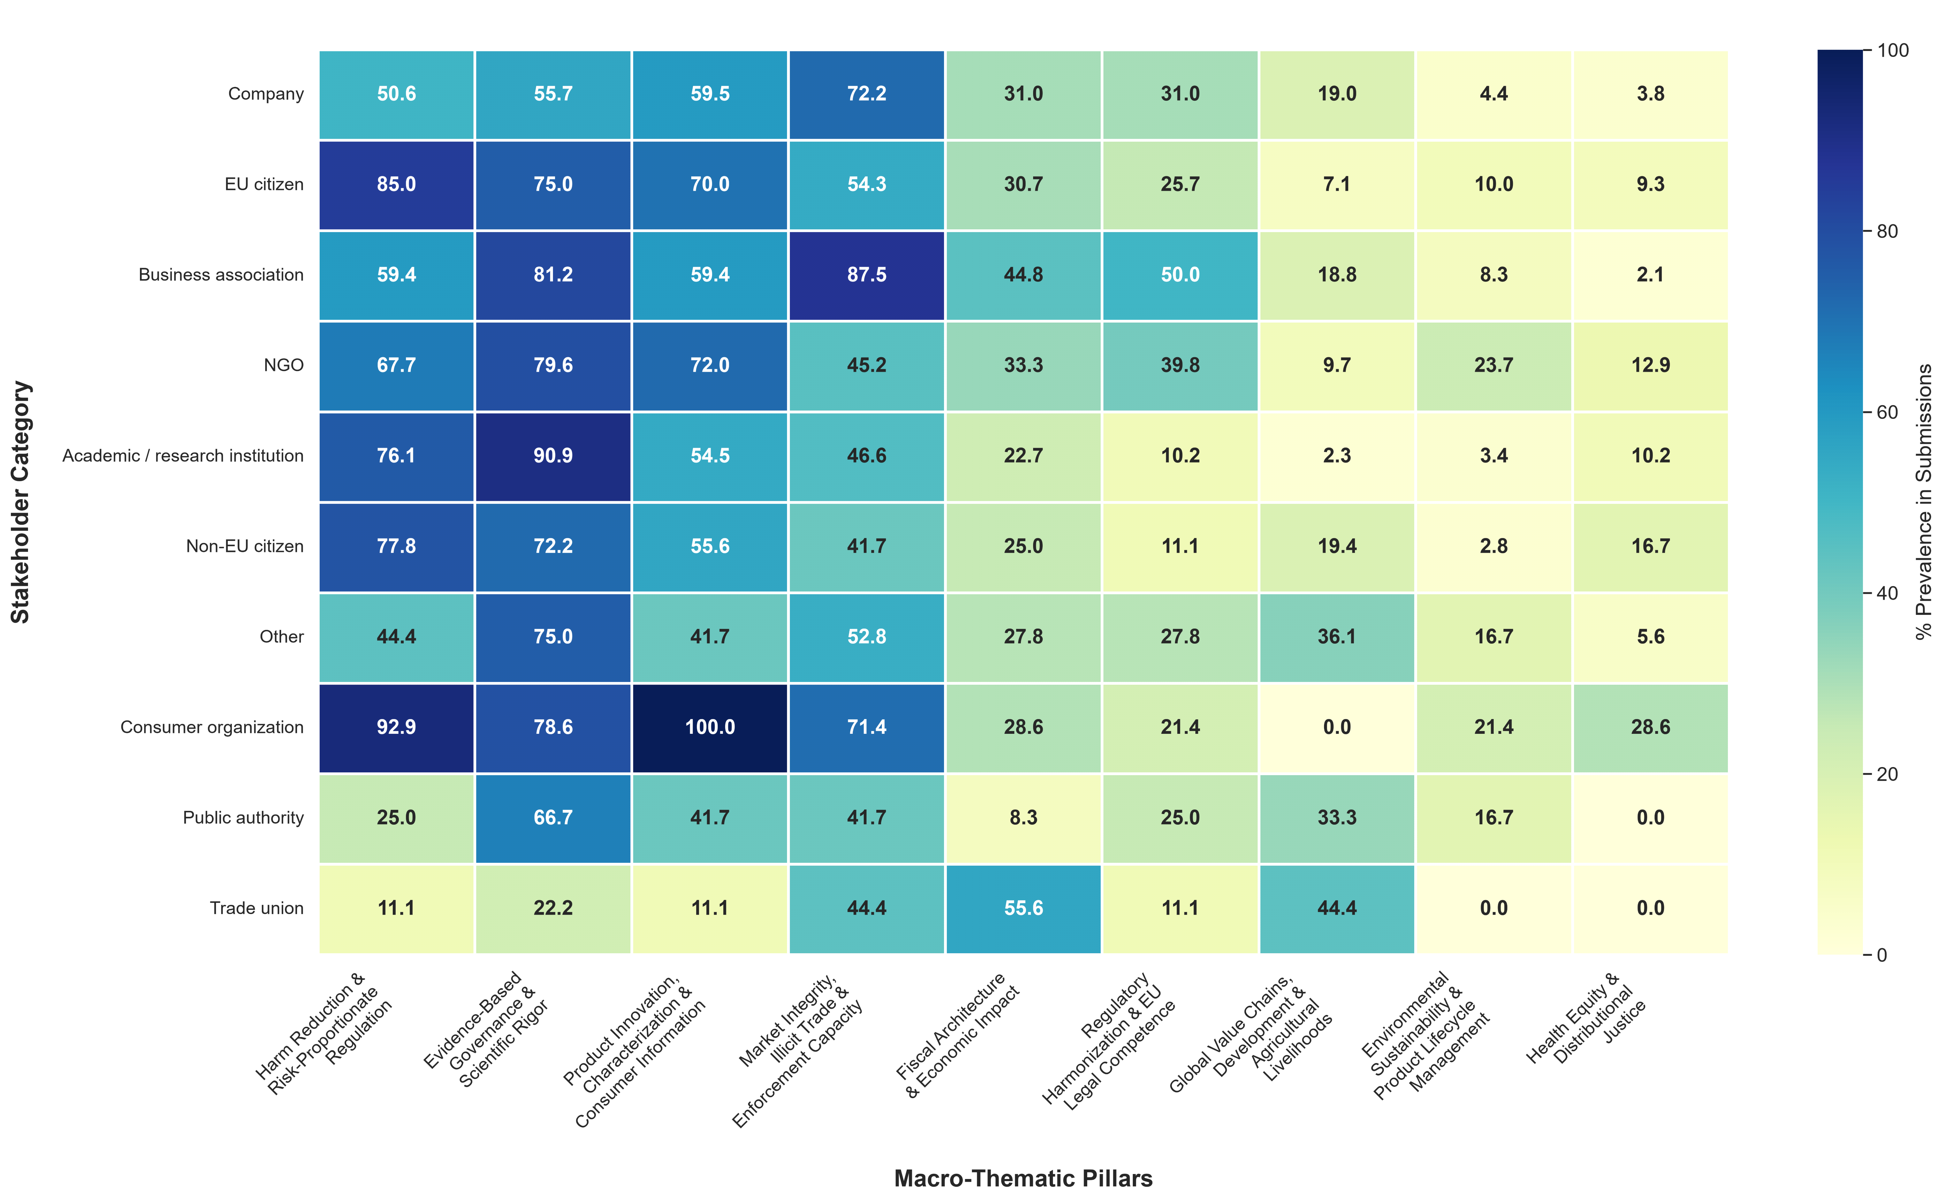

Supplementary Table 1. Global co-occurrence prevalence, the frequency with which pairs of thematic pillars were addressed within the same submission. Global co-occurrence prevalence = nr of submissions containing both themes / total nr of submissions in the dataset
 | Evidence-Based Governance & Scientific Rigor | Harm Reduction & Risk-Proportionate Regulation | Product Innovation, Characterization & Consumer Information | Market Integrity, Illicit Trade & Enforcement Capacity | Fiscal Architecture & Economic Impact | Regulatory Harmonization & EU Legal Competence | Global Value Chains, Development & Agricultural Livelihoods | Environmental Sustainability & Product Lifecycle Management | Health Equity & Distributional Justice
Evidence-Based Governance & Scientific Rigor |  | 389 (57.0%) | 365 (53.5%) | 298 (43.7%) | 163 (23.9%) | 179 (26.2%) | 46 (6.7%) | 52 (7.6%) | 52 (7.6%)
Harm Reduction & Risk-Proportionate Regulation | 389 (57.0%) |  | 344 (50.4%) | 275 (40.3%) | 153 (22.4%) | 150 (22.0%) | 31 (4.5%) | 40 (5.9%) | 53 (7.8%)
Product Innovation, Characterization & Consumer Information | 365 (53.5%) | 344 (50.4%) |  | 255 (37.4%) | 140 (20.5%) | 166 (24.3%) | 32 (4.7%) | 52 (7.6%) | 47 (6.9%)
Market Integrity, Illicit Trade & Enforcement Capacity | 298 (43.7%) | 275 (40.3%) | 255 (37.4%) |  | 176 (25.8%) | 145 (21.3%) | 61 (8.9%) | 46 (6.7%) | 39 (5.7%)
Fiscal Architecture & Economic Impact | 163 (23.9%) | 153 (22.4%) | 140 (20.5%) | 176 (25.8%) |  | 97 (14.2%) | 26 (3.8%) | 26 (3.8%) | 32 (4.7%)
Regulatory Harmonization & EU Legal Competence | 179 (26.2%) | 150 (22.0%) | 166 (24.3%) | 145 (21.3%) | 97 (14.2%) |  | 21 (3.1%) | 31 (4.5%) | 20 (2.9%)
Global Value Chains, Development & Agricultural Livelihoods | 46 (6.7%) | 31 (4.5%) | 32 (4.7%) | 61 (8.9%) | 26 (3.8%) | 21 (3.1%) |  | 8 (1.2%) | 3 (0.4%)
Environmental Sustainability & Product Lifecycle Management | 52 (7.6%) | 40 (5.9%) | 52 (7.6%) | 46 (6.7%) | 26 (3.8%) | 31 (4.5%) | 8 (1.2%) |  | 8 (1.2%)
Health Equity & Distributional Justice | 52 (7.6%) | 53 (7.8%) | 47 (6.9%) | 39 (5.7%) | 32 (4.7%) | 20 (2.9%) | 3 (0.4%) | 8 (1.2%)

Supplementary Table 2. Random selection of submissions for manual validation, stratified by stakeholder.

Stakeholder | n (%)
Company | 16 (23.5)
EU citizen | 14 (20.6)
Business association | 10 (14.7)
NGO (Non-governmental organisation) | 9 (13.2)
Academic / research institution | 8 (11.8)
Non-EU Citizen | 4 (5.9)
Other | 4 (5.9)
Consumer Organization | 1 (1.5)
Public authority | 1 (1.5
Trade union | 1 (1.5)
Total | 68 (100)

Supplementary Table 3. Precision, recall and F1-score for THR stance.

THR stance | Precision | Recall | F1-Score | N
Anti | 1 | 1 | 1 | 11
Neutral | 0.91 | 1 | 0.95 | 21
Pro | 1 | 0.94 | 0.97 | 36
Average/Total | 0.97 | 0.97 | 0.97 | 68

Supplementary Table 4. Precision, recall, F1-score and Cohen's kappa for each thematic (LLM verification).
Thematic | Precision | Recall | F1-Score | Cohen's kappa | n
Evidence-Based Governance & Scientific Rigor | 0.93 | 0.77 | 0.84 | 0.49 | 52
Harm Reduction & Risk-Proportionate Regulation | 0.92 | 0.86 | 0.89 | 0.73 | 42
Product Innovation, Characterization & Consumer Information | 0.97 | 0.80 | 0.88 | 0.74 | 41
Market Integrity, Illicit Trade & Enforcement Capacity | 0.97 | 0.83 | 0.90 | 0.76 | 42
Fiscal Architecture & Economic Impact | 0.70 | 0.80 | 0.74 | 0.63 | 20
Regulatory Harmonization & EU Legal Competence | 0.76 | 0.72 | 0.74 | 0.65 | 18
Global Value Chains, Development & Agricultural Livelihoods | 1.00 | 0.80 | 0.89 | 0.87 | 10
Environmental Sustainability & Product Lifecycle Management | 0.83 | 1.00 | 0.91 | 0.90 | 5
Health Equity & Distributional Justice | 1.00 | 1.00 | 1.00 | 1.00 | 4

