Supplemental File

Supplemental Table 1. Genotype-Phenotype Associations and Clinical Outcomes Among Children With P/LP Variants*
P/LP gene/genotype | Phenotype distribution | N | Death | Transplant | Death/HT | Death/HT %
TTN | DCM (3); RCM (3); ACM/ARVC (1) | 7 | 3 | 1 | 4 | 57.1%
MYH7 | DCM (6) | 6 | 2 | 0 | 2 | 33.3%
MYBPC3 | HCM (3); DCM (1) | 4 | 0 | 0 | 0 | 0.0%
FLNC | DCM (3) | 3 | 2 | 0 | 2 | 66.7%
PTPN11 | HCM (3) | 3 | 0 | 0 | 0 | 0.0%
RAF1 | HCM (3) | 3 | 0 | 0 | 0 | 0.0%
SLC22A5 | DCM (3) | 3 | 0 | 0 | 0 | 0.0%
BRAF | HCM (2) | 2 | 0 | 0 | 0 | 0.0%
DSP | DCM (2) | 2 | 0 | 0 | 0 | 0.0%
PRDM16 | DCM (2) | 2 | 0 | 0 | 0 | 0.0%
TNNT2 | DCM (2) | 2 | 2 | 0 | 2 | 100.0%
AGK | HCM (1) | 1 | 0 | 0 | 0 | 0.0%
ATP7B | DCM (1) | 1 | 0 | 0 | 0 | 0.0%
BAG3 | DCM (1) | 1 | 0 | 0 | 0 | 0.0%
CAST | DCM (1) | 1 | 0 | 0 | 0 | 0.0%
DSC2 | DCM (1) | 1 | 0 | 0 | 0 | 0.0%
DSG2 | HCM (1) | 1 | 0 | 0 | 0 | 0.0%
HRAS | HCM (1) | 1 | 0 | 0 | 0 | 0.0%
KCNQ1 | DCM (1) | 1 | 1 | 0 | 1 | 100.0%
LMNA | DCM (1) | 1 | 0 | 0 | 0 | 0.0%
MYL2 | DCM (1) | 1 | 0 | 0 | 0 | 0.0%
NEB | DCM (1) | 1 | 0 | 0 | 0 | 0.0%
PLN | DCM (1) | 1 | 1 | 0 | 1 | 100.0%
SGCB | DCM (1) | 1 | 0 | 1 | 1 | 100.0%
TBX20 | DCM (1) | 1 | 0 | 0 | 0 | 0.0%
TERT | DCM (1) | 1 | 0 | 0 | 0 | 0.0%
TNNI3 | RCM (1) | 1 | 0 | 0 | 0 | 0.0%
TPM1 | DCM (1) | 1 | 0 | 0 | 0 | 0.0%
*Ambiguous combined entries without separable gene-level classification were excluded from this gene-specific summary. P/LP findings reflect variants reported by the clinical diagnostic laboratory and include primary cardiomyopathy, syndromic, metabolic, and arrhythmia-associated genes when clinically relevant.

Supplemental Table 2. Patients With ≥2 Cardiomyopathy-Associated Variants and Clinical Outcomes
Phenotype | Patient-level genetic result | Reported genes | Gene-level classification | No. of reported gene variants | Clinical outcome | Death/HT event
DCM | P/LP | TTN, SGCB | LP, LP | 2 | Heart transplantation | Yes
DCM | VUS | PKP2, RPL3L, VCL | VUS, VUS, VUS | 3 | Death | Yes
DCM | VUS | TNNI3K, RAF1 | VUS, VUS | 2 | Alive without HT | No
DCM | P/LP | FLNC, RPL3L | LP, VUS | 2 | Death | Yes
DCM | VUS | TNNI3, TTN | VUS, VUS | 2 | Heart transplantation | Yes
DCM | P/LP | NEXN, AMPD1 | Not separately resolved | 2 | Alive without HT | No
DCM | VUS | RRAGD, LDB3 | VUS, VUS | 2 | Alive without HT | No
DCM | P/LP | DES, KCNQ1, TERT | VUS, P, LP | 3 | Death | Yes
DCM | P/LP | MAF, NEB, DVL1 | VUS, LP, VUS | 3 | Alive without HT | No
DCM | P/LP | BAG3, FLNC | LP, VUS | 2 | Alive without HT | No
DCM | P/LP | CAST, KLHL24 | LP, VUS | 2 | Alive without HT | No
DCM | VUS | CASQ2, RYR2 | VUS, VUS | 2 | Alive without HT | No
DCM | P/LP | MYH7, MYBPC3 | P, LP | 2 | Alive without HT | No
DCM | VUS | TMEM43, CDH2 | Not separately resolved | 2 | Alive without HT | No
DCM | P/LP | DSP, ATP7B | P, P | 2 | Alive without HT | No
DCM | VUS | TNNI3K, second VUS (source gene label unresolved) | VUS, VUS | 2 | Alive without HT | No
ACM/ARVC | VUS | PKP2, DSG2, LMOD2 | Not separately resolved | 3 | Alive without HT | No
[ACM = arrhythmogenic cardiomyopathy; ARVC = arrhythmogenic right ventricular cardiomyopathy; DCM = dilated cardiomyopathy; HT = heart transplantation; LP = likely pathogenic; P = pathogenic; VUS = variant of uncertain significance]

Supplemental Table 3. Genetic Variant Burden, Phenotypic Severity, and Clinical Outcomes
Genetic variant burden | N | Death/HT, n (%) | DCM, n | DCM Death/HT, n (%) | Median LVEF, % | Median NT-proBNP, pg/mL | DCM median LVEF, % | DCM median NT-proBNP, pg/mL
Negative/no variant | 16 | 7 (43.8) | 11 | 5 (45.5) | 33.0 | 5,430 | 22.0 | 3,920
P/LP only | 49 | 11 (22.4) | 30 | 9 (30.0) | 32.0 | 5,980 | 22.5 | 6,090
VUS only | 42 | 16 (38.1) | 33 | 12 (36.4) | 21.5 | 6,230 | 20.0 | 6,015
P/LP + VUS | 5 | 2 (40.0) | 5 | 2 (40.0) | 15.0 | 12,850 | 15.0 | 12,850
[DCM = dilated cardiomyopathy; HT = heart transplantation; LVEF = left ventricular ejection fraction; NT-proBNP = N-terminal pro-B-type natriuretic peptide; P/LP = pathogenic/likely pathogenic; VUS = variant of uncertain significance. Overall 4-group transplant-free survival: log-rank P=0.049. P/LP+VUS carriers had lower median LVEF than the remaining tested cohort (15% vs 27%; P=0.017); the DCM-only comparison was not significant (P=0.069)]

Supplemental Table 4. Imaging Characteristics According to Definitive Genetic Test Result
Measure | P/LP, n with data | P/LP value | Negative, n with data | Negative value | P value
Echo LVEF, % | 54 | 40.0 ± 25.0 | 16 | 39.3 ± 24.6 | 0.834
LVIDd, mm | 54 | 41.3 ± 16.1 | 16 | 48.6 ± 14.9 | 0.120
TAPSE, mm | 54 | 13.9 ± 3.4 | 16 | 16.1 ± 5.1 | 0.167
CMR LVEF, % | 30 | 29.7 ± 19.8 | 12 | 31.5 ± 17.7 | 0.531
CMR RVEF, % | 26 | 38.3 ± 18.3 | 11 | 37.1 ± 22.6 | 0.842
CMR RVEDVi, mL/m² | 26 | 105.3 ± 66.9 | 11 | 132.5 ± 114.7 | 0.855
LGE present, n (%) | 30 | 21 (70.0) | 12 | 6 (50.0) | 0.292
Values are mean ± SD or n (%), as appropriate. “n with data” indicates the number of children within each genetic-result group with the corresponding imaging measurement available. Patients with VUS were excluded from the P/LP-versus-negative comparison.
[CMR = cardiac magnetic resonance; LGE = late gadolinium enhancement; LVEF = left ventricular ejection fraction; LVIDd = left ventricular internal dimension in diastole; RVEDVi = right ventricular end-diastolic volume index; RVEF = right ventricular ejection fraction; TAPSE = tricuspid annular plane systolic excursion]

Supplemental Figure 1. Transplant-free survival comparing P/LP-positive and genetic-test-negative children in the overall cohort and DCM subgroup.
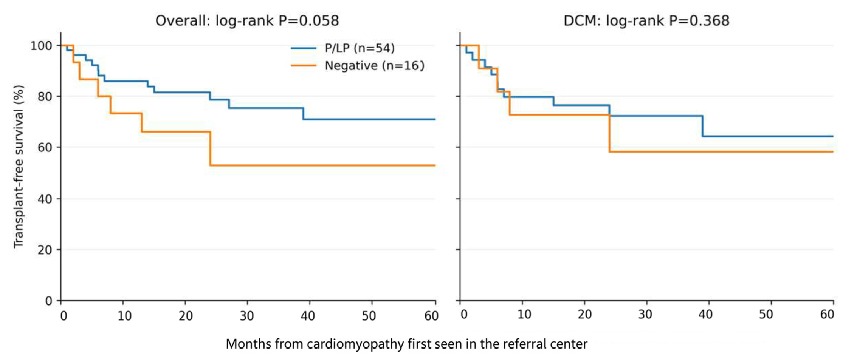
[The DCM subgroup comparison is descriptive because of the modest genetic-negative comparator group. HCM and RCM genotype-specific survival comparisons were not displayed because the genetic-negative comparator groups were too small for stable inference.]

Supplemental Figure 2. Transplant-free survival according to multiple-variant burden (≥2 reported cardiomyopathy-associated variants versus 0–1 variant).
