Supplementary material for Environmental Science and Pollution Research

Artificial consortia of Bacillus amyloliquefaciens HM618 and Bacillus subtilis for utilizing food waste to synthetize iturin A
Chang-Hao Miao ^{a,c}, Xiao-Feng Wang ^{a,c}, Bin Qiao ª, Qiu-Man Xu^{b*},Chun-Yang Cao^{a,c}, Jing-Sheng Cheng ^{a,c*}
ª Frontiers Science Center for Synthetic Biology and Key Laboratory of Systems Bioengineering (Ministry of Education), School of Chemical Engineering and Technology, Tianjin University, Yaguan Road 135, Jinnan District, Tianjin, 300350, PR China.
^{b} Tianjin Key Laboratory of Animal and Plant Resistance, College of Life Science, Tianjin Normal University, Binshuixi Road 393, Xiqing District, Tianjin 300387, People’s Republic of China.
^{c} SynBio Research Platform, Collaborative Innovation Centre of Chemical Science and Engineering (Tianjin), School of Chemical Engineering and Technology, Tianjin University, Yaguan Road 135, Jinnan District, Tianjin, 300350, PR China.
*Corresponding author: Qiu-Man Xu (qmxu0929@126.com), Jing-Sheng Cheng (Email: jscheng@tju.edu.cn)

Table S1 Strains in this study
Strains | Genotype | Source
B. subtilis WB800N | B. subtilis derivative, Neo^{r}, nprE aprE epr bpr mpr :: ble nprB :: bsr vpr wprA :: hyg | Hongsai Biological
E. coli DH5α | Host for plasmid construction | Laboratory stock
WB-L01 | WB800N derivative, carrying plasmid pHT-lip1a | This work
WB-L02 | WB800N derivative, carrying plasmid pHT-P43lip1a | This work
WB-L03 | WB800N derivative, carrying plasmid pHT-SP_{nprB}lip1a | This work
WB-L04 | WB800N derivative, carrying plasmid pHT-P43SP_{nprB}lip1a | This work
WB-L05 | WB800N derivative, carrying plasmid pHT-lip2 | This work
WB-L06 | WB800N derivative, carrying plasmid pHT-P43lip2 | This work
WB-L07 | WB800N derivative, carrying plasmid pHT-SP_{nprB}lip2 | This work
WB-L08 | WB800N derivative, carrying plasmid pHT-P43SP_{nprB}lip2 | This work
WB-L09 | WB800N derivative, carrying plasmid pHT-lipA | This work
WB-L10 | WB800N derivative, carrying plasmid pHT-P43lipA | This work
WB-L11 | WB800N derivative, carrying plasmid pHT-SP_{nprB}lipA | This work
WB-L12 | WB800N derivative, carrying plasmid pHT-P43SP_{nprB}lipA | This work
WB-A13 | WB800N derivative, carrying plasmid pHT-amyEBa | This work
WB-A14 | WB800N derivative, carrying plasmid pHT-P43amyEBa | This work
WB-A15 | WB800N derivative, carrying plasmid pHT-SP_{nprB}amyEBa | This work
WB-A16 | WB800N derivative, carrying plasmid pHT-P43SP_{nprB}amyEBa | This work
WB-A17 | WB800N derivative, carrying plasmid pHT-amyEMH | This work
WB-A18 | WB800N derivative, carrying plasmid pHT-P43amyEMH | This work
WB-A19 | WB800N derivative, carrying plasmid pHT-SP_{nprB}amyEMH | This work
WB-A20 | WB800N derivative, carrying plasmid pHT-P43SP_{nprB}amyEMH | This work

Table S2 Plamids in this study
Plasmids | Characteristics | Source
pHT43 | Expressing vector for B. subtilis, Cat^{r}, Amp^{r}, P_{garc}, SP_{amyQ} | Hongsai Biological
pHT-lip1a | pHT43 derivative, lipase gene lip1a from Pseudomonas fluorescens | Tsingke synthesis
pHT-P43lip1a | pHT-lip1a derivative, promoter replaced by P43 | This work
pHT-SP_{nprB}lip1a | pHT-lip1a derivative, signal peptide replaced by SP_{nprB} | This work
pHT-P43SP_{nprB}lip1a | pHT-lip1a derivative, promoter replaced by P43 and signal peptide replaced by SP_{nprB} | This work
pHT-lip2 | pHT43 derivative, lipase gene lip2 from Yarrowia lipolytica | Tsingke synthesis
pHT-P43lip2 | pHT-lip2 derivative, promoter replaced by P43 | This work
pHT-SP_{nprB}lip2 | pHT-lip2 derivative, signal peptide replaced by SP_{nprB} | This work
pHT-P43SP_{nprB}lip2 | pHT-lip2 derivative, promoter replaced by P43 and signal peptide replaced by SP_{nprB} | This work
pHT-lipA | pHT43 derivative, lipase gene lipA from Pseudomonas aeruginosa | Tsingke synthesis
pHT-P43lipA | pHT-lipA derivative, promoter replaced by P43 | This work
pHT-SP_{nprB}lipA | pHT-lipA derivative, signal peptide replaced by SP_{nprB} | This work
pHT-P43SP_{nprB}lipA | pHT-lipA derivative, promoter replaced by P43 and signal peptide replaced by SP_{nprB} | This work
pHT-amyEBa | pHT43 derivative, amylase gene amyEBa from Bacillus amyloliquefaciens HM618 | This work
pHT-P43amyEBa | pHT-amyEBa derivative, promoter replaced by P43 | This work
pHT-SP_{nprB}amyEBa | pHT-amyEBa derivative, signal peptide replaced by SP_{nprB} | This work
pHT-P43SP_{nprB}amyEBa | pHT-amyEBa derivative, promoter replaced by P43 and signal peptide replaced by SP_{nprB} | This work
pHT-amyEMH | pHT43 derivative, amylase gene amyEMH from Bacillus stearothermophilus | Tsingke synthesis
pHT-P43amyEMH | pHT-amyEMH derivative, promoter replaced by P43 | This work
pHT-SP_{nprB}amyEMH | pHT-amyEMH derivative, signal peptide replaced by SP_{nprB} | This work

Table S2 Plamids in this study (continiued)
Plasmids | Characteristics | Source
pHT-P43SP_{nprB}amyEMH | pHT-amyEMH derivative, promoter replaced by P43 and signal peptide replaced by SP_{nprB} | This work

Table S3 Genes of lipase and amylase
gene | strains | NCBI Number
lip1a | Pseudomonas fluoresce | CP000094.2
lipA | Pseudomonas aeruginosa | AB290342.1
lip2 | Yarrowia lipolytica | AJ012632.1
amyMH | Bacillus stearothermophilus | MG002406.1
amyEBa | B. amyloliquefaciens HM618 | CP029466.1

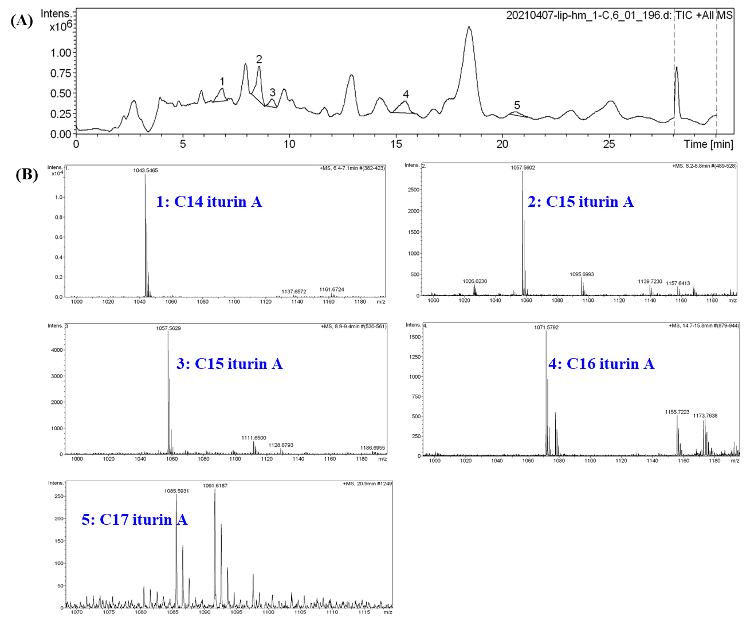
Fig. S1 HPLC-MS identification of iturin A extracts from fermentation supernatant.
(A): HPLC chromatograms of iturin A produced from B. amyloliquefaciens HM618. The numbers represent 5 peaks of iturin A. (B): MS spectrum of iturin A homologues.

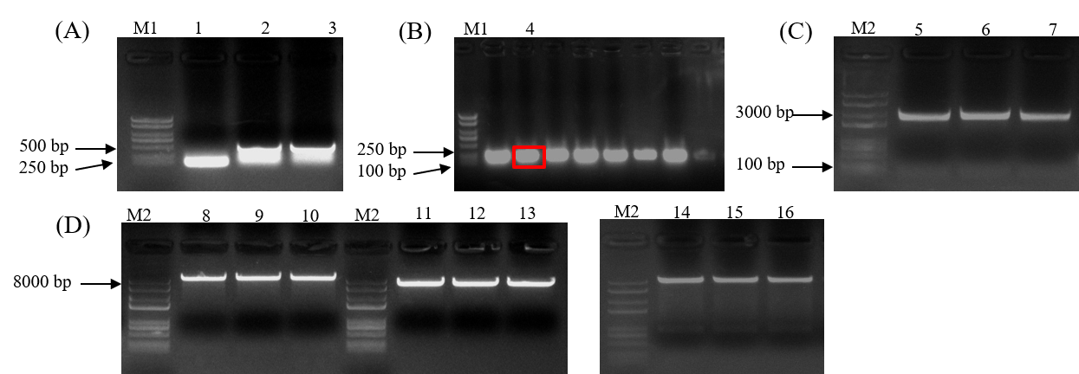
Fig. S2 The electropherogram of recombinant pHT-lip1a fragments and vectors
(A): PCR, Lane M1: BM2000+ DNA marker, Lane 1: SP_{nprB}, Lane 2: P43-SP_{amyQ}, Lane 3: P43-SP_{nprB}; (B): Colony PCR identification of recombinant vector pLB-SP_{nprB}; (C): Lane M2: BM8000 DNA marker; Lanes 5-7: Double digesting vector pLB-SP_{nprB} with Not I and BamH I; (D): Lanes 8-10: Double digesting vector pHT-lip1a with Not I and BamH I, Lanes 11-13: Double digesting vector pHT-lip1a with Sac I and Not I, Lanes 14-16: Double digesting vector pHT-SP_{nprB}lip1a with Sac I and Not I; Red frames: Correct band.

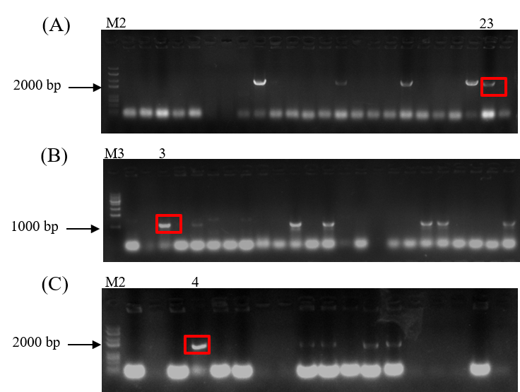
Fig. S3 The electropherogram of expression vectors with lip1a
(A): Lanes M2: BM8000 DNA marker, Colony PCR identification of recombinant vector pHT-P43lip1a; (B): Lane M3: 1 kb DNA ladder, Colony PCR identification of recombinant vector pHT-SP_{nprB}lip1a; (C): Colony PCR identification of recombinant vector pHT-P43SP_{nprB}lip1a; Red frames: Correct band.
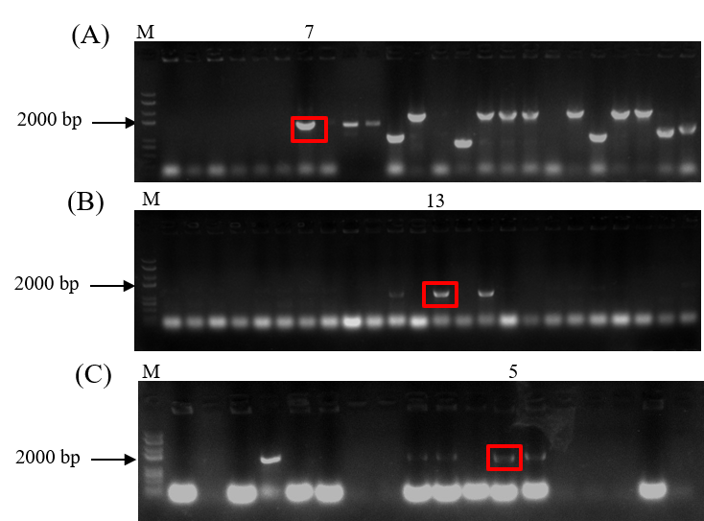
Fig. S4 The electropherogram of expression vectors with lip2
(A): Colony PCR identification of recombinant vector pHT-P43lip2; (B): Colony PCR identification of recombinant vector pHT-SP_{nprB}lip2; (C): Colony PCR identification of recombinant vector pHT-P43SP_{nprB}lip2; Lanes M: BM8000 DNA marker; Red frames: Correct band.
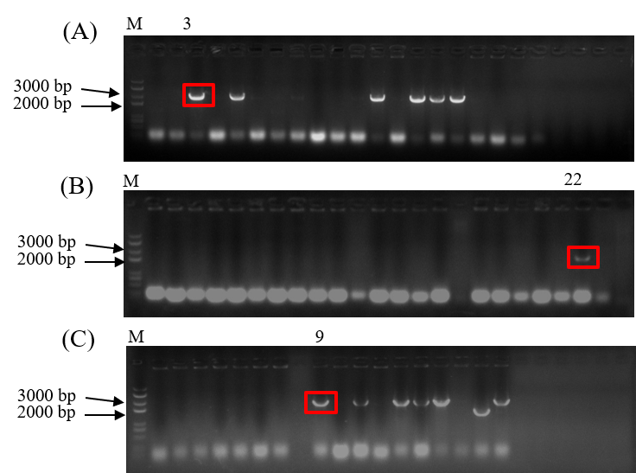
Fig. S5 The electropherogram of expression vectors with lipA
(A): Colony PCR identification of recombinant vector pHT-P43lipA; (B): Colony PCR identification of recombinant vector pHT-SP_{nprB}lipA; (C): Colony PCR identification of recombinant vector pHT-P43SP_{nprB}lipA; Lanes M: BM8000 DNA marker; Red frames: Correct band.
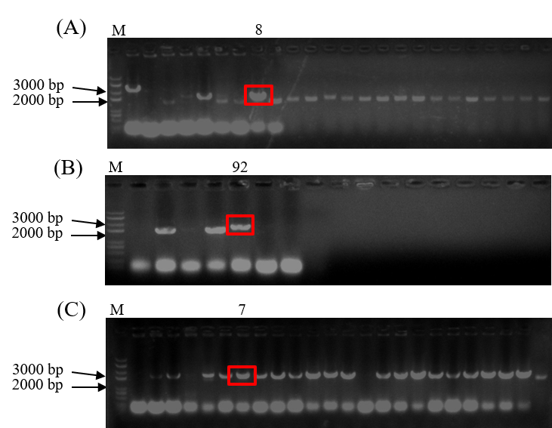
Fig. S6 The electropherogram of expression vectors with amyEMH
(A): Colony PCR identification of recombinant vector pHT-P43amyEMH; (B): Colony PCR identification of recombinant vector pHT-SP_{nprB}amyEMH; (C): Colony PCR identification of recombinant vector pHT-P43SP_{nprB}amyEMH; Lanes M: BM8000 DNA marker; Red frames: Correct band.
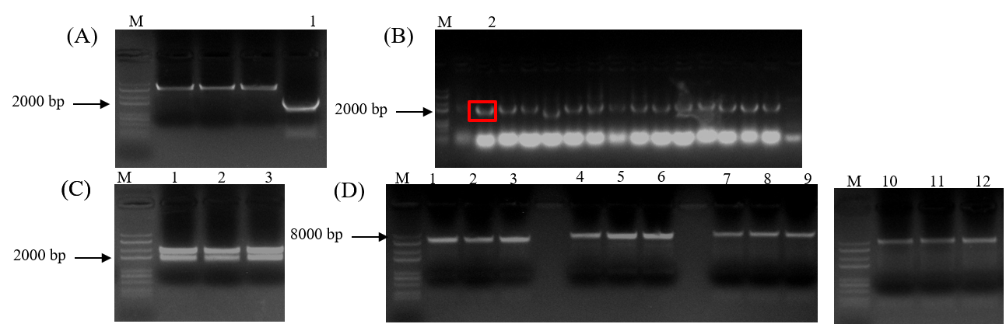
Fig. S7 The electropherogram of double digested fragments and vectors
(A): PCR of amyEBa; (B): Colony PCR identification of the vector pLB ligated fragment amyEBa; (C): Double digesting vector pLB-amyEBa with BamH I and Xba I; (D): Double digesting four pHT43 derivative vectors with BamH I and Xba I;Lanes M: BM8000 DNA marker; Red frames: Correct band.
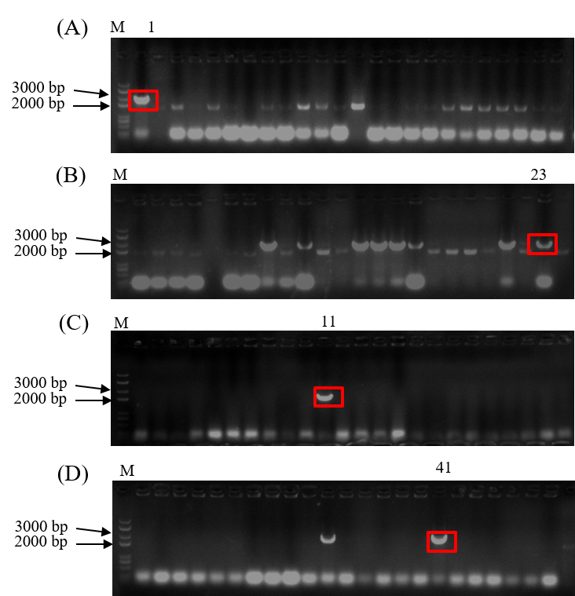
Fig. S8 The electropherogram of expression vectors with amyEBa
(A): Colony PCR identification of recombinant vector pHT-amyEBa; (B): Colony PCR identification of recombinant vector pHT-P43amyEBa; (C): Colony PCR identification of recombinant vector pHT-SP_{nprB}amyEBa; (D): Colony PCR identification of recombinant vector pHT-P43SP_{nprB}amyEBa; Lanes M: BM8000 DNA marker; Red frames: Correct band.

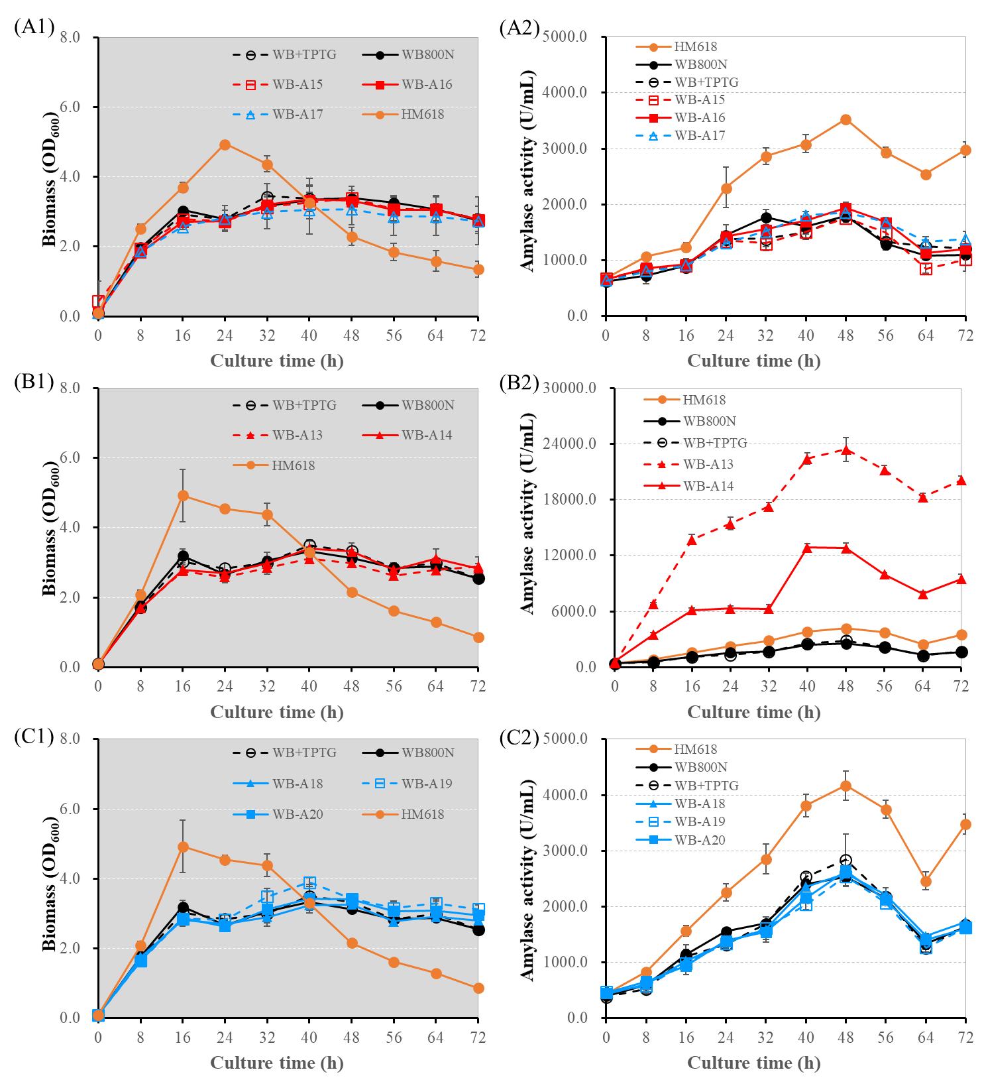
Fig. S8 Co-culture of HM618 and WB800-amyE. A1, B1, and C1: the changes of biomass (OD₆₀₀), A2, B2, and C2: the changes of amylase activity in co-culture fermentation. ○/●: Control strains, △/▲: Carrying signal peptide SP_{amyQ}, □/■: Carrying signal peptide SP_{nprB}, dotted lines: Carrying IPTG inducible promoter P_{garc}, solid line: Carrying constitutive promoter P43.

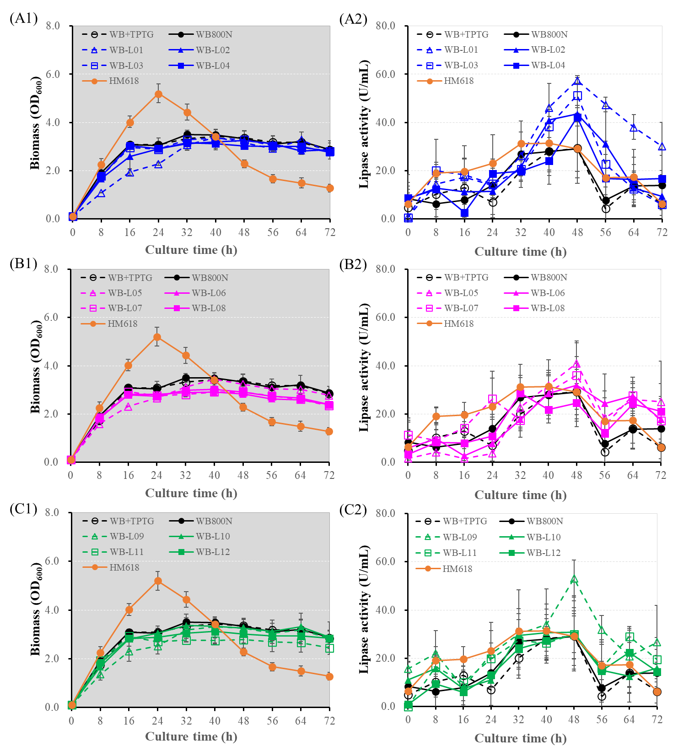
Fig. S9 Co-culture of HM618 and WB800-Lip. A1, B1, and C1: the changes of biomass (OD₆₀₀), A2, B2, and C2: the changes of lipase activity in co-culture fermentation. ○/●: Control strains, △/▲: Carrying signal peptide SP_{amyQ}, □/■: Carrying signal peptide SP_{nprB}, dotted lines: Carrying IPTG inducible promoter P_{garc}, solid line: Carrying constitutive promoter P43.
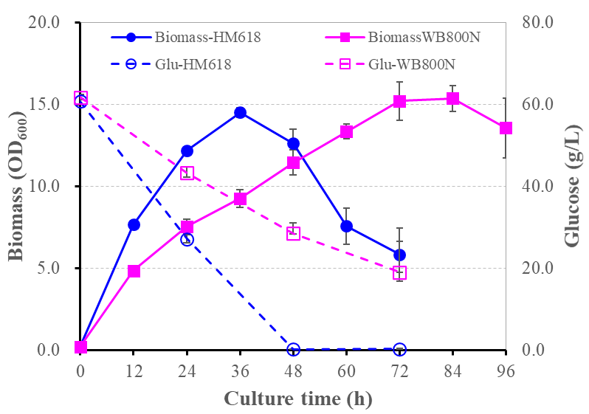
Fig. S10 Biomass and glucose consumption of HM618 and WB800N.

