Appendix Table 1 Sample characteristics

 |  | 2008 |  |  |  | 2013
 | Urban | Rural | Total |  | Urban | Rural | Total
Rural (%) | -- | -- | 73.8 |  | -- | -- | 51.3
Female (%) | 48.6 | 55.6 | 50.0 |  | 51.2 | 49.8 | 50.5
Age (%)
-14 | 11.9 | 19.6 | 17.7 |  | 13.7 | 18.0 | 16.0
15-44 | 40.3 | 43.1 | 42.3 |  | 37.1 | 34.9 | 36.0
45-64 | 33.2 | 34.0 | 28.5 |  | 31.6 | 27.5 | 33.6
65- | 16.3 | 9.8 | 11.5 |  | 16.1 | 13.1 | 14.5
Currently Married (%) | 64.4 | 60.8 | 61.7 |  | 68.6 | 64.7 | 66.8
Education (%)
No formal education | 6.1 | 14.8 | 12.9 |  | 4.3 | 14.0 | 10.3
Primary school | 24.8 | 44.8 | 39.3 |  | 23.1 | 44.9 | 36.1
Junior and high school | 61.4 | 39.9 | 42.2 |  | 62.5 | 40.4 | 44.5
Junior college and above | 7.7 | 0.7 | 5.4 |  | 10.1 | 0.6 | 9.2
Employment status (%)
Farmers | 3.7 | 51.1 | 46.9 |  | 3.2 | 52.4 | 45.7
Unemployed | 25.8 | 15.1 | 21.2 |  | 27.1 | 16.7 | 22.1
Informal employed | 23.7 | 9.1 | 19.5 |  | 30.3 | 12.0 | 17.3
Formal employed | 41.8 | 5.6 | 12.4 |  | 45.5 | 6.8 | 14.9
Household income per capita (1000RMB) ª | 11.0 (1.8) | 5.2 (1.2) | 6.6 (1.5) |  | 20.3 (3.7) | 10.2 (2.7) | 14.1 (3.2)
Health insurance status (%)
NCMS | 11.8 | 89.5 | 68.7 |  | 5.2 | 79.1 | 51.1
URRMS | -- | -- | -- |  | 5.0 | 14.9 | 9.9
URBMI | 10.6 | 0.7 | 3.8 |  | 28.1 | 2.7 | 13.2
UEBMI | 46.3 | 1.8 | 13.7 |  | 54.2 | 1.7 | 21.0
None | 31.3 | 8.0 | 12.9 |  | 7.5 | 1.6 | 4.4
N | 46,510 | 118,991 | 177,501 |  | 133,393 | 140,295 | 273,687
NCMS, New Rural Cooperative Medical Schemes; URBMI, Urban and Rural Resident-based Medical Schemes; URBMI, Urban Resident-based Basic Medical Insurance; UEBMI, Urban Employee-based Basic Medical Insurance.
ª Mean, standard deviation (SD)

Appendix Table 2 Impact of health insurance and health workforce on healthcare use with interaction terms of year before and after China’s health system reform

 | Outpatients visits (IRR) |  |  | Hospital admissions (IRR)
 | Model without interaction | Model with interaction |  | Model without interaction | Model with interaction
ARR at PHC institutions | 0.87 ***  (0.86, 0.88) | 1.33 ***  (1.20, 1.50) |  | 1.37 ***  (1.25, 1.51) | 1.41 ***  (1.25, 1.68)
ARR at county hospitals | 0.87 ***  (0.86, 0.89) | 1.12 ***  (1.07, 1.17) |  | 1.30 ***  (1.11, 1.54) | 1.34 ***  (1.19, 1.52)
Physicians density at PHC institutions | 0.98 ***  (0.97, 1.01) | 1.09 *  (0.99, 1.24) |  | 1.00  (0.99, 1.02) | 1.01**  (1.00, 1.02)
Physicians density at county hospitals | 0.66 ***  (0.65, 0.66) | 1.00  (0.98, 1.02) |  | 0.98  (0.96, 1.01) | 1.01  (0.99, 1.03)
ARR at PHC institutions × year |  | 0.97 ***  (0.95, 0.98) |  |  | 0.92 ***  (0.84, 0.99)
ARR at county hospitals × year |  | 0.87 ***  (0.86, 0.88) |  |  | 0.78 ***  (0.65, 0.91)
Physicians density at PHC institutions × year |  | 0.86 ***  (0.85, 0.88) |  |  | 0.62 ***  (0.55, 0.72)
Physicians density at county hospitals × year |  | 0.81***  (0.79, 0.82) |  |  | 0.95 ***  (0.94, 0.97)

Appendix Table 3 Impact of health insurance and health workforce on choice of healthcare providers with interaction terms of year before and after China’s health system reform

 | Healthcare providers for outpatient care (RRR) |  |  |  | Healthcare providers for inpatient care (RRR)
 | Township/  community healthcare centers | County hospitals | Municipal hospitals |  | County hospitals | Municipal hospitals | Provincial hospitals
Model without interaction
ARR at PHC institutions | 2.37***  (1.87, 3.00) | 1.34**  (1.03, 1.76) | 1.02  (0.98, 1.06) |  | 0.65 ***  (0.55, 0.76) | 0.27 ***  (0.22, 0.32) | 0.45 ***  (0.36, 0.57)
ARR at county hospitals | 1.02  (0.95, 1.08) | 1.54***  (1.14, 2.08) | 1.97***  (1.43, 2.71) |  | 1.23 ***  (1.10, 1.38) | 1.72 ***  (1.46, 2.02) | 2.14 ***  (1.78, 2.57)
Physicians density at PHC institutions | 1.53***  (1.21, 1.93) | 0.92***  (0.88, 0.96) | 0.94***  (0.91, 0.98) |  | 0.85 ***  (0.80, 0.90) | 0.78 ***  (0.73, 0.84) | 0.86 ***  (0.80, 0.92)
Physicians density at county hospitals | 0.94***  (0.91, 0.96) | 1.01  (0.99, 1.04) | 1.03**  (1.00, 1.06) |  | 1.17 ***  (1.13, 1.22) | 1.21 ***  (1.16, 1.26) | 1.23 ***  (1.17, 1.28)
Model with interaction
ARR at PHC institutions | 1.10***  (1.03, 1.16) | 0.63***  (0.61, 0.67) | 0.48***  (0.43, 0.53) |  | 0.96 ***  (0.92, 1.00) | 0.90 ***  (0.87, 0.91) | 0.84 ***  (0.80, 0.89)
ARR at county hospitals | 0.97  (0.89, 1.04) | 1.20***  (1.18, 1.21) | 1.63***  (1.61, 1.66) |  | 1.13 ***  (1.03, 1.27) | 1.29 ***  (1.28, 1.30) | 1.30 ***  (1.25, 1.35)
Physicians density at PHC institutions | 1.16*  (1.10, 1.35) | 0.68***  (0.61, 0.77) | 0.87  (0.70, 1.08) |  | 0.98 ***  (0.97, 0.99) | 1.10  (0.95, 1.16) | 0.98  (0.84, 1.01)
Physicians density at county hospitals | 1.02**  (1.00, 1.04) | 1.17***  (1.16, 1.18) | 1.20***  (1.18, 1.21) |  | 1.19 ****  (1.18, 1.20) | 1.22 ***  (1.21, 1.23) | 1.23 ***  (1.22, 1.24)
ARR at PHC institutions × year | 1.92***  (1.73, 2.12) | 3.82***  (3.27, 4.44) | 5.44***  (4.26, 7.30) |  | 0.72 ***  (0.67, 0.76) | 0.34 ***  (0.30, 0.40) | 0.67 ***  (0.61, 0.74)
ARR at county hospitals × year | 1.10  (0.87, 1.41) | 1.02  (0.78, 1.33) | 0.64***  (0.48, 0.84) |  | 0.92  (0.64, 1.30) | 0.95  (0.83, 1.10) | 1.18 ***  (1.07, 1.29)
Physicians density at PHC institutions × year | 1.08  (0.61, 1.95) | 2.21***  (1.62, 3.03) | 1.29  (0.77, 2.21) |  | 0.90 ***  (0.86, 0.96) | 0.62 ***  (0.52, 0.94) | 0.90 ***  (0.78, 1.38)
Physicians density at county hospitals × year | 0.89***  (0.84, 0.96) | 0.71***  (0.68, 0.74) | 0.68***  (0.64, 0.72) |  | 0.79 ***  (0.76, 0.83) | 0.77 ***  (0.73, 0.82) | 0.77 ***  (0.72, 0.81)

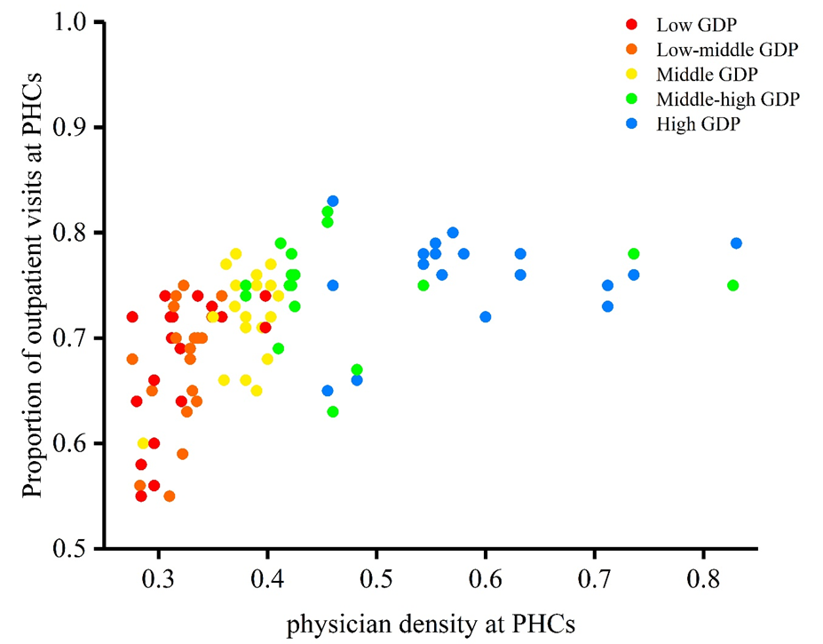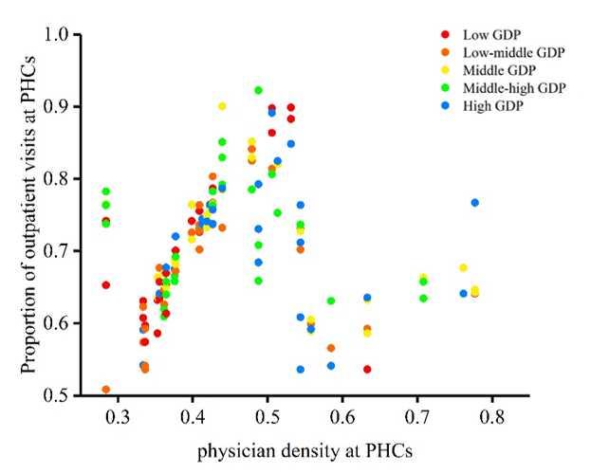
B
A

Appendix Figure 1 Comparing the proportion of outpatient visits at PHC institutions to physician density at PHC institutions by GDP group, 2008 (A) and 2013 (B)

