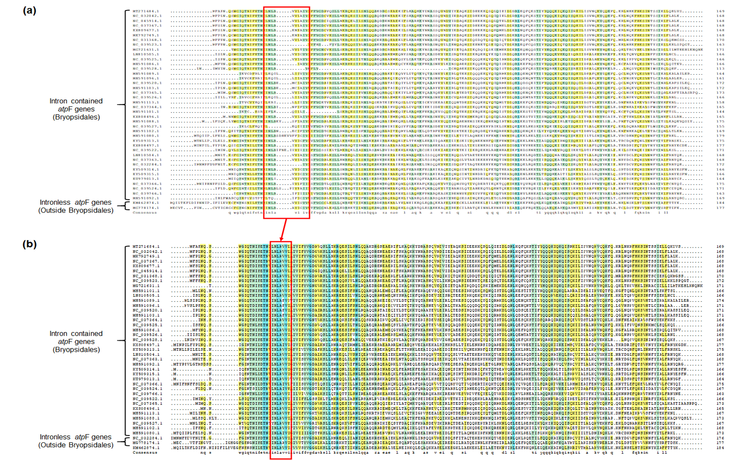
Figure S4. Comparison of multi-sequence alignments between original annotation sequences in the database (a) and amino acid sequences that deduced by adjusting the exon-intron boundaries (b) of atpF.
Figure S5. Comparison of multi-sequence alignments between original annotation sequences in the database (a) and amino acid sequences that deduced by adjusting the exon-intron boundaries (b) of ccsA (partial).

