Supplementary Information
Optimising Co-Culture Viability and Metabolic Activity
To generate meaningful molecular and functional data, it is necessary to first establish co-culture conditions which are stable and reliably support both LMCs and ASCs. As these cell types require their own specialised media with growth supplements, the media composition and cell-cell ratio will directly influence the cell viability, metabolic activity, and growth patterns(Ma et al. 2011). These parameters must be optimised before RNA sequencing and functional assays to ensure the cells are healthy without metabolic stress.
The MTT and AlamarBlue assay were used to test the cellular proliferation, viability, and metabolic activity of the co-culture conditions. For this, we tested three different seeding ratios of LMCs:ASCs (50:50, 70:30, 30:70) in five different media combinations (LMC:ASC, 50:50, 70:30, 30:70), comparing to the monoculture controls in their respective media. Once the cells reached confluency, MTT and AlamarBlue was conducted. The MTT data shows similar cell viability compared to the LMC control across all conditions, showing there is no significant changes in viability which would be indicative of cell death or stress. There was a significant reduction in cell viability in the 50:50 seeding ratio in ASC media (Figure S1(Ai)) and in the 70:30 ratio in LMC media (Figure S2(Aii)), highlighting mixed media is the most suitable for improving the viability of both cell types.
AlamarBlue analysis revealed elevated metabolic activity in co-cultures maintained in either LMC or ASC medium (Figure S1B), which may reflect mild metabolic stress or increased cellular activity under non-optimal media conditions. Overall, both assays demonstrated that LMCs and ASCs remain viable across a range of ratios and media combinations, with ASCs consistently showing lower baseline viability and metabolic activity than LMCs, consistent with previous reports(Greaney et al. 2025). Real-Time Cell Analysis using xCelligence confirmed these findings, with 30:70 ratio showed comparable growth patterns to our LMC monoculture control over 7 days growth (Figure S1C). Based on the combined results, 30:70 LMC:ASC ratio in 30:70 media was selected for subsequent direct co-culture experiments as this ratio displays high cell viability, similar growth curves, without a significant change to metabolic activity suggesting a stable environment.

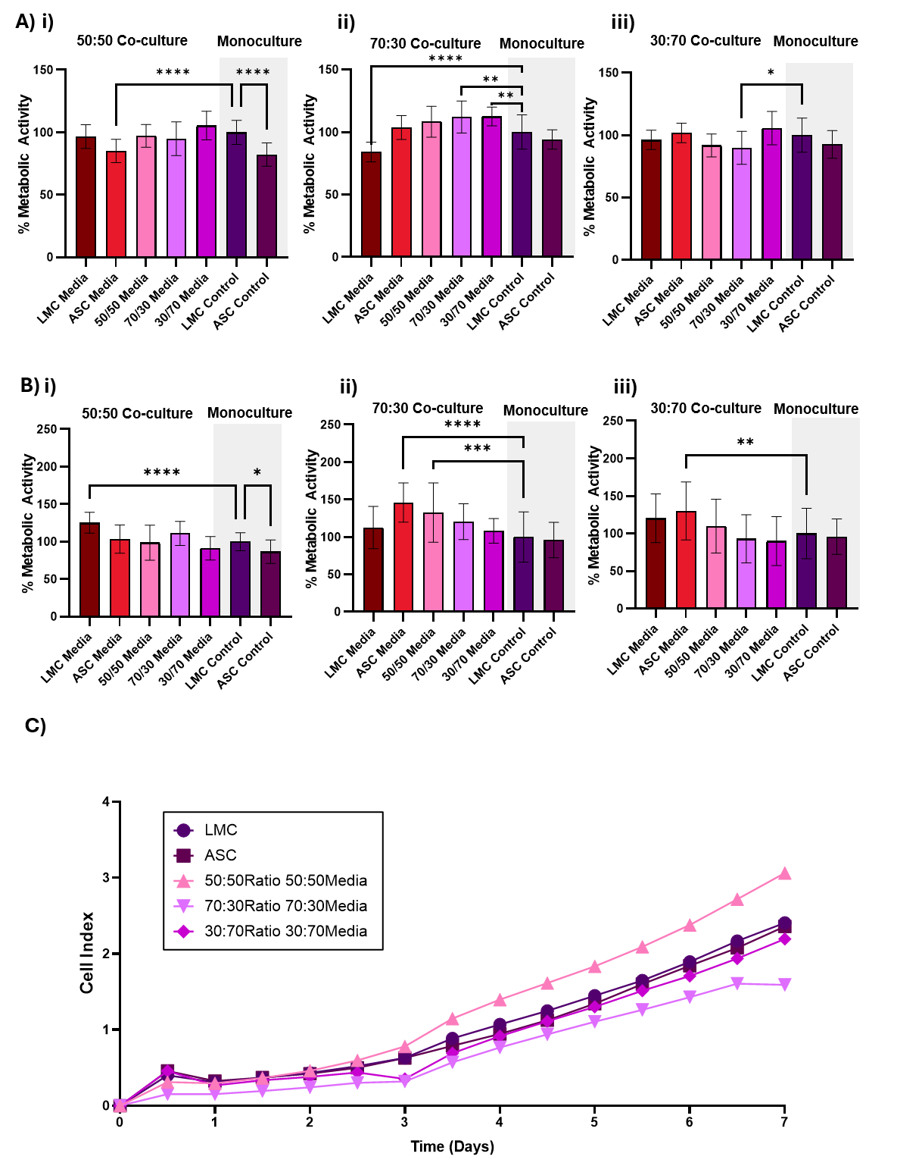
Figure S1: A) MTT data of co-culture conditions in different media combinations compared to monoculture controls – LMC cells in LMC media or ASC cells in ASC media (shaded in grey) i) 50:50 ratio of LMC:ASC ii) 70:30 ratio of LMC:ASC iii) 30:70 ratio of LMC:ASC. B) AlamarBlue data of co-culture conditions compared to monoculture in different media combinations i) 50:50 ratio of LMC:ASC ii) 70:30 ratio of LMC:ASC iii) 30:70 ratio of LMC:ASC. C) xCelligence data examining the main ratios to examine the cell growth patterns across 7 days.

Table S1: Bulk RNA Sequencing packages used within Galaxy and RStudio
Package | Version | Package | Version
AnnotationDbi | 1.64.1 | ggrepel | 0.9.6
Biobase | 2.62.0 | ggtext | 0.1.2
BiocGenerics | 0.48.1 | IRanges | 2.36.0
BiocParallel | 1.36.0 | MatrixGenerics | 1.14.0
biomaRt | 2.58.2 | matrixStats | 1.5.0
Cutadapt | Galaxy Version 5.1+galaxy0 | MultiQC | Galaxy Version 1.27+galaxy3
DESeq2 | 1.42.1 | org.Hs.eg.db | 3.18.0
devtools | 2.4.5 | pheatmap | 1.0.13
dplyr | 1.1.4 | PoiClaClu | 1.0.2.1
enrichR | 3.4 | purrr | 1.1.0
Falco | Galaxy Version 1.2.4 +galaxy0 | RColorBrewer | 1.1.3
Fastp | Galaxy Version 1.0.1+galaxy1 | readxl | 1.4.5
Flatten Collection | Galaxy Version 1.0.0 | reshape2 | 1.4.4
genefilter | 1.84.0 | S4Vectors | 0.40.2
GenomeInfoDb | 1.38.8 | SummarizedExperiment | 1.32.0
GenomicRanges | 1.54.1 | sva | 3.50.0
ggforce | 0.5.0 | tidyr | 1.3.1
ggplot2 | 4.0.3 | tidyverse | 2.0.0

Details of human patients tissue
To validate the expression of the proteins identified from the RNA sequencing data and literature, two human patient samples were used – one male and one female. These samples were obtained from the South West Dementia Brain Bank in Bristol under ethical approval.
Table S2: Details of human patient samples used for IHC
Age | Sex | Pathology Diagnosis Details | Post Mortem Delay (Hours)
69 | Male | Control | 31.25
69 | Female | Control | 38.25

Table S3: Information on the candidate markers in the study
Gene | Full Name | Core Function | Role in Meninges
BMP5 | Bone Morphogenetic Protein 5 | TGF-β family morphogen, regulates chondrogenesis, ossification, and ECM remodelling | BMP5 has been shown to be expressed in pial cells (DeSisto et al. 2020) with possible role in corticogenesis
NGFR | Nerve Growth Factor Receptor (p75NTR) | Neurotrophin signalling, apoptosis, axon guidance | Pial marker (DeSisto et al. 2020)
CRABP2 | Cellular Retinoic Acid-Binding Protein 2 | Retinoic acid transport and signalling | Crabp2 has been used an arachnoid marker (DeSisto et al. 2020; Abubaker et al. 2024)
Fibronectin | FN1 (Fibronectin 1) | ECM glycoprotein, adhesion, migration, wound repair | Widely used as a meningeal cell marker (Heck et al. 2007)
VE-cadherin | Cadherin 5 (CDH5) | Endothelial adherens junction protein | VE-Cadherin has been identified the pia and arachnoid in the meninges (Mapunda et al. 2023)
ACTA2 | Actin Alpha 2, Smooth Muscle | Contractile cytoskeleton in smooth muscle/pericytes | Acta2 is used to identify vascular smooth muscle and mural cells in meninges (Kearns et al. 2023)
GFAP | Glial Fibrillary Acidic Protein | Astrocyte intermediate filament protein | Reports of meningeal cells staining positive for GFAP (Hainfellner et al. 2001; Xin et al. 2010)
S100B | S100 Calcium Binding Protein B | Calcium-binding protein; astrocyte marker | Shown to be present in some meningioma cases (Behling et al. 2023)

Table S4: Details of primary and secondary antibodies used in the immunocytochemistry
Antibody | Species | Product Code | Primary Dilution | Product Code | Secondary Dilution
BMP5 | rabbit | bs-6614R | 1/200 | ab175471 | 1/500
NGFR | mouse | 14-9400-82 | 1/100 | ab150115 | 1/500
ACTA2 | mouse | A2547 | 1/500 | ab150115 | 1/500
GFAP | rat | 13-0300 | 1/750 | A48262 | 1/500
Fibronectin | rabbit | ab271831 | 1/500 | ab175471 | 1/1000
VE-cadherin | rabbit | ab33168 | 1/500 | ab175471 | 1/500
S100B | rabbit | ab52642 | 1/400 | ab175471 | 1/500
CRABP2 | rabbit | 10225-1-AP | 1/400 | ab175471 | 1/500

Table S5: Details of primary and secondary antibodies used in the immunohistochemistry
Antibody | Product Code | Clone | Primary Dilution | Antigen Retrieval
BMP5 | bs-6614R | Polyclonal | 1/200 | ER1 (pH6) 1AR
NGFR | 14-9400-82 | ME20.4 | 1/100 | ER1 (pH6) 1AR
ACTA2 | A2547 | 1A4 | 1/2000 | ER1 (pH6) 1AR
Fibronectin | ab271831 | F1 | 1/1000 | ER1 (pH6) 1AR
VE-cadherin | ab33168 | Polyclonal | 1/500 | ER1 (pH6) 1AR
CRABP2 | 10225-1-AP | Polyclonal | 1/400 | ER1 (pH6) 1AR

References:
Behling, F., Fodi, C., Skardelly, M., Paulsen, F., Tabatabai, G., Honegger, J., Tatagiba, M. and Schittenhelm, J. (2023) 'The prognostic role of the immunohistochemical expression of S100 in meningiomas', Journal of Cancer Research and Clinical Oncology, 149(7), 2975-2985.

Greaney, A.J., Abubaker, M., McCarthy, C.M., Reardon, E.C. and Mulvihill, J.J.E. (2025) 'Mechanical contrast between brain and leptomeninges: Insights into leptomeningeal cell and astrocyte responses to mechanical stiffness alterations', Acta Biomaterialia.

Heck, N., Garwood, J., Dobbertin, A., Calco, V., Sirko, S., Mittmann, T., Eysel, U.T. and Faissner, A. (2007) 'Evidence for distinct leptomeningeal cell-dependent paracrine and EGF-linked autocrine regulatory pathways for suppression of fibrillar collagens in astrocytes', Molecular and Cellular Neuroscience, 36(1), 71-85.

Ma, J., van den Beucken, J.J.J.P., Yang, F., Both, S.K., Cui, F.-Z., Pan, J. and Jansen, J.A. (2011) 'Coculture of osteoblasts and endothelial cells: optimization of culture medium and cell ratio', Tissue Engineering Part C: Methods, 17(3), 349-357.

