Supplement
Drug quantification in single 3D organoids reveals correlation to reported in vivo brain uptake and demonstrates translational relevance for prediction of blood-brain barrier permeability
Cindy Bay¹, Meike Kästing¹, Jiayi Chu¹, Eric Mühlberg^{2,3}, Camilo Scherkl¹, Philipp Uhl^{3,4}, Julia Carolin Stingl¹, Jürgen Burhenne¹, Gzona Bajraktari-Sylejmani¹, Max Sauter^{1,†}, Johanna Weiss^{1 ,†, *}

Supplement Table S1: Mass spectrometry and chromatography parameters for analyzed drugs
Parameter mass spectrometry | Fluoxetine ([²H₆]-Fluoxetine)
MRM-transition [m/z]  Capillary voltage  Cone voltage  Dwell time  Collision energy  Collision gas flow (Ar) | 309.9 → 43.8 (315.8 → 43.8)  0.2 kV  2 V  79 ms  6 V  0.05 mL/min
Chromatography
Column | ACQUITY® UPLC® BEH C18 column (1.7 µm, 2.1 × 50 mm)
Column temperature | 40 °C
Aqueous eluent A | H₂O/ACN (95/5, v/v) + 0.1 % FA
Organic eluent B | ACN + 0.1% FA
Flow rate | 0.5 mL/min
Injection modus | Full loop (20 µL)
Gradient | 0-0.5 min: 10% eluent B
 | 0.5 – 2.0 min: increase to 90% eluent B
2.0 – 2.5 min: 90% eluent B
2.5 – 3.0 min: decrease to 10% eluent B
3.0 – 3.5 min: 10% eluent B
Parameter mass spectrometry | Octreotide ([¹³C₆]-Octreotide)
MRM-transition [m/z]  Capillary voltage  Cone voltage  Dwell time  Collision energy  Collision gas flow (Ar) | 510.2 → 119.9 (513.2 → 119.9)  0.7 kV  10 V  25 ms  30 V  0.15 mL/min
Chromatography
Column | ACQUITY® Premier Peptide BEH C18 (1.7 µm, 2.1 × 50 mm)
Column temperature | 60 °C
Aqueous eluent A | H₂O/ACN (95/5, v/v) + 0.1% FA
Organic eluent B | ACN + 0.1% FA
Flow rate | 0.5 mL/min
Injection modus | Full loop (20 µL)
Gradient | 0 – 0.1 min: 5% eluent B
 | 0.1 – 2.5 min: increase to 20% eluent B
2.5 – 2.7 min: increase to 95% eluent B
2.7 – 3.2 min: 95% eluent B
3.2 – 3.4 min: decrease to 5% eluent B
3.4 – 3.7 min: 5% eluent B
Parameter mass spectrometry | Olaparib ([²H₄]-Olaparib)
MRM-transition [m/z]  Capillary voltage  Cone voltage  Dwell time  Collision energy  Collision gas flow (Ar) | 435.4 → 281.1 (439.4 → 367.2)  3 kV  28 V  63 ms  24 V (14 V)  0.15 mL/min
Chromatography
Column | ACQUITY® UPLC® BEH C18 column (1.7 µm, 2.1 × 50 mm)
Column temperature | 40 °C
Aqueous eluent A | H₂O/ACN (95/5, v/v) + 0.1% FA
Organic eluent B | ACN + 0.1% FA
Flow rate | 0.5 mL/min
Injection modus | Full loop (20 µL)
Gradient | 0-0.5 min: 5% eluent B
 | 0.5 – 2.0 min: Increase to 95% eluent B
2.0 – 2.5 min: 95% eluent B
2.5 – 3.0 min: decrease to 5% eluent B
3.0 – 3.5 min: 5% eluent B
Parameter mass spectrometry | Paroxetine (Diazepam)
MRM-transition [m/z]  Capillary voltage  Cone voltage  Dwell time  Collision energy  Collision gas flow (Ar) | 330.16 → 70.13 (285.16 → 154.12)  0.5 kV  12 V (24 V)  25 ms  26 V (26 V)  0.15 mL/min
Chromatography
Column | ACQUITY® UPLC® BEH C18 column (1.7 µm, 2.1 × 50 mm)
Column temperature | 40 °C
Aqueous eluent A | H₂O/ACN (95/5. v/v) + 0.1% FA
Organic eluent B | ACN + 0.1% FA
Flow rate | 0.5 mL/min
Injection modus | Full loop (20 µL)
Gradient | 0-0.1 min: 10% Eluent B
 | 0.1 . 2.5 min: increase to 50% eluent B
2.5 – 2.6 min: increase to 95% eluent B
2.6 – 2.8 min: 95% eluent B
2.8 – 3.0 min: decrease to 10% eluent B
3.0 – 3.1 min: 10% eluent B
Parameter mass spectrometry | Selinexor ([²H₆]-Ulixertinib)
MRM-transition [m/z]  Capillary voltage  Cone voltage  Dwell time  Collision energy  Collision gas flow (Ar) | 444.1 → 334.1 (439.1 → 220.1)  3 kV  36 V  108 ms  18 V  0.15 mL/min
Chromatography
Column | ACQUITY® UPLC® BEH C18 column (1.7 µm, 2.1 × 50 mm)
Column temperature | 40 °C
Aqueous eluent A | H₂O/ACN (95/5. v/v) + 0.1% FA
Organic eluent B | ACN + 0.1% FA
Flow rate | 0.5 mL/min
Injection modus | Full loop (20 µL)
Gradient | 0-0.5 min: 30% eluent B
 | 0.5 – 3.0 min: increase to 70% eluent B
3.0 – 3.5 min: 95% eluent B
3.5 – 4.0 min: 30% eluent A
Parameter mass spectrometry | Senicapoc (Lorlatinib)
MRM-transition [m/z]  Capillary voltage  Cone voltage  Dwell time  Collision energy  Collision gas flow (Ar) | 324.2 → 122.03 (407.3 → 149.0)  3 kV  14 V (28 V)  21 ms  36 V (20 V)  0.15 mL/min

Chromatographie
Column | ACQUITY® UPLC® BEH C18 column (1.7 µm, 2.1 × 50 mm)
Column temperature | 40 °C
Aqueous eluent A | H₂O/ACN (95/5, v/v) + 0.1% FA
Organic eluent B | ACN + 0.1% FA
Flow rate | 0.5 mL/min
Injection modus | Full loop (20 µL)
Gradient | 0-0.5 min: 5% eluent B
 | 0.5 – 1.5 min: increase to 95% eluent B
1.5 – 2.0 min: 95% eluent B
2.0 – 2.5 min: 5% eluent B
2.5 – 3.0 min: 5% eluent B
Parameter mass spectrometry | Temsirolismus ([¹³C₃, ²H₇]-Temsirolismus)
MRM-transition [m/z]  Capillary voltage  Cone voltage  Dwell time  Collision energy  Collision gas flow (Ar) | 1052.4 → 461.1 (1062.5 → 471.2)  3 kV  62 V  80 ms  56 V  0.15 mL/min
Chromatography
Column | ACQUITY® UPLC® BEH C18 column (1.7 µm, 2.1 × 50 mm)
Column temperature | 60 °C
Aqueous eluent A | H₂O/ACN (95/5, v/v) + 0.1% FA
Organic eluent B | ACN + 0.1% FA
Flow rate | 0.5 mL/min
Injection modus | Full loop (20 µL)
Gradient | 0-0.5 min: 50% eluent B
 | 0.5 – 3.0 min: increase to 95% eluent B
3.0 – 3.5 min: 95% eluent B
3.5 – 4.0 min: 50% eluent B
Parameter mass spectrometry | Ulixertinib ([²H₆]-Ulixertinib)
MRM-transition [m/z]  Capillary voltage  Cone voltage  Dwell time  Collision energy  Collision gas flow (Ar) | 433.1 → 262.1 (439.1 → 268.2)  0.5 kV  40 V  80 ms  16 V  0.15 mL/min
Chromatography
Column | ACQUITY® UPLC® BEH C18 column (1.7 µm, 2.1 × 50 mm)
Column temperature | 40 °C
Aqueous eluent A | H₂O/ACN (95/5, v/v) + 0.1% FA
Organic eluent B | ACN + 0.1% FA
Flow rate | 0.5 mL/min
Injection modus | Full loop (20 µL)
Gradient | 0-0.5 min: 5% eluent B
 | 0.5 – 2.0 min: increase to 98% eluent B
2.0 – 2.5 min: 98% eluent B
2.5 – 3.0 min: 5% eluent B

Parameter mass spectrometry | drug (IS) | Collision energy [V]
MRM-transition [m/z]  Repotrectinib  Selitrectinib  Futibatinib  Lorlatinib  Larotrectinib  Capillary voltage  Cone voltage  Dwell time  Collision gas flow (Ar) | 356 → 161 (425 → 302 [²H₆]-Futibatinib)  381 → 202 (425 → 302 [²H₆]- Futibatinib)  419 → 296 (425 → 302 [²H₆]- Futibatinib)  407 → 228 (411 → 228 [²H₃,¹³C₁]-Lorlatinib)  429 → 342 (433 → 342 [²H₄]-Larotrectinib)  1 kV  20 V  29 ms  0.15 mL/min | 22 (22)  32 (22)  22 (22)  15 (15)  29 (29)
Chromatography
Column | ACQUITY® UPLC® BEH C18 column (1.7 µm, 2.1 × 50 mm)
Column temperature | 60 °C
Aqeaus eluent A | H₂O/ACN (95/5, v/v) + 0.1% FA
Organic eluent B | ACN + 0.1% FA
Flow rate | 0.5 mL/min
Injection modus | Full loop (20 µL)
Gradient | 0 - 0.1 min: 5% eluent B  - 2.3 min: 45% eluent B
2.3 – 2.5 min: increase to 95% eluent B
2.5 - 2.8 min: 95% eluent B
2.8 – 3.0 min: decrease to 5% eluent B
3.0 – 3.3 min: 5% eluent B

All drugs were quantified in positive ion mode. The cone gas flow was 150 L/h, the source temperature 150 °C, the desolvation gas flow (N₂) 1000 L/h and the desolvation temperature 600 °C.

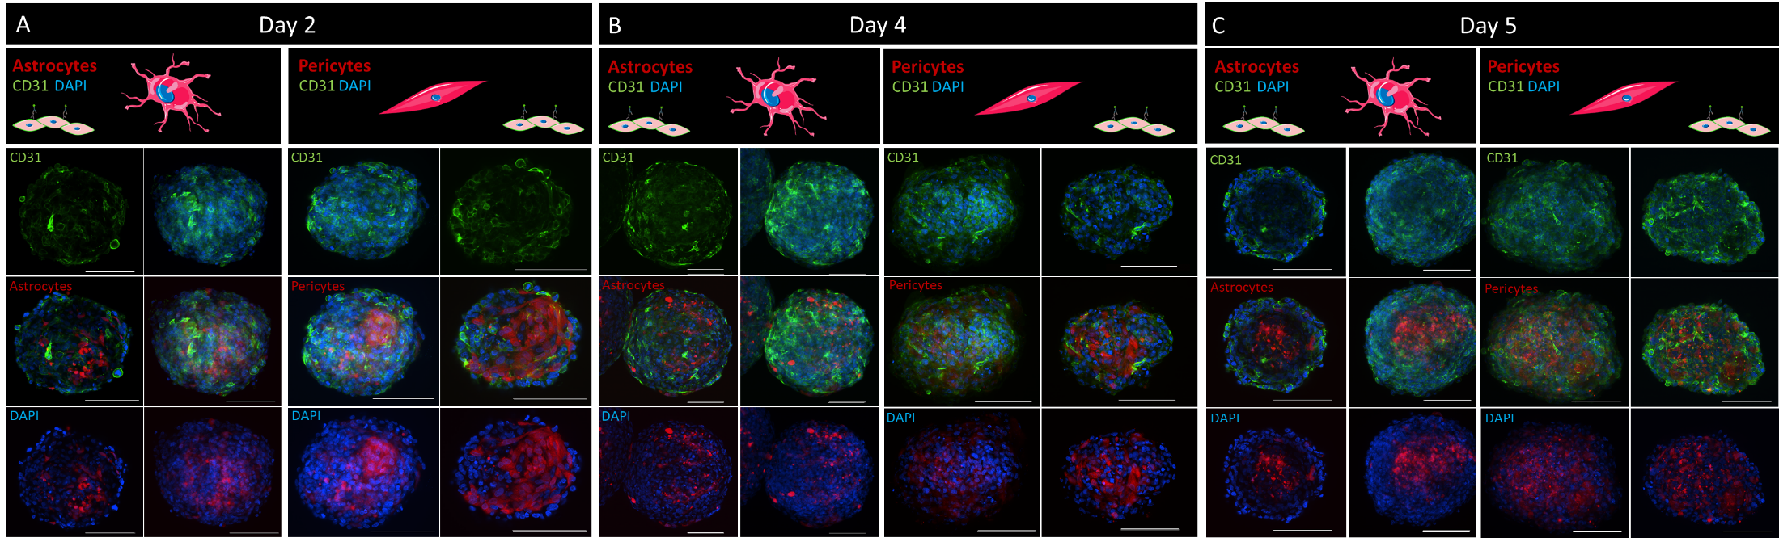
Supplementary Figure S1: Representative CLSM images over culture time on A day 2 B day 4 and C on day 5 after assembly. See main manuscript for selected analysis time point day 3. Either pericytes or astrocytes were stained with CellTrackerTM in red as indicated in the respective panel. hCMEC/D3 were stained with the CD31-antibody (green). Cell nuclei are labeled with DAPI (blue). The middle panels of each day depict the z-projections. Right and left side show the z-slices. Different channel combinations are depicted as indicated in the images. All images are representative for at least three independent organoid preparations. Scale bar = 100 µm. Cell illustrations taken and adapted from Smart Servier.

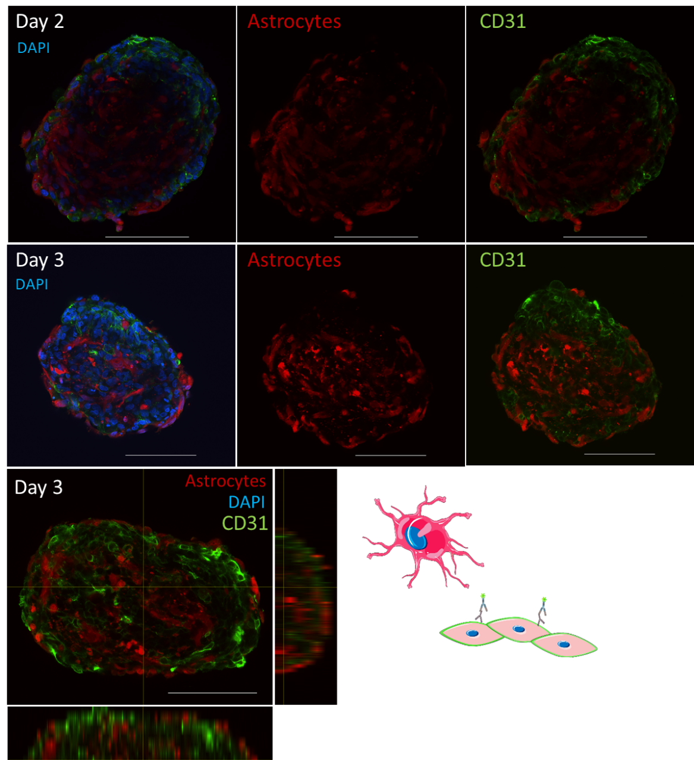
Supplementary Figure S2: Representative CLSM images of astrocytes located outside the organoid cover in some organoid preparations. All nuclei were labeled with DAPI (blue). Scale bar = 100 µm. Cell illustrations taken and adapted from Smart Servier.

Supplementary Table S2: Validation results for ᴅ-Tyr(Me)Orn in organoid matrix
Organoid matrix |  | LLOQ | low QC | mid QC | high QC
 |  | 0.050 ng/mL | 0.150 ng/mL | 112.5 ng/mL | 225 ng/mL
Intraday
1 | mean [ng/mL] | 0.047 | 0.144 | 100.6 | 195.76
 | accuracy [%] / precision [% CV] | 93.7/11.3 | 95.9/4.92 | 89.4/2.89 | 87.0/9.48
2 | mean [ng/mL] | 0.049 | 0.14 | 99.2 | 195.7
 | accuracy [%] / precision [% CV] | 97.0/8.32 | 93.3/8.42 | 88.2/3.35 | 87.0/5.28
3 | mean [ng/mL] | 0.050 | 0.147 | 107.0 | 198.4
 | accuracy [%] / precision [% CV] | 99.5/13.9 | 97.9/4.07 | 95.1/3.56 | 88.2/4.89
Interday
 | mean [ng/mL] | 0.048 | 0.144 | 102.3 | 196.5
 | accuracy [%] / precision [% CV] | 96.4/10.5 | 95.7/6.01 | 90.9/4.62 | 87.3/6.56
Precision [% CV]; accuracy [% nominal value] LLOQ: lower limit of quantification; QC: quality control. n = at least four replicates.
 | mid QC  112.5 ng/mL | high QC  225 ng/mL
Matrix effect [%] | 111.8 | 114.5
Recovery [%] | 85.6 | 85.4
IS: internal standard, QC: quality control. n = three replicates per QC-Level.

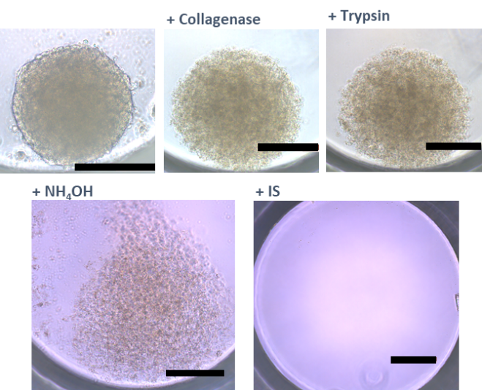
Supplementary Figure S3: Representative light microscopy images of organoid lysis. Stepwise images of organoid lysis, starting with enzymatic digestion by collagenase and trypsin, followed by cell lysis with aqueous ammonia solution and addition of IS. Scale bar = 200 µm.

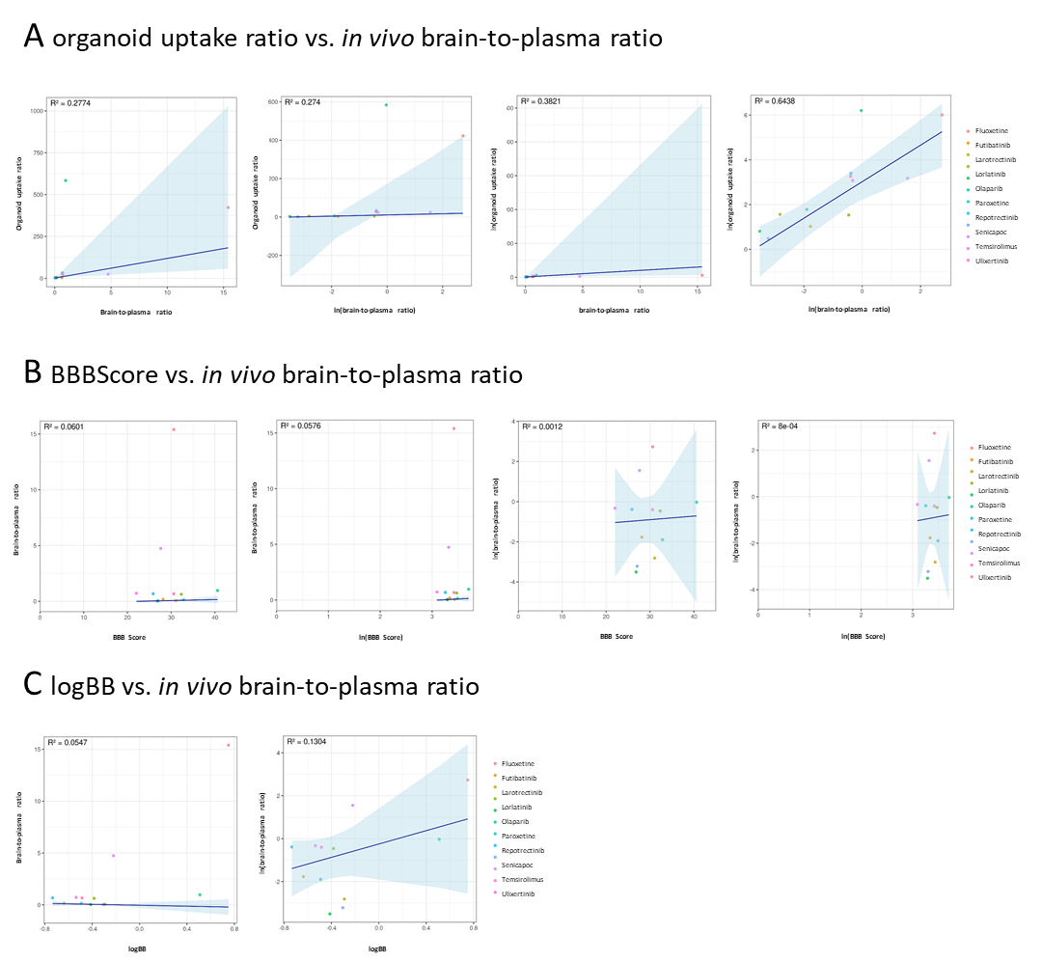Supplementary Figure S4: Comparisons of direct and logarithm transformed correlations. A Correlation of the organoid uptake ratios and the reported mammalian in vivo brain-to-plasma ratios (Table 3), with the logarithm transformed brain-to-plasma ratios, logarithm transformed organoid uptake ratios and both combined. B Correlation between the BBScore of the in silico model ADMETboost and the reported in vivo brain-to-plasma ratios, logarithm transformed BBB Score, with the logarithm transformed brain-to-plasma ratios and both combined C Correlation of the logBB of the in silico model logBB_Pred and the reported in vivo brain-to-plasma ratios and the with the logarithm transformed brain-to-plasma ratios.

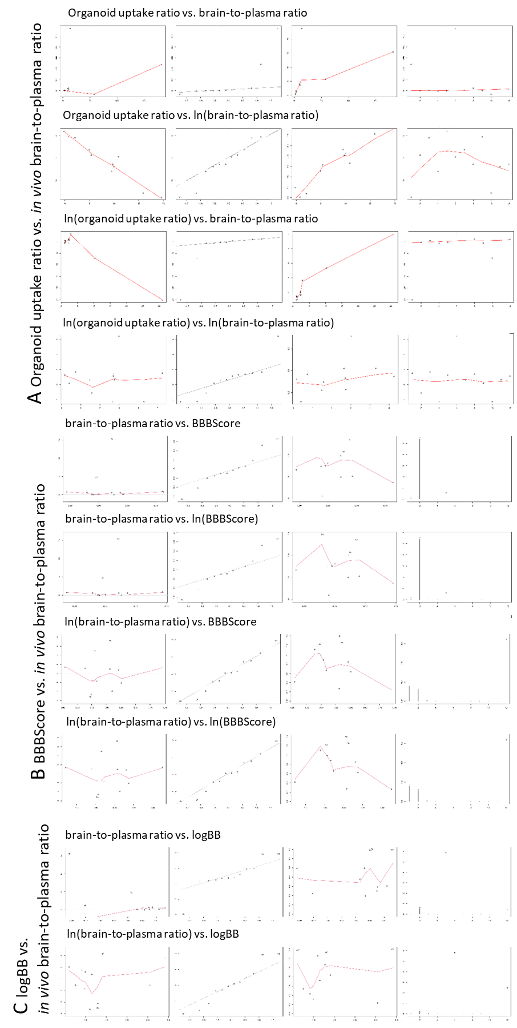
Supplementary Figure S5: Diagnostic plots for performed correlations with and without logarithmic transformation. A For correlation between organoid uptake ratio and reported mammalian in vivo brain-to-plasma ratios. B For BBBScore with the brain-to-plasma ratios and C for logBBB and brain-to-plasma ratios. From left to right: Residual vs. fitted plot; QQ-plot; Scale-Location plot; Crook’s distance or Residual vs Index for Deming Regression.

Supplementary Table 3: Representative quality control results for UPLC-MS/MS drug assays
drug | Fluoxetine | Octreotide | Olaparib | Paroxetine | Selinexor | Senicapoc | Temsirolimus
Intraday
precision [% CV] | 1.76 – 10.5 | 3.42 – 16.2 | 3.27 – 14.3 | 3.04 – 13.6 | 1.94 – 14.2 | 5.58 – 17.4 | 4.20 – 15.3
accuracy [%] | 85.1 – 112.0 | 87.2 – 121.5 | 88.9 – 114.5 | 88.9 – 124.7 | 104.7 – 110.8 | 86.1 – 113.9 | 105.7 – 126.9
Interday
precision [% CV] | 6.38 – 9.16 | 9.95 – 17.2 | 10.02 – 13.91 | 13.0 – 15.9 | 10.8 | 9.02 – 13.9 | 6.55 – 15.3
accuracy [%] | 94.1 – 110.5 | 99.2 – 108.4 | 99.8 – 101.5 | 100.2 - 118 | 108.4 | 94.1 – 95.7 | 99.0 – 126.9
Specificity | Blank in organoid matrix
Digestion stability | 93.0 – 105.5 | 102.1 – 110.8 | 94.4 – 98.3 | 93.4 – 93.6 | 106.2 – 115.4 | 102.6 – 104.2 | 90.5 – 107.6
drug | Ulixertinib | Repotrectinib | Futibatinib | Lorlatinib | Larotrectinib | Selitrectinib
Intraday
precision [% CV] | 1.03 – 8.62 | 2.74 – 23.4 | 2.19 – 9.14 | 2.20 – 14.74 | 1.16 – 7.73 | 3.26 – 15.9
accuracy [%] | 89.4 – 103.8 | 87.5 – 112.5 | 106.1 – 114.9 | 88.4 – 102.9 | 86.2 – 107.3 | 71.8 – 111.0
Interday
precision [% CV] | 5.88 – 8.15 | 4.66 – 13.4 | 4.57 – 6.88 | 3.52 – 10.13 | 7.19 – 11.3 | 14.0 – 16.0
accuracy [%] | 97.1 – 98.5 | 103.3 – 109.8 | 109.7 – 112.1 | 90.54 – 97.6 | 93.5 – 100.8 | 84.6 – 98.4
Specificity | Blank in organoid matrix
Digestion stability | 101.1 – 104.8 | 104.4 – 124.1 | 97.2 – 105.2 | 95.1 – 101.0 | 125.7 – 144.8 | 97.3 – 115.0

Supplementary Table S4: Statistical analysis of drug uptake in organoids over time
drug |  | drug
Octreotide |  | Ulixertinib
 | ns | 3000 ng/mL 15 min vs. 1 h | **** <0.0001
Olaparib |  | 15 min vs. 2 h | **** <0.0001
50000 ng/mL 1 h vs. 2 h | * 0.047 | 15 min vs. 4 h | **** <0.0001
Paroxetine |  | 1 h vs. 2 h | * 0.0249
3000 ng/mL 15 min vs 4 h | * 0.017 | 1 h vs. 4 h | ** 0.002
1000 ng/mL 1 h vs 4 h | ** 0.008 | 1000 ng/mL 15 min vs. 2 h | **** <0.0001
2 h vs 4 h | * 0.017 | 15 min vs. 4 h | * 0.0356
Senicapoc |  | 1 h vs. 2 h | * 0.0351
15 min vs. 1 h | **** <0.0001 | 1 h vs. 4 h | **** <0.0001
Selinexor |  | 300 ng/mL 15 min vs. 2 h | *** 0.0002
300 ng/mL 2 h vs. 4 h | * 0.023 | 15 min vs. 4 h | **** <0.0001
Temsirolimus |  | 2 h vs. 4 h | * 0.0468
2000 ng/mL 15 min vs. 1 h | ** 0.003 | Futibatinib
15 min vs 4 h | * 0.02 |  | ns
666,7 ng/mL 15 min vs. 2 h | * 0.032 | Larotrectinib
1 h vs 4 h | * 0.024 | 180 ng/mL 2 h vs. 4 h | *** 0.0003
200 ng/mL 15 min vs. 4 h | ** 0.007 | 4 h vs. 6 h | * 0.038
1 h vs 4 h | ** 0.002 | Lorlatinib
Fluoxetine |  |  | ns
150 ng/mL 15 min vs. 1 h | * 0.034 | Repotrectinib
15 min vs. 4 h | **** <0.0001 |  | ns
50 ng/mL 15 min vs 1 h | ** 0.0074 | Selitrectinib
50 ng/mL 15 min vs 2 h | * 0.032 |  | ns
50 ng/mL 15 min vs 4 h | * 0.014
Statistical analysis for multiple groups was performed with mixed-effect analysis with simple effect between columns (time points) and for single concentrations one-way ANOVA, both with Turkey’s multiple comparisons.

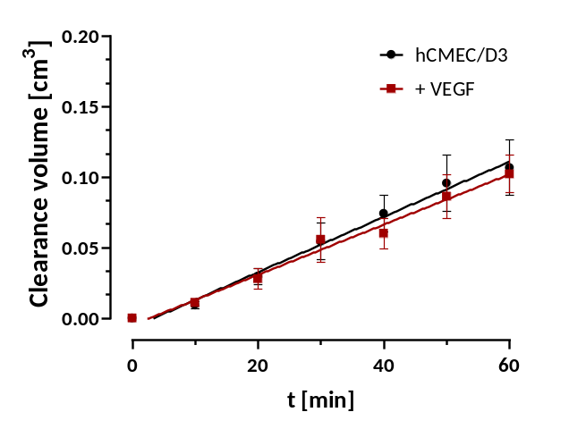
Supplementary Figure S6: Clearance volume of Transwell® experiments of ᴅ-Tyr(Me)Orn for hCMEC/D3. Untreated monolayer results are shown in black and red line depicts clearance volume after VEGF treatment (200 ng/mL VEGF in cell culture medium for 4 h before permeability measurement). Control group (untreated monolayer) were already published⁵⁰. Please refer to this previous publication for methodical details of Transwell experiments.

