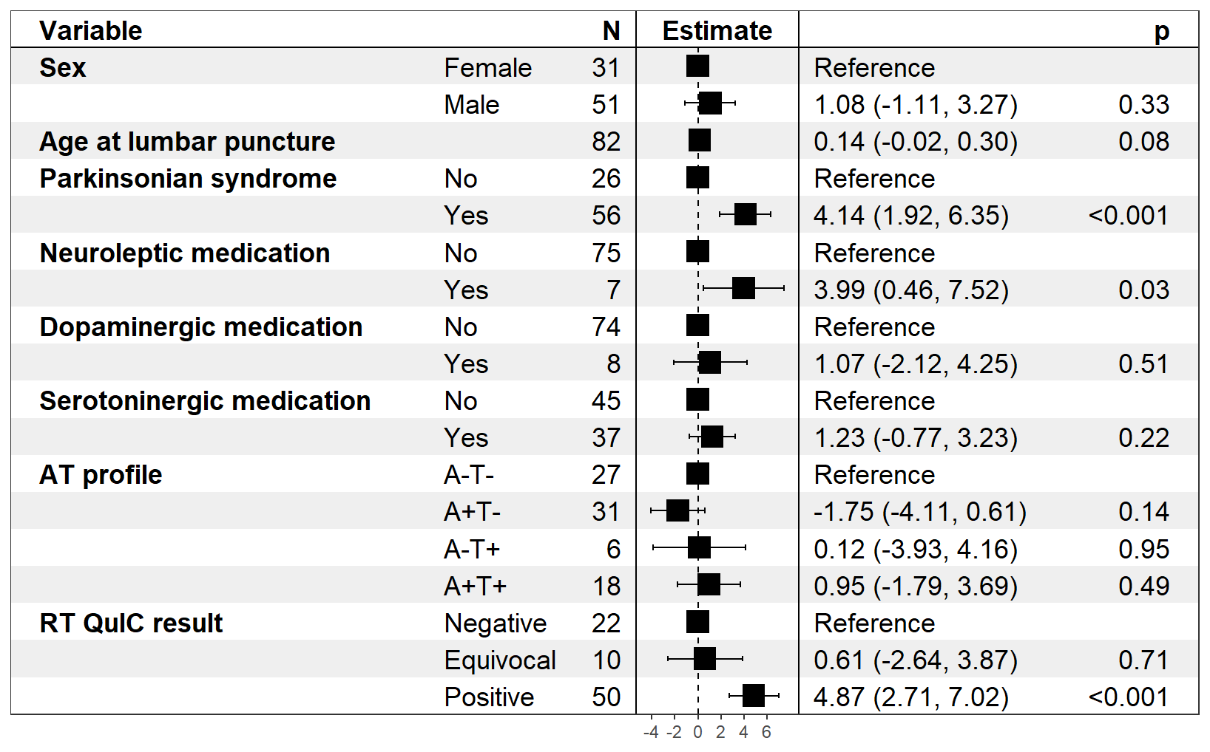
Additional file 2: Figure S1: Sensitivity analysis of factors associated with CSF DDC levels, including AT profile and α-synuclein RT-QuIC (n = 82).
Forest plot of the multivariable linear model of inverse-transformed DDC values ([1/x] × −1000), adjusted for sex, age, parkinsonian syndrome, neuroleptic, dopaminergic and serotoninergic medication, AT profile and RT-QuIC result. Higher estimates correspond to higher raw DDC concentrations. Squares indicate point estimates and horizontal bars their 95% confidence intervals.

