Supplementary Information
Boosting Multifunctional Composites Thermal Conductivity via Nanometallic Interfacial Low-Frequency Phonon Resonance

Qiuchen Wang^{1, #}, Qian Li^{2, #}, Ru Xia¹, Jiasheng Qian^{1, *}, Bin Wu^{1, *}
¹Key Laboratory of Environment-Friendly Polymeric Materials of Anhui Province, School of Chemistry & Chemical Engineering, Anhui University, Hefei, Anhui, China, 230601
²Department of Pharmaceutical and Artificial-Intelligence Sciences, Shanghai Jiao Tong University, Shanghai, China, 200025
#These authors contributed equally to this work.
*E-mail: qianjsh@ahu.edu.cn; lwbin@ahu.edu.cn
This file includes:
Supplementary Notes 1-4
Supplementary Figures 1-27
Supplementary Tables 1
Supplementary References

Supplementary Note 1
Characterizations
The equipment used for sample preparation included a precision linear DC power supply with constant-voltage and constant-current regulation (TN-XXZ02, Guochong Charging Technology Jiangsu Co., Ltd., China); a high-speed shear disperser (FA25, FLUKO, China); a probe-type ultrasonic sonochemical processing system (YPS17-HB, Hangzhou Success Ultrasonic Equipment Co., Ltd., China); a benchtop high-speed centrifuge (H4-20K, Hunan Kecheng Instrument Equipment Co., Ltd., China); and a hot press (YLJ-HP2, Hefei Kejing Materials Technology Co., Ltd., China). The crystalline structures of the samples were characterized by X-ray diffraction (XRD, Rigaku, MiniFlex 600, Japan). In situ Raman spectra were acquired using a Raman system (EC-Raman, Xiamen SHINs Technology Co., Ltd., China) with an excitation wavelength of 532 nm. Conventional Raman spectra and Raman spectra at different excitation wavelengths were acquired using a confocal Raman microscope (inVia Reflex, Renishaw, UK), with excitation wavelengths of 325, 532, and 785 nm. Fluorescence emission spectra were recorded using a spectrofluorometer (FluoroMax Plus, HORIBA Scientific, USA). Surface elemental compositions and chemical states were analyzed by X-ray photoelectron spectroscopy (XPS, VG Scientific, ESCALAB 220i-XL, UK).
The surface and cross-sectional morphologies of the composite films were examined by scanning electron microscopy (SEM; Hitachi, S-4800, Japan; Zeiss, Sigma 500, Germany). The morphology and lattice fringes of AgNWs and TAgNW were examined by transmission electron microscopy (TEM, Hitachi, H-7800, Japan) and high-resolution TEM (HRTEM, JEOL, JEM-2100, Japan). Atomic force microscopy (AFM; AFM5500M, Hitachi, Japan) was used to characterize the surface topography and obtain height profiles.
The orientation of the three film types was characterized by two-dimensional wide-angle X-ray scattering (2D WAXS, Bruker AXS, NanoStar, Germany). The degree of orientation (Π) was calculated using the following equation:
$$\begin{aligned}\text{Π=}\frac{\text{180°-FWHM}}{\text{180°}}\#\left(\text{1}\right)\end{aligned}$$
where FWHM is the full width at half-maximum of the azimuthal intensity distribution along the equatorial (002) reflection and is expressed in degrees.
The Hermans orientation factor, ${\text{f}}_{\text{h}}$, was calculated from the azimuthal intensity distribution of the X-ray scattering pattern as follows:
$$\begin{aligned}{\text{f}}_{\text{h}}\text{=}\frac{\text{3}\left\langle {\text{cos}}^{\text{2}}\text{φ}\right\rangle \text{-1}}{\text{2}}\#\left(\text{2}\right)\end{aligned}$$
$$\begin{aligned}\left\langle {\text{cos}}^{\text{2}}\text{φ}\right\rangle \text{=}\frac{\int_{\text{0}}^{\frac{\text{π}}{\text{2}}}{\text{I}\left(\text{φ}\right){\text{cos}}^{\text{2}}\text{φ}\text{sin}\text{φ}\text{d}\text{φ}}}{\int_{\text{0}}^{\frac{\text{π}}{\text{2}}}{\text{I}\left(\text{φ}\right)\text{sin}\text{φ}\text{d}\text{φ}}}\#\left(\text{3}\right)\end{aligned}$$
where φ is the azimuthal angle and I(φ) is the intensity distribution. The Hermans orientation factor and its angular average are dimensionless.
The mechanical properties of the composite films were evaluated using a universal testing machine (Instron, 5967, USA). Electrical conductivity was measured using an FT-361 four-point probe resistivity measurement system (Ningbo Ruike Micro Intelligent Technology Co., Ltd., China). The folding endurance of the composite films was evaluated using an MIT-type folding endurance tester (ASR-5651, Guangdong Aisry Instrument Technology Co., Ltd., China).
Thermal conductivity was measured by the transient plane source method (Hot Disk, TPS 3500, Sweden). Thermal resistance was measured following ASTM D5470 at 80 °C and 10 psi (Long Win Science and Technology Corporation, LW-9389MD, Taiwan, China). Surface temperature distributions under heat-dissipation conditions were recorded by infrared thermography (FLIR Systems, T1040, USA).

Supplementary Note 2
EMI shielding effectiveness (EMI SE) characterization
The electromagnetic parameters from 8.2 to 40 GHz were measured using a vector network analyzer (VNA, Anritsu MS46322B, Japan). The scattering parameters ${\text{S}}_{\text{11}}$, ${\text{S}}_{\text{21}}$, ${\text{S}}_{\text{12}}$, and ${\text{S}}_{\text{22}}$ were recorded directly. For incidence from port 1, the power reflection, transmission, and absorption coefficients were calculated as:
$$\begin{aligned}\text{R=}{\text{|}{\text{S}}_{\text{11}}\text{|}}^{\text{2}}\text{=}{\text{|}{\text{S}}_{\text{22}}\text{|}}^{\text{2}}\#\left(\text{4}\right)\end{aligned}$$
$$\begin{aligned}\text{T}\text{=}{\text{|}{\text{S}}_{\text{21}}\text{|}}^{\text{2}}\text{=}{\text{|}{\text{S}}_{\text{12}}\text{|}}^{\text{2}}\#\left(\text{5}\right)\end{aligned}$$
$$\begin{aligned}\text{A}\text{=1-}\text{R}\text{-}\text{T}\#\left(\text{6}\right)\end{aligned}$$
For incidence from port 2, the corresponding coefficients were calculated using S₂₂ and S₁₂. The coefficients R, T, and A are dimensionless. The total, reflection, and effective absorption shielding effectiveness values (in dB) were calculated as follows:
$$\begin{aligned}{\text{SE}}_{\text{T}}\text{=-10}{\text{log}}_{\text{10}}\left(\text{T}\right)\#\left(\text{7}\right)\end{aligned}$$
$$\begin{aligned}{\text{SE}}_{\text{R}}\text{=-10}{\text{log}}_{\text{10}}\left(\text{1-}\text{R}\right)\#\left(\text{8}\right)\end{aligned}$$
$$\begin{aligned}{\text{SE}}_{\text{A}}\text{=-10}{\text{log}}_{\text{10}}\left(\frac{\text{T}}{\text{1-}\text{R}}\right)\#\left(\text{9}\right)\end{aligned}$$
$$\begin{aligned}{\text{SE}}_{\text{T}}\text{=}{\text{SE}}_{\text{R}}\text{+}{\text{SE}}_{\text{A}}\#\left(\text{10}\right)\end{aligned}$$

Supplementary Note 3
Non-equilibrium molecular dynamics (NEMD) simulation
The models, each measuring 150 Å × 48 Å, were positioned in parallel with an overlap of 13 Å along the x direction. All molecular dynamics simulations were performed using the Large-scale Atomic/Molecular Massively Parallel Simulator (LAMMPS) package¹. Interatomic interactions were described using a combination of the COMPASS force field, the Tersoff potential, and the Lennard-Jones (LJ) potential^{2,3}.
Periodic boundary conditions were applied in all three directions, and a time step of 0.01 fs was used in the NEMD simulations. Atomic regions at both ends of the system along the x direction were fixed, while the adjacent layers were designated as the heat source and heat sink. The configuration was first optimized by energy minimization using the conjugate-gradient algorithm. The system was then equilibrated at 300 K under the NVT ensemble. After equilibration, Langevin thermostats were applied to maintain the cold and hot regions at Tcold = 250 K and Thot = 350 K, respectively. During the NEMD production run, the non-fixed atoms were integrated using the NVE algorithm while the Langevin thermostats remained applied to the hot and cold regions⁴. A steady-state temperature profile was established along the x direction⁵.
At steady state, the heat flux was calculated from the mean absolute energy-transfer rates of the hot and cold Langevin reservoirs:
$$\begin{aligned}\text{J}\text{=}\frac{\left|{\dot{\text{E}}}_{\text{hot}}\right|\text{+}\left|{\dot{\text{E}}}_{\text{cold}}\right|}{\text{2}{\text{S}}_{\text{⊥}}}\#\left(\text{11}\right)\end{aligned}$$
where ${\dot{\text{E}}}_{\text{hot}}$ and ${\dot{\text{E}}}_{\text{cold}}$ are the steady-state energy slopes of the hot and cold reservoirs, respectively, and ${\text{S}}_{\text{⊥}}$ is the cross-sectional area normal to the heat-flow direction. The energy-transfer rates have units of energy per time, and the cross-sectional area has units of area; after unit conversion, J is reported in W m⁻².
The system was subdivided into 40 slabs along the x direction to obtain the steady-state temperature profile. Linear fits to the temperature profiles on the two sides of the interface were extrapolated to the interface, and the interfacial thermal conductance (ITC) was calculated as:
$$\begin{aligned}\text{G}\text{=}\frac{\text{J}}{{\text{Δ}\text{T}}_{\text{int}}}\#\left(\text{12}\right)\end{aligned}$$
where ${\text{Δ}\text{T}}_{\text{int}}$ is the interfacial temperature discontinuity obtained from the extrapolated linear temperature profiles. Thus, G is reported in W m⁻² K⁻¹.

Supplementary Note 4
Density functional theory (DFT) simulations
All first-principles calculations were performed using the Quantum ESPRESSO package⁶. The exchange-correlation interactions were described using the Perdew-Burke-Ernzerhof (PBE) functional within the generalized gradient approximation, together with the Grimme D3 dispersion correction to account for van der Waals interactions among graphene, TCNQ molecules, and the Ag interface^{7,8}. The interactions between the ionic cores and valence electrons were described using ultrasoft pseudopotentials (USPPs). The kinetic-energy cutoffs for the wave functions and charge density were set to 60 Ry and 600 Ry, respectively, and the Brillouin zone was sampled using a 6×6×1 Monkhorst-Pack k-point mesh. The three interface models were geometrically optimized until the total-energy convergence threshold reached 10⁻⁶ Ry and the residual force on each atom was below 10⁻⁴ Ry Bohr⁻¹. Self-consistent-field and non-self-consistent-field calculations were performed using the optimized structures to obtain the electronic band structures, density of states, projected density of states, and charge-density-difference distributions.
Electron-phonon coupling properties were evaluated using density functional perturbation theory (DFPT) in combination with the EPW code^{9,10}. The phonon frequencies, phonon polarization vectors, and electron-phonon coupling matrix elements were calculated using Quantum ESPRESSO on a coarse 4×4×1 q-point mesh, as expressed by the following equation¹¹:
$$\begin{aligned}{\text{g}}_{\text{mnν}}\left(\text{k,q}\right)\text{=}\left\langle {\text{ψ}}_{\text{m}\text{,k+q}}\text{|}{\text{Δ}}_{\text{q}\text{ν}}{\text{V}}^{\text{KS}}\text{|}{\text{ψ}}_{\text{n}\text{,k}}\right\rangle \#\left(\text{13}\right)\end{aligned}$$
Here, ${\text{ψ}}_{\text{n}\text{,k}}$ and ${\text{ψ}}_{\text{m}\text{,k+q}}$ are the initial and final Kohn-Sham states, respectively. The mode-normalized perturbation ${\text{Δ}}_{\text{q}\text{ν}}{\text{V}}^{\text{KS}}$ contains the phonon eigenvector, atomic-mass, and frequency normalization used by EPW. The symbols $\text{k}$, $\text{q}$, and $\text{ν}$ denote the electron wave vector, phonon wave vector, and phonon branch, respectively. The electron-phonon matrix element has units of energy.
Maximally localized Wannier functions were used to interpolate the electronic states, phonon states, and electron-phonon matrix elements onto dense 30 × 30 × 1 k- and q-point meshes. The phonon linewidth for each mode was calculated as:
$$\begin{aligned}{\text{γ}}_{\text{q}\text{ν}}\text{=2π}{\text{ω}}_{\text{q}\text{ν}}\sum_{\text{mn}\text{k}}{{\text{w}}_{\text{k}}{\left|{\text{g}}_{\text{mnν}} , \left(\text{k,q}\right)\right|}^{\text{2}}\text{δ}\left({\text{ε}}_{\text{n}\text{k}}\text{-}{\text{ε}}_{\text{F}}\right)\text{δ}\left({\text{ε}}_{\text{m}\text{,k+q}}\text{-}{\text{ε}}_{\text{F}}\right)}\#\left(\text{14}\right)\end{aligned}$$
where ${\text{w}}_{\text{k}}$ is the normalized k-point weight, ${\text{ε}}_{\text{F}}$ is the Fermi energy, and the Dirac delta functions were represented using numerical broadening. The phonon linewidth in Eq. (14) has units of angular frequency; multiplication by ℏ gives the corresponding energy linewidth. The mode-resolved electron-phonon coupling constant was obtained from¹²:
$$\begin{aligned}{\text{λ}}_{\text{q}\text{ν}}\text{=}\frac{{\text{γ}}_{\text{q}\text{ν}}}{\text{π}\text{ℏ}\text{N}\left({\text{ε}}_{\text{F}}\right){\text{ω}}_{\text{q}\text{ν}}^{\text{2}}}\#\left(\text{15}\right)\end{aligned}$$
where $\text{N}\left({\text{ε}}_{\text{F}}\right)$ is the electronic density of states at the Fermi level. This density of states has units of states per energy, and the resulting coupling constant is dimensionless. The isotropic Eliashberg spectral function was constructed as:
$$\begin{aligned}{\text{α}}^{\text{2}}\text{F}\left(\text{ω}\right)\text{=}\frac{\text{1}}{\text{2}}\sum_{\text{q}\text{ν}}{{\text{w}}_{\text{q}}{\text{ω}}_{\text{q}\text{ν}}{\text{λ}}_{\text{q}\text{ν}}\text{δ}\left(\text{ω}\text{-}{\text{ω}}_{\text{q}\text{ν}}\right)}\#\left(\text{16}\right)\end{aligned}$$
Under the normalization in Eq. (16), α²F(ω) is dimensionless. The cumulative electron-phonon coupling strength up to a cutoff frequency was evaluated from the first inverse moment of the Eliashberg spectral function:
$$\begin{aligned}\text{λ}\text{=2}\int_{\text{0}}^{\text{∞}}{\frac{{\text{α}}^{\text{2}}\text{F}\left(\text{ω}\right)}{\text{ω}}\text{d}\text{ω}}\#\left(\text{17}\right)\end{aligned}$$
The phonon density of states (PhDOS) was calculated over the full Brillouin zone using normalized q-point weights.
For component-resolved analysis, the contribution of material component s to each phonon mode and the corresponding component-projected PhDOS were defined as:
$$\begin{aligned}\begin{aligned}{\text{W}}_{\text{s}}\left(\text{q}\text{ν}\right)\text{=}\frac{\sum_{\text{κ}\text{∈}\text{s}\text{,}\text{a}}{{\left|{\text{e}}_{\text{κa}}^{\text{q}\text{ν}}\right|}^{\text{2}}}}{\sum_{\text{κ}\text{,}\text{a}}{{\left|{\text{e}}_{\text{κa}}^{\text{q}\text{ν}}\right|}^{\text{2}}}}\end{aligned}\#\left(\text{18}\right)\end{aligned}$$
$$\begin{aligned}{\text{F}}_{\text{s}}\left(\text{ω}\right)\text{=}\sum_{\text{q}\text{ν}}{{\text{w}}_{\text{q}}{\text{W}}_{\text{s}}\left(\text{q}\text{ν}\right)\text{δ}\left(\text{ω}\text{-}{\text{ω}}_{\text{q}\text{ν}}\right)}\#\left(\text{19}\right)\end{aligned}$$
where ${\text{e}}_{\text{κa}}^{\text{q}\text{ν}}$ is the Cartesian eigenvector component of atom $\text{κ}$ in mode $\left(\text{q}\text{ν}\right)$. The first relation gives the normalized component weight, and the second defines the component-projected PhDOS. The component weight W_{s} is dimensionless, whereas F_{s}(ω) has units of inverse frequency.
The low-frequency PhDOS fraction was obtained by integrating the total PhDOS below 3 THz and normalizing it by the full-spectrum integral. The component contribution within this window was obtained analogously from the component-projected PhDOS.
The phonon participation ratio (PPR) was used to quantify mode localization. For each mode, the atomic weights ${\text{p}}_{\text{κ}}\left(\text{q}\text{ν}\right)$ were obtained by summing the squared Cartesian eigenvector components and were normalized so that $\sum_{\text{κ}}{{\text{p}}_{\text{κ}}}\text{=1}$. The normalized PPR was calculated as:
$$\begin{aligned}{\text{PPR}}_{\text{q}\text{ν}}\text{=}\frac{\text{1}}{\text{N}\sum_{\text{κ}}{{{\text{p}}_{\text{κ}}}^{\text{2}}\left(\text{q}\text{ν}\right)}}\#\left(\text{20}\right)\end{aligned}$$
Here, $\text{N}$ is the number of atoms in the model. Modes with PPR ≥ 0.1 were classified as delocalized. The reported low-frequency delocalized-mode fraction was calculated from the normalized q-point-weighted mode counts, and the material-component contributions were obtained by weighting the selected modes with ${\text{W}}_{\text{s}}\left(\text{q}\text{ν}\right)$. PPR is dimensionless and ranges from 1/N to 1.
The valence electron density was evaluated from the occupied Kohn-Sham states using normalized k-point weights and the fractional occupations arising from electronic smearing.
Interfacial charge redistribution was quantified from the charge-density difference:
$$\begin{aligned}\text{Δ}\text{ρ}\left(\text{r}\right)\text{=}{\text{ρ}}_{\text{int}}\left(\text{r}\right)\text{-}\sum_{\text{s}}{{\text{ρ}}_{\text{s}}\left(\text{r}\right)}\#\left(\text{21}\right)\end{aligned}$$
where ${\text{ρ}}_{\text{int}}$ is the charge density of the complete interface and ${\text{ρ}}_{\text{s}}$ is the charge density of isolated component $\text{s}$. Each isolated-component density was evaluated in the same supercell, with the atoms fixed at their interfacial positions and with identical numerical settings. The charge-density difference has units of charge per volume (e Å⁻³).
The total density of states was (TDOS) evaluated from the Kohn-Sham eigenvalues and normalized k-point weights. Orbital- and element-projected densities of states (PDOS) were obtained from projections onto the orthogonalized atomic orbitals used by Quantum ESPRESSO.
Bader analysis was used to quantify interfacial charge transfer. The electron population ${\text{N}}_{\text{i}}$ was obtained by integrating the valence electron density within Bader basin ${\text{Ω}}_{\text{i}}$. For the valence charge density generated with ultrasoft pseudopotentials, the net atomic charge was defined as:
$$\begin{aligned}{\text{Q}}_{\text{i}}\text{=}{\text{Z}}_{\text{i}}^{\text{val}}\text{-}{\text{N}}_{\text{i}}\#\left(\text{22}\right)\end{aligned}$$
where ${\text{Z}}_{\text{i}}^{\text{val}}$ is the valence charge assigned to atom $\text{i}$ by the pseudopotential. Charges were reported in units of the elementary charge e; a positive net atomic charge denotes electron depletion. Component charge transfer was obtained by summing ${\text{Q}}_{\text{i}}$ over all atoms in the corresponding component.
The band center was calculated from the projected density of states as:
$$\begin{aligned}{\text{ε}}_{\text{d}}\text{=}\frac{\int_{{\text{E}}_{\text{1}}}^{{\text{E}}_{\text{2}}}{\text{ED}\left(\text{E}\right)\text{d}\text{E}}}{\int_{{\text{E}}_{\text{1}}}^{{\text{E}}_{\text{2}}}{\text{D}\left(\text{E}\right)\text{d}\text{E}}}\#\left(\text{23}\right)\end{aligned}$$
where $\text{D}\left(\text{E}\right)$ is the projected density of states, and ${\text{E}}_{\text{1}}$ and ${\text{E}}_{\text{2}}$ define the integration window relative to the Fermi level. The integration limits and band-center energy are in eV relative to the Fermi level, and the projected density of states is in states eV⁻¹.

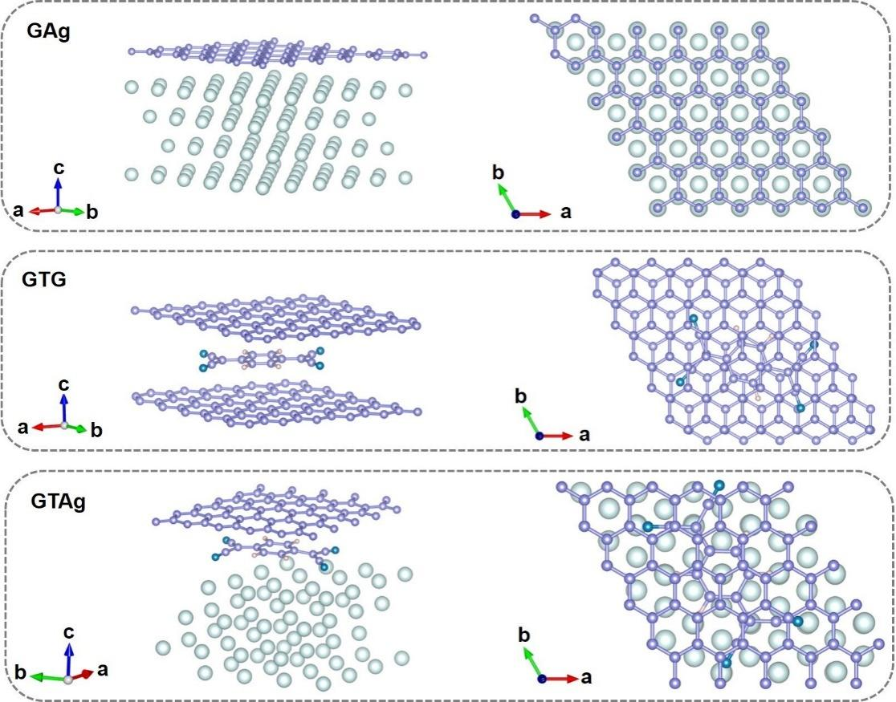
Supplementary Figure 1. Structural models of GAg, GTG, and GTAg used for DFT calculations.
Supplementary Figure 2. Total and projected electronic densities of states of GTAg, GAg, and GTG. (a, c and e) Total densities of states of GTAg, GAg, and GTG, respectively. (b, d and f) Corresponding orbital-resolved projected densities of states.
Supplementary Figure 3. k-resolved PDOS maps of GTAg.

Supplementary Figure 4. k-resolved PDOS maps of GAg.

Supplementary Figure 5. k-resolved PDOS maps of GTG.

Supplementary Figure 6. k-resolved molecular PDOS maps of GTAg, GAg, and GTG. (a) GTAg, (b) GAg and (c) GTG.

Supplementary Figure 7. Electronic band dispersions and electron linewidths of GTAg, GAg, and GTG. (a) GTAg, (b) GAg; and (c) GTG. Colors indicate the electron linewidth.

Supplementary Figure 8. Phonon dispersions and phonon linewidths of GTAg, GAg, and GTG. (a) GTAg, (b) GAg and (c) GTG. Colors indicate the phonon linewidth.

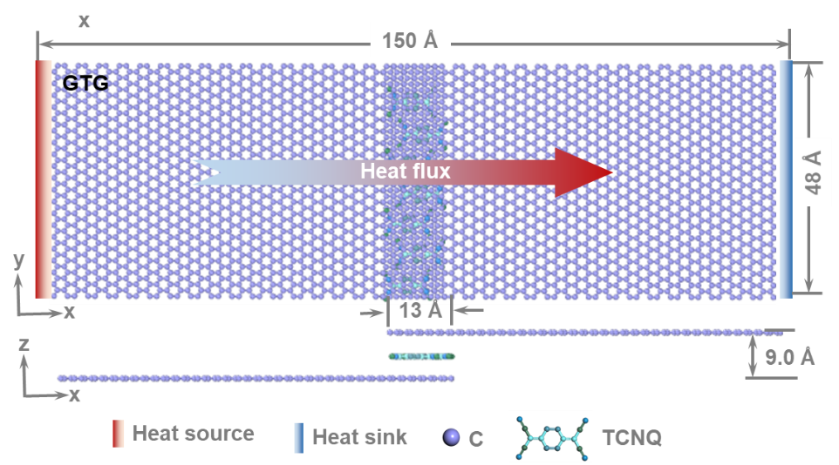
Supplementary Figure 9. Model of GTG used for molecular dynamics simulations.

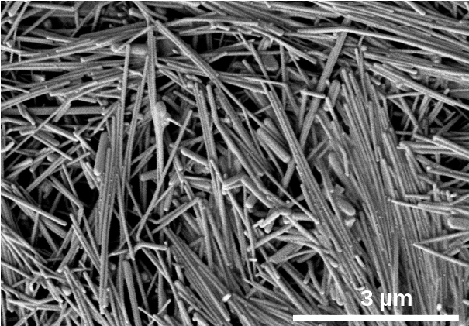
Supplementary Figure 10. SEM image of AgNWs.

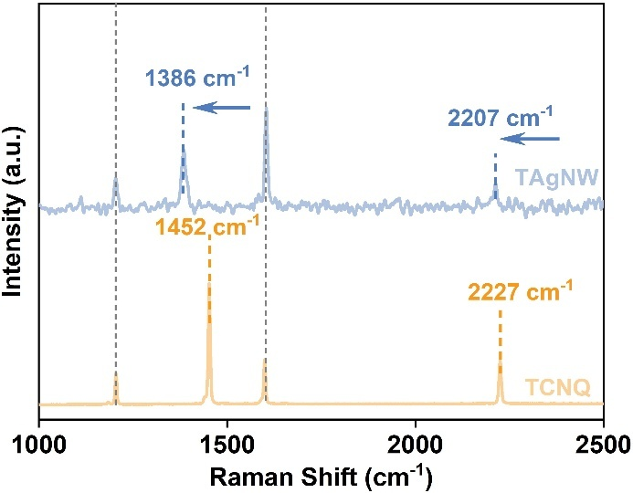
Supplementary Figure 11. Raman spectra of TAgNW and TCNQ.
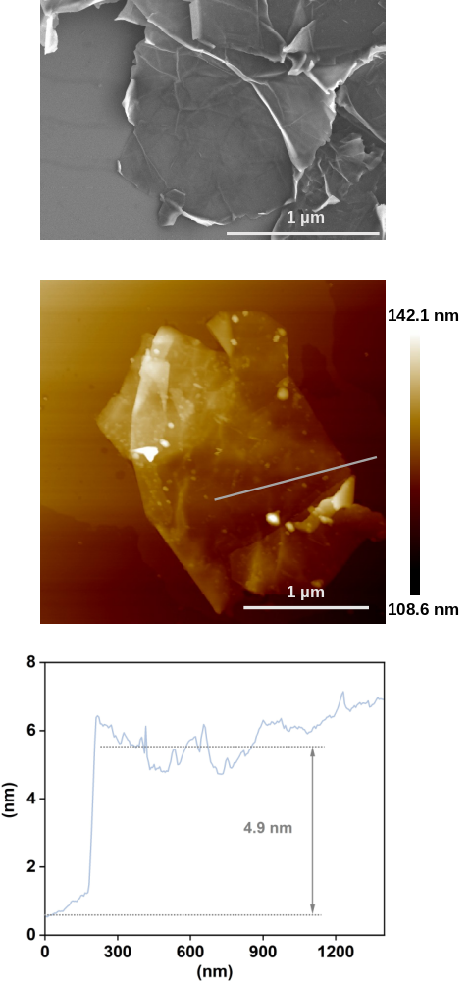
Supplementary Figure 12. Morphology and thickness characterization of GNS. SEM image, AFM topographic image, and corresponding height profile of GNS.
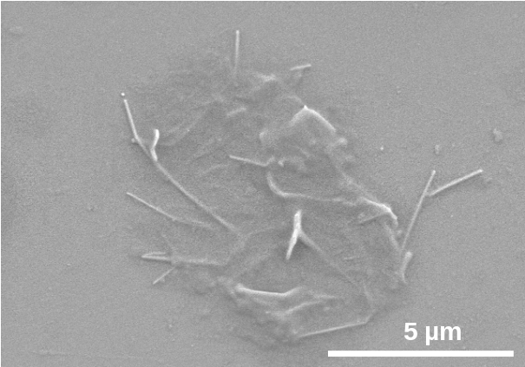
Supplementary Figure 13. SEM image of GTAgNW.

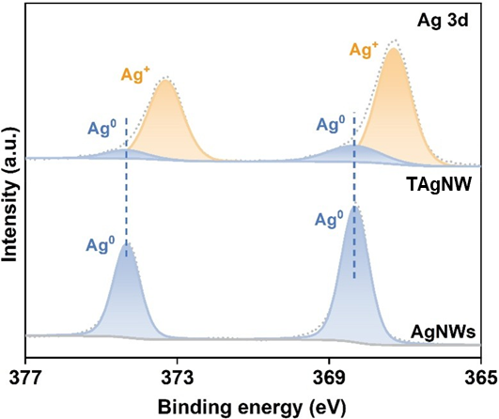
Supplementary Figure 14. High-resolution XPS spectra of Ag 3d for pure AgNWs and TAgNW.

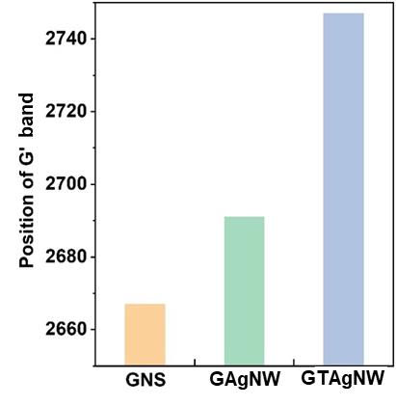
Supplementary Figure 15. Comparison of the Raman G’ band positions of GNS, GAgNW, and GTAgNW.

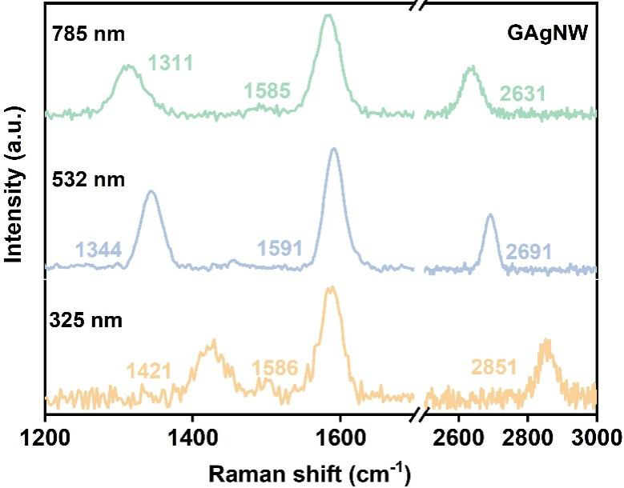
Supplementary Figure 16. Raman spectra of GAgNW acquired at different excitation wavelengths.

Supplementary Figure 17. Magnified cross-sectional SEM image of GTAg₃₀/PNFs.

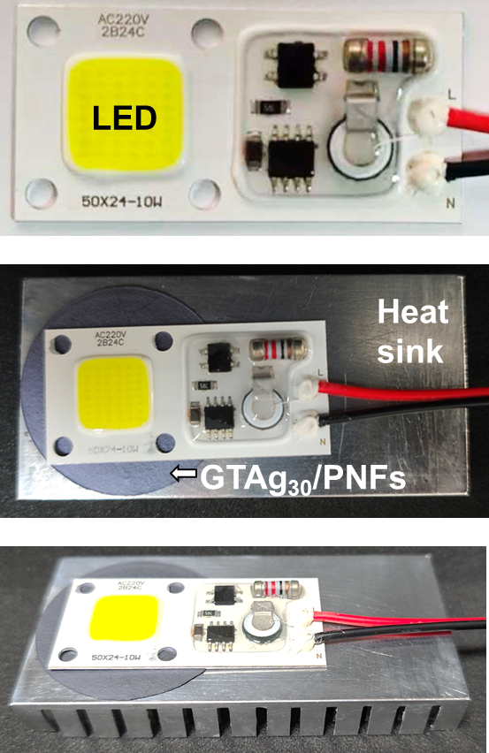
Supplementary Figure 18. Experimental setup for LED heat-dissipation measurements. Photographs of the LED module and the assembly used to evaluate heat dissipation. A GTAg₃₀/PNFs film is placed between the LED module and the heat sink.
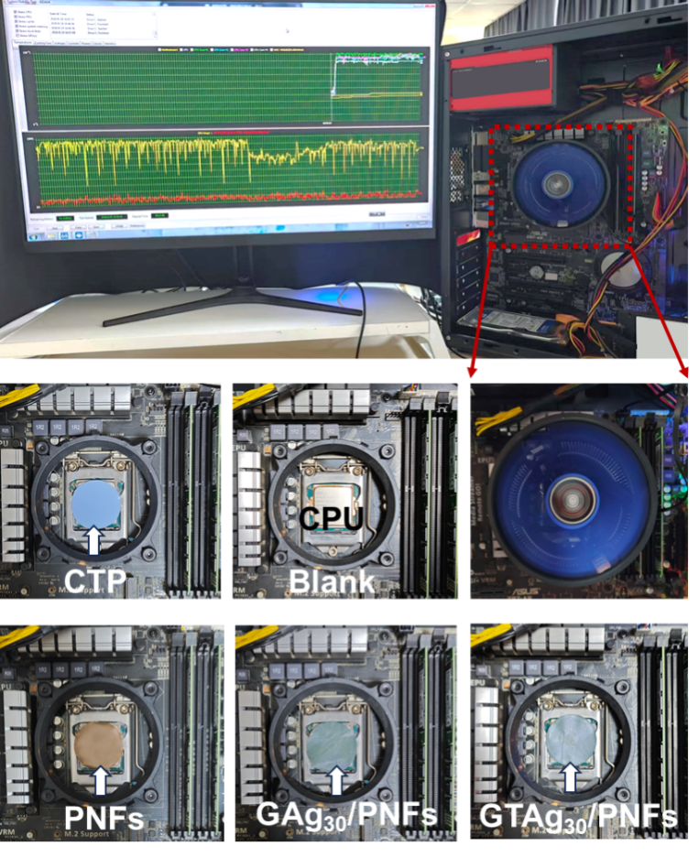
Supplementary Figure 19. CPU cooling setup and thermal interface configurations. Photographs of the desktop-computer CPU cooling setup and sample installation configurations. Configurations are shown without an interface film (Blank) and with CTP, PNFs, GAg₃₀/PNFs, and GTAg₃₀/PNFs.

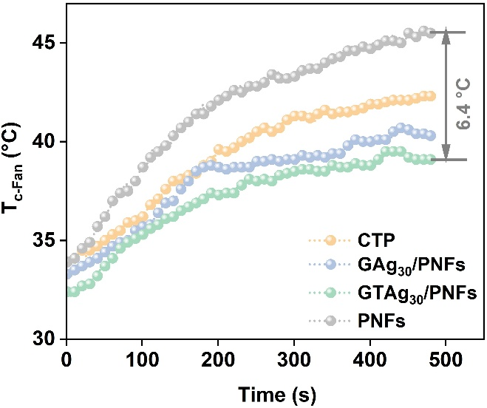
Supplementary Figure 20. Temperature evolution during CPU operation with different interface materials. T_{c-Fan} during CPU operation with PNFs, CTP, GAg₃₀/PNFs, and GTAg₃₀/PNFs as interface layers.

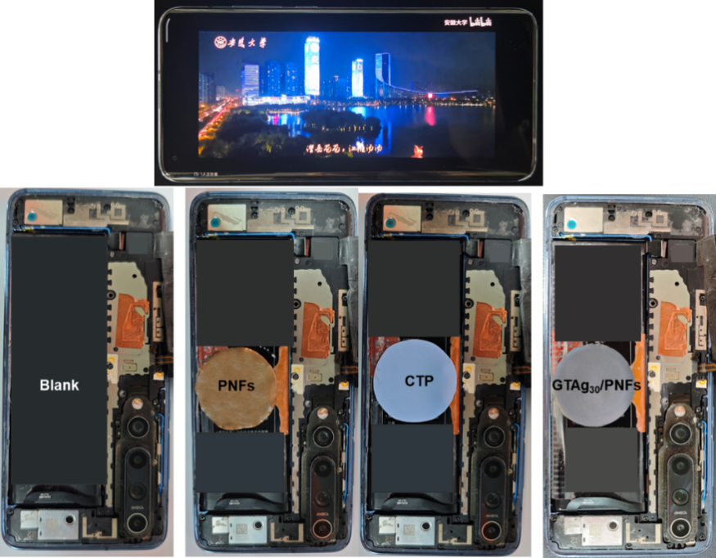
Supplementary Figure 21. Experimental configurations for smartphone heat-dissipation measurements. Photographs of the smartphone during video playback and the battery configurations used for heat-dissipation measurements. Configurations include Blank and PNFs, CTP, and GTAg₃₀/PNFs attached to the battery surface.
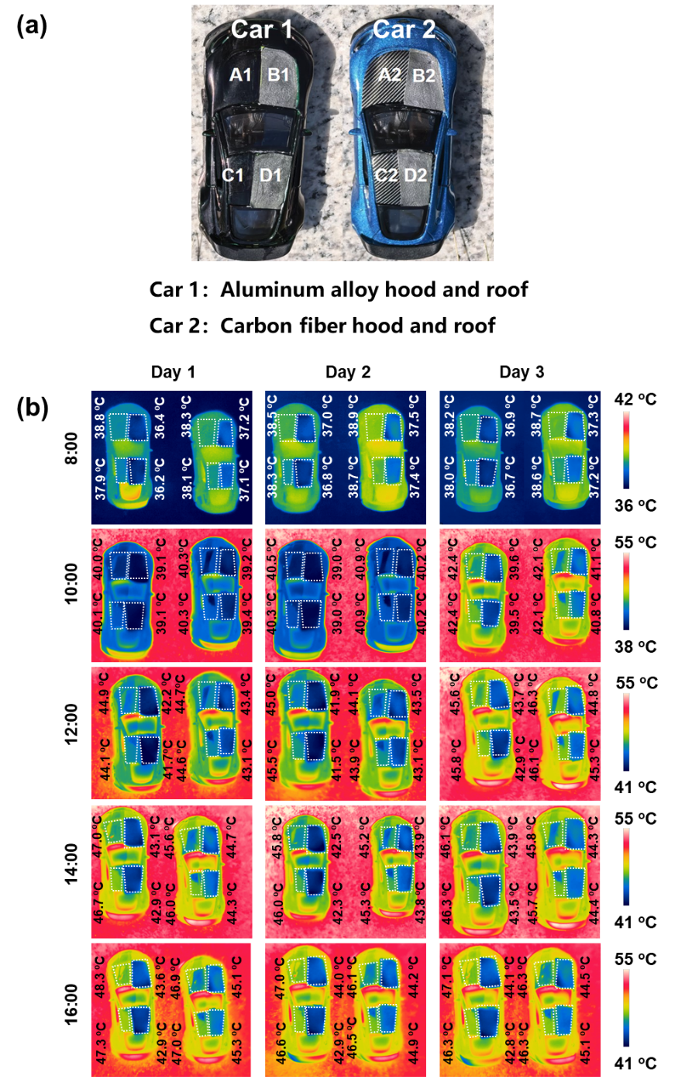
Supplementary Figure 22. Experimental configurations and infrared thermal imaging of model vehicles. (a) Top-view photograph of model vehicles with aluminum alloy- and carbon fiber-based hoods and roofs. Two sample-free regions and the corresponding sample-covered regions were defined on each vehicle. (b) Thermal infrared images of two model vehicles at five distinct time points over three consecutive days.
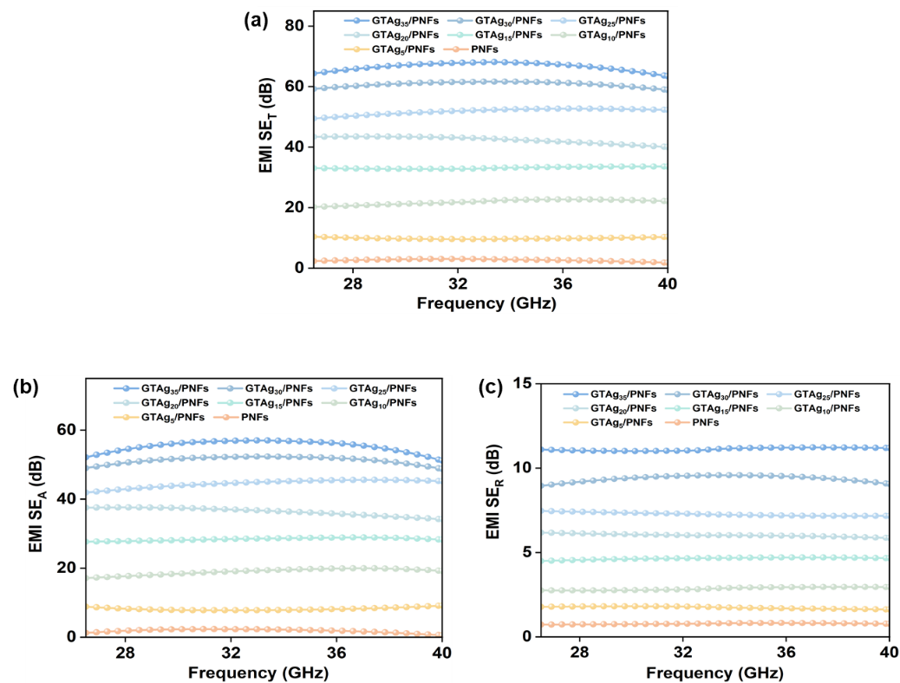
Supplementary Figure 23. Ka-band electromagnetic interference shielding performance of PNFs and GTAg_{x}/PNFs. Frequency-dependent (a) SE_{T}, (b) SE_{A} and (c) SE_{R} of PNFs and GTAg_{x}/PNFs.

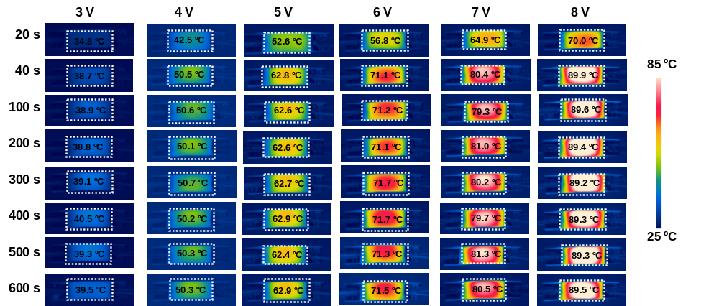
Supplementary Figure 24. Time-dependent infrared thermal imaging of the GTAg₃₀/PNFs surface at various applied voltages.

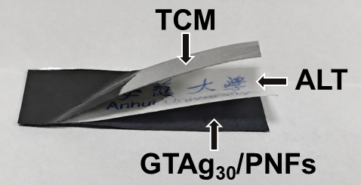
Supplementary Figure 25. Thermochromic assembly for visualizing Joule heating. Photograph of the layered assembly comprising thermochromic material (TCM), an Anhui University logo tag (ALT), and GTAg₃₀/PNFs.

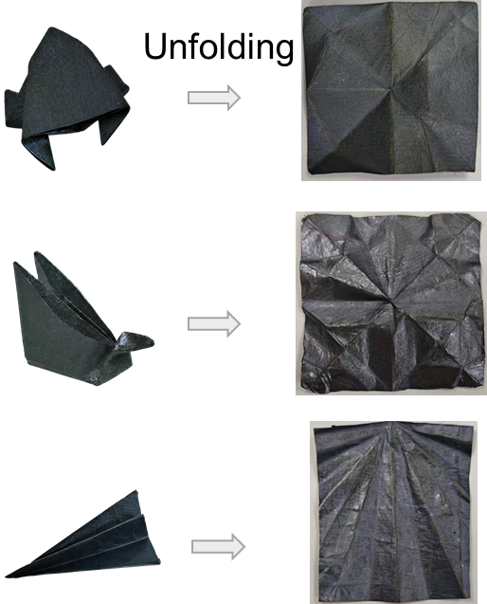
Supplementary Figure 26. Foldability of GTAg₃₀/PNFs films. Photographs of GTAg₃₀/PNFs folded into frog-, swan-, and airplane-shaped structures (left, from top to bottom) and the corresponding unfolded films (right).

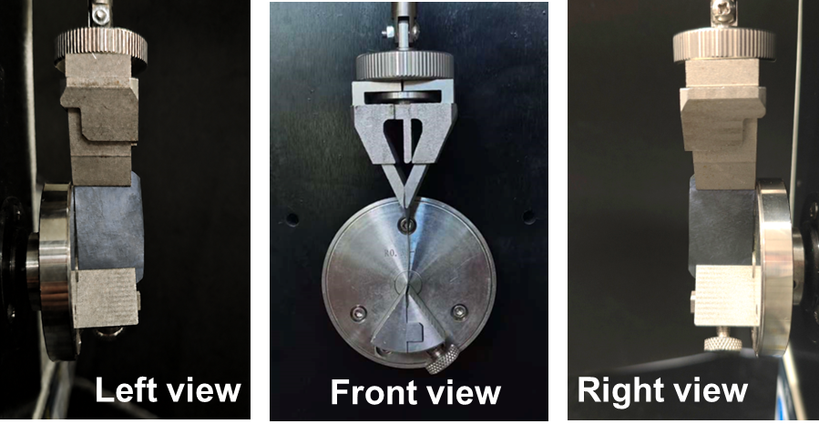
Supplementary Figure 27. Experimental setup for cyclic bending tests. Left, front, and right views of GTAg₃₀/PNFs mounted in the folding endurance tester for cyclic bending tests.

Supplementary Table 1. Temperature forecasts for Shushan District, Hefei, Anhui, China
Time  Date | 08:00 | 10:00 | 12:00 | 14:00 | 16:00
July 14, 2026 | 30.0 ºC | 32.7 ºC | 34.0 ºC | 34.0 ºC | 34.0 ºC
July 15, 2026 | 31.0 ºC | 33.7 ºC | 35.0 ºC | 35.0 ºC | 34.3 ºC
July 16, 2026 | 32.0 ºC | 33.3 ºC | 34.0 ºC | 34.0 ºC | 32.7 ºC
Source: China Weather.

Supplementary References
1. Thompson, A. P. et al. LAMMPS-a flexible simulation tool for particle-based materials modeling at the atomic, meso, and continuum scales. Comput. Phys. Commun. 271, 108171 (2022).
2. Sun, H. COMPASS: an ab initio force-field optimized for condensed-phase applications-overview with details on alkane and benzene compounds. J. Phys. Chem. B 102, 7338–7364 (1998).
3. Tersoff, J. Empirical interatomic potential for carbon, with applications to amorphous carbon. Phys. Rev. Lett. 61, 2879–2882 (1988).
4. Li, Z. et al. Influence of thermostatting on nonequilibrium molecular dynamics simulations of heat conduction in solids. J. Chem. Phys. 151, 234105 (2019).
5. Hong, Y., Li, L., Zeng, X. C., Zhang, J. Tuning thermal contact conductance at graphene–copper interface via surface nanoengineering. Nanoscale 7, 6286–6294 (2015).
6. Giannozzi, P. et al. QUANTUM ESPRESSO: a modular and open-source software project for quantum simulations of materials. J. Phys.: Condens. Matter. 21, 395502 (2009).
7. Tesch, J. et al. Structural and electronic properties of graphene nanoflakes on Au(111) and Ag(111). Sci. Rep. 6, 23439 (2016).
8. Blowey, P. J. et al. Re-evaluating how charge transfer modifies the conformation of adsorbed molecules. Nanoscale 10, 14984–14992 (2018).
9. Baroni, S., de Gironcoli, S., Dal Corso, A., Giannozzi, P. Phonons and related crystal properties from density-functional perturbation theory. Rev. Mod. Phys. 73, 515–562 (2001).
10. Lee, H. et al. Electron-phonon physics from first principles using the EPW code. npj Comput. Mater. 9, 156 (2023).
11. Giustino, F. Electron-phonon interactions from first principles. Rev. Mod. Phys. 89, 015003 (2017).
12. Giustino, F., Cohen, M. L., Louie, S. G. Electron-phonon interaction using Wannier functions. Phys. Rev. B 76, 165108 (2007).

