Supplementary information for

Lineage plasticity and tumor microenvironment transcriptional features define a novel aggressive state in pediatric rhabdomyosarcoma

Davide Pernici^{1,%}, Stefano Percio^{2,%}, Gabriele Tiné³, Elena Di Blasi⁴, Bahar Fayaztorshizi¹, Renata Ferri¹, Yiyi Zhu³, Loris De Cecco⁵, Paola Collini⁴, Stefano Chiaravalli⁶, Michela Casanova⁶, Rosalba Miceli³, Sandro Pasquali², Andrea Ferrari^{6,7}, Patrizia Gasparini^{8,$}, Roberta Sulsenti^{1,$}, and Elena Jachetti^{1,$,*}

¹ Molecular Immunology Unit, Department of Translational Research, Epidemiology and Data Science, Fondazione IRCCS Istituto Nazionale dei Tumori di Milano, Milan, Italy
² Molecular Pharmacology Unit, Department of Translational Research, Epidemiology and Data Science, Fondazione IRCCS Istituto Nazionale dei Tumori di Milano, Milan, Italy
³ Unit of Biostatistics for Clinical Research, Department of Translational Research Epidemiology and Data Science, Fondazione IRCCS Istituto Nazionale dei Tumori di Milano, Milan, Italy
⁴ Pathology Unit, Department of Advanced Diagnostics, Fondazione IRCCS Istituto Nazionale dei Tumori di Milano, Milan, Italy.
⁵ Integrated Biology of Rare Cancers Unit, Department of Translational Research, Epidemiology and Data Science, Fondazione IRCCS Istituto Nazionale dei Tumori di Milano, Milan, Italy
⁶ Pediatric Oncology Unit, Fondazione IRCCS Istituto Nazionale dei Tumori di Milano, Milan, Italy
⁷ Department of Oncology and Hemato-oncology, University of Milan, Milan, Italy
⁸ Epigenomic and Biomarkers of Solid Tumors Unit, Department of Translational Research, Epidemiology and Data Science, Fondazione IRCCS Istituto Nazionale dei Tumori di Milano, Milan, Italy

Supplementary information includes three supplementary tables (provided as separate excel files) and one supplementary figure.

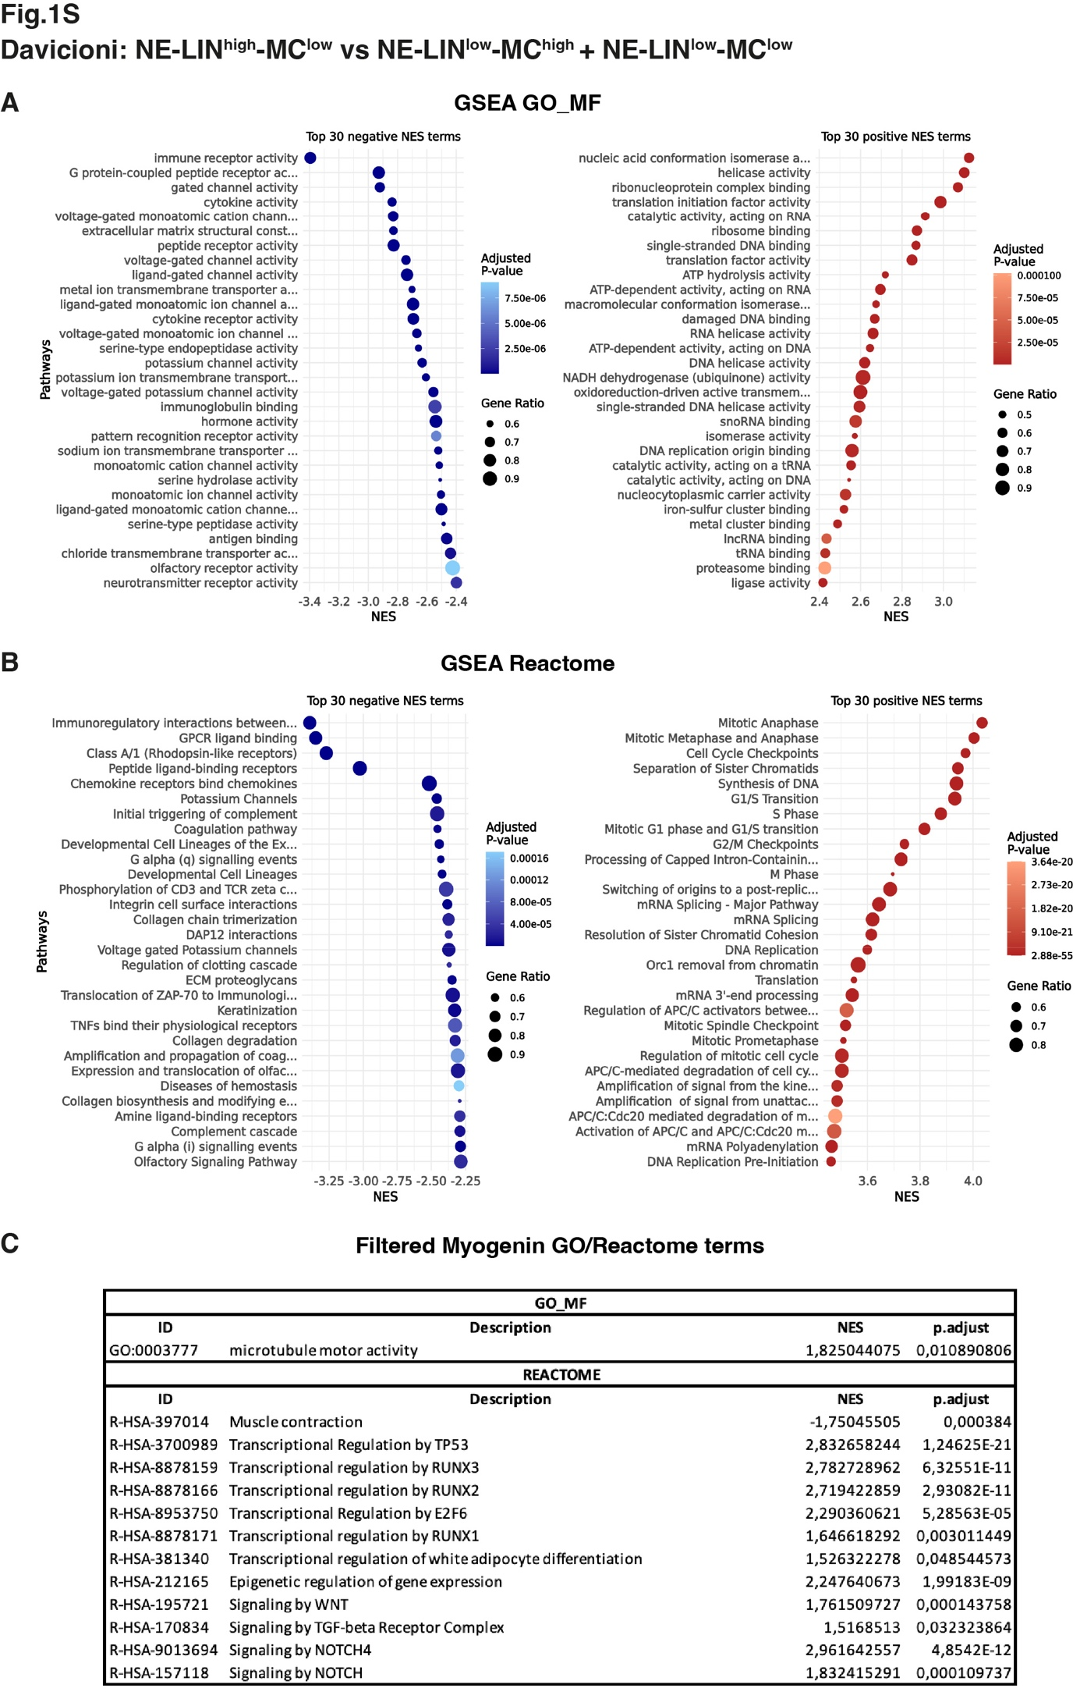
Supplementary Figure 1. Pathway enrichment analysis confirms the biological features of PAAS-RMS in the Davicioni datasets. A-B. Bubble plots illustrate the top-30 negative (left panels) and top-30 positive (right panels) enriched gene sets identified by GSEA in the NE-LIN^{high}/MC^{low} vs NE-LIN^{low}/MC^{high} + NE-LIN^{low}/MC^{low} comparison, ranked according to their normalized enrichment score (NES); only significantly enriched pathways are shown. C. Selected myogenesis-related gene sets significantly enriched in the NE-LIN^{high}/MC^{low} cluster. The table reports NES and adjusted P value for each gene set.

