Figure S1. Classification standard of m⁶A clusters.
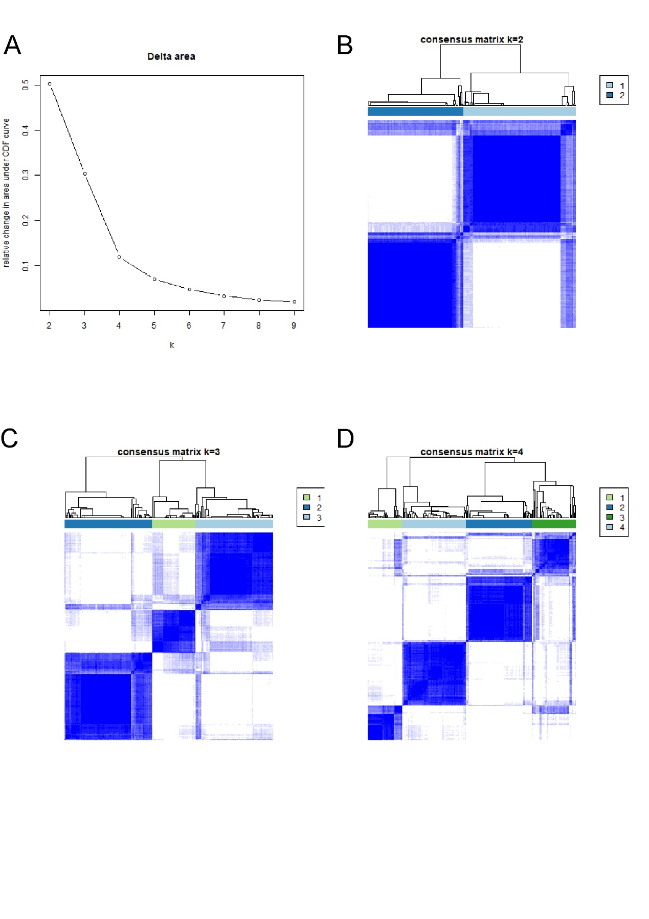
(A) Curve of cumulative distribution. When k equals to three, area under the curve (AUC) does not increased significantly. (B)-(D) The internal correlation of classifications when k value ranges from two to four. When k value equals to three, the internal correlation of classifications is the mostly close with abundant samples.
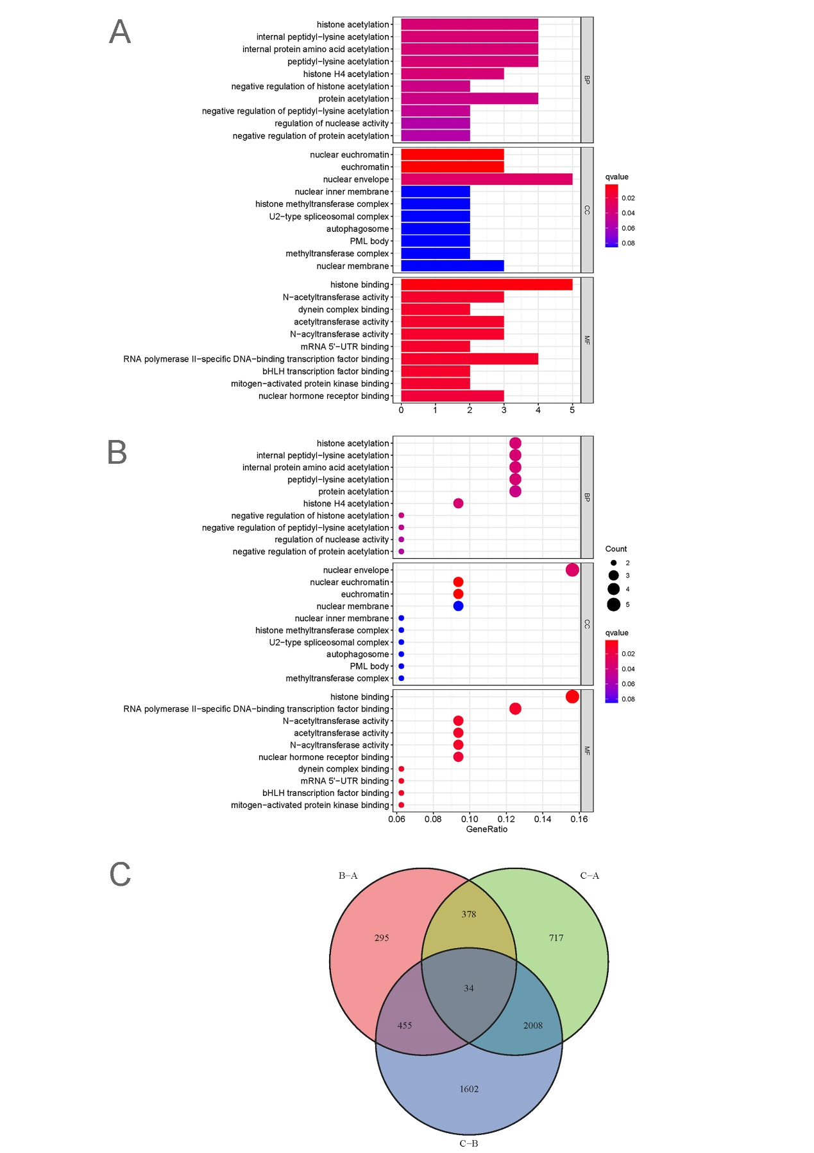
Figure S2. GO enrichment analysis and intersection of DEGs.
- Bar plot. Enrichment sites and biological function were determined by p value. (B) Bubble plot. Enrichment sites and biological function were determined by p value.(C) Intersection of cluster A, cluster B and cluster C. 34 different expression genes(DEGs) got indentified.
Figure S3. Classification testimonies of m⁶A prognositic-related genes.
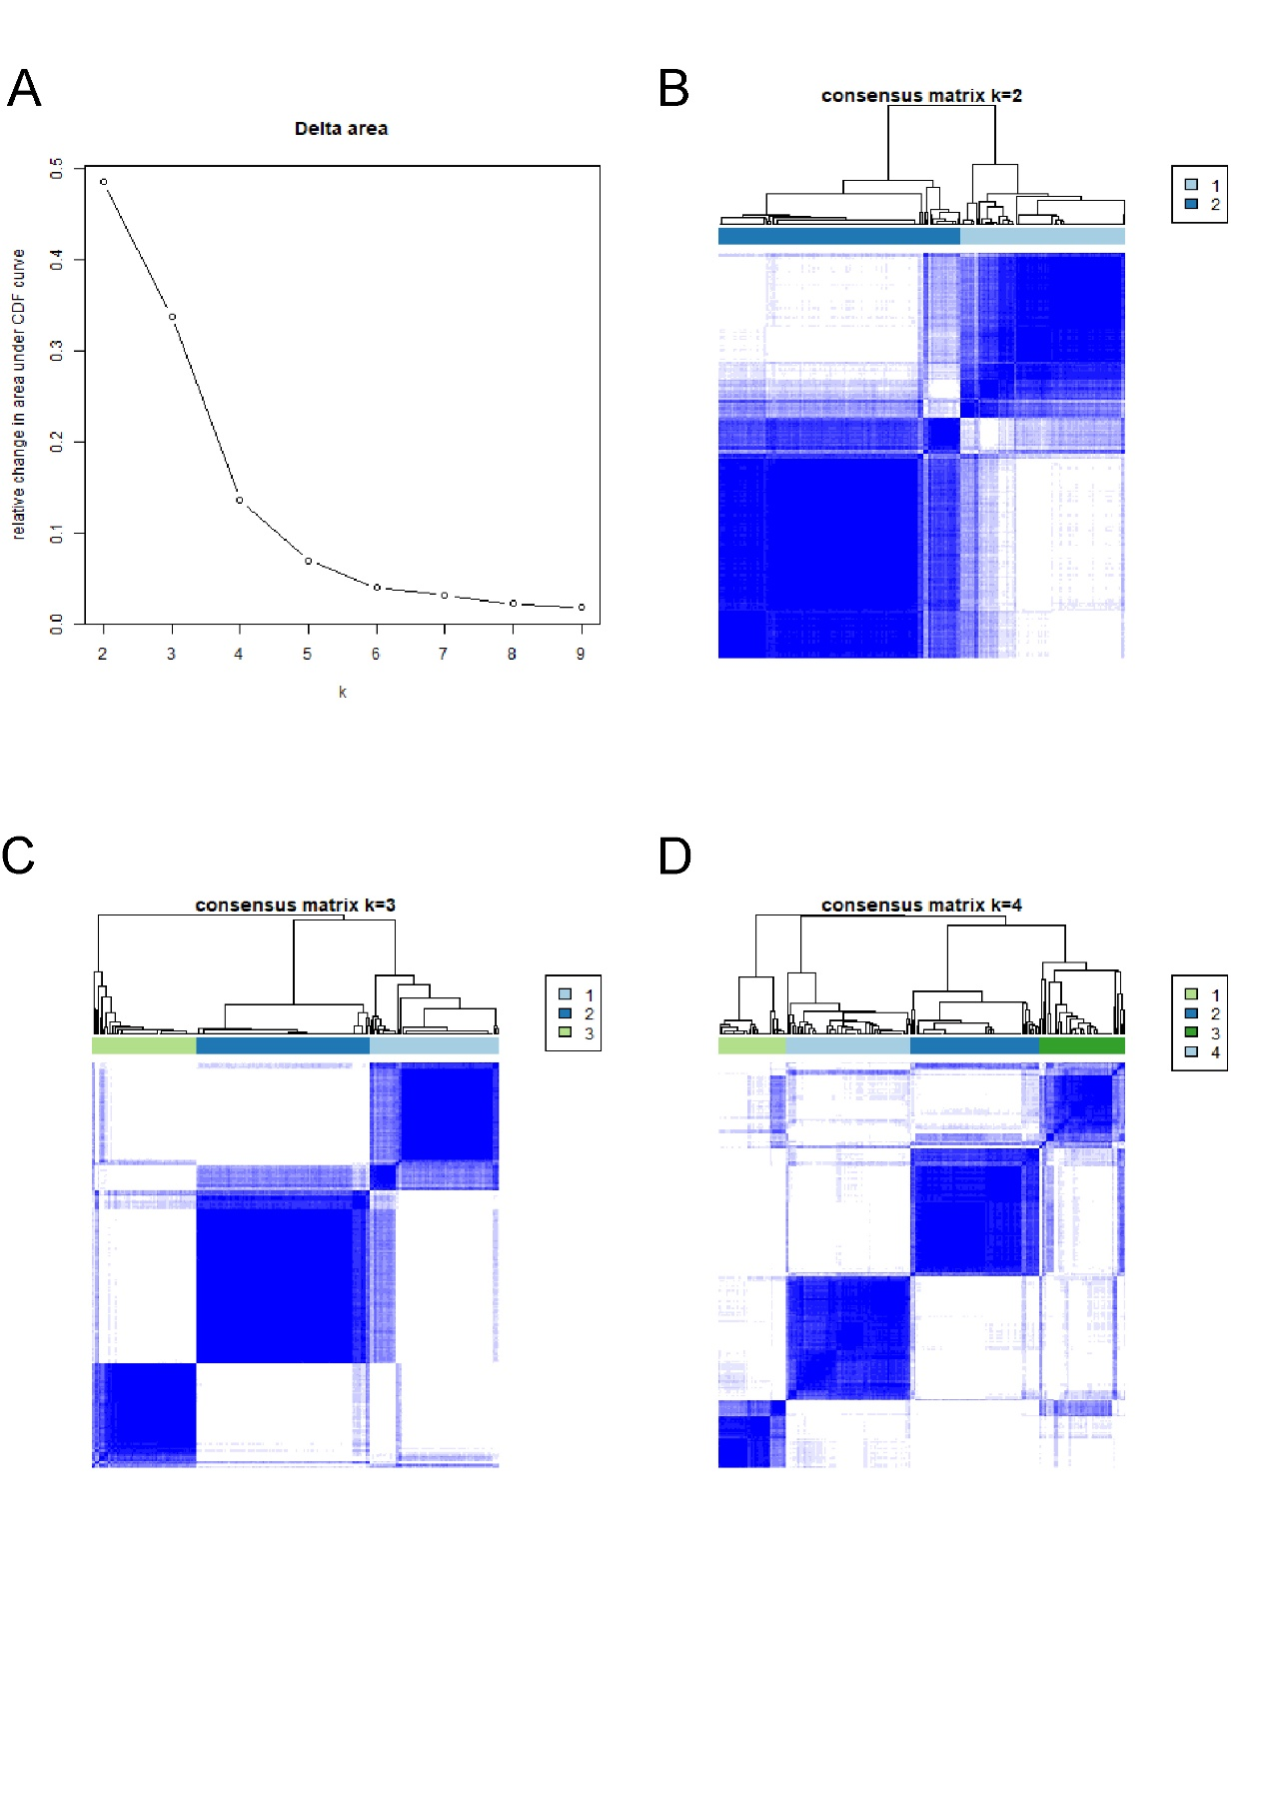
- Curve of cumulative distribution. When k value equals to three, area under the curve (AUC) does not increase prominently. (B) When k value equals to two, internal correlation status between classifications. (C) When k value equals to three, internal correlation status among classifications. (D) When k value equals to four, internal correlation status among classifications.
Figure S4. Survival status in different clinical classifications based on m⁶Ascore.
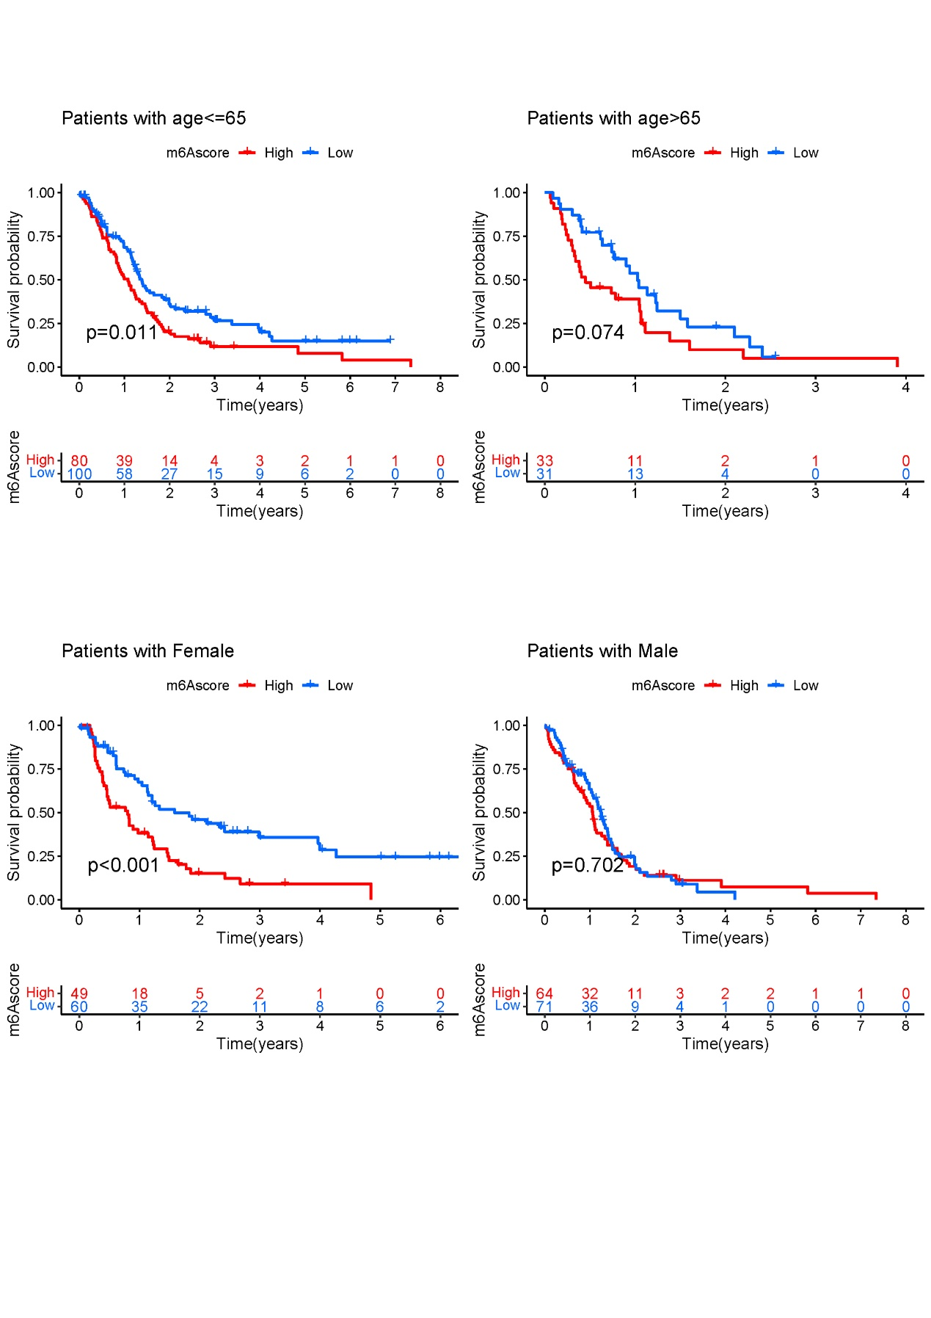
- Survival curve graph of patients younger than 65 years old. (B) Survival curve graph of patients older than 65 years old. (C) Survival curve graph of female’s group. (D) Survival curve graph of male’s group.

