Supporting Information
Molecular substitution controls film connectivity and charge transport in pyrene-based organic field-effect transistors
Ziya Dağalan, Fatma Bayrakçeken Nişancı, Hasan Feyzi Budak and Betül Güzeldir*
Corresponding author: bguzeldir@atauni.edu.tr

Experimental Characterization Data

Electrochemical Characterization

Cyclic voltammetry (CV) measurements were performed to investigate the electrochemical properties of the synthesized pyrene derivatives and to estimate their frontier molecular orbital energy levels. The measurements were carried out at room temperature in anhydrous acetonitrile (CH₃CN) containing 0.1 M tetrabutylammonium perchlorate (TBAP) as the supporting electrolyte. Thin films of Py-1–Py-4 deposited on ITO-coated glass substrates were used as the working electrodes, and Ag/AgCl was employed as the reference electrode. The cyclic voltammograms were recorded over a potential range from −2.0 to +2.0 V at a scan rate of 50 mV s⁻¹.

All four pyrene derivatives exhibited oxidation and reduction processes within the investigated potential window. The oxidation onset potentials were approximately 0.94, 1.58, 1.09, and 0.85 V for Py-1, Py-2, Py-3, and Py-4, respectively, whereas the corresponding reduction onset potentials were −1.24, −1.40, −1.48, and −1.64 V. The oxidation and reduction onset potentials were used to estimate the HOMO and LUMO energy levels, respectively. The resulting HOMO energies were −5.647, −6.292, −5.800, and −5.560 eV, while the corresponding LUMO energies were −3.469, −3.302, −3.227, and −3.070 eV for Py-1–Py-4, respectively. The electrochemical energy gap (Eg^{EC}) was determined from the difference between the LUMO and HOMO energy levels.

Py-1
Yellow powder; yield: 85%; mp: 212–213 °C. ^1H NMR (400 MHz, CDCl₃) δ 8.26 (d, J = 7.8 Hz, 1H), 8.23 (dd, J = 7.6, 1.2 Hz, 1H), 8.20 (dd, J = 7.6, 1.2 Hz, 1H), 8.13 (m, 2H), 8.07–8.04 (m, 2H), 7.92 (d, J = 7.8 Hz, 1H), 7.78 (d, J = 9.2 Hz, 1H), 7.67 (s, 1H), 7.19 (s, 1H), 3.94 (s, 3H), 3.73 (s, 3H). ^13C NMR (101 MHz, CDCl₃) δ 150.85, 147.57, 138.54, 137.13, 131.77, 131.51, 131.44, 130.94, 129.01, 128.09, 128.01, 127.45, 127.42, 126.33, 125.66, 125.43, 125.03, 124.78, 124.76, 124.62, 118.26, 108.61, 57.27, 56.52. ESI-QTOF m/z (%): (M+H)+ calcd for C24H17NO4: 384.1230; found: 384.1230.

Py-2
Yellow powder; yield: 90%; mp: 187–188 °C. ^1H NMR (400 MHz, CDCl₃) δ 8.25–8.16 (m, 3H), 8.14 (d, J = 2.1 Hz, 1H), 8.11 (d, J = 3.0 Hz, 2H), 8.07 (s, 2H), 8.04 (t, J = 7.6 Hz, 1H), 7.93 (d, J = 7.9 Hz, 1H), 7.80 (dd, J = 8.5, 2.3 Hz, 1H), 7.27 (d, J = 8.6 Hz, 1H), 4.08 (s, 3H). ^13C NMR (100 MHz, CDCl₃) δ 152.32, 139.75, 136.21, 134.53, 133.75, 131.53, 131.16, 130.94, 128.58, 128.27, 127.97, 127.54, 127.44, 126.35, 125.62, 125.28, 125.06, 124.87, 124.38, 113.66, 56.86. ESI-QTOF m/z (%): (M+H)+ calcd for C23H15NO3: 354.1125; found: 354.1122.

Py-3
Yellow powder; yield: 87%; mp: 140–141 °C. ^1H NMR (400 MHz, CDCl₃) δ 8.25 (d, J = 7.8 Hz, 1H), 8.21–8.16 (m, 2H), 8.11–8.08 (m, 2H), 8.03–7.98 (m, 3H), 7.91 (d, J = 9.2 Hz, 1H), 7.10–6.99 (m, 3H), 3.85 (s, 3H), 3.67 (s, 3H). ^13C NMR (100 MHz, CDCl₃) δ 153.67, 151.75, 134.23, 131.51, 131.12, 131.01, 130.84, 129.27, 128.03, 127.58, 127.45, 127.27, 126.00, 125.98, 125.12, 124.98, 124.95, 124.83, 124.62, 118.21, 113.83, 112.65, 56.48, 55.94. ESI-QTOF m/z (%): (M+H)+ calcd for C24H18O2: 339.1380; found: 339.1378.

Py-4
Yellow powder; yield: 92%; mp: 165–166 °C. ^1H NMR (400 MHz, CDCl₃) δ 8.51 (t, J = 2.0 Hz, 1H), 8.36–8.32 (m, 1H), 8.23 (d, J = 7.9 Hz, 2H), 8.19 (d, J = 6.8 Hz, 1H), 8.16–8.09 (m, 2H), 8.09–8.00 (m, 3H), 7.94 (d, J = 7.9 Hz, 2H), 7.71 (t, J = 7.9 Hz, 1H). ^13C NMR (100 MHz, CDCl₃) δ 148.49, 142.99, 136.76, 134.71, 131.49, 131.41, 130.88, 129.43, 128.46, 128.44, 128.17, 127.45, 127.40, 126.40, 125.75, 125.40, 125.00, 124.88, 124.80, 124.17, 122.32. ESI-QTOF m/z (%): (M+H)+ calcd for C22H13NO2: 324.1019; found: 324.1011.

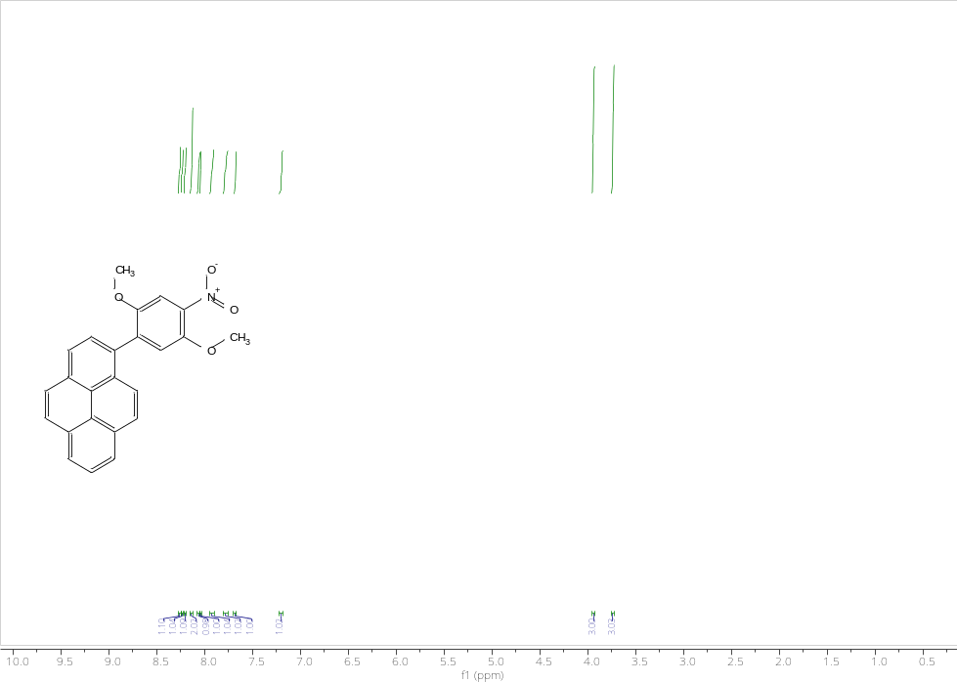
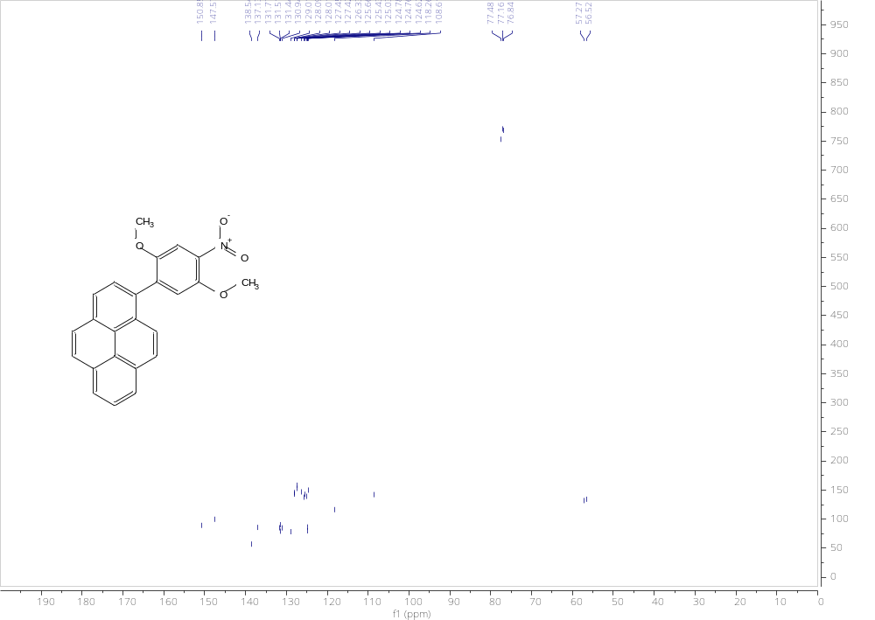
Figure S1. 1H NMR (400 MHz) and 13C NMR (100 MHz) spectra of Py-1 recorded in CDCl3, confirming the successful formation of the conjugated pyrene framework.

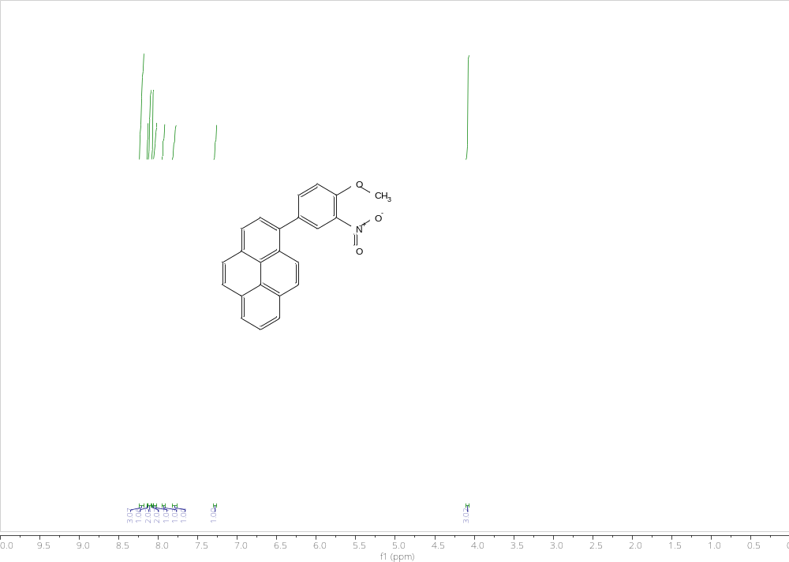
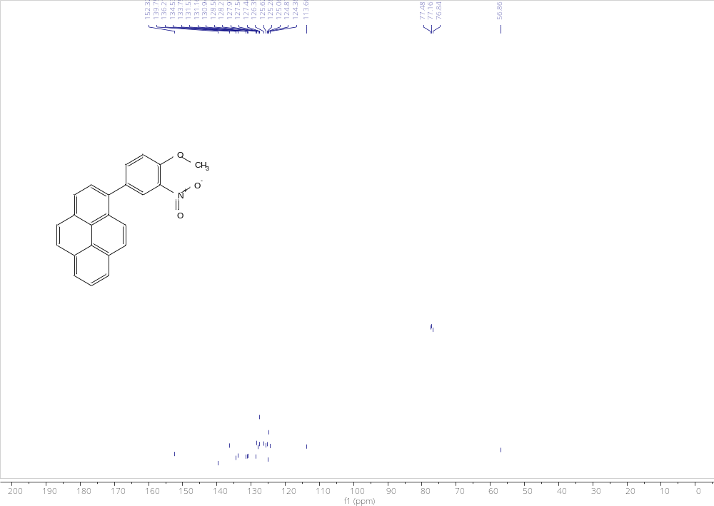
Figure S2. 1H NMR (400 MHz) and 13C NMR (100 MHz) spectra of Py-2 recorded in CDCl3, confirming the successful synthesis and structural integrity of the substituted pyrene-based conjugated semiconductor derivative.
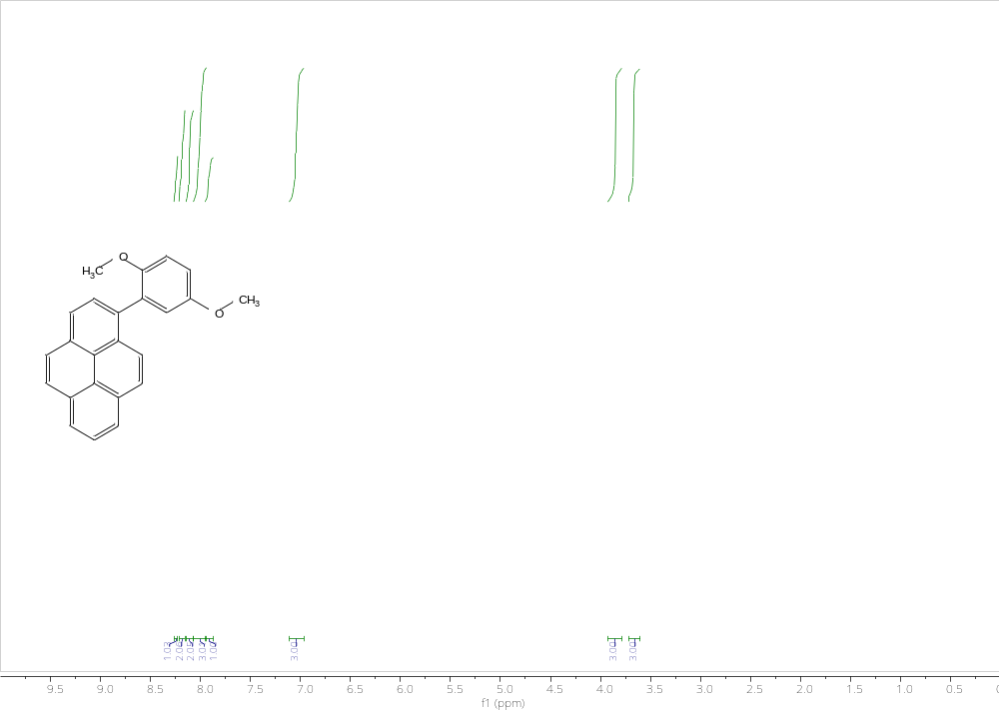
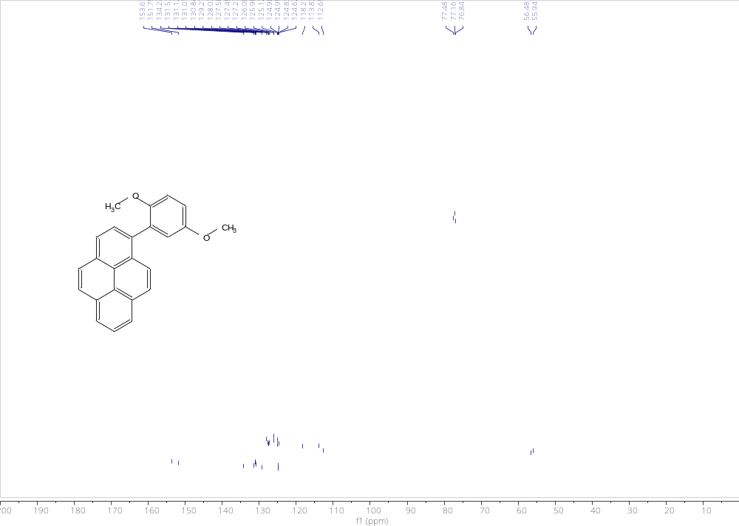
Figure S3. 1H NMR (400 MHz) and 13C NMR (100 MHz) spectra of Py-3 recorded in CDCl3, verifying the successful incorporation of the conjugated aromatic substituent groups within the pyrene framework.
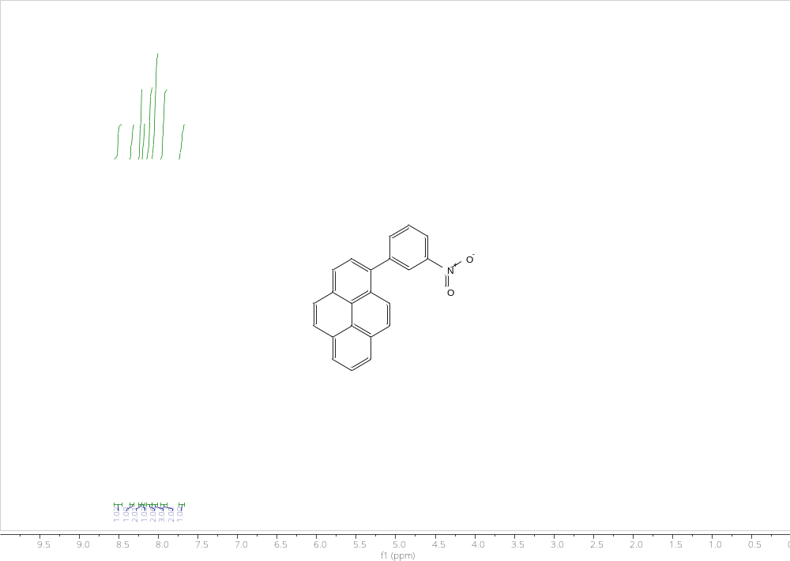
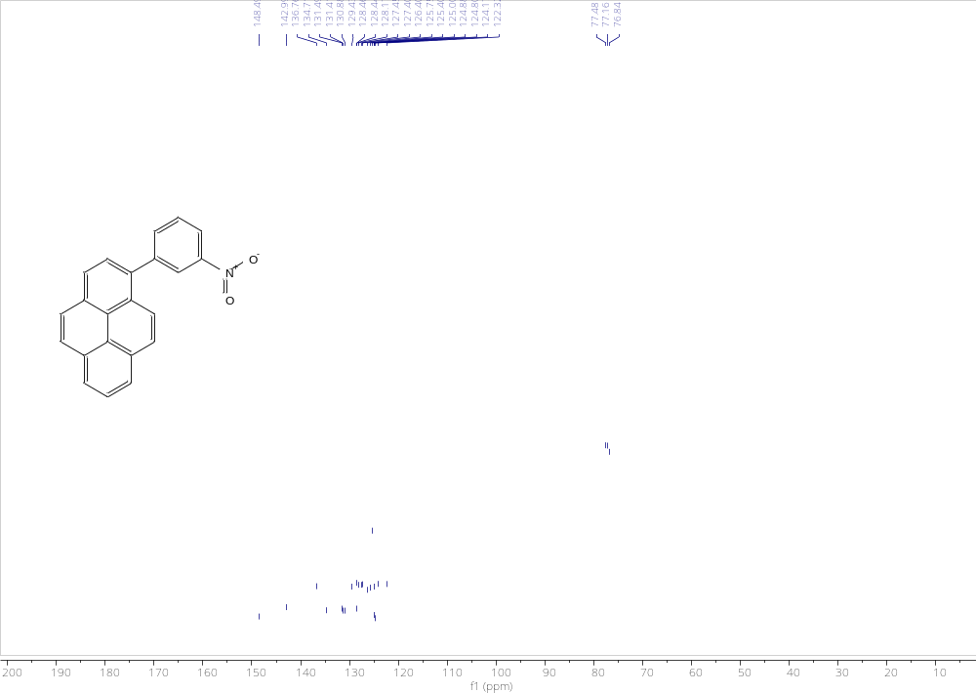
Figure S4. 1H NMR (400 MHz) and 13C NMR (100 MHz) spectra of Py-4 recorded in CDCl3, confirming the molecular integrity and conjugated architecture of the synthesized pyrene-based semiconductor system.

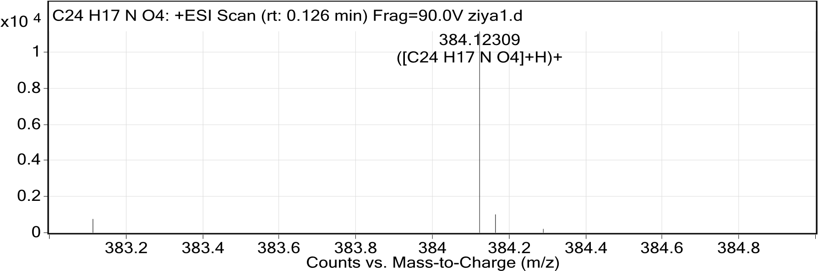
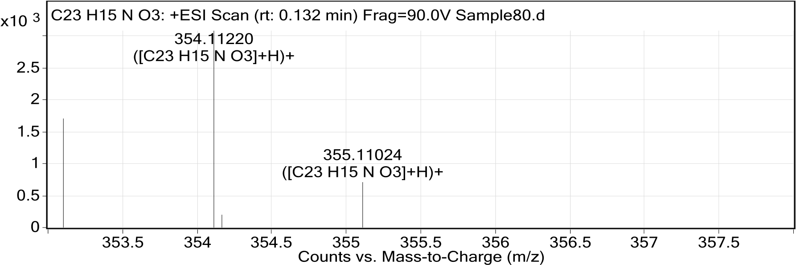
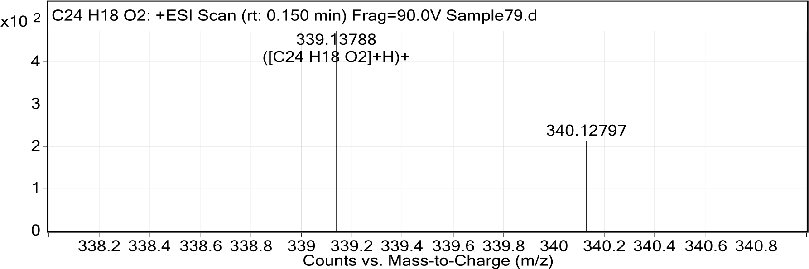
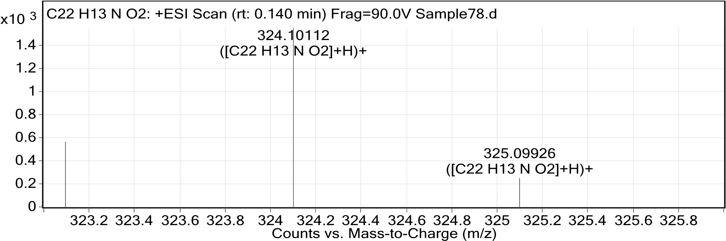

Figure S5. ESI-QTOF mass spectra of the synthesized pyrene-based semiconductor derivatives: (a) Py-1, (b) Py-2, (c) Py-3, and (d) Py-4. The experimentally observed molecular-ion signals are consistent with the calculated molecular masses of the corresponding derivatives.
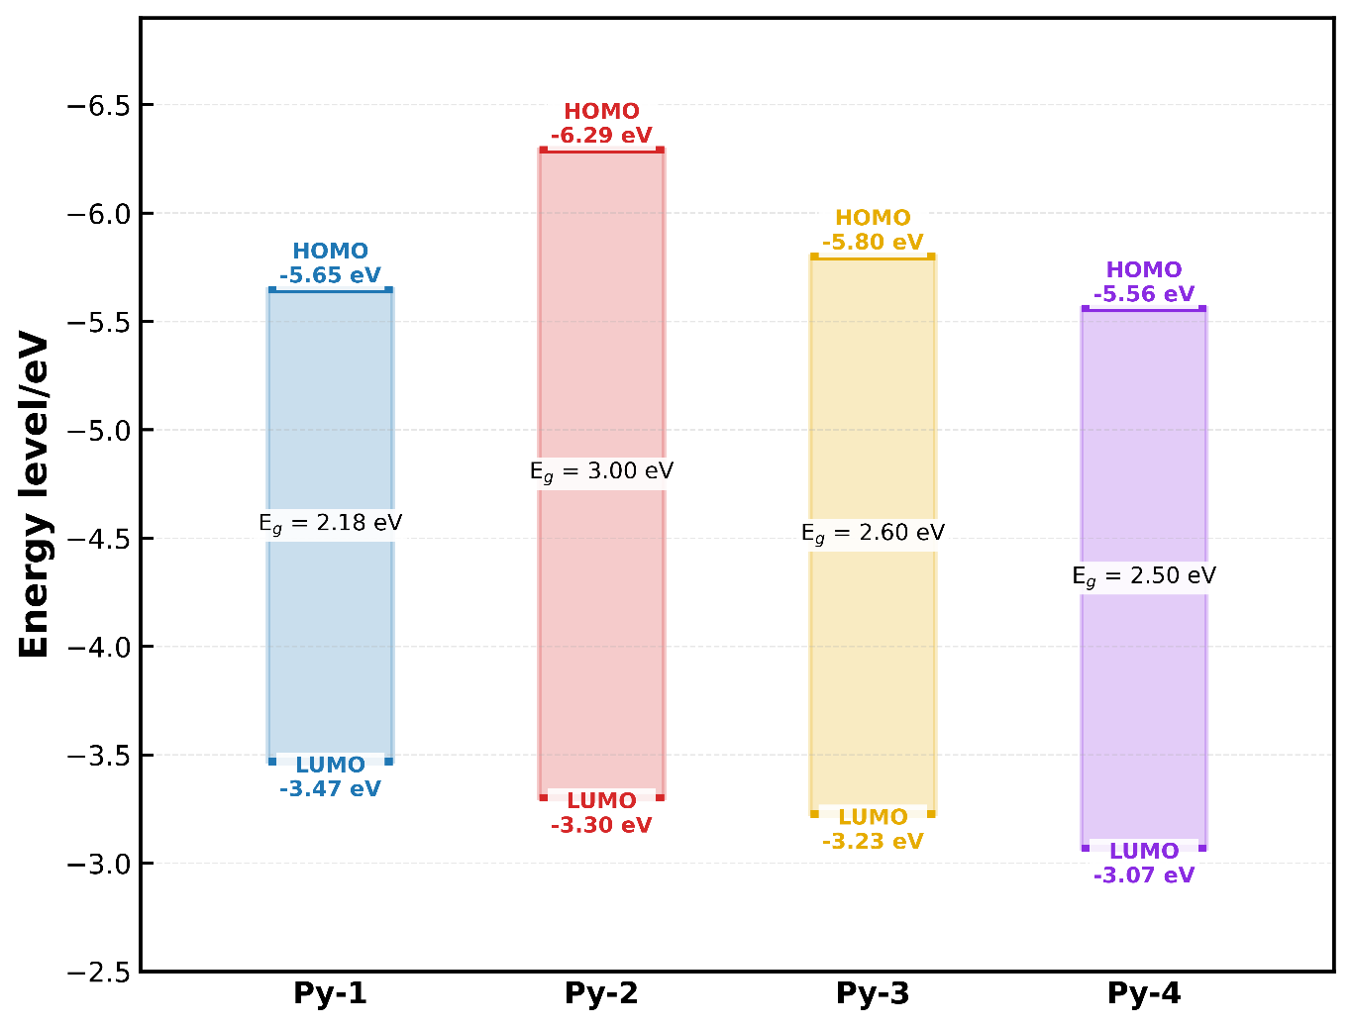

Figure S6. Electrochemically estimated energy-level alignment of the synthesized pyrene-based semiconductor derivatives (Py-1–Py-4), showing the thin-film HOMO and LUMO energy levels derived from cyclic-voltammetry measurements together with the corresponding electrochemical energy gaps (E_{g}EC). These values represent experimentally estimated thin-film electrochemical energy levels and are distinct from the gas-phase Kohn–Sham orbital energies obtained from the DFT calculations.

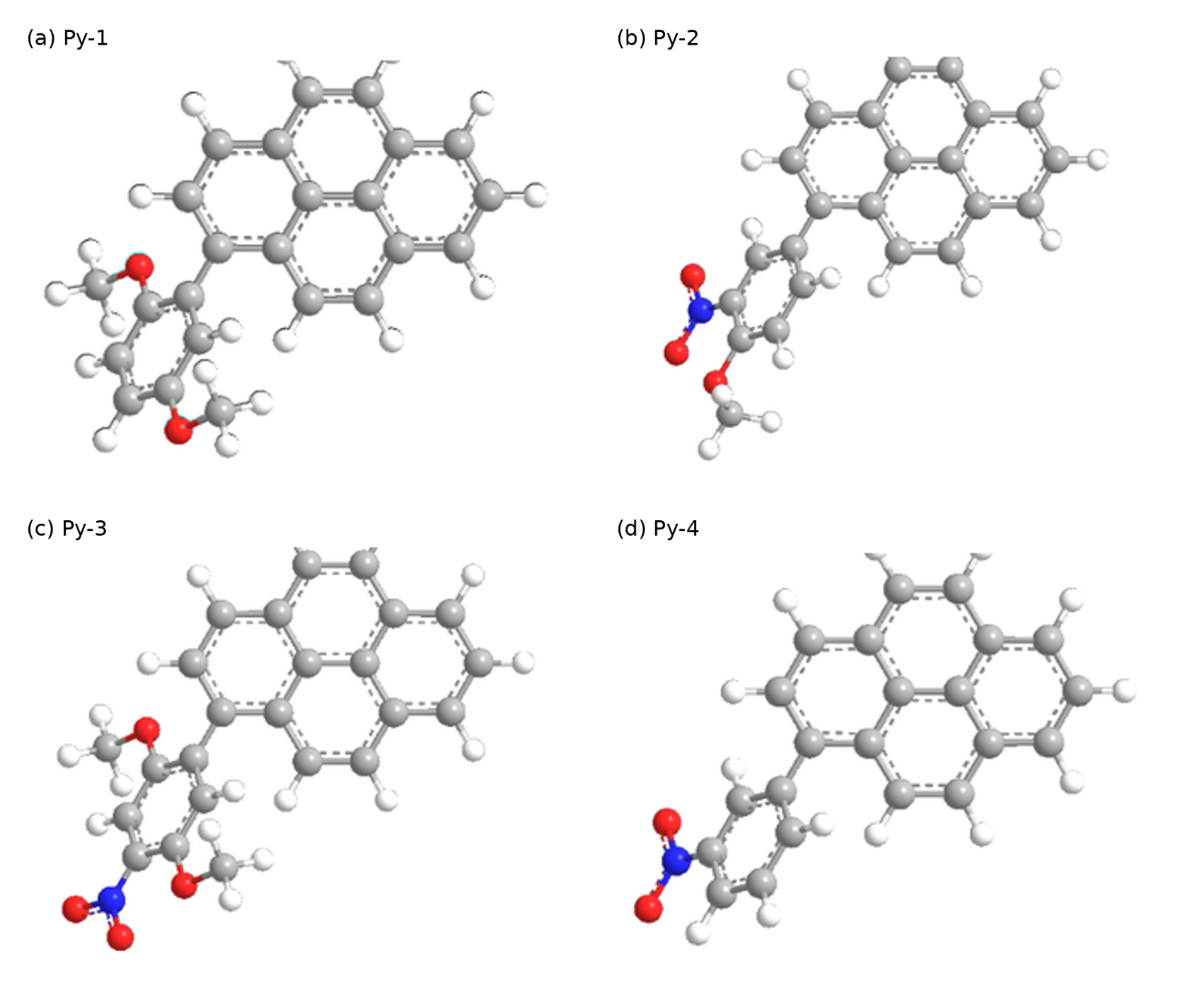
Figure S7. Three-dimensional optimized molecular geometries of the synthesized pyrene-based semiconductor derivatives: (a) Py-1, (b) Py-2, (c) Py-3, and (d) Py-4. The calculated structures reveal substituent-dependent differences in molecular conformation, steric arrangement, and orientation of the conjugated framework. These molecular-level differences provide a structural basis for considering the distinct optical, morphological, and electronic responses observed across the Py-1–Py-4 series; however, the optimized molecular geometries are not interpreted as direct evidence of a specific solid-state packing motif.

Computational Details and Additional Electronic-Structure Data
Density functional theory calculations were performed using the PySCF quantum-chemistry framework at the B3LYP/6-31G(d,p) level. The neutral Py-1–Py-4 molecules were treated using restricted Kohn–Sham (RKS) calculations, whereas the corresponding radical cations were treated using unrestricted Kohn–Sham (UKS) calculations with a total charge of +1 and a doublet spin state. The neutral and radical-cation geometries were independently optimized prior to the final electronic-structure calculations.
Adiabatic ionization potentials (IP_{ad}) were obtained from the energy difference between the independently optimized radical-cation and neutral states. Internal hole reorganization energies (λ_{h}) were calculated using the four-point approach described in the main manuscript. In addition to the optimized-state energies, single-point calculations were therefore performed for the radical cation at the optimized neutral geometry, E⁺(Q₀), and for the neutral molecule at the optimized radical-cation geometry, E⁰(Q₊). The complete energy components used in the four-point analysis are summarized below.
The unrestricted calculations yielded ⟨S²⟩ values close to the ideal value of 0.75 expected for a pure doublet state, supporting only limited spin contamination in the radical-cation calculations. The calculated quantities reported here describe isolated-molecule electronic and structural-relaxation energetics and are therefore used for comparative analysis across the Py-1–Py-4 series rather than as direct representations of solid-state packing, intermolecular transfer integrals, or experimentally determined thin-film energy levels.

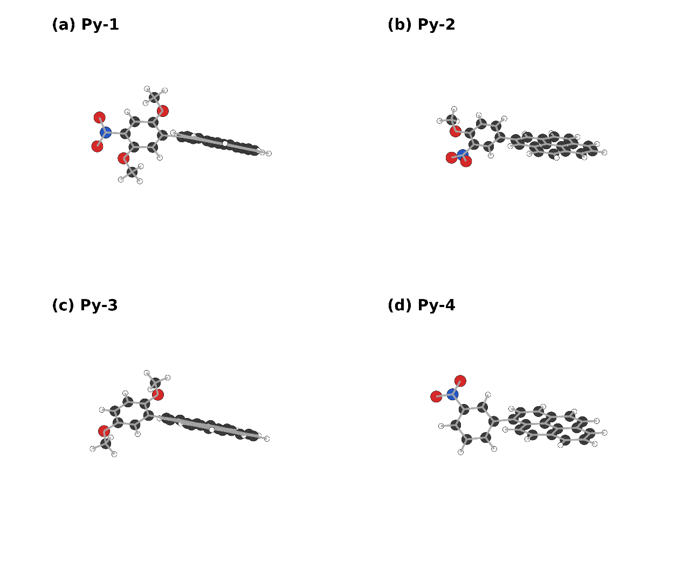

Figure S8. Optimized doublet radical-cation geometries of (a) Py-1, (b) Py-2, (c) Py-3, and (d) Py-4 calculated at the UKS-B3LYP/6-31G(d,p) level. The independently optimized cationic structures were used in the calculation of the adiabatic ionization potentials and internal hole reorganization energies.

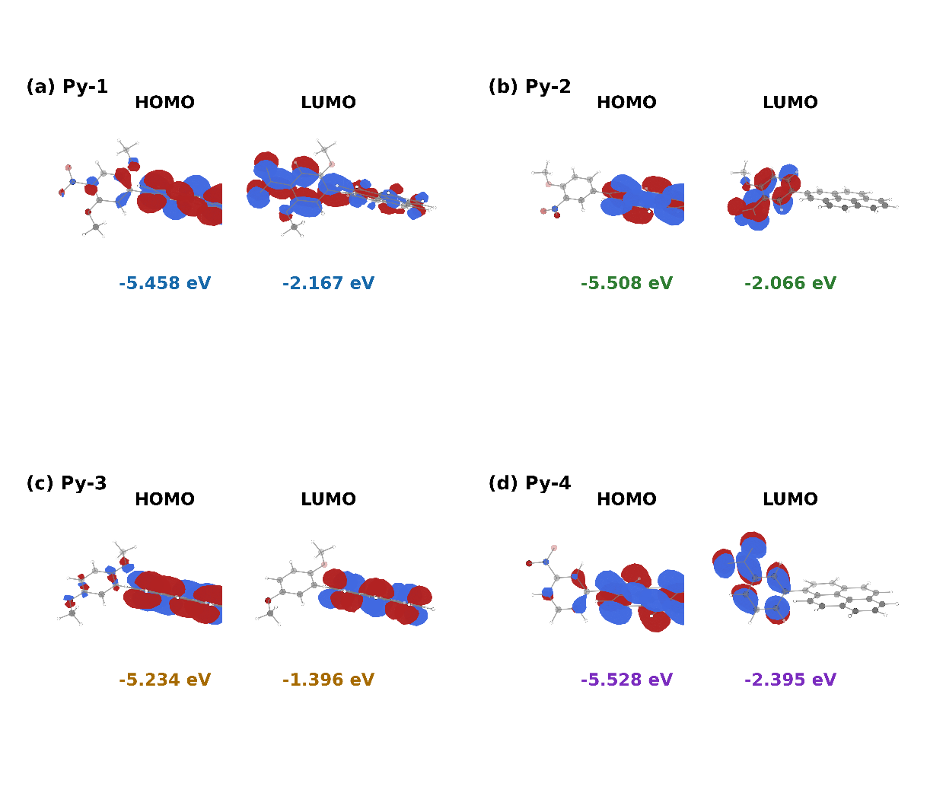

Figure S9. Calculated frontier molecular orbital distributions of (a) Py-1, (b) Py-2, (c) Py-3, and (d) Py-4 obtained for the optimized neutral geometries at the B3LYP/6-31G(d,p) level. HOMO and LUMO isosurfaces are displayed using a common isovalue of 0.025 a.u., with red and blue regions representing opposite orbital phases. The corresponding Kohn–Sham orbital energies are indicated for each derivative. The orbital distributions are used to compare substituent-dependent intrinsic electronic characteristics across the Py-1–Py-4 series and should not be interpreted as direct representations of solid-state intermolecular electronic coupling.

Table S1. Electrochemical parameters of the synthesized pyrene-based semiconductor derivatives obtained from cyclic voltammetry measurements. The tabulated gaps are retained as reported; subtraction of rounded onset potentials yields 2.18, 2.98, 2.57, and 2.49 eV, respectively.
Sample | E_{red, onset} (V) | E_{ox, onset} (V) | HOMO (eV) | LUMO (eV) | E_{g}^{EC} (eV)
Py-1 | −1.24 | 0.94 | −5.647 | −3.469 | 2.18
Py-2 | −1.40 | 1.58 | −6.292 | −3.302 | 2.99 ≈ 3.00
Py-3 | −1.48 | 1.09 | −5.800 | −3.227 | 2.57 ≈ 2.60
Py-4 | −1.64 | 0.85 | −5.560 | −3.070 | 2.49 ≈ 2.50

Table S2. Summary of the optical absorption maxima (λ_{abs}​), photoluminescence emission maxima (λ_{PL}​), electrochemically estimated HOMO and LUMO energy levels, and electrochemical energy gaps (Eg^{EC}​) of the synthesized pyrene-based semiconductor derivatives.
Sample | λabs (nm) | λPL (nm) | HOMO (eV) | LUMO (eV) | E_{g}^{EC} (eV)
Py-1 | 345 | 548 | −5.647 | −3.469 | 2.18
Py-2 | 351 | 464 | −6.292 | −3.302 | 3.00
Py-3 | 337 | 562 | −5.800 | −3.227 | 2.60
Py-4 | 349 | 543 | −5.560 | −3.070 | 2.50

Table S3. Total electronic energies used for the four-point calculation of the internal hole reorganization energy (λ_{h}) and the resulting adiabatic ionization potentials of Py-1–Py-4 at the B3LYP/6-31G(d,p) level.
Compound | E⁰(Q₀) (Ha) | E⁺(Q₊) (Ha) | E⁺(Q₀) (Ha) | E⁰(Q₊) (Ha) | λ₁ (eV) | λ₂ (eV) | λ_{h} (eV) | IP_{ad} (eV)
Py-1 | −1280.36025135 | −1280.11446090 | −1280.10986009 | −1280.35561199 | 0.1252 | 0.1262 | 0.2514 | 6.6883
Py-2 | −1165.84404995 | −1165.59100930 | −1165.58766616 | −1165.84083401 | 0.0910 | 0.0875 | 0.1785 | 6.8856
Py-3 | −1075.87526435 | −1075.63835275 | −1075.63505478 | −1075.87174209 | 0.0897 | 0.0958 | 0.1856 | 6.4467
Py-4 | −1051.32668398 | −1051.07392382 | −1051.07051841 | −1051.32329493 | 0.0927 | 0.0922 | 0.1849 | 6.8780

Note: Q₀ and Q₊ denote the independently optimized neutral and radical-cation geometries, respectively. E⁰(Q₀) and E⁺(Q₊) are the corresponding optimized-state electronic energies, whereas E⁺(Q₀) and E⁰(Q₊) are cross-geometry single-point energies. The individual relaxation contributions were calculated as λ₁=E⁺(Q₀) −E⁺(Q₊) and λ₂=E⁰(Q₊) −E⁰(Q₀), with λ_{h}=λ₁+λ₂. IP_{ad} was obtained from E⁺(Q₊) −E⁰(Q₀). Energies in hartree (Ha) were converted to electronvolts using 1 Ha = 27.211386 eV.

Table S4. Spin-state diagnostics for the radical-cation calculations of Py-1–Py-4.
Compound | ⟨S²⟩,  optimized cation Q₊ | ⟨S²⟩, E⁺(Q₀) | Ideal ⟨S²⟩ | Spin state
Py-1 | 0.7668 | 0.7641 | 0.7500 | Doublet
Py-2 | 0.7728 | 0.7708 | 0.7500 | Doublet
Py-3 | 0.7614 | 0.7611 | 0.7500 | Doublet
Py-4 | 0.7700 | 0.7680 | 0.7500 | Doublet

Note: For an ideal pure doublet state, the expectation value of the total spin operator is ⟨S²⟩ = 0.750. The values obtained for both the independently optimized radical cations and the cross-geometry E⁺(Q₀) calculations remain close to this value, indicating limited spin contamination across the Py-1–Py-4 series.

