Supporting Information

Clustering of Spin-labeled Drug Fenofibrate in Lipid Raft-mimicking Bilayers

Anastasiya N. Atnyukova,^{1,2} Denis S. Baranov,² Andrey Yu. Komarovskikh,² Sergei A. Dzuba²*

¹Department of Physics, Novosibirsk State University, Novosibirsk 630090, Russia
²Voevodsky Institute of Chemical Kinetics and Combustion, Russian Academy of Sciences, Novosibirsk 630090, Russia

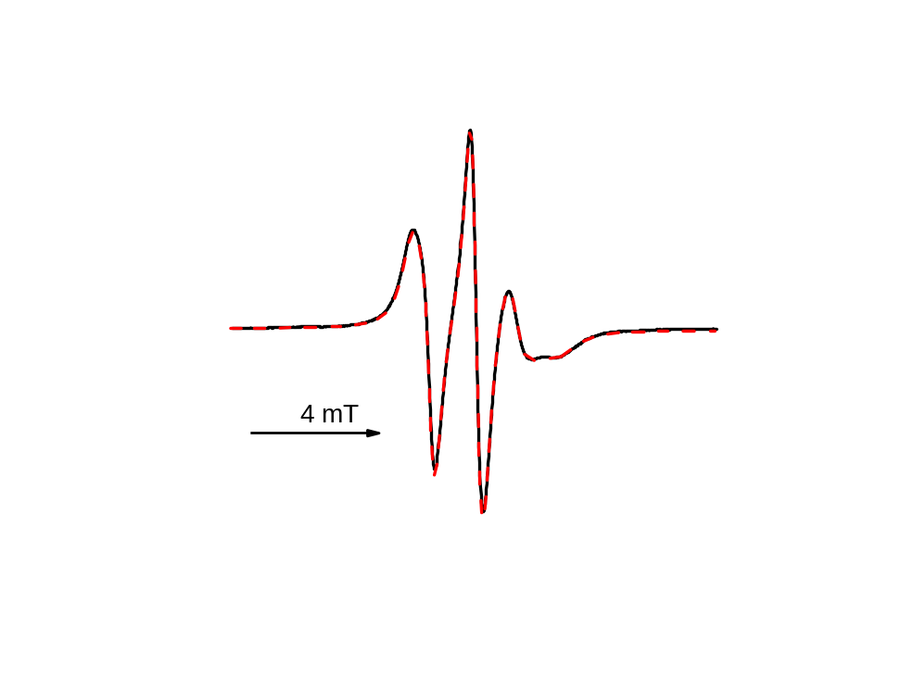

Figure S1. Room temperature EPR spectra of Feno-SL at its concentration χ = mol% in a DOPC/DPPC/Chol (35/35/30) bilayer before freezing (black solid line) and after freezing to 200 K and subsequent heating (red dashed line).

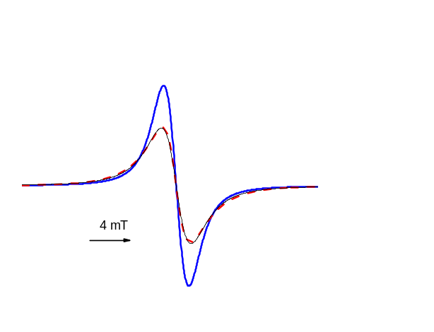
Figure S2. Thick blue solid line: the Voigt line shape used to simulate the EPR spectra in Figure 5B. Dashed red line: EPR spectra of Feno-SL powder obtained at 200 K. Thin solid black line: the best-fit Lorentzian line shape for the latter, with ΔB_{pp} = 3.03 mT. The spectra are normalized to constant second integral.

