Supplementary Information
Pharmacological and genetic induction of fetal haemoglobin converge on a shared transcriptional signature
Jack Odoyo Otieno and Osim Loisiligaki Kambei
Department of Studies in Biotechnology, University of Mysore, Mysuru, Karnataka 570006, India
Correspondence: otienojack06@gmail.com
Contents
Supplementary Methods — software, parameters and reproducibility
Fig. S1. Consensus depth and per-contrast differential expression
Fig. S2. Physicochemical space and drug-likeness of the candidate set
Table S1. Datasets and contrasts entering the consensus
Table S2. Consensus induced signature, 139 genes (Supplementary Data, sheet S2)
Table S3. Consensus repressed signature, 28 genes (Supplementary Data, sheet S3)
Table S4. Differential expression per contrast
Table S5. DSigDB signature-matching ranking
Table S6. Docking score matrix and ligand efficiency
Table S7. Redocking validation of each grid box
Table S8. Ligand-preparation control
Table S9. Physicochemical and predicted ADMET properties
Table S10. Safety and developability triage
Supplementary Methods
Differential expression
Counts were analysed with PyDESeq2 0.5.4 under a negative binomial model. Transcript-level quantifications (Salmon .sf for GSE247096, kallisto abundance tables for GSE284289) were summed to gene level by the tximport convention before fitting; series supplying gene-level counts were read directly. Donor was included as a covariate wherever more than one donor contributed to a contrast, and the deposited batch variable was included where the series defined one. Each matrix was checked for estimated rather than integer counts by the ratio of the largest to the smallest column sum: a spread below 1.05 indicates a library-size-normalised matrix (TPM or FPKM) and the series was rejected rather than rounded. Genes were called differentially expressed at Benjamini-Hochberg adjusted P < 0.05 and |log₂ fold change| ≥ 0.58, equivalent to a 1.5-fold change.
Mechanism-class consensus
Each of the ten contrasts was assigned to one of five mechanism classes by the molecular machinery it perturbs: A, PRC2/EED; B, AMPK; C, H3K9 methylation (WIZ, EHMT2); D, direct editing at the beta-globin locus or its enhancer; E, MBD2/NuRD. A gene entered the consensus signature when it was significant and directionally consistent in at least three distinct classes, with at least one pharmacological and at least one genetic contrast among them. This replaces the conventional split into a pharmacological arm and a genetic arm, which counts two perturbations of the same protein as independent evidence when they are not.
Signature matching
The induced signature was queried against L1000CDS² (CMap/LINCS L1000) and against DSigDB through Enrichr, with SigCom LINCS used as a cross-check. Positive controls specified in advance were decitabine, vorinostat, pomalidomide, thalidomide and hydroxyurea. Platform coverage was computed by intersecting the signature with the gene space each resource actually measures, which is the basis of the coverage audit in Fig. 3A of the main text.
Molecular docking
Receptors were prepared from the deposited PDB entries listed in Table S7. Where an entry contained several copies of the co-crystal ligand, copies were grouped by chain and residue number and the copy with the modal heavy-atom count was retained, so that the grid box encloses one binding site rather than the union of several. Waters and non-structural heteroatoms were removed; metals were retained with case-sensitive AutoDock types. Ligands were built from isomeric SMILES with RDKit ETKDGv3 embedding and MMFF94 minimisation, then written to PDBQT with Meeko, retaining all rotatable bonds. Docking used AutoDock Vina 1.2.5 at exhaustiveness 16 with a fixed seed of 42, reduced to exhaustiveness 8 for ligands with more than fifteen torsions and capped at 900 s of wall clock; a timeout is recorded as a missing score and never as zero. Each grid box was validated by redocking its own co-crystal ligand and requiring a heavy-atom RMSD below 2.0 Å against the crystallographic pose (Table S7). Ligand efficiency is the best score divided by the heavy-atom count.
The ligand-preparation control (Table S8) rebuilds each co-crystal ligand by the same flexible route used for the candidates and redocks it into its own pocket, which isolates the score shift attributable to preparation alone.
Physicochemical and safety profiling
Descriptors were computed with RDKit from canonical SMILES retrieved by PubChem CID (Table S9). Lipinski violations, Veber criteria, predicted human intestinal absorption and predicted blood-brain-barrier penetration follow the standard rule definitions. Regulatory status in Table S10 was verified against PubMed-indexed primary literature, cited by DOI; no status is asserted from model knowledge alone.
Reproducibility
All analysis code, intermediate matrices and docking inputs and outputs are deposited with the manuscript. Random seeds are fixed throughout (seed 42 for conformer generation and docking). Software versions: PyDESeq2 0.5.4, RDKit 2024.03, Meeko 0.6, AutoDock Vina 1.2.5, Python 3.11.
Supplementary Figures
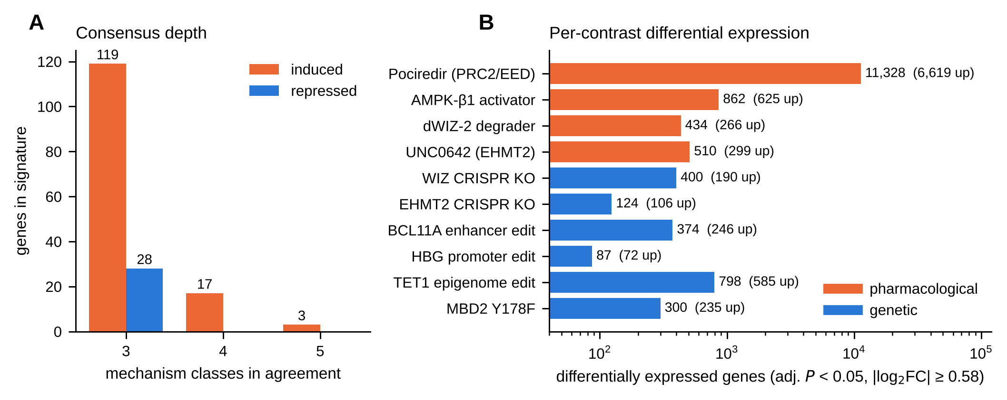
Fig. S1. Consensus depth and per-contrast differential expression. (A) Number of genes in the consensus signature as a function of how many of the five mechanism classes agree on the direction of change. Three classes is the inclusion threshold; 17 induced genes reach four classes and three reach all five. No repressed gene exceeds three classes, which is why the repressed signature is the weaker of the two. (B) Differentially expressed genes per contrast at adjusted P < 0.05 and |log₂ fold change| ≥ 0.58, on a logarithmic scale, with the induced count in parentheses. The pociredir dose series is two orders of magnitude larger than any other contrast; requiring agreement across mechanism classes, rather than pooling, is what prevents it from dominating the signature.
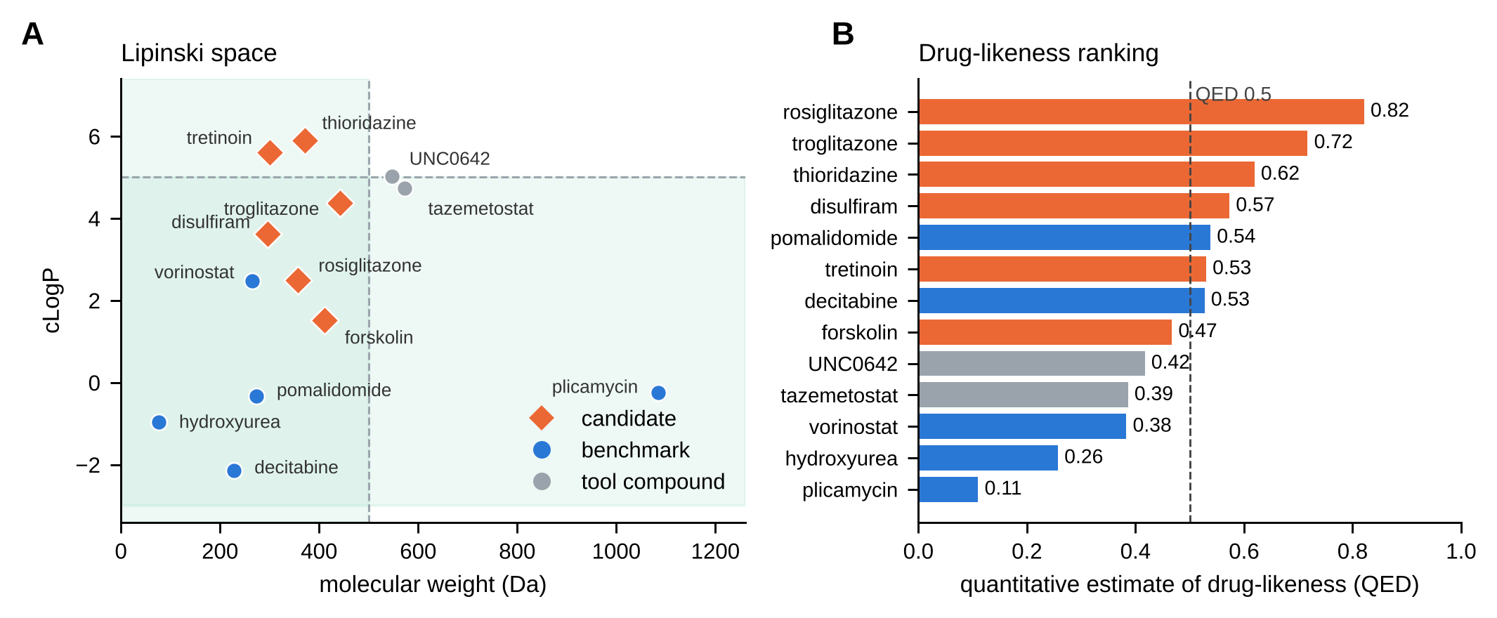
Fig. S2. Physicochemical space and drug-likeness of the candidate set. (A) Molecular weight against cLogP for the six candidates, five benchmarks and two tool compounds. The shaded region marks the Lipinski bounds of 500 Da and cLogP 5. Plicamycin sits far outside on both axes, consistent with its withdrawal; all six candidates fall inside or at the boundary. (B) Quantitative estimate of drug-likeness (QED). Rosiglitazone ranks highest of all thirteen compounds at 0.82, above every benchmark inducer, and hydroxyurea — the current standard of care — ranks second from last at 0.26. QED measures drug-likeness, not efficacy, so this is a developability observation and not a claim of superiority.

Supplementary Tables
Table S1. Datasets and contrasts entering the consensus. Ten contrasts drawn from five GEO series. Mechanism class is assigned by the machinery perturbed, not by whether the perturbation is a drug or an edit; GSE247096 contributes two pharmacological and two genetic contrasts within one experimental system, which is what makes the concordance test in Fig. 1 possible.
GEO accession | Contrast | Mechanism class | Arm | System | Replication | Series n | Platform | Processed data used
GSE309131 | Pociredir (PRC2/EED inhibitor) 11-300 nM vs DMSO | A (PRC2/EED) | pharmacological | CD34+ erythroid, day 14 | 3 donors, 3-4 reps/condition | 34 | NovaSeq X Plus (GPL34284) | gene-level counts
GSE223925 | AMPK-beta1 activator (oxindole compound B) vs DMSO | B (AMPK) | pharmacological | CD34+ cells | 3 per arm | 12 | HiSeq 2500 (GPL16791) | per-sample counts
GSE247096 | dWIZ-2 degrader vs DMSO | C (H3K9 methylation) | pharmacological | Erythroblasts, day 7 | 3 per condition | 60 | NovaSeq 6000 (GPL24676) | Salmon transcript quant
GSE247096 | UNC0642 (EHMT2/G9a inhibitor) vs DMSO | C (H3K9 methylation) | pharmacological | Erythroblasts, day 7 | 3 per condition | 60 | NovaSeq 6000 (GPL24676) | Salmon transcript quant
GSE247096 | WIZ CRISPR knockout vs non-targeting guides | C (H3K9 methylation) | genetic | Erythroblasts, day 7 | 3 per condition | 60 | NovaSeq 6000 (GPL24676) | Salmon transcript quant
GSE247096 | EHMT2 CRISPR knockout vs non-targeting guides | C (H3K9 methylation) | genetic | Erythroblasts, day 7 | 3 per condition | 60 | NovaSeq 6000 (GPL24676) | Salmon transcript quant
GSE264491 | CRISPR-Cas9 at BCL11A erythroid enhancer vs unedited | D (locus editing) | genetic | CD34+ erythroblasts, day 11 | 3 per arm | 9 | NovaSeq 6000 (GPL24676) | merged counts
GSE264491 | CRISPR-Cas9 at HBG1/2 promoter BCL11A site vs unedited | D (locus editing) | genetic | CD34+ erythroblasts, day 11 | 3 per arm | 9 | NovaSeq 6000 (GPL24676) | merged counts
GSE284289 | TET1 epigenome editing at HBG vs mock | D (locus editing) | genetic | HUDEP-2 | 3 per guide | 40 | GPL18573 + GPL24676 | kallisto transcript quant
GSE284289 | MBD2 Y178F mutant vs wild type | E (MBD2/NuRD) | genetic | HUDEP-2 | 5 per arm | 40 | GPL18573 + GPL24676 | kallisto transcript quant
Table S4. Differential expression per contrast. Thresholds as in the Methods. HBG1 and HBG2 fold changes are given for every contrast; both are significant in all ten, which is the primary on-target check.
Contrast | Arm | Mechanism class | Genes tested | DE genes (adj. P<0.05, |log2FC|>=0.58) | Induced | Repressed | HBG1 log2FC | HBG2 log2FC
Pociredir (PRC2/EED) | pharmacological | A (PRC2/EED) | 22337 | 11328 | 6619 | 4709
AMPK-beta1 activator | pharmacological | B (AMPK) | 16145 | 862 | 625 | 237
dWIZ-2 degrader | pharmacological | C (H3K9 methylation) | 14447 | 434 | 266 | 168
UNC0642 (EHMT2) | pharmacological | C (H3K9 methylation) | 17553 | 510 | 299 | 211
WIZ CRISPR KO | genetic | C (H3K9 methylation) | 18909 | 400 | 190 | 210
EHMT2 CRISPR KO | genetic | C (H3K9 methylation) | 19775 | 124 | 106 | 18
BCL11A enhancer edit | genetic | D (locus editing) | 14834 | 374 | 246 | 128
HBG promoter edit | genetic | D (locus editing) | 10124 | 87 | 72 | 15
TET1 epigenome edit | genetic | D (locus editing) | 14689 | 798 | 585 | 213
MBD2 Y178F | genetic | E (MBD2/NuRD) | 17075 | 300 | 235 | 65
Table S5. DSigDB signature-matching ranking. Positions of the pre-specified positive controls and of every candidate taken forward. Decitabine at rank 1 of 2,099 is the checkpoint the protocol required. Hydroxyurea's absence is expected and self-consistent: it produces few RNA-level changes in erythroid cells, so a transcriptional method should not recover it.
Rank (of 2,099) | Term | Adjusted P | Overlapping genes | Mechanism | Role
1 | Decitabine | 0.00062 | 29 | DNMT1 inhibitor | positive control - PASS
2 | Retinoic acid | 0.00081 |  | RAR agonist | candidate
3 | Thioridazine (PC3) | 0.0015 |  | dopamine D2 antagonist | candidate - excluded at Stage 5
4 | Colforsin | 0.0015 |  | forskolin analogue, cAMP | candidate
5 | Rosiglitazone | 0.0018 |  | PPAR-gamma agonist | candidate - lead
6 | Disulfiram | 0.0018 |  | ALDH inhibitor | candidate
7 | Ethacrynic acid | 0.0018 |  | loop diuretic | candidate
8 | Medroxyprogesterone | 0.0043 |  | progestin | candidate
10 | Estradiol | 0.0043 |  | oestrogen receptor agonist | candidate
11 | Aspirin | 0.0043 |  | COX inhibitor | candidate
12 | Troglitazone |  |  | PPAR-gamma agonist | candidate - excluded at Stage 5
13 | Thioridazine (MCF7) |  |  | dopamine D2 antagonist | independent replicate of rank 3
15 | Carvedilol | 0.0053 |  | beta blocker | candidate
16 | Tretinoin |  |  | RAR agonist | independent replicate of rank 2
27 | Vorinostat | 0.014 | 10 | HDAC inhibitor | positive control - PASS
1007 | Pomalidomide | 0.277 |  | cereblon modulator | positive control - not recovered
1311 | Thalidomide | 0.316 |  | cereblon modulator | positive control - not recovered
1576 | Hydroxyurea | 0.381 |  | ribonucleotide reductase inhibitor | positive control - not recovered (expected; weak transcriptional footprint)
Table S6. Docking score matrix and ligand efficiency. Vina scores in kcal/mol against the five validated targets. 'Not docked' marks a run that exceeded the wall-clock cap and is recorded as missing rather than as a score. Ligand efficiency is the best score per heavy atom and is reported because raw score correlates with size.
Compound | EHMT2/G9a | EED/PRC2 | LSD1/KDM1A | PPAR-gamma | RAR-alpha | Heavy atoms | Best score (kcal/mol) | Ligand efficiency (kcal/mol/HA)
tazemetostat | -8.342 | -9.291 | -10.24 | -8.308 | not docked | 42 | -10.24 | -0.244
disulfiram | -4.687 | -4.404 | -5.393 | -4.795 | -5.829 | 16 | -5.393 | -0.337
tretinoin | -7.42 | -8.246 | -7.899 | -7.405 | -10.33 | 22 | -8.246 | -0.375
troglitazone | -8.214 | -9.939 | -10.02 | -9.161 | -9.54 | 31 | -10.02 | -0.323
plicamycin | not docked | not docked | -8.97 | -4.9 | not docked | 76 | -8.97 | -0.118
thioridazine | -6.261 | -6.774 | -8.754 | -7.149 | -8.827 | 25 | -8.754 | -0.35
hydroxyurea | -4.052 | -4.819 | -3.834 | -3.832 | -3.726 | 5 | -4.819 | -0.964
vorinostat | -6.922 | -7.888 | -7.194 | -7.215 | -7.975 | 19 | -7.888 | -0.415
rosiglitazone | -6.62 | -8.349 | -8.165 | -7.788 | -9.457 | 25 | -8.349 | -0.334
pomalidomide | -6.427 | -7.584 | -7.719 | -6.666 | -8.558 | 20 | -7.719 | -0.386
forskolin | -5.873 | -5.817 | -8.084 | -6.462 | -3.807 | 29 | -8.084 | -0.279
decitabine | -5.718 | -7.029 | -6.475 | -5.579 | -6.525 | 16 | -7.029 | -0.439
UNC0642 | -8.802 | -8.335 | -9.436 | -8.979 | not docked | 39 | -9.436 | -0.242
Table S7. Redocking validation of each grid box. Every box reproduces its crystallographic pose well within the 2.0 Å gate, so pose recovery is not the limitation. Table S8 shows where the limitation actually lies.
PDB ID | Target | Co-crystal ligand (CCD) | Grid box (A) | Box centre (x, y, z) | Redock score (kcal/mol) | Heavy-atom RMSD (A) | Gate (RMSD < 2.0 A)
5VSE | EHMT2/G9a | 9HG | 21.2 x 20.4 x 20.0 | 6.4, 16.6, 27.6 | -10.03 | 0.24 | PASS
6W7G | EED/PRC2 | Q3A | 22.0 x 20.0 x 21.9 | 15.6, 24.3, 24.4 | -13.62 | 0.26 | PASS
5L3E | LSD1/KDM1A | E11 | 22.9 x 22.1 x 20.0 | -3.1, 47.2, 82.0 | -10.89 | 0.45 | PASS
4EMA | PPAR-gamma | BRL | 20.0 x 20.0 x 21.2 | 14.8, 7.1, 44.5 | -10.24 | 0.69 | PASS
6FX0 | RAR-alpha | E9T | 20.0 x 22.0 x 20.0 | 15.3, -10.0, -6.8 | -17.09 | 0.2 | PASS
Table S8. Ligand-preparation control. Each co-crystal ligand rebuilt by the flexible route used for the candidates and redocked into its own pocket. The mean preparation artefact of 2.67 kcal/mol exceeds most of the between-compound differences the matrix would otherwise be read as resolving; comparisons between a rigid reference and a flexibly prepared candidate are therefore not interpretable.
Target | Co-crystal ligand (CCD) | Rigid redock (kcal/mol) | Flexible rebuild (kcal/mol) | Preparation artefact (kcal/mol) | Best candidate (kcal/mol) | Candidate - flexible reference
EHMT2/G9a | 9HG | -10.03 | -7.631 | -2.4 | -8.21 | -0.58
EED/PRC2 | Q3A | -13.62 | -9.035 | -4.58 | -9.94 | -0.9
LSD1/KDM1A | E11 | -10.89 | -8.947 | -1.94 | -10.02 | -1.07
PPAR-gamma | BRL | -10.24 | -7.841 | -2.4 | not in panel | not in panel
RAR-alpha | E9T | -17.09 | -15.07 | -2.02 | not in panel | not in panel
Table S9. Physicochemical and predicted ADMET properties. Computed with RDKit from PubChem canonical SMILES. Predictions are rule-based and are reported as screening filters, not as measured values.
Compound | PubChem CID | MW (Da) | cLogP | TPSA (A^2) | H-bond donors | H-bond acceptors | Rotatable bonds | QED | Lipinski violations | Veber pass | HIA predicted | BBB predicted | Aromatic rings | Fraction Csp3
rosiglitazone | 77999 | 357.4 | 2.49 | 71.5 | 1 | 6 | 7 | 0.821 | 0 | True | True | True | 2 | 0.28
troglitazone | 5591 | 441.5 | 4.37 | 84.9 | 2 | 6 | 5 | 0.717 | 0 | True | True | False | 2 | 0.42
thioridazine | 5452 | 370.6 | 5.89 | 6.5 | 0 | 4 | 4 | 0.619 | 1 | True | False | True | 2 | 0.43
disulfiram | 3117 | 296.6 | 3.62 | 6.5 | 0 | 4 | 4 | 0.573 | 0 | True | True | True | 0 | 0.8
pomalidomide | 134780 | 273.2 | -0.33 | 109.6 | 2 | 5 | 1 | 0.538 | 0 | True | True | False | 1 | 0.23
tretinoin | 444795 | 300.4 | 5.6 | 37.3 | 1 | 1 | 5 | 0.53 | 1 | True | True | True | 0 | 0.45
decitabine | 451668 | 228.2 | -2.14 | 123.5 | 3 | 7 | 2 | 0.527 | 0 | True | False | False | 1 | 0.62
forskolin | 47936 | 410.5 | 1.52 | 113.3 | 3 | 7 | 2 | 0.467 | 0 | True | True | False | 0 | 0.82
UNC0642 | 53315878 | 546.7 | 5.02 | 66 | 1 | 8 | 10 | 0.417 | 2 | True | True | True | 2 | 0.72
tazemetostat | 66558664 | 572.8 | 4.73 | 86.9 | 2 | 6 | 9 | 0.386 | 1 | True | True | False | 3 | 0.47
vorinostat | 5311 | 264.3 | 2.47 | 78.4 | 3 | 3 | 8 | 0.383 | 0 | True | True | True | 1 | 0.43
hydroxyurea | 3657 | 76.1 | -0.96 | 75.4 | 3 | 2 | 0 | 0.257 | 0 | True | True | False | 0 | 0
plicamycin | 163659 | 1085.2 | -0.25 | 358.2 | 11 | 24 | 15 | 0.11 | 3 | False | False | False | 2 | 0.77
Table S10. Safety and developability triage. Regulatory status verified against primary literature and cited by DOI. The two best-scoring compounds from the docking stage, troglitazone and thioridazine, are both excluded here on safety grounds; rosiglitazone survives and retains the PPAR-gamma mechanism that appeared twice independently in the signature-matching stage.
Compound | Role | Mechanism | Regulatory and safety status | Verdict | DOI
Rosiglitazone | candidate | PPAR-gamma agonist | Black box warning and restricted access for myocardial infarction risk 2007-2010; restrictions removed November 2013. Non-iDILI comparator of its own class. | VIABLE, with caution | 10.18553/jmcp.2019.25.1.072
Tretinoin | candidate | RAR agonist | Approved for APL. Differentiation syndrome and teratogenicity are known and clinically managed. No myelosuppression signal. | VIABLE
Disulfiram | candidate | ALDH inhibitor | Approved for alcohol dependence. Weakest docking score of the candidate set. | VIABLE
Forskolin | candidate | adenylyl cyclase activator | Not an approved drug; supplement or tool compound. Limited human safety data. | VIABLE as tool only
Troglitazone | candidate | PPAR-gamma agonist | Withdrawn for idiosyncratic drug-induced liver injury; the reference iDILI-positive compound in the literature. | EXCLUDE | 10.3390/antiox12071315
Thioridazine | candidate | dopamine D2 antagonist | FDA-restricted with a black box warning for QTc prolongation and sudden death. | EXCLUDE | 10.1097/01.CHI.0000046860.56865.25
Hydroxyurea | benchmark | ribonucleotide reductase inhibitor | Approved for SCD. Myelosuppression is dose-limiting - the liability this study aims to avoid. | benchmark
Decitabine | benchmark | DNMT1 inhibitor | Approved for MDS/AML. Myelosuppression is dose-limiting. | benchmark
Vorinostat | benchmark | HDAC inhibitor | Approved for CTCL. Thrombocytopenia and anaemia are common. | benchmark
Plicamycin | benchmark | transcription inhibitor | Withdrawn. Severe bleeding diathesis and hepatotoxicity. | EXCLUDE
Supplementary Data
Supplementary_Data.xlsx contains all ten tables as machine-readable sheets, including the two that are too long to typeset here:
Sheet S2 — the full consensus induced signature, 139 genes, with Ensembl identifier, symbol, the mechanism classes in agreement, the number of contrasts in which the gene is significant, and the mean log₂ fold change.
Sheet S3 — the full consensus repressed signature, 28 genes, in the same format. Seventeen of the 28 are KRAB zinc-finger genes; as shown in the main text, these fall only under perturbation of chromatin machinery and are near-unchanged under direct locus editing, so they mark trans-acting perturbation rather than fetal haemoglobin induction.

