Supplementary Information For
The growth characteristics and metabolic profiling of Δ^{5,7}-sterols and fatty acids in Schizochytrium sp. S31 under different culture conditions
Xiao-Yu Zhang¹, Pei-Shan He², Yi-Nan Liao¹, Juan Peng^{1,}*, Jian-Ping Yuan¹, Jun Zhao¹
¹ School of Marine Sciences, State Key Laboratory of Environmental Adaptability for Industrial Products, Sun Yat-Sen University, and Southern Marine Science and Engineering Guangdong Laboratory (Zhuhai), Zhuhai 519082, China
² School of Food and Health, Guangzhou City Polytechnic, Guangzhou 511370, China

*Corresponding author:
E-mail: pengj28@mail.sysu.edu.cn (J. Peng)

Lists of contents:
- Support Figures and Tables

Fig. S1. Cell morphology of Schizochytrium sp. S31 cultured under different glucose concentrations. The labels in the upper left corner indicate glucose concentration and microscope magnification.
Fig. S2. Cell morphology of Schizochytrium sp. S31 cultured under different sea salt concentrations. The labels in the upper left corner indicate sea salt concentration and microscope magnification.

Fig. S3. Cell morphology of Schizochytrium sp. S31 cultured at different pH values. The labels in the upper left corner indicate pH value and microscope magnification.

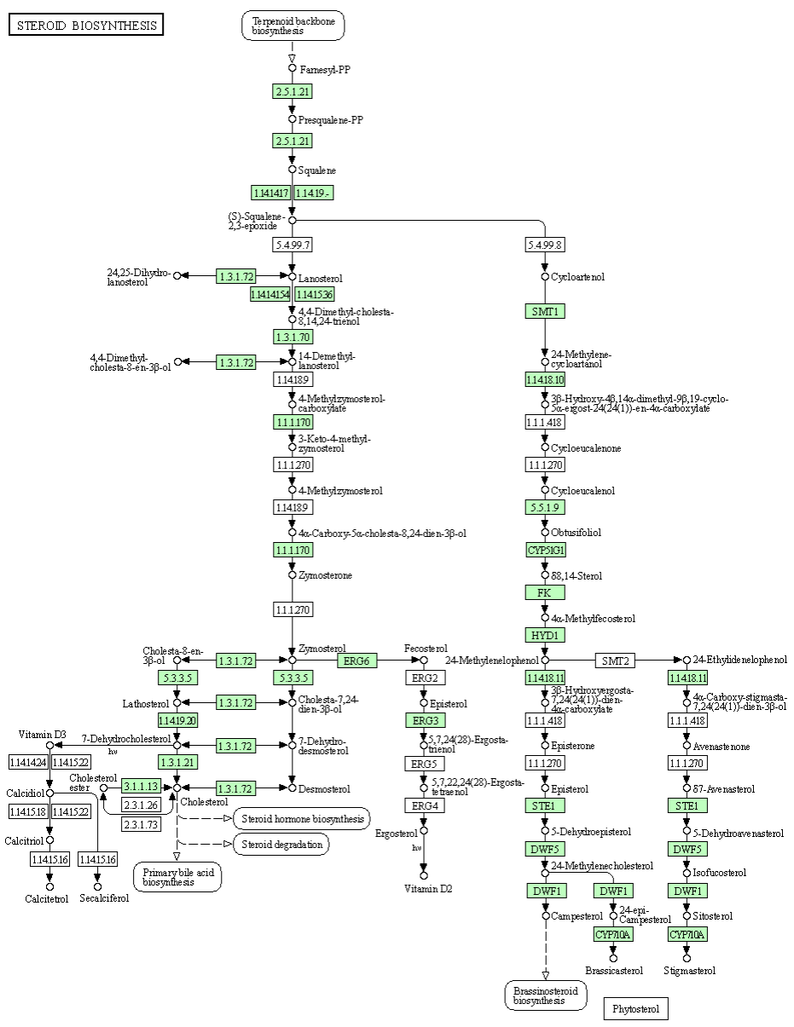

Fig. S4. Steroid biosynthesis pathway in Schizochytrium sp. S31. Green boxes: annotated genes; white boxes: unannotated gene.

Table S1 Annotation of the DEGs for Schizochytrium sp. S31 cultured under 10 g/L sea salt (treatment group, Treat) and 20 g/L sea salt (control group, CK).

Gene ID | Annotation | Abbreviation | log₂(FC) | padj
Fatty acid metabolism
TRINITY_DN175_c1_g1_i2 | pyruvate dehydrogenase E1 component | acee | 4.38 | 0.00
TRINITY_DN1272_c0_g1_i1 | hydroxymethylglutaryl-CoA synthase | hmgcs | 1.56 | 0.00
TRINITY_DN1074_c0_g2_i1 | enolase | eno | 1.49 | 0.00
TRINITY_DN1001_c0_g1_i1 | enolase | eno | 1.40 | 0.00
TRINITY_DN18476_c0_g1_i1 | phosphoglycerate mutase, 2,3-bisphosphoglycerate-independent | gpmb | 1.27 | 0.00
TRINITY_DN2215_c0_g1_i1 | geranylgeranyl pyrophosphate synthase / farnesyltranstransferase | ggps1 | 1.71 | 0.00
TRINITY_DN1309_c0_g1_i1 | pyruvate dehydrogenase E1 component alpha subunit | pdha | -1.11 | 0.00
TRINITY_DN1309_c0_g1_i2 | pyruvate dehydrogenase E1 component alpha subunit | pdha | -1.51 | 0.00
TRINITY_DN604_c1_g3_i4 | glyceraldehyde-3-phosphate dehydrogenase | gapdh | -1.41 | 0.00
TRINITY_DN245_c4_g2_i2 | pyruvate kinase | pk | -1.15 | 0.00
TRINITY_DN2207_c0_g1_i1 | acetyl-CoA carboxylase carboxyl transferase subunit alpha | acca | 1.50 | 0.00
TRINITY_DN31800_c1_g1_i1 | enoyl-CoA hydratase | echa | 2.05 | 0.00
TRINITY_DN13284_c0_g1_i2 | acetyl-CoA C-acyltransferase / 3-ketoacyl-CoA thiolase | fada | 1.50 | 0.00
TRINITY_DN44_c0_g1_i1 | fatty acid desaturase | fadn | 1.20 | 0.00
TRINITY_DN2590_c0_g1_i2 | acetyl-CoA C-acetyltransferase / acetoacetyl-CoA thiolase | acat | 2.99 | 0.00
TRINITY_DN2590_c0_g1_i4 | acetyl-CoA C-acetyltransferase / acetoacetyl-CoA thiolase | acat | 2.93 | 0.00
TRINITY_DN18341_c0_g1_i1 | acetyl-CoA C-acetyltransferase / acetoacetyl-CoA thiolase | acat | 1.45 | 0.00
TRINITY_DN748_c1_g1_i1 | acyl-CoA oxidase | acox1 | 4.12 | 0.00
TRINITY_DN285_c0_g1_i1 | acyl-CoA oxidase | acox1 | 2.85 | 0.00
TRINITY_DN890_c1_g2_i2 | long-chain-fatty-acid-CoA ligase | acsl | 4.77 | 0.00
TRINITY_DN890_c1_g1_i1 | long-chain-fatty-acid-CoA ligase | acsl | 3.08 | 0.00
TRINITY_DN1429_c0_g1_i1 | long-chain-fatty-acid-CoA ligase | acsl | 1.62 | 0.00
TRINITY_DN313_c11_g1_i1 | long-chain-fatty-acid-CoA ligase | acsl | 1.51 | 0.00
TRINITY_DN890_c1_g3_i1 | long-chain-fatty-acid-CoA ligase | acsl | 1.42 | 0.00
TRINITY_DN890_c1_g4_i1 | long-chain-fatty-acid-CoA ligase | acsl | 1.12 | 0.00
TRINITY_DN1865_c0_g1_i1 | 3-oxoacyl-[acyl-carrier-protein] synthase II | fabf | 2.58 | 0.00
TRINITY_DN3113_c1_g1_i1 | 17‑beta‑hydroxysteroid dehydrogenase 8 | hsd17b8 | 1.25 | 0.00
TRINITY_DN878_c1_g1_i1 | 3-oxoacyl-[acyl-carrier-protein] reductase | fabg | 1.37 | 0.00
TRINITY_DN86_c1_g3_i2 | elongation of very long chain fatty acids protein 5 | elovl5 | 1.83 | 0.00
TRINITY_DN333_c2_g3_i1 | acetyl-CoA carboxylase | acaca | -2.65 | 0.00
TRINITY_DN112_c1_g1_i1 | acetyl-CoA carboxylase biotin carboxylase subunit | accc | -1.37 | 0.00
TRINITY_DN598_c1_g1_i1 | fatty acid synthase, beta subunit | fas2 | -2.96 | 0.00
TRINITY_DN2187_c0_g1_i14 | enoyl-[acyl-carrier-protein] reductase I | fabl | -2.93 | 0.00
TRINITY_DN2187_c0_g1_i4 | enoyl-[acyl-carrier-protein] reductase I | fabl | -2.78 | 0.00
TRINITY_DN2187_c0_g1_i5 | enoyl-[acyl-carrier-protein] reductase I | fabl | -2.70 | 0.00
TRINITY_DN150_c2_g1_i1 | 3-hydroxyacyl-[acyl-carrier-protein] dehydratase | fabz | -2.07 | 0.00
TRINITY_DN753_c0_g1_i1 | carbonyl reductase / 3-oxoacyl-ACP reductase | cbr4 | -9.71 | 0.00
TRINITY_DN753_c0_g1_i2 | carbonyl reductase / 3-oxoacyl-ACP reductase | cbr4 | -4.53 | 0.00
TRINITY_DN753_c0_g1_i5 | carbonyl reductase / 3-oxoacyl-ACP reductase | cbr4 | -2.65 | 0.00
TRINITY_DN753_c0_g1_i4 | carbonyl reductase / 3-oxoacyl-ACP reductase | cbr4 | -2.30 | 0.00
TRINITY_DN2492_c0_g2_i2 | long-chain-fatty-acid-CoA ligase, bubblegum family | acsbg | -1.24 | 0.00
TRINITY_DN648_c1_g2_i2 | fatty acid desaturase 2 / delta-6 fatty acid desaturase | fads2 | -1.17 | 0.00
TRINITY_DN2283_c0_g2_i1 | sterol carrier protein 2 / non-specific lipid-transfer protein | scp2 | -2.19 | 0.00
TRINITY_DN1175_c3_g5_i1 | 17-beta-hydroxysteroid dehydrogenase 4 | hsd17b4 | -1.77 | 0.00
Steroid biosynthesis
TRINITY_DN1692_c0_g1_i1 | delta(14)-sterol reductase | erg24 | 1.30 | 0.00
TRINITY_DN35578_c1_g1_i1 | farnesyl-diphosphate farnesyltransferase / squalene synthase | fdft1 | -1.00 | 0.00
TRINITY_DN155_c0_g2_i4 | sterol 14-alpha-demethylase | cyp51 | -1.56 | 0.00
TRINITY_DN1454_c1_g1_i1 | C-5 sterol desaturase | erg3 | -1.77 | 0.00
TRINITY_DN429_c0_g1_i1 | C-5 sterol desaturase | erg3 | -1.45 | 0.00
Carotenoid biosynthesis
TRINITY_DN595_c4_g2_i2 | phytoene synthase | crtb | 8.04 | 0.00
TRINITY_DN9_c2_g1_i1 | phytoene desaturase | crti | -1.41 | 0.00
TRINITY_DN293_c0_g1_i1 | carotenoid isomerase / carotene isomerase | crtr | -1.22 | 0.00

