Natural Heritage Sites with the Highest Threat Level
Case 1: Lake Malawi National Park
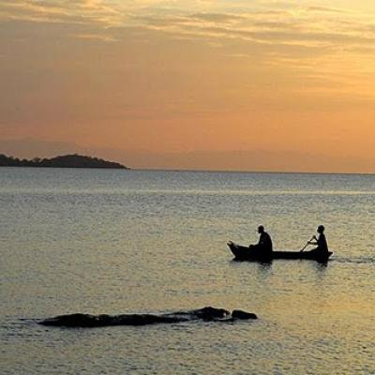
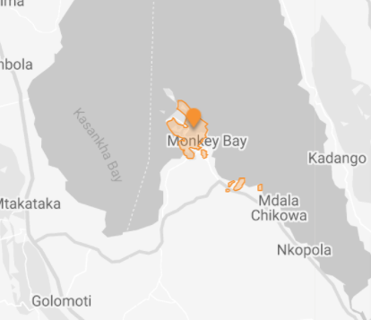
The national park is located at the southern end of the great expanse of Lake Malawi, with its deep, clear waters and mountainous landscape. It is home to hundreds of fish species, almost all of which are endemic. Lake Malawi, included in the UNESCO heritage list in 1984, is the ninth largest lake in the world. The lake has a length of 560 km, a depth of up to 704 m, and a surface area of 29,604 km2. The countries bordering Lake Malawi are Tanzania, Malawi, and Mozambique. (IUCN 1984; World Heritage Committee 2010). Biodiversity and endemism among fish close to the shore are quite high in the lake, which continues to be a region of extraordinary natural beauty in terms of aesthetics. However, some areas of the park have begun to show signs of reduced aquatic biodiversity, which is seen as a threat to the natural area. The main threats present include poaching, deforestation, overfishing, poor waste management, poorly managed tourism, oil exploration, and climate change.
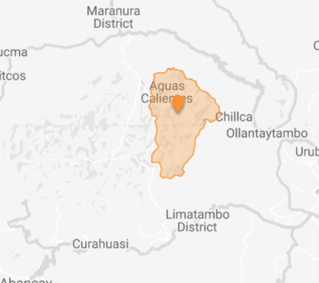
Case 2: Historic Sanctuary of Machu Picchu
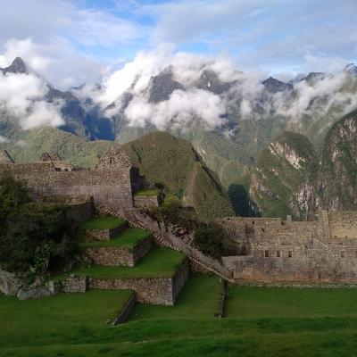
Machu Picchu Historic Reserve is located 2,430 meters above sea level in the middle of a tropical mountain forest. The natural area on the eastern slopes of the Mountains includes the upper Amazon basin with its rich diversity of flora and fauna. Located on Peru's Andes Urubamba Valley, Machu Picchu Historic Sanctuary was recognized as a World Heritage Site by UNESCO in 1983. The city was built around 1450 by Pachacutec Yupanqui, an Incan ruler. The purpose and meaning of the establishment of the area, which consists of stone structures connected by more than 200 staircase systems, is the subject of debate until today. The area is thought to have played a role in the Incas' advanced understanding of astronomy and the domestication of wild plant species.
Machu Picchu is one of South America's top tourist attractions. During the peak season, the number of daily visitors is limited to 2000 people due to the risk of collapse. Pollution from waste, increasing tourism demand and changes in temperature patterns associated with climate variability have negative effects on the ecological and archaeological structure of the area. On the other hand, tourism itself not only provides economic benefits but also leads to significant cultural and ecological effects.
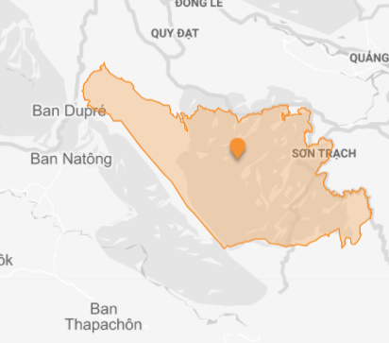
Case 3: Phong Nha-Ke Bang National Park
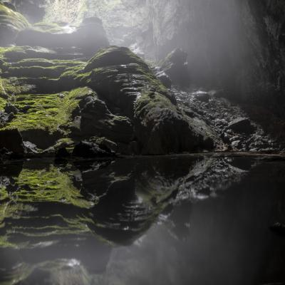
Included in the UNESCO World Heritage list in 2003, Phong Nha-Ke Bang National Park covers an area of ​​85,754 hectares. It is located in Quang Binh, 50 km from Dong Hoi city of Vietnam and 450 km from the capital Hanoi. It is a World Heritage site of great importance for our better understanding of the geological, geomorphic, and geochronological history of the region. The terrain of the park consists of limestone plateaus and tropical forests. It has great geological diversity and offers spectacular phenomena, including numerous (about 300) caves and underground rivers. It has a high level of biodiversity and hosts many endemic species. Karst formation is considered to be the oldest karst region in Asia due to its development in about 400 million years. The caves show different sequences of events that outstripped fossil cave passages (pre-buried and now unearthed paleokarst) at various levels. With its forest cover, it is one of the largest remaining relatively intact moist forests on karst in Indochina (World Heritage Committee 2012).
The majority (almost 75%) of the Phong Nha-Ke Bang (PNKB) area is covered by tropical dense moist evergreen forest on limestone below 800 m. It is home to more than 2700 species of vascular plants, including 133 threatened plant species worldwide and more than 400 species endemic to Vietnam. It is also home to more than 800 vertebrate species. In this highly biodiverse area, the biodiversity values ​​of the forest are threatened by invasive plants and poaching, and other illegal resource use. The number of visitors to the park has increased from a few thousand in 1995 to almost 1 million in 2019. According to the site management plan, it includes an estimated/target of 3.5 million visitors by 2030. The initial development of the tourism product focused on providing access to show caves where pollution and damage problems were experienced. With the acceleration of tourism, remedial measures were taken, including training for staff and tourist guides, banning the use of motorboats and fuel lights in caves, and installing waste collection systems (UNEP-WCMC 2011).
References
IUCN (1984) World Heritage Nomination - IUCN Technical Evaluation, Lake Malawi National Park (Malawi). IUCN, Gland, Switzerland
UNEP-WCMC (2011) Phong Nha-ke Bang National Park. http://world-heritage-datasheets.unep-wcmc.org/datasheet/output/site/phong-nha-ke-bang-national-park/
World Heritage Committee (2010) Decision 34 COM 8E Lake Malawi National Park (Malawi) Retrospective Statement of Outstanding Universal Value. https://whc.unesco.org/en/decisions/4261/
World Heritage Committee (2012) Decision: 36 COM 8E Phong Nha-Ke Bang National Park Adoption of retrospective Statements of Outstanding Universal Value (Viet Nam). https://whc.unesco.org/en/decisions/4841/

