Supplementary Information
Harmonized cross-cohort vaginal microbiome data integration improves machine learning prediction of preterm birth

Contents
Supplementary Methods
Supplementary Table S1. Differences in the nine features between PTB and TB (EUMC+DC)
Supplementary Table S2. Clinical parameters in TB and PTB (EUMC)
Supplementary Table S3. Detection of Peptostreptococcus anaerobius by cohort and sCL status
Supplementary Figure S1. Conditional entropy matrix and CL/WBC comparison

Supplementary Methods

Conditional entropy analysis
To assess how much information each clinical variable carries about the TB/PTB label, pairwise conditional entropies among the clinical variables were calculated and displayed as a matrix (Supplementary Figure S1A). Lower values in the row labeled “Label” indicate less remaining uncertainty about the TB/PTB label given the variable in the column.

Supplementary Tables
Supplementary Table S1. Differences in the nine features between PTB and TB in the pooled EUMC+DC dataset. Values are mean ± SD of relative abundance (%; the Shannon index is unitless). P-values are from the Wilcoxon rank-sum test.
Feature | PTB | TB | P | Significance
Gardnerella | 6.42 ± 15.1 | 7.13 ± 14.86 | 3×10⁻⁸ | ****
Lactobacillus | 49.63 ± 41.89 | 59.89 ± 39.82 | 2×10⁻⁹ | ****
Prevotella | 7.02 ± 14.3 | 3.44 ± 7.25 | 9×10⁻⁷ | ****
L. coleohominis | 0.07 ± 0.4 | 0.09 ± 0.35 | 3×10⁻⁴ | ***
L. crispatus | 16.27 ± 33.22 | 20.79 ± 37.32 | 3×10⁻¹⁰ | ****
L. iners | 24.01 ± 33.42 | 25.42 ± 33.92 | 3×10⁻² | *
L. jensenii | 4.04 ± 15.28 | 5.57 ± 16.44 | 5×10⁻²¹ | ****
L. reuteri | 0.05 ± 0.3 | 0.13 ± 0.54 | 1×10⁻⁹ | ****
Shannon index | 1.21 ± 0.91 | 1.08 ± 0.85 | 7×10⁻⁵ | ****

Supplementary Table S2. Clinical parameters in TB and PTB in the EUMC cohort. Values are mean ± SD (n). P-values are from the Wilcoxon rank-sum test. CRP values entered as “<0.3” were excluded.
Parameter | TB | PTB | P | Significance
Age (years) | 32.92 ± 3.88 (n=87) | 32.84 ± 3.99 (n=57) | 0.8870 | ns
BMI (kg/m²) | 26.03 ± 2.69 (n=85) | 25.15 ± 3.28 (n=56) | 0.1870 | ns
Cervical length (mm) | 29.6 ± 8.53 (n=48) | 21.59 ± 12.85 (n=47) | 0.0016 | **
CRP | 0.53 ± 0.95 (n=42) | 2.12 ± 3.12 (n=51) | 0.0001 | ***
WBC | 9.02 ± 1.89 (n=85) | 10.46 ± 3.18 (n=56) | 0.0075 | **

Supplementary Table S3. Detection of Peptostreptococcus anaerobius by cohort and sCL status. Values are from the earlier model iteration in which P. anaerobius was the top-ranked feature of the sCL classifier. The organism was detected almost exclusively in VMET, which led to its exclusion from the final classifier.
Cohort | sCL group | Mean cervical length (mm) | Mean relative abundance of P. anaerobius (%)
EUMC | nCL | 32.29 | 0.000075
EUMC | sCL | 12.54 | 0
VMET | nCL | 33.03 | 0.001825
VMET | sCL | 19.39 | 0.245671

Supplementary Figures
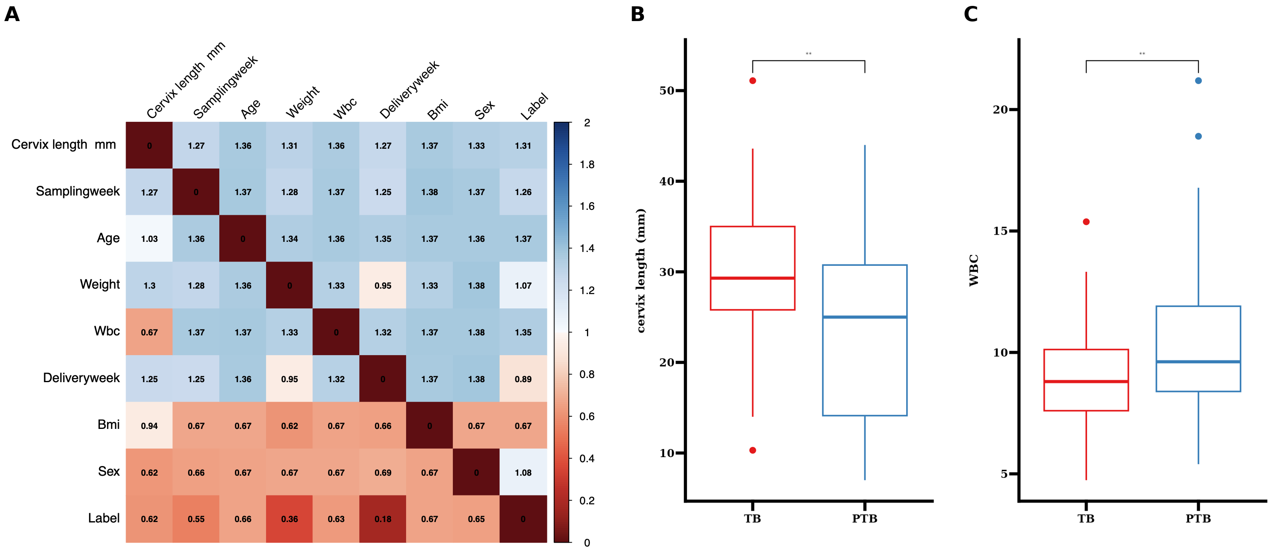
Supplementary Figure S1. Clinical variables and the TB/PTB label in the EUMC cohort. (A) Conditional entropy matrix among clinical variables; lower values in the “Label” row indicate less remaining uncertainty about the TB/PTB label given the variable in the column. The lowest values were observed for delivery week (0.18) and weight (0.36), followed by sampling week (0.55), cervical length (0.62), and WBC (0.63); age (0.66), sex (0.65), and BMI (0.67) were close to the latter. (B) Cervical length and (C) WBC in TB and PTB (Wilcoxon rank-sum test, **p<0.01).

