Supplementary Material
Bacterial diversity and predicted enzymatic function in a multipurpose surface water system – from wastewater effluent discharges to drinking water production
Ananda Tiwari, Anna-Maria Hokajärvi, Jorge Santo Domingo, Michael Elk, Balamuralikrishna Jayaprakash, Hodon Ryu, Sallamaari Siponen, Asko Vepsäläinen, Ari Kauppinen, Osmo Puurunen, Aki Artimo, Noora Perkola, Timo Huttula, Ilkka T. Miettinen and Tarja Pitkänen

Table S1. Latitude and longitude of surface water sampling locations.
No | Sampling site | Latitude | Longitude
1 | Ratinanvuolle | 6823179 | 327455
2 | Pyhäjärvi | 6821482 | 325614
3 | Rajasaari | 6820277 | 318752
4 | Sotkanvirta | 6817114 | 312630
5 | Nokiankoski (upstream) | 6820104 | 314890
6 | Nokiankoski (downstream) | 6819577 | 310206
7 | Siuronkoski | 6821375 | 304678
8 | Hiedanvuolle | 6814187 | 290176
9 | Rautavesi | 6808403 | 284378
10 | Liekovesi | 6806482 | 277832
11 | Keikyä | 6800064 | 269326
12 | Karhiniemi | 6794212 | 267916
13 | Loimijoki | 6789165 | 268155
14 | Kojo, Kolsi | 6802112 | 251104

Table S2. The climatic conditions at the cities of Tampere and Turku are located around the study area, south-western part of Finland.
Season |  | Daylight¹  (hours: minutes) |  | Temperature² (°C) |  | Precipitation² (mm)
 |  | Tampere | Turku | Tampere | Turku | Tampere | Turku
Autumn | September | 12:56 | 12:54 | 10.5 | 11.2 | 59.8 | 62.8
 | October | 10:04 | 10:09 | 5.3 | 6.4 | 66.1 | 75.4
 | November | 7:13 | 7:27 | -2.0 | 1.3 | 53.6 | 72.9
Winter | December | 5:25 | 5:47 | -4.1 | -2.1 | 46.1 | 64.9
 | January | 6:20 | 6:37 | -6.1 | -4.0 | 45.3 | 54.4
 | February | 9:02 | 9:10 | -6.7 | -4.8 | 30.8 | 37.6
Spring | March | 11:45 | 11:45 | -2.4 | -1.4 | 33.5 | 38.7
 | April | 14:45 | 14:38 | 3.5 | 4.0 | 31.4 | 31.0
 | May | 17:33 | 17:16 | 9.9 | 10 | 39.7 | 37.6
Summer | June | 19:26 | 18:59 | 14.4 | 14.4 | 64.3 | 55.4
 | July | 18:33 | 18:12 | 17.4 | 17.5 | 74.6 | 77.6
 | August | 15:53 | 15:43 | 15.6 | 16.2 | 74.7 | 78.2
¹Daylight duration of 15th of each month of 2013 (data source: https://www.timeanddate.com/). ²Monthly average temperature and precipitation between 1981-2010 (data source: https://en.ilmatieteenlaitos.fi/home).

Table S3. The selection of public health-related bacteria (PHRB) and their detection frequency within the whole data (n = 230). ND = not detected.
No. | Selected PHRB genus¹ | Detection Frequency % | Family | Order | Class | Phylum
1 | Mycobacterium spp. | 87 | Mycobacteriaceae | Actinomycetales | Actinobacteria | Actinobacteria
2 | Bifidobacteria spp. | 40 | Bifidobacteriaceae | Bifidobacteriales | Actinobacteria | Actinobacteria
3 | Actinomyces spp. | ND | Actinomycetaceae | Actinomycetales | Actinobacteria | Actinobacteria
4 | Propionobacterium spp. | ND | Propionibacteriaceae | Propionibacteriales | Actinobacteria | Actinobacteria
5 | Raoultella spp. | ND | Propionibacteriaceae | Propionibacteriales | Actinobacteria | Actinobacteria
6 | Tsukamurella spp. | ND | Tsukamurellaceae | Actinomycetales | Actinobacteria | Actinobacteria
7 | Bacteroides spp. | 75 | Bacteroidaceae | Bacteroidales | Bacteroidia | Bacteroidetes
8 | Prevotella spp. | 47 | Prevotellaceae | Bacteroidales | Bacteroidia | Bacteroidetes
9 | Clostridium spp. | 66 | Clostridiaceae | Clostridiales | Clostridia | Firmicutes
10 | Lactococcus spp. | 36 | Streptococcaceae | Lactobacillales | Bacilli | Firmicutes
11 | Ruminococcus spp. | 34 | Ruminococcaceae | Clostridiales | Clostridia | Firmicutes
12 | Lachnospiraceae spp. | 32 | Lachnospiraceae | Clostridiales | Clostridia | Firmicutes
13 | Enterococcus spp. | 14 | Enterococcaceae | Lactobacillales | Bacilli | Firmicutes
14 | Streptococcus spp. | 5 | Streptococcaceae | Lactobacillales | Bacilli | Firmicutes
15 | Lactobacillus spp. | 3 | Lactobacillaceae | Lactobacillales | Bacilli | Firmicutes
16 | Eubacterium spp. | ND | Eubacteriaceae | Clostridiales | Clostridia | Firmicutes
17 | Peptococcus spp. | ND | Peptococcaceae | Clostridiales | Clostridia | Firmicutes
18 | Peptostreptococcus spp. | ND | Peptostreptococcaceae | Clostridiales | Clostridia | Firmicutes
19 | Staphylococcus spp. | ND | Staphylococcaceae | Bacillales | Bacilli | Firmicutes
20 | Fusobacterium spp. | 8 | Fusobacteriaceae | Fusobacteriales | Fusobacteriia | Fusobacteria
21 | Pseudomonas spp. | 91 | Pseudomonadaceae | Pseudomonadales | Gammaproteobacteria | Proteobacteria
22 | Acinetobacter spp. | 84 | Moraxellaceae | Pseudomonadales | Gammaproteobacteria | Proteobacteria
23 | Legionella spp. | 52 | Legionellaceae | Legionellales | Gammaproteobacteria | Proteobacteria
24 | Desulfovibrio spp. | 46 | Desulfovibrionales | Desulfovibrionales | Deltaproteobacteria | Proteobacteria
25 | Citrobacter spp | 45 | Enterobacteriaceae | Enterobacterales | Gammaproteobacteria | Proteobacteria
26 | Stenotrophomonas spp. | 27 | Xanthomonadaceae | Xanthomonadales | Gammaproteobacteria | Proteobacteria
27 | Aeromonas spp. | 17 | Aeromonadaceae | Aeromonadales | Gammaproteobacteria | Proteobacteria
28 | Vibrio spp. | 2 | Vibrionaceae | Vibrionales | Gammaproteobacteria | Proteobacteria
29 | Aliivibrio spp. | ND | Vibrionaceae | Vibrionales | Gammaproteobacteria | Proteobacteria
30 | Burkholderia spp. | ND | Burkholderiaceae | Burkholderiales | Betaproteobacteria | Proteobacteria
31 | Campylobacter spp. | ND | Campylobacteraceae | Campylobacterales | Epsilonproteobacteria | Proteobacteria
32 | Enterobacter spp. | ND | Enterobacteriaceae | Enterobacterales | Gammaproteobacteria | Proteobacteria
33 | Escherichia spp. | ND | Enterobacteriaceae | Enterobacterales | Gammaproteobacteria | Proteobacteria
34 | Francisella spp. | ND | Francisellaceae | Thiotrichales | Gammaproteobacteria | Proteobacteria
35 | Grimontia spp. | ND | Vibrionaceae | Vibrionales | Gammaproteobacteria | Proteobacteria
36 | Helicobacter spp. | ND | Helicobacteraceae | Campylobacterales | Epsilonproteobacteria | Proteobacteria
37 | Klebsiella spp. | ND | Enterobacteriaceae | Enterobacterales | Gammaproteobacteria | Proteobacteria
38 | Morganella spp. | ND | Morganellaceae | Enterobacterales | Gammaproteobacteria | Proteobacteria
39 | Salmonella spp. | ND | Enterobacteriaceae | Enterobacterales | Gammaproteobacteria | Proteobacteria
40 | Shigella spp. | ND | Enterobacteriaceae | Enterobacterales | Gammaproteobacteria | Proteobacteria
41 | Yersinia spp. | ND | Yersiniaceae | Enterobacterales | Gammaproteobacteria | Proteobacteria
42 | Leptospira spp. | ND | Leptospiraceae | Leptospirales | Spirochaetes | Spirochaetes
¹According to WHO, 2003; Cabral, 2010; and WHO, 2017.

Table S4. Spearman correlation coefficients between the taxonomic richness and evenness indices. The significance of the reported coefficients was p < 0.001 (N = 230).
 | #OTU | Observed | ACE | Chao1 | Shannon | Simpson
#OTU | 1 | 0.95 | 0.98 | 0.92 | 0.65 | 0.45
Observed |  | 1 | 0.95 | 0.98 | 0.68 | 0.51
ACE |  |  | 1 | 0.94 | 0.61 | 0.41
Chao1 |  |  |  | 1 | 0.65 | 0.49
Shannon |  |  |  |  | 1 | 0.88
Simpson |  |  |  |  |  | 1

Figure S1. Box-plot comparison of (A) read counts and alpha-diversity indices: (B) Chao1, (C) Shannon diversity index and (D) Simpson diversity index of bacterial communities in the sample groups.

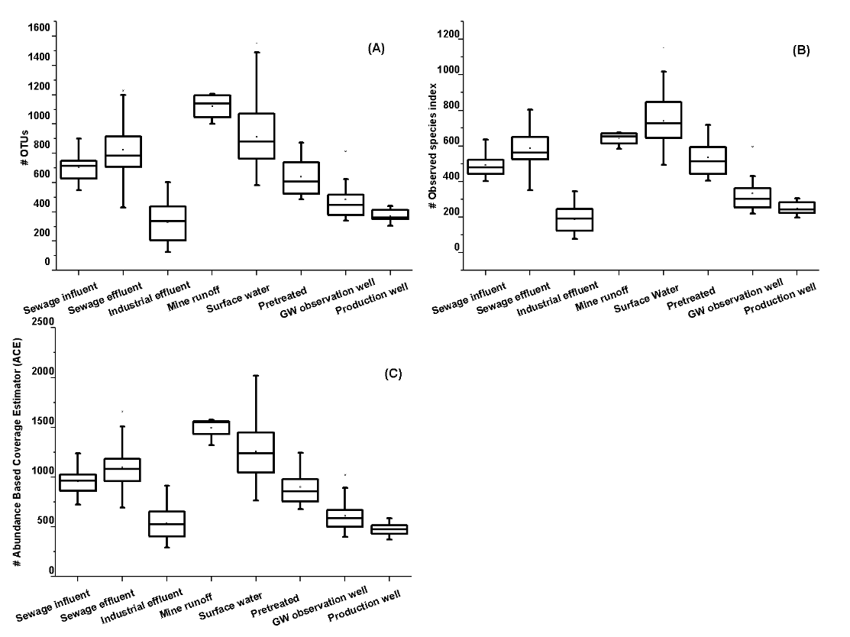
Figure S2. Box-plot comparison of (A) the number of OTUs, (B) observed species index and (C) ACE estimator of bacterial communities in the sample groups.
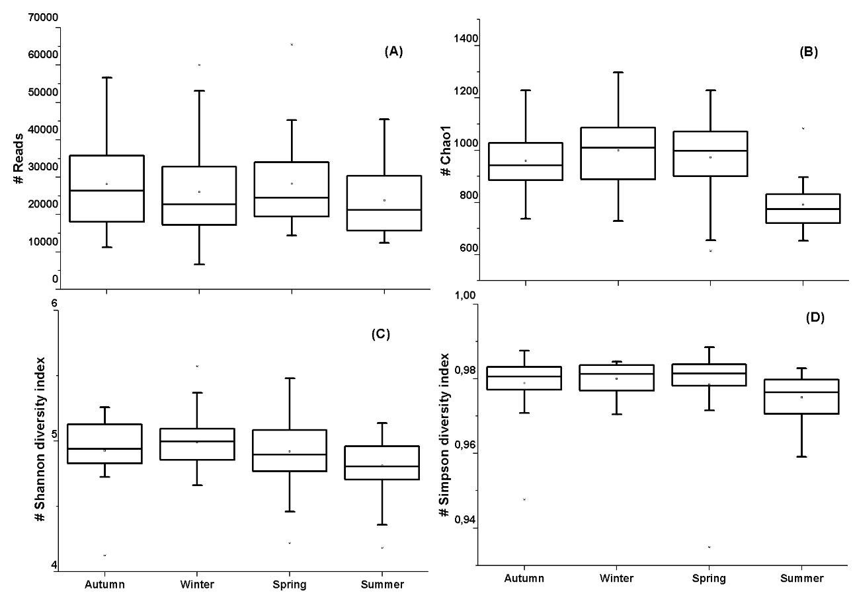
Figure S3. Box-plot comparison of (A) read counts and alpha-diversity indices: (B) Chao1, (C) Shannon and (D) Simpson of bacterial communities in surface water in four seasons of a year.
Figure S4. Box-plot comparison of (A) the number of OTUs, (B) observed species index and (C) ACE estimator of bacterial communities in surface water in four seasons of a year.

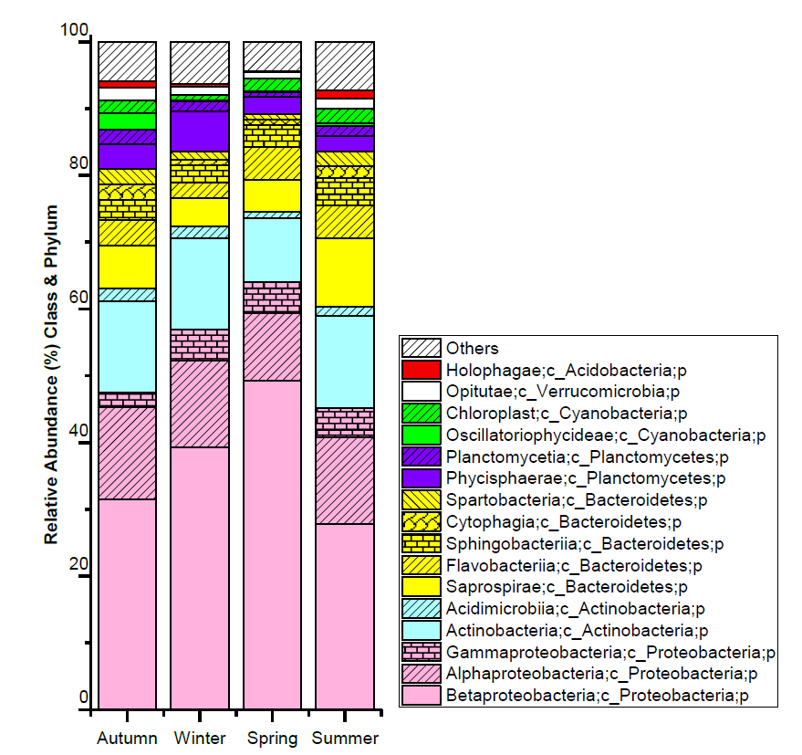Figure S5. Seasonal variation in the bacterial taxa in surface water samples. Others: Taxa with relative abundance less than 1%.

References
- Cabral J.P.S, 2010. Water Microbiology. Bacterial Pathogens and Water. Int. J. Environ. Res. Public Health, 7, 10, 3657-3703. doi: 10.3390/ijerph7103657.

- WHO, 2017. World Health Organization. Guidelines for drinking-water quality: fourth edition incorporating the first addendum. ISBN 978-92-4-154995-0, Geneva, Switzerland.

- WHO, 2003. World Health Organization. Guidelines for safe recreational water environments. Volume 1, Coastal and fresh waters. Chapter 4: Faecal pollution and water quality, 51-101, Geneva, Switzerland.

