Supplementary Information

Automated Underwater Delivery System for Coral Probiotics

Alexander Przybysz¹*, Neus Garcias-Bonet², Eslam O. Osman², Francisca C. García², Ahmed R. Aliyu³, José Ilton de Oliveira Filho⁴, Raquel Peixoto²*, Khaled Nabil Salama¹*

Power Consumption
The optimal battery dimensions given the constraints of the enclosure was a 12V 12 Ah sealed lead acid (SLA) battery. To conserve energy, the device is placed in sleep mode where the dormant current of the device was found to be around 6 mA with 60 mA spikes lasting 3.5 seconds that occur every minute. These spikes are due to the device waking up interrogating the real-time clock and going back to sleep. The energy consumed during this minute cycle is 1.748 mWh. The energy consumption for the 10-second agitation and 30 mL pumping cycle was determined to be 23 mWh and 42.66 mWh, respectively. Given an hourly agitation frequency and 30 mL daily dispensation volumes, the battery has a projected life of 830.899 hours or 34 days. In practice, however, the results vary slightly (Figure 2d), which suggests that these variations due to manufacturing tolerances.
Agitation
Regarding agitation, there are two types of failure, namely: slip and stall. A slip condition is where the magnetic coupling is lost and the driver spins freely while the impeller is stationary. A stall condition is where the driver motor does not have an adequate amount of torque to drive the impeller and both the driver and the impeller remain stationary. It was determined that the impellers slip if connected directly to 12 volts. Therefore, the driver motors are controlled with a 1 kHz 12 V pulse width modulation (PWM) signal, which can be used to tune the speed of the motors to avoid slippage.
As the relationship between magnetic force and distance is not linear, an experiment was conducted to determine the strength of the coupling of the magnetic driver and the impeller as a function of distance. It was experimentally determined that for the agitation of distilled water, the driver pole-face to impeller pole-face distances where the stall condition occurs are beyond 15 mm (Figure S1a).
Due to the physical constraints of the device the minimum pole-face to pole-face distance that could be achieved is 7 mm, which should mitigate stalling risks. With this fixed distance, the relationship between dynamic viscosity and maximum impeller appears to be logarithmic (Figure S1b). At a maximal solution dynamic viscosity of 0.67 Pa.s, the impeller speed was found to be 55 RPM and the duty cycle of the PWM is 13.73%. Exceeding this viscosity threshold results in a stall condition. The maximum speed that can be achieved without slippage was determined to be 973.5 RPM, which occurs at a maximum PWM duty cycle of 26.67 % and a dynamic viscosity is 0.0010049 Pa.s, which is the viscosity of distilled water at 20 ºC.
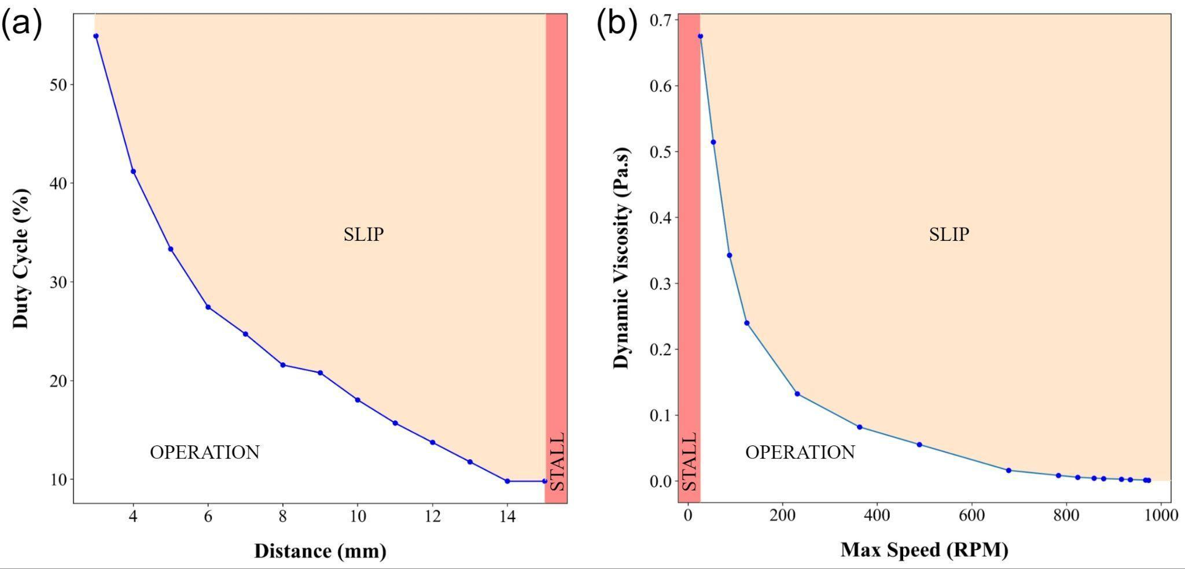
Figure S1. Agitation experiment results. (a) Voltage signal PWM duty cycle with respect to minimum pole-face to pole-face distance. (b) Dynamic viscosity of solution with respect to impeller speed.
Mobile Application
To allow seamless interfacing with the controller board, a companion mobile application was implemented. The app connects to the device if programming mode is enabled. Once connected, the user can perform diagnostic tests for possible hardware faults (Figure S2a). A variety of parameters can be tuned to give the user more flexibility for scheduling, dispensation volume control and agitation settings (Figure S2b). Additionally, the application facilitates fleet management via storing data logs and settings of individual devices (Figure S2c).

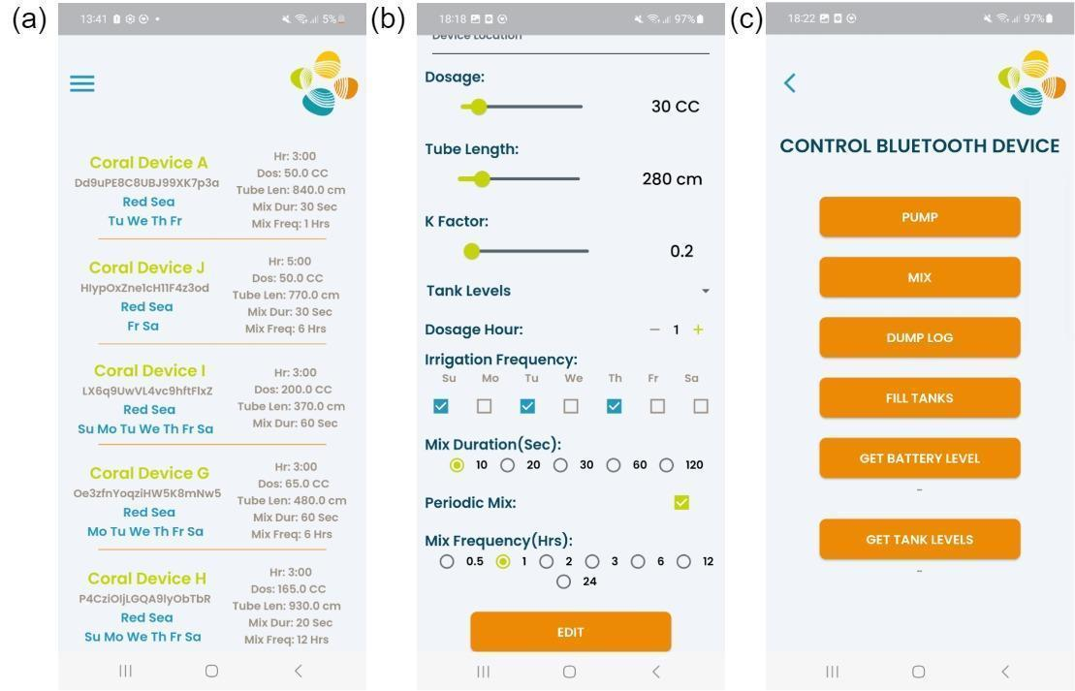
Figure S2. Mobile application interface. (a) Fleet management menu for storing information of multiple dispensers. (b) Parameter tuning menu for setting the dispensation and agitation parameters. (c) Diagnostic menu for testing the device.

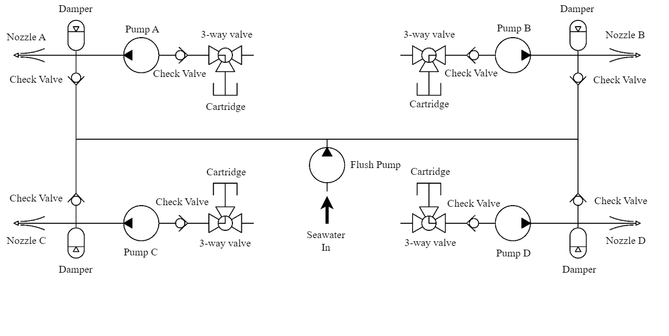
Figure S3. Hydraulic circuit of the dispenser.

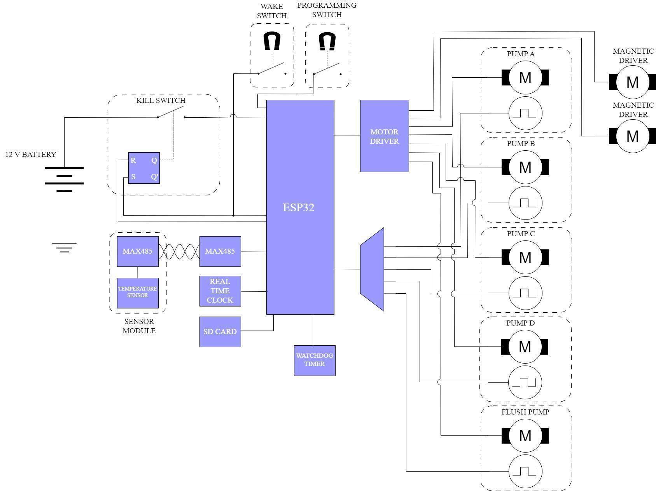
Figure S4. Circuit diagram of the controller board.
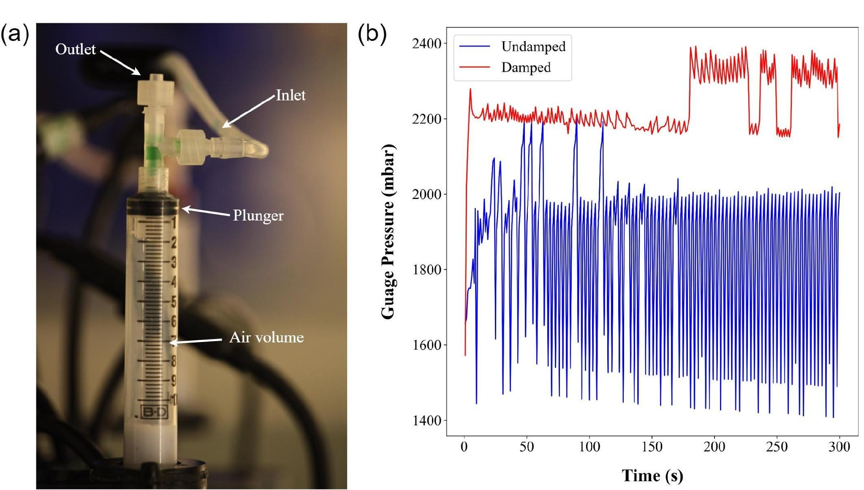
Figure S5. Hydraulic damper. (a) hydraulic damper assembly with delivery tube and nozzle detached. (b) pressure comparison of undamped continuous pumping and damped intermittent pumping.

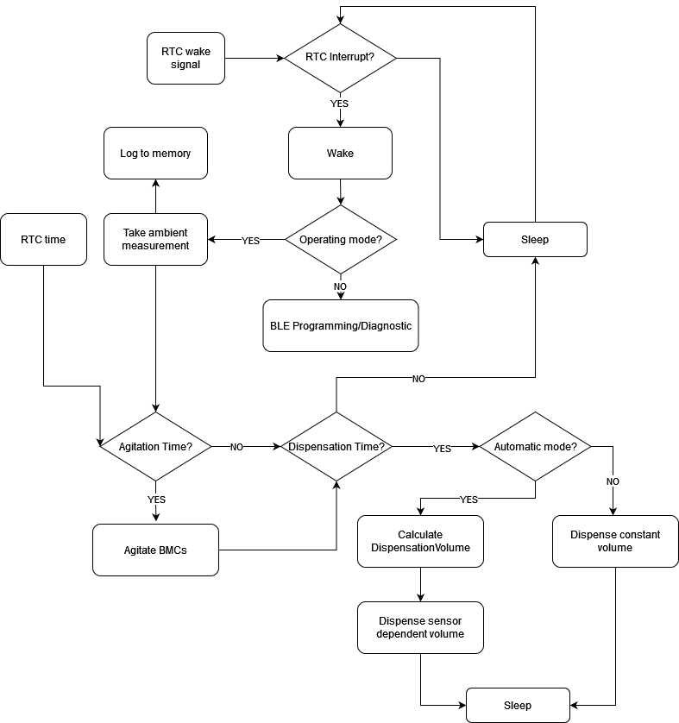
Figure S6. Program flow diagram.

Table S1 - Mechanical Components and Their Function in the System

Name | Brand | Model | Function
Delivery Nozzle | Sprycle | SPL11-048 | To disperse probiotic and to prevent ingress of contaminants
Delivery tube A | ANPTGHT | ‎aww-123100980 | Transports probiotics from device to coral
Deliver tube adapter A | ‎AIEX | ‎ B13246 | Couples to Delivery tube A
Deliver tube socket | ‎AIEX | B13193 | Couples to tube luer to damper tee
Damper tee | VALUE PLASTICS, INC. | FTLT-6 | Couples to Delivery tube socket, Damper syringe and damper inlet adapter
Damper syringe | Becton Dickinson | 302995 | Takes up pressure spikes and improves dispensation volume accurace
Silicone stopper | Made in house | - | To contain the compressible volume of air in the damper syringe
Deliver tube adapter B | ‎AIEX | B13193 | Couples delivery Tube B to damper tee
Flush tee | Orbit | ‎67401 | Couples delivery, pump and flush line
Check valve | Leinuosen | 4346798961 | prevents backflow into flush pump
1/4" tubing | PRUNkuar | YY0001 | Used to transport liquid throughout the entire device
M3 Brass insert | ‎AIEX | B16155 | Used for fastening purposes
M3x20 Nylon | Electronics-Salon | ‎ SCW-NLB/M3x20-100 | Used for fastening purposes
Damper Bayonet | Made in house | - | Bracket that holds the Damper syringes
Compression rod nut | ‎ Brookview Bolt | 12CNFHN | Fastens components to the compression rod
Compression brace top | Made in house | - | Squeezes down on enclosure flanges and holds syringe and damper brackets
Compression brace bottom | Made in house | - | Squeezes down on enclosure flanges and holds syringe and damper brackets
Compression rod | Enpro Industries | Custom request | Takes up tension for the compression braces and provides a support structure for syringe and damper brackets
Stand bolt | McMaster-Carr | 94175A670 | Stand legs for the device
Stand nut | Vital-Parts | HN934-M10-NY-N | Lock nut for Stand bolt
M12 washer | Made in house | - | Maintains gap for the foot of the 500 mL syringe cartridge
Syringe Top Clip | Made in house | - | Holds the foot 500 mL syringe cartridge
Syringe Bottom Clip | Made in house | - | Holds the foot 500 mL syringe cartridge
Nozzle bracket | Made in house | - | Holds the nozzle of the 500ml syringe cartridge and the magnetic driver assembly
M3 spacer | Electronics-Salon | ‎ SPC-RB7x4x3-100 | Maintains gap for the foot of the 500 mL syringe cartridge
Three way valve | Tiantiankeji | EMT | Luer lok valve for syringe cartridge
Nozzle Luer | ‎AIEX | B13193 | For making the syringe cartridge luer compatible
Syringe Cartridge | Jiansu Nuohong Medical Technology | 500ML | Reservoir for the probiotic solution.
Probiotic Intake adapter A | MEETOOT | MLLPHBA-316-10 | Adapts the intake tube to syringe valve
Probiotic Intake adapter B | ‎ ITROLLE | FLJSASTJLL-T10 | Adapts the intake tube to syringe valve
Impeller frame | Made in house | - | Holds the magnetic impeller
Impeller thick spacer | Made in house | - | Spaces impeller from the frame
Impeller thin spacer | Made in house | - | Spaces impeller from the frame
Impeller | ABCRapid | Custom manufacture from design | Agitates the probiotic solution
Disk magnet | First4Magnets | F1025-20 | Used in magnetic agitation
Impeller grub screw | Accu-components | SFF-M10-30-N | Support axle for impeller
Impeller bearing | Bushing MFG | 6000 10x26x8 | Corrosion proof bearing for impeller
O-ring | Uxcell | a18041600ux0071 | Used for gripping the impeller frame with the syringe
Driver tube | Guangzhou Engineering Plastic Factory | Custom length | Forms part of enclosure for magnetic driver
Driver end cap | ABCRapid | Custom manufacture from design | Forms part of enclosure for magnetic driver, also used for sensor enclosure
Driver top cap | ABCRapid | Custom manufacture from design | Forms part of enclosure for magnetic driver, also used for sensor enclosure
Driver disk | ABCRapid | Custom manufacture from design | Forms part of enclosure for magnetic driver, also used for sensor enclosure
Driver motor | Ningbo Leison Motor Co., Limited | RS-555-SH-4033 | Driver motor for magnetic agitation driver
Driver platform | Made in house | - | support platform for driver motor
Driver support rod | Uxcell | a16071500ux0035 | Support pillar for motor in driver enclosure
Driver cable | GjQ | GJQ-0012 (2P) | For delivering power to the driver motor
Bolt | McMaster-Carr | 91239A110 | Fastening purposes
Wetlink penetrator 6.5mm | Bluerobotics | WLP-M10-6.5MM-LC | Compression gland form 1/4" tubing
Vent hole and plug | Bluerobotics | VENT-M10-R1-RP | Allows access for battery charging cable.
Pressure relief valve | Bluerobotics | PRV-M10-ASM-R1-RP | Releases any buildup of pressure in enclosure
End flange | Bluerobotics | WTE6-M-FLANGE-SEAL-R1 | Seals the end cap of the enclosure tube
Acrylic end cap | Bluerobotics | WTE6-P-END-CAP-R1 | Blanks off the end where the controller board is situated
15-hole end cap | Bluerobotics | WTE6-M-END-CAP-15-HOLE-R1 | Provides the interface for the tubes and cables for the enclosure
6" Acrylic tube | Bluerobotics | WTE6-P-TUBE-R1 | Enclosure tube
Brass hex stand | Augiimor | XYDA0276 | Supports the motor frame to the end flange
Pump Frame Top | Made in house | - | Supports the diaphragm pumps
Pump Frame Top | Made in house | - | Supports the diaphragm pumps
Encoder magnet | First4Magnets | F413-20 | Encodermagnet for the pump motor
Diaphragm pump | ET-Pump | R27-02 | Diaphragm pump
Battery top clip | Made in house | - | Supports the battery
Battery bottom clip | Made in house | - | Supports the battery
Battery | Yuasa | NP12-12 | Sealed Lead Acid Battery
Controller board frame | Made in house | - | Supports the controller board
Nylon board hex stand | XunLiu | ‎ XL-NY-CA | Pillar for controller board support
Tether cable | Bluerobotics | CAB-NBPUF-4UTP-26AWG-R2 SKU | For connecting the sensor board to the main device through RS-485
Electronic Components
PCB | PCBway | Custom design | Circuit board of controller
Clock battery holder | Q&J | CR2032-BS-6-1 | Holder for RTC time keeping battery
Clock battery | Energizer | CR-2032 | Powering clock battery
Sensor board | PCBway | Custom design | Circuit board of sensor board
Conrtroller | Atmel | ATMEGA-328 | Microcontroller unit for sensors
Temperature probe | Dallas Semiconductor | DS18B20 | Temperature sensor
RS485 transceiver | Analog Devices | MAX485 | For communicating with
Capacitors | LCSC | 100 nF, 680 uF, 1 uF
Resistors | LCSC | 10k, 56k, 91k, 100k, 120
TVS diodes | LCSC | SMBJ12A, ESD5V5U5ULC, SM712, P4FL3.3A | Protects circuit from voltage transients
Voltage regulators | LCSC | AMS1117-5.0,AMS1117-3.3 | Provides 3.3v and 5V buses
LEDs | MOUSER | OVLGC0C6B9,  C503B-BAS-CZ0A0452 | Indicator LEDs
Watchdog timer | Texas Instruments | TPL5010 | To reboot microcontroller if program crashes for some reason
Real time clock | Maxim Integrated | DS3231 | To keep track of real time
SD card holder | Molex | 47219-2001 | For connected the SD card
SD card | Kioxia | Exceria 64 GB | For logging data
Latch power transistor | International Rectifier | IRF9540N | For latching/unlatching power from the battery to the rest of the circuit
Motor driver transistor | International Rectifier | IRF540N | For driving pumps and motors
Gate driver transistor | On-Semi | 2n7002 | For driving the gates of the Motor drive transistors
Buffer opamp | Texas Instruments | LMV321 | For measuring battery voltage
ESP32 | Hiletgo | ESP-WROOM-32 Dev | Microcontroller board for controller

