Original article
Gene Expression Profiling in Extranodal NK/T-cell Lymphoma

Ji Yun Lee^{1*}, Joo Hyun Kim ^{2*}, Heejin Bang³, Junhun Cho⁴, Young Hyeh Ko⁴, Seok Jin Kim², Won Seog Kim²

¹Division of Hematology-Oncology, Department of Internal Medicine, Seoul National University Bundang Hospital, Seongnam, Korea
²Department of Health Sciences and Technology, Samsung Advanced Institute for Health Sciences and Technology, Samsung Medical Center, Sungkyunkwan University School of Medicine, Seoul, Korea
³Department of Pathology, Kangnam Sacred Heart Hospital, Hallym University College of Medicine, Seoul, Republic of Korea
⁴Department of Pathology and translational genomics, Samsung Medical Center, Sungkyunkwan University School of Medicine, Seoul, Korea
⁵Division of Hematology-Oncology, Samsung Medical Center, Sungkyunkwan University School of Medicine, Seoul, Korea

Supplementary table 1. Association between EGR1 expression and patient’s characteristics
 | EGR1 > 95.3, n (%) | EGR1 ≤ 95.3, n (%) | P-value
Primary site
Nasal | 17 (85.0) | 15 (65.2) | 0.1381
Non-nasal | 3 (15.0) | 8 (34.8)
Stage
I-II | 19 (95.0) | 12 (52.2) | 0.0018
III-IV | 1 (5.0) | 11 (47.8)
PINK
Low | 15 (75.0) | 5 (21.7) | 0.0005
Intermediate/High | 5 (25.0) | 18 (18.3)
PINK-E
Low | 8 (61.5) | 2 (10.5) | 0.0051
Intermediate /High | 5 (35.5) | 17 (89.5)
Relapse
No | 7 (35.0) | 7 (30.4) | 0.7500
Yes | 13 (65.0) | 16 (69.6)
PINK, prognostic index for natural killer cell lymphoma; PINK-E, prognostic index for natural killer lymphoma–Epstein-Barr virus

Supplementary table 2. EGR1 expression according to the immune subtyping
Immune subtype | IT | IE-A | IE-B | IS | P-value
Immune subtype | (n = 3) | (n = 16) | (n = 9) | (n = 2) | P-value
EGR1 | 395.1 [272.6;546.3] | 185.1  [53.1;323.1] | 90.8  [42.0;178.3] | 41.6  [19.2;64.0] | 0.144
IT, immune tolerance; IE-A, immune evasion-A; IE-B, immune evasion-B; IS, immune silenced (IS).

Supplementary table 3. 133 nCounter genes list
No. | Genes | No. | Genes | No. | Genes | No. | Genes
1 | ADRB2 | 35 | CSF2 | 69 | KIR2DL1 | 103 | SH2D1B
2 | AGT | 36 | CTLA4 | 70 | KIR2DL2 | 104 | SIRPA
3 | ALK | 37 | CTSB | 71 | KIR2DL4 | 105 | SLC16A3
4 | ALS2 | 38 | CTSC | 72 | KIR2DS1 | 106 | SLC19A1
5 | ANK2 | 39 | CTSS | 73 | KIR2DS2 | 107 | SLC19A2
6 | ANXA3 | 40 | CXCR3 | 74 | KIR2DS5 | 108 | SLC7A7
7 | ARHGEF10 | 41 | CXCR4 | 75 | KLRC2 | 109 | SMARCA2
8 | ATP6V0D1 | 42 | CXCR7 | 76 | KLRD1 | 110 | SMOX
9 | AXL | 43 | CYBB | 77 | LILRB1 | 111 | SNAP91
10 | BATF3 | 44 | CYP26A1 | 78 | LPAR1 | 112 | SOD2
11 | BTBD11 | 45 | DMRT1 | 79 | MSH6 | 113 | SOX8
12 | CAT | 46 | DNER | 80 | MYCN | 114 | SPAST
13 | CCNA1 | 47 | EFNB2 | 81 | NCAM1 | 115 | STAT1
14 | CCNE1 | 48 | EGR1 | 82 | NKX2_1 | 116 | STK3
15 | CCR1 | 49 | FABP3 | 83 | NLRP7 | 117 | TBX21
16 | CCR10 | 50 | FASLG | 84 | NOTCH1 | 118 | TCN2
17 | CCR11 | 51 | FGF18 | 85 | NR1H3 | 119 | THY1
18 | CCR2 | 52 | FNTB | 86 | PCOLCE2 | 120 | TIAM2
19 | CCR3 | 53 | FPR1 | 87 | PDE4DIP | 121 | TMEM158
20 | CCR4 | 54 | FTL | 88 | PDXK | 122 | TMOD1
21 | CCR5 | 55 | GALNT2 | 89 | PELI1 | 123 | TNFRSF8
22 | CCR6 | 56 | GAS1 | 90 | PERP | 124 | TUBB2B
23 | CCR7 | 57 | GATA3 | 91 | PITPNA | 125 | TUBB6
24 | CCR8 | 58 | GUCA2A | 92 | PLSCR1 | 126 | TYR
25 | CCR9 | 59 | HCK | 93 | PRDX3 | 127 | UBE2L6
26 | CD244 | 60 | HPSE | 94 | PRKCB | 128 | WARS
27 | CD28 | 61 | HRASLS | 95 | PRKG1 | 129 | WDFEY3
28 | CD40 | 62 | HS6ST2 | 96 | PSAP | 130 | WNK1
29 | CD59 | 63 | IFI30 | 97 | PTHLH | 131 | WNT7B
30 | CDC14B | 64 | IFNG | 98 | RAMP3 | 132 | ZBTB17
31 | CHI3L1 | 65 | IL13RA1 | 99 | REL_1 | 133 | ZFYVE27
32 | CLTC | 66 | IL1RAP | 100 | ROBO1
33 | COL6A1 | 67 | JAK2 | 101 | S1PR3
34 | CREG1 | 68 | KIF3B | 102 | SEPT_6

Supplementary table 4. Sequence of primers used in reverse transcription quantitative PCR (RT-qPCR)
Gene symbols | Sequence
EGR-1_Forward | AAA GTT TGC CAG GAG CGA TG
EGR1_Reverse | CAG GGG ATG GGT ATG AGG TG
GAS1_Forward | CCT CAT TCA GCT CAA CCA CA
GAS1_Reverse | CTT GGT GGA CTT GCA GTT CT
RAMP3_Forward | TGC AAC GAG ACA GGG ATG C
RAMP3_Reverse | GCA TCA TGT CAG CGA AGG C
CXCR7_Forward | ACA GGC TAT GAC ACG CAC TG
CXCR7_Reverse | ACG AGA CTG ACC ACC CAG AC
CD59_Forward | ATT TCA ACG ACG TCA CAA CCC
CD59_Reverse | CAG AAA TGG AGT CAC CAG CAG
GAPDH_Forward | ATC ATC AGC AAT GCC TCC T
GAPDH_Reverse | CAT CAC GCC ACA GTT TCC

Supplementary Figure 1. ROC curve of EGR1 expression and their area under the curve (AUC)
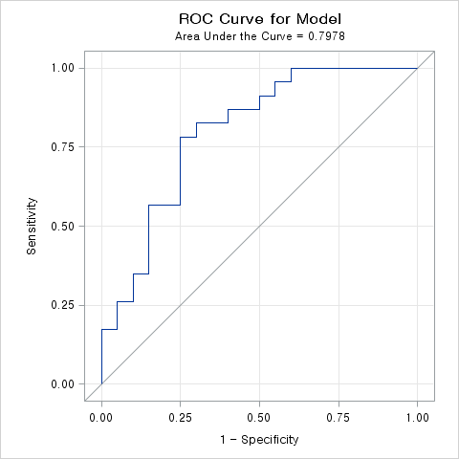
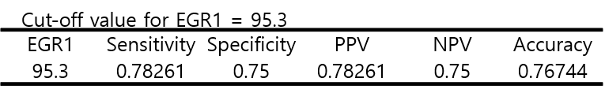

Supplementary Figure 2. Kaplan-Meier survival curves for ENKTL patients according to EGR1 expression
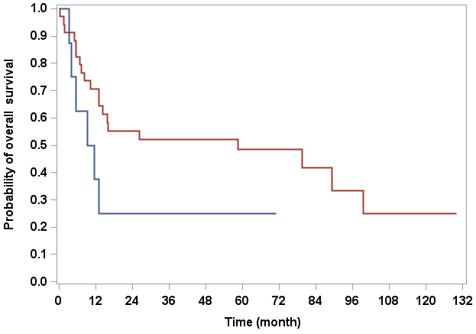
Cut-off value for EGR1 = 35.7

