Extended Data for

Attractor computation in continuous-time digital networks
Authors: Xu Meng¹†, Wenrui Xu¹†, Yousheng Wang¹, Xu Wang¹, Zhuo Liu¹, Hao Shu¹, Guangjian Zhao¹, Tao Chen¹*
Affiliations:
¹School of Microelectronics, University of Science and Technology of China, Hefei, Anhui, China.
†These authors contributed equally to this work.
*Corresponding author. Email: tchen@ustc.edu.cn

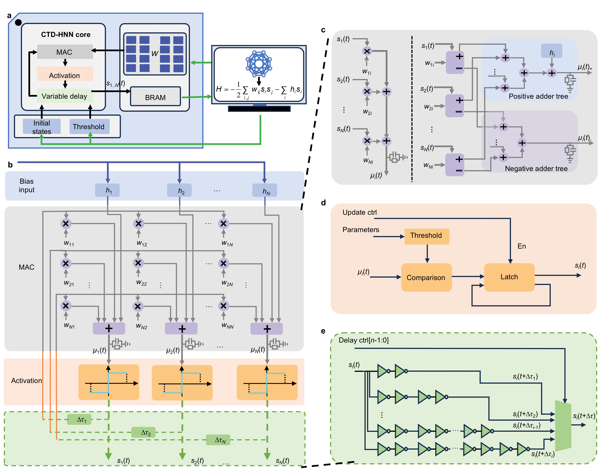
Extended Data Fig. 1 | Schematic diagrams of the modules in CTD-HNN. a, Schematic of the whole system. A host computer downloads the weight matrices and configurations to the CTD-HNN, and reads out the neural states. b, Core structure of the CTD-HNN. c, Logic diagrams of the serial MAC module (left) and the parallel MAC module (right). The parallel MAC module uses two adder trees operating in parallel, with positive and negative products routed to and accumulated by separate trees. d, Logic diagram of the activation modules. e, Logic diagram of the variable delay implemented with inverter chains.

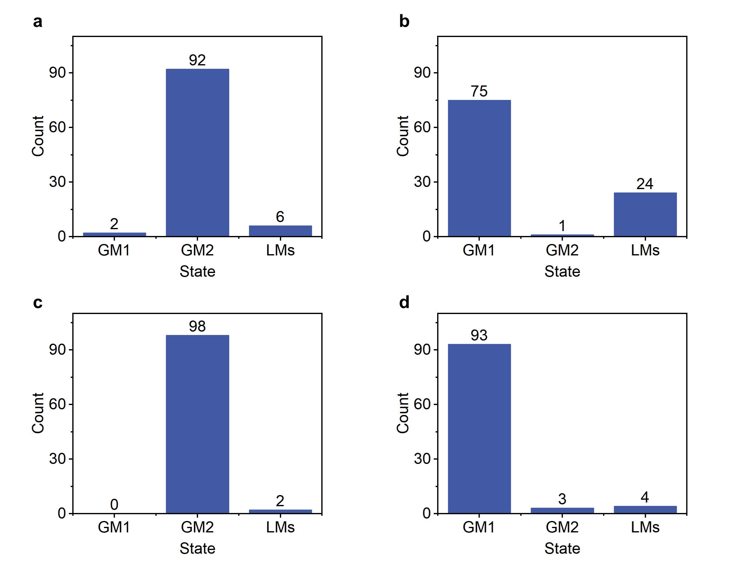

Extended Data Fig. 2 | Effect of symmetry-breaking in the activation. a, b, Counts of final states in 100 runs of a 3 × 3 ferromagnetic Ising model. The activation of zero weighted sum is set to -1 (a) and +1 (b) respectively. c, d, Counts of final states in 100 runs of a 3 × 3 antiferromagnetic model. The activation of zero weighted sum is set to -1 (c) and +1 (d) respectively. GM1 and GM2 denote the two degenerate global minima, and LMs denote all local minima.
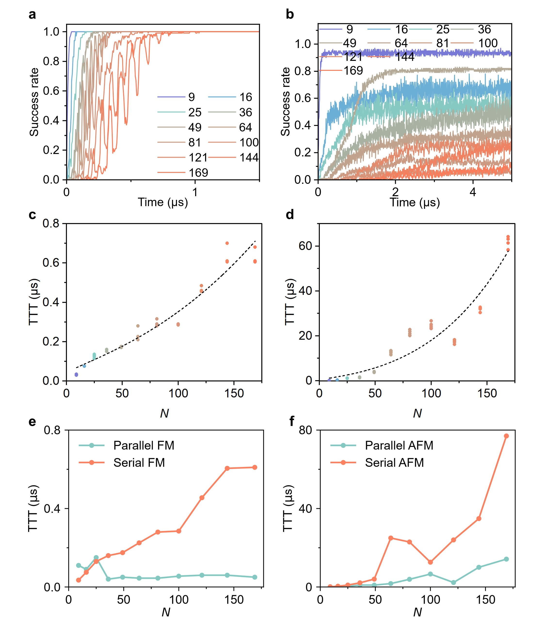
Extended Data Fig. 3 | Success rates of reaching global minima and comparison of TTT between parallel and serial MAC. a, b, Success rates of finding ground states in 100 runs, with random initial configurations. The CTD-HNN running ferromagnetic models (a) reached ground states faster and more often than running antiferromagnetic models (b). c, d, Time-to-target scaling with problem size N. The dashed lines show fits to $e^{b\sqrt{N}}$. We synthesised the same Verilog code five times, which yielded slightly different implementations on the FPGA and slightly different TTTs. e, f, TTT comparison between parallel and serial MAC implementations for ferromagnetic (FM) (e) and antiferromagnetic (AFM) Ising models (f).

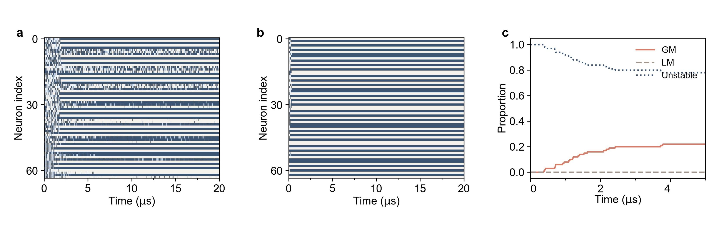

Extended Data Fig. 4 | Neural state evolution and attractor dynamics in an 8 × 8 antiferromagnetic Ising model. a, b, Neural traces from representative runs that (a) remained unstable and (b) reached a stable final state, corresponding to the trajectories projected in Fig. 2g and h, respectively. White and blue indicate binary states -1 and +1, respectively. c, Fractions of trajectories classified as unstable or stable at a local minimum (LM) or global minimum (GM). A trajectory is considered stable at a given time point if the states of all neurons remain unchanged for the rest of the observation window.

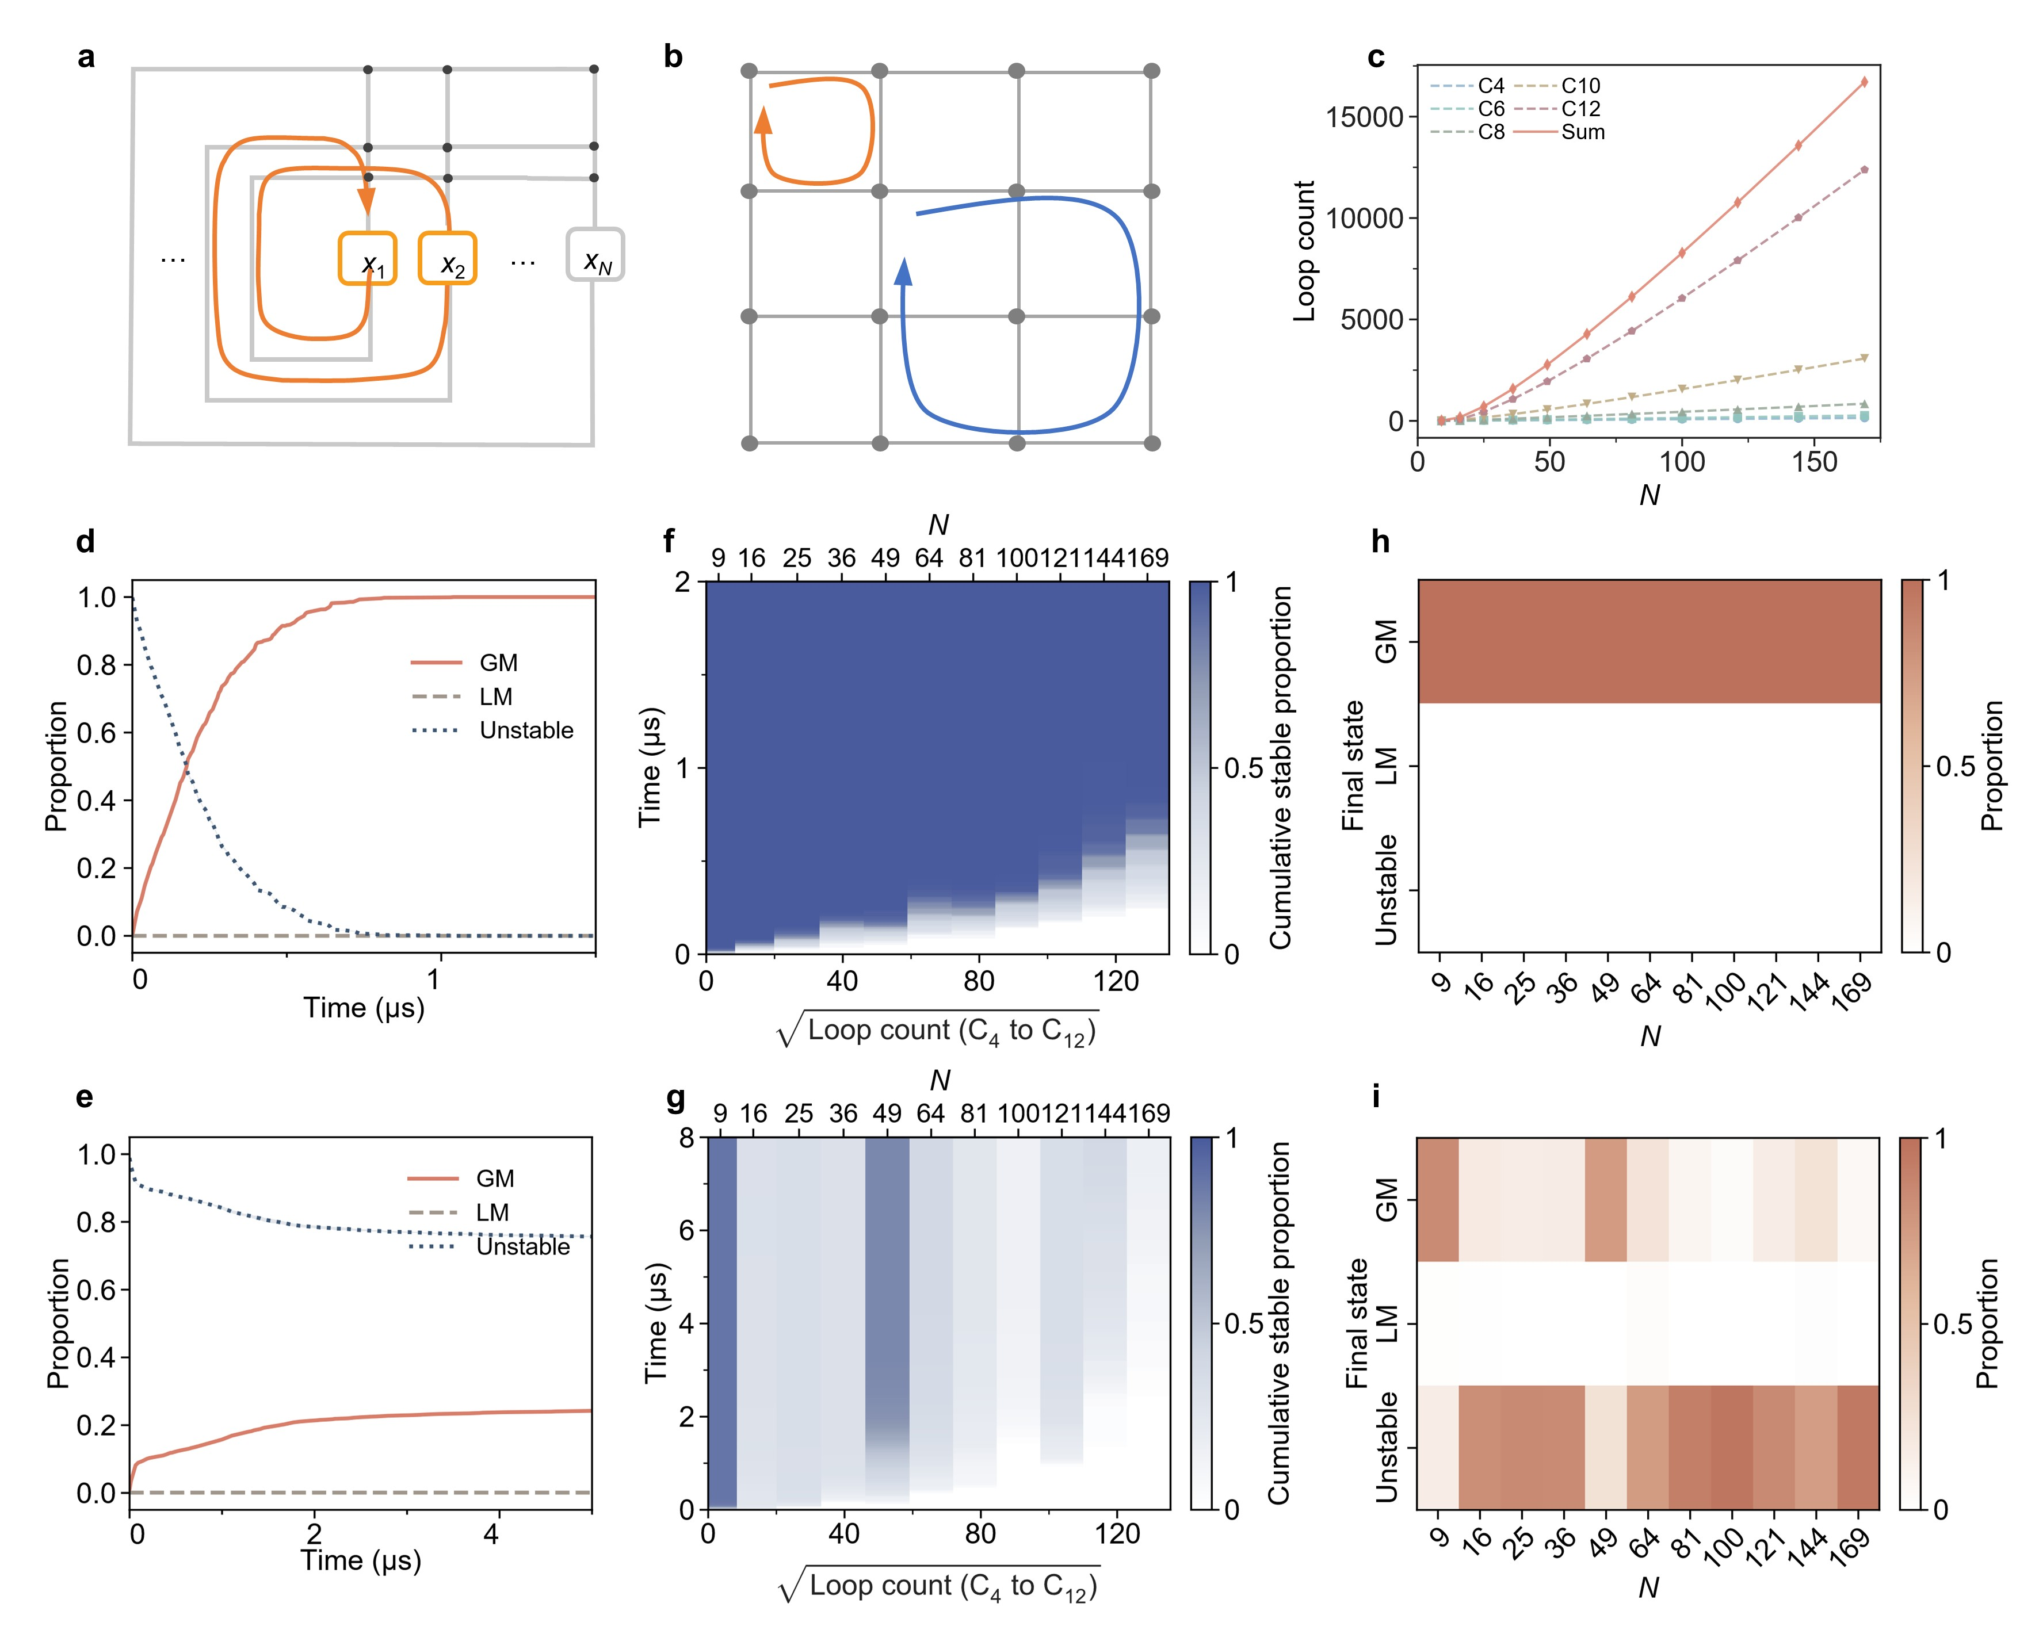
Extended Data Fig. 5 | Embedded feedback loops and stability scaling in ferromagnetic and antiferromagnetic Ising models. a, Schematic of an embedded feedback loop. b, A 4 × 4 spin lattice shared by the ferromagnetic and antiferromagnetic models. Orange and blue paths indicate C₄ and C₈ loops, respectively, defined by the number of distinct spins visited along each loop. c, Numbers of C₄–C₁₂ loops and their sum versus the network size N. Each undirected loop is counted once, irrespective of its starting node or traversal direction. d, e, Proportion of trajectories classified as global minima (GM), local minima (LM), or unstable over time, averaged across all network sizes, for ferromagnetic (d) and antiferromagnetic (e) models. f, g, Heatmaps of the proportion of stabilised runs as a function of time and the square root of the total number of C₄–C₁₂ loops for ferromagnetic (f) and antiferromagnetic (g) models. The colour represents the proportion of stabilised runs defined in d, e, respectively. The square-root transformation of the horizontal axis is for visual clarity. h, i, Final-state distributions across network sizes for ferromagnetic (h) and antiferromagnetic (i) models. For d–g, a trajectory is considered stable at a given time point if all sampled neural states remain unchanged thereafter. For h, i, a trajectory is classified as having a stable final state only if the states of all neurons remain unchanged throughout the last 8 µs.

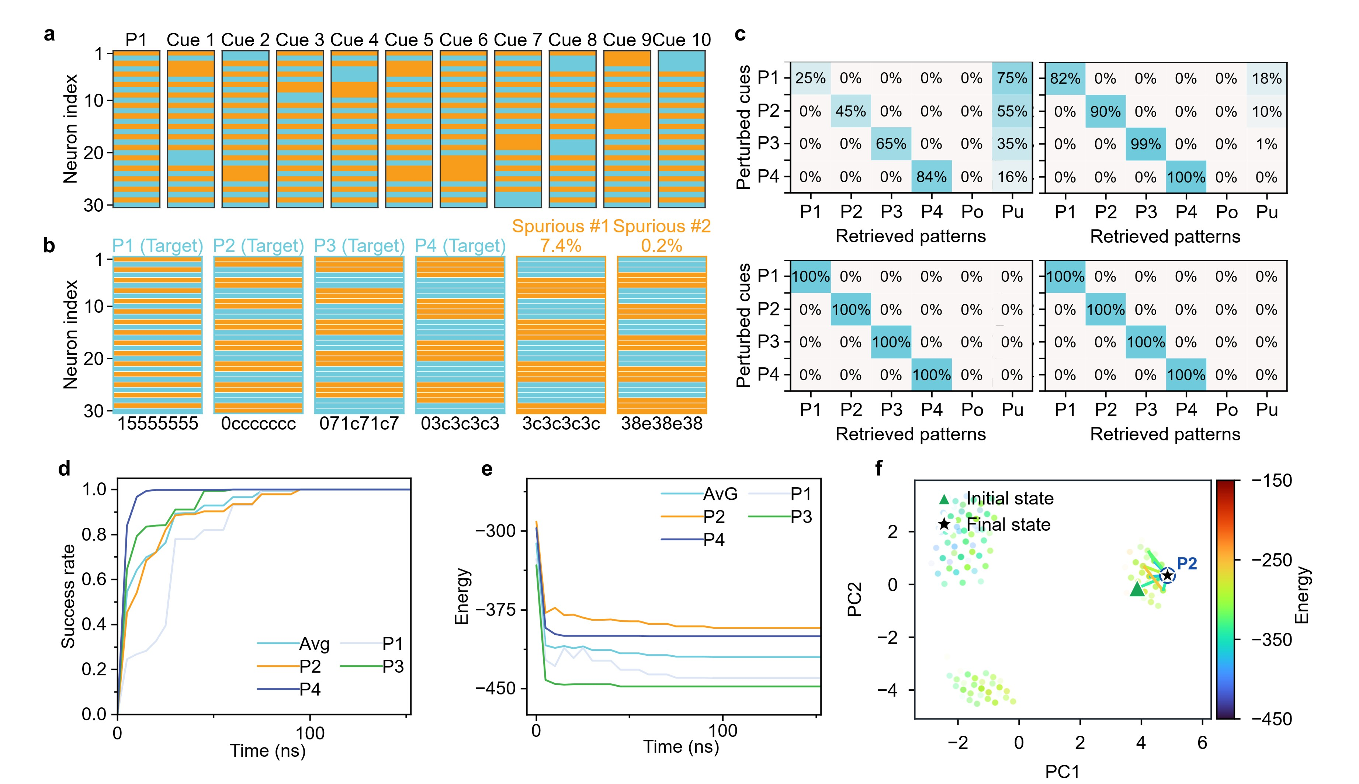
Extended Data Fig. 6 | Stored patterns, spurious retrieval and recall under block evolution. a, P1 pattern and 10 exemplary perturbed cues. Light blue and orange denote neural states -1 and +1, respectively. b, P1–P4 patterns and the most frequently observed spurious patterns in the retrieval trials without block evolution. These two patterns occurred with frequencies of 7.4% and 0.2%, respectively. c, Confusion matrices at 5, 50, 100 and 150 ns under block evolution. d, Success rate of retrieval over time. e, Evolution of energy over time. f, Two-dimensional PCA projection of the trajectory of a representative successful P2 retrieval. The blue circle denotes P2.

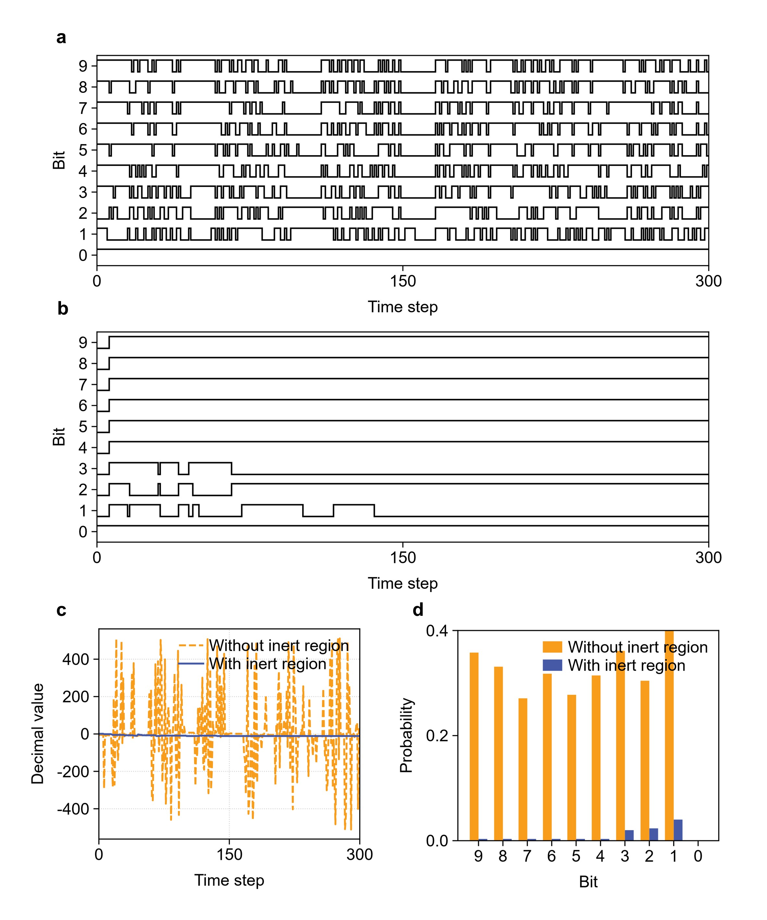
Extended Data Fig. 7 | Effect of the inert region on weighted sum in a 100-vertex Max-Cut instance with 50% connectivity. a, b, Digital waveforms of a representative weighted sum $μ_{i}$, encoded as a 10-bit two’s-complement word, without (a) and with (b) the inert region. c, Decimal values of $μ_{i}$ decoded from the two’s-complement representation under the two conditions. d, Bit-flipping probability for each bit under the two conditions.

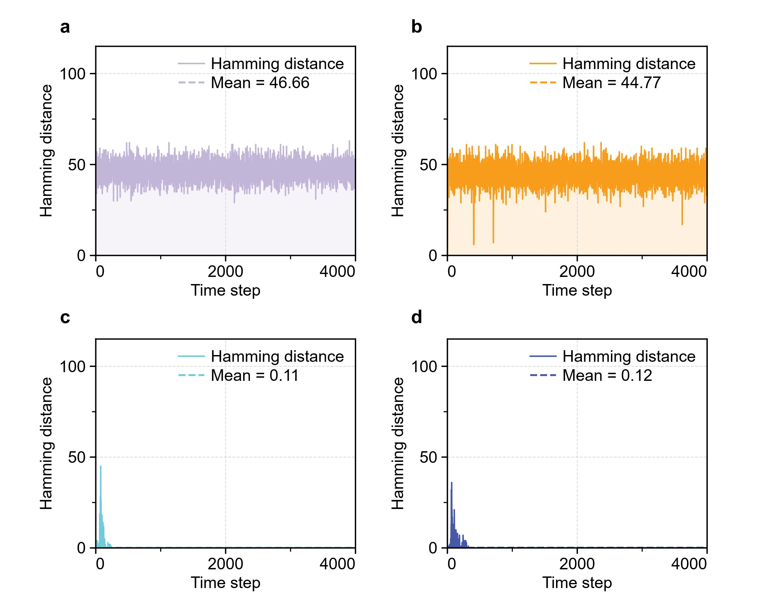
Extended Data Fig. 8 | Stepwise Hamming distance for the same representative 100-vertex Max-Cut trajectories shown in Fig. 4. a, Fully parallel evolution, b, Block evolution, c, Inert region, and d, Variable delays. Larger values indicate that more neural states differ between consecutive samples.

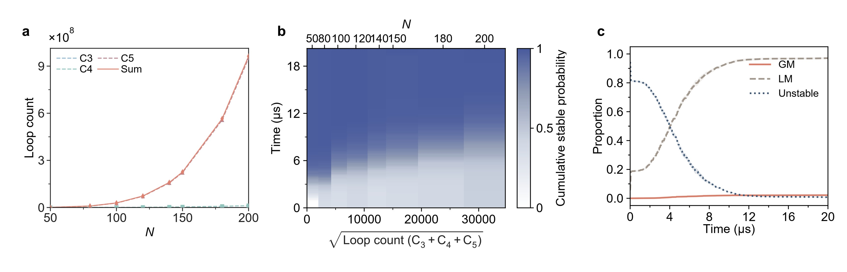
Extended Data Fig. 9 | Feedback-loop counts and convergence properties in Max-Cut problems. a, Counts of loops traversing 3, 4 or 5 distinct nodes (C₃, C₄ and C₅) and their sum as functions of network size N for Max-Cut instances with 50% connectivity. Each undirected simple cycle is counted once, irrespective of its starting node or traversal direction. b, Heatmap of the proportion of stabilised runs as a function of time and the square root of the total number of C3–C5 loops. The loop counts and proportions of stabilised runs are averaged over five instances per network size, with the square root applied to the mean total loop count. The square-root transformation of the horizontal axis is for visual clarity. c, Fractions of trajectories classified as global minima (GM), local minima (LM) or unstable over time, averaged across the investigated network sizes. For b, c, a trajectory is considered stable at a given time if all sampled neural states remain unchanged thereafter. Here, GM and LM denotes stable states corresponding to the known maximum cut and other cut value, respectively.

