Supplementary Information
An Insert-Compatible Magnetic Actuation Platform for Dynamic Air–Liquid Interface Culture of Human Alveolar Epithelial Cells
Yu-Che Lin et al.

Table S1. Primer sequences used for RT-qPCR analysis.
Gene | Forward primer (5′→3′) | Reverse primer (5′→3′)
GAPDH | GCAGGGGGGAGCCAAAAGGG | TGCCAGCCCCAGCGTCAAAG
AQP5 | GGCCACCTTGTCGGAATCTA | CTTTGATGATGGCCACACGC
PDPN | GGAAGGTGTCAGCTCTGCTC | CGCCTTCCAAACCTGTAGTC
SFTPB | TGCAAGCTAGGGACCCATTC | GGACGGTGTCTTTTTCTTTCTCA
SFTPC | ACACACGGAGATGGTTCTGG | GGCCTGGAAGTTGTGGACTT
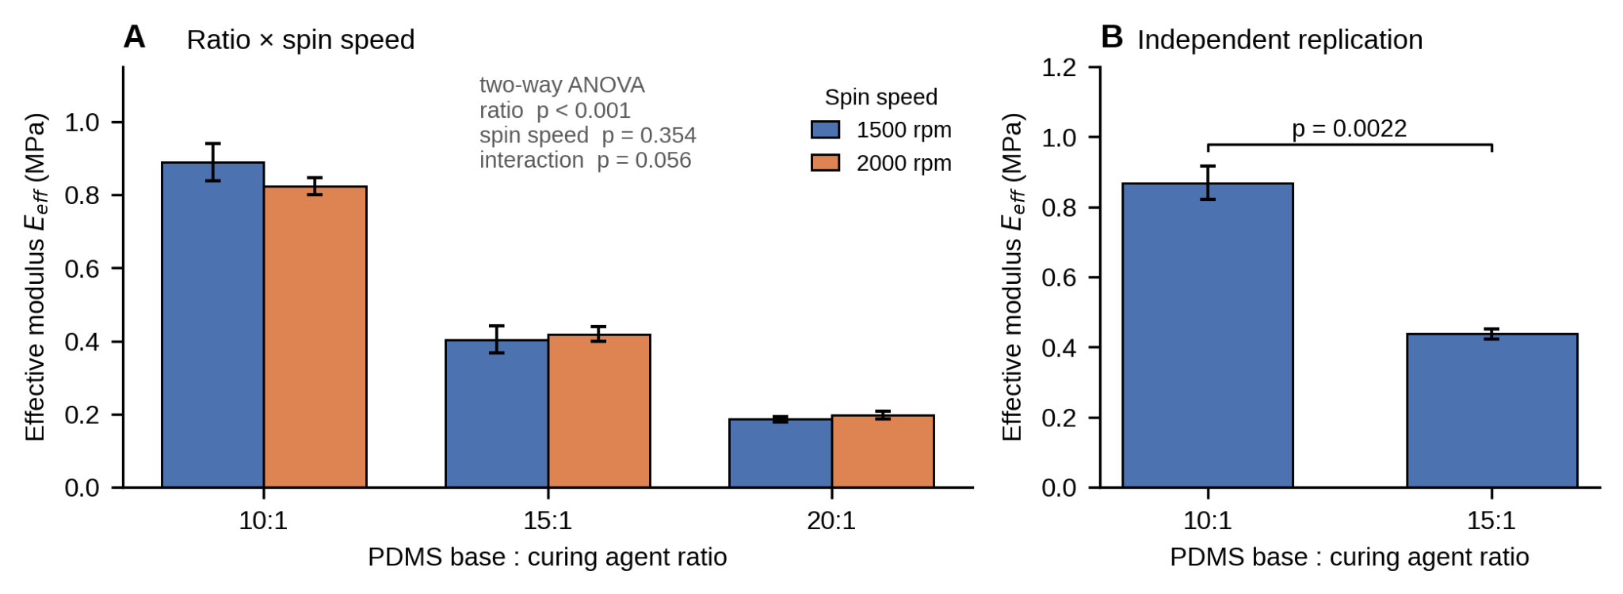
Figure S1. Development-stage effective Young’s modulus screening of porous PDMS membranes. (A) 10:1, 15:1, and 20:1 PDMS at 1500 or 2000 rpm (n = 3 per condition). (B) Independent n = 3 replication comparing 10:1 and 15:1 formulations. These data were used to select the final membrane condition and are not treated as a primary biological result.
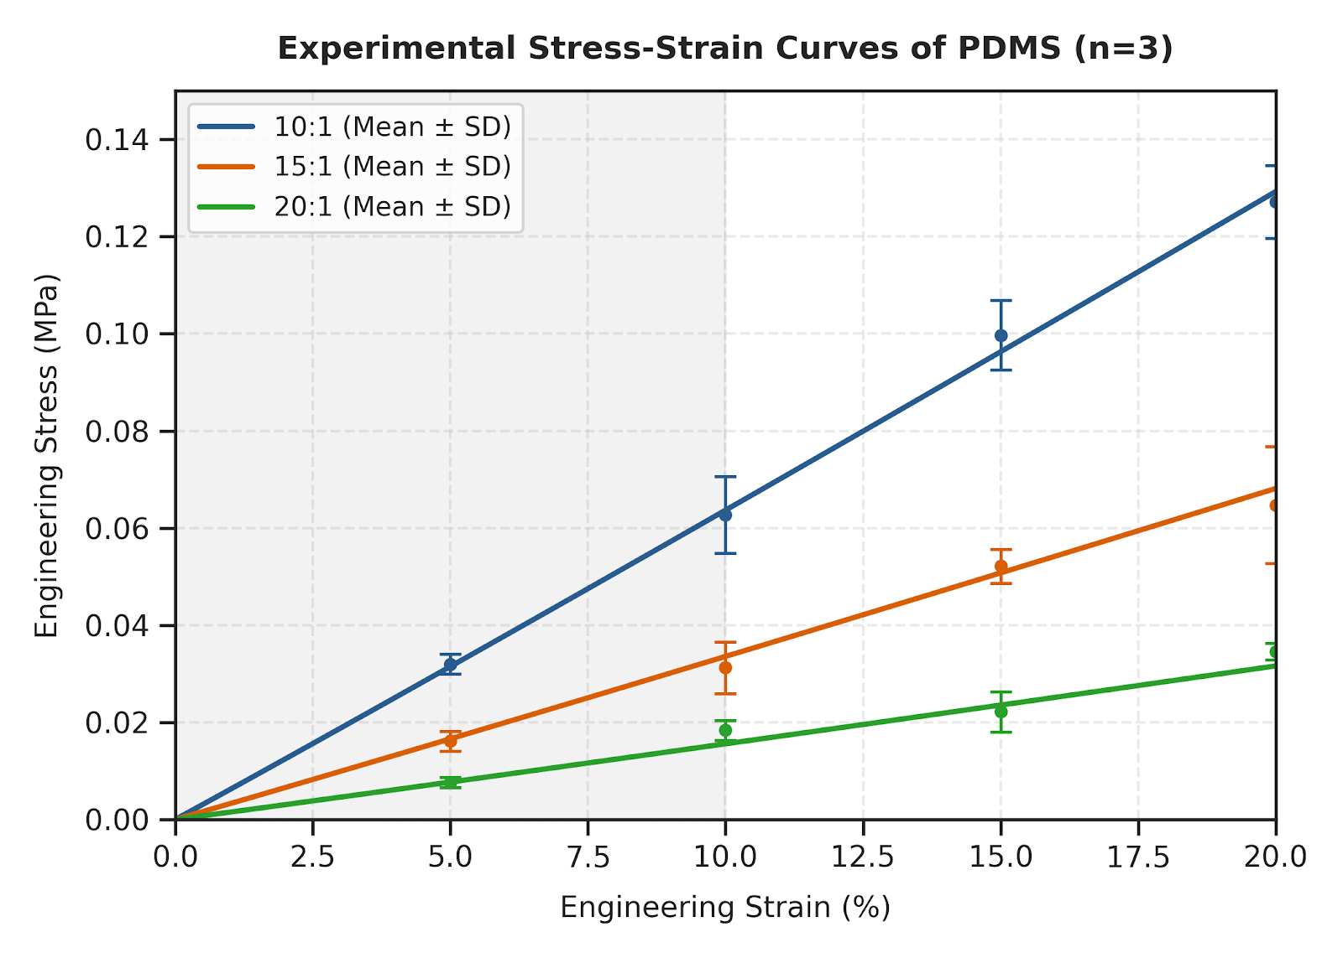
Figure S2. Development-stage engineering stress–strain curves of 10:1, 15:1, and 20:1 PDMS. Points and error bars show mean ± SD from three specimens per formulation over nominal strains from 0 to 20%.
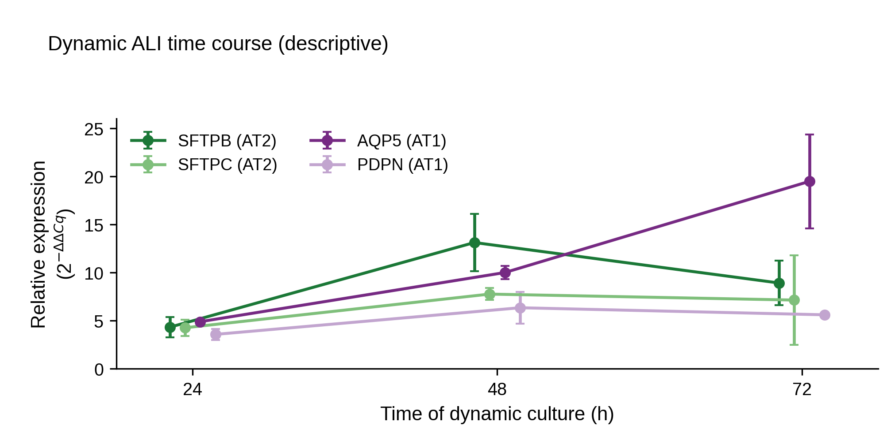
Figure S3. Descriptive RT-qPCR time course during dynamic ALI culture. SFTPB and SFTPC (AT2-associated) and AQP5 and PDPN (AT1-associated) were measured at 24, 48, and 72 h (mean ± SD, n = 3 independent inserts). Static-ALI and submerged controls were collected only at 72 h; therefore, the 24–48–72 h dynamic series is shown descriptively and is not used to infer an actuation-specific temporal trajectory.

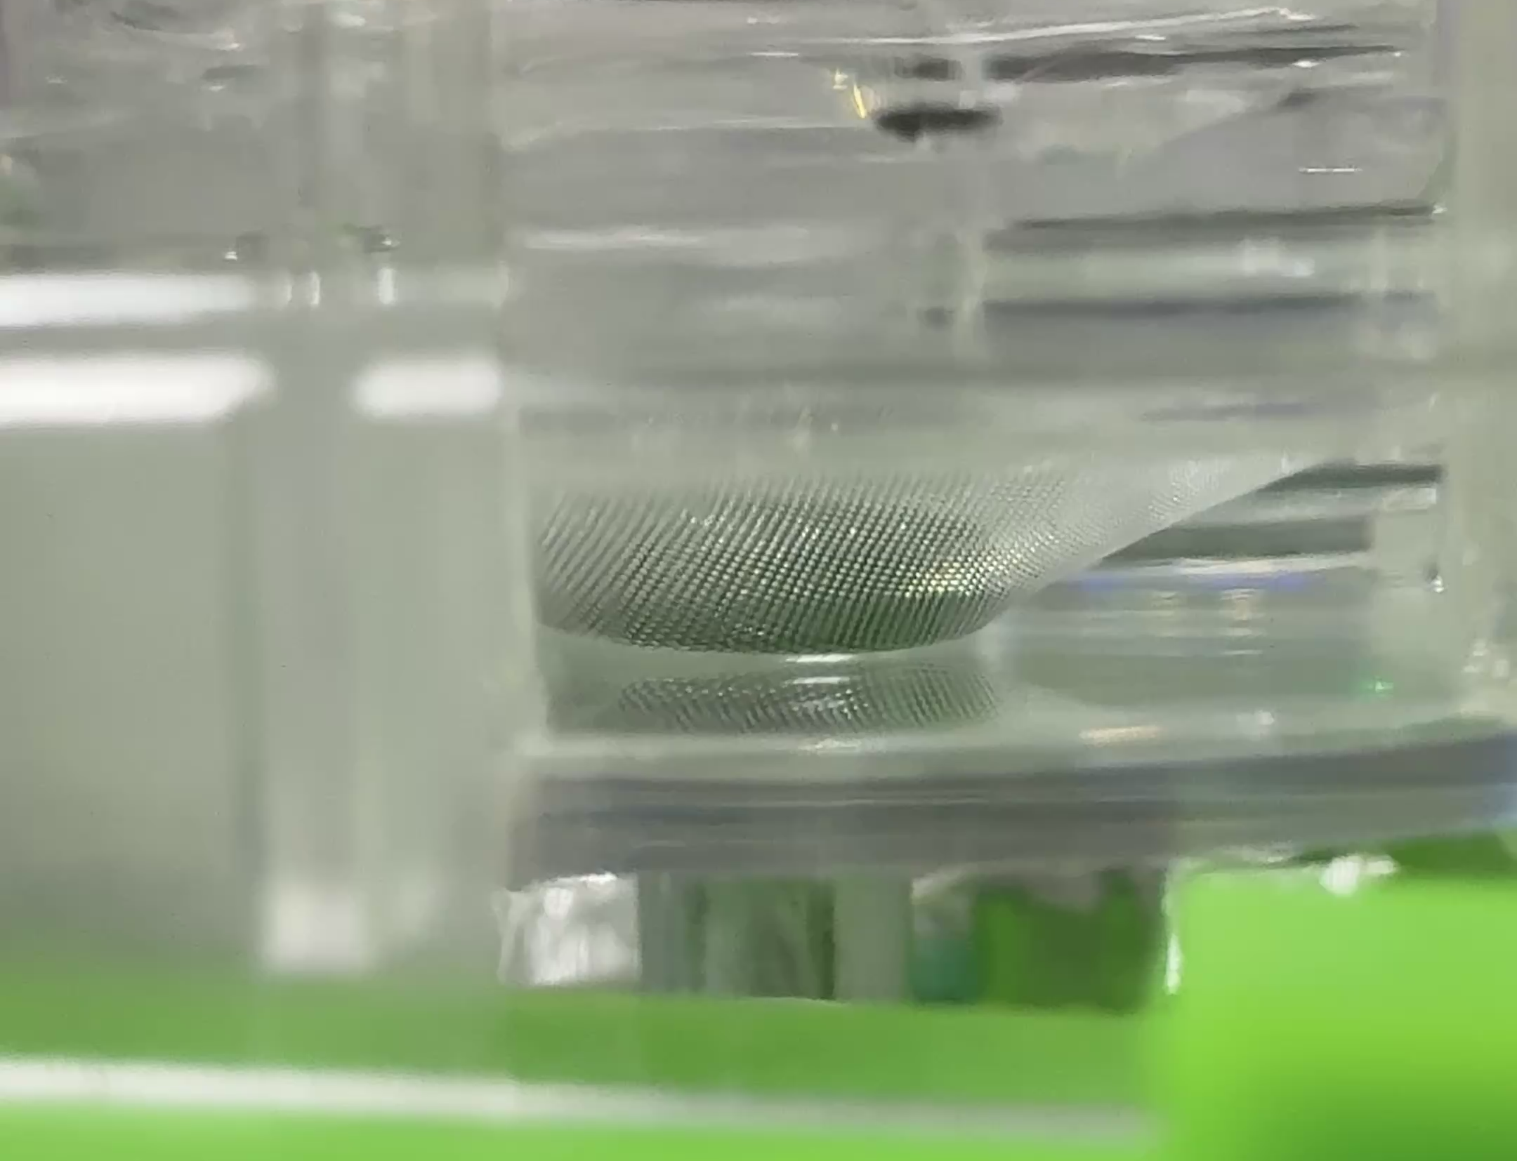
Video S1. Representative 0.2 Hz magnetic actuation movie.

