Mouse Flt1 sequence differences limit direct translation of human SSO-targeted regions.
To assess whether the intron 13 regions identified in the human FLT1 transcript were sufficiently conserved to support evaluation in a mouse model, we examined sequence homology across the corresponding mouse and human regions. The exon 13-intron 13 region targeted by the proximal SSO showed 73% sequence homology between human FLT1 and mouse Flt1, while the regions corresponding to the distal PolyA1 and PolyA2 sites showed 93% and 73% homology, respectively (Supplementary Fig. 1a). Mouse-specific SSOs were therefore designed to target the corresponding exon 13–intron 13 junction and PolyA1 and PolyA2 regions. In mouse 661W cells, we assessed Flt1 transcript expression by TaqMan qPCR. Total Flt1 transcript abundance was unchanged following treatment with any of the mouse-specific SSOs (Supplementary Fig. 1b). In contrast, the exon 13-intron 13 junction with the me13-i13 SSO resulted in a significant reduction in the Flt1 exon 13-14 junction transcript (P < 0.0001). In contrast, the mi13 PolyA1 and mi13 PolyA2 SSOs did not significantly alter this transcript (Supplementary Fig. 1c). These findings indicate that the mouse Flt1 transcript's sequence and splicing context do not fully recapitulate the human Flt1 intron 13 regulatory regions identified in this study. Although mice naturally produce soluble FLT1, these species-specific differences in FLT1 sequence and splicing regulation limit the direct translation of the human SSO strategy to conventional mouse models and therefore complicate in vivo validation of the human-targeted SSOs.
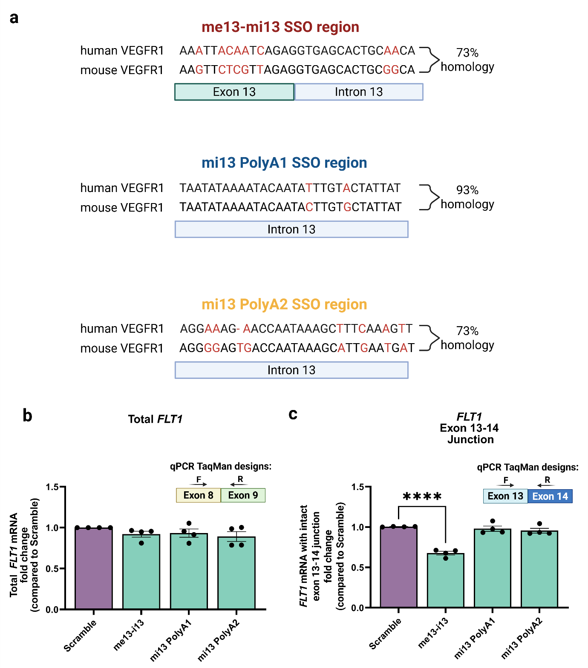

Sequence conservation and functional assessment of mouse Flt1 SSO target regions. (a) Sequence homology between human FLT1 and mouse Flt1 across the exon 13–intron 13 junction and regions corresponding to the distal PolyA1 and PolyA2 sites. (b) Quantification of total Flt1 transcript expression by TaqMan qPCR following transfection of mouse 661W cells with mouse-specific SSOs targeting the exon 13–intron 13 junction (me13-i13) or regions corresponding to PolyA1 (mi13 PolyA1) and PolyA2 (mi13 PolyA2). (c) Quantification of Flt1 transcripts containing the exon 13–14 junction by TaqMan qPCR. SSO sequences are provided in Supplementary Table 1, and TaqMan probe information is provided in Supplementary Table 3. Gene expression was normalized to GAPDH and is presented relative to the scramble SSO control. Data are presented as mean ± s.e.m. (n = 4). n = independent biological replicates. Statistical significance was determined using one-way ANOVA followed by Dunnett's multiple-comparison test. P < 0.0001 (****); ns, not significant; F, forward primer; R, reverse primer—figure created with BioRender.com.

Supplementary Table 1. Sequences of the 30bp SSOs used for the 255bp walk along the exon-intron junction and two distal PolyA sites.

SSO name | SSO target sequence (5′→3′)
Scramble | GGTAATAAGAAGAGGATCCGCACAATAAGA
SSO-1 | TGCTCCTTAGTGATGGCCATTTTTTGCTTG
SSO-2 | GATGGTAAGATTAAGAGTGATGGAGTGCTC
SSO-3 | CTGAATCTTGCAGGGAAACATTCATGATGG
SSO-4 | TTCCTGGCTCTGCAGGCATAGGTGCCTGAA
SSO-5 | GAGGATTTCTTCCCCTGTGTATACATTCCT
SSO-6 | CTCTGATTGTAATTTCTTTCTTCTGGAGGA
SSO-7 | ACAGCCTTTTTGTTGCAGTGCTCACCTCTG
SSO-8 | TTTAAATTTGGAGATCCGAGAGAAAACAGC
SSO-9 | GTGTGGTACAATCATTCCTTGTGCTTTTAA
SSO-10 | GTCCTTTAATGTTTTACATTACTTTGTGTG
SSO-11 | TATTATTTTCTCTTAAAACATACAAATATG
SSO-12 | ATAATAGTACAAATATTGTATTTTATATTA
SSO-13 | CACAGATTTGTAGTTTTTGCACTATATAAT
SSO-14 | AAAGAATTAATTCAAGAGGCAGAGGCACAG
SSO-15 | ATTCCCTTCCCAAATGCAAGCAACCAAAGA
SSO-16 | GCTTTATTGGTTCTTTCCTTTCTCCATTCC
SSO-17 | CAGGAGAATTTCTTGAACTTTGAAAGCTTT
SSO-18 | CTAAGTTGTAAGGCAGCAGACCAAACAGGA
SSO-19 | TTTGTGTTACTCAACTGTCAGTAACCTAAG
SSO-20 | TGATTGATGTATTTGTGGGGGCGTGTTTGT
me13-i13 | TGCCGCAGTGCTCACCTCTAACGAGAACTT
mi13 Poly1 | ATAATAGCACAAGTATTGTATTTTATATTA
mi13 Poly2 | GCTTTATTGGTCACTCCCCTCCCTCCCCTC

Supplementary Table 2. PCR primers were used to validate the presence of human full-length, membrane-bound FLT1 for cell line selection. F: Forward, R: Reverse. GAPDH is used as a housekeeping gene.
Primer set | Target region | Primer sequence
hmVEGFR1 PCR |  | F: GCG GAC AGT TAA TAA CAG AAC AAT  R: GAC AGT CTA AAG TGG TGG AAC T
GAPDH  (Housekeeping) | 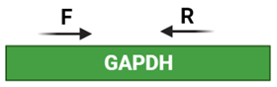 | F: TGA CAT CAA GAA GGT GGT GAA G  R: TAC TCC TTG GAG GCC ATG T

Supplementary Table 3. TaqMan assay probes used to validate full-length membrane-bound FLT1 and total FLT1. All TaqMan probes are pre-designed and ordered from ThermoFisher Scientific. F: Forward, R: Reverse. P: probe. GAPDH is used as an internal positive control (IPC).
Assay name (catalog number) | Target region | Assay ID
Human FLT1 Exon 8-9 | 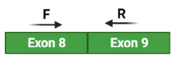 | Hs01052961_m1
Human FLT1 Exon 13-14 |  | Hs01052938_m1
Human FLT1 Exon 14-15 |  | Hs01052939_m1
Human GAPDH |  | Hs99999905_m1
Mouse Flt1 Exon 8-9 |  | Mm01210876_m1
Mouse Flt1 Exon 13-14 |  | Mm01210863_m1
Mouse Gapdh |  | Mm99999915_g1

Supplementary Table 4. Sequences of the 20 bp sgRNAs used for the CRISPRa (dCas9-VPR system) and their distance upstream of the transcriptional start site (TSS).
sgRNA name | target sequence | Position relative to FLT1 TSS in bp
sgRNA1 | GGGCGGAAAGTCCGATCCAA | -428 to -408
sgRNA2 | TCTGGGGGCCGCCCGAAACT | -368 to -348
sgRNA3 | AGCACCTCCCCACGCGCGCT | -216 to -196
sgRNA4 | GGCTCGCTTCCCTGCGGCTA | -153 to -133
sgRNA5 | GACCCCTTGACGTCACCAGA | -88 to -68

